Supplemental Online Appendix: Figures and Tables

Figure A-1: Example Wikisurvey Voting Page

Table A-1. Characteristics of Study Participants (N=1,506) Compared with McGinty et al., 2017 and National Estimates

 | Study Sample  (% of non-  missing cases, n) | McGinty et al. (2017)  (%) | National Comparison¹  (%)
Sex/Gender  Female  Male  Transgender  Other | 40% (607)  59% (891)  0.3% (4)  0.3% (4) | 55%  45%  --  -- | 51%  49%  --  --
Age (of those 21 and older)  Ages 21-34  Ages 35-44  Ages 45-54  Ages 55-64  Ages 65 +  Race  White  Black  Other  Hispanic ethnicity  Hispanic  Non-Hispanic  Education  Less than high school diploma  High school diploma or equivalent  Some college or higher  Political Party Affiliation  Republican  Independent  Democrat  Other  Recreational Marijuana Legal in State of Residence?  Yes  No  Legalization Support  In states where recreational use was legal at the time of the survey  In states where recreational marijuana use was illegal at the time of the survey | 19% (21)  18% (274)  17% (255)  22% (335)  23% (351)  89% (1333)  7% (111)  6% (84)  7% (98)  93% (1408)  2% (25)  12% (180)  86% (1301)  28% (425)  27% (402)  38% (571)  7% (108)  35% (529)  65% (977)  64% (339)  59% (576) | 26%  18%  19%  17%  19%  80%  11%  9%  8%  92%  4%  31%  64%  33%  37%  37%  --  31%  69%  --  -- | --  --  --  --  --  77%  13%  20%  18%  82%  --  --  --  29%  30%  35%  --  --  --  --  --

¹ We extracted comparison demographic data from the July 2016 Current Population Survey (https://www.census.gov/quickfacts/fact/table/US/PST045216) and political ideology data from the Huffington Post’s October 21, 2016 moving average of 1,483 polls from 105 pollsters (https://elections.huffingtonpost.com/pollster/party-identification).

Figure A-2: Relative Strength of Pro-Legalization Arguments by Political Party

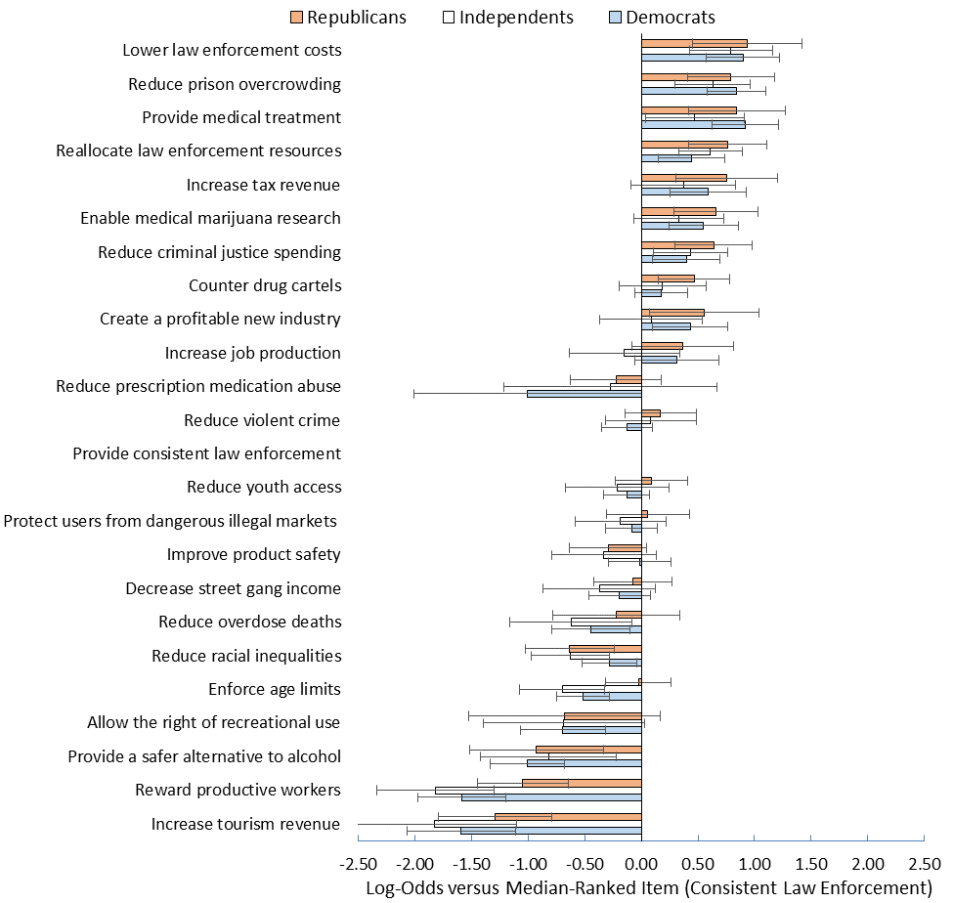

Figure A-3: Relative Strength of Anti-Legalization Arguments by Whether or Not Resides in a State with Legalized Recreational Marijuana
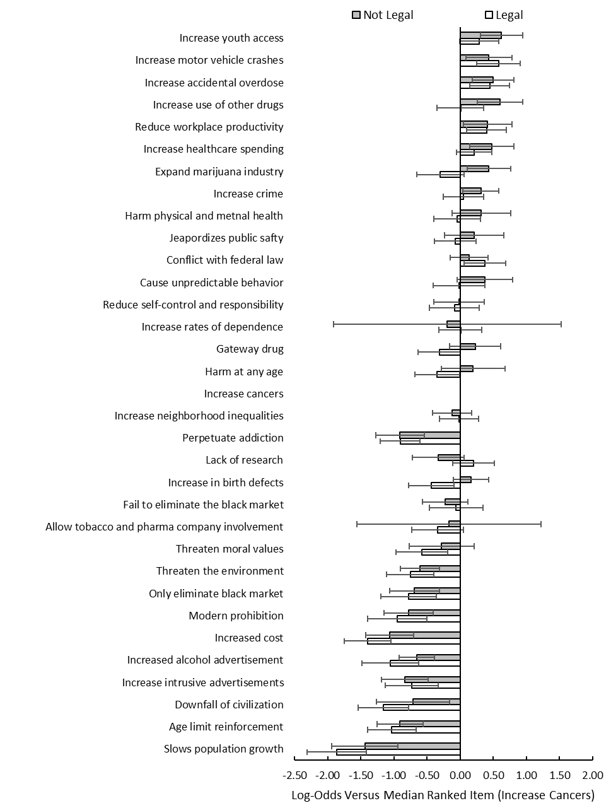

Figure A-4: Relative Strength of Pro-Legalization Arguments by Individual-Level Support or Opposition to Legalization

