Picture 1. Taobao’s Imbedded IM Tool Aliwangwang

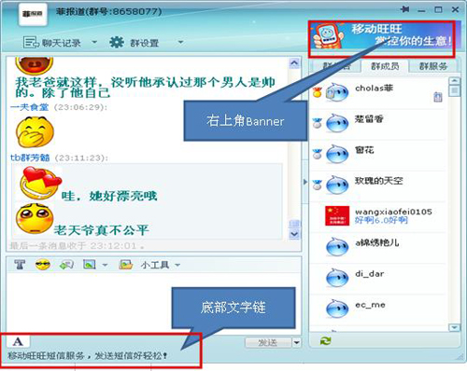

Picture 2. The First Taobao Village Summit in Lishui, Zhejiang Province in 2013


Picture 3. Mourning Hall for Jack Ma set up by the Anti-Taobao Coalition in Hong Kong
