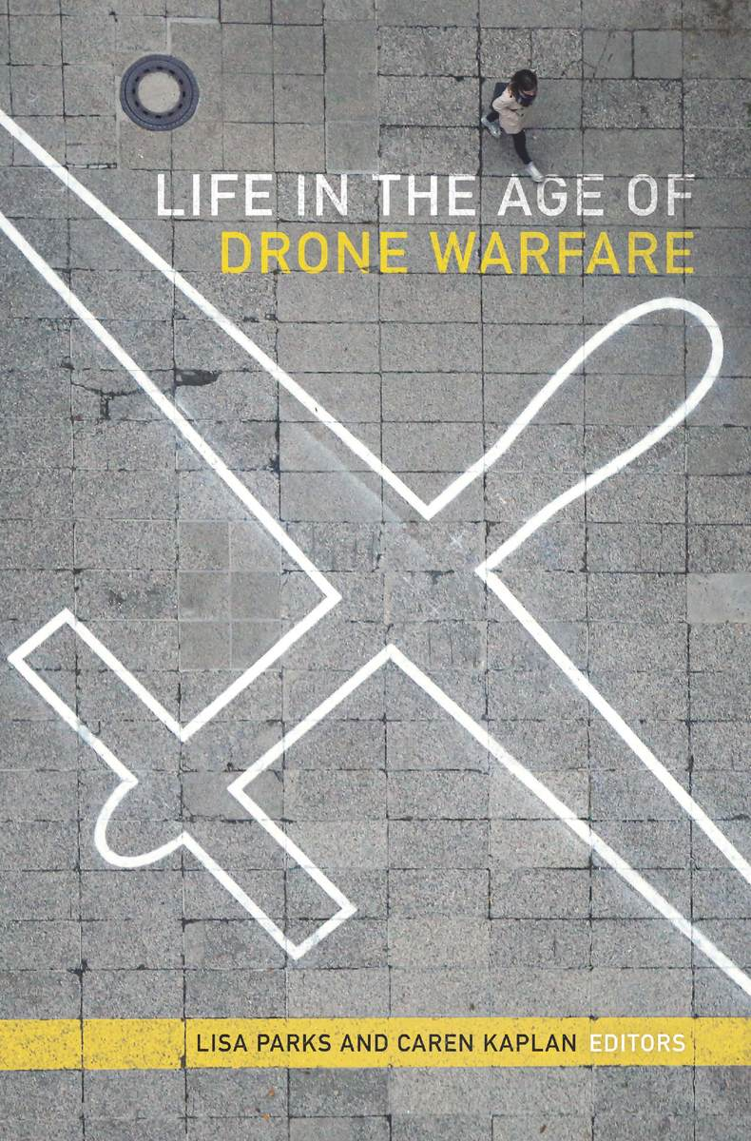
Lisa Parks and Caren Kaplan (Editors)
Life in the Age of Drone Warfare
Duke University Press, Durham, 2017
448p, $29.95 (paperback)

Hugo Ljungbäck
University of Wisconsin-Milwaukee

Late on December 19, 2018, Gatwick Airport, the second-largest hub in the U.K., had to close its runways, diverting thousands of passengers to nearby airports, while cancelling hundreds of other flights. Tens of thousands of passengers were stranded in London and at airports across the world throughout the next day, as police investigated sightings of a drone close to the runway. In direct violation of British law, which forbids flying drones within one kilometer of an airport, this “deliberate disruption” caused a major financial, security, and infrastructural crisis, and even warranted the deployment of the army. As people waited impatiently for the airport to resume its operations, drones made a sudden comeback into public consciousness, as people debated the shortcomings and oversights in crisis planning, security measures, and legal recourse -- at last, drone disruptions had hit too close to home.
While private drone “incidents” have become increasingly common around Europe and the U.S. in the mid-2010s, occasionally causing disruption but generally being a nuisance, since the early 2000s, military drones have assumed a permanent and permeating presence throughout the Federally Administered Tribal Areas (FATA) of northwestern Pakistan, where they hover for hours, days, and sometimes even weeks, tracking, surveying, and then killing their human targets with Hellfire missiles. Lisa Parks’ and Caren Kaplan’s collection, Life in the Age of Drone Warfare, offers a welcome investigation of the material, psychological, and cultural impacts of drone warfare on and beyond the contested battlefields, exploring drones’ corporeal and environmental effects, drone pilots’ and operators’ traumatic labor, and artists’ and activists’ resistance to military violence.
Developing out of a number of conferences and symposia at UC-San Diego (2012), UC-Santa Barbara (2013), and UC-Davis (2013 and 2016), Parks’ and Kaplan’s pioneering collection brings together scholars from a variety of interdisciplinary fields -- from geography, sociology, visual arts, political theory, global and American studies, and gender studies, to information, technology, infrastructure, and surveillance studies. The authors’ exploration of subjects ranging from legal discourse, colonialism, and human/nonhuman relations, to contemporary literature, racial profiling, and labor subjectivities, makes the multidisciplinary scope of this project both appealing and relevant to a large audience and offers an exemplary model for continued interdisciplinary research within the critical humanities.
Through a combination of historiography, criticism, and theory, the scholars draw on and analyze a variety of primary materials, including newspaper articles, government reports, Google Maps and satellite imagery, music videos, novels, and art installations, as evidence that drone warfare has significantly changed the way of life both at home and abroad. Humans’ relations to technology and each other have been reconfigured by rewriting the rules of engagement and changing the labor conditions of military personnel, who now operate drones and kill Taliban leaders in Pakistan remotely from their bases in Florida or Nevada, before picking their kids up from school for soccer practice; and by stripping citizens in the FATA and elsewhere of legal protections, so that some children now live in an Orwellian state of super-surveillance, where anyone can be secretly watched at any time, and in an instant blown to pieces for seemingly any reason.
Divided loosely into three sections, this volume explores the political, environmental, social, cultural, ethical, and technological implications and dimensions of life in the age of drone warfare. The first section, “Juridical, Genealogical, and Geopolitical Imaginaries,” explores the legal, historical, and geographical conditions which have constituted the terms of international drone policy. Derek Gregory argues that the FATA in Pakistan have become a “space of exception” where people live without legal protections and the military can kill with little consequence because of the region’s geographical and juridical liminality at the border against Afghanistan, and explores how the CIA developed “targeted killing” as a framework and means for legalizing assassination. Lisa Hajjar accounts for how states have reinterpreted International Humanitarian Law and pushed at the boundaries of what is legally acceptable to legitimize acts of state violence in the Israeli-Palestinian conflict through what she calls “state lawfare.” Tracing the drone’s origin to Word War II and the early 1940s, Katherine Chandler places “television-guided assault drones” in the context of internal military disputes about drones’ proclaimed benefit and efficiency, where it was positioned at the center of debates on human/nonhuman relations in technology and warfare. Andrea Miller explores the underlying racializing logic of “incitement to violence” discourse, which has been used to justify the logic of preemption, through which suspected terrorists are stopped from potentially committing terrorist attacks in the future either by imprisonment or extrajudicial killing. Finally, Lisa Parks considers drones as tools of “vertical mediation,” which can not only change people’s thoughts, behavior, and movement on the ground through PSY-OPS or by simply hovering, but produce material changes in the air’s chemical composition and on the earth’s surface through their bombing raids.
In the second section, “Perception and Perspectives,” the authors account for the cultural impact of drones on everyday life, and artists’ responses to their presence at home and abroad. Caren Kaplan opens this section by arguing that technologies of visual reproduction encourage a specific kind of seeing that removes audiences from the atrocities of “distance warfare” through both time and space gaps, and considers how this multimedia coverage of drone strikes distracts audiences from holding public officials accountable for their policies while death tolls keep rising. Artist Ricardo Dominguez reimagines the futuristic potential of drone technology by performing four “utopian plagiarist gestures,” in which he appropriates a short story by Nathaniel Hawthorne, online articles, and a Department of Defense report into a dystopian narrative about autonomous drone attacks, a fictional account of how the U.S. Army is weaponizing the weather, and a musing on corporate rivalry. Dominguez concludes his chapter with imagined press releases about a drone crashing onto UC-San Diego’s campus, a faux media event or “minor simulation” he staged as part of the “Drones at Home” art exhibition in 2012. Thomas Stubblefield continues this engagement with drone art by exploring how James Bridle and other artists use and appropriate smartphone applications and social media to post satellite images of drone strike sites and send real-time messages to subscribers whenever a drone attack occurs to counter and disrupt drones’ networked logic and indexical vision. Madiha Tahir turns her attention back to Pakistan’s FATA region, where she counters Gregory’s “state of exception” by arguing that the FATA is regulated by an intricate system of regional governance that extends British colonial rule to the modern day. Finally, Anjali Nath analyzes the music video “Soup Boys (Pretty Drones)” as an activist gesture that counters the “sober” discourse of traditional documentary film and news media with a South Asian diasporic “discourse of inebriation” which appropriates and subverts the visual and aerial politics of drone warfare.
The third and final section, “Biopolitics, Automation, and Robotics,” considers the specifically material, environmental, and sociotechnical implications of drone technology. Jeremy Packer and Joshua Reeves consider drones as characteristic of the “coming humanectomy,” a larger, but contentious, shift toward technologically autonomous systems and decentralized decision-making away from centralized, hierarchical, expert-based, and even human military command. Peter Asaro follows their essay by writing about the very human labor that is still required to operate unmanned drones, explores how the new labor conditions of drone pilots and operators has come to constitute a form of “bureaucratized killing,” a complex merger of paperwork with remote killing, and accounts for drone pilots’ marginal career prospects. Following Asaro’s excellent study of these workers’ “new subjectivities” and anxieties, Brandon Bryant’s “Letter from a Sensor Operator” offers a heartfelt and personal account of the traumatizing work he performed during his six-year tenure in the U.S. Air Force. Devoid of academic jargon, Bryant’s is a direct and conversational narrative detailing the training he received, the day-to-day operations in the ground control station, his first kill-mission, and living in isolation and with post-traumatic stress disorder after he left the force. Jordan Crandall follows by developing a “robotic ontology” that reconsiders how drones exist as material, infrastructural, and cognitive beings, and how automation is changing these relations throughout the spheres of the battlefield and the home. Concluding the collection, Inderpal Grewal returns to consider the drone in relation to postcolonialism and imperialism by analyzing a Broadway play about the subjectivities and psychological trauma of a former female drone pilot and a short story about the consequences of a neoliberal India where drones are deregulated and available to anyone as tools of both visual and biometric surveillance.
The contributions to this book are exemplary of well-researched, critical, and interdisciplinary work in the humanities. Rather than provide a comprehensive study of the history of drone warfare, drone technology, or drone politics, this collection provides a comprehensive survey of the methods and approaches of scholars across disciplines and offers their chapters as excellent models for continued research into drones from a variety of perspectives. While Dominguez’s and Bryant’s contributions stand out in this collection because of their break from the traditional academic format, this break also highlights the political and activist aims of the volume at large. However, while it is evident that all authors share this motivation, the language they use is sometimes inaccessible to non-academics, which seems slightly counterintuitive for a book whose aim is to not only show and bring awareness to how drones and drone warfare are changing the way of life, but to offer the vocabulary and tools to engage in critical discussions, conversation, and activism.

