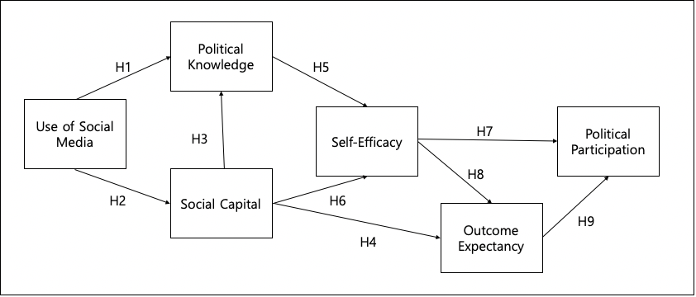

Figure 1. Proposed Model of the Effect of Social Media on Political Participation

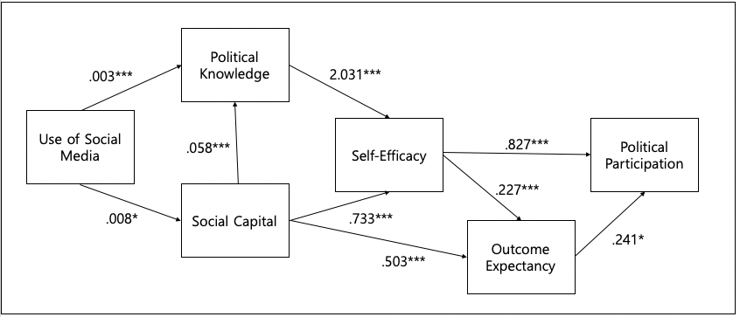

Figure 2. Results of Standardized Path Analysis for the Proposed Model
Note. *** p < .001, ** p < .01, * p < .05

Table 1. Factor Analysis Results for Items Related to the Proposed Model
 | Rotated Component Matrix
 | I | II | III | IV
1) I feel I am part of the community | .841
2) I am interested in what goes on in the community | .837
3) Interacting with people makes me feel like a part of a larger community | .738
4) Interacting with people in the community makes me want to try new things | .730
5) I am confident that I have the ability to give answers to questions or inquiries from others about political issues |  | .875
6) I am confident that I have the ability to provide political knowledge that other citizens consider valuable |  | .883
7) I am confident that I have the ability to contribute to the goals of this country |  | .671
8) I am confident that I have the ability to provide experiences for political events |  | .794
9) I am confident that I have the ability to recommend political events to anyone who seeks advice about the event |  | .750
10) By participating in political activities and events, I will get support from others |  |  | .825
11) By participating in political activities and events, I will find something to talk about |  |  | .800
12) By participating in political activities and events, I will find others who respect my views |  |  | .868
13) By participating in political activities and events, I will improve others' welfare in society |  |  | .850
14) By participating in political activities and events, I will satisfy my ideological aspiration |  |  | .706
15) I have discussed politics with someone on the Internet |  |  |  | .661
16) I have attended public hearings, town hall meetings, or city council meetings during the past 12 months |  |  |  | .818
17) I have spoken to a public official in person during the past 12 months |  |  |  | .767
18) I have participated in any demonstrations, rallies, protests, or marches during the past 12 months |  |  |  | .859
19) I have been involved in public interest groups, political action groups, political clubs, or party committees during the past 12 months |  | . |  | .767

Table 2. Pearson Correlation of the Variable Related to Political Participation
 | 1 | 2 | 3 | 4 | 5 | 6
1. Political Participation | 1.00
2. Use of Social Media | .188** | 1.00
3. Political Knowledge | .276** | .222** | 1.00
4. Social Capital | .458** | .163** | .263** | 1.00
5. Self-Efficacy | .560* | .174** | .449** | .552** | 1.00
6. Outcome Expectancy | .376** | .119* | .269** | .566** | .522** | 1.00
Note. ** p < .01, * p < .05
Table 3. Results of Hypothesis Testing
Hypothesis | Hypothesized Direction | Estimation (β) |  | Significance  (p)
H1 | Use of Social Media on Political Knowledge | .003 |  | ***
H2 | Use of Social Media on Social Capital | .008 |  | *
H3 | Social Capital on Political Knowledge | .058 |  | ***
H4 | Social Capital on Outcome Expectancy | .503 |  | ***
H5 | Political Knowledge on Self-Efficacy | 2.031 |  | ***
H6 | Social Capital on Self-Efficacy | .733 |  | ***
H7 | Self-Efficacy on Political Participation | .827 |  | ***
H8 | Self-Efficacy on Outcome Expectancy | .227 |  | ***
H9 | Outcome Expectancy on Political Participation | .241 |  | *
Note. *** p < .001, ** p < .01, * p < .05

