Appendix I: Dictionary development

Challenges
Given a large amount of text information in a crosscultural comparison situation, it is almost impossible to conduct traditional content analysis due to the human cost involved. Automatic text analysis such as dictionary-based sentiment analysis has been used to study the tone of news reporting in a single language situation (e.g. Young & Soroka, 2012; Backfried & Shalunts, 2016). The premise of dictionary-based sentiment analysis is simple: counting number of words with specific sentiment meaning in a piece of text. There are many of these “off-the-shelf” dictionaries available, with the most popular being LIWC (Tausczik & Pennebaker, 2010). However, dictionary-based sentiment analysis, especially those using “off-the-shelf” sentiment dictionaries, often raise questions of validity, reliability (González-Bailón & Paltoglou, 2015) and interpretability (Puschmann & Powell, 2018). There are more sophisticated methods such as machine learning-based sentiment indicators and some authors suggested them as a viable alternative (González-Bailón & Paltoglou, 2015). Machine learning-based sentiment indicators can consider the influence of context on sentiment. However, these machine learning-based methods require a larger dataset to train the algorithm. One way to improve the validity and reliability of dictionary-based is to adopt the dictionary to cater to the context of the text material (Diesner & Evans, 2015; Grimmer & Stewart, 2013). However, this solves only part of the problem because most of the sentiment tools are language-dependent and thus render the procedure useless in crosscultural, multilingual comparisons. Some have suggested to using machine translation of dictionaries as a quick fix to the problem (Mohammad & Turney, 2013; Lind et al., 2018). The NRC multilingual dictionary is a product using such method (Mohammad & Turney, 2013). Unfortunately, the validity and reliability of sentiment analysis using translated dictionaries are not certain. From a normative point of view, machine translation cannot translate the cultural context of words and this cultural context is important for sentiment detection. For example, one positive word in the NRC dictionary is biblical (German: biblisch). Although the word is automatically translated into other languages and still considered to be a positive word, people from Muslim-dominant countries might not consider this word as positive.
The current study aimed to offer a multilingual and context-sensitive dictionary for evaluation of sentiment in TMR reports. Using the “human-in-the-loop” principle of dictionary adoption (Diesner & Evans, 2015), we deployed and modified the crowdcoding methods suggested by Haselmayer and Jenny (2017) and Benoit, Conway, Lauderdale, Laver, & Mikhaylov (2016). Using our crowdcoding method, we utilized the non-expert native speakers online to code sentences from TMR reports and used those coded sentences to generate dictionaries.
Development of sentiment dictionary
In this study, we developed our own sentiment dictionaries in four languages (English, German, Lebanese Arabic and Turkish). There are available sentiment dictionaries that we could use. For example, the crowdcoding-based NRC sentiment dictionary covers many emotions and multiple languages are available via machine translation from English (Mohammad & Turney, 2013). We refrained from using this sentiment dictionary are based on two reasons, 1) the validity of machine translated sentiment dictionary has not been established; 2) the NRC dictionary is not adapted for the purpose of this study. Previous benchmark studies of general-purpose sentiment dictionaries such as NRC have shown that the validity of unadapted dictionaries depends heavily on the material applied to (González-Bailón & Paltoglou, 2015; Ribeiro, Araújo, Gonçalves, Gonçalves, & Benevenuto, 2016). Because of that, we developed our own multilingual sentiment dictionaries based on the previously established crowdcoding-based method (Benoit, Conway, Lauderdale, Laver, & Mikhaylov, 2016; Haselmayer & Jenny, 2017). Our dictionaries were aimed to achieve a maximum level of compatibility with the source material that we are studying (news articles and political blogs about Terrorism, Islam and Refugees) and with measurable criterion validity and interpretability. The basic idea of the method is to use the crowdcoded sentiment of sentences containing an individual word to infer the sentiment of that word. Following Haselmayer and Jenny (2017), we used the crowdsourcing platform Figure Eight (previously known as CrowdFlower) to conduct this crowdcoding procedure.
We modified some aspects of Haselmayer and Jenny’s protocol to adapt to the research questions of this study. The following paragraphs describe the procedure of the dictionary development in this study.
First, we developed our coding instructions in four languages. The first and second author developed the English version of coding instructions with two aims in mind: 1) to answer our research questions; 2) to be as short as possible. There is one major difference between our coding instructions and the one used by Haselmayer and Jenny (2017): in this study, we aimed at five emotions but Haselmayer and Jenny focused only on one negative emotion. Also, we used a nominal scale to ask the coders to determine the dominant emotion in a sentence, rather than the Likert scale used by Haselmayer and Jenny. Because of that, we need to modify the statistical analysis to reflect this difference. It will be explained in the subsequent paragraphs.
The English coding instructions are available in Appendix III. For the rest of three languages (German, Turkish and Arabic), we asked two bilingual translators to conduct the forward-translation (from English to the targeted language) and backward-translation (from the targeted language back to English) respectively. The first author then checked the consistency between the original English version and the backward-translated version. If inconsistency existed between the original and backward-translated version, the two translators were consulted to clarify and modify the translation.
For each of the four languages, we selected the relevant articles using the TMR keywords and then preprocessed the text. In the Haselmayer and Jenny’s protocol, all text is lemmatized, e.g. the German word sieht (see as a verb, third person singular) is transformed to the infinitive form sehen, or the Turkish word evda (house as a noun, in the house) is reduced to the form without the suffix ev. In this study, all relevant articles were first tokenized into sentences using the tokenizer R package (Mullen, Benoit, Keyes, Selivanov, & Arnold, 2018) and then parsed each sentence with the UDPipe framework (Straka & Straková, 2017) with the language-specific language model. This procedure was aimed to ensure we can obtain the correct lemmas of words. The reason for doing that can be illustrated with the German word versteckt. This word can function as either the third person singular declension of the verb verstecken (e.g. er versteckt sich vor dem Gegner, He hides from the enemy) or as an adjective (e.g. Sein Beweggrund ist versteckt, His motive is concealed.) The parser can distinguish the functions of the word versteckt in the two sentences and lemmatize the word to corresponding lemma (verstecken in the first case and versteckt in the second case). The lemmas of words in each sentence were then matched with a list of seed words. These seed words potentially carried our targeted sentiments and were used for filtering candidate sentences and helped to identify additional words which carry sentiments in TMR coverages. Our list of seed words contained the words from the NRC dictionaries (Mohammad & Turney, 2013) with fear, joy, sadness and anger sentiments and words associated with harm from the Moral Foundations Dictionary (Graham, Haidt, & Nosek, 2009). The latter was used to represent the pity sentiment. All English seed words were automatically translated using the Google Translate into the rest of three languages. We deemed this procedure as valid because those seed words were only used to filter candidate sentences. In the end, all words would be further validated by human judgments. We did a weighted random sampling of 3000 candidate sentences with the total number of matching seed words in a sentence as the weight. As noted by Haselmayer & Jenny (2017), this candidate selection exercise is not required, but it could reduce coding costs.
Then, we conducted a preliminary analysis of the interrater reliability (IRR) between two parties: “gold standard” team and untrained crowdcoders. The “Gold standard” team comprised of the first and second authors of this paper and a bilingual native speaker. The three members of the team coded the same material together with the bilingual native speaker as the translator. The final coding of a sentence is based on the consensual coding between the three members.
The aims of this procedure were to evaluate the practicalities of our coding instructions and the quality of crowdcoding. A random subset of 100 candidate sentences for each language was coded by the “gold standard” team and crowdcoders using the same coding instructions. Then we calculated the Krippendorff's alpha, Brennan-Prediger’s Kappa and raw agreement between the three pairs (“gold standard” team vs. crowdcoder, trained coder 1 versus crowdcoders and trained coder 2 versus crowdcoders). As a standard practice, test questions are used to filter out bad coders on the crowdsourcing platform (Lind, Gruber & Boomgaarden, 2017).
For the English and Arabic content, we have obtained poor IRR in the initial run and therefore we launched the crowdcoding exercise for a second time with better targeting of crowdcoders based on geographic locations and experience of the crowdcoders. The second run did result in better IRRs than the initial run. Therefore, we used the settings in the second run for the subsequent crowdcoding. Unfortunately, we couldn’t obtain a usable Arabic dictionary from the second run due to sparsity in emotion. For example, there is no word in the category of joy because only 17 sentences from our 3000 sentences were coded as joy. And therefore, we launched a third run using the sentences coded with emotions in the second run as test questions to “train” the crowdcoders on how to pick up emotions in text. Other set of 3000 sentences were selected as the material to be coded. After the IRR had been studied, the crowdcoding exercises of 3000 candidate sentences for each of the four languages were conducted. We paid the crowdcoders at least 3 US cents per decision. We made the payment a bit higher in some cases to encourage participation. Previous study has shown that the payment does not affect the quality of crowdcoders and their works (Rouse, 2015). For each sentence, we required at least three codings from three different crowdcoders. There is no consensus in the literature on which aggregation function to use to determine the final coding from crowdcoders. We took the most common answer from the three codings as the final coding.
Estimation of the tonality of words
In order to evaluate the criterion validity of our dictionary, we divided our data into two sets, 80% as training set (i.e. 2400 sentences) and 20% as test set. For all sentences S_{i} in our training set with the i ∈{1,2,3….2400} , we have the sentiment of the i^{th} sentence t(S_{i}) with the one of the six emotions e (fear, joy, anger, sadness, pity, no emotion), e.g. t(S_{i}) = {fear, joy, joy, anger….}.
Suppose we have in total K number of word w_{k} with k ∈{1,2,3…., K} in our corpus and we estimated the tonality score for a specific emotion e (e.g. fear) of a word w_{k}, i.e. t_{e}(w_{k}) , using the n number of S containing the word w_{k}
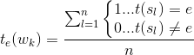
One can interpret this t_{e}(w_{k}) score as the tendency for crowdcoders to interpret the emotion e out of the sentences containing this wk word. This score was used subsequently to determine the optimal sizes of our dictionaries.
Determine the optimal size of the dictionary
The optimal size of the dictionary for each emotion was determined by a threshold of t_{e}(w_{k}). Words with t_{e}(w_{k}) larger than this threshold were included. To determine this threshold, a 10-fold cross validation procedure was conducted. In this procedure, the training set was randomly divided into 10 parts. In ten successions, 9 parts were used to select the optimal threshold and then test on the rest of one part. The evaluation is based on the frequency of sentiment words of each sentence for emotion e, C_{e}(S_{i}), with t_{e}(w_{k}) larger than the threshold and uses that frequency to predict the t(S_{i}). For each part, the threshold with the largest area under the ROC curve for predicting the crowdcoded emotion was selected. The final threshold was the average value from the results from the 10 parts.
Evaluation
Based on the optimized dictionaries created using the previously selected thresholds for t_{e}(w_{k}), the performance of our dictionaries was evaluated with the data from the test set. The aforementioned ROC technique was used. The results from this test-set evaluation were used as indicators of criterion validity of our dictionaries. An area under ROC curve of around 0.5 indicates the dictionary’s inability to distinguish emotion.
Interrater reliabilities between “gold standard” team and crowdcoders on 100 sentences are presented in table I.1. The “gold standard” team and crowdcoders achieved a level of agreement in sentiment coding among each other on par with the previous reported level (Mozetič, Grčar, & Smailović, 2016) with the exception being the Arabic language. As mentioned above, we have launched the crowdcoding exercise of Arabic sentences for three times. The reported value in table I.1 is the best we could obtained.
The criterion validity of our dictionaries (ROC analysis) is presented in table I.2. The English and Turkish dictionaries worked reasonably well in the test set. However, the German and Arabic counterparts worked just slightly better than or similar to chance.
Reasons for such poor performance
We determined that there are several possible reasons for such poor performance. Firstly, crowdcoders coded more latent meanings of words and latent meanings of words are interpreted differently from one person to another, than the “gold standard” team. Secondly, crowdcoders tended to code some motifs as emotional. For example, sentences with vocal criticisms, communications of threat or disgusts were usually coded as angry. Similarly, sentences communicating events turns better were usually coded as joy. These motifs are not always an expression of emotions. It highlights a challenge of using crowdcoding: due to the briefness of the coding instructions, it is difficult to explain to the crowdcoders what should be coded as emotion and what should not. Crowdcoders coded the content mainly by intuition. This discrepancy in coding between those from “gold standard” team and crowdcoders begs the fundamental question of our validation practice: who should we trust to determine the emotions in news? The untrained general public -- those similar to the crowdcoders on the crowdsourcing platforms-- or knowledgable people such as the members of the “gold standard” team. Should we trust the emotions in text determined by guided instructions or intuition? Previous best practice paper suggests the latter (Lind, Gruber & Boomgaarden, 2017). We don’t have definitive answers to these questions.
There are additional challenges with this crowdcoding approach. Previous methodological papers on crowdcoding include only one Indo-European language, either English or German (e.g. Benoit et al. 2016; Haselmayer & Jenny 2017; Lind, Gruber & Boomgaarden, 2017). Whether or not multilingual materials should use the same protocol for all languages remains an open question. Our failure to generate a usable Arabic dictionary in our second run highlights the difficulty of using a universal protocol for all languages. Some methodological deviations might be needed as there are fundamental differences between Semitic languages and other languages (Masrai & Milton, 2016). Another challenge is the occurrence of bots. It is an open secret that bots are threatening the validity of scientific studies involving crowdsourcing (Dreyfuss 2018). We observed bot-like activities in our German and Arabic crowdcoding tasks, e.g. some crowdcoders coded all sentences with the same answer. We have monitored these abnormal activities during the crowdcoding tasks and manually removed the codings from these bots, as per Lind, Gruber & Boomgaarden (2017). However, we cannot guarantee that the codings are completely free of bots’ influence. These bots are not only wasting our money but also require attention to control. Our experience with crowdcoding contradicts with the previous positive experience of applying crowdsourcing in scientific studies, e.g. “cheap, fast and good” (Snow et al. 2008) and “reproducible and agile” (Benoit et al. 2016). Instead, we suggest further studies should use crowdcoding sparingly in multilingual situations.

References
Backfried, G., & Shalunts, G. (2016). Sentiment Analysis of Media in German on the Refugee Crisis in Europe. In P. Díaz, N. Bellamine Ben Saoud, J. Dugdale, & C. Hanachi (Eds.), Information Systems for Crisis Response and Management in Mediterranean Countries (pp. 234–241). Springer International Publishing.
Benoit, K., Conway, D., Lauderdale, B. E., Laver, M., & Mikhaylov, S. (2016). Crowd-sourced Text Analysis: Reproducible and Agile Production of Political Data. American Political Science Review, 110(2), 278–295. https://doi.org/10.1017/S0003055416000058
Diesner, J., & Evans, C. S. (2015). Little Bad Concerns: Using Sentiment Analysis to Assess Structural Balance in Communication Networks. In Proceedings of the 2015 IEEE/ACM International Conference on Advances in Social Networks Analysis and Mining 2015 (pp. 342–348). New York, NY, USA: ACM.
Dreyfuss, E. (2018). A BOT PANIC HITS AMAZON'S MECHANICAL TURK. WIRED. https://www.wired.com/story/amazon-mechanical-turk-bot-panic/
González-Bailón, S., & Paltoglou, G. (2015). Signals of Public Opinion in Online Communication: A Comparison of Methods and Data Sources. The ANNALS of the American Academy of Political and Social Science, 659(1), 95–107. https://doi.org/10.1177/0002716215569192
Graham, J., Haidt, J., & Nosek, B. A. (2009). Liberals and conservatives rely on different sets of moral foundations. Journal of Personality and Social Psychology, 96(5), 1029.
Grimmer, J., & Stewart, B. M. (2013). Text as Data: The Promise and Pitfalls of Automatic Content Analysis Methods for Political Texts. Political Analysis, 21(3), 267–297.
Haselmayer, M., & Jenny, M. (2017). Sentiment analysis of political communication: combining a dictionary approach with crowdcoding. Quality & Quantity, 51(6), 2623–2646.
Lind, F., Eberl, J.-M., Heidenreich, T., Boomgaarden, H. G., Montero, E. L. G., Herrero, B., & Berganza, R. (2018). Multilingual Dictionary Construction: A Roadmap to Measuring Migration Frames in European Media Discourse. Presented at the 68th annual conference of the International Communication Association, Prague.
Lind, F., Gruber, M., & Boomgaarden, H. G. (2017). Content analysis by the crowd: Assessing the usability of crowdsourcing for coding latent constructs. Communication methods and measures, 11(3), 191-209.
Masrai, A., & Milton, J. (2016). How different is Arabic from other languages? The relationship between word frequency and lexical coverage. Journal of Applied Linguistics and Language Research, 3(1), 15-35.
Mohammad, S. M., & Turney, P. D. (2013). Crowdsourcing a word–emotion association lexicon. Computational Intelligence, 29(3), 436–465.
Mozetič, I., Grčar, M., & Smailović, J. (2016). Multilingual Twitter sentiment classification: The role of human annotators. PloS One, 11(5), e0155036.
Mullen, L. A., Benoit, K., Keyes, O., Selivanov, D., & Arnold, J. (2018). Fast, Consistent Tokenization of Natural Language Text. Journal of Open Source Software, 3(23), 655.
Puschmann, C., & Powell, A. (2018). Turning Words Into Consumer Preferences: How Sentiment Analysis Is Framed in Research and the News Media. Social Media + Society, 4(3), 2056305118797724. https://doi.org/10.1177/2056305118797724
Ribeiro, F. N., Araújo, M., Gonçalves, P., Gonçalves, M. A., & Benevenuto, F. (2016). SentiBench - a benchmark comparison of state-of-the-practice sentiment analysis methods. EPJ Data Science, 5(1), 23. https://doi.org/10.1140/epjds/s13688-016-0085-1
Rouse, S. V. (2015). A reliability analysis of Mechanical Turk data. Computers in Human Behavior, 43, 304–307. https://doi.org/10.1016/j.chb.2014.11.004
Snow, R., O'Connor, B., Jurafsky, D., & Ng, A. Y. (2008, October). Cheap and fast---but is it good?: evaluating non-expert annotations for natural language tasks. In Proceedings of the conference on empirical methods in natural language processing (pp. 254-263). Association for Computational Linguistics.
Straka, M., & Straková, J. (2017). Tokenizing, pos tagging, lemmatizing and parsing ud 2.0 with udpipe. Proceedings of the CoNLL 2017 Shared Task: Multilingual Parsing from Raw Text to Universal Dependencies, 88–99.
Tausczik, Y. R., & Pennebaker, J. W. (2010). The Psychological Meaning of Words: LIWC and Computerized Text Analysis Methods. Journal of Language and Social Psychology, 29(1), 24–54. https://doi.org/10.1177/0261927X09351676
Young, L., & Soroka, S. (2012). Affective News: The Automated Coding of Sentiment in Political Texts. Political Communication, 29(2), 205–231. https://doi.org/10.1080/10584609.2012.671234

Table I.1
Interrater reliabilities between gold standard and crowdcoders
 | α | κ | π
English | 0.710 | 0.880 | 0.856
German | 0.447 | 0.840 | 0.808
Turkish | 0.432 | 0.760 | 0.712
Arabic | 0.156 | 0.610 | 0.532
α: Krippendroff’s alpha; κ: Brennan-Prediger’s Kappa; π: raw agreement
Higher value indicates higher interrater reliability

Table I.2
Criterion validity of the 4 dictionaries: area under ROC curve
 | Fear | Joy | Sadness | Anger | Pity
English
Training | 0.88 | 0.88 | 0.80 | 0.75 | 0.86
Testing | 0.69 | 0.45 | 0.54 | 0.54 | 0.48
German
Training | 0.86 | 0.91 | 0.89 | 0.87 | 0.98
Testing | 0.54 | 0.53 | 0.58 | 0.45 | 0.63
Turkish
Training | 0.890 | 0.861 | 0.908 | 0.825 | 0.783
Testing | 0.652 | 0.535 | 0.740 | 0.586 | 0.746
Arabic
Training | 0.892 | 0.891 | 0.822 | 0.815 | 0.910
Test | 0.542 | 0.550 | 0.556 | 0.552 | 0.485

Higher value indicates better prediction accuracy. Values equal to 0.5 indicate the prediction accuracy is not better than random guess.

Appendix II
Keywords used to identify topics
Language | Terrorism (T) | Muslim (M) | Refugees (R)
English | terroris[tm]|terror attack | muslim|islam | refugee
German | terror* | muslim|moslem|islam|mohammedaner | fl[uü]cht*
Turkish | [tT]erörizm|[Tt]erörist|[tT]erör saldırısı|[tT]erör saldırıları | [İIiı]sl[âa]m|[Mm]üslüman | [Mm]ülteci|[Mm]uhacir|[Ss]ığınan kimse
Lebanese Arabic | يباهرإ|يباهرإ مكح|باهرإلا نع ئشان رعذ|باهرإئجال | مالسإلا|ملسم | ذئاللا|رجّهم|نيبراه|براه|نيرجاهم|نيرجهم|رجاهم|نيحزان|نيئجال|حزان|ئجال

Appendix III: English coding instructions

In this job, you will be presented with sentences extracted from news coverage. Read the sentences carefully. For each sentence, please answer two questions.

Question 1
Please determine whether the sentence expresses one of the following five emotions: fear, joy, sadness, anger and pity. Please consider only the actual content of the sentence! Stay impartial, your personal preferences towards persons or organizations should not influence your decisions. If the sentence expresses more than one emotion, please select the dominant one.

Examples:

Sentence | Answer
The U.S. issued a dire warning to its citizens on Saturday about “credible threats” to tourist areas in Turkey. | This sentence expresses fear
“This ruling is a big victory for Iowa women,” she said. | This sentence expresses joy
She is, instead, suffering, just as he is -- from disappointment and abandonment. | This sentence expresses sadness
The San Bernardino shooters were still at large, but our shameful president was trying to gain from the tragedy. | This sentence expresses anger
Singapore has expressed its deepest condolences to the bereaved families and wished the injured a quick recovery. | This sentence expresses pity
A former journalist has announced that she will run for the Senate. | This sentence expresses none of the five emotions
The perpetrator publicly accused her of burning the Koran and activists were afraid that religious leaders would obstruct the investigation. | There is a hint of anger in the first part of this sentence. But the dominant emotion is fear as expressed in the second part of the sentence.

Question 2
Please determine whether the sentence contains text unrelated to the sentence’s meaning, such as photo captions, meta-information from social network sites, links to related stories, URLs and HTML code.

Examples:

Sentence | Answer
AFP PHOTO/ MANDEL NGAN (Photo credit should read MANDEL NGAN/AFP/Getty Images) CBS News Congressional Correspondent Nancy Cordes wait for the beginning of a presidential debate on November 14, 2015 in Iowa. | Yes (Photo caption)
This horrifying shooting comes just one day after singer Christina Grimmie was fatally shot at an Orlando concert. [image via screengrab] | Yes (Photo caption)
Full story Why markets are partying while the world burns: The world is staggering through a chaotic month. | Yes (“Full story” is possibly a link.)
ET 29 COMMENTS ISTANBUL—Israel and Turkey are poised to re-establish diplomatic ties after years of tense relations. | Yes (“ET 29 COMMENTS” is possibly social media-related information)
ims=tzrwu&utm_campaign=Infowars+Placement&utm_source=Infowars.com&utm_medium=Widget&utm_content=Brain+Force Anthroplex 39.95 29.95 Introducing Anthroplex, the twice daily pill foundation for men. http://www.infowars.com/wp-content/uploads/2016/02/anthroplex-200.jpg http://www.infowarsstore.com/health-and-wellness/infowars-life/anthroplex.html? | Yes (URLs / HTML code)
Related Story: France aims to ease religious fears after jihadists kill priest Pope Francis has walked silently through the main gate of Auschwitz, beginning a historic visit to the former Nazi death camp. | Yes (Link to related story)
A former journalist has announced that she will run for the Senate. | No

Thank you for your contribution!
----

Read the sentence below

[sentence]

Which emotion is expressed in this sentence?
O fear (1)
O joy (2)
O sadness (3)
O anger (4)
O pity (5)
O none of the above (0)

Does this sentence contain text unrelated to the sentence’s meaning?
O Yes (1)
O No (0)

Appendix IV: Additional analysis
Figure IV.1: Religion-specific variations in emotions by topics: relative risk, a) joy, b) sadness, c) anger, d) pity
a) Joy
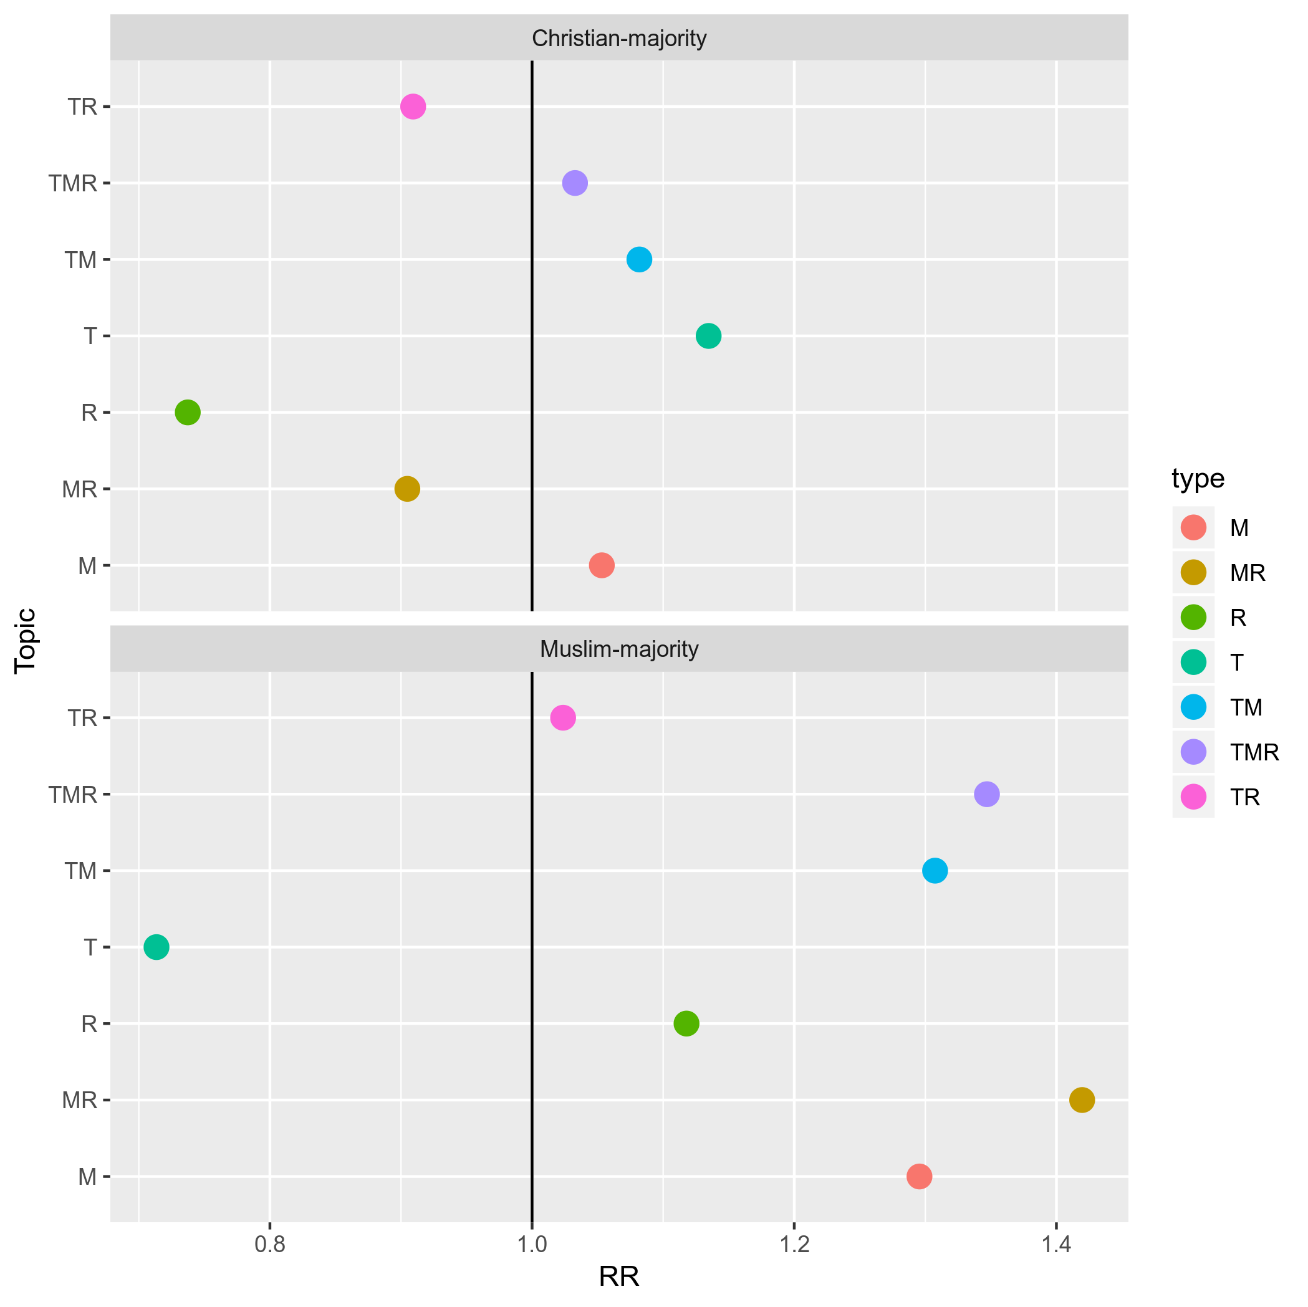
b) Sadness
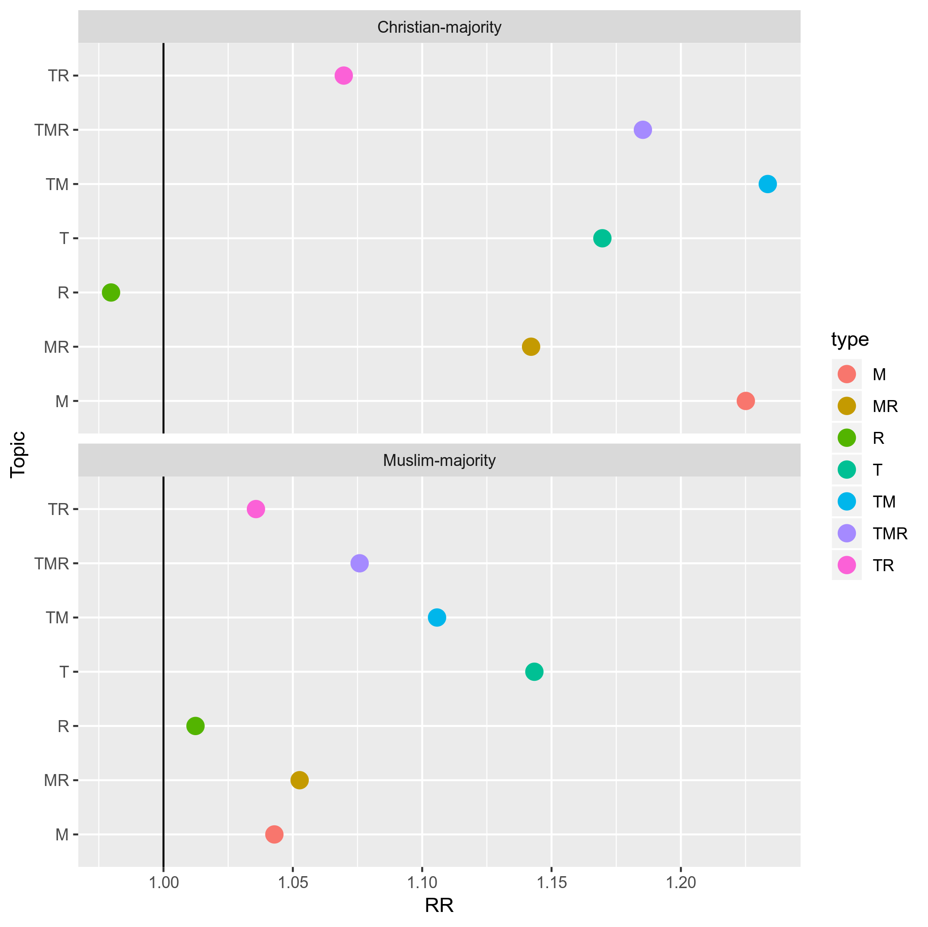
c) Anger
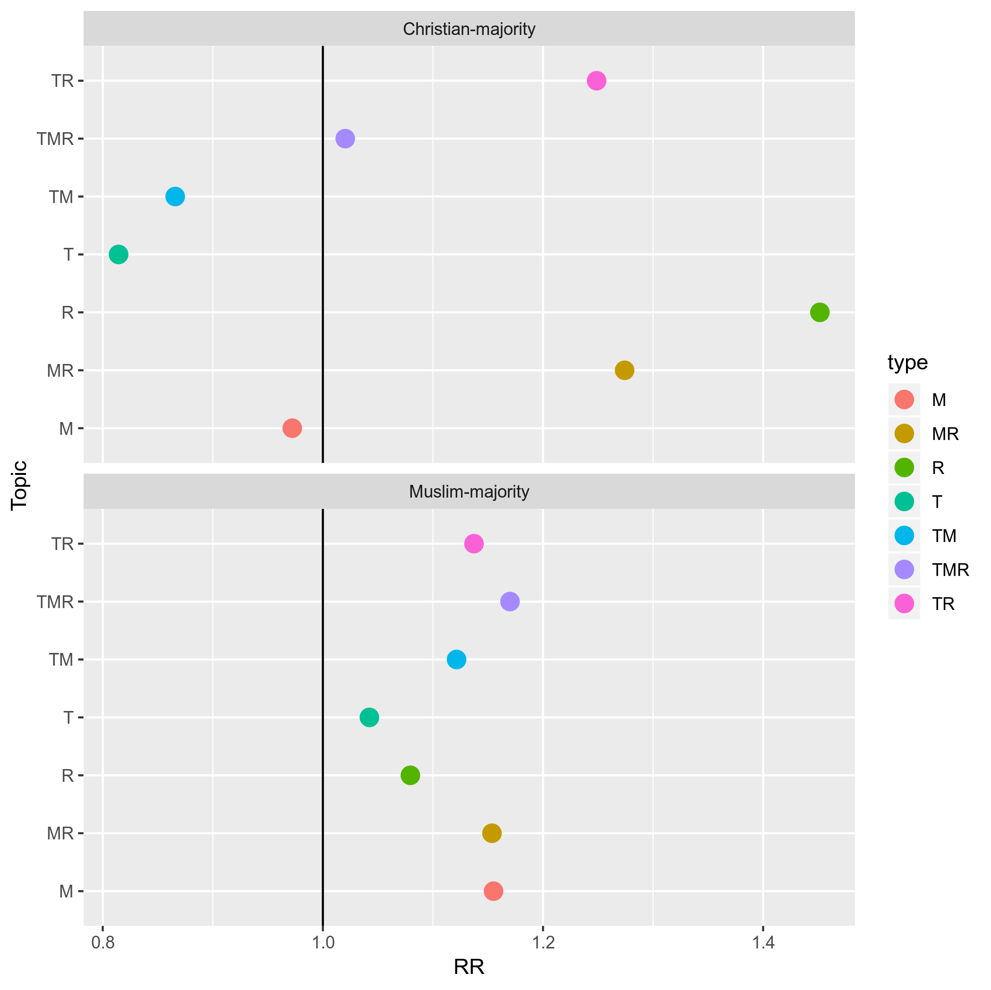
d) Pity
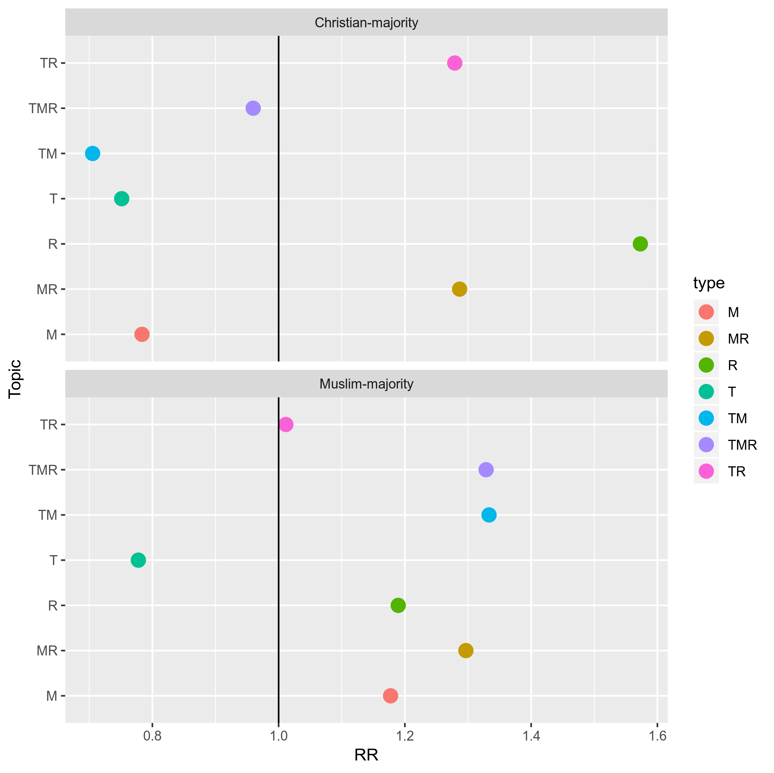
RR: Relative risk, a higher value indicates more likely to occur than controls and vice versa.

Figure IV.2: Relevance-specific variations in emotions by topics: relative risk, a) joy, b) sadness, c) anger, d) pity
a) Joy
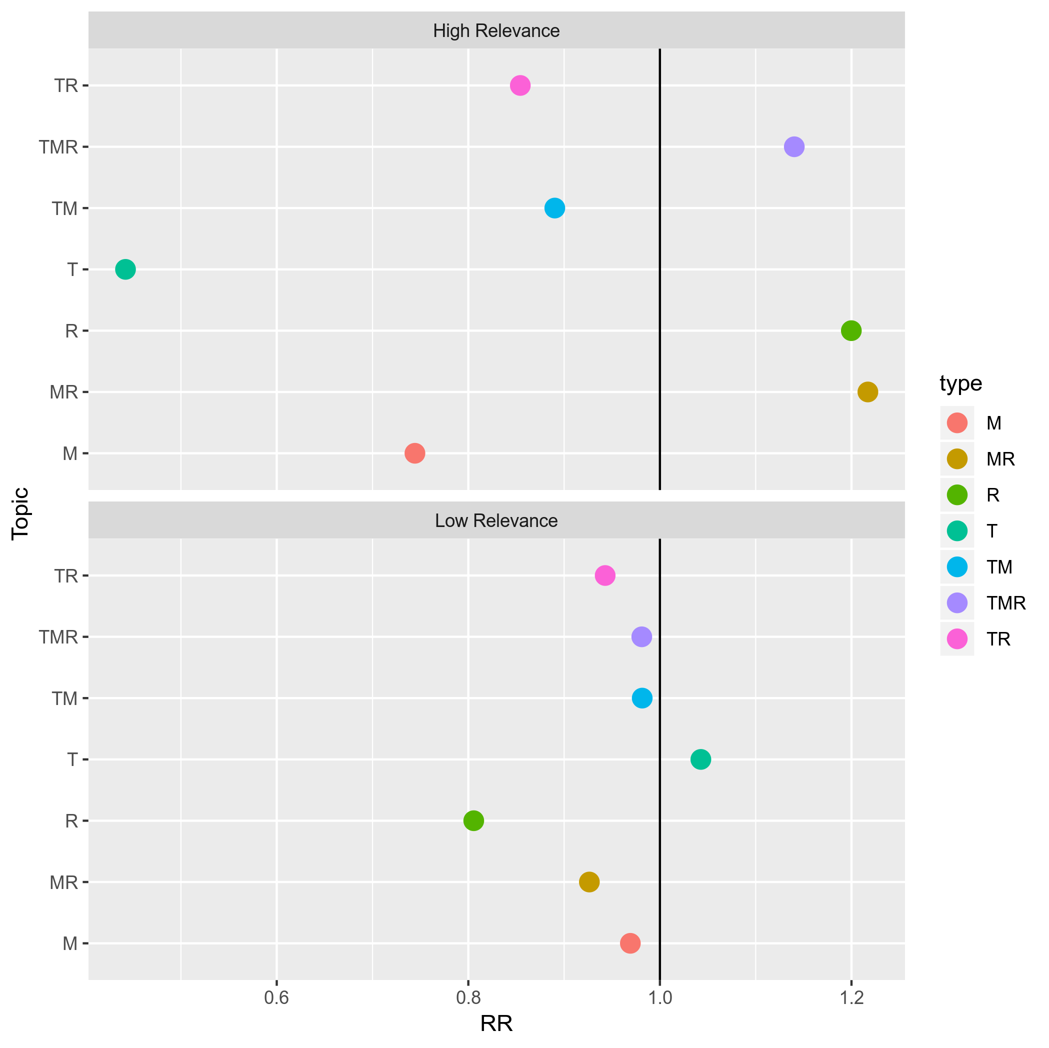
b) Sadness
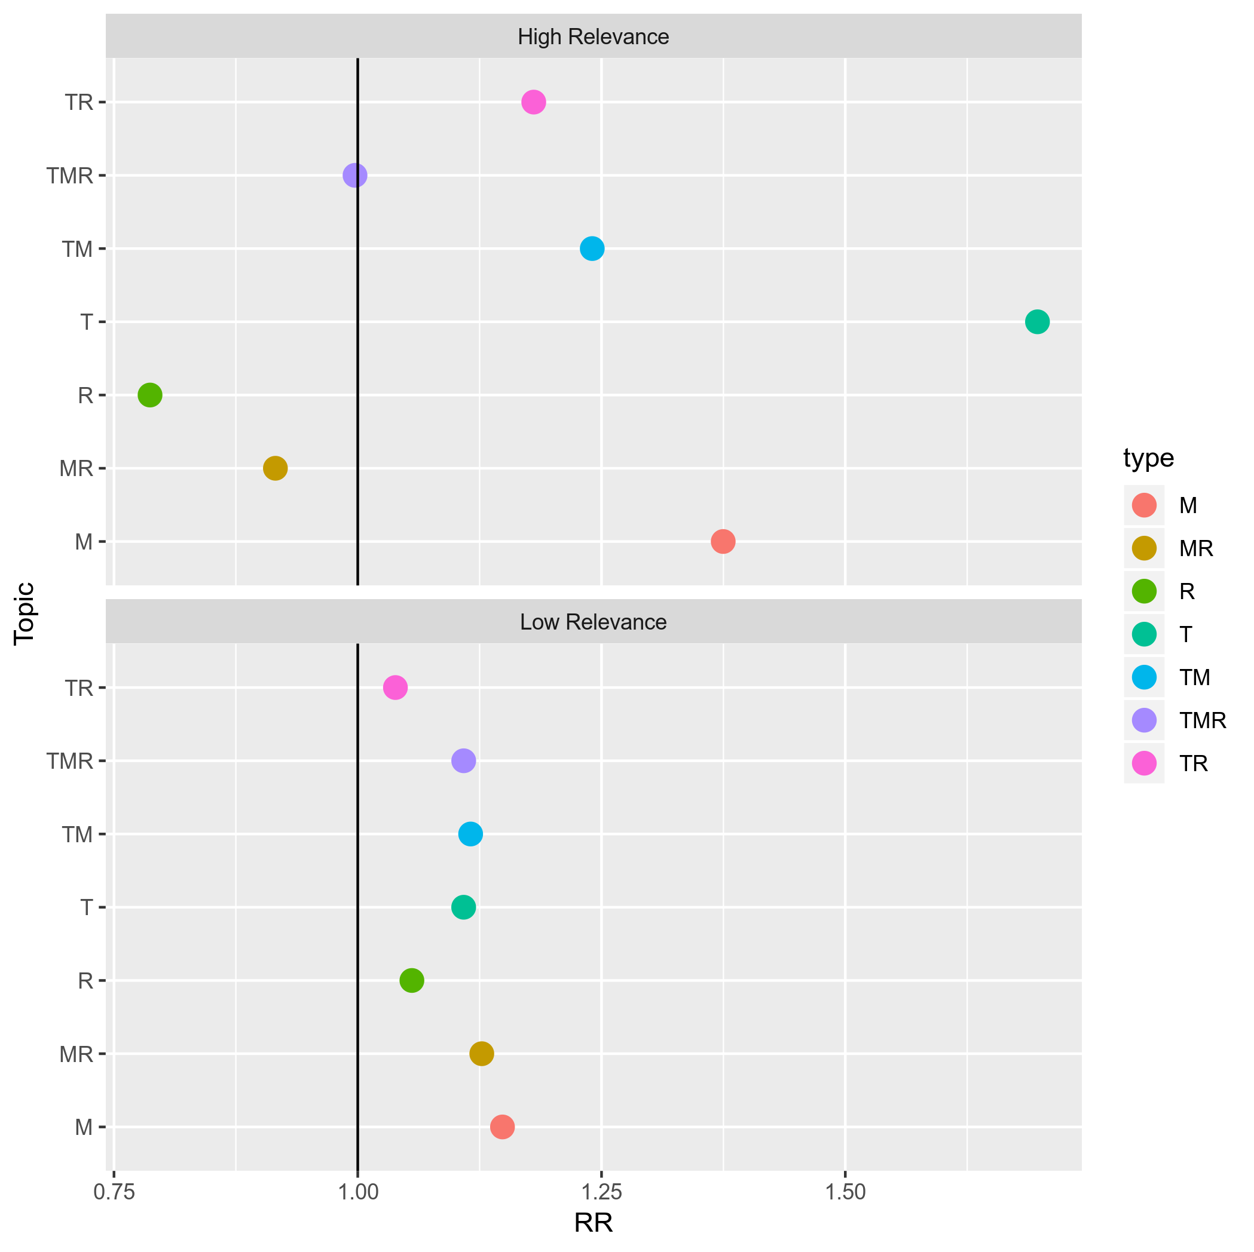
c) Anger
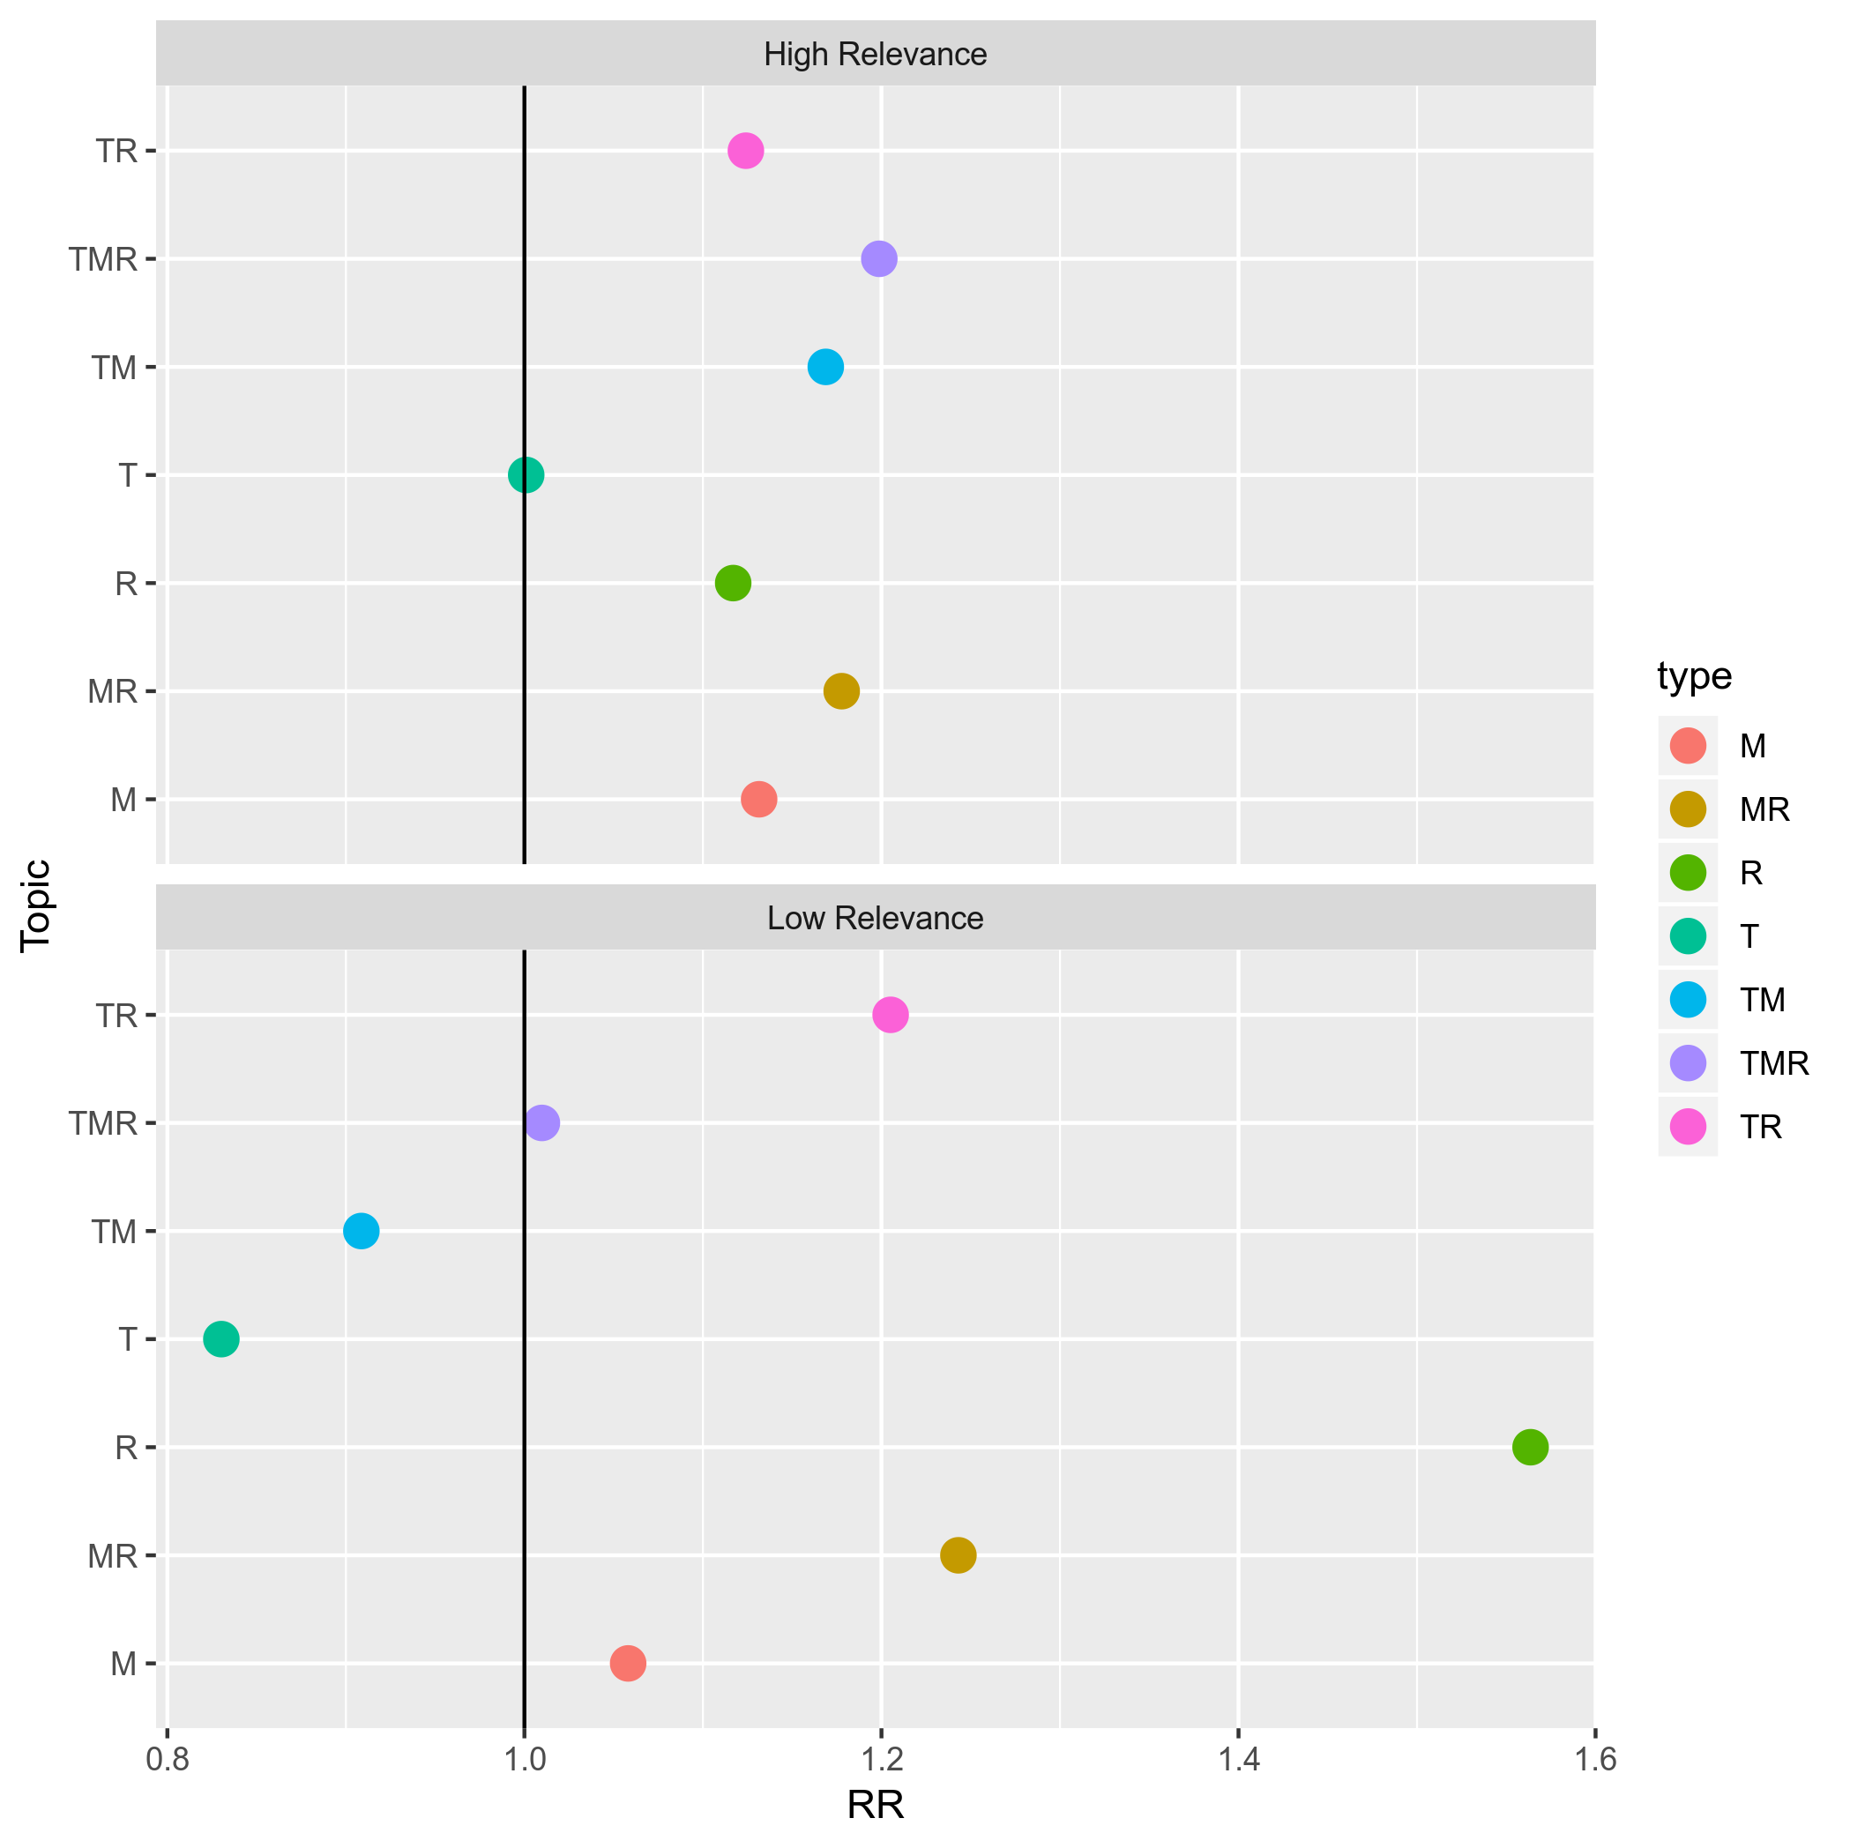
d) Pity
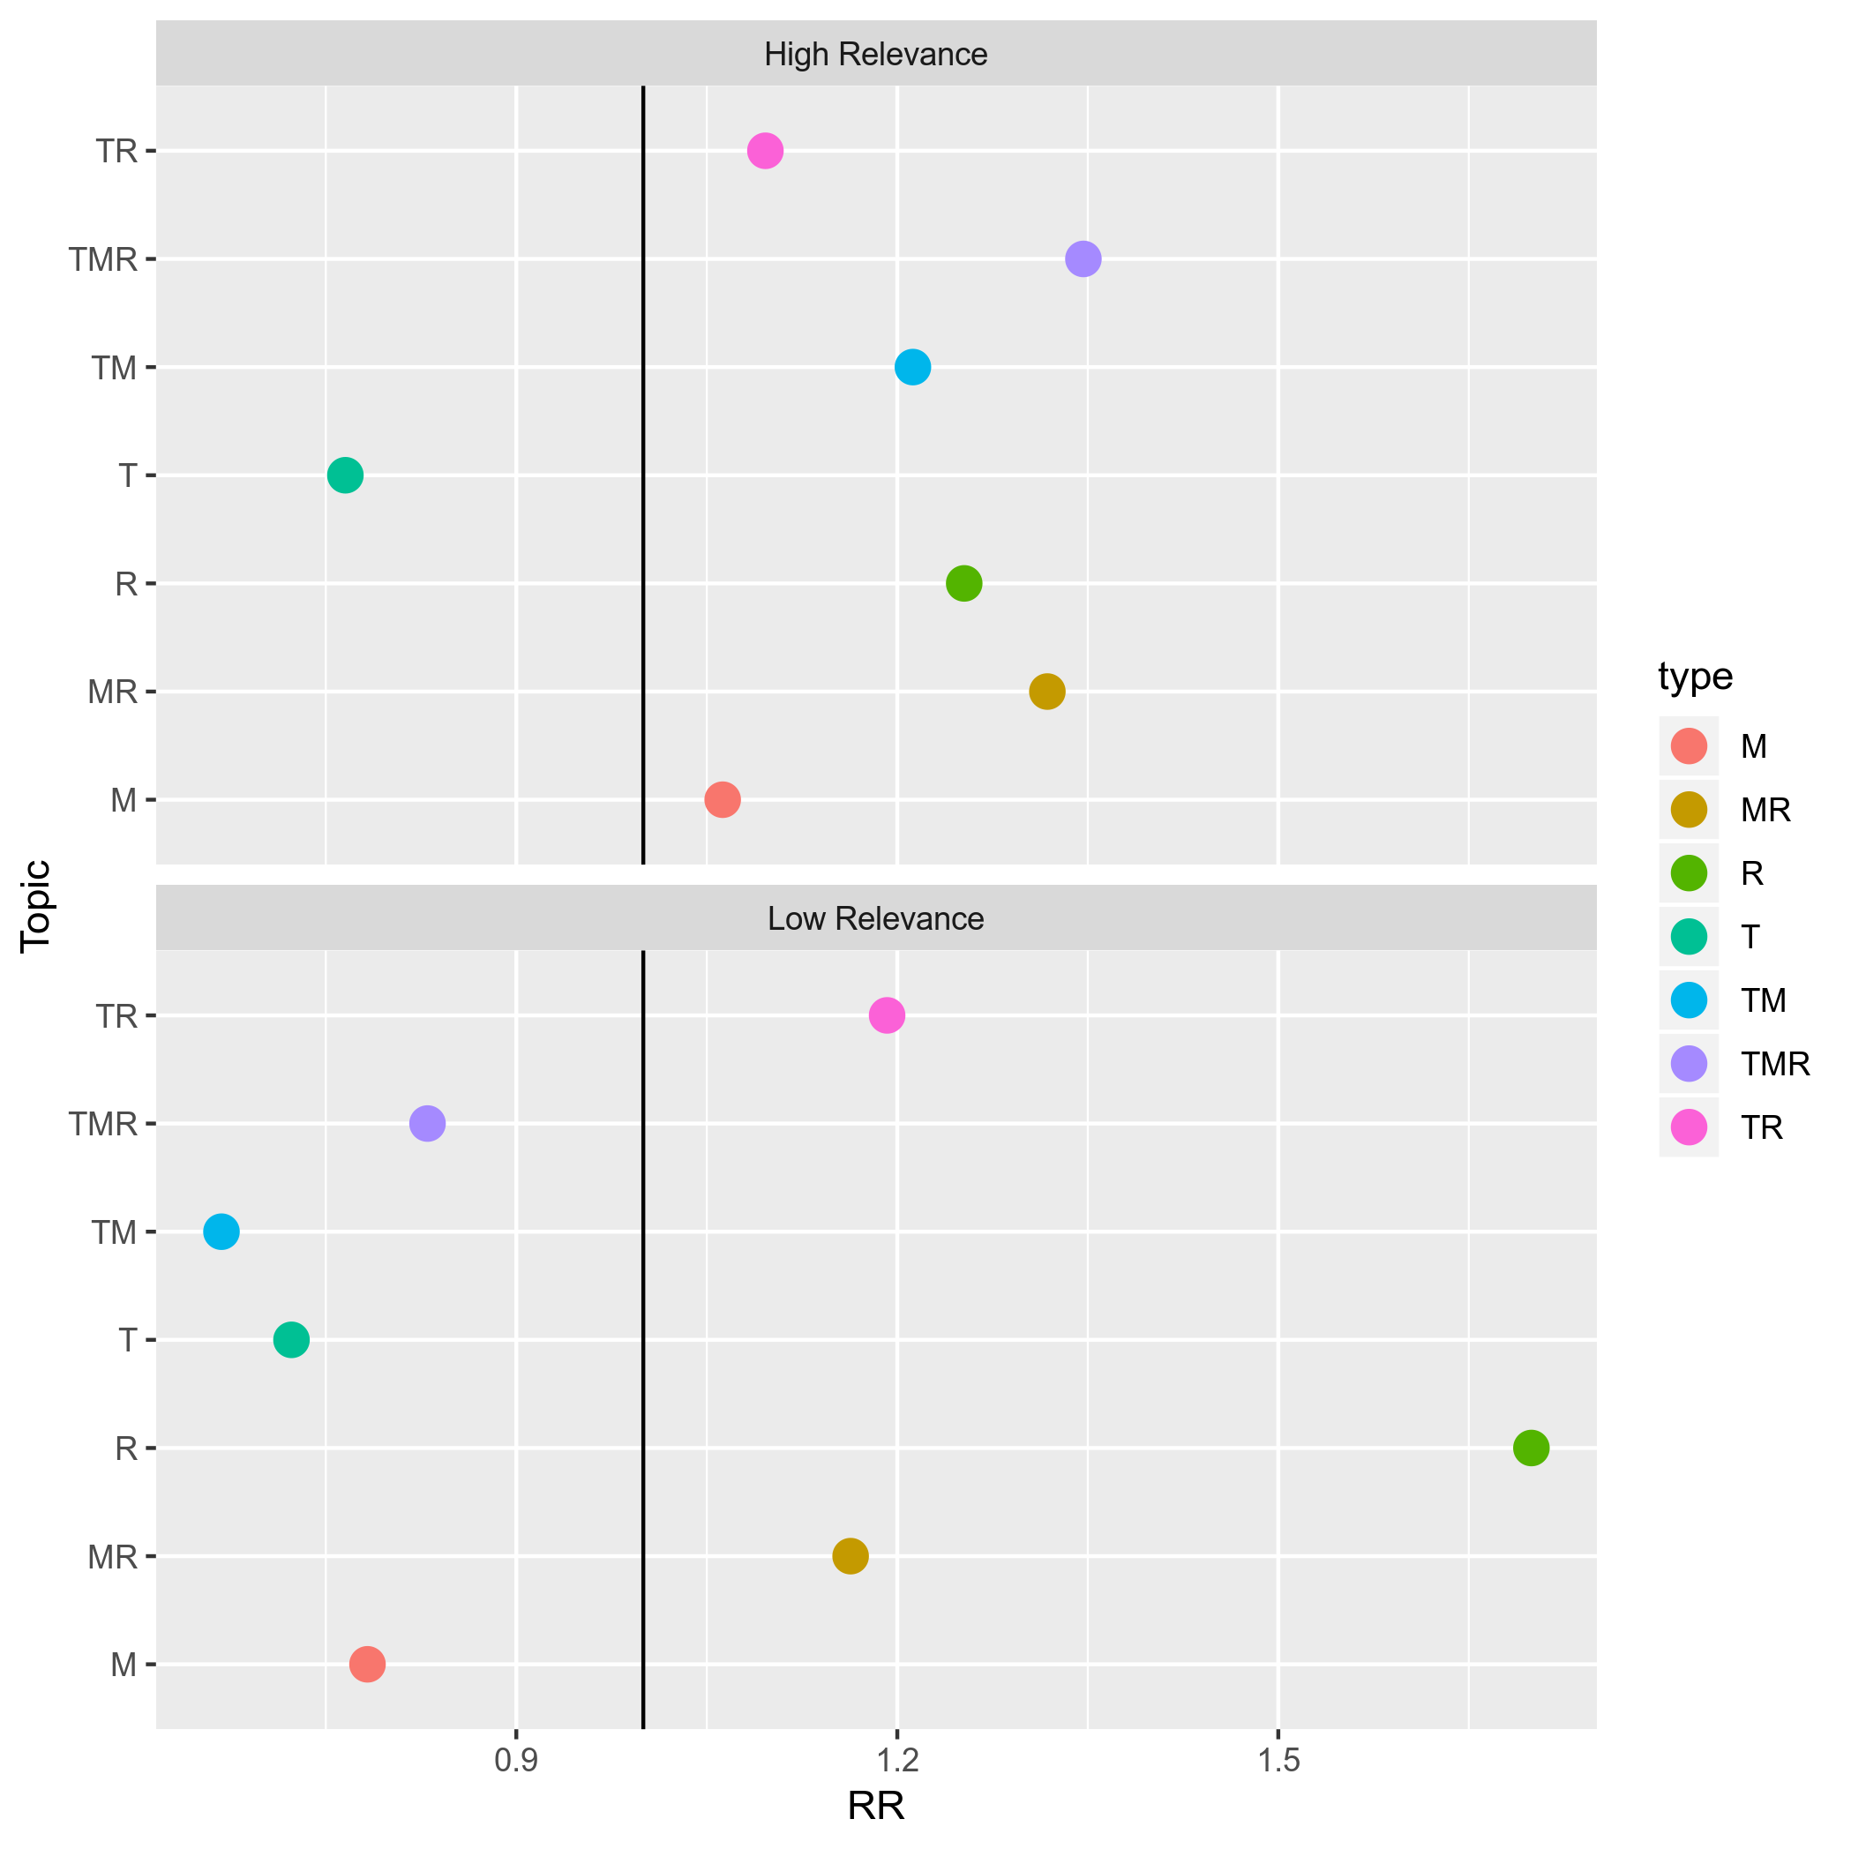
RR: Relative risk, a higher value indicates more likely to occur than controls and vice versa.
Figure IV.3: Ideology-specific variations in emotions by topics: relative risk, a) joy, b) sadness, c) anger, d) pity
a) Joy
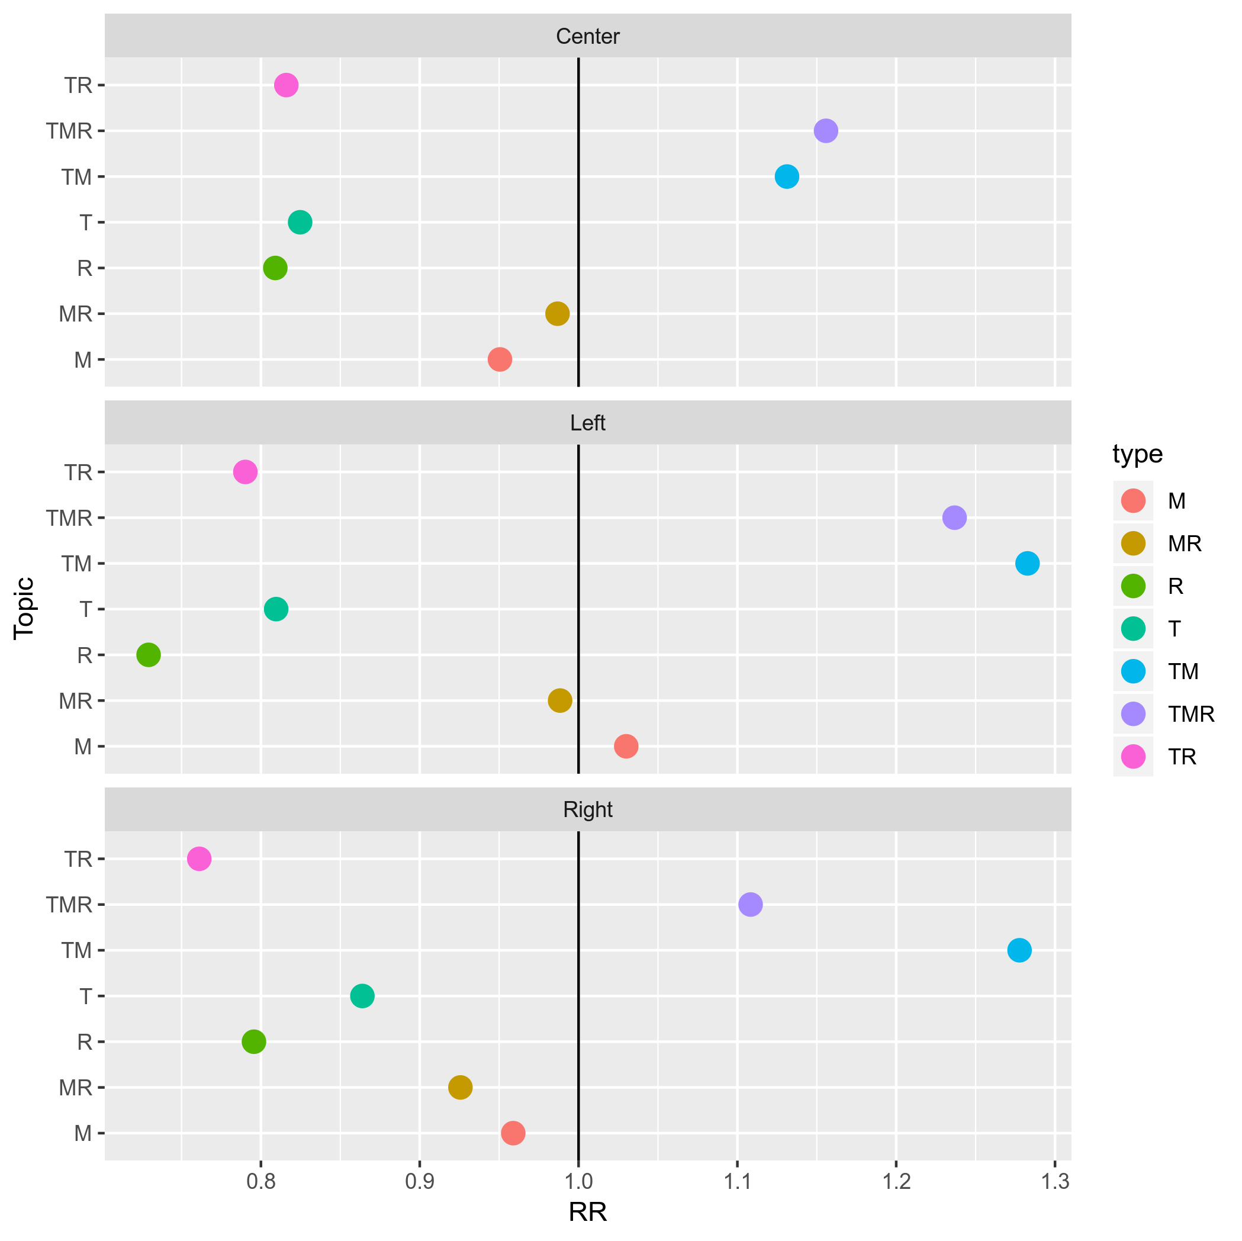
b) Sadness
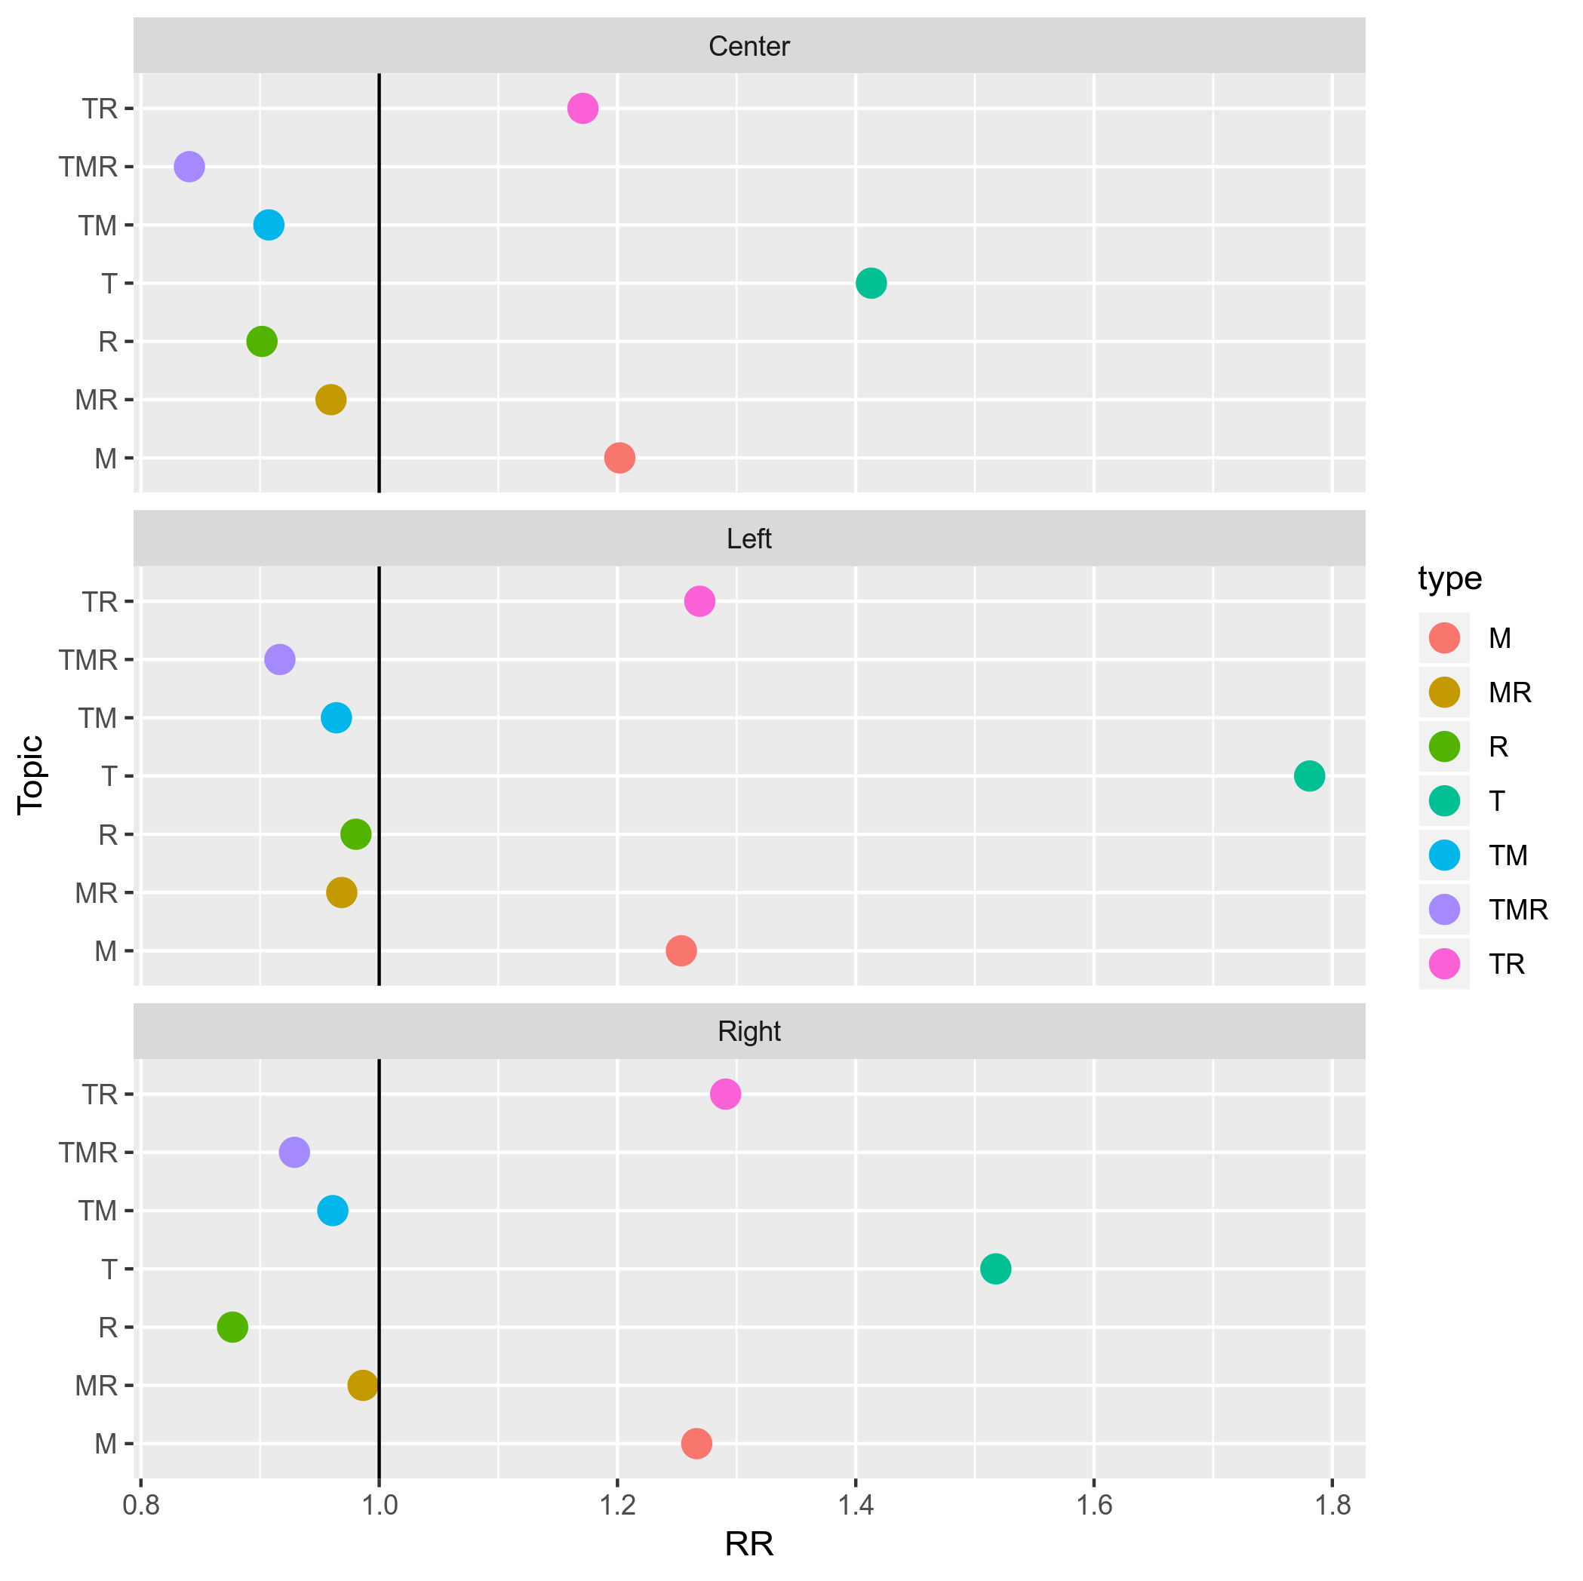
c) Anger
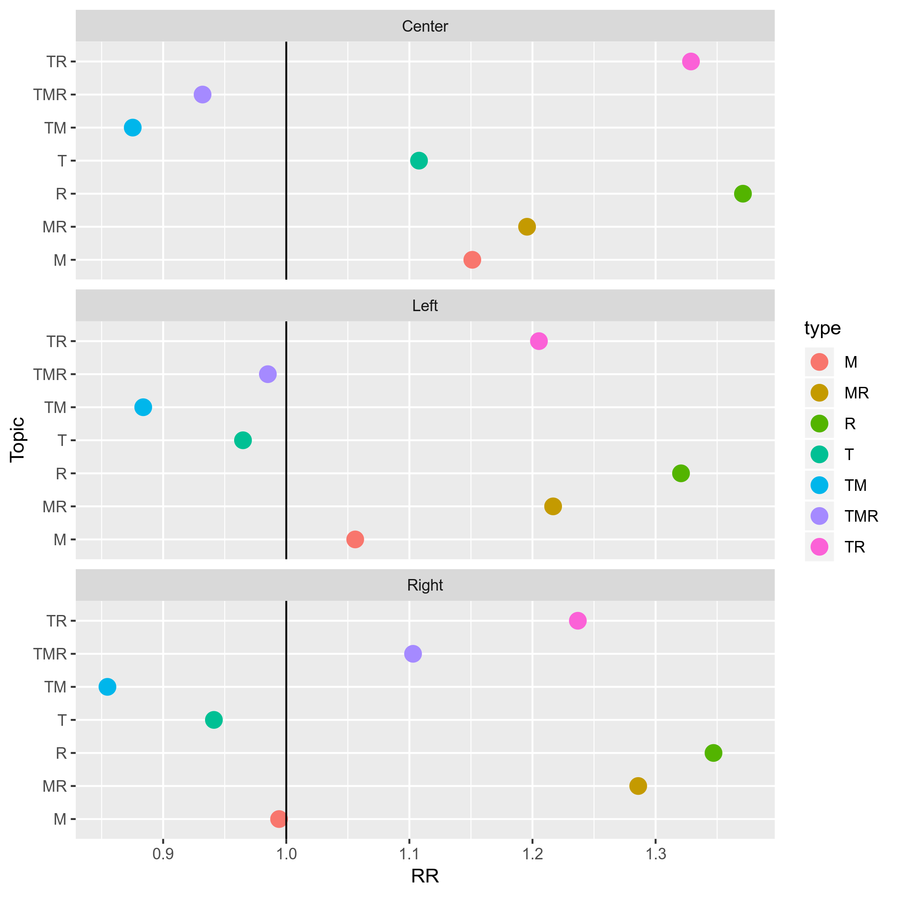
d) Pity
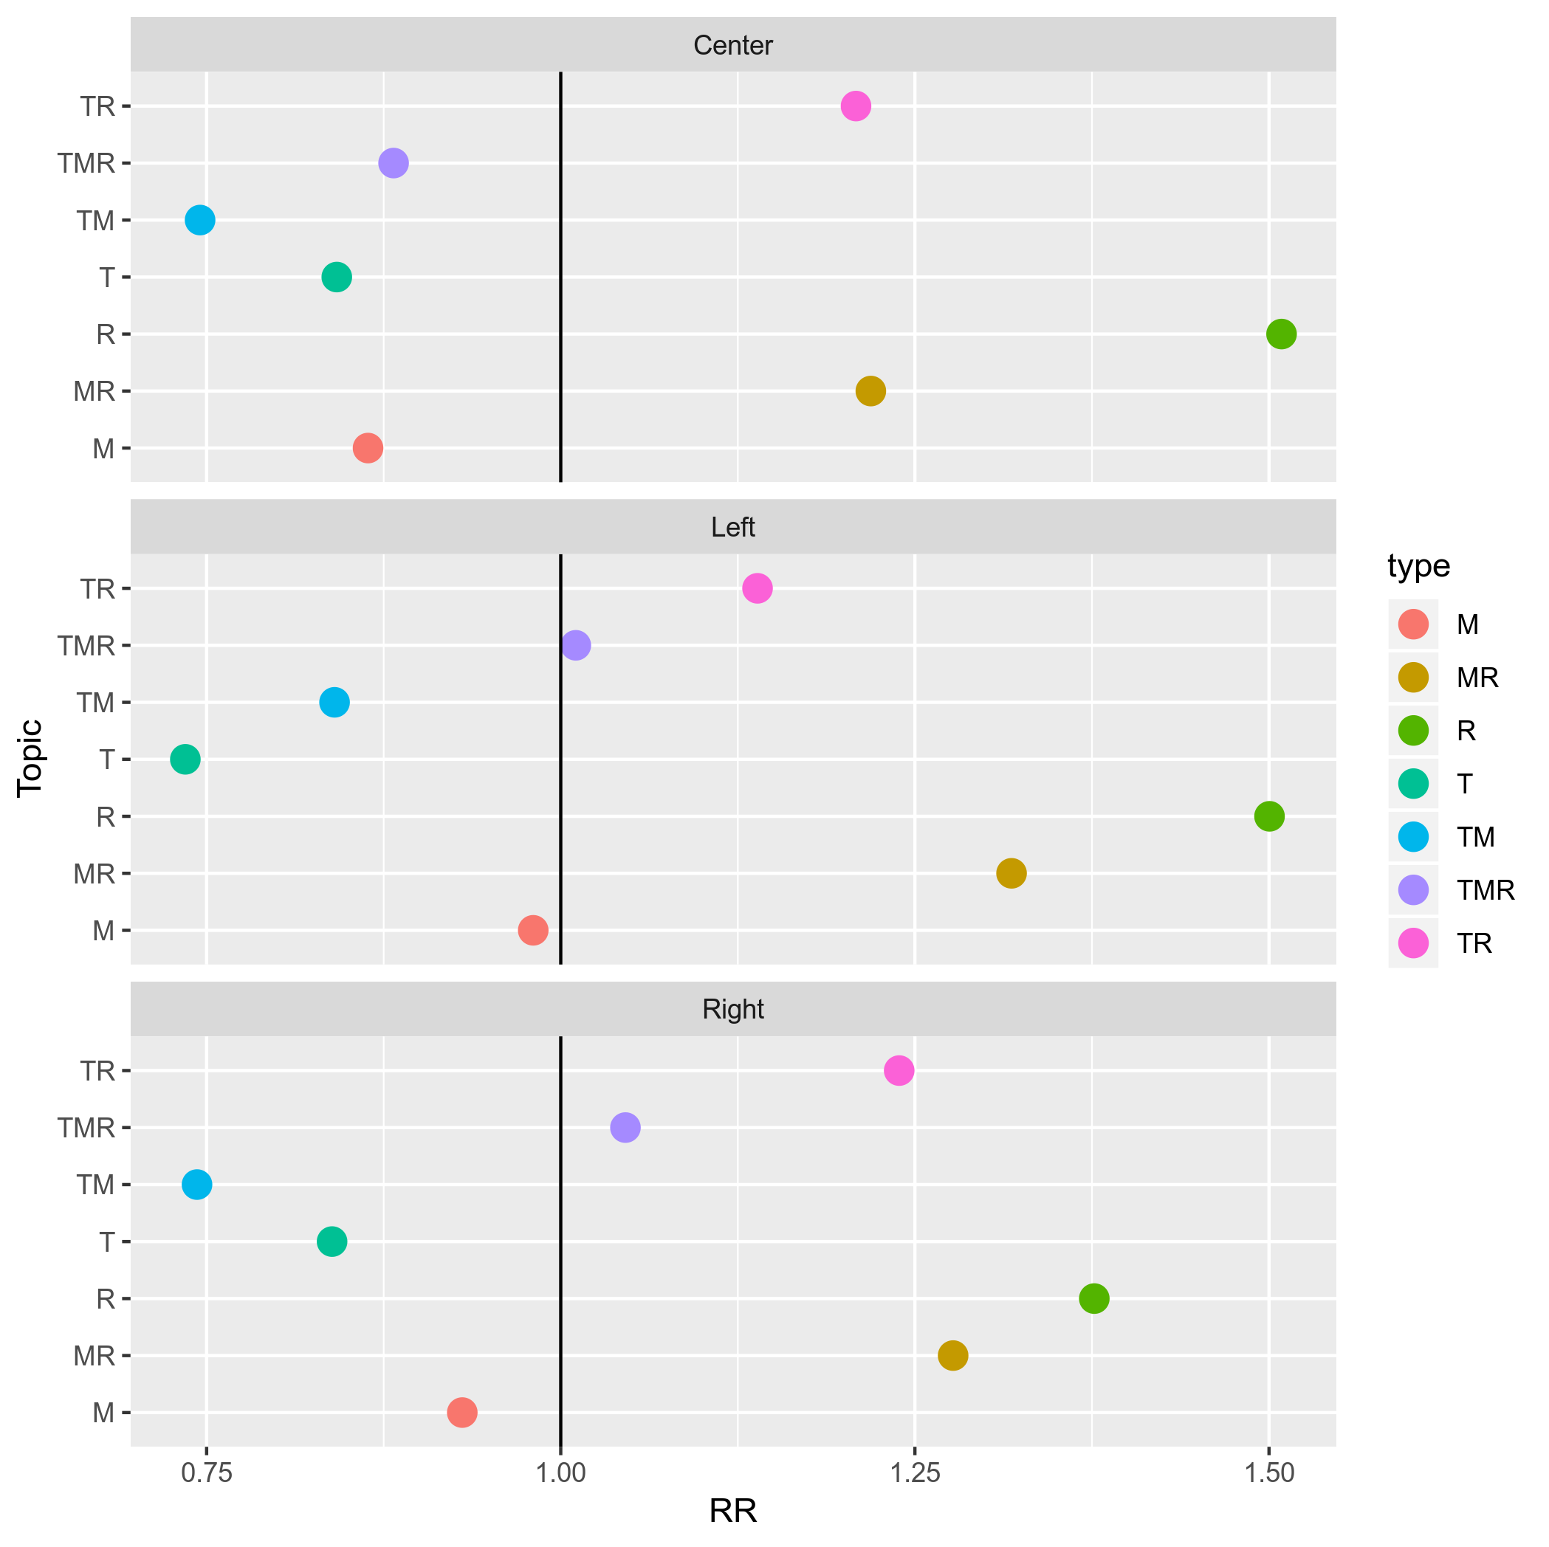
RR: Relative risk, a higher value indicates more likely to occur than controls and vice versa.
Figure IV.4: Country-specific variations in emotions by topics: relative risk, a) joy, b) sadness, c) anger, d) pity
a) Joy
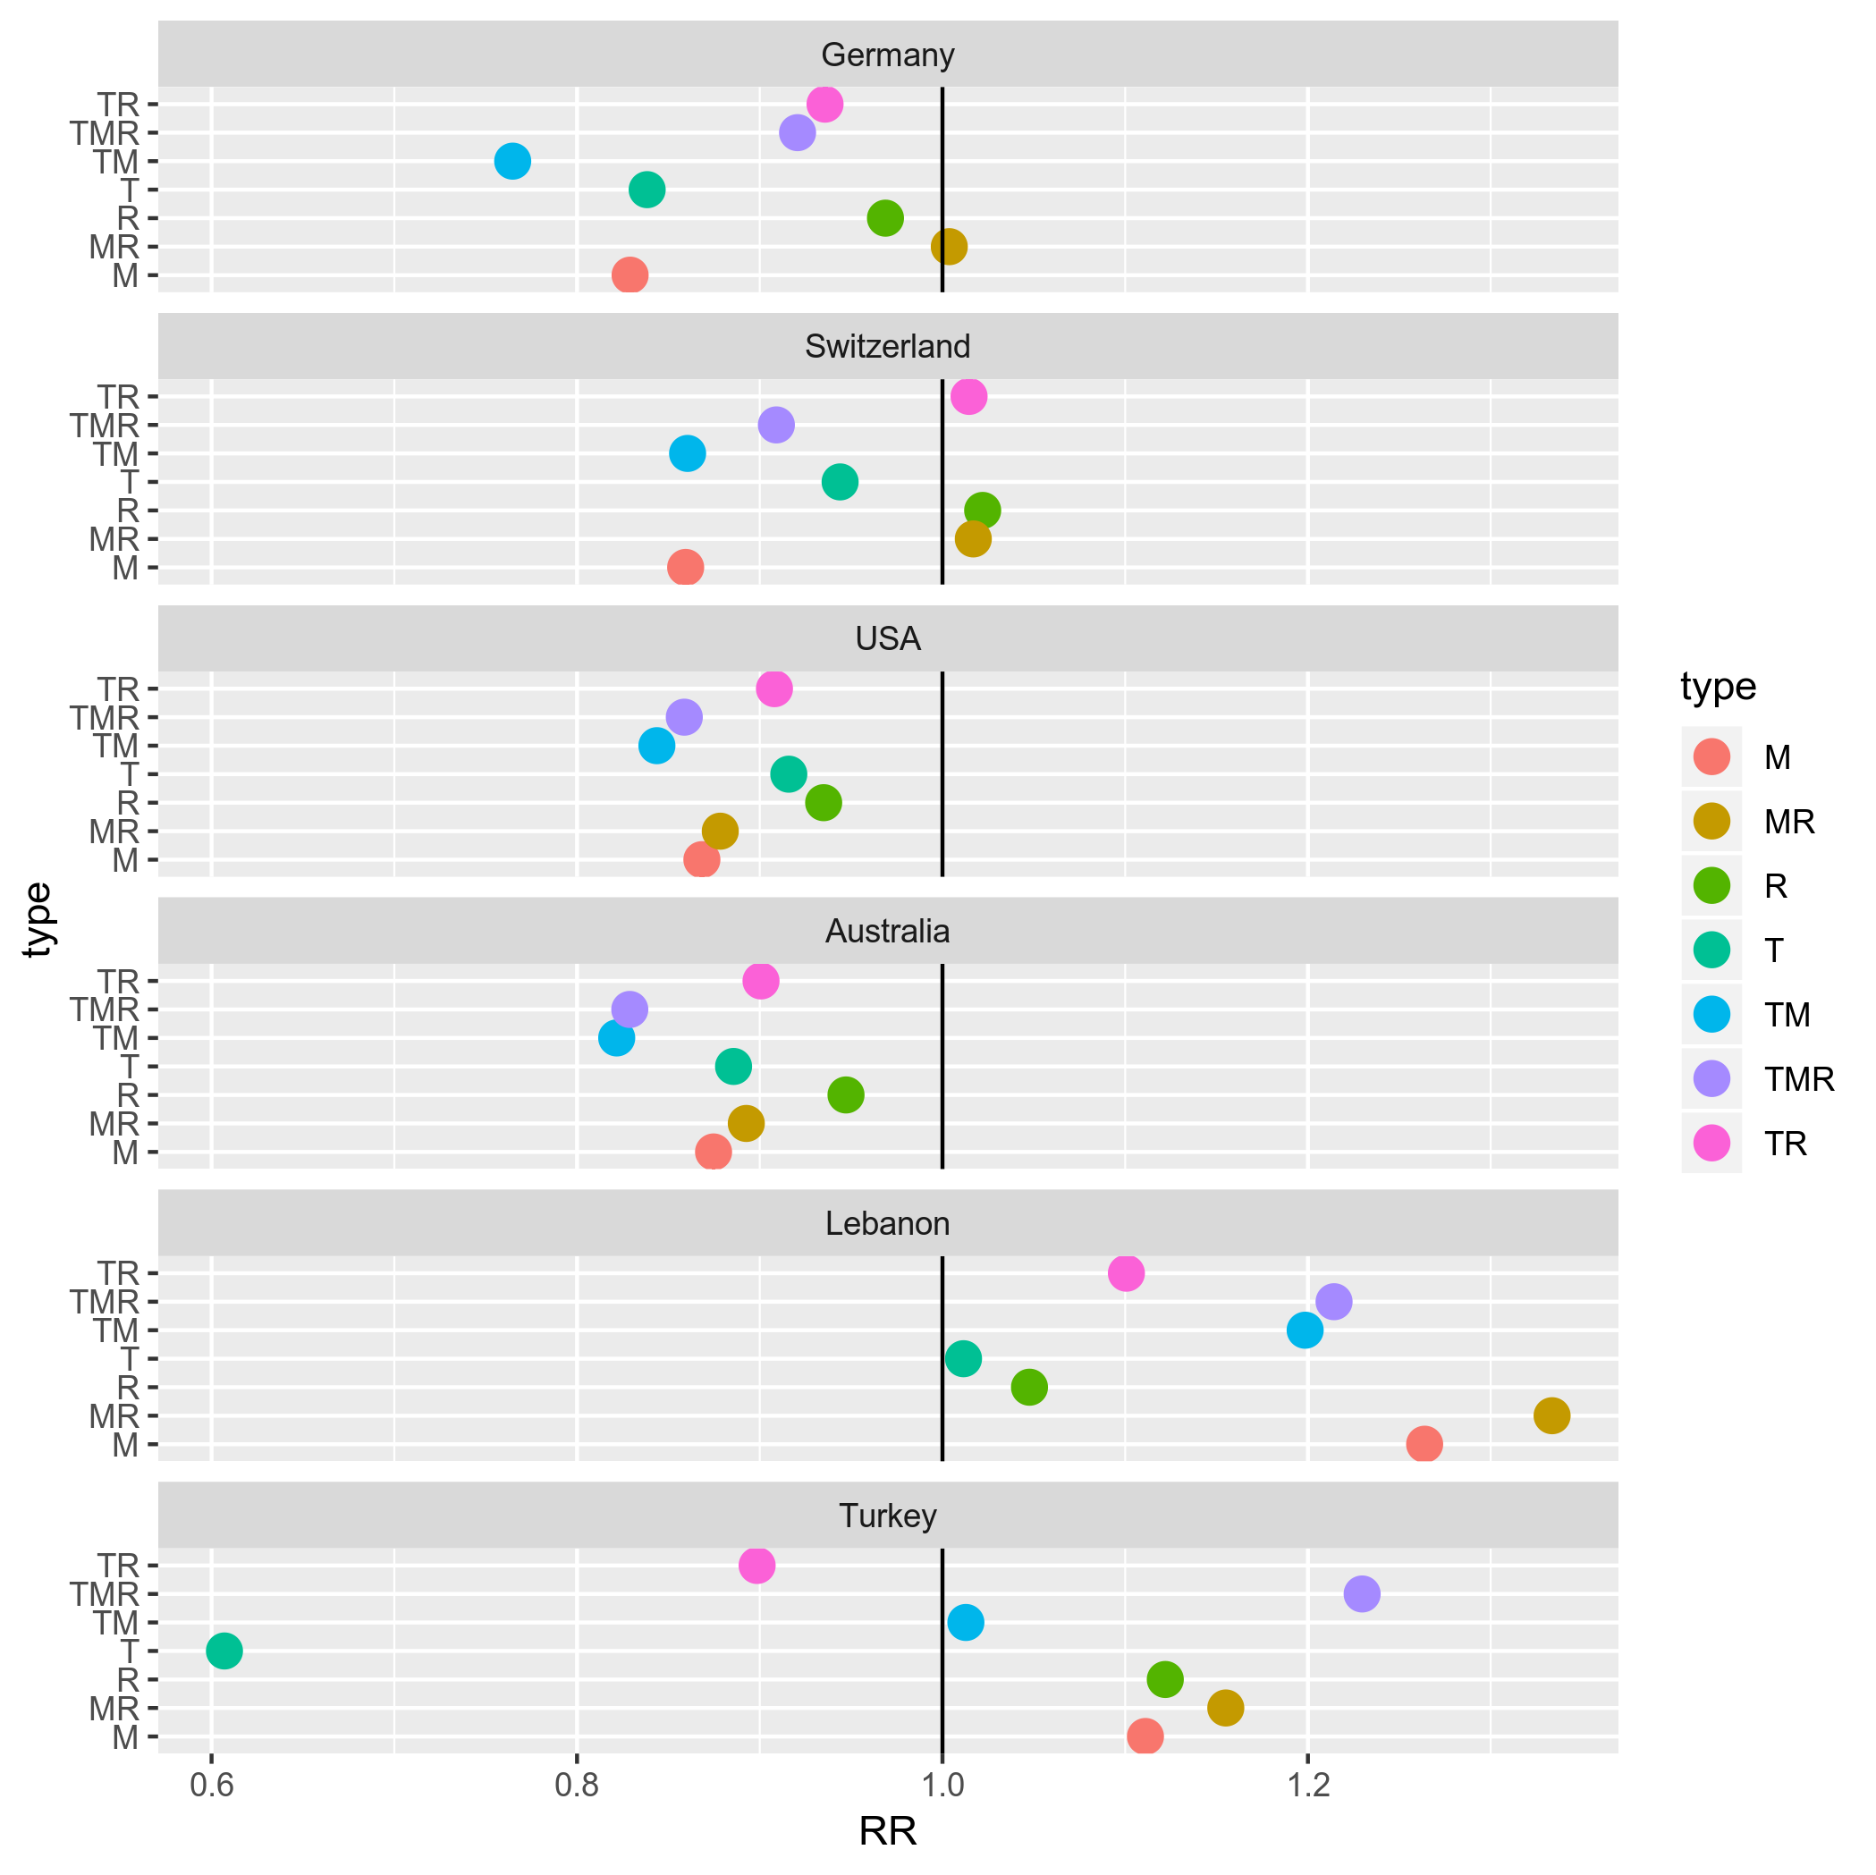
b) Sadness
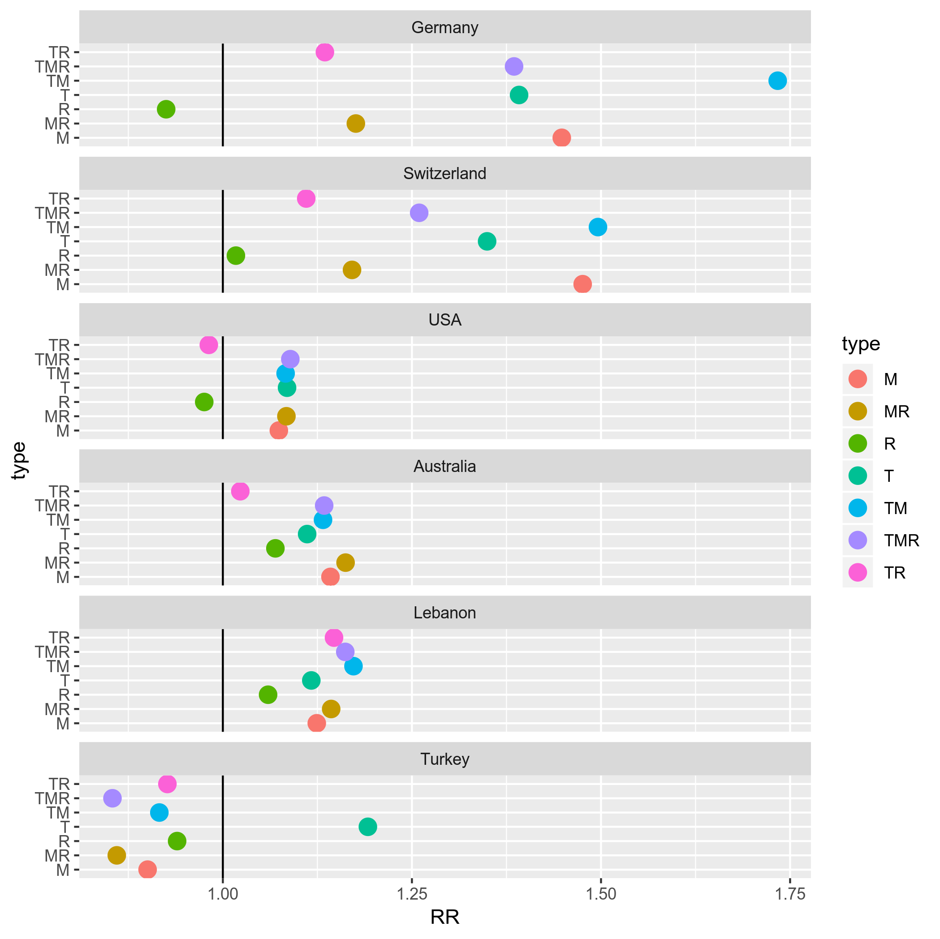
c) Anger
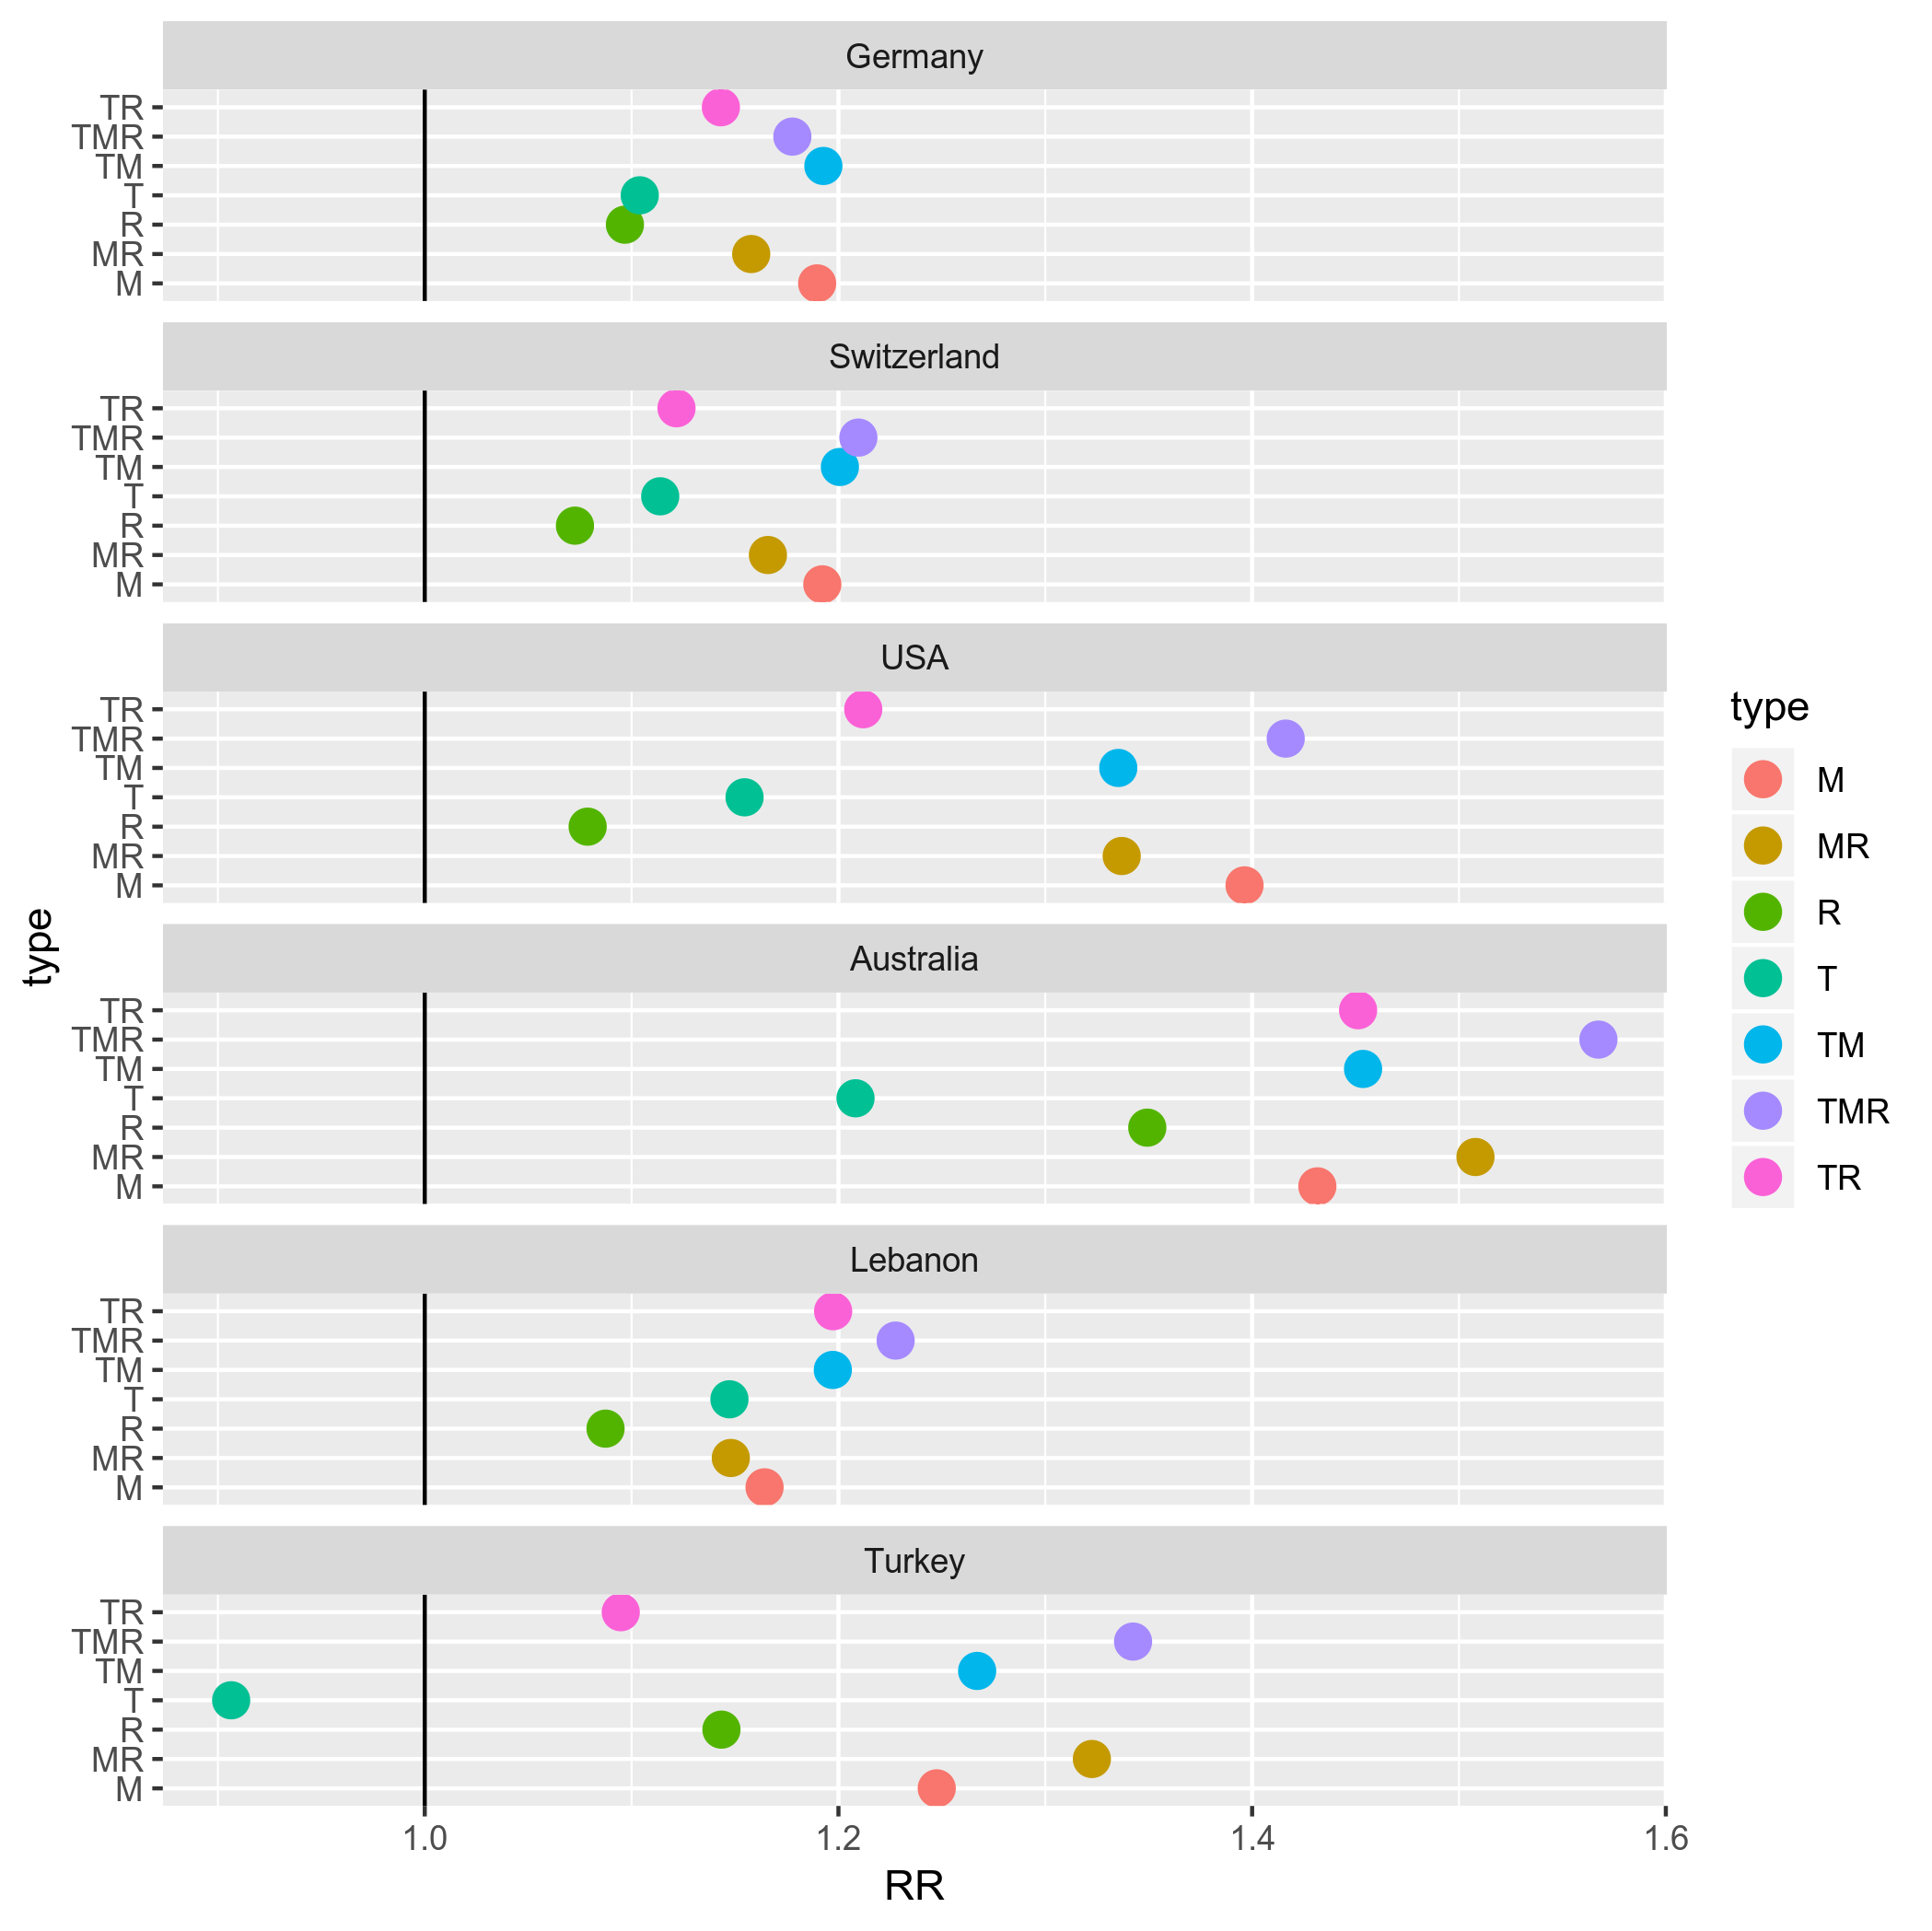
d) Pity
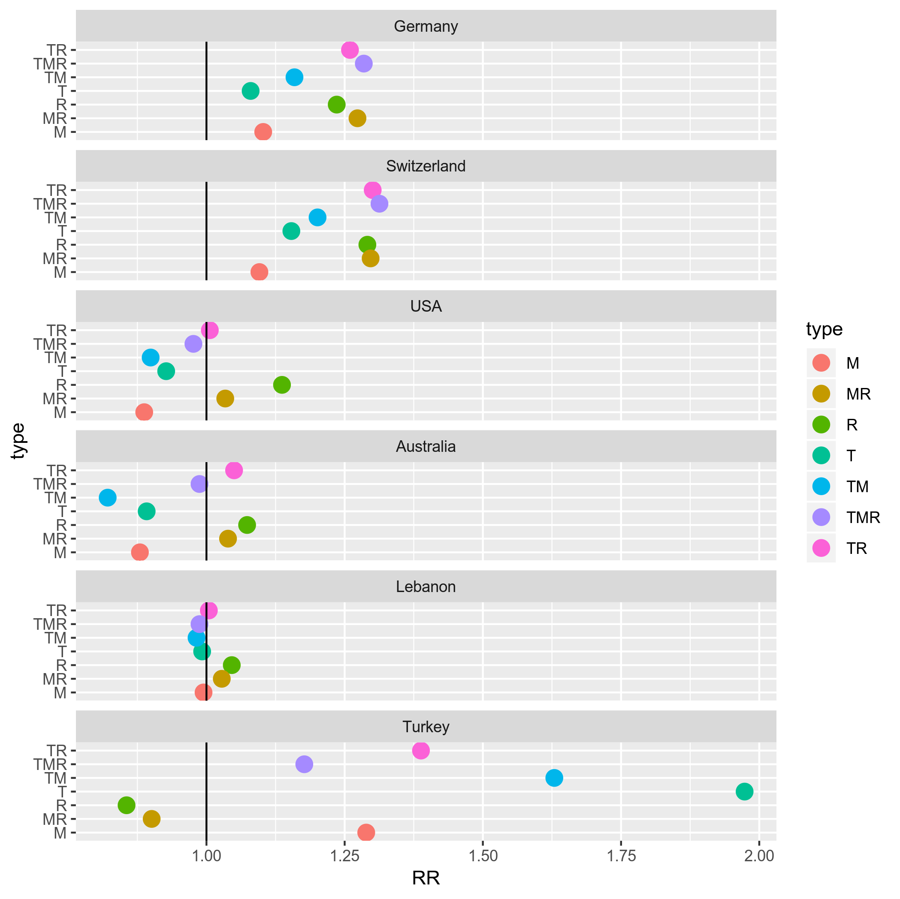
RR: Relative risk, a higher value indicates more likely to occur than controls and vice versa.
Appendix V: dictionaries
 | Sentiment words
English (Fear) | adopt, afraid, airstrike, ally, analyst, anyone, arise, assistant, award, aware, bad, basis, beat, belong, beyond, bigger, biggest, blood, blow, bombing, brutal, budget, bus, campus, capability, catch, cause, caution, celebrate, ceremony, certain, challenge, chaos, circulate, cite, civilian, clearly, collapse, commitment, communication, comparison, concern, condition, connect, consequence, continue, controversial, convert, convict, coordinate, corruption, credit, criticize, daily, danger, dangerous, deadly,  debt, delay, department, deport, discover, discrimination, discussion, disease, dramatically, drive, drone, easily, editor, effective, embassy, ethnic, evacuate, evening, eventually, expert, external, fear, feed, fence, fighting, flee, flow, freedom, gas, govern, grow, guardian, halt, handle, hatred, headline, higher, highlight, horror, humanity, hunt, imagine, immediate, imminent, improve, improvement, industry, inform, infrastructure, inquiry, inspire, insult, jail, journalism, journalist, judiciary, killer, killings, labor, lack, land, large, lay, level, liberty, locate, manager, market, massive, match, memorial, mile, mobile, monitor, music, net, newspaper, objective, offensive, outlet, outside, pack, page, particularly, perpetrator, planning, plant, pose, positive, poverty, presence, prison, prisoner, privacy, prompt, province, racial, rally, rapid, recount,  regard, regional, register, regularly, repeat, repeatedly, restaurant, restriction, revelation, risk, road, scale, scene, score, scream, sexually, shape, shield, shoot, shooter, shootings, shopping, significant, soccer, solidarity, spot, spread, spring, status, stick, strand, succeed, summit, supply, tend, tension, threat, threaten, throw, ticket, torture, tourism, train, trend, troops, unfolding, vehicle, village, violence, vulnerable, wag, wait, warming, warn, warning, weaken, weather, weekend, window, witness, worry, worse, woun
English (Joy) | aboard, achieve, advantage, amount, analyst, annual, anything, article, attend, attention, audience, available, beat, begin, behind, big, bring, budget, celebrate, ceremony, chance, clean, coast, college, communicate, concert, confront, contain, convict, criticize, crossing, culture, daily, declare, decline, defend, depth, desire, device, disease, dog, drama, dramatically, earn, employee, encourage, energy, essential, eventually, expand, familiar, fifth, file, formally, fresh, funding, gain, gift, good, guard, happen, happy, higher, hit, honor, huge, human, hurt, improvement, indicate, individual, insist, joint, joke, journey, kick, liberty, life, light, list, love, manager, match, memorial, mind, mission, movement, mutual, nominate, opponent, paper, path, person, personnel, pick, plant, poverty, praise, president, progress, project, proposal, publicly, rage, rapid,  rate, read, relative, renew, rescue, resettlement, resource, respect, return, rise, room, round, sake, sale, season, seem, self, seven, ship, similar, soon, source, specific, spike, spirit, sport, spot, status, succeed, success, surprise, surround, television, tender, territory, together, toward, treat, trip, truth, understand, vessel, vice, visit, water, weather, welcome, worry
English (Sadness) | abduct, aboard, aware, bad, barrel, blood, civilian, computer, condolence, debt, depression, desk, die, displace, either, fit, football, gather, genuine, heritage, honor, husband, immediately, injur, injure, killer, lose, miss, newly, occupation, reason, restriction, self, sexually, slow, subway, tragedy, unclear, wall, woun, wounded
English (Anger) | allegedly, anger, angry, ban, bit, blame, blast, commentator, compassion, completely, condemn, criticise, daughter, directly, draft, drama, entire, evening, feed, grab, hate, hatred, hear, ideology, impose, innocent, instance, instead, insult, intellectual, joke, justify, legitimize, liberal, mistake, neighbour, oblige, occupation, outrage, pledge, plight, politician, principle, protester, purpose, quickly, racism, rage, rail, regularly, relief, remark, repeatedly, rush, simply, specifically, spike, spread,strongly, suggestion, tear, transition, treatment, unfolding, vow, word, worry, writer
English (Pity) | anger, baby, beach, belong, command, condolence, crossing, desperate, drown, evacuate, eventually, exhaust, feel, holiday, hurt, intense, justify, loss, mission, mourn, nominate, particular, production, racism, remind, round, sea, season, silence, storm, tear, tool, track, tragic, worship
German (Fear) | abgeben, absturz, aktivität, angst, anliegen, arbeitslosigkeit, aufhalten, ausbau, bedeuten, begrenzung, behördenangabe, besetzen, besorgt, betreuen, bürgerkriegsland, egal, entführen, entführer, erschweren, falle, feind, fliehen, fürchen, fürchten, gewalt, inmitten, insbesondere, junge, kriegen, kritiker, kümmern, lebensmittel, meiden, millionen, montagabend, mörderisch, nachbar, nackt, namens, pilot, prägen, preis, rechtsextrem, reden, schlimm, schmerz, schub, schwach, silvesternacht, sorge, spekulation, sperren, stets, streitkraft, studie, tier, tillich, unabhängigkeit, unklar, unsicherheit, unterschied, ursache, verstärken, verunsichern, wachsen, wahrnehmen, warnung, weihnacht, weihnachten, wochenende, zünden, zunehmen, zuschauer
German (Joy) | abhalten, abkomme, abkommen, anwalt, aufregung, auge, aussicht, autor, bedeutung, begrüßen, bereitschaft, besetzen, besorgt, demokratie, denken, dutzende, eher, erfüllung, erhöhen, erlassen, erzählen, feier, feiern, film, fließen, freuen, fühlen, gelangen, gelegenheit, gesetz, geste, gewißheit, heben, hervor, historisch, hoffnung, hören, innenminister, interesse, investition, jahrzehnt, kämpfen, kehren, kind, kirche, klang, lernen, minute, möglichkeit, nah, nahe, null, publikum, rechtsstaat, relativ, revolution, schauspieler, schön, schritt, sparen, student, stunde, stunden, teilnehmer, teilweise, tourist, überweisen, verhältnis, verpflichten, verursachen, viert, vorbei, wahl, wahr, wahrnehmen, willkommen, wobei, zeichen, zukunft, zusammenarbeit
German (Sadness) | aktualisiert, angehörige, attacke, attackieren, bank, bieten, bürgerkrieg, dutzend, egal, einfluß, entführen, entsetzen, enttäuscht, ereignen, ereignis, erinnerung, ermorden, explosion, extrem, familienmitglied, gefährden, gefährlich, insasse, küste, leiche, mächtig, mindestens, mittwochabend, möglichst, publizieren, schicken, schlacht, schmerz, schüler, schwester, selbstmordanschlag, serie, sitzen, sohn, sprengstoff, stürzen, taufen, tod, töten, traurig, treten, unterbringung, verbrechen, verletzte, verlust, verteidigungsministerium, verurteilen, volk, zählen, zünden, zusammenstoß, zwingen
German (Anger) | abgeordnete, abhängig, ablehnen, afghanisch, akt, aktivist, all, allgemein, allzu, angeblich, angreifen, anhänger, anklage, ankündigung, antwort, armee, aufnahme, äußern, beamter, bedrohen, beenden, begriff, begrüßen, behandeln, bekämpfung, beleidigung, benötigen, beraten, bereit, berichten, beschäftigen, besonder, bestimmen, bestimmt, bewaffnet, bezeichnen, bleiben, blutig, bodentruppe, boot, braun, brief, bühne, bundespolizei, drama, durchsetzen, ebenfalls, egal, einheimisch, einschließlich, einsetzen, einzigartig, elite, entführung, entsetzen, entstehen, enttäuscht, erbeuten, ereignis, erfolgreich, erheblich, ermittlung, erneut, erstaufnahmeeinrichtung, experte, explosion, extremistisch, falsch, feind, fernsehen, feuer, flughafen, flugzeug, fordern, frau, frei, freitagabend, freuen, frühjahr, fühlen, führend, fürchen, fürchten, gefängnis, gefecht, geführt, geistig, gelegenheit, gemeinsam, genauso, genfer, geschehen, gewalt, gewerkschaft, gewiß, glück, grenzkontrolle, grund, gründen, haß, herbst, herrschen, herum, hoffnung, humanitär, immerhin, informieren, interview, jen, jugendliche, justiz, kämpfer, kandidat, karriere, klagen, konservativ, kontakt, kontinent, kreis, kreisen, kritisieren, kürzlich, lager, landen, längst, lauen, lehrer, leiter, liefern, links, logisch, lösen, luft, luftangriff, luftraum, machthaber, manchmal, maschine, massenhaft, massiv, maßnahme, meiden, meinung, mitarbeiter, mithilfe, mittlerweile, mord, nacht, nähe, nämlich, netzwerk, niedrig, obergrenze, phänomen, platz, politik, presse, publikum, rauben, rauch, reagieren, reaktion, realität, rebell, rechts, religion, rest, revolution, riesig, rücken, satz, schaden, scharf, scheinen, schicken, schlimm, schriftsteller, schule, schuß, selbstmordanschlag, sendung, sicherheitskraft, sieg, sonntagabend, sorge, sozusagen, spende, sprecher, staat, stammen, ständig, streit, student, taufen, tausend, tausende, telefonat, territorium, tief, tödlich, tot, trotz, truppe, überlebende, überschreiten, überzeugt, umgehen, umstand, unbekannt, union, unterbringung, unterstützen, untersuchung, vehement, verbessern, verboten, verbreiten, verdanken, vergangenheit, verhalten, verhindern, verlangen, vermutlich, verschieben, versehentlich, verstehen, vertreter, verüben, verursachen, verurteilen, verzeichnen, voll, vollständig, vorbereiten, vorgehen, vorstellung, wachsen, waffe, wagen, warnung, weiß, weiterhin, werfen, westens, wiederum, wille, willkommen, willkommenskultur, wunsch, zeichnen, ziel, zufrieden, zuletzt, zunehmen, zuständig, zustrom
German (Pity) | akzeptieren, allgemein, angeblich, angebot, angehörige, ansicht, arbeiten, arbeitslosigkeit, arbeitsmarkt, außenminister, beenden, behandeln, behandlung, behaupten, bekämpfen, bekämpfung, beobachten, besonder, bevorzugen, bild, botschaft, bürgerkrieg, chef, demonstration, denken, diskutieren, dutzend, ehrenamtlich, emotional, erschießen, essen, exotisch, extrem, fällen, fassen, flugzeug, folge, formulieren, freiheit, gast, gefahr, gegner, genauso, gesicht, griechisch, großteil, gründen, hart, helfen, helfer, hinweisen, hotel, humanitär, hundert, idee, industriestaat, information, inhalt, insel, integrieren, internet, job, justiz, kämpfer, kindheit, kopf, krankenhaus, krieg, kümmern, küstenwache, leid, leiden, leisten, lesen, leute, loben, mädchen, manch, männlich, medizinisch, ministerpräsident, mitglied, mitten, motiv, mut, mutmaßlich, national, not, notwendigkeit, obwohl, öffnen, ökonomisch, orten, paar, parlamentswahl, partner, positiv, quadratmeter, rasch, rein, retten, satz, schicksal, schiff, schutz, schützen, schutzsuchende, schweigeminute, selbstverständlich, situation, solidarität, steigend, struktur, szene, tausend, telefonat, tote, triefen, übergang, unterbringen, unterbringung, unterschiedlich, unterstützen, verbreiten, verbündete, verdienen, verein, verfassungsschutz, verpflichtung, versorgen, verstehen, verteilung, verurteilen, völlig, währen, warnung, warten, weise, werfen, zählen, zumindest, zurzeit, zusammenarbeit
Turkish (Fear) | ada, adliye, ağaç, ağır, ağırlık, ağrı, ak, akın, akşam, alan, alçak, alevi, ambulans, arac, araç, aşağı, asayiş, astsubay, ateş, ateşe, ateşt, azınlık, bacak, bağlantı, barikat, barınak, bas, başkonsolosluk, belirtil, biçim, binlerce, birim, böl, bölge, bomba, boşal, boy, büyükelçilik, cadde, caddesi'nde, çalışan, canlı, çanta, çaplı, çatışmalar, cephe, çevre, ciddi, cihatçı, cinayet, cumhurbaşkanlık, dağ, daire, dakik, demir, depo, derece, dikkatli, dolaş, duman, dur, düşmanlık, düşün, düşür, duyurul, elbise, elçi, en, endişe, erken, etme, etraf, euro, federal, geç, geçiş, gelecek, geniş, gerçekleş, gerekçe, gider, giy, giyim, gizle, görün, görüntü, görüntüle, gücün, güney, güvence, harca, hassas, hat, hata, hatay, havalimanı'n, hayal, hesab, hollan, hüküm, ibadet, içer, idam, ihbar, ihtimal, iklim, ilçes, ilerle, iletiş, ili, infaz, infilak, islamcı, istasyon, ırkçı, jet, kaçan, kaçın, kaçır, kalabalık, kaldır, kalıcı, kamera, kanlı, kapa, kapatıl, karakol, karakolu'n, karşi, kasım, katkı, kavşak, kaybı, kaygı, kent, kır, kırsal, kökenli, komiser, kongre, konum, kork, korku, korkunç, köy, kumanda, kurşun, kuvvet, kuvveti, lice, mağduriyet, mahalle, maruz, menfez, metro, mezra, miktarı, miting, muhtemel, normal, nusaybin, oda, okul, olası, ölü, öncülüğ, örgü, otobüs, özellik, özellikle, panik, patla, patlama, patlat, polis, profesyonel, propaganda, radikal, rahatlık, risk, roketatar, sabah, sağ, sağcı, sakla, sal, saldır, şans, sebep, sekreter, sempati, servis, ses, seviye, seyahad, sivil, siyah, siyasal, şoför, sokak, sol, spor, şube, suçlu, suikast, sur, sürücü, taciz, tamamla, tanık, tara, tarz, tavsiye, tehdid, tehdit, tehlike, terörün, tim, top, topl, turist, turistik, tuzak, uçur, uçuş, üstlen, üstünlük, uy, uyan, uyarı, uyarıs, uyuşturucu, uzak, uzaklık, vatandaş, vatandaşlar, vatandaşları, vatandaşlarımız, video, yaralanan, yasak, yay, yaygın, ye, yıldız, yolcu, yönetmen, yönü, yük, yüksel, yürüyüş, zırh
Turkish (Joy) | aksine, algı, barın, başarılı, bebek, belediyesi, bertaraf, bünye, duygu, emine, gençlik, gönül, hedefle, insani, iş, işid'in, konser, kuru, kutla, manevi, memnuniyet, müjde, ödül, otobüs, şebeke, sev, sevgi, tanık, tat, tıpkı, tl, umut, vesile, yaşantı, zafer
Turkish (Sadness) | abi, abla, abluka, açiklama, acı, adaletsizlik, adli, ağır, ağrı, ağustos, akşam, amaçlı, anayasal, anne, arac, arkadaş, as, asıllı, ask, asker, askerin, astsubay, ateşle, ateşt, ayak, aylan, ayrı, bağlantı, bar, batı, bebek, beden, beklenti, bekleyiş, belediye, belirt, benze, beraber, birim, borsa, boyut, bünye, bütçe, büyükelçilik, çaresiz, çavuş, cenaze, cesedi, ceset, cinsel, çocuk, cumartesi, dakik, dakika, dalga, daral, deniz, derin, devri, direktör, doğrudan, dök, doktor, dokunulmazlığ, dolu, dönük, döşe, dosya, dram, düğün, dürüst, düş, düştük, düşür, elçi, endişe, erkek, ertele, eş, eşit, eşitsizlik, esnas, fakülte, fikir, füze, garı, geçici, geçişi, gemi, genç, gençlik, genişle, gerilim, gidiş, göm, görevi, görevli, gözyaşı, güçlük, günah, günlük, hafif, hain, hakikat, hakkâr, hasar, hastalık, hastane, hatay, hatırla, havaliman, havalimanı'n, havalimanı'nda, hayal, hayat, ihlali, ihmal, ikamet, ilçe, ilçesi'n, ilçesi'nde, ileri, infilak, internet, irtibat, isabet, işkence, işsiz, istismar, isyan, itibari, jandar, kadir, kafa, kahraman, kalıcı, kamyon, kan, kana, kap, karakolu'n, kardeş, kardeşlik, kay, kaybet, kayıp, kaza, keskin, kına, kız, koca, komiser, kon, korun, köy, kritik, kulak, kumanda, kurban, kürsü, kurşun, kurtarılamay, kurtul, kutla, maddi, mağdur, mahallesi'n, mahallesi'nde, mahrum, mardin, maruz, masum, may, mazlum, meclisi, mekân, memleket, memur, merm, mesafe, metre, metro, mezar, miras, miting, müdahale, mülki, namazı, nişancı, nitele, nusaybin, öl, örneğin, ortaklar, öt, özür, patlama, patlatıl, patlayıc, pazarlık, pazartesi, perşembe, problem, rahatsız, rakam, roketatar, şair, sakla, sebeb, şehit, şehitler, şehr, seks, sevgi, şiddetli, site, siyasetçi, sıkış, sınıra, sırt, slogan, sok, sonsuz, sonuç, sorunsuz, sürücü, sürükle, tablo, takviye, taslak, tatil, tavr, tedavi, tehdid, teşhis, tesisler, tez, ticari, tip, tir, toplam, topluluk, toprak, tören, tren, tuzakla, tweet, uğra, uğurla, üniversitesi, unut, üsteğmen, uyruk, uzman, üzüntü, vahşet, vatan, vatandaşı, vicdan, vicdani, vur, yağ, yalan, yanı, yarala, yaralan, yaralı, yaş, yaşam, yaşlı, yatır, yerleş, yitir, yıllarca, yıllık, yoksul, yolculuk, yolla, yükle, yürek, yurttaş, yüzyıl, zırh, zorlan
Turkish (Anger) | aç, açı, açık, açıklamas, açıklık, açlık, adaletsizlik, adam, aday, adres, af, ağaç, ah, akademik, akademisyen, akım, akşam, alçak, aleyh, alınmış, alışveriş, alkol, alternatif, anayasa, anı, anımsa, anlamlı, anlayış, arka, asıl, asıllı, aşırı, ask, aşk, askerlik, asla, at, ata, ateşe, ateşke, ayak, ayrılık, ayrım, ayrımcılık, azınlık, bacak, bahane, bahçe, bale, bar, barın, baş, baskı, başkonsolosluk, batı, bedel, beden, belediyesi, belli, ben, benze, benzerlik, biz, böl, bölün, bombala, bombalı, boşal, boy, bozuk, bu, bulunmas, bunca, bürün, bütünlük, büyü, çaba, çağrı, çağrıs, çal, cam, çare, çaresiz, çatışmalar, ce, cephe, ceset, çet, çevir, çevre, cinayet, çıkarma, çoğal, çoğunluk, çöz, cümle, daha, darbe, darp, dayan, değerlen, değil, demokras, demokrat, den, denge, devleti, dey, din, diyarbakır, dışarı, doğ, doğu, doktor, dolu, dönük, dönüş, dostluk, dram, düşman, düşmanlık, düşür, duvar, duyurmuş, duyuru, düze, egemenlik, eğlence, elbise, eleştiri, elimiz, emlak, emperyalizm, engelle, erkek, etki, etnik, etraf, ez, fail, faili, fark, faşist, fikir, film, fırsat, fra, füze, geldiğ, genişle, gerçek, gerçekleştiril, gerçekten, gerile, gerilim, gez, gider, gidiş, gönüllü, görüştük, görüşül, göster, güç, güçleri, gücün, gül, günah, güneş, gurur, had, hakaret, hakikat, hakim, hâkim, haklı, haksız, halk, harca, hastalık, hatay, hatırla, havaalanı, havalimanı'n, havza, hayvan, hazine, hedef, hemen, hendek, her, hesap, hoca, hukuk, idam, iftira, ihanet, ihlal, ihtimal, iklim, iktidar, ilçesi'nde, iletiş, imkan, imzala, inanç, infaz, inşallah, insan, insanlık, intihar, irade, iş, işgal, işkence, islamcı, işle, iste, istismar, isyan, itibari, itiraz, ittifak, ırkçı, kabul, kafa, kalabalık, kalkış, kamera, kamp, kampanya, kanlı, kap, karakol, karakolu'n, kararlılık, kardeşlik, karış, karşi, karşı, karşılama, karşılan, karşıt, kart, katıl, katliam, kavga, kavşak, kaybol, kesin, kesinlik, kilo, kirala, kirli, kın, kına, kır, kısmı, koca, kökenli, kol, kolaylık, komiser, komisyonu'n, konser, konum, kork, korum, korun, köşe, kötü, kritik, kulak, kullanıcı, kumanda, kurtar, kuş, lazım, leke, liberal, maalesef, maç, mağdur, mahal, makale, maksatlı, maruz, masa, masum, meclis, meclisi, medeniyet, mekân, mekke, menfaat, menfur, merm, mermi, mescit, mesela, meslek, mevcut, meydan, mi, militan, milleti, moda, muhalefet, muhtaç, muhtemel, nefret, nitele, niyet, öde, öfke, öğretmen, ola, öldür, öldürül, ölüm, olumsuz, omuza, öner, organizasyon, örgütü'n, orman, öt, otu, otur, oyun, özür, parmak, parti, patlat, patlatıl, pay, paylaş, paylaşım, pazarlık, pembe, peri, peş, politik, potansiyel, problem, propaganda, protesto, rahatsız, rahatsızlık, reddet, reform, rejim, rol, ruh, saf, sağ, şah, saldırgan, sar, saray, sarf, savaş, savaşçı, savaşı, savcı, say, sayfa, sayın, sebeb, şebeke, şehir, seks, sergile, sert, ses, seslen, şiddet, şiddetli, şikayet, silahla, site, siyasi, siz, sığ, sıkıntı, sıkış, sınıra, skandal, slogan, şoför, sok, sor, sorgula, sorumlu, sorumluluk, soykırım, söyl, söylem, sözcük, standart, subay, suç, suçla, suçlu, şüphelen, sürdür, sürekli, suret, sus, suu, taciz, tahrik, tahrip, tane, tartış, tartışmalar, taş, tat, tavır, tavr, tecavüz, tehdit, tel, temsil, tepki, tercih, terk, teröre, terörün, ters, teslim, tıpkı, to, trol, turistik, tutum, tuzak, tuzakla, twitter, üçüncü, uçur, uğr, üniversite, unsur, üre, uyarı, uzak, uzaklaş, vah, vahş, vahşet, vazgeç, vaziyet, vekil, vesile, vicdan, vicdani, vize, vizesiz, vur, yabancı, yağ, yak, yakalan, yaklaşım, yalan, yang, yanı, yanıtlay, yanlış, yargı, yarım, yarış, yat, yataklık, yaz, yazar, yazık, ye, yerel, yet, yık, yıllarca, yoğunlaştır, yönetici, yöneticiler, yönetimi, yürek, yurttaş, yürüt, yüzyıl, zarar, zorla
Turkish (Pity) | acil, anı, aziz, başsağlık, belediyes, boğ, buluş, değerli, dua, kın, kırmızı, komşu, kuvveti, mağduru, menfur, mensuplar, mezun, milletine, rahmet, renk, şehid, şehitler, şifa, taziye, töre, vatan
Arabic (Fear) | آمَن, أَبعَد, أَثَر, أَخَذ, أَدرَك, أَذَى, أَرجَح, أُسلُوب, أَصَاب, أَصلِيّ, أَضَاف, أَعظَم, أَعمَى, أَغلَب, أَقترَب, أَقدَم, أَقَرّ, أقول, أَلاهلِيّ, أَلزر, أَلزَم, أَلمناضَل, أُلهبَة, أمامهما, أَمَانَة, أَهلِيّ, أوطاننا, أَوقَع, أَوقَف, أَينَمَا, إِبدَاء, إِبعَاد, إِبقَاء, إِتمَام, إِثَارَة, إِجرَام, إِجمَاع, إِخلَاء, إِدخَال, إِرسَاء, إِسترَاتِيجِيّ, إِشرَاف, إِعدَاد, إِنتِرنِت, إِنفَاق, إِيقَاف, إِيمَان, اِبنَة, اِتِّبَاع, اِتَّفَق, اثمانا, اِجتِيَاح, اِحتِيَاج, اِحتِيَاط, احرار, اِختَصَر, اِختَلَف, اِرتَدّ, اِرتَفَع, اِستِئنَاف, اِستِثمَار, اِستِثنَاء, اِستِجَابَة, اِستَحَقّ, اِستِعرَاض, اِستِفهَام, اِستِكمَال, اِستِمَاع, اِستِنتَاج, اسرار, اسطولنا, اشكالات, اِضطِرَاب, اِطِّلَاع, اقاربهم, اِقتِرَاب, اِقتَرَب, اِقتَرَح, الأخبار, الاعتصام, الاكثرية, البارد, البغيلية, التمدد, الجهادئ, الحادثة, الحاضنة, الحزن, الحكيم, الحلوة, الخاطية, الخلوي, الخلية, الذاكرة, الشهير, الطيبة, العشاء, العناد, القتالية, المتعاطفين, المرتبط, المس, المغتربين, الميثاقية, الهادي, الهاربين, الهرمل, الهلع, امامنا, امنت, امون, انا, انتحاري, انتحاريين, اِنتِقَاد, اِنتِقَال, انتقام, اندفاع, اِندِلَاع, انشغال, اِنقِسَام, اِنقِلَاب, باتجاه, بارود, بَاقِي, بالمال, بالنفس, بامرة, بامن, بانه, بتأكيد, بترشيح, بثلاثة, بحرب, برز, برفقت, بركان, بَرمِيل, بَطن, بُعد, بُغيَة, بلديا, بني, بَيدَ, تَأَكُّد, تَأمِين, تَارَة, تَامّ, تَبَقَّى, تبني, تَجرِبَة, تَجمِيد, تَجهِيز, تَحذِير, تَحَسُّب, تَحسِين, تَحَكَّم, تَحَمُّل, تَخَطَّى, تَخَلُّص, تَدَاعِي, تَدبِير, تَدرِيجِيّ, تَدمِير, تَرَاجَع, تَرَاجُع, تَربَوِيّ, تَزوِيد, تَسَبَّب, تَسهِيل, تَشغِيل, تَطوِير, تَعَرُّض, تعزية, تَعقِيد, تَعَهَّد, تَفَاوُض, تفجر, تَقَارُب, تَقَرَّر, تقويض, تَكَوَّن, تَلَا, تَمَتَّع, تَمَسَّك, تناقض, تنظيما, تَهوِيل, توتر, تَوَتُّر, تَوَعَّد, تَوفِيق, تَوَقَّع, تَوقِيف, تَوَلَّى, ثَبَت, ثَبَّت, جَاز, جحيم, جد, جِدِّيَّة, جذور, جرأة, جرود, جُرُود, جَرِيدَة, جَزِيرَة, جَسَد, جَعل, جُغرَافِيّ, جلال, جلد, جمعة, جُونز, حادثة, حَارَب, حارة, حَاضِر, حَجب, حَربِيّ, حَفر, حَمد, حَمل, حولنا, حِيَالَ, خَائِف, خَارِجِيّ, خَالِد, خَالَف, خَالِي, خِبرَة, خَزِينَة, خَشِي, خُصُوصِيّ, خفي, خِلَافَة, خَلَص, خُلق, خَوف, خيانة, دَائِر, دَاخِلِيّ, دَاعِيَة, دَافِع, دَام, دَخَل, دَرس, درع, دَم, دُولَار, دِيبلُومَاسِيّ, ذَهَاب, رَأس, رائد, رَاتِب, رَاح, راعي, رَافِض, رَاكِب, رَاهِن, راينا, رَبِيع, رَحَّب, رَصَاص, رَصد, رَصَد, رعب, رَفِيع, رَمز, رمزي, رِهَان, رَهِينَة, رِيف, زَاد, زِلزَال, زَوَاج, زَوج, زَوجَة, سُرعَة, سطوة, سِفَارَة, سَقف, سَكَنِيّ, سَمَاء, سَمَاوِيّ, سَمع, سُمعَة, سَنَوِيّ, سَيَّارَة, شَبِيه, شتى, شِرَاكَة, شَرِيحَة, شرير, شَرِيعَة, شُعُور, شَغَل, شُغل, شَفَّافِيَّة, صَاحِبَة, صَار, صَارُوخ, صانعي, صُحُفِيّ, صِحِّيّ, صُدُور, صَرف, صَغِير, صِفر, صفو, صَقر, صُلب, صُندُوق, صِيغَة, ضَرب, ضَعِيف, ضِفَّة, ضَمَانَة, ضَيِّق, طعام, طُول, ظَرف, ظِلّ, عَاجِز, عامر, عبء, عِبء, عبادة, عَبَث, عُبُور, عَجز, عد, عِدَاد, عَدَالَة, عرسأل, عَرقَلَة, عزل, عَزل, عَشِيَّة, عِصَابَة, عصره, عظيم, عَظِيم, عَقَائِدِيّ, عقاب, عَقد, عَكَس, عَلَّق, عَمَلِيّ, عُنصُرِيّ, غازي, غَزو, غَطَّى, غَيَّر, فَاشِل, فَاق, فَتح, فَجأَة, فِرَار, فرز, فُرصَة, فَرضِيَّة, فَرعِيّ, فَسَّر, فَشِل, فَصِيلَة, فل, فم, فَوضَى, فَوقَ, قَائِم, قَادِر, قَادِم, قاس, قَاسِي, قِبَل, قَدر, قِدِّيس, قَذِيفَة, قُرآن, قَرِيب, قَسرِيّ, قَصِير, قَلَق, قومية, قِيمَة, كَاد, كَارِثَة, كارثية, كَافَّة, كَافِي, كِتَاب, كتف, كَرِيم, كَشف, كِلَا, كَلَّف, كَمَن, كنا, كورقة, لَاحِق, لاستسلام, لتخفيف, لتوظيفهما, لتوّه, لَحم, لدينا, لَقَب, لكلية, لكننا, لَولَا, ليسرى, مَادِّيّ, مَاذَا, مَالِيَّة, مباركة, مُبَرِّر, مُبَكِّر, مُتَفَجِّر, مُتَوَسِّط, مُتَوَقَّع, مَتَى, مَجهُول, مُحَاصَرَة, مُحَاضَرَة, مُحَافِظَة, مُحتَمَل, مَحدُود, محسن, مُحَلِّل, مَخَافَة, مُخَصَّص, مُخَيَّم, مُدَّة, مَدعُوّ, مَدعُوم, مراسلة, مَرصَد, مَرفَأ, مُرُونَة, مَزِيد, مُسَاعِدَة, مَسَافَة, مُسَانَدَة, مُسَاوَاة, مُستَحِيل, مستشفى, مستقر, مَسرَح, مَسقَط, مُسَلسَل, مشبوّهة, مُشتَبَه, مشرف, مشروعها, مَشعَر, مَشهَد, مَصرِف, مَضَى, مَطَاف, مُطَالَب, مطر, مَظهَر, مُعَارِض, مُعَامَلَة, مُعَانَاة, مَعرِفَة, مَعرُوف, مُعَسكَر, مُعلِم, مُعنَوَى, مُعنويَا, مَعنَى, مُفَاوِض, مفوضها, مُفِيد, مُقَاتِل, مقدس, مَقصُود, مقولة, مَكَان, مُلَائِم, مُلَاحَقَة, مِلَفَّة, مُمتَلَكَات, مُمَيَّز, مَنح, مَنضَوِيّ, مَنطِق, منطقتنا, منظور, مُنفَصِل, مَنهَج, مُهَدَّد, مُهِمَّة, مُوجِب, مَوجَة, مُوَجَّه, موقوف, نَار, نَاسِف, نَبَأ, نَبِيّ, نحسن, نسي, نَصب, نِضَال, نعيش, نَفطِيّ, نكبة, نِهَايَة, نَهر, نَوعِيّ, نَوَى, هَامِش, هُدنَة, هُدُوء, وَاجَه, وادي, وَافَق, وَاقِعِيَّة, واكثر, والأرواح, والاخير, والاديان, والاستحقاقات, والتخلص, والتفاهم, والحقد, والخلافات, والشرق, والقومي, وامكان, وبصر, وَبلِدَة, وبيئته, وتعاون, وتوجه, وجعل, وجل, وَرَد, ورسالة, وِزَارِيّ, وُسع, وطريقة, وقرار, ولكل, ويتابع, يبقى, يخفى, يدمر, يقاتل, يقولوا, يليق, يمكننا, ينفع
Arabic (Joy) | أَبدَى, أَحَاط, أَحَبّ, أَخَّر, أُستَاذ, أَسفَر, أَغلَبِيَّة, أَقترَب, أَقدَم, أقول, أُكتُوبِر, أَنجَز, أهلنا, أَوسَع, أَيُّوبِيّ, إِبدَاع, إِحبَاط, إِرشَاد, إِس, إِسَاءَة, إِصلَاحِيّ, إِلٰهِيّ, إِمدَاد, اِبتِزَاز, احتضان, اِحتِيَاج, اريد, اِستِئنَاف, اِستِثنَائِيّ, اِستَحَقّ, اِستِشهَاد, اِستِعرَاض, اِستِقدَام, اِستِقطَاب, اِستِمَاع, اِستَهَلّ, اظن, افادته, التشدد, التكفيريين, الجلوس, الجيران, الختام, الروحي, الشقيق, العصابات, الفقي, اِلقَمَع, المتروبوليت, المتن, النصر, النيات, الهاربين, اِلهرَمَل, الينا, امير, اِنتَمَى, اندفاع, اِنسِحَاب, اِنعِكَاس, اولوياته, بآمر, بَابَا, باحتفال, بالاحرى, برفقت, بَطَل, بَعثَة, بلدتي, بمزيد, بنيته, بوصلة, بية, بِيل, بيننا, تَأسِيس, تَاجِر, تحية, تَحِيَّة, تَخَلَّى, تَخَوُّف, تَربِيَة, تَرسِيخ, تزوج, تشويش, تَصَاعُد, تَعَالَى, تَعذِيب, تَعوِيض, تَفَاؤُل, تقليد, تكريمية, تِلَاوَة, تنكر, توتر, تَوَلِّي, ثَبَّت, جَامعِيَّة, جُثمَان, جَدُر, جَدوَل, جُرُود, جلال, حَارِس, حاضر, حافر, حَافِز, حُبّ, حَدِيد, حديقة, حَرِج, حرض, حَرَمَان, حَفل, حكومتنا, حُلُول, حَمد, خَادِم, خَشِي, خَفَى, خفي, خندق, خَوض, خَير, خَيرِيّ, دَاعِم, دَمَار, ذِكرَى, ذوي, رَأَس, رَائِحَة, رائد, رَاحِل, رَبّ, رَجَّح, زِلزَال, زين, سايلين, سَجِين, سِرِّيّ, سعادته, سكر, سَلَف, سيدا, شَرَف, شريف, شَرِيف, شَغَب, شَكَر, شكلية, شمس, شهاب, شَهِير, صَدَد, صديق, صَدِيقَة, صمود, صَنَّف, صَيف, ضَحَّى, ضَخم, طَائِفَة, طَبَّق, طفولة, طَمَع, عَاشِر, عُثُور, عجزت, عجل, عَرش, عِرقِيّ, عسيري, عمدت, عَينِيّ, غِبطَة, غِرَار, فَاصِل, فَردِيّ, فرن, فَورَ, قَدَاسَة, قَدَم, قُدُم, قُدوَة, قَسرِيّ, قَصَد, قَصَر, قَضَائِيّ, كامل, كَثَافَة, كره, لتوظيفهما, لجَأَى, لشهداء, لَعب, للحكم, لِمَاذَا, لَولَا, مُبَارَك, مُبتَكِر, مَبنِيّ, مُتَضَرِّر, مُتَّفَق, مُثَلَّث, مَجمَع, مُحَافِظَة, محب, مَُحَبّ, مختار, مُخَدِّر, مُرَاقِب, مَرفَأ, مُسَابَقَة, مسرح, مسكن, مُصطَلَح, مطر, مُعنَوَى, مُفَاجِئ, مفاجات, مفاصل, مُقَابَلَة, مقاوم, مُقَدَّمَة, مُقَرَّرَات, مُقَعِدّ, مُكارَم, ملاذ, مَلِك, مِلكِيَّة, مَمَرّ, مُهِمَّة, نَارِيّ, نَاشِئ, نَافَس, نبل, نَصب, نطالب, نِقَاش, نَوم, هربا, هَندَسَة, هَوَى, وإنني, وابناي, واستقرار, وَاصِف, واعدام, والاستحقاقات, والانسانية, والتفاهم, وَالِد, والزنا, والشرق, والعيش, والفوضى, والقرى, والمحبة, وامن, وانتم, وباسم, وتامين, وتبين, وتحدثنا, وتحقق, وتسليح, وتهاني, وجل, وحضر, وحضور, وسلامة, وسنقاوم, وصحيح, وعقيلة, وعلينا, وُقُوف, ولاء, وَلِيّ, ومروان, ونعتبر, يجعلنا, يحبون, يروج, يليق
Arabic (Sadness) | آنَذَاكَ, آيَة, أَب, أَبعَد, أَبلَغ, أَثَّر, أَثَرِيّ, أَجمَع, أَجنَبِيّ, أَحَاط, أَحدَث, أَحضَر, أَخَّر, أَخطَر, أَدَان, أَدرَك, أَذَى, أَربَعُون, أَرجَح, أُستَاذ, أَصغَر, أَصلِيّ, أَطَال, أَظهَر, أَعرَب, أعلى, أَعمَى, أغلب, أَغلَبِيَّة, أُفُق, أَقترَب, أَقدَم, أَقَر, أُكتُوبِر, أَكمَل, أَلَم, أَلمقعَد, أنثى, أَنَد, أننا, أنهما, أهلنا, أَهَم, أَوقَع, أَيَّار, أيديهم, أَينَ, إِبدَاء, إِبلَاغ, إِثَارَة, إِثرَ, إِجَابَة, إِجمَالِيّ, إِحَالَة, إِحيَاء, إِخرَاج, إِذ, إِرضَاء, إِزَاءَ, إِزَالَة, إِس, إِسَاءَة, إِصَابَة, إِلعلمَائِيّ, إِلٰهِيّ, إِليَاس, إِمَّا, إِمبِرَاطُورِيَّة, إِمِيل, إِنمَاء, اب, اِتَّفَق, اِتَّهَم, اِجتِيَاح, اِحتِقَان, اِحتَلّ, اِحتِوَاء, اِحتِيَاط, احدهما, اِختَار, اِختِفَاء, اِختَفَى, اِرتَدَى, اِرتَكَب, است, اِستِشهَاد, اِستِفَادَة, اِستِقدَام, اِستَمَع, اِشتَرَى, اشد, اِعتِدَال, اِعتِرَاض, اِعتِرَاف, اِعتَزَم, اعلاميا, اِفتَتَح, اقتصادنا, الاخ, الاسد, الاغتراب, الاكتفاء, الامامين, الانتحاري, البطريرك, البوصلة, التبانة, التشدد, التطبيقية, الجبل, الجندي, الجهادئ, الجهاديين, الحداد, الحزن, الحسنين, الحكيم, الخاطية, الدنيا, الرقة, الركن, الزور, الشك, الطاولات, الظن, العايدين, الفتاح, الفقي, القاري, القبة, الكاتبة, اللهيان, المتعاطفين, المجندين, المدعومة, المرتبط, المس, المغتربين, المقبول, الممنوع, المناصفة, الموتى, الميثاق, الهاربين, امون, انتحاري, اِنتَخَب, انتصارات, اِنتَمَى, اِنخِرَاط, اِندِمَاج, انسجام, اِنسَحَب, اِنضِمَام, انطاكية, اِنطِلَاق, اِنعِكَاس, اِنفِجَار, اِنفَجَر, انهار, انهما, اِنهِيَار, اوطان, بَاحَة, باحتفال, بَادِئ, بارد, باسره, بالاحرى, بالتاريخ, بالدرجة, بَالِغ, بالنفس, بامتياز, بانتظار, بايدي, بَثّ, بَحر, بحزب, بدأناه, بدعة, بَدَل, بدماء, بديع, بَذَل, بَرَاءَة, بركان, بَرمِيل, بَرِيء, بريد, بريف, بصفتنا, بَطن, بَعَث, بعضنا, بعلاقة, بَقَاء, بقعة, بلدتي, بَلَغ, بنيته, بوجوب, بُوست, بية, بَيت, بيتنا, بيضاء, بيك, بَينَمَا, تَأثِير, تَأجِيل, تَألِيف, تَابَع, تَالِي, تبني, تَثبِيت, تَجَاهُل, تَجَاوُز, تجفيف, تجلى, تحافظ, تحدق, تَحدِيث, تَحدِيد, تَحَرُّر, تَحرِير, تحصين, تَحَقَّق, تَخَوُّف, تَدَاوُل, تَدَفُّق, تذوق, تُرَاث, تَربَوِيّ, تَربِيَة, تَرَشُّح, تَروِيج, تَزَامُن, تَزوِيد, تَسَبَّب, تَسرِيع, تَشكِيل, تَصَرُّف, تَصرِيح, تَضَمَّن, تَطَلَّب, تَعَامَل, تَعبِير, تَعَدَّى, تَعدِيل, تَعقِيد, تَغطِيَة, تَغَيُّر, تَفَاؤُل, تَفتِيش, تفجر, تَفجِير, تفجيري, تَفكِير, تَقدِير, تَقرِيب, تَقسِيم, تقلصت, تَكَرَّر, تكفيري, تَكَلَّم, تَكلِيف, تَلّ, تَلَا, تِلَاوَة, تَلَقَّى, تلمس, تلو, تَمثِيل, تَمَسُّك, تَمَيُّز, تَميِيز, تَنَاسَب, تَنفِيذِيّ, تنكر, تَهدِيد, تُهمَة, تَوَافُق, تَوَجَّه, تَوَسُّع, تَوسِيع, تَوفِير, تَوَقَّف, تَوقِيع, تَوَلِّي, ثَبَت, ثَبَّت, ثِقَة, ثَمَانِيَة, ثَمَّةَ, ثَمَن, ثُنَائِيّ, جاد, جَاز, جَامِعِيّ, جَامعِيَّة, جُثَّة, جَدَل, جِدِّيّ, جذور, جَرَّاء, جُرح, جَرِيح, جُزء, جَزِيرَة, جَسَد, جِسر, جسم, جُمعَة, جَنَاح, جِهَادِيّ, جهدنا, جواب, جَوَاب, جِوَار, جُوع, حَادِث, حَارَب, حَاصِل, حَبس, حَتمِيّ, حَدَث, حَرَس, حرض, حَرِيص, حزبية, حزم, حساسية, حَصر, حَضَّر, حَفر, حَقَّق, حقل, حَقل, حَقِيقِيّ, حكاية, حِكمَة, حُلم, حلولا, حِمص, حَمَّل, حمى, حَمَى, حنان, حولنا, حياتنا, حِينَ, خَازِن, خَالِد, خَالَف, خِتَامِيّ, خَتَم, خَدَم, خِدمَة, خَسَارَة, خَصَّص, خصم, خُصُوصِيَّة, خطئية, خطبتي, خَطَر, خَطف, خطيب, خَلَص, خلف, خَلفَ, خَلَق, خندق, خيانة, خَيبَة, دَاعِم, داغر, دَخل, دِرَاسَة, دَرَس, درع, درويش, دستور, دعوى, دِفَاعِيّ, دَفَع, دَمَار, دنس, ذَاكَ, ذُروَة, ذَكَّر, ذِكرَى, رَاح, رَاكِب, رُبَّمَا, رِحلَة, رَحمَة, رَحِيل, رَسَم, رَصَد, رَعَى, رَغمَ, رَفَع, رِفقَة, رفيق, رَفِيق, رِهَان, رياسي, زَوج, ساحات, سَار, سَبَّب, سبلين, سَحب, سَحَب, سخرية, سَعَى, سَعي, سَفِينَة, سَقَط, سَقف, سَلبِيّ, سِلسِلَة, سِلمِيّ, سُلُوك, سماء, سَمَاء, سَمَاح, سَمَاحَة, سِنّ, سِيَاحِيّ, سياستنا, سياسيون, سيدي, سَير, شَاء, شَارَك, شاعر, شَامِل, شَاهَد, شَاهِد, شَبَابِيّ, شتى, شِدَّة, شر, شَرِيحَة, شَرِيط, شَرِيف, شعبنا, شعبي, شَعَر, شِفَاء, شَقِيق, شَهِيد, شَيء, صَحَافَة, صَحَافِيّ, صُحُفِيّ, صحوة, صَدر, صَدَر, صَدمَة, صَدِيقَة, صديقه, صفو, صُلب, صَنَّف, صوتا, ضَبط, ضَحَّى, ضَحِيَّة, ضَرِيبَة, ضُعف, ضِفَّة, ضَمِن, ضِمنَ, طائفي, طائل, طَاقَة, طَاقِم, طال, طَال, طَاوَل, طَبع, طَبِيعِيّ, طعم, طفولة, طِوَالَ, طَوِيل, طَيَرَان, طِيلَةَ, ظَاهِرَة, عَائِد, عَائِلَة, عَابِر, عَاجِل, عَادِيّ, عَاشِر, عَال, عَالِم, عالمنا, عاليا, عَامِل, عِبء, عُبُور, عُثُور, عُدوَانِيّ, عَرش, عُرف, عَرقَلَة, عِرقِيّ, عَزَاء, عَصر, عصفورين, عُطلَة, عَقَائِدِيّ, عَقَار, عُقب, عَكس, عِلَاج, عَلَّق, عَلمَم, عليهما, عُمق, عملنا, عَمَلِيّ, عَنِيف, عيش, عَين, غَاب, غَاز, غَايَة, غَدَاة, غَضَب, غِطَاء, فَائِدَة, فَترَة, فِتنَة, فَجأَة, فَجَّر, فَرضِيَّة, فَسَاد, فَشَل, فَصل, فَصَل, فضول, فظيعة, فَقَد, فَورَ, فَورِيّ, قَائِل, قَاتِل, قَاد, قَاطَع, قَاع, قَاعَة, قانوني, قاووق, قَتَل, قَدَّر, قُدوَة, قَذِيفَة, قَرَأ, قَسرِيّ, قَصف, قَضَائِيّ, قِطَار, قِمَّة, قَمَر, قِيَام, قَيد, قَيدَ, قِيمَة, كَاتِب, كارثية, كَتَب, كَثِيف, كَرَّس, كورقة, كِيَان, كَيفَ, كَيفِيَّة, لإننا, لَائِحَة, لافتة, لاننا, لتوّه, لتيار, لحماية, لَخَّص, لدعوة, للازمة, للبطريرك, للحكم, للسير, للقول, لَيِس, ليسرى, لَيل, مأساة, مُؤَدِّي, مُؤَكَّد, مَادِّيّ, مَاضِي, ماهر, مُبَاشِر, مبدأ, مَبدَئِيّ, مُتَابَعَة, مُتَتَالِي, مُتَّخَذ, مِتر, مُتَظَاهِر, مُتَكَامِل, مُتَكَرِّر, متماسك, مَتن, متورط, مُجَاوِر, مجزرة, مَجَلَّة, مُحَافَظَة, مُحَاكَمَة, مُحِبّ, مُحتَجَز, مُحَقِّق, مِحوَر, مُحِيط, مَخَافَة, مدخل, مِدفَعِيَّة, مذهب, مرارة, مُرتَبِط, مَرَض, مروعة, مُرُونَة, مسؤولياتنا, مَسَافَة, مُستَعِدّ, مُستقبِل, مستنقع, مُستَهدَف, مُسَجَّل, مُسَوَّدَة, مَسِيرَة, مُشَارِك, مُشَاهَدَة, مشبوّهة, مشرف, مُصَاب, مُصَالَحَة, مُصَدَّر, مُصطَلَح, مَصَفّ, مَضِيَّة, مُضِيف, مَطَار, مُطَالَب, مَطرُوح, مُطلَق, معراب, مَعرِض, مُعلِم, مَعنَوِيّ, مِعيَار, معيب, مُعَيَّن, مُغَادَرَة, مَغتصَبَة, مَغنِيّ, مفارقة, مُفتَرَض, مَفرُوض, مُفِيد, مُقَابَلَة, مُقَاتِل, مُقَدَّ, مَقصُود, مُقِيم, مَكَّن, مكونة, مُلَاحَقَة, ملاذ, مِلَفَّة, مَلَك, ملموس, مُمتَلَكَات, مُمَثَّل, مناصفة, مَنبَع, مُنتَظَر, مَنشُود, منظور, مَنظُومَة, مُنَفِّذ, منير, مَهَّد, مُهِمداَّة, مهمشة, مِهنِيّ, مَوصِل, مُوَضِّح, مَوكِب, موكله, ميتا, نا, نَاقص, نَال, نَبَوِيّ, نتخلى, نَتسَب, نجاة, نَدوَة, نرا, نريد, نسأل, نَصَب, نِصف, نعرف, نعيش, نَفَّذ, نَفَق, نَقمَة, نقوم, نكبة, نكون, ننسى, نِهَائِيّ, نواجه, نَوعِيّ, نيابية, نيل, هِبَة, هَدِيَّة, هربا, هٰكَذَا, هَل, هُوِيَّة, هَيكَل, وأداة, وإنني, واثار, وَاجِب, واجباتنا, وَاسِع, وَاقِعِيَّة, والاستحقاقات, والاقليات, والتصادم, والفوضى, والقتال, والقلمون, والكرامة, وبحماية, وبكل, وتاليا, وتبين, وتحركات, وتشويه, وَتِيرَة, وَجَب, وجبل, وحريّ, وحشية, ورشة, ورفض, وَرَقَة, وَزَّع, وسائر, وَسط, وِصَايَة, وَصَف, وصناع, وَظِيفَة, وعقيلة, وعلي, وَفَاة, وفاعليات, وفصائل, وقرى, وكأن, وكل, ولاء, ولعل, ولقد, ومروان, ومفاعيل, ومنسقة, ونحن, ونعتبر, ويضعوا, يتصرف, يتميز, يخفى, يدعى, يروج, يسقط, يميز, يودون, يُونِس
Arabic (Anger) | آب, آخِر, آل, آلَة, آمالنا, آمَن, آنَذَاكَ, آية, آيَة, أَبقَى, أبنايهم, أَثَرِيّ, أَجبَر, أَحَبّ, أَخ, أَخذ, أَخلَاقِيّ, أَدَار, أَدنَى, أَرسَل, أسعارهما, أَسفَر, أَسوَأ, أَسِير, أَشَاد, أَصغَر, أَطَال, أعلى, أَعمَى, أَقَال, أَقَام, أَقَر, أَقرَب, أَقَلّ, أَقنَع, أَكمَل, أَلاقتتَل, أَلاهلِيّ, أَلزَم, أَلغَى, أَلَم, أَلمناضَل, ألوجه, أُمّ, أَنتَج, أنثى, أَنَد, أننا, أنهما, أهلنا, أَوَان, أَوقَع, أَولَوِيَّة, أَوَّلِيّ, إِبَادَة, إِبدَاع, إِتمَام, إِجَابَة, إِجرَامِيّ, إِجمَالِيّ, إِحدَى, إِخلَاء, إِدَانَة, إِرسَال, إِزَاءَ, إِزَالَة, إِس, إِصلَاحِيّ, إِطَاحَة, إِعدَام, إِعلَامِيّ, إِقرَار, إِل, إِلغَاء, إِمدَاد, إِمكَانِيَّة, إِنشَاء, إِنقَاذ, إِيحَاء, اب, اِبتِزَاز, اِبتَعَد, ابنائه, اِتَّسَع, اِتَّضَح, اِتَّفَق, اِتَّهَم, اِثنَان, اجتماعي, اِحتِجَاج, اِحتِقَان, اِحتَلّ, اِحتَوَى, اِختِرَاق, اِختِفَاء, اِدِّعَاء, اِرتَدّ, اِرتِدَاء, ارتداد, اِرتَدَى, اِرتِكَاب, اِزدَاد, است, اِستِبعَاد, اِستِخدَام, اِستِردَاد, استعاد, اِستَغَلّ, اِستِقَالَة, اِستَمَرّ, اِستَمَع, اِستَنَد, استنفار, اِستِهدَاف, اِستَهَلّ, اِشتِبَاك, اشد, اِضطَرّ, اضفنا, اطالة, اظن, اظهار, اِعتِقَال, اِعتِمَاد, اعلا, اِقاتَلّ, اقاربهم, اِقتِحَام, اِقتِرَاب, اِقتَرَب, اِقتَصَر, اقصاء, اقصى, اكثري, الاثباتات, الاعتصام, الامبريالية, الامد, البوابة, التحري, اِلتِقَاط, التكفيريين, الجلوس, الجمال, الجهاديين, الحرارية, الحزن, الحشد, الخاطية, الختام, الخرق, الخلية, الداعمة, الدين, الصلاحية, الطائفي, الظن, العايدين, العبادي, العصابات, العصبيات, الفار, الفصح, اِلقَمَع, الكراهية, اللهيان, الم, المجموعات, المجندين, المحاكمات, المذهب, المضيفة, الممنوع, الموتى, المولوي, النفوس, النمر, الهادي, الهاوية, الهروب, الهويات, الوحشية, الود, اِمتِدَاد, امننا, اِنتِحَارِيّ, اِنتِزَاع, انتصارات, اِنتَظَر, اِنتِفَاضَة, اِنتِقَال, اِنتِهَاء, اِنتِهَاك, انذار, اِنسِحَاب, اِنسَحَب, انصار, انفا, انفس, اهالي, اوانها, اولادهم, بآمر, بَادَر, بَاشَر, بَاطِل, بَاطِن, بالاحرى, بالتاريخ, بالتنظيم, بالدرجة, بالنفس, بايدي, بتأكيد, بتفجير, بَثّ, بحزم, بدماء, بديع, بَرَاءَة, بَرَّر, برز, بزي, بسالة, بَسِيط, بَشَرِيّ, بَعثَة, بكل, بلدتي, بلديا, بَلوَر, بنت, بنوده, بني, بِنيَة, بوبكر, بوجوب, بِيئِيّ, بية, بِيل, بَينَمَا, تَأَثَّر, تأكيدهم, تَابِع, تَبَادُل, تَبَرُّع, تَبرِير, تَبِع, تَبَيَّن, تَجَاهُل, تَجَاوَز, تَجَاوُز, تجبر, تَجنِيد, تحافظ, تحدق, تَحَرَّك, تَحَرُّك, تَحسِين, تحطيم, تَحَكَّم, تَحَوَّل, تَحَوُّل, تَخصِيص, تَخطِيط, تَخَلِّي, تَخَوُّف, تدل, تَدمِير, تَرَدَّد, تَركِيز, تَزوِيد, تَسَاءَل, تَسجِيل, تَسلِيم, تَسوِيق, تَصدِيق, تَصَرُّف, تَصعِيد, تَصفِيَة, تصلح, تَعَاطِي, تَعَرَّض, تَعَرُّض, تَعطِيل, تَعلِيق, تَعلِيم, تَعيِين, تَغطِيَة, تَغيِير, تَفتِيش, تفجيرات, تفجيري, تَقَدَّم, تقويض, تَكَتُّل, تكفيري, تَكلِفَة, تَكَلَّم, تِلَاوَة, تَمَثَّل, تَنَاقُض, تَنفِيذِيّ, تَنَوُّع, تَهجِير, تَوَازُن, تَوَاصَل, توجس, تَوَجَّه, تَوسِيع, تَوَصَّل, تَوطِين, تَوظِيف, تَوَعَّد, تَوَقُّف, تَوَلَّى, ثَبَت, ثَروَة, جاد, جَاز, جبهات, جبين, جِدِّيَّة, جذريا, جذور, جَرَّاء, جرود, جلال, جَمَاعِيّ, جُملَة, جَنَاح, جند, جِنِرَال, جِنسِيّ, جنون, جِهَادِيّ, جُوع, جوقة, جَوِّيّ, جَيِّد, حَادّ, حَاسِم, حَافِز, حافظ, حبل, حَجب, حُجَّة, حَذَّر, حَرِج, حُرِّيَّة, حَرِيص, حَسَبَ, حَضَّر, حِقبَة, حقل, حَقل, حَكَم, حُكُومِيّ, حلحلة, حَلقَة, حمام, حَمد, حَوض, حَوَّل, حِينَمَا, خَارِطَة, خِتَام, خِتَامِيّ, خَدَم, خرق, خَسِر, خَشيَة, خَصم, خُصُوصِيّ, خَضَع, خِطَاب, خَطف, خَطوَة, خُطُورَة, خَطِير, خفي, خلف, خَلفَ, خلق, خَلق, خندق, خَوض, خَيبَة, دِبلُومَاسِيّ, دَرَّاجَة, دَرس, دستورنا, دَعَم, دِفَاعِيّ, دَفع, دق, دَقِيق, دَلِيل, دَم, دنس, دوامة, ذَاوتِيّ, ذبح, ذَخِيرَة, ذَكَّر, ذَهَب, ذي, رَائِد, راعي, راينا, رَبّ, ربح, رُبع, رحمة, رَعد, رَعَى, رَقَابَة, ركن, رُكن, رَمَى, رِهَان, رِوَايَة, روحاني, زَاد, زِيَادَة, سَأَل, سَائِق, سَبَّب, سَجن, سِجن, سَجِين, سَحَب, سِرّ, سراج, سَرَاح, سرب, سُرعَة, سَرِقَة, سِرِّيَّة, سفك, سَقَط, سكاي, سكر, سَلَف, سماء, سَمَاح, سَمَح, سَهَّل, سُوء, سُوق, سِوَى, سَيِّئ, سِيَاحِيّ, سِيَادِيّ, شَاطِئ, شِدَّة, شرارة, شَرَاسَة, شَرَح, شَرعِيّ, شِفَاء, شَفَّافِيَّة, شَمَال, شمس, شَنّ, شَهِير, شُورَى, صَحّ, صَحَافَة, صَدَد, صدق, صَدمَة, صديق, صِدِّيق, صَرَّح, صُعُوبَة, صِفَة, صِفر, صَفقَة, صَلَاحِيَّة, صِلَة, صَلَّى, صَلِيب, صَمت, صُمُود, صُندُوق, صهر, صَوغ, صَيف, ضَبط, ضَحَّى, ضراوة, ضَرَب, ضِعف, ضَعِيف, ضمانة, ضَمِن, ضَوء, ضيق, طَاقَة, طَاقِم, طال, طَبَّق, طَبَقَة, طبول, طَرد, طعمة, طِفل, طُفُولَة, طَمَع, طُنّ, طيب, طِيلَةَ, ظرف, عَائِد, عَاجِل, عَادَة, عار, عارمة, عَالِق, عالمنا, عاليا, عبقرية, عبيد, عُثُور, عَجِز, عجزت, عجل, عَجَلَة, عد, عَدَاء, عُدوَان, عُدوَانِيّ, عَرَّض, عز, عَزَاء, عِصَابَة, عَظِيم, عقاب, عَقَار, عَقِيد, عَكس, عَلِم, عِلمَانِيّ, عَلمَم, عِلمِيّ, عمدت, عَمَلِيّ, عُمُوم, عَمِيد, عَمِيق, عُنصُر, عُنصُرِيّ, عُنف, غارة, غَالِب, غَالِي, غرد, غزوة, غَضّ, غُضُون, فَاعِل, فِاعل, فَاق, فاننا, فَتوَى, فَتِيل, فَجر, فَرَاغ, فرح, فُرصَة, فَرع, فرعون, فريسة, فَصَل, فضائية, فظيع, فَعَّالِيَّة, فَعَل, فَقَط, فَكَّر, فِكرِيّ, فكيف, فن, فَور, فَورِيّ, فوضى, فَوضَى, فِيدِيُو, قَائِمَة, قَاتِل, قَاد, قَادِر, قاضي, قَاطَع, قَاع, قَانُونِيّ, قَاهِرَة, قاووق, قُبَيلَ, قَتَل, قداس, قُدُم, قُدوَة, قُرآن, قُرب, قَصد, قِطعَة, قِمَّة, قمع, قُنبُلَة, قومية, كَارِثَة, كارثية, كِتَاب, كَشَف, كَفَى, كُلَّمَا, كُلِّيّ, كنا, كَيفِيَّة, لَائِم, لَاحِق, لاصطياد, لانه, لاهل, لبس, لجَأَى, لدينا, لرئاسة, لشهداء, لَقِفي, لٰكِن, لِكَي, لل, لمنطق, لناحية, لوطننا, مُؤَامَرَة, مُؤَخَّر, مُؤَدِّي, مُؤَسِّس, مُبَارَاة, مباركة, مبدأ, مُبَرِّر, مَبلَغ, مَبنِيّ, مُتَتَالِي, مُتَّخَذ, مُتَشَدِّد, مُتَضَرِّر, مُتَطَرِّف, مُتَطَوِّر, مُتَظَاهِر, مُتَكَرِّر, مُتَّهَم, مَثَابَة, مِثَال, مَثَل, مَثَّل, مُثَلَّث, مُجَدَّد, مِجرِيّ, مَجزَرَة, مُحَاسَبَة, مُحَافِظَة, مَُحَبّ, مُحتَجَز, مَحكَوَة, محورين, مخاتير, مَخَافَة, مختار, مُخَطَّط, مخيمات, مدخل, مَدعُوّ, مَدعُوم, مدى, مَذبَحَة, مراسلة, مُرَاقَبَة, مُرَبَّع, مُرشِد, مَرَض, مسؤولياتنا, مِسَاحَة, مُسبَق, مُستَمِرّ, مُستَهدَف, مُستَوطِن, مَسرَح, مَسقَط, مسكن, مُشَاهَدَة, مشبوّهة, مشروعها, مَشعَر, مُصَلِّي, مَصنَع, مُضَادّ, مَضمُون, مَضَى, مُطَالَبَة, مُطَّلِع, مطمر, مظهر, مَعًا, مُعَارَضَة, مُعتَقَل, مُعَدَّات, مُعَدَّل, مَعرِض, مَعرِفَة, معروفا, مُعَسكَر, معقل, مَعنَوِيّ, معيب, مُغَادَرَة, مَغتصَبَة, مُفَاجِئ, مُفَاد, مفاصل, مُفَاوِض, مُفَاوَضَة, مُفتَرَض, مُقاتَلّ, مَقَالَة, مُقتَرَح, مُقَدَّم, مُقَدَّمَة, مَقعَد, مقيم, مَكَانَة, مُلَائِم, ملاذ, ملاك, مُمَثَّل, مَمَرّ, مُنَاسِب, مُنَاوَرَة, منبر, مَنَح, منسوب, مَنصِب, منطقتنا, منطلق, مَنع, مُنَفِّذ, منكم, منير, مُهتَمّ, مهدد, مُهَدَّد, مَوت, مُوجِب, مُوَجَّه, مَوجُود, مَورِد, موقوف, موكله, مون, مَيدَان, نَاتِج, ناجي, نَادِر, نارية, نَاقص, نَبِيّ, نتخلى, نجاة, نجد, نَجل, نذر, نسأل, نِسَاء, نِسبِيّ, نسي, نشهد, نَصَب, نِطَاق, نطالب, نعرف, نعش, نعلم, نَعمَة, نعمل, نُفَايَة, نِقَاش, نَقِيب, نمر, نَمَط, نواجه, نَوع, نَوعِيَّة, نُوفِمبِر, نَوم, نَوَّه, نِيَابَة, نيابي, هَائِل, هاجر, هَدَّد, هريرة, هَزِيمَة, هشاشة, هَيمَنَة, وأهل, وإن, واجباتنا, واخيراً, واذ, والأرواح, والاعلام, والافكار, والتحالف, والتصادم, والتعددية, والتهديدات, والجمال, والحضارات, والحقد, والذين, والزنا, والضغط, والعقول, والعيش, والفوضى, والقتال, والقرى, والقلمون, والكرامة, وانتهاك, وباسم, وبان, وبناء, وبيت, وت, وتاليا, وتامين, وتحقق, وتسليح, وتطهير, وتمويل, وَتِيرَة, وثمة, وَثِيقَة, وجبهة, وجعل, وُجُودِيّ, وحريّ, وحلفاء, وحي, وَرَاءَ, ورفض, وَرَق, وشاركت, وصحيح, وَصَف, وصمة, وصناع, وصواريخ, وَظِيفَة, وَعَد, وعون, وقتلت, وقرى, وَقع, وَقَّع, وقوى, وكل, ولاء, ومنسقة, وموسسات, ونهاد, وهكذا, وِوفقَ, ويتركون, ويضعوا, يبقى, يتميز, يحبون, يدمر, يروج, يعيق, يقظة, يقولوا, يليق, يمكننا, يَمِين, ينفع, يودون
Arabic (Pity) | آمالنا, آنَذَاكَ, أَبرَز, أَبيَض, أَثنَاءَ, أَجبَر, أَحضَر, أَربَعَة, أَسبَق, أسعارهما, أَسَف, أَسفَر, أُسلُوب, أَسوَد, أَشَدّ, أَضَاف, أَعطَى, أَعلَى, أَفَاد, أَقَرّ, أَقصَى, أَلزَم, أَلمناضَل, أمامهما, أَمَانَة, أَنَد, أَهلِيّ, أَيَّار, أَيَّد, أيديهم, أَيلُول, إِبعَاد, إِبناي, إِتمَام, إِجرَام, إِجرَامِيّ, إِحدَاث, إِحصَاء, إِخبَارِيّ, إِذَن, إِرشَاد, إِرضَاء, إِزَاءَ, إِسترَاتِيجِيّ, إِسرَاع, إِصَابَة, إِصدَار, إِصرَار, إِعدَام, إِقنَاع, إِل, إِلِكترُونِيّ, إِمكَانِيَّة, إِن, إِنجِيل, إِنذَار, إِنسَانِيّ, إِنَّمَا, إننا, اِبتِزَاز, ابرشية, ابن, ابنائه, اِتِّخَاذ, اِتِّصَال, اِثنَان, اِحتِوَاء, اِحتِيَاج, اِختَصَر, اخرج, اِرتِبَاط, اِزدَاد, اِستِبَاقِيّ, استثماره, اِستِثنَاء, اِستِجوَاب, اِستِقدَام, اِستِكمَال, اسرار, اِشتَرَى, اِضطِرَاب, اطالة, اظهار, اِعتِقَاد, اِعتِقَال, اِعتَمَد, اغتصاب, اِفتَرَض, اقليم, اِكتَفَى, الأسد, الاخ, الامد, الاهالي, البارد, البطريرك, البطريركية, البوصلة, اِلتِزَام, التطبيقية, التعاطف, اِلتِقَاط, الثقافي, الجلسات, الجندي, الحادثة, الحرارية, الحلوة, الختام, الذاكرة, الراعي, العناد, الفورية, الم, المتعاطفين, المحامي, المعتدلين, الميثاق, النزوح, النقاش, النهار, اليّ, الينا, اِمرَأَة, اِنتِشَار, اِنتِظَار, اِنتِقَالِيّ, اِنتِهَاء, انشغال, اِنقِسَام, اننا, اهالي, اوانها, اولادهم, بَادَر, بَاطِل, بالتفاهم, بامتياز, بانتخاب, بترشيح, بحزب, بحق, بحماية, بخاصة, بدعة, بدماء, براءة, بَرمِيل, بِطَالَة, بَعدَمَا, بقعة, بكل, بموضوع, بوجوب, بيضاء, بَيع, بيوة, تَأكِيد, تَارِيخ, تَاسِع, تَامّ, تَبرِير, تَبَنَّى, تجلى, تَحَرُّر, تَحضِير, تَحَقَّق, تَحَمَّل, تَحَمُّل, تَحوِيل, تَدَاعِي, تَدبِير, تدل, تَرتِيب, تَرحِيل, تَرسِيخ, تَرمِيم, تَزَامُن, تساعدنا, تِسعَة, تَسلِيم, تسمئة, تَشجِيع, تَشرِيع, تَشغِيل, تَصَاعُد, تَصدِير, تَصوِير, تَضَامُن, تَطَرَّق, تَطوِير, تَعَاطِي, تَعَامَل, تَعذِيب, تَعَرَّض, تَعلِيق, تَعلِيم, تفاديه, تَفجِير, تفجيرات, تَقدِيم, تَقرِيب, تقلصت, تَكَرَّر, تِلفِزيُونِيّ, تَنَاقُض, تَهجِير, تَوَتُّر, تَوَجُّه, تَوظِيف, تَوَعَّد, تويتر, ثَانَوِيّ, ثِقَة, جَامِعِيّ, جبر, جَبَل, جُثمَان, جحيم, جَرَّاء, جُرح, جَرِيح, جزم, جَسَد, جِسر, جسم, جَعل, جَعَل, جَمَاعِيّ, جَمَع, جُمهُور, جند, جُندِيّ, جَوَاز, جَوهَر, حادثة, حَاسِم, حاضر, حَافِز, حَافِل, حَال, حاملا, حُبّ, حَتمِيّ, حَجب, حُجَّة, حَجر, حَجَر, حَرِيق, حَسب, حَضَارِيّ, حكاية, حِلف, حَلقَة, حُلم, حَمل, حمى, حَمِيد, حَوَالَى, حيدر, حَيِّز, حيوية, خَالِد, خِتَام, خَتَم, خَرَج, خَرِيطَة, خَسِر, خَشيَة, خَصّ, خَفَى, خِلَافَة, خَلَف, خَلفِيَّة, خُلق, خَلِيَّة, خَمسَة, خَمسُون, خَمِيس, دَائِم, دَخَل, دفاعنا, دَقِيق, دُكتُور, دَم, دَوَام, دَوم, ذَخِيرَة, ذَهَاب, ذوي, رائد, رَاهَن, ربيعا, رَحَّب, رَسُول, رِفقَة, رُوح, رِيَاضِيّ, زَاد, زَمَنِيّ, زَمِيل, زَوَاج, زَوجَة, زِيَادَة, سُؤَال, سَابِع, سَاحَة, سَار, سِتَار, سِتَّة, سَرَاح, سرب, سَفَر, سَكَنِيّ, سَمع, سمى, سَيِّئ, سِيَاحَة, سِيَادَة, سياسيون, شَارِع, شَاهَد, شَاهِد, شَبَابِيّ, شُبَاط, شَبِيه, شِرَاء, شرارة, شُرطَة, شَرِكَة, شريف, شعبنا, شَعَر, شُعُور, شِفَاء, شَكّ, شُكر, شَكَّل, شَمس, شَمِل, شَهَادَة, شَهِيد, صَافِي, صانعي, صِحَّة, صَحِيفَة, صُدُور, صَدِيق, صف, صَفحَة, صَلِيب, صُمُود, صَنَّف, ضَحِيَّة, ضَخم, ضرر, ضَرُورَة, ضَرُورِيّ, ضَمَان, طِبِّيّ, طبيب, طَبِيب, طَبِيعَة, طِرَاز, طَرِيقَة, طَعَام, طِفل, طُفُولَة, طَلِيعَة, طِوَالَ, طَيَرَان, ظَلّ, ظَهَر, عَابِر, عَاجِز, عَاجِل, عالمنا, عَامِل, عَانَى, عِبء, عِبَارَة, عَبد, عبقرية, عَبوَة, عُبُور, عَدّ, عِدَّة, عَرَض, عَزَّز, عَشوَائِيّ, عِصَابَة, عظة, عَقِبَ, عقم, عُقُوبَة, عَقِيد, عَقِيدَة, علاء, عِلَاج, علينا, عما, عندنا, عُنف, عَنِيف, عَودَة, عون, غَادَر, غَارَة, غُضُون, غَطَّى, غول, غِيَاب, فَتِيل, فرح, فرز, فَصل, فَقر, فَكَّر, فكيف, فل, فم, فنحن, فُندُق, فوج, قَابَل, قاس, قاضي, قانوني, قَتِيل, قَدَاسَة, قُدس, قَدَم, قَدِيم, قُرب, قَرَّر, قَصَد, قَصَر, قَصف, قَطَع, قِطعَة, قَمَر, قمع, قِيمَة, كاتب, كَاتِب, كَاد, كامل, كَانُون, كَثَافَة, كرامي, كفريا, كَفَى, كفيل, كَلِمَة, كنا, كنت, كِيلُومِتر, لأهالي, لإننا, لَاحِق, لاطلاق, لجَأَى, لِذَا, لكنني, لل, للازمة, للسير, ليرة, لَيِس, مأساة, مَأسَاة, مُؤَدِّي, مَالِيَّة, ماهر, مُبَارَك, مُبتَكِر, مُتَبَادَل, مُتَضَرِّر, مُتَفَجِّر, مُتَقَدِّم, متورط, مُتَوَرِّط, متين, مَجمَع, مَجهُول, مُحَاكَمَة, مُحَامِي, مُحَاوَلَة, مُحِبّ, مُحتَلّ, مُختَلِف, مُخَيَّم, مَدرَسَة, مرارة, مرجع, مَرصَد, مِروَحِيّ, مَزرَعَة, مَسؤُولِيَّة, مُسَاعَدَة, مُسَاعِدَة, مُسَانَدَة, مُسبَق, مستشفى, مُستَشفَى, مُستَمِر, مَسِرحِيّ, مِسرَحِيَّة, مُشَدَّد, مشرف, مَشرِفَة, مشعل, مَشهَد, مُصَاب, مَصرِف, مَصَفّ, مَصنَع, مَصِير, مضطر, مَطَاف, مطران, مَطرُوح, مُطلَق, مَطلُوب, مُعَارَضَة, مُعَانَاة, مُعتَقَل, مُعَدَّل, مَعنَى, معي, مفاعيل, مُفَاوَضَة, مَفخَخَة, مُفَوَّضِيَّة, مُقَابِل, مُقاتَلّ, مُقَارَنَة, مقبل, مُقَدَّ, مُقَدَّس, مُقَرَّب, مُقَرَّر, مكونة, مَلء, مُلَاحَقَة, ملاذ, مِلك, مِلكِيَّة, مُمتَدّ, ممثلون, مَنافَذ, مُنَاقَشَة, منزلي, مَنَع, مُوَافَقَة, مُوَاكَبَة, مُوَالِي, مُوَضِّح, مَولِد, ميل, مِينَاء, ناجي, نَاحِيَة, نَارِيّ, نارية, نَاشِئ, نَاطِق, نَال, نبل, نَبَوِيّ, نبي, نَحو, نريد, نِسَاء, نسي, نَشَر, نَصّ, نَصب, نَظَرِيَّة, نعلم, نَعَم, نفايات, نَفَق, نِقَابَة, نَقد, نَقل, نقوم, نَمَط, نُمُوّ, ننسى, نَهر, نَوع, نِيَابَة, نِيَّة, نِيسَان, هاجر, هُدُوء, هَزِيمَة, هُنَاكَ, واخر, واذ, واستقرار, وَاسِع, وَاقِع, والاخير, والتخلص, والتقوى, والثقافي, وَالِد, والقتال, والقومي, والقى, والمحبة, واننا, واي, وب, وبان, وبحماية, وت, وتحدثنا, وتشويه, وَجَب, وجبهة, وجعل, وجلسات, وحريّ, وحشية, وحماية, وحي, وَرَد, وَرَقَة, وسليم, وَسِيلَة, وطنا, وَعد, وفصائل, وقتلت, وقرار, وقرى, وَقَف, وَكِيل, ول, وَلَد, ولكنه, ويضعوا, يحكى, يَقِين, يودون, يَومِيّ, يُونِس

