Images to accompany the article “Representations of ‘Lolita’ and Intercultural Understanding: The shoujo in Japanese Popular Culture and Western Media Interpretation” by Perry Hinton




The poster from Lolita (1962) and mimicked in the erotic movie Lolita 2000 (1998)



Drew Barrymore in the Amy Fisher Story (1993): the Long Island Lolita



The dutiful young maiko (trainee geisha) Tokiko (right) in The Geisha House (1999)

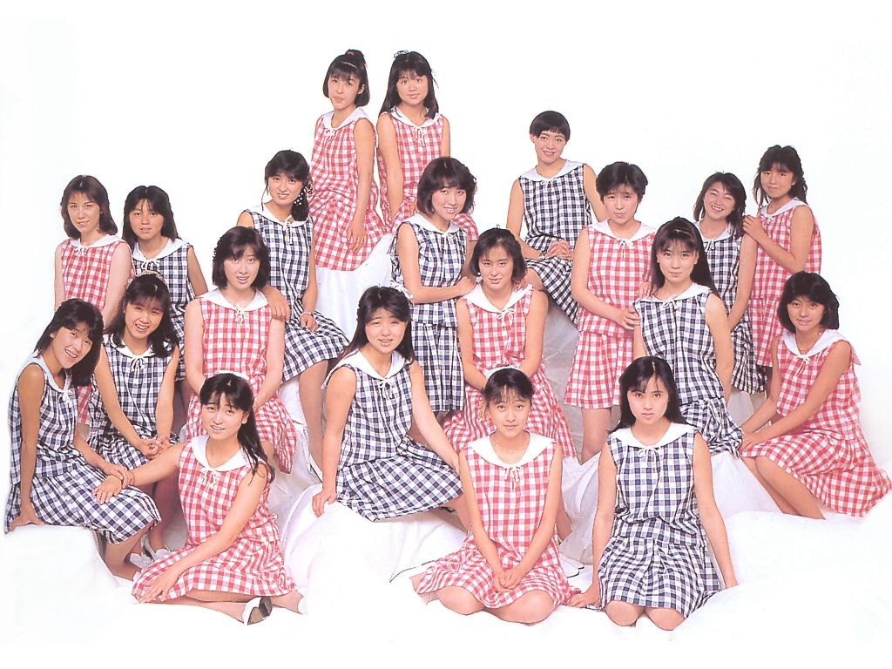

The girls of the Kitten Club from the 1980s

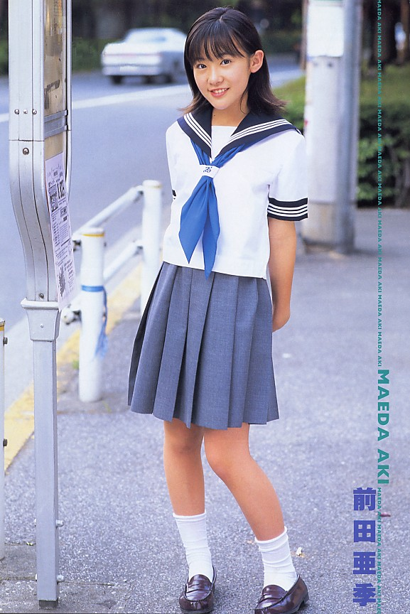

Young idol Aki Maeda wearing seifuku in a photobook. She later starred in Battle Royale (2000)




Cute Hello Kitty

The cute but magical Sailor Moon



The kogal style (short skirt, loose socks, tanned face, dyed hair) of the 1990s – disseminated through the girls magazine ‘egg’
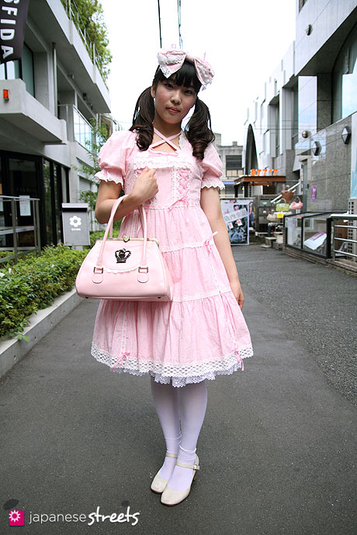

The Lolita style. Girls in such fashion styles often congregate in Harajuku in Tokyo, where they have become a tourist attraction


A schoolgirl fighting for survival from the film Battle Royale (2000)

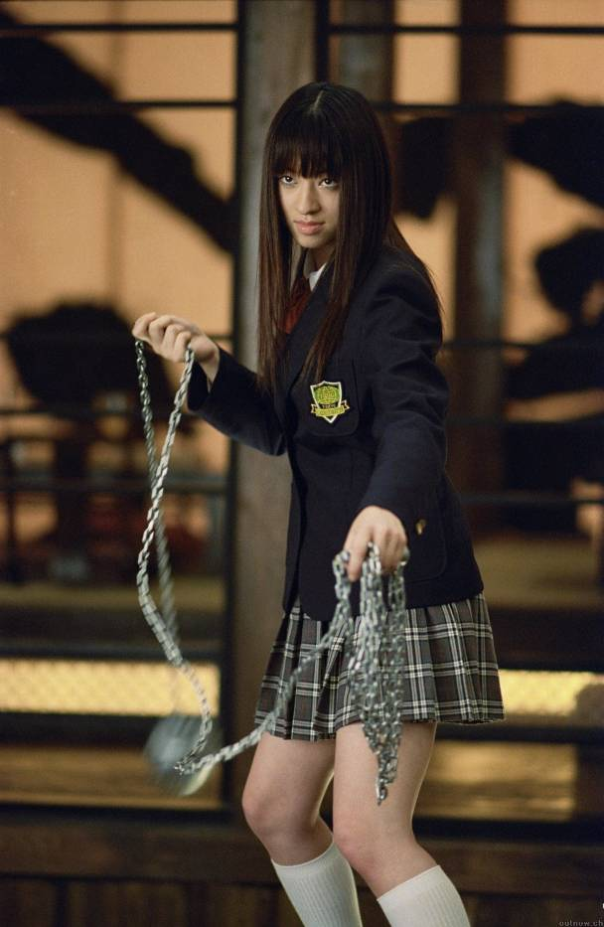

Chiaki Kuriyama as Gogo Yubari in Kill Bill Volume 1 (2004)

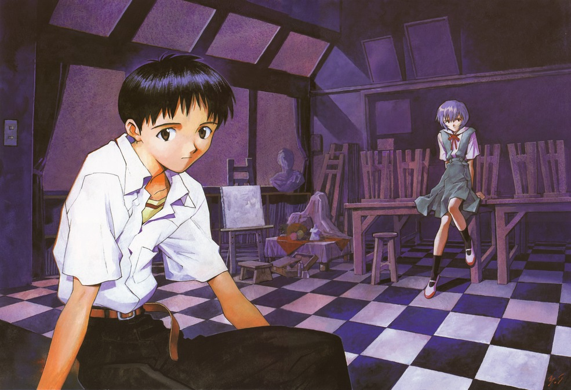

The withdrawn and self-doubting male lead Shinji Ikari in Neon Genesis Evangelion (1995-). The blue haired girl on the right, Rei Ayanami , is in fact an android.



The failed student male lead Keitaro Ushima in Love Hina (1998-), surrounded by the girls living in his Aunt’s female dormitory

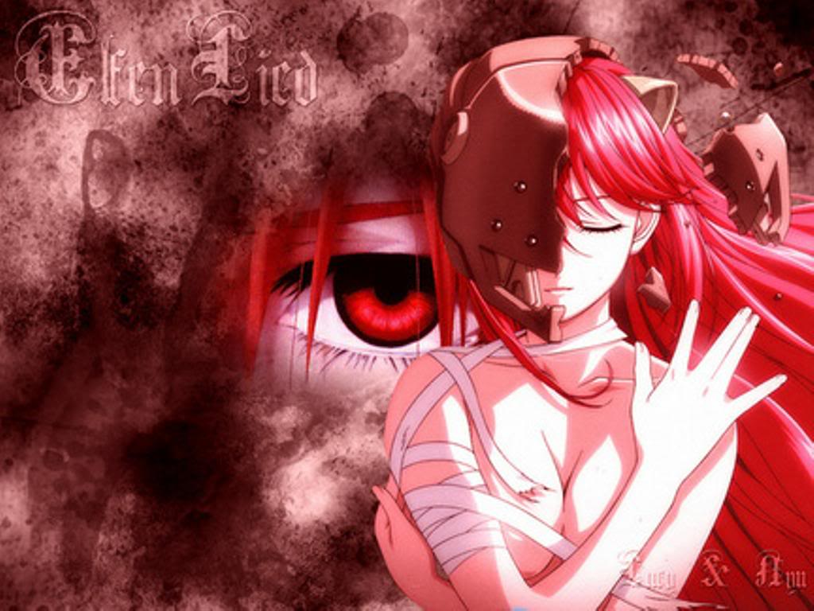

Lucy, the alien Diclonius, in Elfin Lied (2004)


A moe cat-girl

Picture Source

I have not yet sought copyright permission for any of these images.

Page 1
http://ia.media-imdb.com/images/M/MV5BMTY3NDYzNDI5NF5BMl5BanBnXkFtZTcwODU2OTY1Mw@@._V1_.jpg
http://ia.media-imdb.com/images/M/MV5BMTI2NDMyOTI3N15BMl5BanBnXkFtZTcwMDU2ODgxMQ@@._V1_.jpg
http://ia.media-imdb.com/images/M/MV5BNTM2NDE2NjkwNF5BMl5BanBnXkFtZTcwODg2ODMyMQ@@._V1_.jpg
All from the Internet Movie Database (www.imdb.com)

Page 2
http://media.screened.com/uploads/0/34/65823-omocha_large.jpg

http://cfile27.uf.tistory.com/original/161085124CC84D072AA4E5
(from webpage http://electronica.tistory.com/tag/Onyako%20Club)

Page 3
http://gallery.nihon-zone.com/d/19678-1/maeda_20aki01.jpg
(from webpage http://dersonatas.net/actors-7_Aki-Maeda.html)
http://dsmedia.ign.com/ds/image/article/900/900450/hello-kitty-daily-20080820040144113.jpg
http://sailorsite.webs.com/photos/sailormoon-serena-usagi/SMoon.jpg

Page 4
http://2.bp.blogspot.com/_0zjA-Tar8EY/TMNFtuHSufI/AAAAAAAAD9U/E28pe4v-5OA/s1600/kogyaru.jpg
(from webpage http://wonderland-sweet.blogspot.com/2010/10/kogyarutrend.html)
http://www.japanesestreets.com/media/3068.jpg
(from page http://www.japanesestreets.com/photoblog/1072/misa)

Page 5
http://2.bp.blogspot.com/_C_8M2WVWfgM/TUg3GGhn95I/AAAAAAAAIaI/eiIUmaRBZw8/s1600/Battle_Royale_19.jpg
(from webpage http://www.filmforager.com/2011/02/batoru-rowaiaru-battle-royale-2000.html)
http://chiaki-kuriyama.zanlius.com/images/chiaki_kb02a.jpg
(from webpage http://chiaki-kuriyama.zanlius.com/images/kbpromos.html)

Page 6
http://i-d.animepaper.net/thumbnails/preview/60817/1/%5Banimepaper.net%5Dpicture-standard-anime-neon-genesis-evangelion-shinji-and-rei-60817-madoshikurefu-preview-04f8599c.jpg
(from webpage http://www.animepaper.net/art/60817/shinji-and-rei)
http://s406.photobucket.com/albums/pp141/Joseph_james_stephens/anime/?action=view&current=love_hina_6.jpg&newest=1

Page 7
http://img.photobucket.com/albums/v431/Zack_TKWei/EflenLied.jpg
http://i305.photobucket.com/albums/nn236/kyothecat35151/Cat_girls/1.jpg

