Oceanic Negroes: Communicating Pacific Blackness Down, Out, and Under

Accompanying Multimedia content:
“We were all Black”
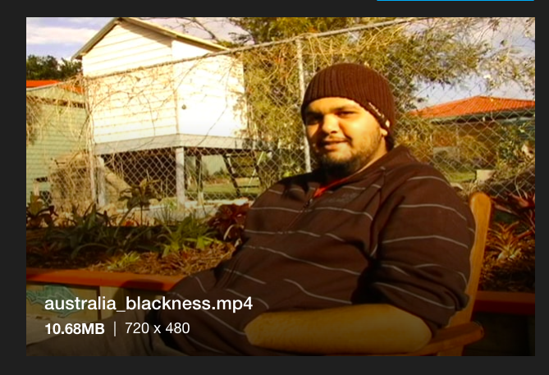
https://vimeo.com/356457346

