Laeeq Khan, PhD
School of Media Arts & Studies,
Scripps College of Communication
Ohio University, Athens, OH 45701
laeeqk@gmail.com

Dr. Larry Gross
Editor, International Journal of Communication

June 09, 2020

Dear Professor Gross,

I am pleased to submit an original research article entitled “Public Engagement Model (PEM) to Analyze Digital Diplomacy on Twitter: A Social Media Analytics Framework” to be considered for publication in International Journal of Communication. The research is timely and relevant in understanding social media engagement of German ambassador in Pakistan.

We gathered Twitter data and conducted textual and thematic analyses to understand the ambassador’s tweets. We present a public engagement model (PEM) for social media communication. Our analysis revealed eight tactical themes: democracy, politics and law, society and culture, conflict and violence, personality, environment and health, economic and social development, personal life, and embassy affairs. Findings of this research can prove to be a guide for international diplomatic communication and public engagement using social media.

The research reported in the manuscript has been self-funded, and meets all ethical guidelines & legal requirements. There are no financial interests or benefits arising from the direct application of this research.

It is also confirmed that this manuscript has not been published and is not under consideration for publication elsewhere. I have no conflicts of interest to disclose.

Thank you for your consideration.

Sincerely,

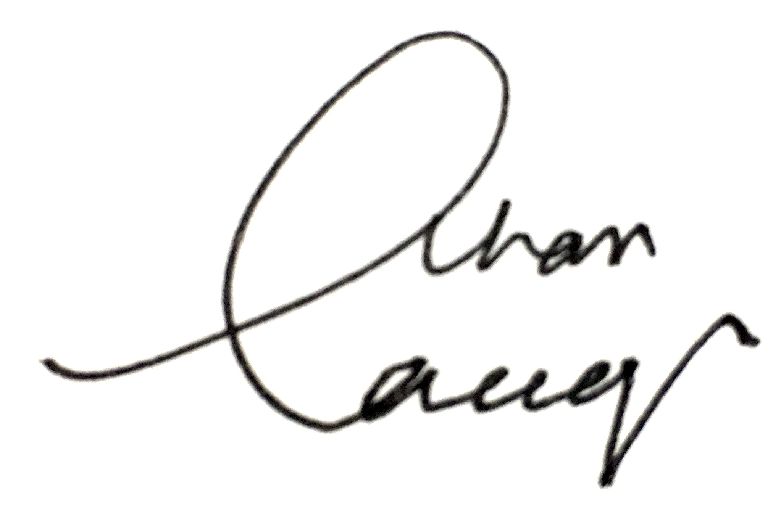
Laeeq Khan, Ph.D.
Assistant Professor, School of Media Arts & Studies
Ohio University

