**Table 1**

Specific Literary Practices Based on FGDS

|  |  |
| --- | --- |
| Technical Competency | I know how to create an account on social media. |
| I know how to delete my account on social media. |
| I know how to deactivate my account on social media. |
| I know how to post content, such as photos, on my social media account. |
| I know how to remove unwanted content on my social media account. |
| I ask others for help when I use social media. |
| Social Relationships | I know the copyright laws governing social media platforms. |
| My posts can be interpreted wrongly by others. |
| What I consider harmless remarks might offend other social media users. |
| Most users only post positive information about themselves. |
| I know the line between funny and offensive posts. |
| I know the differences between different social media platforms. |
| I know how to appropriately handle conflicts in social media. |
| I am aware of my organization’s social media policy. |
| I know how to control how much time I spend on social media. |
| I put much consideration into who I add into my social media network. |
| Informational Literacy | Not everything I read on social media is correct. |
| I know how to search for information on social media. |
| I know how to verify whether what is shared on social media is correct. |
| I know how to use different sources of information to verify information I see on social media. |
| I can tell whether an information on social media is true or false. |
| Privacy Management | I know how to control what posts I see on social media. |
| Social media sites such as Facebook control what I see on social media. |
| I know how to control who gets to see what I post on social media. |
| I know how to control who gets to see my personal details on social media. |
| I cannot always control what other users see from what I do on social media. |
| I know how to protect my account from hackers. |
| I know how to block particular users from being able to interact with me. |
| I know how to block unwanted information from being sent to my account. |
| Everything I do on social media can be tracked. |
| Information that I post on social media is permanent. |
| The advertisements I see on social media are specifically targeted to my preferences. |

*Note.* These statements were identified from focus group discussions with 62 participants.

**Table 2**

14-item PSML: Items and Factor Loadings

|  |  |
| --- | --- |
| How much do you agree with each of the following statements? | Loading |
| *Factor 1 – Technical competency* |  |
| *T1* I know how to create an account on social media | .88 |
| *T2* I know how to delete my account on social media | .86 |
| *T3* I know how to deactivate my account on social media | .86 |
| *T4* I know how to post content, such as photos, on my social media account | .81 |
| *T5* I know how to remove unwanted content on my social media account | .72 |
| *Factor 2 – Social relationships* |  |
| *S1* I know the copyright laws governing social media platforms | .81 |
| *S2* I know how to appropriately handle conflicts in social media | .68 |
| *S3* I am aware of my organization’s social media policy | .85 |
| *Factor 3 – Information literacy* |  |
| *M1* I know how to verify whether what is shared on social media is correct | .91 |
| *M2* I know how to use different sources of information to verify information I see on social media | .85 |
| *M3* I can tell whether an information on social media is true or false | .82 |
| *Factor 4 – Privacy awareness* |  |
| *I1* Social media sites such as Facebook control what I see on social media | .67 |
| *I2* Information that I post on social media is permanent | .85 |
| *I3* The advertisements I see on social media are specifically targeted to my preferences | .77 |
|  |  |

**Table 3**

Sample Characteristics

|  |  |  |  |
| --- | --- | --- | --- |
|  | Study 2 (Jun 2017) | Study 3 (May 2019) | Study 4 (Dec 2019) |
| Age | 34.98 (SD = 11.26) | 40.83 (SD = 15.07) | 40.39 (SD = 12.26) |
| Gender | 50% male | 48% male | 50% male |
| Education | 1.5% primary school  17.4% secondary education  32.7% with Junior College, Polytechnic, or IB  38.1% with bachelor’s degree  10.3% with master’s or PhD | 1.5% primary school  18.4% secondary education  30.3% with Junior College, Polytechnic, or IB  40.8% with bachelor’s degree  9% with master’s or PhD | 1.9% primary school  15.5% secondary education  26.7% with Junior College, Polytechnic, or IB  45.3% with bachelor’s degree  10.6% with master’s or PhD |
| Income | 5.8% Less than $1,000  36.5% $1,001-5,000  39.1% $5,001-10,000  18.6% above $10,001 | 4.8% Less than $1,000  37.8% $1,001-5,000  37.9% $5,001-10,000  19.5% above $10,001 | 5.4% Less than $1,000  31.9% $1,001-5,000  42.2% $5,001-10,000  20.5% above $10,001 |
| Social Media Use | 2.98 (SD = .71) | 3.02 (SD = .76) | 3.00 (SD = .78) |

**Table 4**

**PSML and Demographics**

|  |  |  |  |  |  |  |  |  |
| --- | --- | --- | --- | --- | --- | --- | --- | --- |
|  | PSML Components | | | | | | | |
|  | Technical | | Social | | Informational | | Privacy | |
|  | *β* | *t* | *β* | *t* | *β* | *t* | *β* | *t* |
| Age | -.17* | -5.36 | -.04 | -1.29 | -.13* | -4.36 | -.19* | -6.25 |
| Gender | -.01 | -.33 | -.07** | -2.44 | -.08** | -2.74 | -.04 | -1.24 |
| Education | -.08** | -2.29 | .02 | .45 | .02 | .64 | .09** | 2.72 |
| Income | .12* | 3.51 | .09** | 2.77 | .05 | 1.45 | .09** | 2.70 |
| SM Use | .29* | 9.11 | .38* | 12.32 | .35* | 11.25 | .24* | 7.54 |
| *F* | 34.99* | | 45.82* | | 46.96* | | 40.58* | |
| *adjusted R2* | .14 | | .19 | | .19 | | .17 | |

*Note. \**p *< .001; **p* < .05

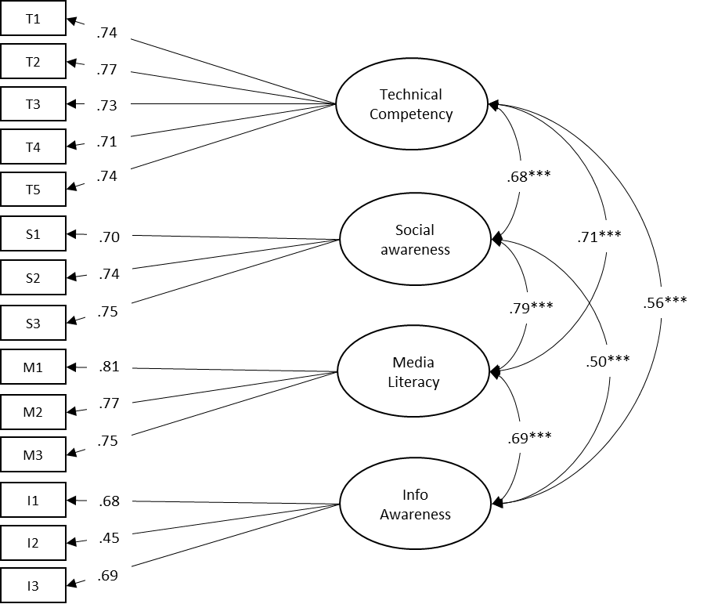

***Figure 1.***CFA illustrating the factor loadings and correlations between the latent variables in the hypothesized measurement model. Satorra-Bentler *Χ2*(71) = 249.504, *p* < .001; CFI = .96; NNFI = .95; RMSEA = .06, SRMR = .04. \*\*\**p* <.001.