Striking by Telegram, Avatar, and Geotag:
Changing ICT Landscapes of Virtual Protest in India

WINIFRED R. POSTER
Washington University, St. Louis, USA

Protest is often very much about place, even when it is virtual. This is apparent when examining virtual strikes via India over the last century: a telegraph strike in 1908, a SecondLife strike in 2007, and a strike on Firechat, Instagram, and other platforms in 2019-20. This historical view reveals how Indian protestors who challenge the hegemonies of technology—from signalers, to software engineers, to data rights and anti-racism activists—have been engaged in virtual strikes for over a century. In common, they have been linking physical, network, and digital landscapes as a key part of their strategy. Through this, they do the critical work of co-producing place in virtual strikes.

Keywords: India, labor, strike, virtual protest, telegram, SecondLife, landscape

With the prevalence of technological-determinist and universalist thinking (especially in the US), “place” is often lost in the discussion of activism through ICTs. Actions like tweetstorms and online petitions appear to function without the need for a location. Likewise, virtual protest may be interpreted as a phenomenon of the contemporary era only. In general, ICTs for social change may seem like they are decontextualized, and that the very definition of a virtual protest is an action that has neither a place nor a history.

This article challenges such narratives on two interrelated accounts, to argue that: 1) protest is very much about place, even when it is virtual, and 2) technologies of protest are embedded in locally and historically articulated configurations of hegemony. With a focus on India across a period of roughly 110 years, this study looks at the changing contours of three particular “virtual strikes”: a telegraph strike in 1908, a strike in the multi-player online game Second Life in 2007, and a strike executed via tag and mesh networks on platforms such as Instagram and Firechat in 2019-20.

Events in India illustrate the need to conceive of virtual strikes in a manner that analyzes social movement tactics in relation to situated hegemonies: as collective actions that challenge tech institutions, by actors who are directly affected by them, and through the use of ICT tools provided by these very institutions. Hence, an historical view reveals how everyday people in India who are marginalized by technology—from telegraph signalers, to software coders, to data rights and anti-racism activists—have been engaged in virtual strikes for over a century. Each virtual strike in India represents the changing technological hegemonies of elites, ICT infrastructures of protest, and creative responses by social movement organizers. Moreover, these cases reveal how three kinds of protest spaces have been integral to these events. Virtual strikers link together and generate physical landscapes, network landscapes, and digital landscapes. Following theorization by Della Porta and Fabbri (2016), I argue that this reflects a dynamic of producing place in social movements.

The first section below reviews the literature on virtual strikes, social movements, and technology. The discussion then turns to the context of India, and presentation of the three cases. The conclusion addresses some of the benefits of striking virtually as well the barriers. Themes of early strikes return over the years, including their imageries, devices, tactics, and legal afterlives. An ironic twist is that an action used by workers in 1908—a shutdown of networks—later becomes a tactic of the state.

Conceptualizing Virtual Strikes

As a researcher of India’s ICT industry over the past few decades (Poster, Forthcoming), I have come across repeated accounts of “virtual strikes” and wondered: Why are participants, scholars, and first-hand observers using this term? What does it mean to them? And why is it happening in the context of India? A virtual strike can be conceptualized as an event that challenges tech institutions, by actors who are directly affected by them, and through the use of ICT infrastructures as protest tools. Such events are “virtual” in the sense that they generate a grouping of solidarity through the communications, and in some instances, they recreate embodied features of “co-presence” and being with others in a strike (Earl & Kimport, 2011). For instance, Upchurch and Grassman (2016) describe a practice of “striking through social media.” Workers use Facebook posts and Youtube videos to publicize grievances, gain public support, and pressure elites. Della Porta and Mosca (2005) describe “netstrikes” in which anti-globalization protestors log onto at an official website (like the World Trade Organization) at the same time, overwhelming the system, and jamming its entry. In what would now be called a distributed denial of service, activists create a digital roadblock to prevent use of that site through their collective assembly.

However, my selection of cases suggests that the historical boundaries of the virtual strike can be pushed by considering how the electronic media undergirding them go beyond contemporary social media, all the way back to telegraphy. What unites the events labeled virtual strikes in this paper is that they form an opposition to hegemonic institutions of Tech and its systems of control and oppression. Technology is not just a tool for these activists—it is (at least) a part of why they are organizing to begin with. Strikers’ engagement with material devices (including their hardware and software), along with the data and communications that run through them, is tactical. It demonstrates the unexpected strength of marginalized groups vis-a-vis tech elites and institutions. Significantly, such tactics involve “repurposing” ICT infrastructures of elites by activists and using them for their own aims (Hoyng, 2014).

What interests me for the present study is how virtual strikers, as they mobilize and intervene in the infrastructures of virtual communications, use and create place. Indeed, social movement scholars have been noting the complex “interweaving” of ICTs, protest, and space (Hoyng, 2014). Analyzing global protests of 2011, Castells observes (2015, p. 250): “While these movements usually start on the Internet social networks, they become a movement by occupying the urban space... The space of the movement is always made of an interaction between the space of flows on the Internet and wireless communication networks, and the space of places of the occupied sites and of symbolic buildings targeted by protest actions.”

Similarly focused on the hybridization of movement space, Constanza-Chock (2014) has analyzed practices of “transmedia organizing” that are common in bottom-up movements. These strategies bridge media platforms and incorporate varying technologies, while simultaneously emphasizing face to face communication and taking part in walkouts. Oppositional groups like Anonymous (Coleman, 2014) also reveal this hybridized, transmedia organization, as they challenge financial institutions and their accumulation of power through technology in the US. Their movement merges online and offline tactics, by infiltrating network servers, rummaging through informational databases, and occupying Wall Street. This example highlights the interweaving of ICTs and urban space in tactical “weapons of the Geek.”

Insightful for conceptualizing the multi-dimensional elements of place in social movements is work by Della Porta and Fabbri (2016). They review and synthesize theorizations of place in protest: sometimes in structural terms as the location of where an event occurs in material space; other times through its representational dimensions, as in the signs, symbols, and sense of what a place means for the movement. Interaction between one and the other, furthermore, is yet a third element in the constitution of place. Della Porta and Fabbri astutely conclude that utilizing these various dimensions is how social movement actors “produce” spaces of protest.

Drawing on this framework, I show how place is co-produced in virtual strikes. It happens in this study as the strikers interact with three kinds of geographies. The physical landscape refers to the locational space. This is where the striker has her/his feet on the ground—in the immediate area of the protest site, as well as the larger national space where it is occurring. The network landscape is infrastructural space. It is the geography of ICT hardware points, which are often linked through nodes of stations, hotspots, etc. These are the material devices that connect the striker to the network, and more importantly, other strikers to the collective. This network is not just a tool for organizing protest—it can also be an end goal and target of activism.

Digital landscapes are the communicative spaces of virtual strikes. These are the informational sites where protest happens, appearing in the form of textual, visual, or graphical representations. Pre-digital landscapes may be electronic and wired, if not yet computer-driven. At times, digital landscapes are meant to mirror protest spots in the physical landscape (i.e., as technological counterparts). But not always. As I show here, they can be qualitatively different and even independently functioning.

My argument is that strikers are the intermediaries who weave these landscapes together. In this role, they do the work of making place in virtual protest. It involves generating, reconstituting, and/or reappropriating spaces in each landscape. And it involves connecting the landscapes together.

Virtual Strikes “Via India.” My research is set in India as a national socio-geography. This setting shapes the patterning of where participants are recruited and where protest happens on the ground—the linkage of offices, stations, streets, cities, etc.—which are not random dispersedly, but instead highly structured. India is informative for looking at virtual strikes, as it has often been at the crossroads of technology and social movements. On one hand, India has become a world leader in the ICT industry. It is a producer of software programming, communications services, and datafication systems for the global market, as I will outline. On the other hand, its history includes massive and successful mobilizations. The scale of these events is magnified in part by India’s population, which is the second largest in the world at 1.3 billion people. Regarding ICTs in particular, Indians have been at the forefront of resistance to hegemonies of science under colonialism (Abraham, 2006; Baber, 2001), as well as critics of ICT infrastructures of the global north under post-colonialism (Shiva, 2000).

However, situating my analysis in India takes me beyond the national boundary itself. Following Hoyng’s approach of examining “connections running ‘via Asia’ that touch ground in Asia but that also produce the spaces of Asia and beyond” (p. X), this study takes India as a starting point through which to view the wider spread and impact of ICTs movements. This happens in all three insurgencies, as the Telegraph strike opens out to neighboring countries across South Asia; as the IBM strike connects Indian activists to those in Europe and the US; and as strikes against the Indian state gain support from diasporic activists abroad. This affirms arguments of Della Porta and Fabri that the very work of producing place—through the aid of communication infrastructures—helps to make those movements transnational. Furthermore, India matters for its social positioning in global politics as a former colony and contemporary grouping in the global south. These hierarchical and postcolonial relations shape the motivations for protest at the outset, including their ICTs as “infrastructures of empire” (Aouragh & Chakravartty, 2016).

Examining India and its global relations, my analysis unpacks locally and historically articulated configurations of tech hegemony, as they have shifted throughout the colonial and postcolonial periods of Indian history. Changing societal institutions have governed ICTs vis a vis the public. The analysis explores the way such systems were deployed by administrators of the British empire, then by multinational IT firms in India’s liberalizing economy, and then by the Indian government itself though policies of datafication, labor, and citizenship.

Activism by Indians at each stage takes the form of virtual strikes against the regime in question. Thus, my cases represent critical junctures in the network landscape of protest, when organizers use: the telegraph to shut down a colonial communication network; the personal computer and Internet to protest a global tech firm in its own virtual buildings; the mobile phone with its apps to create a mesh network and subvert a state Internet blackout. As the devices transform, the scope of participants changes as well. It is not coincidental that the protest actors and the social movements they participate in become broader over time. In the early cases, to be a virtual striker is most accessible to (or only possible for) a relatively elite group—like ICT workers who were introduced to these systems for their jobs. Later on, this role is open to a larger portion of the public by virtue of the diffusion of mobile computing. In turn, their diverse concerns about hegemonies of technology are expressed through virtual strikes.

Overall, the goal of this analysis is to understand how place is constructed in the virtual strikes happening “via India.” I ask what instances of virtual strikes are organically emerging from the Indian ICT context, and how they represent particular tech hegemonies, infrastructures, and movement strategies. My aim is not to align “similar” cases that can remain “constant” along certain variables. Rather, I am precisely interested in the unevenness of these strikes in terms of whom or what they target at different points in history and who gets involved in them. Most intriguing to me is how, despite these differences in the events, “place” is repeatedly invoked, and how it is reconstituted through tactical use of ICTs to subvert particular locally and historically articulated tech hegemonies. Table 1 summarizes the place-producing dimensions of the three strikes that I will discuss in detailed manner below.

Table 1. Co-producing Place in Virtual Strikes via India over the Past Century
Tech Hegemonies in India and Protests Against Them | Strike against British Empire  (1908) | Strike against US Tech Firm IBM  (2007) | Strikes against Indian State Policies  (2019-20)
Strikers | Signal, Peon, and Other Telegraph Workers | Software, Engineering, and Other ICT Workers | Tech Workers Alongside Multisector Labor, Citizenship, and Data Rights Activists
Physical Landscape | Telegraph Stations Dispersed Across India and the Empire | IBM Offices—in India, Italy, and Other Countries of its Multinational Corporate Territory | Public Spaces in Cities  across India: Streets, Plazas, Town Centers, Universities
Network Landscape | Connections of Telegraph Machines | Connections of Desktop Computers (and their Programs) | Connected Hotspots through Mobile Phones and their Apps, Forming a Mesh Network
Network Landscape | Connections of Telegraph Machines | e.g., Second Life | e.g., FireChat, Signal, Instagram, and Telegram
Digital Landscape | Coded Text-based Messages Sent Across the Telegraph | Graphical Worlds:  Union Island, IBM Buildings | Images, Hashtags, Maps, and GeoTags of Protest Sites Posted on Social Media
Integrating Diverse Landscapes  to Co-Produce Place in Protests | Using Information Flows within the Network to Shut it Down | Inhabiting Avatars and Moving in Digital Space to Upload Tactics of Street Protest (Demonstrations, Sit-Ins, and Disruption of Corporate Meetings) | Creating Communications Networks Under Conditions of Internet Shutdown;  Digitally-Tagging Images of Rallies on the Ground, in order to Extend an Action across Time and Place

Striking by Telegraph: Protests Against the British Empire

We think of virtual striking as new, but India shows us such an event that happened in the early twentieth century—through the telegraph exchange. This can be seen in the height of the British Empire, on the informational infrastructure that connected it together. It was done by the workers who stood by and operated the signal stations. While these activists may seem like they are non-digital, they showed us how early kinds of virtual strikers could use ICTs in highly organized and disruptive ways.

Historian Deep Choudhury (2003) documents this in the telegraph strike of 1908, as the “first strike of a virtual community.” The telegraph was a primary means of transnational communication for the British empire, and was the lifeline that held it together. As such, it represents a colonial infrastructure of technological hegemony. Its information system connected trading across nations which were spread out over what is now India, Pakistan, Bangladesh, Sri Lanka, Myanmar, Iran and Afghanistan, as well as across waterways like the Indian Ocean, Persian Gulf, and Bay of Bengal. Locally, this system was administered by the Indian Telegraph Department and its civil and military divisions, which would become the front-line target for opposition by its workers.

Signalers had a key role in overseeing the communication nodes at various points of this network. They were technically skilled in the language of dots, dashes, and spaces of Morse Code, but also the workings of the machines themselves (including their adjustments and repairs, and knowledge of electricity). They represented a select group of employees, at a time when ICT jobs were very rare and access to telegraph machines was limited.

But in 1908, there were significant changes in that labor process. This year marked a transformation of temporalities, as the British empire revised its methods of time keeping in India. They switched from local to Greenwich standard time, and from divisions of 12, to a continuous time scale with divisions of 24. This in turn increased work for signalers, doubling their load. Along with this were other bureaucratic changes in the labor process, as well as layoffs and pay cuts.

The Strike

In response, workers used the telegraph itself to protest these actions.
Choudhury notes how the signalers talked to each other through the telegraph. They formed a community of activism through their transmissions, much in the same way that virtual strikers do within contemporary forms of electronic media.

Critically, in addition, the signalers used the telegraph as a staging platform for the strike. They used coded messages for shutdown to organize work stoppages across several countries, and especially within India. With the message “diabolic 15,” they sent a signal to stop working. The stoppage rolled in succession across major cities: first Calcutta, then Bombay, then Agra, and so on (Figure 1). In some cases, the events also involved breaking or fusing the main lines, walking out, or passive resistance in the form of ignoring work.

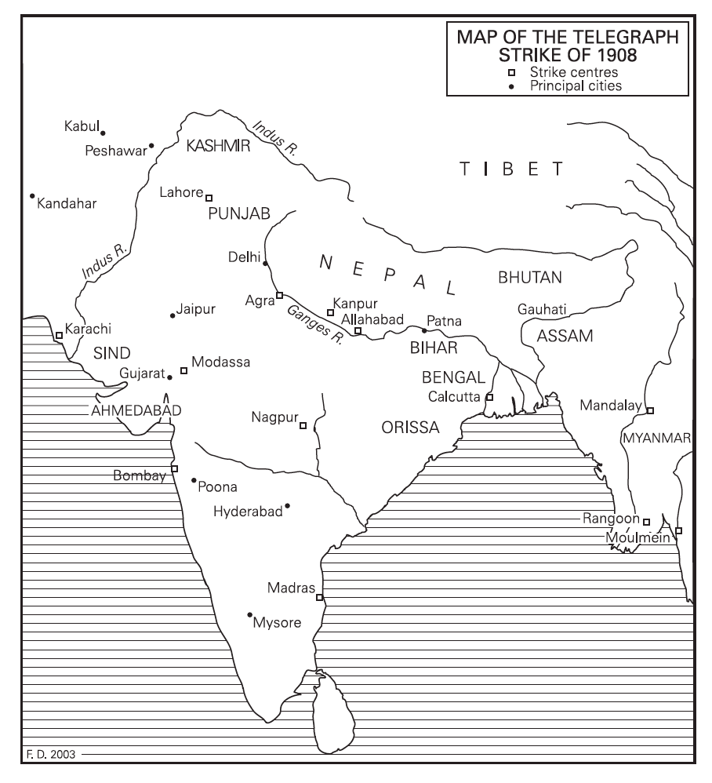
Figure 1. Map of the telegraph strike (Source: Choudhury, 2003)

The impact was manifested in pileups of messages at each station—and delays: “delay meant the unified world time and the global world market were in jeopardy.” The administration was more concerned with transmission and motion than with posts and stations. With the pileup, the messages didn’t get a time and date stamp: “The disappearance of date and time of dispatch from telegrams seemed to threaten the very basis of the need for rapid communication.” Merchants were outraged—especially in delays to opium shipments.

Within twelve days, the strike was over. The government instituted a 20% pay increase. Aside from the material gains, the strike reflected a case of cross class and ethnic unity—between the delivery workers, peon workers, and signalers.

Implications

With this event, strikers took creative steps to co-produce place, and it was done by interfacing with three types of landscapes. Signalers took advantage of their physical landscape (i.e., the geography of the British administration in and across India) to reconstitute the network landscape (i.e., the mapping of stations and their telegraph machines) for their own activist purposes. In the process, they transformed the nodes of the communications system into geographic points of a resistance space.

Throughout, the informational (or pre-digital) landscape was pivotal for carrying this out. Electronic transmissions of telegram messages, and the communications passed within them, were crucial for this event at many stages. They helped to create solidarity among disparate signalers. They helped in planning by passing information on how to organize the protest. They were central for the core action of the shutdown itself, which was triggered by the receipt of successive coded messages. And on top of all that, the messages were—in symbolic terms—the goal or target of the event, in terms of disabling the entire network and future telegrams sent between colonial personnel. In short, this strike could only be achieved through the strategic interweaving of all three landscapes – and their agencies of place.

For India, this was a joining of forces of telegraph workers from around the country, and further in South Asia as well. They used their own technology on the “shopfloor” to resist the British administration. It is a remarkable example of using the empire’s own infrastructure to undermine its lifeline—the flow of information that is essential for its coordination of colonial rule. In a subversive act, signalers repurposed the very means of ICT production against elites.

The telegraph strike was a successful event, for a focused issue. And it was only one of many by the signalers. But significantly, we’ll see below how their tactics—shutdowns of information infrastructures—can be picked up by elites, and used against Indian protestors themselves.

Striking on Second Life: Protests Against IBM

The postcolonial era in India introduced another set of hegemonic institutions regarding technology. The state became an independent entity, but its opening of the economy to foreign investment led to the rising influence of global actors such as multinational IT firms. Instead of the British then, the new transnational authorities would be US tech giants like IBM. Ironically, the physical landscape of their subsidiary outposts would be reappropriated by strikers as a global tool for organizing against them.

The Internet and personal computer would become the defining ICT infrastructures for virtual striking. With these network landscapes, activists encountered the popularity of virtual worlds and explored the idea of holding events there. Their events would mimic protests in the streets, as organizers began to upload grassroots rallies and sit-ins to entirely digital spaces.

This is illustrated in a strike against IBM by its workers on Second Life in 2007. Indians participated in a global action against a common multinational IT employer, via a platform which connects Indians transnationally to fellow IT workers. With its graphical interface and an immersive online “world,” Second Life would serve as a digital landscape for strikers to gather collectively despite their distance, infiltrate elite spaces, and disrupt the routines of high-tech elites.

IBM’s Global Reach—in India and in Second Life

IBM has a unique history in India that dates back to the 1970s. It was an early champion of ICT outsourcing and taking advantage of lower labor costs for technically-skilled workers in the global south.

Notably, after the Indian state’s restructuring policies, IBM expanded its presence there to become the largest of its workforces outside the US (Goel, 2017). Furthermore, the year of the strike—2007—would be another tipping point. Waves of layoffs and downsizing in the US, combined with a surge in outsourcing abroad, would change the map again. Now the Indian branch would become its largest workforce worldwide. Yet Indian workers would be treated differently than others. Wages for Indian-based IBM employees are estimated to be one fifth to one half of those in the US offices.

As part of their expanding influence, IBM extended their presence virtually as well —into Second Life. Second Life (of SL for short) is a “3D interactive environment,” where hundreds of thousands of players per month gather. It is an example of what industry insiders call a massive, multi-player online game (MMOG). While it is a leisure or entertainment arena for some, it has many of elements of a full-fledged world—including people, countries, and firms. Many of these Second Life elements are paired with real life counterparts.

Accordingly, many businesses have representations of their firms in SL. This was the case for IBM, which has several buildings in Second Life. Their managers hold meetings with employees at the IBM headquarters in Second Life (Figure 2).
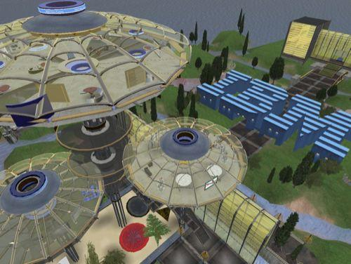

Figure 2. IBM Property on Second Life (Source: UNI, 2007)

Along with other premier tech companies in India like Wipro, IBM India uses Second Life to do things like hiring and training. For South Asian technospaces, this has cascading effects: “the very fact that these big companies have announced their presence in Second Life draws more young job seeking Indians and other Asians into Second Life, thus changing the cultural, visual, and interactive climate within this three-dimensional reality” (Gajjala, 2010, p. 531).

Moving Street Protest from Physical to Digital Landscapes

I became aware of the SL strike while conducting fieldwork in India and interviewing members of IT unions, including UNITES Pro. Their global partner, Union Network International (UNI) based in Switzerland, was organizing a transnational event to support fellow IT workers at the Italian branch of IBM. Workers there reported that managers were refusing to pay decent wages and benefits, and moreover, rescinding part of their salaries during wage negotiations. Several unions stepped in to mediate and organize, including the local union affiliated with UNI, Rappresentanza Sindacale Unitaria (RSU) IBM Vimercate. This is when they took to Second Life to stage part of their protest.

Given the reach of IBM around the world, Indians would have a relatable experience to its employees in other locations, in terms of being the global workforce for ICT outsourcing. So it is not surprising that workers from India—along with those from many other countries—joined as an act of global solidarity with their colleagues in Italy. UNI organized the strike in less than a month. It started with launching a media campaign worldwide and creating a strike kit in multiple languages. This taught members how to use Second Life, set up a membership account, and create an avatar.

Critically for this analysis, organizers created their own “land” in SL. UNI set up a Union Island (Figure 3), to be a “virtual home for all trade unionists around the world.” They valued SL as “a place to hold open and protected virtual meetings,” its “free decent instant translation tools,” and as “an alternative to phone, email, fax, letter, Skype and MSN: getting in touch with UNI and other union organisations through a virtual office.”



Figure 3. Union Island on Second Life (Source: SL Unions, 2007)

Then on September 27, strikers convened for 12 hours in front of IBM offices on Second Life. They held picket signs saying things like “Join the First Ever Virtual Strike” (IBM SL Protest, 2007). Worker-avatars also conducted sit-ins in IBM offices. They disrupted online staff meetings, by “teleporting” into a virtual session of IBM officials in their Business Center (Figure 4). In all, 2,000 people-avatars participated in the event.

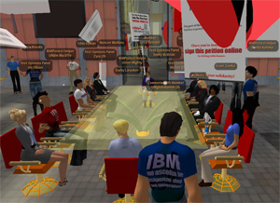

Figure 4. Strikers teleporting inside the IBM business meeting (Source: IBM SL Protest, 2007)

These actions had immediate gains. The union received several concessions from IBM. Managers opened new meetings with the union, reinstated the bonus, and negotiated a better deal for the workers. The action also led to a letter of reprimand from the IBM parent company in the US, and the resignation of the CEO of the Italian subsidiary. It had an impact on UNI organizing as well, with plans to use Second Life as a staging site for future virtual actions.

Creating a Space for Indian and Other Strikers to Participate

A major asset of this strike was enabling participation by activists from around the world—like those in India. One striker remarked on the welcome diversity of nationalities, including Indians: “I have no idea … if they are from Canada or India! But they all showed up, speaking many languages, demonstrating with the banners, all wearing colored IBM t-shirts.” Indeed, the online location enhanced the organizers’ ability to coordinate at scale and across borders. The event was transnational, involving unionists 30 countries (Figure 5).

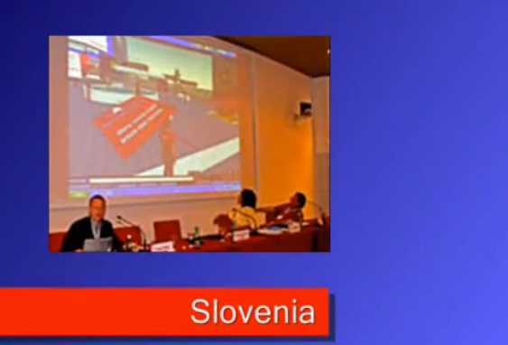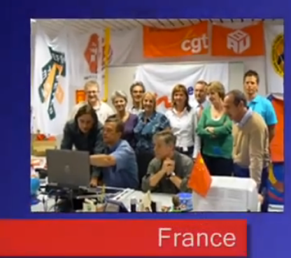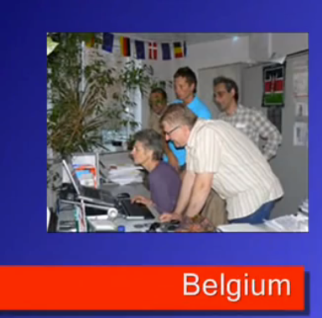

Figure 5. Strike participants around the world at their computers (Source: Union Network International, 2010)

The inclusion of Indians in the strike mattered for fostering global alliances among activists. Leaders of the strike announced how they were especially pleased to have Indians present (Banks, 2007): “this action will turn on the lights on the project of creation of a global union alliance, that is engaging the unions from [many] … countries worldwide, including the new IT boundary: India.” Furthermore, the success of the strike would impact Indian workers as well. Even if they weren’t the direct beneficiaries, a gain for the union at any single subsidiary could potentially open the door for wins at other locations of the MNC in the future.

Another asset was reproducing interactive elements of street protest within virtual spaces. More than any other case in this analysis, the SL strike offered an immersive experience of place—as if the person was “in” the live strike on the ground. One of the organizers posted in a blog about the strike:

… this is my first virtual protest! Surprising to notice how close to RL (Real Life) it really is... I’m in a virtual world, protesting outside IBM offices…
And people in Second Life are exactly as you’d expect them to be in the streets: SHOUTING slogans, jumping up and down, picketing and mingling. You have the quiet ones who sit on a bench and watch, the really original ones with funny outfits …, and the ones playing music and talking too.

SL provides an embodied experience that was visual, auditory, and affirming of “co-presence,” or the feeling of being together with other activists in the same place.

There are limitations to holding strikes in virtual worlds though. One is ICT accessibility. During this period, devices that could best handle the large memory and data requirements of Second Life software were desktop computers. This meant that participation was restricted to activists who could afford a PC (in Figure 5), and had skills or familiarity with online gaming. For India, this especially included software engineers and computer scientists—the upper tier of the tech workforce.

Another limitation is longterm organizing. In the case of Second Life, UNI shut down Union Island a few years later, citing a lack of resources for staffing it. Moreover, Second Life itself had been experiencing a declining membership even before this event was staged. For reasons like this, securing stable online venues for action will be an ongoing issue for activism.

Implications

The SecondLife strike shows how Indian and fellow protestors co-produced place in a particular way for the computer era. They made use of the physical landscape of IBM and its many subsidiary locations—in India and around the world—as a means of recruiting tech worker supporters. With this base, they fashioned a network landscape of desktop PCs, linked through software for SecondLife. This in turn enabled them to organize activities in a digital landscape of virtual IBM buildings and Union islands.

Strikers merged these three landscapes to create a unique space for the movement. It is a space where people can convene from different physical locations, and carry out protest actions that they couldn’t do elsewhere. But more importantly, SecondLife is a place where they can confront global institutions directly in the “buildings” they have created online. Strikers go there, in other words, to follow US tech companies. In all these dimensions then, the place of action on SecondLife is not just a mirror of an offline location, nor is it utilized just to reclaim or subvert a place on the ground. It is a qualitatively different place, reflecting how tech power centers—and the resistance against them—move to digital landscapes.

Striking by Digital Tag and Mesh Network: Protests Against the State

The 2010s in India would bring a shift in technological hegemonies, and another round of virtual strikes. In this period, the Indian state becomes a central actor in ICT authority over its own population. It shows its face with aggressive moves toward privatization, undercutting of labor standards, and promotion of ethnic division. At the same time, a series of policies would entrench a deep tech apparatus for the state vis a vis workers, students, consumers and citizens.

Strikers, on their side, would respond by turning the streets, public spaces, and transport systems of India into a physical landscape of protest. They would take advantage of a new ICT infrastructure—the cell phone and its apps—for virtual striking. Equipped with mobile technologies, they would generate network landscapes of protest through mesh networks as a means of coordinating ground-based protest during situations of state authoritarian control. Strikers would then fashion a digital landscape by interfacing their actions on the streets with online hashtags, geotags, and maps.

Converging Movements: Mega-protests erupted in India in late 2019 and 2020. They arose in parallel and at moments came to intersect. One was a national labor strike. This was a time-specific event, waged in opposition to rising prices, privatization of state industries, degradation of full-time employment, and decreasing recognition of unions. Their list of demands included addressing unemployment, enforcing labor laws, and raising the minimum wage.

This strike coincided with a longer series of protests over citizenship. The flashpoint was a set of ethnically discriminatory policies put forth by the state in 2019. They drastically reduced the pathways to citizenship for millions of immigrants, many of them Muslim. The Citizenship Amendment Act (CAA) banned citizenship to immigrants arriving after 2014 from three neighboring countries (Pakistan, Bangladesh, and Afghanistan) with Muslim-majority populations.

Significantly, the accompanying policies established a data infrastructure for carrying it out. The National Registry of Indian Citizens (NRIC, or NRC for short) is a count of legal citizens, and essentially a data-based tool for excluding ethnic minorities (Muslims, in particular, something not done before in India). It would be the digitized muscle of the CAA, enforcing a tiered citizenship regime.

All of this was concurrent to the development of an even broader tech infrastructure by the state, in its bid to enlarge authority over workers, consumers, and ethnic-minorities alike. The NRC would operate alongside other state information systems: the National Population Register (NPR), Census 2021, and “Aadhar” Universal ID, which is the largest state-based biometric database of population worldwide (Masiero & Das, 2019). Together, these databases link many kinds of personal information within centralized systems that are controlled by the government. Geevan (2020) notes that privacy protections are not included in many of these systems, and their scope signals the encroachment of a data “monster that the world has not seen.”

As overlapping events then, the two sets of strikes cross over in participants and in theme. Activists were mobilizing for rights of workers and ethnic minorities, but also for a pressing issue for the second decade of 21st century—data justice. We see this in how they describe their actions. Citizenship strikes were represented by rallying cries of racial equity, justice for Muslims, and “I am not your data.” Labor strike leaders affirmed how they were marching against what they consider to be “anti people and anti labor” policies by the state (Macleod, 2020)—including the citizenship and data policies.

Rise of the Cell Phone and Mobile Spaces of Protest

For activists, cell phones are transformative in that everyday people can use them, and they can do so in an untethered manner. While the telegraph strikers were fixed at their stations, and SL strikers at their chairs, cell phone strikers have a tool to carry and activate on the streets.

Revealing how technologies of virtual strikes come full circle, the names of apps used in these Indian strikes invoke metaphors of earlier devices. The texting app Telegram, for instance, memorializes the first widespread technology for text-based, electronic communications. Similarly, the photo-sharing app Instagram came about as an amalgam of “instant camera” and “telegram,” to convey the idea of sending images as fast as an electronic message. These reflect the historical legacy and continuity of infrastructures of communication that are, in turn, used within virtual striking.

With cell phones and apps, strikers can do more than just connect with others to plan or orchestrate an event, however. They do the work of co-producing place. Strikers can make their own network and digital landscapes based on their movements around the physical landscape of the protest site. Below I show how they do this first through mesh networks, and second through digital tags and maps.

Mesh Networks

Certain apps can turn cell phones into communication networks for protestors under conditions of Internet shutdown. By combining mobile bodies with these devices in their hands, strikers are able to generate a moveable geography of information that is (at least partially) outside the purview of the state and the telecom companies.

Turning off the Internet has become a habit for the Indian government. India holds the title of being “the Internet shutdown capital of the world,” even while announcing itself as the world’s largest democracy (Web Desk, 2020). It has become a go-to tool of the BJP administration, which has regularly shutdown the Internet to quell dissent. In 2019, the Indian government shutdown the Internet 106 times, in almost every state region (Software Freedom Law Centre, 2020). India has also held the world’s longest lasting shutdown.

Colonial era regulations permit the state in such actions (Hsu, 2020). Harking again back to the first case above, this comes from the Indian Telegraph Act of 1885. It established British control over India’s Telegraph lines. In 2017, the Temporary Suspension of Telcom Services Rule expanded its applicability to the Internet. Today, these laws give the state sweeping authority over Internet service providers, and the right to impose short-order shutdowns at regional and city levels with the click of an email. During the citizenship protests, the Indian state conducted shutdowns both preemptively and reactively, and on both cell phones and landlines (Software Freedom Law Centre, 2020).

Activists responded with the use of mesh networks. A mesh network is a peer-to-peer technology that enables people to communicate “off the grid,” or without the intermediary of a telephone company and its access points. Using special apps on the phone like FireChat, Bridgefy and Signal, users can communicate without cellular data or Internet access. Instead, the app functions through WIFI or Bluetooth connections, by acting like a cell tower or a two-way walkie-talkie. It searches for phones that have the same app operating, and that are within a certain vicinity (usually a couple hundred feet). Then it connects them (Figure 6). Various apps have different capabilities, but many enable users to text, send images and videos, chat within a virtual group, and / or make calls. Several have encryption features that help to protect against outside surveillance (Web Desk, 2020).

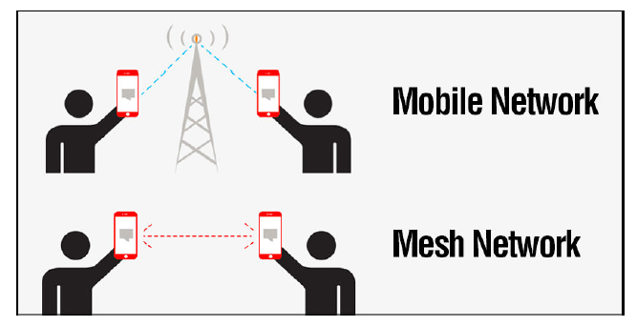

Figure 6. How a mesh network works (Source: Tengyuen 2020)

Immediately following the onset of the protests on December 13th, 2019, the downloads for these apps in India “skyrocketed” (Mihindukulasuriya, 2020). This happened with FireChat and Bridgefy, apps which create mesh networks through Bluetooth functions. They were available in India prior to the CAA protests, but by the end of that week, FireChat was downloaded 30,000 times—a 7,500 per cent increase over the previous week. Most of the downloads were in the city of Delhi where protests were especially large and volatile. The apps are sometimes faulted for limited geographic range and spotty effectiveness. Nonetheless, they have been praised for their utility. Even the former vice-president of Nasscom, India’s largest tech association group and frequent face of the tech industry, called them “invaluable.” Indeed, Nishant Shah discusses these apps as illustrations of how Internet shutdowns are “leaky” and have “human work-arounds.” I would add that this also happens in the course of deliberate and organized strategies of activism.

During the citizenship protests, activists used these devices to facilitate their organizing. They enable the collection of images and videos of abusive police officers, and the documenting of human rights violations for later reporting. In particular, mesh networks—in combination with encrypted social media apps—have many practical uses in countries where the state is punitive and surveillant. For instance, strikers can use a Telegram bot and other channels to collect real-time information and then map out what the police are doing: their locations of vehicles, use of tactical gear, and firing of tear gas. With this, activists can redirect their colleagues to safer areas (Stempeck & Teng, 2019). The ensuing digital landscape is a graphical representation of the protest site, for strategic use by activists as a defense against a militarized state.

Tagging Place

Another set of apps on the phone assist Indian strikers in co-producing place in their protests. They use platforms like Instagram and Twitter to create
digital tags for marking and building digital landscapes. Tagging place happens in a couple different ways.

One is by the name of the action. #BharatBandh is a hashtag for an all-India strike that occurred in January of 2020. It was #4 on the Twitter ranking for India on January 7, 2020. This national labor strike brought together 250 million workers for a two-day action across the country (Macleod, 2020). It was touted as the largest labor strike in history, only topping the country’s own record in 2010 of a strike with 100 million workers.

Significantly, technical workers like engineers and telecommunications employees participated alongside coal miners, aviators, and finance personnel. In coalescing workers across industries and sectors of the economy, ICT and otherwise, these strikes reveal the broadening base from the previous cases.

Tagging the strike gives it a representational presence online—as a step in carving out its virtual place. It is also important for recruiting participants and supporters to the site.

Another type of tag is the location where an event occurred. Particular sites become landmark symbols for the movement. One was at Jamia Millia Islamia University. Its students were early leaders in the opposition to the citizenship policies, organizing strikes across campus through marches and rallies. It happened at a historically inclusive university for students of diverse communities, particularly Muslims. Protests became violent on December 15th, 2019, when the police stormed the campus (Scroll Staff, 2019). They fired tear gas shells into buildings and beat the protestors, injuring 200 nonviolent student marchers (Phartiyal & Ravikumar, 2019). The severity of the police response became a sign to the rest of the country of the state’s abuse of power toward protestors. It affirmed how the policies about citizenship and data would have tangible implications for peoples’ bodies.

Entering the search term “#jamiamilliauniversity” in Instagram yields images, texts, and artifacts about the events (Figure 7). Even months after they took place, the “top posts” appearing on the screen for this hashtag are almost exclusively about the protest. In the upper right, there is a photo of students standing in a cloud of tear gas with the caption “another incident of firing at Jamia Millia University.” In the upper left, students at universities from around the country support the Jamia Millia protestors. Images show sit-ins and activists holding banners saying “BHU [Banaras Hindu University] Stands with Jamia.”

Students speaking about the protests around the country are featured in other posts. Captioned as “two powerful voices of the nation,” images show two women in front of a microphone, wearing Hijab headscarves, and with arms upheld in power. In the bottom left, there is a statement about how the country was more peaceful before the current Bharatiya Janata Party (BJP) government came to power. Counterpoint views are represented in the posts as well. In the upper left, a caption expresses agreement with the government and its stance on citizenship: “This government has guts to take bold steps for a better India. This image [of a protestor] says it all. Why we need NRC.”

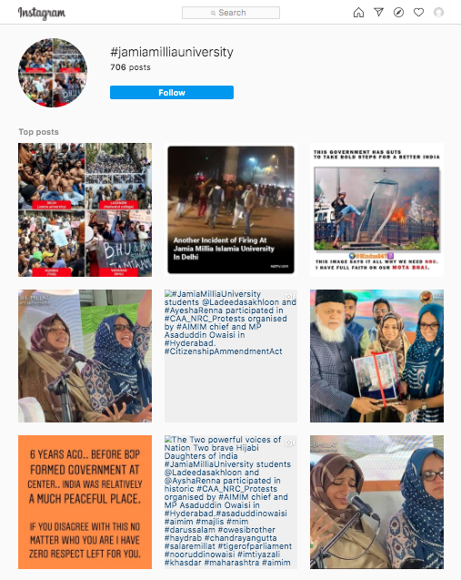

Figure 7. Instagram hashtag for protests at Jamia Millia Islamia University
(Source: Screenshots of Instagram mobile application, May 14, 2020)

Instagram hashtags for this event reveal the meaning of digital place (Pearl, 2018). A location’s name can represent the event online, and serve as a way of extending its life. People can make posts after the original event. And those who “travel” to those sites can see what it was like, its visual images, the intensity of the police crackdown, and varying opinions about the policy. It lives on in this digital space, regardless of where the viewer is geographically.

A similar reconstitution of space is being done on Instagram with geotags. Activists use cameras on their phones to take photos of sites where they are protesting. Location-identifying technology in the app then tags the address for each photo. When an Instagram user searches for a given location, they see a map with pin on that spot. Below it, they see posts from users about that place. Geotags represent a mapping strategy for constructing virtual space. By clicking on the tag, a striker can see the protest as a point on a digital landscape in relation to its physical landscape. They see not only the tag as a name or a picture, but as a literal representation of geography.

Furthermore, those tags become a searchable archive for other protestors within the platform. Making a tag adds to the number of people involved in a protest, magnifying its size. These tags can help to overcome challenges of momentum and longevity faced in SL. As an ongoing spectacle, they enable users to find like-minded activists, and organizers to advertise upcoming events to keep the protest alive over time.

In this way, Indian hashtags and geotags for places like Jamia Millia University can enable the citizenship protest movement to sustain itself temporally. The digital marker provides an anchor for viewers to re-experience the movement and invites others to engage in its actions.

Implications
These protests against the state reveal how strikers co-produce place by interweaving the three landscapes. They use the physical landscape to hold street-level marches and rallies, cutting off lifelines of transport for the state, and displaying their widespread support in cities around the country. When the state shuts down the Internet, strikers deploy network landscapes by installing their own cell phone-based “mesh” system of communicating.

Interfacing with those two landscapes of protest, strikers enact a third. They create digital landscapes to support their activities through tags, photos, and reports of protest sites on social media platforms. These elements help to reify a place online for a protest—giving it a name, a collective presence, images and markers of where it is on a map, and descriptors of the qualities of the event to activate the immersive experience of being in it. This digital landscape facilitates many stages of the life cycle of a protest: drawing people to a physical place by advertising events (before and while they are happening); mapping the site for medical pickups and police presence (in the midst of the event), and creating a digital space for returning to events (even after they have ended on the ground). In these ways, strikers do the work of co-producing place. They link the various landscapes together, deploying one versus another at different moments depending on the circumstances and timeline of the protest.

Conclusion

Virtual strikes via India over the last century have been very much embedded in and generative of place. Although if it may seem paradoxical that virtual events should have a place, three distinct spaces become apparent in these cases: physical, network, and digital landscapes. Each is equally important for strikers’ aims and strategies. Strikers flexibly use these landscapes as multi-dimensional tools which can connect a protest (e.g., walkout or production stoppage) to a material infrastructure (e.g., telegraph, cell phone mesh network), and an immaterial infrastructure (e.g., informational communities). In this process, virtual strikers are key agents, who incorporate the landscapes at different moments, in combinations, or all at once. They do the complicated navigational coordination which links various landscapes together, and thus the significant work of co-producing space for social movements.

This elaborates previous research on the “interweaving” of cyber activities of social movements with those on the ground (Castells, 2015). In identifying the various landscapes, and charting how they operate, this study underscores the value of recognizing how they work together (rather than studying them on their own). Signalers, for instance, used their digital landscape of telegraph messages for the goal of shutting down the network landscape of machines. In the other direction, alternatively, tech workers used the physical landscape of street protest to upload their organizing strategies onto the digital landscape of SecondLife, and then disrupt elites meeting there. My analysis affirms theories of social movements which argue for a hybridization of offline and online protest, and eliminating the boundary between them.

While underscoring the place-producing nature of virtual strikes, this analysis has focused on India as a way to foreground the changing configurations of tech hegemonies, as they are locally and historically articulated. India’s story reveals how virtual strikes emerge out of particular colonial and postcolonial contexts as well as the shifting relations of hegemonic actors and strikers. Signalers resist exploitative labor conditions within the communication infrastructure of the British Empire. Programmers resist US tech firms, and their globally-tiered system of tech production through ICT outsourcing. And workers, students and citizens resist the increasingly data-fied regime of the Indian state, through its labor, information, and citizenship policies.

There are some benefits of striking virtually, as shown here. Activists are able to coopt elite technologies for resistance, foster embodied activism, facilitate transnational participation, enable accessibility for everyday people, and subvert state shutdowns of the Internet and cell phones. Some of these protests achieved their specific aims (e.g., higher wages), some have been suppressed, and others are still unfolding as I write.

Still for virtual strikes ahead, there are many challenges—not the least of which is who controls the platforms on which activists are creating their digital landscapes. Hashtags and geotags, for instance, are situated on platform infrastructures that are commercial, and subject to surveillance, account termination, as well as data profiteering from platform owners. Another challenge is when employers use the same techniques against workers. Elsewhere, this happened when US telecom company Verizon designed an app using geotags for surveilling and reporting on striking union employees (Hawn, 2015). For India in particular, there are cautionary tales in the historical view of virtual strikes. Certain themes resurface across time. The telegraph, for instance, reappears in its symbols, tactics, and policies. It becomes the centerpoint for brand imagery and naming in the contemporary activist apps. Its legal regulations become precedents for later state control of communications. And worker acts of resistance occurring through it—like shutting down a network system—also re-emerge, but this time in the hands of the state, against the strikers.

The context of India evokes more questions for future scholars. For instance, why have Facebook’s Free Basics and the CAA citizenship policies mobilized collective action, but other recent tech-based policies like Aadhaar (state biometric IDs) and Aarogya Setu (state covid tracing app) have not? Comparison of such protests would illuminate what empowers strikers as they inter-weave physical, network, and digital landscapes, and as they tactically subvert the tech hegemonies directed at them.

References

Abraham, I. (2006). The Contradictory Spaces of Postcolonial Techno-Science. Economic and Political Weekly, 41(3), 210–217.

Aouragh, M., & Chakravartty, P. (2016). Infrastructures of Empire. Media, Culture & Society, 38(4), 559–575.

Baber, Z. (2001). Colonizing Nature. British Journal of Sociology, 52(1), 37–58.

Banks, M. (2007). IBM Faces Second Life Strike. The Register, August 24.

Castells, M. (2015). Networks of Hope and Outrage. Cambridge, UK: Polity Press.

Choudhury, D. K. L. (2003). India’s First Virtual Community and the Telegraph General Strike of 1908. International Review of Social History, 48, 45–71.
Coleman, G. (2014). Hacker, Hoaxer, Whistleblower, Spy. London, UK: Verso.

Della Porta, D., & Fabbri, M. (2016). Producing Space in Action. Social Movement Studies, 15(2), 180–196.

Della Porta, D., & Mosca, L. (2005). Global-net for Global Movements? Journal of Public Policy, 25(1), 165–190.

Earl, J., & Kimport, K. (2011). Digitally Enabled Social Change. Cambridge, MA: MIT Press.

Gajjala, R. (2010). Placing South Asian Digital Diasporas in Second Life. In T. K. Nakayama & R. T. Halualani (Eds.), The Handbook of Critical Intercultural Communication (pp. 517–533). Malden, MA: Blackwell Publishing.

Geevan, C. P. (2020). Risks of digitalisation with NPR. The Economic Times, Jan 23, 1–2.

Goel, V. (2017). IBM Now Has More Employees in India Than in the U.S. The New York Times, Sept 28, 1–5.

Hawn, J. (2015). As strike looms, new app lets Verizon monitor union workers. RCR Wireless News, July 23, 1–2.

Hoyng, R. (2014). Place Brands, Nonbrands, Tags and Queries. Cultural Studies, 28(3), 494–517.

Hsu, J. (2020). How India, the World’s Largest Democracy, Shuts Down the Internet. IEEE Spectrum, Jan 27, 1–3.

IBM SL Protest. (2007). Official Blog. http://ibmslprotest.blogspot.com/

Macleod, A. (2020). In What May be the Largest Strike in World History, Millions in India Protest PM Modi’s Policies. MintPress News, Jan 8, 1–3.

Masiero, S., & Das, S. (2019). Datafying Anti-Poverty Programmes. Information Communication and Society, 22(7), 916–933.

Mihindukulasuriya, R. (2020). FireChat, Bridgefy see massive rise in downloads amid internet shutdowns during CAA protests. The Print, December 2, 1–3.

Pearl, A. R. (2018). Protesting in the Streets of Instagram. Ada: A Journal of Gender, New Media, and Technology, (14), 1–15.

Phartiyal, S., & Ravikumar, S. (2019). From Instagram to TikTok: Indians Wage Online Battle Against Citizenship Law. Reuters, Dec 18, 1–3.

Poster, W. R. (Forthcoming). Multi-surveillances. Cambridge, MA: MIT Press.

Scroll Staff. (2019). Citizenship Act: Delhi Police Storm Jamia Campus, Fire Tear Gas Inside, Students Injured. Scroll.in, Dec 15, 1–14.

Shiva, V. (2000). Stolen Harvest. Cambridge, MA: South End Press.

SL Unions. (2007). Union Island. www.slunions.org

Software Freedom Law Centre. (2020). Internet Shutdown Tracker. New Delhi, India: indiashutdown.in

Stempeck, M., & Teng, F. (2019). The Civic Stack: Hong Kong Protest Movement. Civic Hall, Dec 10, 1–11, www.civichall.org

Tengyuen, N. (2020). 6 Apps To Chat And Text With No Internet Connection Via Mesh Network. Jan 8, 1–5. geckoandfly.com

Union Network International. (2010). e-UNI--Second Life. (Accessed 12/16/10): http://www.union-network.org/uniwebmasters.nsf/slibm?openform

Upchurch, M., & Grassman, R. (2016). Striking with Social Media. Organization, 23(5), 639–656.

Web Desk. (2020). How to communicate when there’s an internet shutdown? The Week, 1–3.

ACKNOWLEDGEMENTS: National Science Foundation grants (#SES-0240575 and #SES-1535218) provided support for this project. I am grateful to the participants of the study for their insights, and attendees of conferences Media in Transition 7 (2011) and Digital Labor (2014) for their comments on earlier versions. Througout, Labor Tech Research Network has been a haven of scholarly community and inspiration. IJOC editors, reviewers, and guest editor Rolien Hoyng went well beyond the call in assisting with this article. Opinions expressed herein are those of the author alone.

