

Dr. Larry Gross

Editor-in-Chief

*International Journal of Communication*

November 21, 2020

Dear Dr. Gross,

I am writing to submit my manuscript titled “‘It’s Do or Die’: Cultural Labor, Competitive Reality TV, and the Reproduction of Neoliberal Capitalism” to be considered for publication as an original research article in the *International Journal of Communication.*

Drawing from Marxist critiques of the reality television mode of production, this manuscript focuses on the distinctive genre of creative competition shows, in which cultural workers compete for explicitly career-focused prizes. Analyzing participation in these competitions as both a form and a representation of labor, I explore the genre’s pedagogical function and its shaping of the cultural workforce.

Through a qualitative textual analysis of Amazon Studios’ 2020 fashion design competition *Making the Cut*, I argue that the creative competition genre reproduces capitalist hegemony by naturalizing neoliberal values, the myth of meritocracy, and the precarity of cultural labor. Like other creative competition shows, *Making the Cut* subjects participants to intense, destructive competition under the ideologically charged guise of finding the best of the best and weeding out the undeserving. The show’s structure obfuscates underlying privilege and valorizes contestants who conform to the demands of authority, reshaping their artwork to serve capitalist ends. Dramatic challenges that ask contestants to produce work in short timeframes, with the winning look sold for Amazon’s profit, efficiently extract surplus value from cultural workers while rhetorically constructing this exploitation as a career opportunity. Ultimately, *Making the Cut* and similar shows contribute to the hegemonic reproduction of neoliberal capitalism and the devaluation of cultural work.

Please note that this manuscript contains two images. I have received permission from Mr. Tim Thavirat, creator of the comic image titled “Freelance Exposure,” to use his work in this paper. The other image, “You have died of exposure,” I include here under fair use.

I confirm that this manuscript has not been published elsewhere, nor is it currently under consideration by another journal. I also confirm that I am the article’s sole author.

Please do not hesitate to contact me if you have any questions. Thank you very much for your consideration.

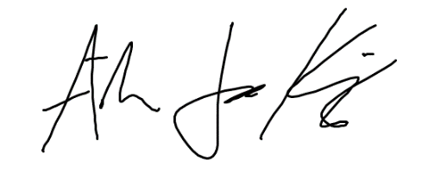

Aiden James Kosciesza, MA

Doctoral student, Media and Communication Program

Lew Klein College of Communication

Temple University

# 2020 N. 13th Street

Philadelphia, PA 19122

484-326-4935

aiden.kosciesza@temple.edu