**TikTok Politics: Tit for Tat on the India-China Cyberspace Frontier**

MEGHA MISHRA

Deloitte, UK

pu yan

Peking University, China

Ralph schroeder

University of Oxford, UK

TikTok has enjoyed wide popularity in the Global South. But in the summer of 2020, a tit for tat altercation erupted over the use of the app in India against the backdrop of a border dispute between India and China. India banned TikTok, along with other Chinese mobile applications. This ban raised larger ongoing issues around user privacy, cybersecurity threats, and content regulation issues on social media platforms and telecommunications equipment around the world. In this paper we explore these issues and the wider debates on social media. To do so, we interviewed policymakers and academics as well as representatives from India’s technology industry. We also applied computational linguistic analysis on 6,388 Twitter posts about the ban by Indian users. The discourses on Twitter show intense nationalistic rhetoric and that Indian Twitter users were vocal in urging the government to ban TikTok. In-depth expert interviews suggested there were intense geopolitical conflicts behind the TikTok ban. We situate these findings with a broader analysis of the current geopolitics of social media platforms.

*Keywords:* *TikTok, India, China, geopolitics, cyber-nationalism*

On June 29, 2020, the Government of India announced that it would block 59 mobile applications of Chinese origin, including TikTok – India’s most popular and downloaded app of 2019 and 2020 (BBC, 2020). The Indian Ministry of Electronics and Information Technology issued a statement alleging that these applications were ‘stealing and surreptitiously transmitting users’ data in an unauthorized manner to servers with locations outside of India. It further explained that the move was essential, ‘for safety, security, defense, sovereignty & integrity of India and to protect data & privacy of the people of India’ (NYT, 2020). A month later, US President Donald Trump issued an executive order to ban TikTok due to the links between the app’s parent company, ByteDance, and the Chinese government. Trump cited similar concerns as those of India, namely, that the app ‘allow[s] the Chinese Communist party access to Americans’ personal and proprietary information’, which posed a national security risk (Executive Order on Addressing the Threat Posed by Tiktok, 2020). The order referred to two precedents whereby the US government had previously banned the use of TikTok on the phones of federal government employees - and secondly, the Indian government’s ban on the use of TikTok and other Chinese mobile applications (Executive Order on Addressing the Threat Posed by Tiktok, 2020). An earlier and still ongoing similar dispute at the global level is the US-China rift, which involved other countries over the use of Huawei equipment in 5G networks. The justification by reference to a national security threat is a common denominator here.

We will refer throughout this paper to the TikTok ban even though other apps were also banned. The ban has come amid wider debates about the threats of information warfare, cybersecurity threats, and surveillance associated with social media. Farrell and Newman (2019) argue that global asymmetric network structures have created a potential for ‘weaponized interdependence’. In a similar vein, Buzan and Waever have argued that geopolitics has changed such that issues like traditional military strength are no longer so central, and ‘what is and what is not a security issue’ has come to be redefined (Waever et al., 1998, p 1). The paper will put the TikTok ban in the larger context of geopolitical rivalry and geoeconomic competition – ‘war by other means’ (Blackwill & Harriss 2016) - that is increasingly shaping the Internet and emerging as a source of conflict in the 21st century. The paper combines interviews with policymakers, media, and academics as well as computational social science analysis of discourse on Twitter about the ban to examine its wider implications.

**Background**

The ban must set against the background of the complex history of geopolitical relations between China and India. The main issue in this respect is the conflict on the India-China border, which has led to a number of military skirmishes since 1954. The clash is over the so-called ‘line of control’ in a remote mountainous region between the two countries where borders have never been firmly established. As a result, there have been numerous clashes in this region since the 1980s and meetings between the leaders of both countries to try to resolve them. Moreover, the region is also adjacent to Jammu and Kashmir as well as Tibet, areas which have been at the centre of geopolitical tensions also involving Pakistan. Attempts to stealthily extend borders and infrastructure in these zones have resulted in a number of clashes. China has also developed good relations with Pakistan, which has become India’s military enemy after partition. Pakistan is also part of China’s ‘digital silk road’ (Freyman 2020), which is part of China’s larger ‘Belt and Road Initiative’ to expand its soft power abroad. As we shall see, the TikTok ban became embroiled in a conflict over China’s efforts to expand its digital economy abroad and with the border conflict between India and China, including India’s antagonistic relations with Pakistan, and entailing India’s hyper-nationalistic response to China.

A few relevant features of the Indian media and political systems and those of China can be also be highlighted by way of background (for more details, see Yan and Schroeder, 2021): India has had a media system that is largely autonomous from the state though it used to be dominated by public broadcasting (Athique, 2012). In recent decades the media has become largely commercial and there is lively – some might say unruly - media debate in Indian society. Under the Modi government, the autonomy of the media has been undermined, including a greater role for surveillance (Khan, 2021) though there remains a strong civil society with many activist organizations. But politics has also been dominated recently by Modi’s populism and its electoral successes, which have given Bhartiya Janata Party (BJP) a majority in parliament and a growing number of states. This dominance is not complete, however, since journalistic freedom and political opposition, including a number of states which are governed by other parties, remain. China’s media system is, of course, largely shaped by an authoritarian party-state, though it, too, has lively debate, especially in online media.

Trade relations between India and China have grown throughout the 1990s, with bilateral trade between India and China increasing from USD 2.71 billion in 2001 to 70 billion in 2016 (PHD Chamber, 2020). From 2001-2016, India’s imports from China jumped from USD 1.83 billion to USD 60.48 billion, while India’s trade deficit with China expanded (Krishnan, 2020). India imports 73% of its telecommunication equipment, 82% of semiconductor devices from China, which makes it highly dependent on the relationship with China (The Hindu, 2019). Meanwhile India’s low volume of exports to China are mainly limited to raw materials such as low-grade ores, cotton, and chemicals. Chinese outbound investment almost doubled from US$107.8 billion in 2013 to US$196.1 billion in 2016, where India only ranked 31st, even if it is still growing.

Chinese investments and acquisitions of Indian start-ups started in 2016, the same year as TikTok was launched in India. Unlike during the pre-2014 period, much of the investment since then has come from the Chinese private sector (Krishnan, 2020). Dozens of Chinese technology firms and venture capital funds, led by technology giants Alibaba and Tencent, have acquired minority or controlling stakes in Indian companies (KPMG, 2019). Eighteen of India’s 30 unicorns are Chinese-funded (Gateway House, 2020). Apart from TikTok, smartphone brands like leader Xiaomi and Oppo have cornered three-quarters of the Indian market. According to the Economic Times (2019), firms like Qiming Venture Partners nearly doubled Chinese investments in Indian start-ups to $3.9bn in 2019. As prime minister, Modi has initiated campaigns to accelerate India’s digital economic prowess, as with his Startup India and Digital India initiatives. India’s efforts also include digitizing government services, including the flagship Aadhaar system of personal digital identification, which was begun under Congress party rule but has been taken further under Modi (see most recently, Khan 2021).

TikTok is a short-video platform for markets outside China owned by ByteDance, a Beijing-based technology company that also previously launched Douyin solely for the Chinese market in September 2016. In 2018, TikTok merged with the social media app, Musical.ly, another App of Chinese origin but with a pre-existing larger base in the global market. Both services, Duoyin and TikTok, are similar, but they run on separate servers to comply with Chinese regulations (Kaye, Chen & Zeng, 2020). TikTok is considered a social media platform because, like Twitter and Instagram, its users have a social group of followers and other users they follow. It offers users a unique method of sharing creative videos, which consist of short self-made video clips combined with external audio (and sometimes external visual) content. Users consume content via an algorithmically generated feed on the landing page called ‘For You’, which TikTok says is ‘a personalized video feed’.

Available in 150 countries, TikTok has rapidly become popular, reaching more than a billion users two years since its launch by October 2019 (Serrano, Papakyriakopoulos & Hegelich, 2020), yet there is little academic research on TikTok (an exception is a recent special issue of this journal, see Zeng, Abidin and Schaefer 2021). India is a mobile-first country where most Internet users access the web through their phones, and other short video platforms such as Likee, VMate, and Fireworks compete for the lion’s share of the market. India has the highest number of TikTok users in the world, approximately 30% of the global market of 611 million or so downloads (Mandavia, 2020). Indians spend an average of 34 minutes per day on TikTok (Ananth & Barman, 2020), and those who produce content are often young people who seek fame and fortune as TikTok stars (Poonam & Bansal, 2019). Collectively, Indians spent 750 million hours on the app (Bellan, 2020).

**Methods**

***Computational Linguistic Analysis of Twitter Discourses about the TikTok Ban in India***

To understand the discourses around the TikTok ban in India, we collected tweets created by Indian users, who were identified using the country ID geotags of tweets, between January 1st 2020 and March 31st 2021 from Twitter’s Academic API[1]. We removed duplicate tweets for this analysis. We cleaned the tweet content by employing the following steps: sentences in tweets were tokenized and we removed punctuation, hyperlinks, and common English stop words identified in the NLTK library. We identified frequently co-located word combinations using bigram and ran lemmatization, only keeping nouns, adjectives, verbs, and adverbs for content analysis.

Extraction of top-ranked keywords was based on TF-IDF score, which is a better measurement of the relevant frequency of words in the document that controls for the fact that some words appear more frequently than chance. We also conducted sentiment analysis of the tweets and calculated the polarity scores of tweets. Polarity scores range from -1 to 1, where -1 indicates negative sentiment and 1 positive sentiment. We applied latent Dirichlet allocation (LDA) to identify underlying topics in the corpora of TikTok ban related tweets. The number of topics (N = 10) was selected based on running multiple models using different numbers of topics and compared to the models with the optimal coherence values. We also took the interpretability of the LDA result into account when deciding on the number of topics to select.

***Interviews with Technology Companies, Policymakers, Journalists, and Academics***

This study used elite interviews obtained by means of purposive sampling. We sought out experts from technology companies, journalists, think tanks, and academia. There were ten semi-structured interviews at which point saturation was reached as answers no longer surfaced with new themes or distinctive views. Interviewees have been anonymized and most interviews took place via Zoom and were recorded, transcribed manually, and shared with interviewees for checking accuracy before citing. The list of interviewees and their roles is provided in appendix C. The interview length ranged from 28 to 75 minutes and took place between October and November 2020 so that interviewees often referred to the US election and Indian state elections. There were also frequent references to the Covid-19 pandemic and the India/China border conflict. Most of the sample (60%) were either Indian citizens or people of Indian origin, 20% were from China, and 20% were from the US.

**Findings**

***Time Series, Sentiment Analysis, and Keyword Analysis of TikTok Ban Related Tweets***

Figure 1a shows the change in the number of TikTok ban related tweets in India during our data collection period. The first peak of Twitter discourses about the ban is between late April to early May 2020, when the battle of words between YouTube vs TikTok started among fans of YouTube celebrity CarryMinati and TikToker Amir Siddiqui. The battle got intense when fans of CarryMinati started downrating the TikTok App, showing their disapproval towards the removal of CarryMinati’s video on YouTube (see Figure 1b for top-ranked words in tweets during this period). The second peak of Twitter discourses on the TikTok ban is between mid-June 2020, right before the Indian government banned TikTok along with other 58 Chinese Apps (see Figure 1c for top keywords during the second peak). Interestingly, we found that the YouTube-TikTok war invoked a higher level of public debates around banning TikTok than the boycott movement of TikTok after the China-India border conflict.

|  |  |
| --- | --- |
| (a) | |
| (b) | (c) |

*Figure 1 The number of TikTok ban related tweets in India during the data collection period (left) and word clouds of two peaks of numbers of tweets (right)*

We also calculated the sentiment scores of TikTok ban related tweets and visualized the distribution of sentiment scores across 2020. We found that the average sentiment towards the TikTok ban among Indian Twitter users is positive and supportive (mean = 0.06, std = 0.26), indicating general support for the ban among the public (see Figure 2a for the distribution of sentiments in tweets across time). However, TikTok being missed by its fans was the most negative tweet about the TikTok ban with a user who posted that ‘Life is boring without TikTok. #tiktokban’.

|  |
| --- |
| (a) |
| ***(b)*** |

*Figure 2 Distribution of sentiments of TikTok ban related tweets across time (top) and histogram of sentiment scores (polarity values) in tweets (bottom)*

We ranked the top 50 keywords about the TikTok ban on Twitter using TF-IDF scores of words (see Appendix A for a list of keywords and Figure 3 for a visualisation of keywords). We found a general call (‘petition’) for banning TikTok by Indian Twitter users. Government officials such as ‘prakashjavdekar’, Indian Minister of Information & Broadcasting, were frequently tagged in tweets about the TikTok ban to ask for ‘government’ action. An example tweet from our dataset, sent by a verified Twitter user, showed how supporters of the BJP saw the ban as an indication of India’s diplomatic leadership (see Figure 4). This widespread appeal for banning TikTok in India is also reflected in top-ranked emojis (for example, flag of India or angry face) as well as hashtags such as #indiansagainsttiktok (see Appendix B for top-ranked emojis and hashtags in TikTok ban related tweets).

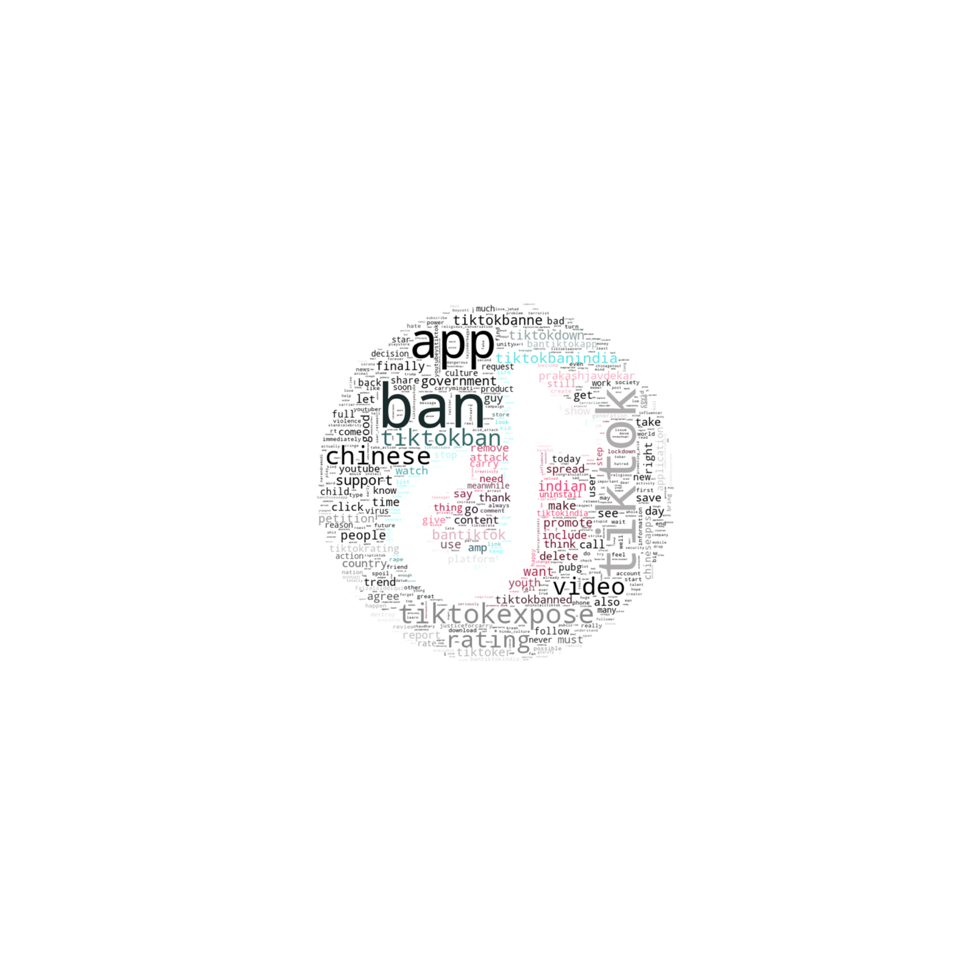

*Figure 3 Word Cloud of keywords in TikTok Tweets ranked by TF-IDF scores*

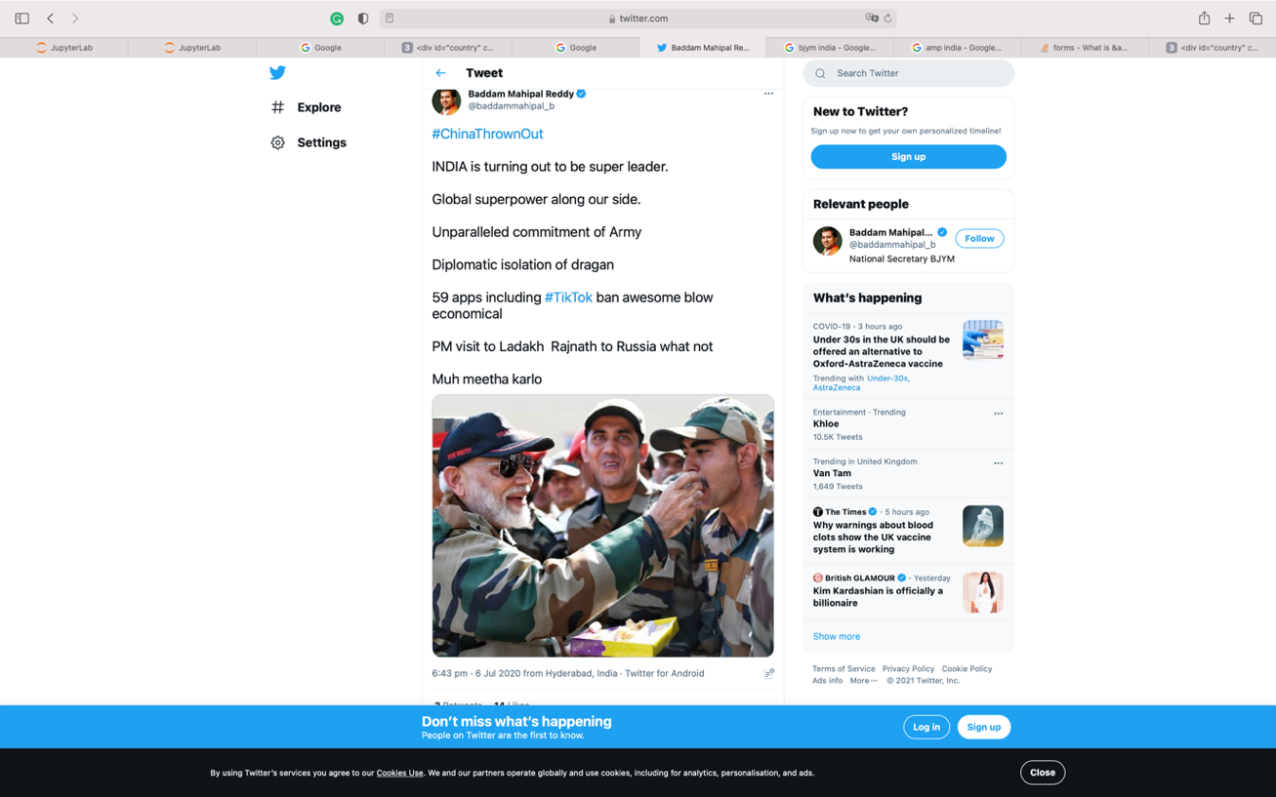

*Figure 4 An example of a TikTok ban related tweet in the dataset (from a verified account) showing prime minister Modi on a visit*

***Underlying Themes of Public Discourse Related to TikTok Ban on Twitter***

Topic modelling analysis using LDA informs the underlying themes in the corpus. In our topic modelling analysis, we identified ten distinct topics in TikTok ban related tweets. Figure 5 shows word clouds of top-ranked keywords in the ten topics identified in topic modelling analysis. Figure 6 visualizes the ranking of ten topics by the number of documents with each topic as the dominant topic and by topic weight.

*Most Important Topics in TikTok Ban Related Tweets*

Topic 6 has the highest number of tweets by topic weight and topic dominance and is about the negative influence from TikTok on promoting violence and provoking conflicts of values. Keywords in this topic include the negative impact from TikTok ‘videos’ for ‘promoting acid’ [acid attacks] and sex ‘abuses’. TikTok is also linked with ‘love jihad’, a conspiracy theory that Muslim-Hindu interfaith marriage will lure Hindu women into converting to Islam[2].

The second most important topic is Topic 7, which consists of proposals or practices for government and individual users to take to ban TikTok in India. TikTok is considered as the weapon of ‘Chinese terrorism’ and harmful to the ‘economy’. Individual actions such as ‘delete’ the ‘app’ are demanded by users on Twitter before the government ban was enforced. Collective actions such as ‘mass’ reporting were also called for.

The third most important topic is Topic 3, which is about concerns for TikTok’s influence on the ‘future’ ‘generation’, including preventing them from paying attention to ‘life’. One tweet declared that ‘We don’t want cheap creativity BAN TIKTOK’. The topic is followed by Topic 0, where ‘demands’ are made to ‘avoid’ harming ‘child’ and the ‘leak’ of ‘user’ ‘privacy’.

|  |  |  |  |  |
| --- | --- | --- | --- | --- |
| State-led actions – culture | YouTuber vs TikToker | Digital battleground | Concerns for future generations | Crimes and social issues |
|  | | | | |
| State-led actions – security and society | Violence and conflicts | User-initiated actions and appeals | Comparing social media platforms | Nationalistic sentiments |
| *Figure 5 Word clouds of top-ranked keywords in ten topics identified in the topic modelling analysis* | | | | |

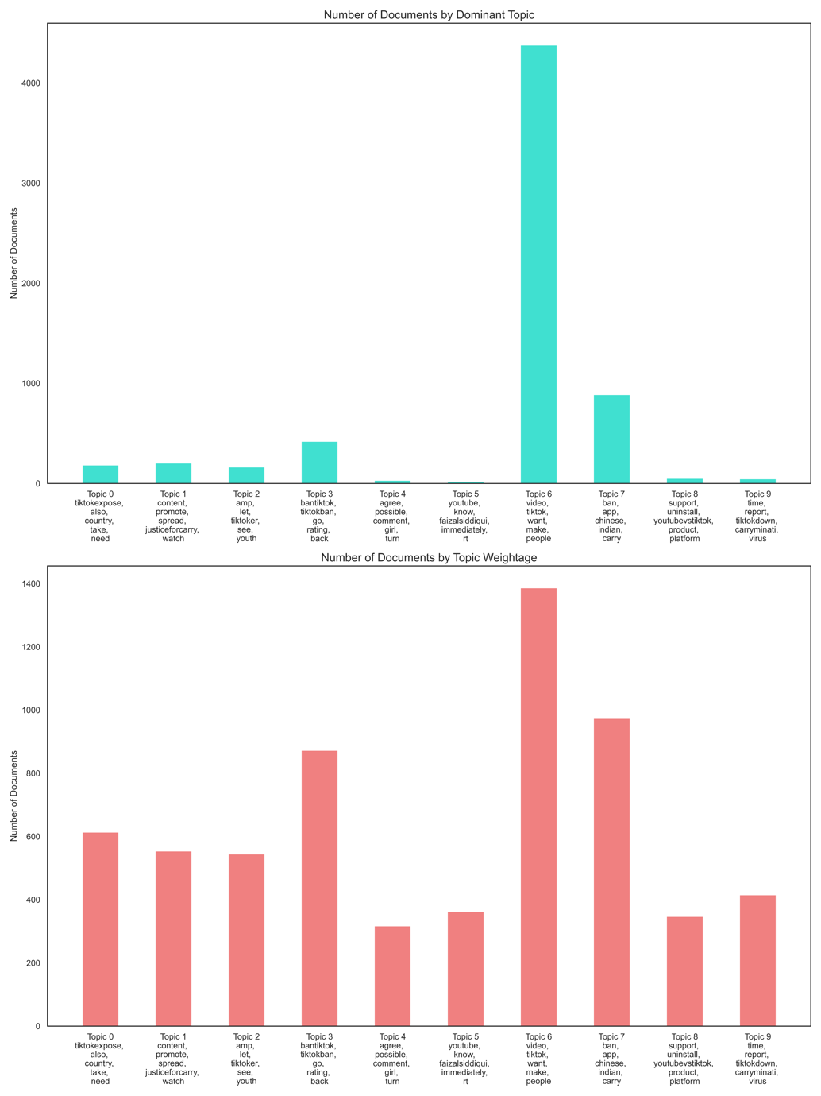

*Figure 6 Bar plots of the number of documents ranked by dominant topic (top) and topic weights (bottom)*

*Most Liked Topics in TikTok Ban Related Tweets*

We triangulate tweet-level statistics such as the number of likes and retweets with topics identified in the tweets using topic modelling analysis. We found that Topic 1, Topic 2, Topic 8, and Topic 4 received the highest average number of likes and retweets (see Figure 7 for boxplots of topics and their average numbers of likes and retweets). We found that the digital battle between TikTokers and YouTubers, despite its lack of importance measured by the number of documents categorized under the topic, received widespread likes and retweets.

The digital battle between the fans of YouTuber Carry Minati and TikToker Amir Siddiqui received the highest number of likes and retweets on average. Hashtags such as ‘#justiceforcarry’ and ‘tiktokvsyoutube’ appeared in Topic 1, along with actions such as ‘roast’ the ‘tiktokcreator’ or forming a ‘community’ of fans for different platforms. The government imposed TikTok ban can be seen as largely a result of the collective mobilization from the fan community. Similar to Topic 1, Topic 2 received the second-highest average likes and retweet, which called for more specific actions such as ‘retweeting’ messages related to the ‘campaign’ of ‘revenge’ for Carry Minati.

Tweets for reporting criminals in Topic 4 were also among the most liked or retweeted tweets. Appreciation was expressed towards Indian officials behind the TikTok ban, including Modi and Prakash Javadekar, Minister of Information & Broadcasting, for example, ‘Thank you for imposing ban on #Tiktok and other Chinese applications @PMOIndia @AmitShah @PrakashJavdekar’.

*Appeals for State Engagement and Hyper-nationalistic Rhetoric*

Topic 5 includes keywords related to popular appeals calling for state actions and engagement in banning TikTok. An example tweet stated:

Now war begins between #TikTokers and non- tiktokers nationalist. Come on show ur power of nationalism and throw out this Chinese spy app from our country. #Bantiktok @PMOIndia @narendramodi.

Tweets calling for national actions against TikTok tagged Modi’s Twitter accounts directly. One source of the anger was triggered by concerns over ‘national security’ and the ‘threat’ to ‘state’ security. However, another important source of public discontent were reactions from TikTokers to Acid Attacks on Indian women. For example, ‘deepikapadukone’, a celebrity who initiated a TikTok challenge to recreate the looks of an acid attack survivor and ‘faizalsiddiqui’ who was allegedly ‘glorifying’ an acid attack on TikTok were heavily criticised within this topic. Topic 0 also indicates public appeals for state engagement, with keywords such as ‘demand’ ‘justice’ for ‘citizens’. Tweets within this topic focused more on ‘culture’ than state affairs.

It is worth noting that Topic 9 contains many keywords related to nationalistic sentiment during the TikTok ban in India. A good example of such sentiments is:

Better Late than Never. Because Tiktok had become an platform where anti national things used to happen. Making videos and making fun of police. And fun of public. And making fun of Country. and also Religion was oll this! Soon Indian Government Should ban Tiktok #BanTiktok.

Specific actions that can showcase one’s commitment to participate in the movement were also included in this topic. For example, down-grading ‘tiktokrating’ on ‘googleplay’ store and cleaning one’s mobile phone by following the video on how to delete TikTok shared by ‘technicalguruji’.

|  |
| --- |
|  |
|  |

*Figure 7 Boxplots of topics and their average numbers of likes (top) and retweets (bottom)*

***Understanding TikTok Politics from Expert Interviews***

*Banning TikTok: ‘A Clear Geopolitical Signal’*

While Internet censorship is by no means new in India, banning a host of applications from a particular country is a first. Under Section 69A of the Information Technology Act from 2000, the government is allowed to block websites/URLs if they threaten the sovereignty and integrity of the country, foreign relations, public order, or the security of the state, among other grounds (SFLC, 2020). Though this form of censorship does not need to be made public, in the case of the ban on TikTok and other Chinese apps, there was an official government statement. One of the interviewees, who has been tracking censorship in India for the last ten years, highlighted this:

This is the first time the government of India has issued a press release informing the public of an ICT ban. However, the legal order to ban these applications is neither available in the public domain, nor is it clear how these specific applications were identified posing issues of national security.

An Internet freedom activist, whose NGO has been systematically engaging in the tracking of Internet shutdowns, commented:

This ban on TikTok and other Chinese platforms, to me personally, doesn’t seem like a free speech and expression issue. If anything, it is a clear geopolitical signal.

An international industry leader, with experience across domains, including TikTok, likewise saw the ban as geopolitically motivated: ‘China only understands and responds to show of strength, and in this instance, India has shown a way to the world’. This view is support by a Pew Research report (2020), which shows that Indians’ favorable views towards China nearly halved from 41 per cent in 2017 to just 23 per cent in mid-June 2020, exacerbated by the pandemic and the current India-China border dispute.

Chinese hardware dominates the Indian market, while Chinese apps lag way behind their big American counterparts. Yet since the Indian market cannot easily afford to ban hardware – after all, hardware has become part of the physical infrastructure and so is costly to replace or reinstall - software became an easier target. An interviewee working in the media pointed to the role of Chinese hardware and its dominance in the Indian market by commenting:

Isn’t it ironic that the public is outraging on social media about boycotting a country, not realizing that the very devices [mobile phones] that they are tweeting from are almost entirely Chinese?

On social media, hashtags such as #Boycott_China_MNCs and #MadeInIndia were popular, especially, as we saw earlier, on Twitter. Some of the tweets linked China’s role to India’s independence movement against British colonialism while others noted the amount of money India could save if it boycotted Chinese goods. As we saw earlier, much of the ban on Twitter was in fact fueled by celebrity attacks, which then also carried over into traditional media. One interviewee who works at Twitter in the content moderation team observed that:

It is tough to say where did the campaign to #BoycottChina…Today, the media and social media are entwined that what happens in one realm affects the other instantly. I would say several actors played in, NGO’s, political groups, independent actors, right-wing media.

Meanwhile, the anti-China sentiment was amplified by the English and Hindi television news channels that supported the deletion of Chinese applications because of the alleged spread of fake news, stealing personal data, and as revenge for the border skirmish and China’s handling of Covid-19 (SCMP, 2020). Some of the Indian television media called the ban a ‘digital strike’ by the Modi government, a reference to the ‘surgical strikes’ that were often referred to in relation to military action against Pakistan by the Modi government. The rhetorical parallels with military strikes are evidence of the ‘securitization’ of the ban.

Hyper-nationalistic themes have been popular in Indian news. A 2019 analysis of the issues discussed on top primetime shows found that the Indian media widely focused on nationalistic narratives, while issues such as education or environment or discussions on government policies were widely ignored (News Laundry, 2019). Republic TV is India’s most-watched right-wing English language news channel, an Indian equivalent of Fox News in the US. Founder Arnab Goswami supports the Modi government and believes that ‘being a nationalist is a prerequisite to being a journalist’ (Newslaundry, 2017). Goswami insults those who disagree with his hyper-nationalist views, yet he garnered viewership as high as 74 per cent with one of his Boycott China debates (Republic World, 2020). Headlines during this period included ‘India ensures China’s global isolation’. Vernacular media, which have a wider audience reach than English-language news media (Neyazi 2018), had similar themes.

*Threats of TikTok: Data Breach? China’s Propaganda?*

A senior media interviewee supports this view that the data privacy of Indian users is at stake, saying ‘any of these applications can be used to launch cyberattacks such as doxxing and data theft’. Yet another interviewee from the senior leadership at TikTok disagreed concerning data but agreed concerning China’s potential propaganda uses:

The preferences of a fourteen-year-old lip-synching on TikTok is not particularly interesting to the Chinese leadership. However, they could use the platform to push propaganda or a positive view of China to the world. As far as I know, ByteDance has not allowed that to happen. They’ve pushed back aggressively and maintained that what’s outside China’s borders is not under the Chinese government’s jurisdiction. But I do know that the Chinese government likes to get its way. In that respect, I understand the concerns of the Indian or the US governments, but it’s not data concerns.

An interviewee who quit TikTok recently explained that, theoretically, it is possible for election interference to happen via any social media platform, and TikTok is no exception. However, given the interviewee’s experience with formulating the political content policy at TikTok, they were certain that this had not happened. While TikTok has publicly asserted that they have not given any data to the Chinese government, there is no way of verifying that or having an assurance that it may not happen in the future. TikTok’s domestic platform, Douyin, bears more of a mark on Chinese Internet regulation than TikTok, by promoting content about ‘positive energy’ or patriotism, which provoked domestic controversy (Kaye, Chen, & Zeng, 2020).

While all platforms are subject to regulation about content moderation, one interviewee noted that for TikTok, ‘the platform has been the subject of intense scrutiny in different national contexts, partly due to its Chinese roots while ignoring its corporate identity’. Another interviewee, the Internet freedom activist whose NGO has been systematically engaging in the tracking of Internet shutdowns quoted earlier, pointed out that:

The public doesn’t understand what the data is, what is the threat. Are we really expecting these consumers to understand the nitty-gritty of the data issues - terms that only circulate among technology policy circles? … They just know TikTok is collecting data. I ask, what is Facebook and Twitter collecting then? … We have seen Cambridge Analytica. We’ve seen the involvement of India’s Facebook lead with the ruling government.

India does have a disproportionately great extent of cyber-attacks and data breaches. For example, BigBasket - India’s leading grocery delivery platform - faced a breach whereby personally identifiable information of over 20 million users such as full names or date of birth was put on sale on the dark web. India is lacking data protection laws, but breaches like these have not invited the same kind of scrutiny as Chinese applications where there is no evidence of user data being misused or leaked. A civil society activist interviewee said that:

If [the] security of data was really an issue, as the government suggests, all social media platforms and intermediary applications should have been banned. The same risks that are associated with any Chinese platform apply to American or Indian platforms.

This view was vehemently supported by an interviewee from TikTok, who explained that it is easy for the government to securitize an issue that very few understand, and in this case, there is continuity with a populist narrative:

We are a society grappling with issues of fake news, so much so, that we need advertisements on television to not trust everything received via WhatsApp. With that level of awareness, are we expecting consumers to understand the nitty-gritty of data issues? They are going to believe what they are told, and the media is doing a great job at weaponizing it.

*‘It is All about Winning Elections’*

Meanwhile, there are concerns about the links between the Modi government and platform policymakers. For example, an expose published by the Wall Street Journal revealed the close-knit relationship between Ankhi Das, Facebook India’s policy head, and the Indian government. It alleged that Facebook overlooked anti-Muslim hate speech on the platform by several BJP members, while Das openly told employees that ‘punishing violations by politicians from Modi’s party would damage the company’s business prospects in the country’. Hate speech messages were widely reported to be a major inciting factor in the week-long anti-Muslim riots in Delhi in February 2020 (Gettleman, Suhasini & Yasir, 2020). Das reportedly posted a message a day before Modi’s victory in India’s 2014 national elections, saying, ‘We lit a fire to his social media campaign’ (Hortwiz, 2020). One interviewee questioned the hypocrisy in the relations between the government and platforms:

The government of India has mandated in place for the use of social media. Mygov[3], NCPCR[4], NSDC[5] and Maharashtra Government are a few of the prominent government departments and agencies that used TikTok to reach out to an audience…How is it that they suddenly woke up one day and felt like, oh, these platforms are problematic!

Another interviewee who is critical of the BJP commented:

The issue is not TikTok, nor is it to do with any form of security. It is all about winning elections. The Modi government has a record of using national security as an excuse to anything that can help them stay in power.

Jaffrelot (2020, see also Das and Schroeder, 2020) has suggested that national security issues helped the BJP’s election victory in the 2019 election, especially by constant references to the Balakot airstrikes against Pakistan. Modi’s campaign was populist, pitting his aggressive militarist stance against the weakness of his Congress rivals and liberal elites. Within a few hours of the ban, replicas of TikTok flooded the market and were taken up by Indian audiences, as we saw earlier, thus endorsing the economic protectionism promoted by the Modi government’s ‘Made in India’ slogans. Meanwhile, there was no further discussion of data breaches. The interviewee who works in the Internet freedom NGO said:

The government clearly needed something to make scapegoats of to salvage a winning chance at the approaching election and people’s discontentment over the poor handling of Covid-19.

*India after the TikTok Ban*

Before concluding, we can briefly summarize what has happened since the ban. Many TikTok users migrated away from the platform to other Indian copycat platforms. There was strong sentiment for this move as anti-China feelings escalated, and users posted that patriotism should come before popularity. Some migrated to new Indian alternatives while others began using international counterparts such as Instagram Reels (introduced in August 2020) and Snapchat Spotlight (March 2021). The TikTok ban affected 119 million users but in the period since the ban, Indian-born MX TakaTak, Moj and Josh became the most downloaded apps in India in the period to March 2021[6]. And it is not just downloads; there was also considerable investment in these alternatives and excitement about their prospects. For example, Google and Microsoft both invested in Josh.

Those migrating to other platforms did not find the transition straightforward, however. Some TikTok celebrities complained that their audiences were not dispersed and with it the lack of monetization opportunities. Many found that they had to reinvent themselves from scratch and lost earnings. Further, some alternatives like Instagram are predominantly in English, which leaves rural audiences in particular wanting.

At the same time, offline anti-China protests have ebbed as the border conflict has de-escalated and faded from attention, and China continues as India’s largest trading partner with a large trade deficit[7]. One example of continuing trade success is Xiaomi’s smartphones, the top brand in India which increased sales in late 2020[8]. Nevertheless, some business leaders still call for bans on Chinese goods and argue that India should rely more on its own products.

**Conclusion**

In July 2020, a further 43 Chinese apps were banned, bringing the total to 267 (Indian Express, 2020). Modi’s ban was consistent with his populist ultranationalism and economic protectionism. Although he has espoused free market ideals, in fact, as Manor (2020) and Nassemulah (2017) have pointed out, his economic policies are far from ‘neoliberal’ but rather centralize power and promote economic nationalism, as with Trump’s populist politics which led to his bans on Huawei equipment. Hansen (1999) and Schroeder (2020) have traced this ‘patriotic consumption’, which is part of Hindutva politics. Mann has used ‘spectator-sport militarism’ to describe the ‘indirect participation’ in warfare, which stirs up strong emotions but does not entail any real commitment or sacrifice (except among the combatants); it is ‘shallow and volatile’ (1988: 184-5) and entertainment-like. This mobilization of the nation was put to highly effective use by Modi during his election campaign in 2019 when he engaged in a military skirmish with Pakistan and with the TikTok ban.

The analysis of TikTok ban related tweets during 2020 and early 2021 showed that public discourses around the TikTok ban peaked initially in early 2020 when a war of words started between fans of a YouTuber influencer and fans of a TikTok star. However, before the official TikTok ban in India, there was a second peak of public discourses appealing for both public and government actions boycotting TikTok in India. We identified three main categories of TikTok ban discourses on Twitter: concerns for TikTok’s influence on Indian society; debates about the cultural aspects of different social media platforms, especially between TikTok and YouTube; and appeals for grassroots nationalistic actions boycotting TikTok and for government’s engagement in banning Chinese apps. We also found that although concerns for TikTok’s cultural and social influences were dominant topics in TikTok ban related tweets, disputes between users of different platforms were among the most liked and retweeted content. Finally, we identified tweets that indicate strong nationalistic sentiments in the Twitter data on the TikTok ban.

The interviewees broadly agreed that the ban constituted geopolitical signaling to the Chinese government in light of the border conflict. The Modi government used the mobile app ban to serve its goal of promoting ‘spectator sport’ militarism to boost its legitimacy during the border skirmishes. It did not ban infrastructure (hardware) or investment since it depends on China for these. Indian apps were able to reap the benefits as users flocked to them.

As for China, its efforts to expand its global influence with the Belt and Road Initiative (Freyman, 2020. See also Jungherr and Schroeder, 2021) will increasingly encounter pushback against this extension. That is because China’s approach to digital media, managing and controlling them within an authoritarian political system, is bound to be challenged when these digital media venture into foreign markets with different media systems and their governance. For Indian citizens and for the economy, the consequences may not have been major in the sense that they could use other copycat platforms for similar purposes, but they are significant in that they strengthen Modi’s increasing stranglehold over the media and make for a more protectionist economy which is leading India in an authoritarian and illiberal direction that is hostile towards minorities.

We can also relate these conclusions to the competition for market share. As Kaye, Chen and Zeng (2020) argue, ByteDance has segmented its users and audiences into two parallel products: Douyin for the Chinese market which is controlled by the state’s regulatory governance and TikTok for the international market with different governance mechanisms, both by the platform itself and of the platform by the respective countries’ media systems. Naughton has described Chinese technology policy as ‘grand steerage’, by which he means that Xi’s government is actively steering investments into certain technology sectors in order for China to take a worldwide lead in innovation and so propel the country’s economic growth. But tensions over this policy are likely to increase: ‘China may double down on techno-industrial policies because it perceives the outside world as increasingly hostile and unreliable’ (2020: 79).

Again, the separation of Chinese and foreign TikTok platforms seems to have no major effects since most of the content is entertainment. But this is too simple since the content is partly news and politics related, and also because free and open exchange is part of what makes the Internet into the most transnational part of the media system that fosters intercultural communication and information. The balkanization resulting from censorship such as the Indian TikTok ban may therefore have broader detrimental effects if it is repeated elsewhere – even if there are other reasons elsewhere: such a balkanization would lead to an Internet fragmented among different audience bases which companies compete for. But this audience competition is limited by the policies of countries that ban them; in other words, geopolitical conflict, including economic rivalry under the guise of national ‘security’, and enlisting the support of the public via ‘spectator sport’ militarism. In the case of ‘rising powers’ like India and China (Miller, 2021), they seek to assert their place in the world as ‘great powers’ by engaging in this conflict by imposing their rules on digital media companies. As Miller argues, although India has so far been ‘reticent’ in asserting its role in the world order, under Modi it has become ‘aggressively vocal’, and like other powers, needs a narrative to justify its rise (Miller 2021: 153). The US, which is already a great power and arguably a relatively declining one, also needs to re-assert its place in the face of this decline, and China, according to Miller, has actively asserted its ‘rise’. In other words, this tit for tat spat may be a harbinger of things to come for other platforms and in other places around the world, with balkanization a result of this geopolitics among the great powers, shaping digital media via, as noted at the outset, a ‘war by other means’(Blackwill and Harriss, 2016).

Apart from the influence on the competition between TikTok and other apps and Indian copycat apps, what has been the impact on users? It might be said that the vast bulk of TikTok content is for entertainment. But this overlooks that entertainment enriches peoples’ lives, and a few content creators are able to make commercial gain from TikTok. Here we can note that a Chinese report maintains that there are more female users of TikTok than males, that women produce more content, and that women are more likely to be viewed and viewed than male content creators[9]. In India, Internet and mobile phone use is heavily skewed towards men and urban dwellers, and much of the content of TikTok in India is Bollywood themed. But around half of the top influencers on TikTok in India are women, with tens of millions of followers (Thakur, 2021). TikTok content is often sexist, but some content has also empowered women, as when domestic abuse has been highlighted.

We began the paper by noting that the TikTok ban came as there has been increasing debate over the role of social media, free speech, cybersecurity, disinformation, and related issues. We have focused on has two distinctive features within these debates: the first is that it centered on an – albeit relatively minor – military skirmish between two major powers. The second is that it concerned a platform which is overwhelmingly not used for news and political communication but for entertainment. That said, the ban still has a number of lessons for the role of digital media in society. First, there are lessons specific to India and China. Modi used the ban as a jingoistic tool in a propaganda campaign to lend legitimacy and boost morale among the public to support the Indian military efforts in the skirmish. This strategy is in keeping with his increasingly authoritarian populist policies which aim at making India into a more ultranationalist Hindu country with intolerance towards minorities and especially Muslims. ‘Spectator sport’ militarism can boost this jingoism and the TikTok ban is also part of economic nationalism and geopolitical competition under the bogus cover of data security and part of the increasing attacks on media autonomy in India. But here we need to note the main limitation of the paper, which is that the TikTok dispute is a ‘moving target’: even as we write more than a year later, it is not clear if China-India tensions have mellowed, or if further tensions, also involving Pakistan, continue to threaten TikTok and other digital media becoming embroiled in geopolitics.

The more general conclusion is that transnational media are increasingly wrapped up in tit for tat proxy wars; used as excuses for pursuing ‘war by other means’, whether they are geopolitical - as in this case, also using militarism for domestic political purposes – or using national security or data protection in geo-economic competition as in the Chinese-American tit for tat over Huawei. Strengthening the autonomy of media, including digital media, could counter these this use of the ‘fog of war’ on the transnational cyberspace frontiers, since the media could uncover how the pretense of national security misleads citizens with disinformation. Regulation of media to prevent real harms of hate has been a key battleground for digital media, but digital media regulation to block access to publics for reasons that have little to do with such harms but are an excuse to whip up public support for their ‘rise’ as great powers, and these excuses should not become a means to balkanize the Internet and impose cyberspace frontiers on the public, in the case of this geopolitical border dispute - or elsewhere.

**References**

Ananth, V. & Barman, A. (2020). By rolling the dice, Ludo hits a six but squares up the law. India Times. Retrieve from: <https://economictimes.indiatimes.com/tech/software/by-rolling-the-dice-ludo-hits-a-six-but-squares-up-the-law/articleshow/73569730.cms>

Anderson, E. & Jaffrelot, C. (2018). Hindu nationalism and the ‘saffronisation of the public sphere’: An interview with Christophe Jaffrelot, *Contemporary South Asia,* 26(4), 468–482. doi: 10.1080/09584935.2018.1545009

Athique, A. (2012). *Indian Media.* Cambridge: Polity Press.

BBC. (2018). Russia “meddled in all big social media” around US election. BBC News. Retrieved from: <https://www.bbc.com/news/technology-46590890>

BBC. (2020). India bans PUBG, Baidu and more than 100 apps linked to China. BBC News. Retrieved from: https://www.bbc.com/news/technology-53998205

Bellan, R. (2020). Tiktok is the most downloaded App worldwide, and India is leading the charge. Retrieved from <https://www.forbes.com/sites/rebeccabellan/2020/02/14/Tiktok-is-the-most-downloaded-app-worldwide-and-india-is-leading-the-charge/>

Blackwill, R. D., & Harris, J. M. (2016). *War by other means.* Cambridge MA: Harvard University Press.

Business Standard.(2020). Rajiv Gandhi’s visit to China in 1988 broke the ice: Chinese diplomat. Business-standard.com. Retrieved from <https://www.business-standard.com/article/current-affairs/rajiv-gandhi-s-visit-to-china-in-1988-broke-the-ice-chinese-diplomat-117101300537_1.html>

Christopher, N. (2020). Counting the cost of India’s ‘Boycott China’ campaign. South China Morning Post. Retrieved from <https://www.scmp.com/magazines/post-magazine/long-reads/article/3090662/boycott-china-trending-india-turning-rhetoric>

Das, A., & Schroeder, R. (2020). Online disinformation in the run-up to the Indian 2019 election. *Information, Communication & Society*, 24(12), 1762–1778. doi: 10.1080/1369118X.2020.1736123

Dhar, B. (2019). Chinese cheer for Indian exports, the Hindu Business Line. Retrieved from: <https://www.thehindubusinessline.com/opinion/chinese-cheer-for-indian-exports/article26431736.ece>

Dutt, N. (2020). Indian defence experts worried about Karakoram highway’s strategic implications to security. India Today [online]. Retrieved from <https://www.indiatoday.in/magazine/indiascope/story/19780731-indian-defence-experts-worried-about-karakoram-highways-strategic-implications-to-security-818510-2015-01-31>

DW News, (2019). EU: Russia spread disinformation ahead of EU elections. DW News. Retrieved from: <https://www.dw.com/en/eu-russia-spread-disinformation-ahead-of-eu-elections/a-49210802>

Executive Order on Addressing the Threat Posed by Tiktok. (2020). The White House. [online]. Retrieved from: <https://www.whitehouse.gov/presidential-actions/executive-order-addressing-threat-posed-Tiktok/>

Fadia, A., Nayfeh, M., & Noble, J. (2020). Follow the leaders: How governments can combat intensifying cybersecurity risks, McKinsey & Company. Retrieved from: [https://www.mckinsey.com/industries/public-and-social-sector/our-insights/follow-the-leaders-how-governments-can-combat-intensifying-cybersecurity-risks#](https://www.mckinsey.com/industries/public-and-social-sector/our-insights/follow-the-leaders-how-governments-can-combat-intensifying-cybersecurity-risks)

First Post, (2020). Assembly by-elections results, First Post. Retrieved from <https://www.firstpost.com/politics/assembly-by-elections-results-bjp-shores-up-tally-in-mp-several-other-states-congress-suffers-setback-in-gujarat-9000531.html>

Freedom House. (2020). Freedom in the World - China Country Report. Retrieved from: <https://freedomhouse.org/country/china/freedom-world/2020>

Freymann, E. (2020*). One belt one road: Chinese power meets the world.* Cambridge MA: Harvard University Press.

Gateway House. (2020). Chinese investments in India. Retrieved from: <https://www.gatewayhouse.in/chinese-investments-in-india/>

Gettleman, J., Suhasini, R. & Yasir, S. (2020). The roots of the Delhi riots: A fiery speech and an ultimatum, The New York Times. Retrieved from <https://www.nytimes.com/2020/02/26/world/asia/delhi-riots-kapil-mishra.html?auth=login-google&login=smartlock>

Gogna, S. & Khatoon, N. (2020). The China-Pakistan nuclear nexus: How can India respond? The Diplomat. Retrieved November from <https://thediplomat.com/2020/03/the-china-pakistan-nuclear-nexus-how-can-india-respond/>

Goldman, R. (2020). India-China border dispute: A conflict explained. The New York Times. Retrieved from: <https://www.nytimes.com/2020/06/17/world/asia/india-china-border-clashes.html>

Guardian. (2020). India bans 118 Chinese apps, accusing companies of stealing data. Retrieved from: <https://www.theguardian.com/world/2020/sep/03/india-bans-118-chinese-apps-accusing-companies-of-stealing-data>

Gupta, K. (1971). The McMahon line 1911–45: The British legacy. *The China Quarterly*, 47, 521-545.

Hansen, T. (1999). *The saffron wave: Democracy and hindu nationalism in modern India.* Princeton NJ: Princeton University Press

Hindustan Times. (2020). ‘To spur growth’: Nirmala Sitharaman on PM Modi’s Atamanirbhar Bharat Abhiyan. Retrieved from <https://www.hindustantimes.com/india-news/to-spur-growth-nirmala-on-pm-modi-s-atamanirbha-bharat-abhiyan/story-s71j5O0ZG21QY4qsTsUnTP.html>

Horwitz, N. (2020). Facebook’s hate-speech rules collide with Indian politics. Retrieved from <https://www.wsj.com/articles/facebook-hate-speech-india-politics-muslim-hindu-modi-zuckerberg-11597423346>

Indian Express. (2020). AliExpress to Tiktok to PUBG Mobile: Check out full list of Chinese apps banned in India so far. Indian Express. Retrieved from <https://indianexpress.com/article/technology/tech-news-technology/aliexpress-to-Tiktok-to-pubg-mobile-full-list-of-all-chinese-apps-banned-in-india-so-far-7064134/>

Jaffrelot, C. & Verniers, G. (2020). The BJP’s 2019 election campaign: not business as usual, *Contemporary South Asia*, 28(2), 155–177. doi: 10.1080/09584935.2020.1765985

Jungherr, A. & Schroeder, R. (2021). Digital Transformations of the Public Arena. Cambridge: Cambridge University Press.

Khan, A. (2021). Beyond consent: Surveillance capitalism and politics in the data state, *India Review*, 20(2): 158–175. doi: 10.1080/14736489.2021.1895563

Kaye, D. B. V., Chen, X., & Zeng, J. (2020). The co-evolution of two Chinese mobile short video apps: Parallel platformization of Douyin and Tiktok. *Mobile Media & Communication*, 9(2), 229–253. doi: 10.1177/2050157920952120

KPMG. (2019). Start-up ecosystem in India - Growing or mature? Retrieved from: <https://home.kpmg/in/en/home/insights/2019/01/startup-landscape-ecosystem-growing-mature.html>

Krishnan, A. (2020). Following The money: China Inc’s growing stake in India-China relations. Brookings Institution India Center. Retrieved from <https://www.brookings.edu/wp-content/uploads/2020/03/China-Inc%E2%80%99s-growing-stake-in-India-China-relations_F.pdf>

Kumar, R. (2020). Our boycott medicine is hitting the right spot: Sonam Wangchuk on Amul China Ad. Mint [online]. Retrieved from: <https://www.livemint.com/news/india/sonam-wangchuk-our-china-boycott-medicine-is-hitting-right-spot-on-amul-ad-global-times-report-11591672557979.html>

KVN, R. (2020). Govt of India bans Tiktok, ShareIt, Mi video call and 56 other Chinese apps. Retrieved from: <https://www.deccanherald.com/specials/govt-of-india-bans-Tiktok-shareit-mi-video-call-and-56-other-chinese-apps-full-list-855159.html>

Laurila, J. (1997). Promoting research access and informant rapport in corporate settings: Notes from research on a crisis company. Scandinavian Journal of Management, 13(4), 407–418.

Lyngaas, S. (2019). Ukraine’s president accuses Russia of launching cyberattack against election commission. Cyberscoop. Retrieved from: <https://www.cyberscoop.com/ukraines-president-accuses-russia-launching-cyberattack-election-commission/>

Mandavia, M. (2020). Tiktok report shows India sends highest number of user information and content takedown requests. Retrieved from <https://economictimes.indiatimes.com/tech/internet/Tiktok-report-shows-india-sends-highest-number-of-user-information-and-content-takedown-requests/articleshow/76875109.cms?from=mdr>

Mann, M. (1988). *The roots and contradictions of modern militarism, states, war, and capitalism.* Oxford: Blackwell

Manor, J. (2020). India’s far from neo-liberal economic order in the Modi era. *Economic and Political Weekly*, 55(44), 12–15

McDonald, M. (2008). Securitisation and the construction of security. *European Journal of International Relations*, 14(4), 563–587. doi: 10.1177/1354066108097553

Miller, M. C. (2021*). Why nations rise: Narratives and the rise to great power.* Oxford: Oxford University Press.

Naseemullah, A. (2017). The political economy of economic conservatism in India: From moral economy to pro-business nationalism*. Studies in Indian Politics*, 5(2), 233–247. doi: 10.1177/2321023017727981

Naughton, B. (2020). Grand Steerage, in Thomas Fingar and Jean Oi (eds). *Fateful Decisions: Choices that will shape China’s future*. Stanford: Stanford University Press, pp.51–81.

NDTV. (2020). India bans Tiktok, 58 other Chinese Apps: What does it mean? Retrieved from: <https://www.ndtv.com/video/news/news/india-bans-Tiktok-58-other-chinese-apps-what-does-it-mean-553135>

Neyazi, T.A. (2018). *Political communication and mobilisation: The hindi media in India.* Cambridge: Cambridge University Press.

NYT (2020) <https://www.nytimes.com/2020/06/29/world/asia/tik-tok-banned-india-china.html>Poonam, S., & Bansal, S. (2020). Tiktok is taking over India. Retrieved from <https://www.theatlantic.com/international/archive/2019/11/india-Tiktok-stars-are-outshining-traditional-celebrities/602059/>

Press Trust of India. (2017). Rajiv Gandhi’s visit to China in 1988 broke the ice: Chinese diplomat. Business Standard. Retrieved from <https://www.business-standard.com/article/current-affairs/rajiv-gandhi-s-visit-to-china-in-1988-broke-the-ice-chinese-diplomat-117101300537_1.html>

Radchenko, S. (2020). The rise and fall of Hindi Chini Bhai Bhai. Foreign Policy. Retrieved from: <https://foreignpolicy.com/2014/09/18/the-rise-and-fall-of-hindi-chini-bhai-bhai/>

Rej, A. (2020). 4 Reasons why India supports the BRICS. The Diplomat. Retrieved from: <https://thediplomat.com/2020/10/4-reasons-why-india-support-the-brics/>

Republic World. (2020). Arnab’s debate at 9pm records whopping 74% viewership. Times now slides further to 11.8%. Retrieved November 30 2020, from <https://www.republicworld.com/business-news/india-business/arnabs-debate-at-9pm-records-whopping-74-percent-viewership-times-now-slide.html>

Reuters. (2019). Australia's parliamentary IT system hacked earlier this year: report. Retrieved from: <https://www.reuters.com/article/us-australia-cyber-idUSKBN1XO30R>

Saran, S. (2019). Global digital economy will take off without India if New Delhi can’t make up its mind. The Print. Retrieved from <https://theprint.in/diplomacy/global-digital-economy-will-take-off-without-india-if-new-delhi-cant-make-up-its-mind/270718/>

Saran, S. (2020). Navigating the digitisation of geopolitics. Orf Online. Retrieved from: <https://www.orfonline.org/expert-speak/navigating-the-digitisation-of-geopolitics-60612/>

Schroeder, R. (2020). Political Power and the Globalizing Spread of Populist Politics, Journal of Political Power. 13 (1) 22-40.

Sen, R. (2017). Why Arnab Goswami’s Republic TV should be renamed Jai Hind TV, News Laundry. Retrieved from: <https://www.newslaundry.com/2017/05/08/why-arnab-goswamis-republic-tv-should-be-renamed-jai-hind-tv>

Serrano, J. C. M., Papakyriakopoulos, O., & Hegelich, S. (2020). Dancing to the partisan beat: A first analysis of political communication on Tiktok. arXiv preprint. arXiv:2004.05478.

SFLC, (2020). Analysis recent App blocking. Software Freedom Law Center. Retrieved from: <https://sflc.in/analysis-recent-app-blocking>

Sidhu, W.P.S., & Yuan, J.D., (2003). *China and India: Cooperation or conflict?* Boulder, Colorado: Lynne Rienner Publishers.

Silva, M. (2019). Is Russia trying to sway the European elections? BBC News. Retrieved from: <https://www.bbc.com/news/blogs-trending-48296557>

Silver, L, Devlin, K. & Huang, C. (2020). Unfavorable views of China reach historic highs in many countries, Pew Research Center. Retrieved from: <https://www.pewresearch.org/global/2020/10/06/unfavorable-views-of-china-reach-historic-highs-in-many-countries/>

Thakur, S. (2021). Top Indian TikTok Stars and their Stardom. Indiana Beats. Retrieved from <https://indianabeats.com/top-indian-musically-tiktok-stars/>.

The Economic Times. (2020). Google to invest rs 33,737 crore for a 7.7 per cent stake in Jio platforms. The Economic Times. Retrieved from: <https://economictimes.indiatimes.com/tech/internet/google-to-invest-rs-33737-crore-for-a-7-7-stake-in-jio-platforms/articleshow/76977018.cms>

The Economist. (2020). The Trump administration wants a US-China commercial split. Retrieved from: <https://www.economist.com/business/2020/08/13/the-trump-administration-wants-a-us-china-commercial-split>

The Print. (2020). India bans Tiktok, 58 other Chinese Apps, terms them ‘prejudicial’ to national security. The Print. Retrieved from: <https://theprint.in/tech/india-bans-Tiktok-58-other-chinese-apps-terms-them-prejudicial-to-national-security/451253>

Verma, R. (2019). Peeing Human is waging a war on ‘Modia’: Here’s how, and why. News Laundry. Retrieved from: <https://www.newslaundry.com/2019/10/29/peeing-human-is-waging-a-war-on-modia-heres-how-and-why>

Yan, P., & Schroeder, R. (2021). Grassroots information divides in China: Theorising everyday information practices in the Global South. Telematics and Informatics, 63:101665

Zeng, J., Abidin, C., & Schäfer, M. S. (2021). Research Perspectives on TikTok and Its Legacy Apps: Introduction. *International Journal of Communication*, 15:3161–3172

**Appendix A Top-ranked Keywords in TikTok Ban Related Tweets in India**

*Table A1. Top-ranked Keywords (by TF-IDF Score) in TikTok Ban Related Tweets in India*

|  |  |  |  |  |
| --- | --- | --- | --- | --- |
| **Keywords top 1-25** | **TF-IDF score** |  | **Keywords top 25-50** | **TF-IDF score** |
| ban | 318.92 |  | use | 64.29 |
| tiktok | 238.49 |  | promote | 63.96 |
| app | 196.76 |  | prakashjavdekar | 60.70 |
| tiktokexpose | 177.41 |  | watch | 59.31 |
| chinese | 146.76 |  | amp | 56.32 |
| video | 136.45 |  | take | 55.50 |
| rating | 130.63 |  | content | 54.41 |
| tiktokban | 127.23 |  | also | 52.06 |
| tiktokbanindia | 116.01 |  | country | 52.03 |
| support | 103.78 |  | include | 49.53 |
| bantiktok | 93.33 |  | youth | 49.43 |
| tiktokbanne | 92.46 |  | tiktokbanned | 49.18 |
| indian | 91.57 |  | save | 49.16 |
| government | 87.09 |  | thank | 48.92 |
| tiktokdown | 84.87 |  | right | 48.23 |
| want | 80.23 |  | trend | 48.07 |
| people | 77.51 |  | agree | 47.50 |
| go | 70.51 |  | day | 46.70 |
| time | 70.46 |  | get | 46.64 |
| tiktoker | 69.66 |  | say | 46.47 |
| petition | 67.26 |  | remove | 44.80 |
| good | 66.40 |  | attack | 44.04 |
| finally | 65.71 |  | let | 43.98 |
| see | 65.71 |  | delete | 43.09 |
| make | 64.97 |  | guy | 42.69 |

**Appendix B Top-ranked Emojis and Hashtags in TikTok Ban Related Tweets in India**

*Table B1. Top-ranked Emojis by Frequency in TikTok Ban Related Tweets*

|  |  |  |
| --- | --- | --- |
| **Emoji icon** | **Emoji text** | **Frequency** |
| **😂** | face with tears of joy | 573 |
| **🙏** | folded hands | 405 |
| **🇮🇳** | flag: India, 315 | 315 |
| **🤣** | rolling on the floor laughing | 234 |
| **👇** | a backhand index pointing down | 171 |
| **⭐** | star | 127 |
| **💩** | pile of poo | 106 |
| **🔥** | fire | 99 |
| **😅** | grinning face with sweat | 94 |
| **😡** | red angry face | 85 |

*Table B2. Top-ranked Hashtags by Frequency in TikTok Ban Related Tweets*

|  |  |
| --- | --- |
| **Hashtag** | **Frequency** |
| #bantiktokinindia | 2162 |
| #tiktokbanindia | 1656 |
| #bantiktok | 1278 |
| #tiktok | 1198 |
| #bantiktoklnlndia | 751 |
| #tiktokban | 690 |
| #tiktokexposed | 678 |
| #tiktokbanned | 468 |
| #carryminati | 403 |
| #indiansagainsttiktok | 385 |

**Appendix C List of interviewee roles and locations**

*Table C1. List of Interviewee Roles and Locations*

|  |  |  |  |
| --- | --- | --- | --- |
| **Industry** | **Roles** | **Location** | **Number of interviewees** |
| **Journalism** | Journalists and editors | India | 4 |
| **Policymaking** | Policy and digital rights professionals | India | 2 |
| **Policymaking** | Policy and think tank professionals | US and China | 2 |
| **Technology** | Tech professionals | TikTok global and India | 2 |

1. In the initial stage of data collection, we used “TikTok Ban” and “Ban TikTok” (case insensitive) as search queries. We identified top-ranked hashtags (#) related to the TikTok ban in the first sample (N1 = 490) and recollected the final sample (N2 = 6388) by adding the following hashtags in the search query: #bantiktokinindia, #tiktokbanindia, #bantiktok, #tiktokban, #indiansagainsttiktok, #bantiktoklnlndia, #tiktokexposed, #tiktokbanned.
2. <https://www.theguardian.com/world/2020/dec/14/muslims-targeted-under-indian-states-love-jihad-law>
3. MyGov is a platform to build a partnership between Citizens and Government with the help of technology for growth and development in India.
4. National Commission for Protection of Child Rights: <http://www.ncpcr.gov.in/>
5. National Skill Development Corporation: <https://nsdcindia.org/>
6. <https://www.businessinsider.in/advertising/ad-tech/news/mx-takatak-moj-and-josh-are-the-three-most-downloaded-apps-in-india-in-the-last-quarter-sensor-tower/articleshow/81963654.cms>
7. <https://www.businesstoday.in/current/economy-politics/china-pips-us-emerge-india-biggest-trade-partner-2020-despite-border-conflicts/story/432057.html>
8. <https://zeenews.india.com/companies/xiaomi-beats-anti-china-sentiment-to-retain-top-spot-in-india-races-ahead-of-samsung-and-vivo-2323314.html>
9. <http://www.zglfb.net/news/html/8372.html>