Appendix
Motivated Responsibility Attribution in a Pandemic:
Roles of Political Orientation, Perceived Severity, and Construal Level

Table A1
Sample characteristics of the national questionnaire
 |  |  | n | %
Age group
 |  | 18-24 | 108 | 12.6
 |  | 25-34 | 145 | 16.9
 |  | 35-44 | 141 | 16.5
 |  | 45-54 | 154 | 18.0
 |  | 55-64 | 143 | 16.7
 |  | 65 or above | 165 | 19.3
Gender
 |  | Female | 441 | 51.5
 |  | Male | 415 | 48.5
Educational level
 |  | Less than high school diploma | 51 | 6.0
 |  | High school diploma or equivalent including GED | 264 | 30.8
 |  | Some college but no degree | 201 | 23.5
 |  | Associate degree in college | 75 | 8.8
 |  | Bachelor’s degree in college | 167 | 19.5
 |  | Graduate degree | 98 | 11.4
Income
 |  | Less than $10,000 | 72 | 8.4
 |  | $10,001 - $20,000 | 108 | 12.6
 |  | $20,001 - $30,000 | 86 | 10.0
 |  | $30,001 - $40,000 | 96 | 11.2
 |  | $40,001 - $50,000 | 78 | 9.1
 |  | $50,001 - $60,000 | 75 | 8.8
 |  | $60,001 - $70,000 | 55 | 6.4
 |  | $70,001 - $80,000 | 57 | 6.7
 |  | $80,001 - $90,000 | 34 | 4.0
 |  | $90,001 - $100,000 | 41 | 4.8
 |  | More than $100,000 | 132 | 15.4
 |  | Don’t know | 22 | 2.6
Figure A1

Visualization of the Main Model and Alterative Models

Main Model - Moderation
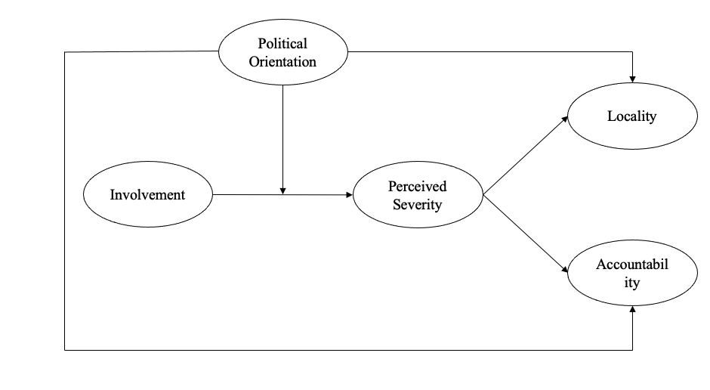

Alternative Model 1 – simultaneous association between political orientation and involvement
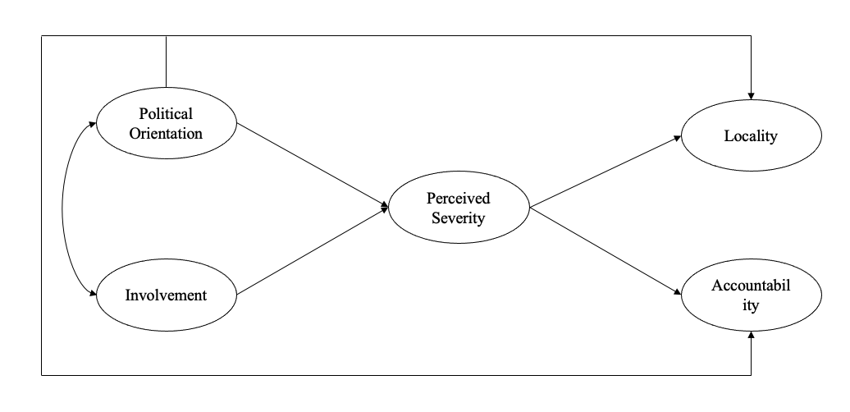

Alternative Model 2 – Involvement and severity as parallel mediators
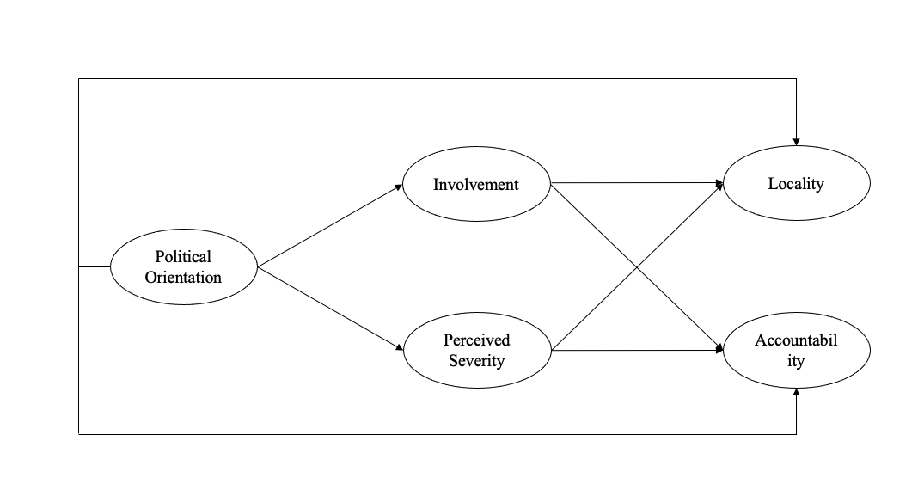

Alternative Model 3 – Indirect effect of political orientation on severity through involvement
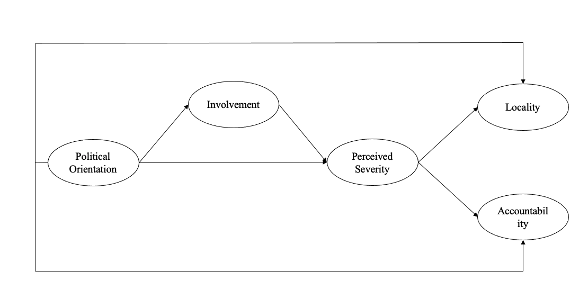

Alternative Model 4 – Indirect effect of political orientation on involvement through severity
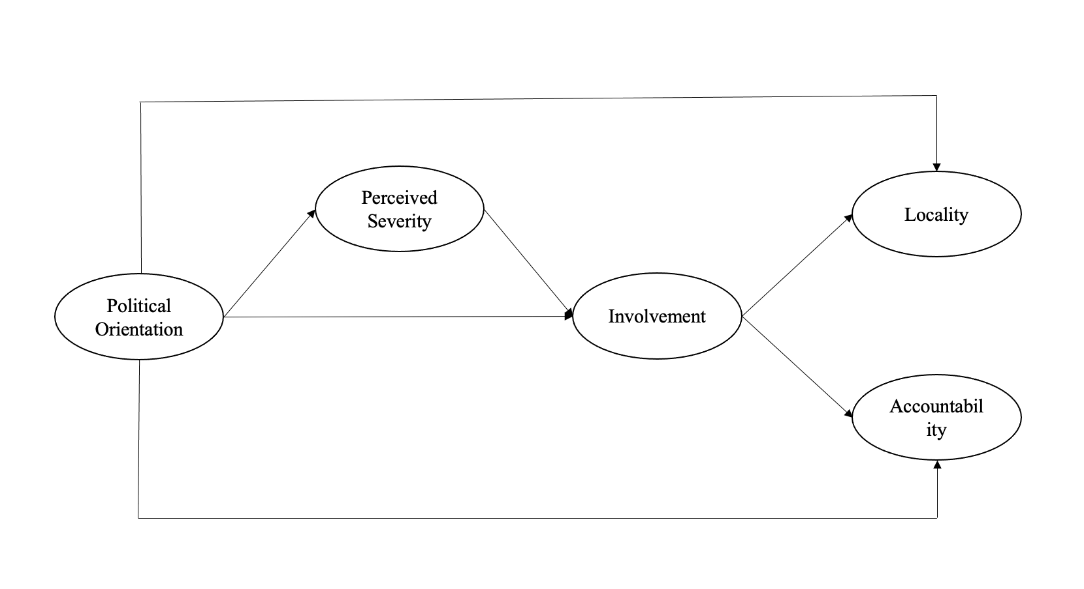

Alternative Model 5 – simultaneous associations between political orientation, involvement, and severity
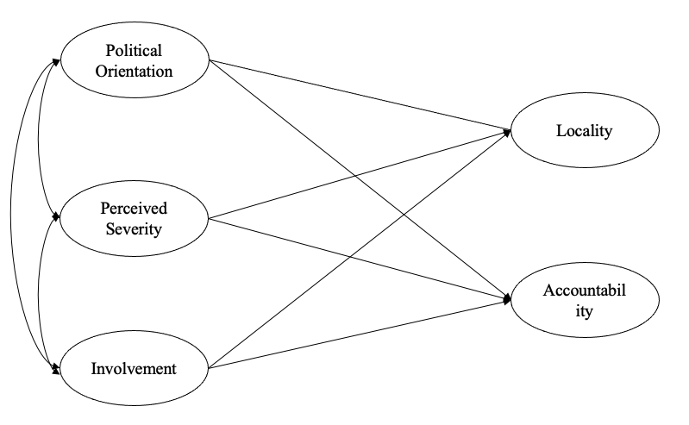

Figure A2

Estimated Parameters the Main Model and Alterative Models

Main Model - Moderation
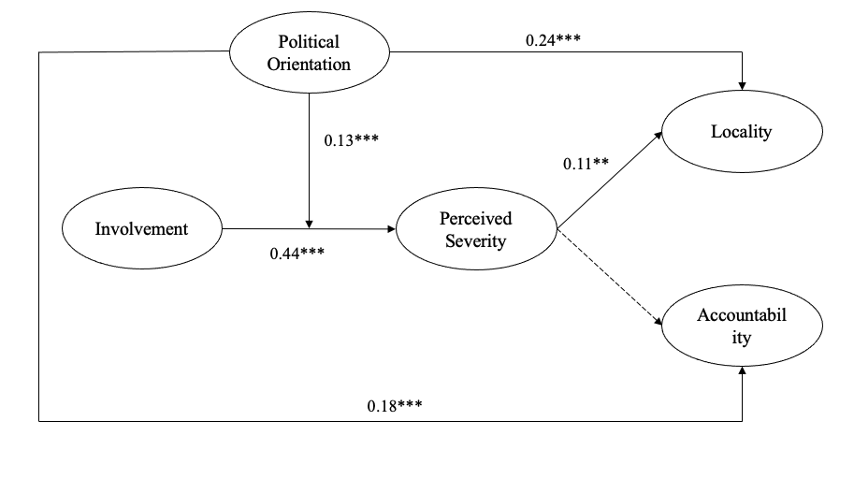

Alternative Model 1 – simultaneous association between political orientation and involvement
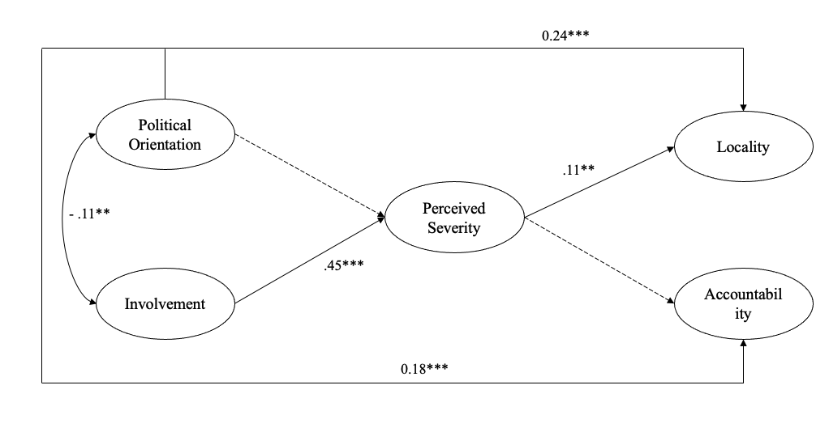

Alternative Model 2 – Involvement and severity as parallel mediators
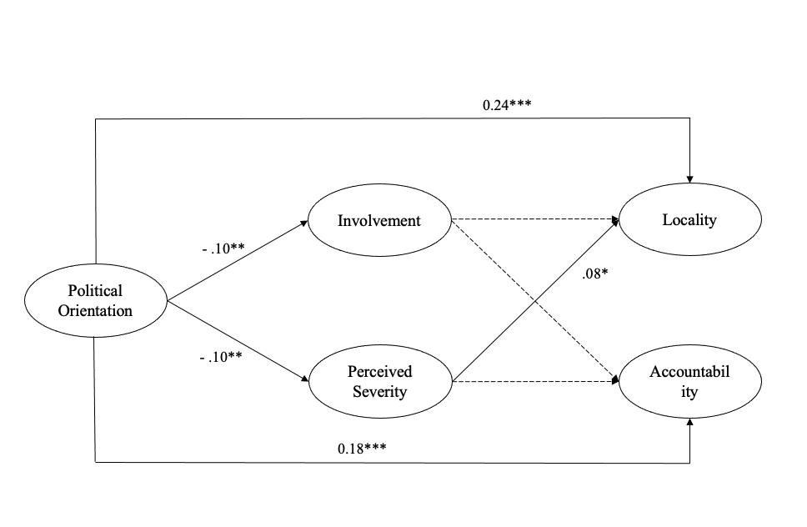
Alternative Model 3 – Indirect effect of political orientation on severity through involvement

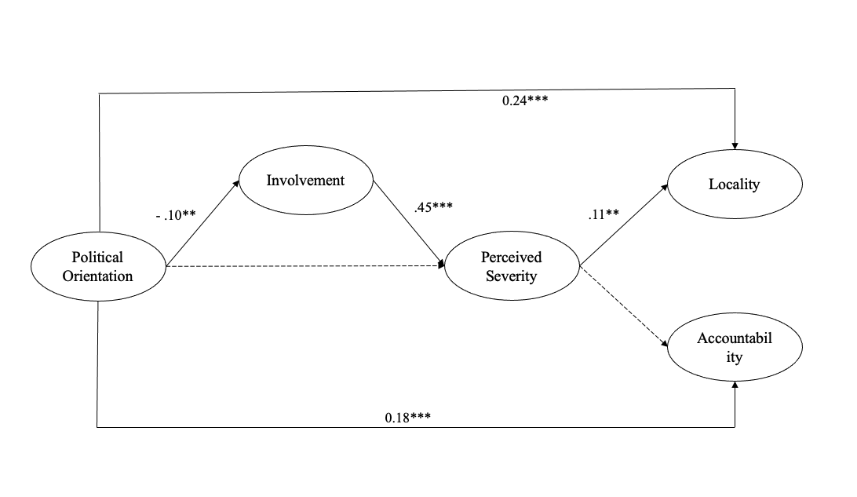

Alternative Model 4 – Indirect effect of political orientation on involvement through severity
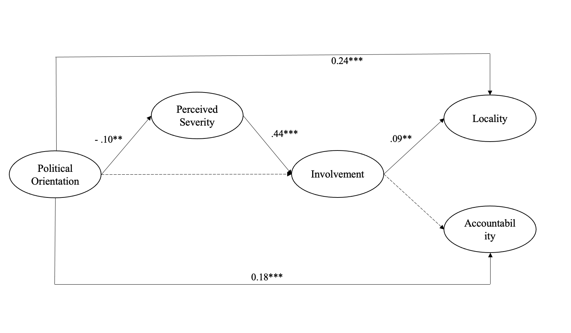
Alternative Model 5 – simultaneous associations between political orientation, involvement, and severity
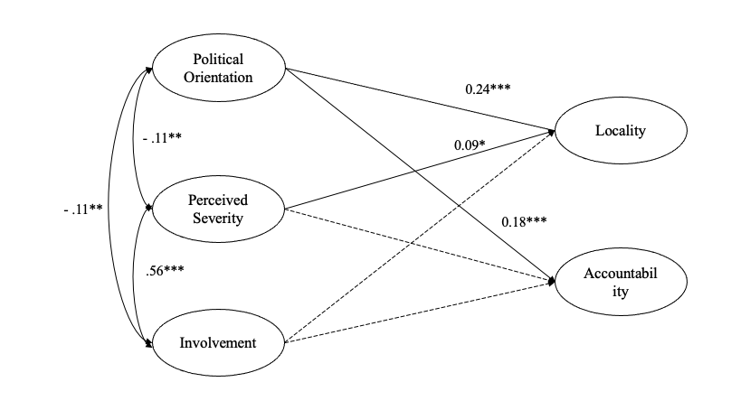

Table A2

Model-Data Fit Indices and Model Comparison

Models | df | Relative Chi-square | RMSEA | CFI | BIC
Main model: Interaction between political orientation and involvement* | 199 | 3.31 | 0.053 | 0.95 | 45,302
The alternative model 1: simultaneous association between political orientation and involvement | 160 | 3.64 | 0.056 | 0.94 | 39,919
The alternative model 2: Involvement and severity as parallel mediators | 152 | 4.38 | 0.064 | 0.93 | 40,057
The alternative model 3: Mediation between political orientation and severity through involvement | 153 | 3.47 | 0.054 | 0.95 | 39,914
The alternative model 4: Mediation between political orientation and involvement through severity | 153 | 3.48 | 0.055 | 0.95 | 39,916
The alternative model 5: simultaneous associations between political orientation, involvement, and severity | 165 | 3.68 | 0.057 | 0.94 | 39,911

Note. *The latent interaction was tested through the match-paired approach (Marsh et al., 2004). Namely, two indicators of the latent interaction term were constructed using standardized scores of issue involvement and political orientation and added to the model.

