Appendix A. Study 1: data exclusion

We excluded participants who completed the study in under 410 seconds (48% of the median time as recommended by SSI, n = 53) and those who were in the experimental conditions but indicated that they did not see any comment or those in the control condition who reported that they saw a comment (n = 153). Because there was some overlap between these groups (i.e., a speeder could also say she did not see a comment in an experimental condition), we got a sample of 457. In the resulting sample, the number of participants in the control condition was not sufficient for further analysis, so these were also excluded (n = 33).

Appendix B. Study 1: the news article and comments

News Article
Protests staged for gun control, gun rights outside NRA meeting

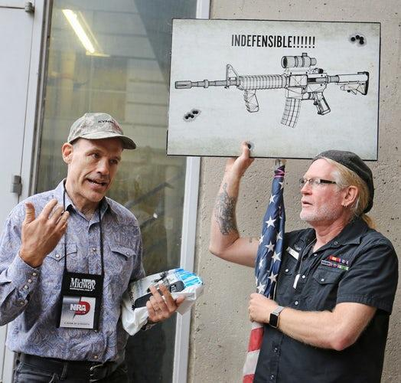
Jim Whalen of West Palm Beach, Fla., a gun proponent, talked civilly with protester David Lyles of Dallas outside the convention center Friday.

DALLAS - Protesters on both sides of the U.S. gun debate took to the streets on Saturday outside the National Rifle Association's annual meeting in Dallas after the latest in a long series of mass shootings put the issue back in the spotlight.

Julia Heilrayne, an Austin, Texas, high school student, attended the protest against NRA with a red target printed on her forehead. Since the Parkland shooting, she said, students at her school are skittish if they hear a loud noise, like a chip bag popping in the cafeteria.

“You can drop a textbook in the hallway, and everyone freezes,” she said. “I'm scared everyday of going to school and if that's the last time I'm going to see my parents.”

“We've seen tragedy after tragedy after tragedy," said Waed Alhayek, a student. “We're trying to regulate the amount of gun violence."

After the gun control protest wrapped up, a group of counterprotesters gathered nearby openly carrying firearms.

“Everyone has sympathy for people who were killed in these horrific events,” said Dante Martin, 52, an NRA member for a decade. “But how many people are killed by drunk drivers? Where’s the outrage there?”

Lawrence Solem, 40, a machinery mechanic from Texas, said he wanted to show his support for the right to carry.

“Evil can and always will exist in the world,” he said. “Evil doesn’t care about time or location. That’s why it’s safest to carry guns at all times.”

After the Florida school shooting massacre, gun control has become a vastly more important issue and both sides are mobilized. It is too early to speculate about what will happen and what repercussions – if any – these movements will have for the future of gun control laws in the United States.

Comments
Civil pro-gun control: People who oppose stricter gun control are simply uninformed. The NRA and its followers do not see that stricter gun control is necessary to prevent future killings, save innocent lives and make our society safe. With a gun, one person can kill others in mass numbers. How can anyone believe that people are safer when there are more guns around? The NRA and those opposing stricter gun control are partly responsible for the all the mass shootings. Lives of hundreds of innocent people could have been saved if there weren’t so many guns. It’s plain and simple, guns kill people. (100)

Uncivil pro-gun control: Those who oppose stricter gun control are stupid IDIOTS. The EVIL NRA and its crew chose to be f&*!*g blind to the fact that stricter gun control is necessary to prevent future killings, save innocent lives and make our society safe. Innocent children are BEING KILLED BY guns!!! Only delusional a&*holes can believe that people are safer when there are more guns around!!! The CORRUPT NRA and all the idiots who oppose stricter gun control have BLOOD on their hands because these mass shootings could have been prevented if there were fewer guns. It’s plain and simple, GUNS KILL PEOPLE!!!!! (100)

Civil counter-gun control: Those who advocate for stricter gun control should rethink their position. Regulating guns will not prevent shootings and other tragedies from happening, criminals will find access to guns whether or not guns are regulated. It is common sense that I can better protect myself and my loved ones with a gun than with a desperate phone call to the cops. The only thing that stops a bad guy with a gun is a good guy with a gun. Gun control supporters want to deprive us of our constitutional rights and risk our lives by making us vulnerable to violent crimes. (101)

Uncivil counter-gun control: Gun control advocates are COMPLETE and TOTAL IDIOTS! They LIE about the “pros” of banning guns: criminals can get their hands on guns illegally anyway, so CRIMINALS WILL KILL PEOPLE whether or not guns are regulated. AND I can better DEFEND myself and my family with my gun than with a desperate phone call to the cops. Those STUPID gun haters don’t seem to understand the plain fact that the only thing that stops a bad guy with a gun is a good guy with a gun. Those a&*holes want to deprive us of our constitutional rights and make us DEFENSELESS AGAINST CRIMINALS!!!! (104)

Appendix C. Study 1: results of the pilot study.

The pilot included 97 Amazon’s Mechanical Turk workers who rated the news article as “strongly opposed to guns” (1) or “strongly supportive of guns” (7) and each comment as “strongly opposed to guns” (1) or “strongly supportive of guns” (7) and “very uncivil” (1) or “very civil” (7). The article (M = 4.27) and all comments (civil anti-gun M_{incivility} = 5.41, M_{position} = 2.59; uncivil anti-gun M_{incivility} = 2.39, M_{position} = 2.34; civil pro-gun M_{incivility} = 5.60, M_{position} = 5.74; uncivil pro-gun M_{incivility} = 2.56, M_{position} = 5.69) were perceived accordingly.

