**Online Appendix**

**Appendix A** – Descriptives for the sample and main variables of interest

|  |  |  |
| --- | --- | --- |
|  | Mean (S.D) | Freq (%) |
| *Age* | 40.21(14.6) |  |
| *Gender* |  |  |
| * Male |  | 250(72.7) |
| * Female |  | 94(27.3) |
| *Education* |  |  |
| * Low |  | 10(2.9) |
| * Middle |  | 78(22.7) |
| * High |  | 256(74.4) |
| *Political interest* | 7.93(1.9) |  |
| *Social media use* | 1.40(1.0) |  |
| *Perceived bias liked party (VRT)* | 4.30(1.7) |  |
| *Perceived bias disliked party (VRT)* | 5.42(2.3) |  |
| *Perceived accuracy (VRT)* | 3.35(2.7) |  |
| *Perceived bias liked party (general media)* | 4.18(1.5) |  |
| *Perceived bias disliked party (general media)* | 5.66(2.1) |  |
| *Media trust (VRT)* | 7.24(2.0) |  |
| *Media trust (general media)* | 6.11(1.9) |  |

**Appendix B –** Experimental stimuli (example for N-VA and Groen)

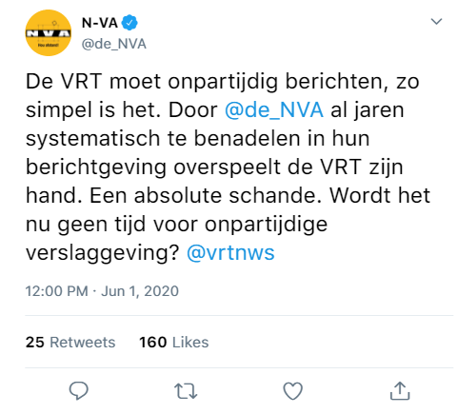

Translation: The VRT [public broadcast must report impartially, it's as simple as that. By systematically disadvantaging @[Party] for years in their reporting the VRT is overplaying its hand. An absolute disgrace. Isn't it time for impartial reporting?

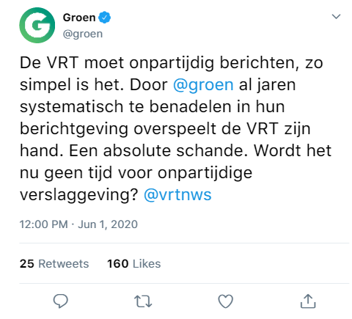

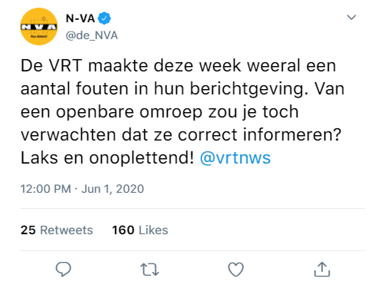Translation: the VRT has again made a number of errors in their reporting this week. You would expect the public broadcaster to inform correctly, wouldn't you? Careless and inattentive!

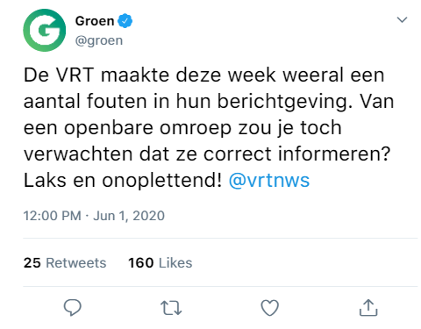

**Note**. The stimuli were similar for the other parties, with only the profile picture and name of the party being changed for respondents with a different (dis)liked party.

**Appendix C** – Balance check

|  |  |  |
| --- | --- | --- |
| **Variable** | **Anova test** | **Chi2-test** |
| Age | F=0.98, df=4, p=0.42 |  |
| Gender | F=0.84, df=4, p=0.50 |  |
| Education |  | Chi2=10.61, df=8, p=0.22 |
| Political interest | F=0.85, df=4, p=0.49 |  |
| Social media use | F=0.69, df=4, p=0.60 |  |
| Party choice |  | Chi2=11.54, df=24, p=0.99 |

**Appendix D1 –** Manipulation check; Party that was shown in the tweet is depicted in the row; party that respondent recalled in column. The shaded cells indicate the correct answers.

|  |  |  |  |  |  |  |  |  |
| --- | --- | --- | --- | --- | --- | --- | --- | --- |
|  | **CD&V** | **Groen** | **N-VA** | **Open VLD** | **PVDA** | **sp.a** | **Vlaams Belang** | **I don’t know** |
| **CD&V** | 80.95% | 4.76% | 4.76% | 0% | 0% | 0% | 0% | 9.52% |
| **Groen** | 0% | 84.2% | 1.75% | 1.75% | 0% | 0% | 3.51% | 8.77% |
| **N-VA** | 0% | 0% | 85.51% | 1.45% | 0% | 0% | 2.90% | 8.71% |
| **Open VLD** | 3.33% | 0% | 3.33% | 76.67% | 0% | 0% | 0% | 16.67% |
| **PVDA** | 0% | 0% | 0% | 0% | 90.2% | 0% | 1.96% | 5.88% |
| **sp.a** | 4.35% | 0% | 2.17% | 0% | 2.17% | 80.43% | 0% | 10.87% |
| **Vlaams Belang** | 0.75% | 0% | 3.01% | 0% | 0% | 0% | 87.97% | 8.27% |

**Appendix D2 –** Manipulation check; Critique that was shown in the tweet is depicted in the row; critique that respondent recognized in column. The shaded cells indicate the correct answers.

|  |  |  |  |  |  |
| --- | --- | --- | --- | --- | --- |
|  | **Ideological bias news article public broadcast** | **Incorrect article public broadcast** | **Ideological bias news media in general** | **None of these** | **I don’t know** |
| **Ideological bias news article public broadcast** | 79.71% | 2.17% | 7.25% | 5.8% | 5.1% |
| **Incorrect article public broadcast** | 17.78% | 62.96% | 3.7% | 4.44% | 11.11% |

**Appendix E – Robustness checks**

E1: Models with respondents who did not pass the manipulation check omitted

|  |  |  |
| --- | --- | --- |
|  | **Model 1**  ***Perceived bias liked party***  **b(SE)** | **Model 2**  ***Perceived bias disliked party***  **b(SE)** |
| *Ref = Control* |  |  |
| Bias article liked party | -.471** | -.227 |
|  | (.239) | (.334) |
| Incorrect article liked party | -.074 | -.359 |
|  | (.236) | (.329) |
| Bias article disliked party | -.382 | -.175 |
|  | (.253) | (.353) |
| Incorrect article disliked party | -.219 | -.351 |
|  | (.256) | (.358) |
| Party fixed effects | *Included* | *Included* |
| Constant | 2.371** | 4.798*** |
|  | (.999) | (1.396) |
| **N** | 262 | 262 |
| **R2** | .419 | .288 |

**Table E1.1** – Predicting perceptions of partisan bias in the public broadcast against the (dis)liked party

|  |
| --- |
| *Standard errors are in parentheses* |
| *\*\*\* p<.01, ** p<.05, * p<.1* |

**Table E1.2** – Predicting perceptions of accuracy public broadcaster

|  |  |  |
| --- | --- | --- |
|  | **Model 3**  ***Perceived accuracy of public broadcast***  **b(SE)** | |
| *Ref = Control group* |  |
| Bias article liked party | -.314 |
|  | (.496) |
| Bias article disliked party | -.524 |
|  | (.487) |
| Incorrect article liked party | -.092 |
|  | (.521) |
| Incorrect article disliked party | -.859 |
|  | (.54) |
| Constant | 3.559*** |
|  | (.329) |
| **N** | 263 |
| **R2** | .012 |
| *Standard errors are in parentheses* | |
| *\*\*\* p<.01, ** p<.05, * p<.1* | |

**Table E1.3** – Predicting perceptions of partisan bias in the media in general against the (dis)liked party

|  |  |  |
| --- | --- | --- |
|  | **Model 4 *Perceived bias liked party***  **b(SE)** | **Model 5**  ***Perceived bias against party***  **b(SE)** |
| *Ref = Control group* |  |  |
| Bias article liked party | -.227 | -.187 |
|  | (.205) | (.315) |
| Incorrect article liked party | .15 | -.488 |
|  | (.203) | (.311) |
| Bias article disliked party | -.251 | -.096 |
|  | (.217) | (.334) |
| Incorrect article disliked party | -.236 | -.129 |
|  | (.22) | (.339) |
| Party fixed effects | *Included* | *Included* |
| Constant | 2.458*** | 4.484*** |
|  | (.858) | (1.319) |
| **N** | 262 | 262 |
| **R2** | .479 | .278 |
| *\*\*\* p<.01, ** p<.05, * p<.1* | | |

**Table E1.4** – Predicting citizens’ trust in the public broadcast (model 6) and in the news media in general (model 7)

|  |  |  |
| --- | --- | --- |
|  | **Model 6**  ***Trust in the public broadcast***  **b(SE)** | **Model 7**  ***Trust in the news media***  **b(SE)** |
| *Ref = Control group* |  |  |
| Bias article liked party | .111 | -.286 |
|  | (.373) | (.36) |
| Bias article disliked party | .598 | -.06 |
|  | (.365) | (.353) |
| Incorrect article liked party | -.391 | -.635* |
|  | (.391) | (.377) |
| Incorrect article disliked party | .084 | -.099 |
|  | (.405) | (.391) |
| Constant | 7.191*** | 6.324*** |
|  | (.247) | (.238) |
| **N** | 263 | 263 |
| **R2** | .023 | .013 |
| *\*\*\* p<.01, ** p<.05, * p<.1* | | |

E2: Models with party interaction

**Table E2.1** – Predicting perceptions of partisan bias in the public broadcast and general media by critique of liked party

|  |  |  |
| --- | --- | --- |
|  | **Model 1**  ***Perceived bias liked party (VRT)***  **b(SE)** | **Model 2**  ***Perceived bias liked party***  ***(General media)***  **b(SE)** |
| *Ref = Control* |  |  |
| Bias article liked party | -.564 | -.276 |
|  | (.352) | (.319) |
| Incorrect article liked party | -.288 | -.125 |
|  | (.346) | (.314) |
| liked party N-VA/VB | -1.02** | -.802** |
|  | (.407) | (.369) |
| Bias article liked party* liked party | .295 | .199 |
| N-VA/VB | (.573) | (.519) |
| Incorrect article liked party* liked | -.188 | -.145 |
| party N-VA/VB | (.586) | (.531) |
| Constant | 4.905*** | 4.571*** |
|  | (.252) | (.228) |
| **N** | 207 | 207 |
| **R2** | .092 | .066 |

|  |
| --- |
| *Standard errors are in parentheses* |
| *\*\*\* p<.01, ** p<.05, * p<.1* |

**Table E2.2** – Predicting perceptions of partisan bias in the public broadcast and general media by critique of disliked party

|  |  |  |
| --- | --- | --- |
|  | **Model 1**  ***Perceived bias disliked party (VRT)***  **b(SE)** | **Model 2**  ***Perceived bias disliked party***  ***(General media)***  **b(SE)** |
| *Ref = Control* |  |  |
| Bias article disliked party | -.951* | -.381 |
|  | (.568) | (.574) |
| Incorrect article disliked party | -.393 | .12 |
|  | (.562) | (.562) |
| Disliked party N-VA/VB | -1.327*** | -.26 |
|  | (.494) | (.5) |
| Bias article dliked party* disliked | .674 | -.391 |
| party N-VA/VB | (.706) | (.714) |
| Incorrect article dliked party* | -.125 | -.647 |
| disliked party N-VA/VB | (.705) | (.708) |
| Constant | 6.56*** | 6.12*** |
|  | (.393) | (.397) |
| **N** | 202 | 203 |
| **R2** | .094 | .043 |

|  |
| --- |
| *Standard errors are in parentheses* |
| *\*\*\* p<.01, ** p<.05, * p<.1* |

E3: Models for general bias

|  |  |  |
| --- | --- | --- |
|  | **Model 1**  ***Perceived general bias (VRT)***  **b(SE)** | **Model 2**  ***Perceived bias disliked party (general media)***  **b(SE)** |
| *Ref = Control* |  |  |
| Bias article liked party | .047 | .181 |
|  | (.219) | (.168) |
| Incorrect article liked party | -.015 | -.081 |
|  | (.22) | (.17) |
| Bias article disliked party | .046 | .162 |
|  | (.219) | (.169) |
| Incorrect article disliked party | -.08 | .038 |
|  | (.222) | (.171) |
| Constant | .853*** | 1.207*** |
|  | (.156) | (.12) |
| **N** | 341 | 339 |
| **R2** | .001 | .01 |

**Table E3** – Predicting perceptions of partisan bias in the public broadcast against the (dis)liked party

|  |
| --- |
| *Standard errors are in parentheses* |
| *\*\*\* p<.01, ** p<.05, * p<.1* |