Supplementary Appendix I - Full version of experimental stimuli

Group 1: No Trump/China

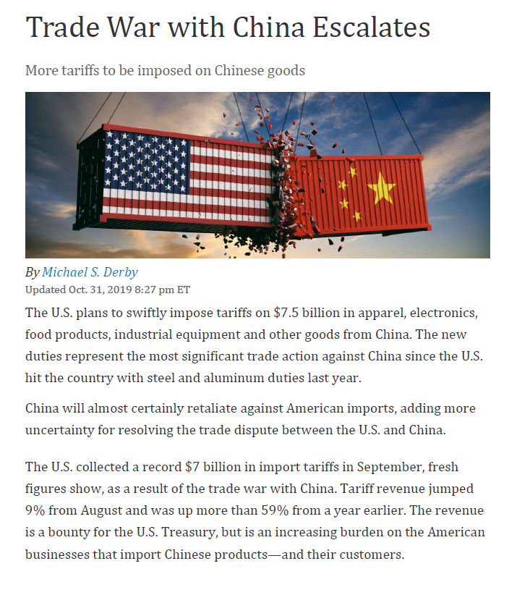

Group 2: Trump/China

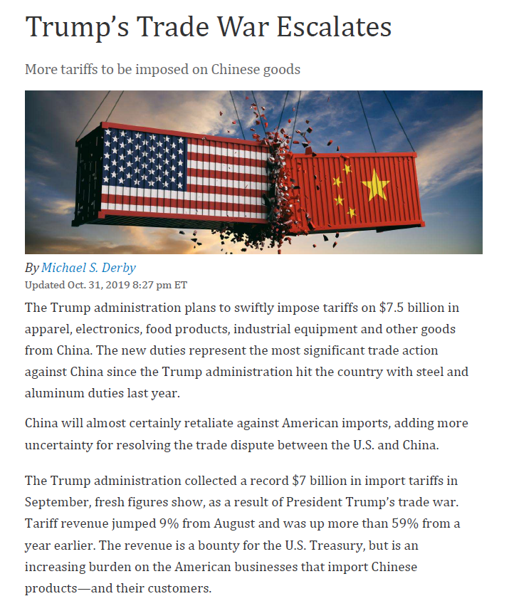

Group 3: No Trump/ E. U.

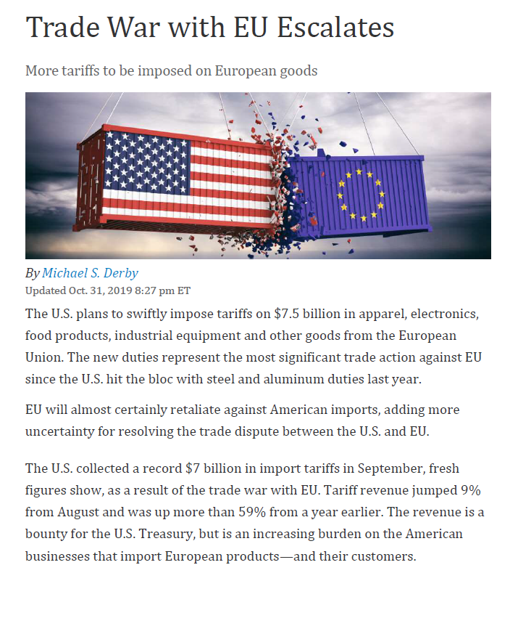

Group 4: Trump/E.U.

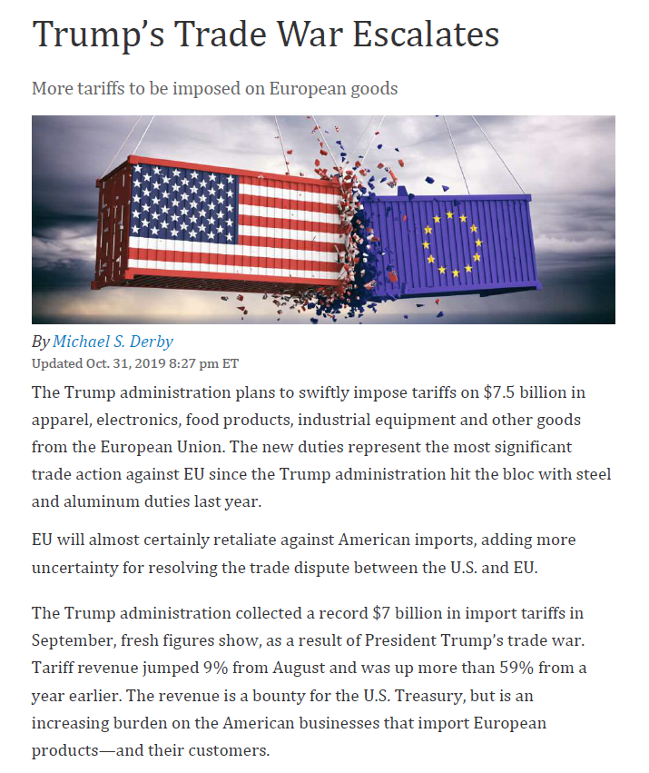

Supplementary Appendix II - Question Wording and Descriptive Statistics for Other Measures

Sex
All respondents were asked, “What is your sex?” Response options were: “Male” (N = 347), “Female” (N = 321), and “Other” (N = 0).

Age
All respondents were asked, “What year were you born?” This number was subtracted from 2019 to generate respondent ages. Respondents ranged from 18 to 90 years of age (M = 50.55, SD = 16.45).

Education
All respondents were asked, “What is the highest level of school you have completed or the highest degree you have received?” Response options were: “None or grades 1-8,” “Some high school, did not graduate,” “High school graduate or GED,” “Technical, trade, or vocational training after high school,” “Some college or Associate degree, no 4-year degree,” “College graduate (B.S., B.A., or other 4-year degree),” and “Post-graduate training or professional degree.” Response options were with a 7-point scale from 0 (“Middle school or below”) to 1 (“Postgraduate”) (M = .70, SD = .24).

Household income
All respondents were asked, “Which category represents the total combined income of all members of your family during the past 12 months? This includes money from jobs, net income from business, farm or rent, pensions, dividends, interest, social security payments and any other money income received by members of your family who are 15 years of age or older.” Response options were: “Less than $5,000”, “$5,000 to 7,499”, “$7,500 to 9,999”, “$10,000 to 12,499”, “$12,500 to 14,999”, “$15,000 to 19,999”, “$20,000 to 24,999”, “$25,000 to 29,999”, “$30,000 to 34,999”, “$35,000 to 39,999”, “$40,000 to 49,999”, “$50,000 to 59,999”, “$60,000 to 74,999”, “$75,000 to 99,999”, “$100,000 to 149,999”, and “$150,000 or more”. Response options were recoded with a 16-point scale from 0 (“Less than $5,000”) to 1 (“$150,000 or more”) (M = .69, SD = .29).

Pre-existing belief about foreign trade
All respondents were asked, 1) “In general, do you think that free trade with foreign countries is a good thing or a bad thing for the U.S.?” (response options ranging from “a very bad thing” to “a very good thing”); 2) “In general, do you support or oppose free trade with foreign countries?” (response options ranging from “strongly to strongly support”); 3) “What do you think free trade with foreign countries means for the U.S.? Do you think free trade is an opportunity for economic growth?” (response options ranging from “not an opportunity at all” to “an enormous opportunity”); and 4) “What do you think free trade with foreign countries means for the U.S.? Do you think free trade is a threat to the economy?” (response options ranging from “not a threat at all” to “an enormous threat”). All questions were measured with a 5-point scale. The four questions were combined to create an index measuring pre-existing belief about foreign trade with a 5-point scale ranging from 0 to 1 where a higher score indicated a more positive pre-existing belief about the trade war (Cronbach’s alpha = .67, M = .63, SD = .17; Q4 reverse coded).

Attitudes towards China and the E.U.
All respondents were asked to report their attitudes towards nine countries with three questions, 1) “In general, what is your overall opinion of the following countries?” (response options ranging from “very unfavorable” to “very favorable”); 2) “For each of the following countries, do you consider it as an ally or an enemy of the U.S.?” (response options including “an enemy”, “unfriendly but not an enemy”, “neither friendly nor unfriendly”, “friendly but not an ally”, “an ally”); and 3) “For each of the following countries, do you consider it a threat to the U.S. or not?” (response options ranging from “not a threat at all” to “an enormous threat”. All questions were measured with a 5-point scale. The three questions regarding China were combined to create an index measuring attitude towards China with a 5-point scale ranging from 0 to 1 where a higher score indicated a more positive attitude (Cronbach’s alpha = .77, M = .44, SD = .24; Q3 reverse coded). The nine questions regarding France, Germany and the U.K. were combined to create an index measuring attitude towards the E.U. with a 5-point scale ranging from 0 to 1 where a higher score indicated a more positive attitude (Cronbach’s alpha = .89, M = .72, SD = .20; Q3 reverse coded).

Nationalism
All respondents were asked, 1) “How important is being an American to you?” (response options ranging from “not at all important” to “extremely important”); 2) “How proud are you to be an American?” (response options ranging from “not at all proud” to “extremely proud”); and 3) “How do you think of the U.S. in comparison with most other countries in the world?” (response options ranging from “the U.S. is the worst country in the world” to “the U.S. is the best country in the world”). All questions were measured with a 5-point scale. The three questions were combined to create an index measuring nationalism with a 5-point scale ranging from 0 to 1 where a higher score indicated a higher level of nationalism (Cronbach’s alpha = .81, M = .73, SD = .25).

