**All Figures (original graphs)**

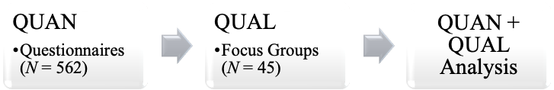

Adapted from Creswell and Clark (2006)

Figure 1 – Explanatory model of the mix method used in the study

Focus Groups

Questionnaires

Figure 2 – Questions used in this study regarding the questionnaires and focus groups

Figure 3 – (Q1) Frequency of daily activities performed by students, organized in groups

Figure 4 – (Q5) Main sources of news information reported by students

Figure 5 – (Q6) Undergraduates’ levels of trust in the news of various sources

Questionnaires

Level of trust

News media

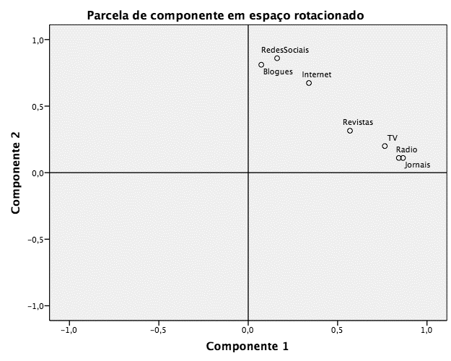

Higher trust

Lower trust

Traditional media

Online media

Figure 6 – (Q6) Clusters obtained in the factor analysis regarding levels of trust in the media

Figure 7 – (Q7) Undergraduates’ level of agreement on statements about the news

Figure 8 – (Q9) Main dimensions identified in student perceptions on the news