‘Seeing but not believing’: undergraduate students’ media uses and perceptions on news trust

Ana Melro (amelro@ismai.pt)
Universidade da Maia, Portugal
Centro de Estudos de Comunicação e Sociedade, Universidade do Minho, Portugal
Sara Pereira (sarapereira@ics.uminho.pt)
Centro de Estudos de Comunicação e Sociedade, Universidade do Minho, Portugal

Abstract
Young people’s engagement with the news is becoming blurred, as social, entertainment and information practices converge on social media. While youngsters often access online news, their trust is placed in traditional media, suggesting a greater understanding of their perceptions about news information. In this paper, we discuss Portuguese undergraduates’ perceptions about trust and news information in different media outlets. We draw on a mix method study using questionnaires (N = 562) and focus groups (N = 45) with 1st year undergraduates from diverse disciplines, between 2016 and 2017. The findings reinforce the paradox found in other studies showing that students trust highly in traditional media despite getting their news mostly from Facebook and YouTube. Student perceptions on the news reveal an idealized view which combines an optimistic and critical perspective. The conclusions emphasize the need for media and information literacy and the rethinking of theoretical concepts considering current media uses.

Keywords: Young people; media uses; media trust; news information; social media.

Funding details: This paper results from a PhD fellowship named “The (dis)interest of young people in current events: study on the role of the media in the information about the world” (SFRH/BD/94791/2013), funded by FCT, QREN and POPH.

Introduction

The role of the media in youth cultures is deeply relevant in all areas of their lives, changing the way they socialize with their peers, how they construct their identities or rebuild their lifestyles (Buckingham 2008; Cardoso, Espanha, and Lapa 2007; Silverstone 2004). Youngsters may not stop to buy newspapers or visit bookstores, but they are always reading and writing in non-traditional ways, taking a glimpse on the news, in their mobiles, while interacting with publications from friends and family on social media (Sampaio 2018). In this complex and convergent media environment, young people combine news access with social and entertainment practices in continuous, incidental and nuanced ways (Boczkowski, Mitchelstein, and Matassi 2017; Fortunati and Magnanelli 2002; Galan et al. 2019; Jenkins 2015; Ling 2002; Lorente 2002; Mante and Piris 2002; Pereira 2014; Sampaio 2018; The Media Insight Project 2015). Long gone are the times where news access used to structure everyday life, giving meaning to daily rituals, such as watching TV at dinnertime, reading the newspaper at breakfast, or listening to the radio on the way to work (Peters and Broersma 2013). Society is increasingly witnessing a ‘de-ritualization’ of news media practices (Peters and Broersma 2013), crossing the limits of time and space, in a liquid state, where news information expands itself to anytime, anywhere, wanted or unwanted.
In this sort of ‘ambient journalism’ where online entertainment, information and social interaction coexist in one space (Galan et al. 2019; Hermida 2010), it remains unclear how meaningful news information is to young people’s lives and how their trust in the news contributes to an informed citizenship. While there are clear signs that young people pay less and less attention to the information on traditional media (Costera Meijer 2007), it also has been argued that there is greater disengagement of young people regarding news information in general than in previous youth generations (Buckingham 2000; Costera Meijer 2007; Cushion 2009). According to Buckingham (2000), the need to seek for information is not because of an age factor but due to a ‘cohort-effect’, meaning that young people’s lack of news interest tends to remain unchanged as they move into adulthood (Barnhurst and Wartella 1998; Buckingham 2000; Costera Meijer 2007; Putnam 1995). This argument motivated a wave of discourses in the literature which points towards a dumbing-down of society and the growth of cynic and apathetic youth cultures, especially towards mainstream politics (Baumgartner and Morris 2006; Bourdieu 1997; Mindich 2005; Nguyen 2012).
It is acknowledged that trust in the news is essential for an informed and engaged citizenship, as it is tightly linked to trust in politics and to a healthy democracy (Dahlgren 2011).While trust in traditional media (TV, radio, written press) has remained rather stable in the EU, at least since 2014, online news trust has seen significant declines (EBU Media Intelligence Service 2018; Newman et al. 2019). Also, the concepts of news trust and the challenges of a ‘post-truth’ or ‘post-fact’ culture, adding to the spread of online disinformation (Mihailidis and Viotty 2017), might lead to rethink about the role of news information in young people’s lives. Furthermore, youth views on the news underpin an idealized role of journalism despite their uses and practices revealing a more entertained and blurred perspective (Costera Meijer 2007).
Given the contrasting nature of the literature on young people’s media uses and news trust, and the scarcity of studies with undergraduates, in this paper we seek to understand how Portuguese university students access news information and how their media uses are related to their perceptions of news and trust. For that, we draw on a mix method study with Portuguese undergraduates from diverse disciplines, using questionnaires and focus groups to answer the following research question: What are undergraduates’ perceptions on the news and media trust, and how these relate to their media uses?
This study contributes to a greater knowledge about young people’s engagement with news information in the current media environment, particularly regarding higher education students with implications for further research.

Literature review

Young people, social media, and the news

The growing importance of the online in young people’s news access is an undeniable trend that has been reported every year by several institutions worldwide. For instance, roughly a decade ago, the Pew Research Center (2012) reported that the majority (60%) of the Americans under 25 years old already used to access online news, especially on social media. Similarly, the Reuters Institute refer that over half (56%) of the Europeans under 25 also used to access the news online (Newman and Levy 2013), with several studies worldwide reporting that traditional media is often used by older people, and that news interest is lower in younger groups (Gonçalves 2015; Newman et al. 2017; Newman and Levy 2013; Pew Research Center 2012).
In 2015, the study on How millennials get News of The Media Insight Project (2015) revealed that for 85% of the Americans between 18 and 34 years old, to be informed about current events is somewhat important for them, even though they do not follow the news in a conventional way. Instead, they are mostly informed on Facebook in a continuous flow, which often combines news access with social connections, problem solving, and entertainment (The Media Insight Project 2015).
In Portugal, the majority of youngsters between 15 and 24 years old mostly use their mobile phones to access the news on social media, with Facebook also being the most used platform for news access (Gonçalves 2015; Newman et al. 2017). Whilst Facebook might now be losing its central role to other platforms, such as Instagram, TikTok or WhatsApp (Newman et al. 2019; Wang 2017), if news information were not be streamed at all on social media, people might not even notice the difference, since “﻿for a majority of people, friends and family content is a perfectly-acceptable-to-excellent substitute for traditional news” (Benton 2018). This suggests that current events are mostly accessed by convenience for being in a space where young people are already there to do other things.
However, these generalizations might not account for differences between diverse people when it comes to news preferences. Combining news access with news interest, Newman and Levy (2013) identified four profiles of individuals: ‘news lovers’, ‘casual users’, ‘non-users’, and ‘daily briefers’. The latter, being the most common profile, as mobile use allows to follow the news many times a day for short periods of time (Newman and Levy 2013). In a Danish study, Schrøder (2010) identified seven profiles, in which for instance the ‘traditional versatile news consumer’ refers to individuals over 35 years old, and the ‘background-oriented digital news consumer’ is mostly composed of young people in their 20’s living in the capital. Recently, in a Reuters Institute report using qualitative data of Americans and British young adults under 35’s, four profiles were highlighted according to different media and platform uses of news access (Galan et al. 2019): the ‘heritage news consumer’ who keeps replicating some of the family habits they grew up with, like watching TV during meals; the ‘passive news absorver’ who does not seek for news information in specific sources but rather remain informed through online and offline fluid experiences; the ‘dedicated news devotee’ who has structured routines and holds strong belief in the value of news; and the ‘proactive news lover’ who actively engage with news from different sources. While the authors of the study state that ‘passive news absorver’ “are the most at risk of falling into an echo-chamber cycle” (Galan et al. 2019:36), other insights need to be taken into account to explain a more complex socio-cultural reality in young people’s media uses of today. For instance, the idea of a passive recipient of the news which has already been marginalized in the late 60’s with the emergence of cultural studies from the Birmingham School, viewing audiences as interpretative communities of media messages, and setting the basis of current media reception studies. Instead of passive audiences, young peoples’ engagement with the news might lead to nuanced perceptions on news definitions that can simultaneously be motivated by social and entertainment intentions (Lee 2013; The Media Insight Project 2015), as well as by status, identity and learning (Galan et al. 2019).

News trust and other paradoxes

Building trust in the media is claimed to be essential for an active citizenship (Buckingham 2000; Dahlgren 2011; Peters and Broersma 2013). Still, it is remains unclear the relationship between news trust and media uses, especially regarding the online (Russmann and Hess 2020; Strömbäck et al. 2020).
According to data of 18 countries from the 2019 Reuters Institute Digital News Report, national levels of trust in the news media have fallen by an average of five percentage points since 2015 (Newman et al. 2020). While many factors might be in the root of this decline, studies have shown that trust in the news media is increasingly tied to levels of trust in politics, meaning that in the existing ‘post-truth’ era, “if the political situation becomes more polarized, even the best news coverage can come to be seen as biased by large sections of the population” (Newman et al. 2020:31). Another aspect mentioned by the authors of the report is that news trust seems to be related to how people perceive the news in meeting “widely accepted goals” (Newman et al. 2020:32), mostly in being newsworthy for them, delivered in a timely manner, being helpful to understand the world around them, and in holding accountability.
One the main challenges in studying news trust relies on the conceptualizations of trust itself, which not only can mean different things but is also a constantly changing concept that evolves around media and technology advances (Fisher 2016). Media trust can be about unspecified news media in general, different media types, media as institutions, individual media outlets, journalists, or content of media coverage (Strömbäck et al. 2020). Rather than debating these conceptualizations in depth, our intention here is to understand how young people perceive news trust in general, which is therefore linked to their overall perceptions and beliefs about news information.
In a study with young adults, Russmann and Hess (2020) found that trust in online and social media is strongly determined by their perceptions of content being reliable and objective, such as presenting fact checked information and different opinions. However, the authors state that despite young people’s uses being mostly online, the media channels they trust the most are the traditional ones (Russmann and Hess 2020). Similarly, in a study with Spanish university students García-García et al. (2014) reveal that the great majority of students (81%) say they do not trust online information despite using the Internet as their main source of information. One common reason for this is the connection made with the so-called fake news spread. For instance, young adults’ general consensus is that there is more dubious content being circulated on social media than on traditional media, despite getting their news mostly on Facebook (Russmann and Hess 2020). Still, it is claimed that “fake news itself is seen as more of a nuisance than a democratic meltdown” (Galan et al. 2019:44), and that some youngsters are able to tackle these issues by being more aware or media literate (Galan et al. 2019; Russmann and Hess 2020).
Overall, this idea that young people’s trust in traditional media while using social media to access the news suggests a deeper understading of youth cultures in the digital age. For Costera Meijer’s (2007), this doble viewing paradox is explained because young people are aware of the social and civic importance of the news, idealizing news under a certain ‘sacrosanctity’. Hence, while they claim for high quality information (objective, accurate, serious), as opposed to light and entertained news, youngsters rather prefer to be informed in an entertained way, excluding themselves as an audience of the high quality standards they hold (Costera Meijer 2007).

Data and methodology

In this paper we seek to understand young people’s perceptions about trust and news information in different media outlets. To address our RQ, we draw on a mix method study using questionnaires (N = 562) followed by focus groups (N = 45) with undergraduates from diverse disciplines of two Portuguese universities. This work draws from a broader doctorate study about the role of media and information in young people’s civic and political lives (Melro 2018).
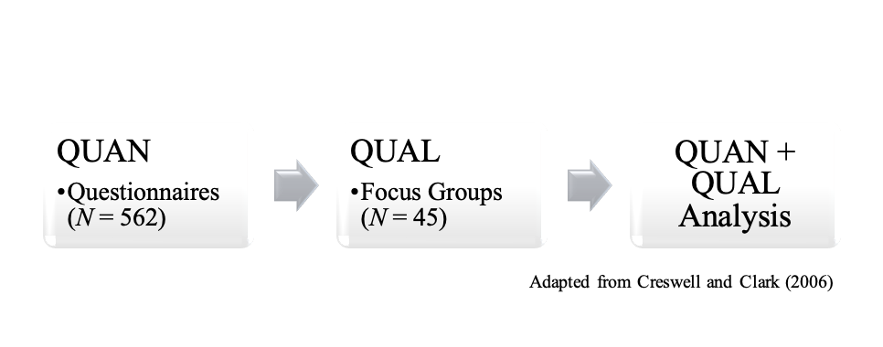
Using the explanatory ‘follow-up’ model (Creswell and Clark 2006), the qualitative method (focus groups) was used to explain the quantitative results from the questionnaires (Figure 1). The questionnaires were conducted firstly, and the focus groups were dynamized afterwards, at a second stage, with a sample of the same respondents. Data was first analyzed separately after each collection and then combined to allow comparison in student responses.
Figure 1 – Explanatory model of the mix method used in the study
The questionnaires were composed of 40 questions (25 closed questions and 15 open-ended questions), divided in seven thematic blocks, and was designed to map student media practices, as well as to understand their perceptions about news information and journalism (such as media interests and media trust), and the connection to civic and political participation. Questionnaires were then applied in class via online, between February and June of 2016, to a convenience sample of 562 first year undergraduates from 18 different fields of study (Social Sciences and Humanities, Health and Sports Sciences, and Engineering and Physical Sciences) in two universities: Universidade do Minho (UMinho), in Braga, and Universidade da Beira Interior (UBI), in Covilha, located in the coastline and interior of Portugal, respectively. Both the location and course were used as criteria for the sample selection to ascertain significant differences among students. The sample of the questionnaires is composed of 332 (59%) females and 230 (41%) males, with an average age of 20 years old (N = 562; SD = 3.4). The quantitative analysis of the closed questions comprehended descriptive and advanced statistics using IBM SPSS.
After gathering and analyzing the data of the questionnaires, the focus groups were conducted in the following year, between March and April of 2017, with the same respondents of the questionnaires. The focus groups were mostly organized by participants of the same course and university to allow comparisons between groups. In total, there were 45 participants from both universities, distributed in eight groups, up to 10 members each (Table 1).

Focus Groups | University | Course | N
A | UMinho | Communications; Economics; Education | 4
B | UMinho | Biochemistry | 4
C | UMinho | Architecture | 3
D | UBI | Sports | 6
E | UBI | Aeronautics Engineering | 3
F | UBI | Communications; Film Studies | 7
G | UBI | Sociology | 10
H | UBI | Architecture | 8
Total |  |  | 45

Table 1 – Number of participants of focus groups by course and university
The sessions lasted an average of 64 minutes, and two main activities were developed around the following topics: perceptions on information about current events; and the role of the news in civic and political participation. The discourses were transcribed, and names of the participants remained fictitious. Both the transcriptions of the focus groups and the open-ended questions of the questionnaires were analyzed separately on QSR NVivo, using an exploratory approach of content analysis, in which the categories emerged from the data (McQuail 2003:331).
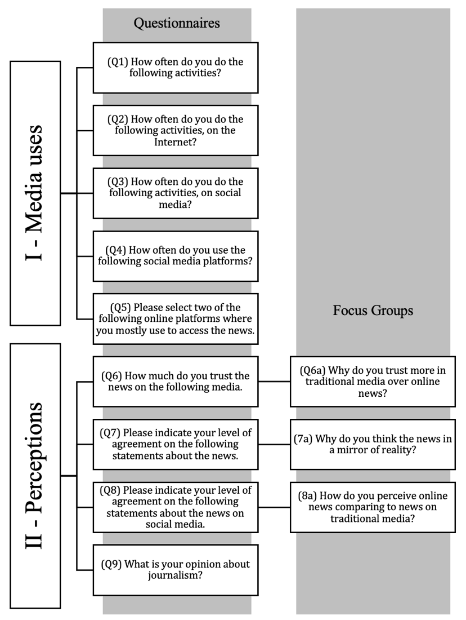
Given the purpose of this paper, we focus on three specific questions of the focus groups and on nine questions of the questionnaire. Following the explanatory mix method, questions of the focus groups are based on the results of the questionnaire, as observed in Figure 2.
Figure 2 – Questions used in this study regarding the questionnaires and focus groups
To contextualize student perceptions on the news, it is important to identify young people’s media uses in the first place, particularly when accessing information on current events. This characterization is answered by questions Q1 to Q5 of the questionnaires. Second, to understand young people’s perspectives about news and the role of information, as well as to know how they trust in different media outlets, we draw on questions Q6 to Q9 of the questionnaires and Q6a to Q8a of the focus groups. Except for the focus groups and questions Q9 (open-ended question) and Q5 (closed question with multiple choices), all the remaining ones used in this study are closed questions which include multiple variables in a 5-point scale. In some cases, we have grouped the categories of the scale and converted into a 3-point scale, for a clearer overview.
In the next section, we present the main findings drawing on the results of the questions mentioned in both research tools, some of them described in more detail and others presented more as a complement, according to their relevance for this paper.

Findings

Media uses: bringing together social, entertainment and information practices

Starting with the first question (Q1) about undergraduates’ daily activities, almost all students (N = 558) access the Internet (95.5%), and use mobile phones (94.2%), computers or tablets (81.2%) more than once a day. Among all the activities listed, those related with new media are the most frequently used by students on a daily basis, as also observed in Figure 3. Question Q1 comprises 13 variables or activities which were then grouped accordingly: written press (read newspapers and magazines); audiovisual media (watch television and listen to the radio); new media (access the Internet and use the computer, tablet or mobile phone); entertainment (listen to music and play videogames); work and study (read books and study); social (chat with friends and family); and sports (practice sports).

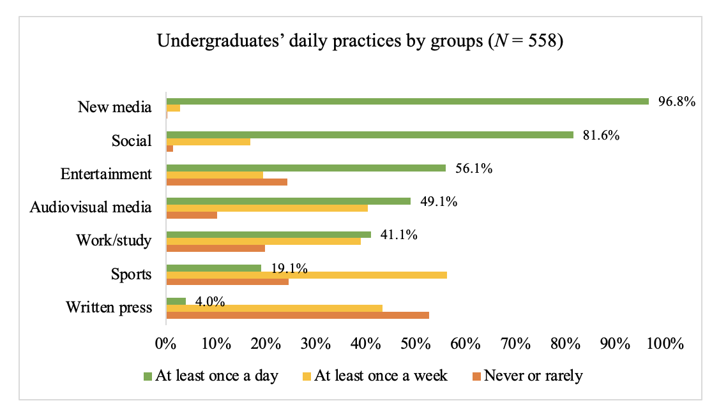
Figure 3 – (Q1) Frequency of daily activities performed by students, organized in groups

Also, highly relevant in the daily lives of these youngsters is socializing with friends and family (81.6%), which often takes place on social media, as we further describe. Within the entertainment group, listening to music is by itself an activity performed daily by the great majority of the students (71.9%). At the other end, over half of the students (52.7%) never or rarely read newspapers and magazines at all. As for audiovisual media uses, ungrouped frequencies are higher when watching television daily (37.6%) and listening to the radio at least once a week (31.7%), although both activities are usually performed by same group of students as they are statistically significant related (p < .01; .25 ≤ |R_{S}| < .5).
Except for the written press, all media related activities play a central role in the everyday life of students. Reading books is more of a weekly basis activity (43.2%), as it is practicing sports (56.3%), while studying is a daily practice undertaken by most students (60.2%).
Overall, students spend most of their time on the Internet, accessing the online many times a day. This is proved to be generalized as there are no significant differences between any of the sociodemographic variables, such as gender or socioeconomic status, for instance. What students do on the Internet is therefore answered by Q2, in which findings reveal that almost all students mostly use the Internet to go on social media at least once a day (93.7%), especially on YouTube (89%) and Facebook (88.6%), as detailed by Q4.
In general, student online practices are shaped by social, entertainment, information, and participation activities, as revealed by the factor analysis of Q2, displayed in Table 1 (KMO = .75; p < .01). In the third factor, for instance, the results show that social media access is related to socializing with friends and family, which most students refer doing at least once a day (71%), as well as watching movies or series (47.5%), and listening to music (62.8%). Participation activities are least performed by students, but we will leave this discussion for future studies.

(Q2) Frequency of undergraduates’ online activities (N = 558) | Factor 1 Information | Factor 2 Participation | Factor 3 Social/Entertainment
Study or work | .74
Search for information | .74
Read books or articles | .68
View emails | .67
Access the news | .54
Engage in forum discussions |  | .78
Visit virtual worlds |  | .76
Play games |  | .64
Comment on information |  | .56
Read blogs |  | .46
Access social media |  |  | .79
Chat with friends and family |  |  | .76
Listen to music |  |  | .68
Watch TV series or movies |  |  | .56
% of variance explained | 18.2 | 17.4 | 15.0
Cronbach’s alpha | .87 | .83 | .84
Table 2 – (Q2) Factor analysis regarding student online activities
Method: PCA with Varimax rotation and Kaiser Normalization.
Regarding the information factor, over half of the students access online news (52.9%) on a daily basis, which often takes place on social media (68.1%), as complemented by the results of Q3 (N = 548). Similarly, responses of the multiple-choice question Q5 (N = 555) also confirm that social media is where most students get their news from (Figure 4).
Figure 4 – (Q5) Main sources of news information reported by students
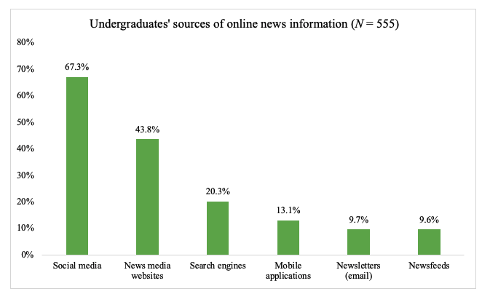
Besides accessing the news, Q3 shows that the topmost frequent activities students undertake on social media are viewing their feed (77.6%) and sending private messages (75.2%) to socialize with friends and family. However, not only there are differences between males and females, but also differences in the activities taking place in different social media platforms. For instance, the Mann-Whitney test and adjusted residuals of Q2 (N = 558) indicate significant differences by showing that accessing online news, many times a day, is more frequent among male students while accessing the news at least once a week is more prevalent in females. Also, crossing the results of Q3 and Q4, we found that there are moderate associations (.25 ≤ |R_{S}| < .5) between accessing the news and using Facebook, and between publishing and using Instagram, suggesting that students use different social media for different purposes.

Perceptions on the news and media trust

As revealed in the previous section, social media is the main source of news information by students of this study. However, they reveal little trust in online information comparing to traditional media. In particular, newspapers are stated as the most trustworthy source of information by over half of the students (Figure 5), but only 4% reads newspapers at least once a day, as shown by Q1. Equally, the radio is regarded as a highly credible media channel by 54% of the students. Slightly below, trust in television is mostly divided between trusting ‘a lot’ (40.6%) and trusting ‘a bit’ (44.7%), as reveal the ungrouped frequencies of Q6.
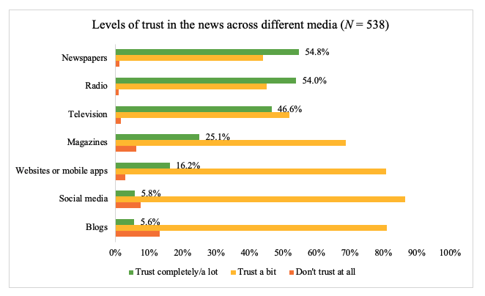
Figure 5 – (Q6) Undergraduates’ levels of trust in the news of various sources
Except for magazines, students reveal lower levels of trust in all online sources of information. Online news from websites or mobile apps in general are most trusted, but only 6% reveals total trust in social media news.
Conducting a factor analysis on Q6 (KMO = .78; p < .01), it is possible to observe the existence of two factors or clusters (Figure 6): (1) one regarding traditional media (accounting 35.9% of variance explained) comprehending higher levels of trust; (2) and another regarding online media (accounting 28.8% of variance explained) comprehending lower levels of trust. This confirms that students reveal higher levels of trust in traditional media compared to online media, despite using the latter more often to access the news.
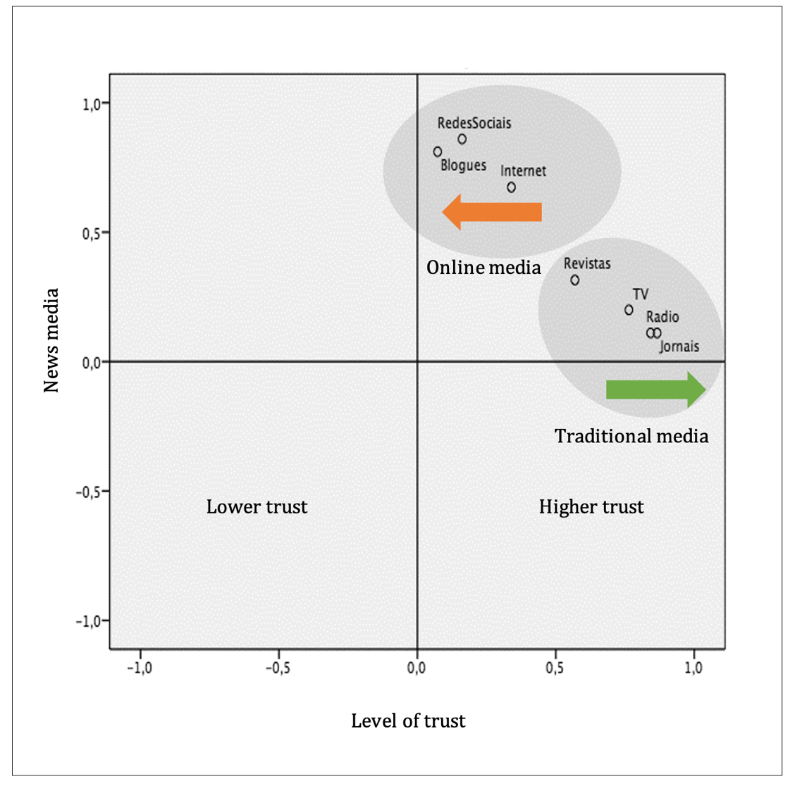
Figure 6 – (Q6) Clusters obtained in the factor analysis regarding levels of trust in the media

Students in the focus groups reinforce this belief held towards traditional media being more trustworthy than online news media. This is revealed by statements given to Q6a where students express their suspicious on online news, as this student comments: “I happen to believe more in television news and in written newspapers than on websites, which... I end up doubting” (Pavarotti, FG-H). Students argue that their low trust in online news, especially on social media, is due to issues involving mis- and disinformation, particularly associated with fake news spread after the 2016 US Presidential election, when this study was conducted. While trust in television news seem to divide student opinions, according to their background and family routines, trust in online news was commonly viewed with suspicion. As these two students explain:

I really prefer to give more importance to [television] news. I happen to prefer something that, even at home, has never been lost, which is watching TV news while having dinner. I still prefer that than viewing the news on Facebook, where nowadays it's very easy to fake. For example, just yesterday I saw a news that Soraia Chaves has died, and it's not true. Thus, it's very easy to get fake news on the Internet. (Margarida, FG-G)

For me, radio is the medium I trust the most (...). Older people still listen to the news a lot on the radio, and I think there is more credibility in the radio, then in television news, and lastly, on the Internet. On the Internet, it's very easy to get fake news, as we've already seen. While television news is always trying to capture people's attention, on the radio, I think it goes more towards meeting peoples’ needs and giving people what they want. (Daniela M., FG-D)

Trust in traditional media is therefore linked to student perceptions on how people in the past used to access and trust the news, in some cases replicating family habits and connecting trust with history and tradition. As one student further justifies, newspapers tend to be more ‘serious’ due to its long printing tradition over the years:

I think it is, maybe, because we are also a bit attached to the past and knowing that in the past the news was actually to deliver the news (...). Whereas now, it's a different business and so we still have that image that in the past people maybe took their jobs more seriously and that's why the news was real (…) like newspapers are real...” (Lee, FG-C)

Similarly, when comparing their perceptions on the news, in both traditional and online media (Q8a), students in the focus groups argue for instance that “perhaps, on traditional media, it was more difficult, for example, to give false information because it was something more serious...” (Debora, FG-F). Whilst today, “everything is about the money, the profit they will gain” (Tiny, FG-H), therefore “it is a competition; it is about whoever gets to be the first to release information and there is no time to check or investigate” (Maria M., FG-A). While news on social media is less trusted, student perceptions on social media news are seen by the great majority (80.7%) as a useful way of keeping up to date about current events, as revealed by Q8 (N = 554) of the questionnaires, which might help explain why they access more on social media comparing to other sources.

Optimist and critical

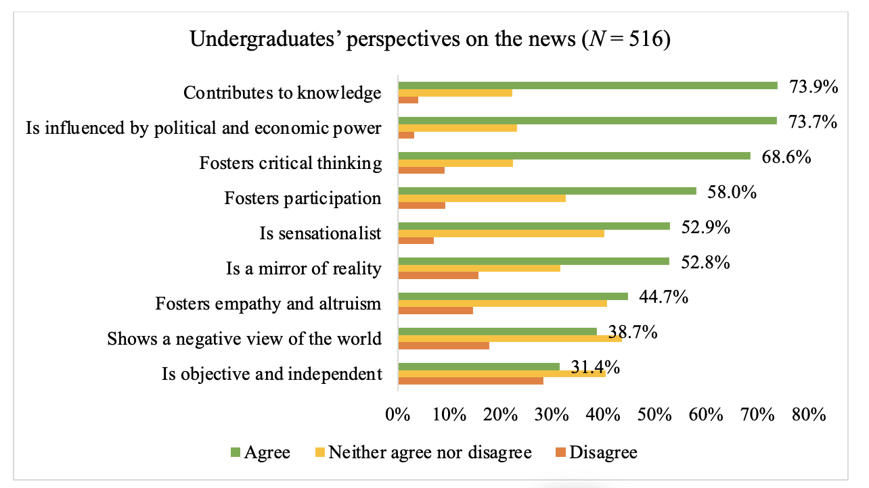
Overall, student perceptions on the news are in general divided between an approach that focus more on the contributions to knowledge formation and a stance which revolves around issues undermining information. In Q7 (N = 516) of the questionnaires (Figure 7), we observed that, on the one hand, the majority of students (73.9%) think the news is essential to build knowledge and to foster critical thinking (68.6%). On the other hand, most students agree with statements that news is influenced by politics and economics (73.7%), and that draws on sensationalism (52.9%).
Figure 7 – (Q7) Undergraduates’ level of agreement on statements about the news
In addition, over half of the students (52.8) holds the idea that news is, or at least should be, a ‘mirror of reality’, which was then further explored in the focus groups (Q7a). Here, students explain that even sensationalism or drama is nothing more than a reflection of society: “people like to exaggerate (…) if there's a rumor, people like to know and the more scandalous it is, the more they want to talk about. That is why it mirrors reality…” (Bruno C., FG-D). Alternatively, news is expected to show what happens in fact, which is tied to an ideal of the news as objective and acting as a watchdog, as this student comments: “supposedly, it is what [the news] should be, a mirror of reality, because it is supposed to convey two sides of the same coin” (Alice, FG-F). Nonetheless, contrary to the questionnaires, most students in the focus groups (nine in 14) disagreed with this statement, revealing instead that news is a social construction or an interpretation of reality from an individual point of view. This was also a perspective more frequent among students of Communications, for instance:

I think the news never mirrors reality because it is produced by a specific person who is going to write under certain principles, values, knowledge, and previous experiences (…). In addition, there are editorial guidelines that shape and determine what and how is going to be covered. (Maria M., FG-A)

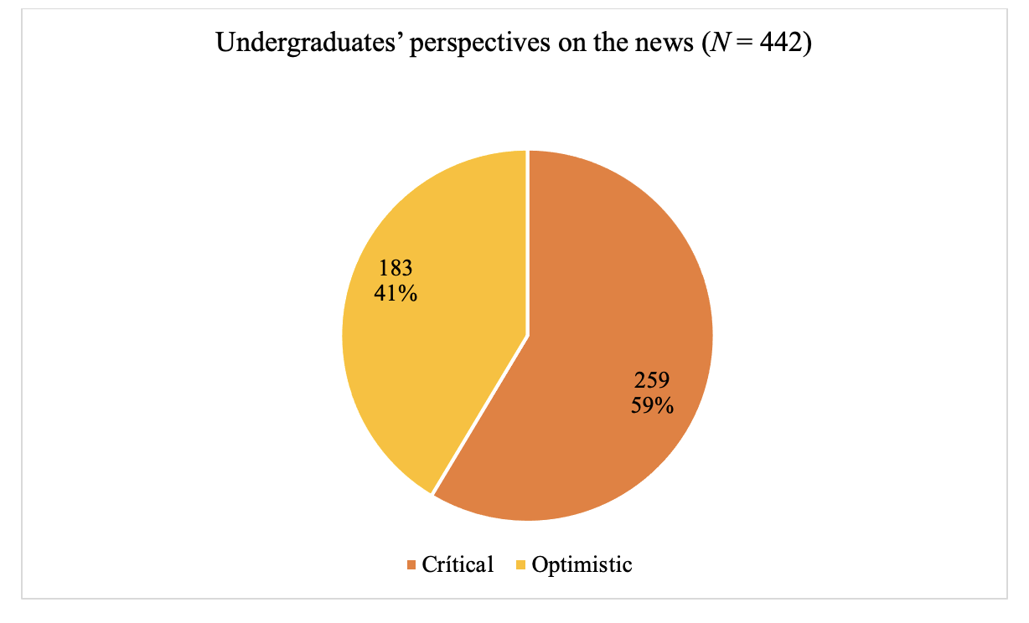
In exploring student perceptions on the news, the open-ended question Q9 (N = 422) allowed us to gain a better overview of what students answered, for instance previously on Q7. Overall, in the answers given to Q9, we have identified two major but not distinct perspectives (Figure 8), meaning that an answer could co-exist or be categorized in both dimensions.
Figure 8 – (Q9) Main dimensions identified in student perceptions on the news
The first dimension is called the optimistic approach (41%), in which students mostly perceive the importance of news information essentially to develop critical thinking and to know what is going on around them so they can be an informed citizen. As for example this student refers: “[the news] is useful and essential for critical development and personal knowledge, not only for young people but for society in general” (male, Sociology, UBI). Whilst referring to positive aspects, students would sometimes combine these with situations where they question information quality, leading to the second perspective or critical approach (59%). Here, most of student responses were about questioning or signposting a range of issues involving the news. Those were organized in more granular subcategories, containing the number of references within a certain case or student response, as described in Table 3.

Subcategories of the critical approach | f (references) | %
News bias and framing | 138 | 37,9%
Sensationalism | 80 | 22,0%
Agenda-setting and gatekeeping | 73 | 20,1%
Credibility/news trust | 47 | 12,9%
Profit-driven market | 22 | 6,0%
Adultcentrism | 4 | 1,1%
Total | 364 | 100,0%

Table 3 – (Q9) Frequency of references categorized within the critical perspective about student perceptions on the news
Many of these students demand quality information while criticizing the role of external forces, mostly political and economic power that might contribute to news bias. As this student puts it: “the news helps us to inform about the reality of the country and the world, but not always in an unbiased way. Through opinion makers, it tends to give a distorted view of reality due to party interests" (male, Architecture, UMinho). Another student commented on how they perceive TV news, for instance:

“(…) I would say that journalism is very biased, manipulated by some economic and personal interests of powerful people. And I would add that television journalism is degrading; during one hour of TV newscast, they are not able to talk about a truly informative and independent subject. Once I have even heard a television news anchor inciting wildfires by saying ‘still only 600 hectares have burned’.” (male, Biochemistry, UMinho)

In the subcategory about sensationalism, students for instance highlight the dramatization, gossip, and the spectacular involving the news, since “they increasingly make sensationalized headlines for content without relevant information (...)” (female, Psychology, UMinho). This goes along with a sense that “some news is published in such a brief way that do not always contain all the information we want to know” (female, Communications, UMinho). Others commented on the way some topics are selected in the media agenda while ignoring others. For instance, when giving much attention to celebrities instead of relevant information (male, Film Studies, UBI) or when disregarding other sports beyond soccer (female, Sociology, UMinho). Also, the focus on negative events, such as crime or tragedies, consists of a news value that students do not identify themselves with, showing “a world in disgrace, a world full of crime, poverty, and hunger…” (female, Law, UMinho). Instead, they seek for positive news, as this student explains: “the media focus more in the negative happenings of the world than in providing a positive view of reality” (female, Communications, UMinho). Still in the subcategory about agenda-setting/gatekeeping is the idea that the media tend to overextend the coverage of certain topics, since “(…) when they don't have any updates, they repeat the same subject several times a day” (Female, Medicine, UBI).
Another issue, as equally mentioned in the focus groups (Q6a), has to do with students’ trust in online news, pointing towards a loss of quality and credibility mostly due to matters of disinformation and the rush felt in the digital environment: “[the news] should be as much objective as possible and it is losing its credibility because of social media” (female, Communications, UMinho). This idea is also linked to a profit-driven understanding of the media in which the intention is set on “selling the story to gain more views” (female, Communications, UMinho).
Lastly, and with only four references, students perceived the news as being made by adults for adults, referring to the fewer times where young people appear on the media as information source or to comment on current events. This adultcentric view on the news is, for example, expressed in the following response:

It is very important for us to stay informed about what is happening around us, in our country and in the world. Many young people, and even adults, don’t value the news, but I think it is often not produced in a way that captures their attention. Maybe the news nowadays is made for adults, they forget about the young people who start out with some curiosity about certain subjects, but at the end, they kind of lose interest. (female, Industrial Design, UBI)

In general, student perceptions on the news combine a mix of both optimistic and critical views. However, those perspectives sometimes are not consistent with their current practices around news information, as we further discuss.

Discussion and conclusions

In this study, we found that young people mostly access the news on the Internet, at least once a day, especially on social media such as Facebook or YouTube, which is also reported in other studies (Newman et al. 2017). Accessing the news on traditional media, however, was proven to be less often and confined to television and radio, widely depending on other aspects, such as family habits or individual interests, while newspapers and magazines readership were down to a minority. These findings are also aligned with other studies (Costera Meijer 2007; Galan et al. 2019; Newman et al. 2019). Instead of purposely accessing the news, our study confirms that most students’ encounter with current events is expressed in blurred and nuanced ways (The Media Insight Project 2015), as they often get informed while using social media. This suggests that media convergence is not just about the reinvention of news media production, but also (and perhaps more importantly) about media practices (Jenkins 2015). As we also found, news and information access is combined with social and entertainment practices through social media.
To address our research question, we argue that the relationship between undergraduates’ media uses and their perceptions on the news and media trust is surfaced by a certain inconsistency or paradox that suggests a more complex reality underneath. While young people discover the news on social media, in an incidental way, their understanding of news trust and how they perceive the news are different from their actual practices. Despite often accessing the news on social media, only a small minority of students reveal complete trust in social media news. On the other hand, newspapers were stated as the most trustworthy news source, but only a small minority of students reads newspapers on a daily basis. Students therefore believe more in the information conveyed by traditional media (which they use the least), than by new media (which they use the most). This paradox around ‘seeing but not believing’ is also acknowledged in other studies mentioned in the literature (García-García et al. 2014; Russmann and Hess 2020).
Given student perceptions on the news, this high level of trust in traditional media can be explained by two related reasons: firstly, by the idea that traditional media is taken more seriously and has longer history than online media; and secondly, by the notion that it is easier to spread mis- and disinformation on the Internet than on traditional media. Similar to Costera Meijer’s (2007) findings, these students demand high quality information and reveal an idealized view of the social and civic status of the news and the role of journalism in society. Therefore, while some students recognize that news is essential to be informed about the world and hold an optimistic stance, most students reveal a critical perspective on the news, mostly based on what they think the news should be. For instance, many students think the news should mirror reality and accurately report the facts, listing some of the issues that compromise their quality standards, such as news bias, profit-driven journalism, sensationalism, disinformation, and questioning media agendas for being repetitive (Bourdieu 1997) or covering soft, entertained and negative topics. Despite claiming an objective and serious type of journalism, students identify themselves with news that are made for them and that bring an entertained and positive view of the world, which is also aligned with the emergency of the constructive journalism (Rice-Oxley 2018). Young people might avoid news content that is boring, but they appreciate contents that are informative and especially relevant to their daily concerns, and not merely entertaining (Buckingham 2000). Nonetheless, one important limitation to acknowledge in this study is the fact that student discourses might reveal what is socially acceptable (Buckingham 2000), enhancing the gap between speech and practice.
Furthermore, contrary to criticisms of a dumbing-down approach that perceives youth as cynic and apathetic (Baumgartner and Morris 2006; Nguyen 2012), this study contributes to the understanding that young people perceive the news in nuanced and paradoxical ways. This leads to reflect on the implications of news perceptions and media uses in the rethinking of theoretical concepts of news information and of the role of journalism (Peters and Broersma 2013), as well as on the need to continuously foster media and information literacy to handle the challenges of disinformation and technology, such as Artificial Intelligence, in a constantly changing post-truth world (Buckingham 2000; Mihailidis and Viotty 2017; Peters and Broersma 2013; Russmann and Hess 2020; The Media Insight Project 2015). Additionally, would be interesting for future research to understand whether young people’s engagement with the news has changed during the COVID-19 pandemics.

References
Barnhurst, Kevin G., and Ellen Wartella. 1998. “Young Citizens, American TV Newscasts and the Collective Memory.” Critical Studies in Mass Communication 15(3):279–305.
Baumgartner, Jody, and Jonathan S. Morris. 2006. “The Daily Show Effect: Candidate Evaluations, Efficacy, and American Youth.” American Politics Research 34(3):341–67.
Benton, Joshua. 2018. “If Facebook Stops Putting News in Front of Readers, Will Readers Bother to Go Looking for It?” Nieman Lab, January 12.
Boczkowski, Pablo, Eugenia Mitchelstein, and Mora Matassi. 2017. “Incidental News: How Young People Consume News on Social Media.” Pp. 1785–92 in 50th Hawaii International Conference on System Sciences, Honolulu.
Bourdieu, Pierre. 1997. Sobre a Televisão. Oeiras: Celta Editora.
Buckingham, David. 2000. The Making of Citizens: Young People, News and Politics. London: Routledge.
Buckingham, David. 2008. “Introducing Identity.” Pp. 1–24 in Youth, Identity and Digital Media, edited by D. Buckingham. Cambridge: The MIT Press.
Cardoso, Gustavo, Rita Espanha, and Tiago Lapa. 2007. E-Generation: Os Usos de Media Pelas Crianças e Jovens Em Portugal. Lisboa: CIES/ISCTE.
Costera Meijer, Irene. 2007. “The Paradox of Popularity: How Young People Experience the News.” Journalism Studies 8(1):96–116.
Creswell, John W. J., and Vicki L. Plano Clark. 2006. Designing and Conducting Mixed Methods Research. London: Sage.
Cushion, S. 2009. “Discouraging Citizenship? Young People’s Reactions to News Media Coverage of Anti-Iraq War Protesting in the UK.” Young 17(2):123–43.
Dahlgren, Peter. 2011. “Young Citizen and Political Participation.” Taiwan Journal of Democracy 7(2):11–25.
EBU Media Intelligence Service. 2018. “Market Insights: Trust in Media 2018.” (May):40.
Fisher, Caroline. 2016. “The Trouble with ‘Trust’ in News Media.” Communication Research and Practice 2(4):451–65.
Fortunati, Leopoldina, and Anna Maria Magnanelli. 2002. “El Teléfono Móvil de Los Jóvenes.” Revista de Estudios de Juventud (57):59–78.
Galan, Lucas, Jordan Osserman, Tim Parker, and Matt Taylor. 2019. How Young People Consume News and The Implications For Mainstream Media. Oxford.
García-García, F., M. Gértrudix-Barrio, and F. Gértrudix-Barrio. 2014. “Análisis de La Incidencia de La Dieta de Servicios Digitales En La Utilidad y Confianza de La Información En Internet En Los Jóvenes Universitarios.” Communication & Society 27(1):59–81.
Gonçalves, Telmo. 2015. Públicos e Consumos de Média: O Consumo de Notícias e as Plataformas Digitais Em Portugal e Em Mais Dez Países. Entidade Reguladora para a Comunicação Social.
Hermida, Alfred. 2010. “Twittering the News: The Emergence of Ambient Journalism.” Journalism Practice 4(3):297–308.
Jenkins, Henry. 2015. Cultura Da Convergência. São Paulo: Editora Aleph.
Lee, Angela M. 2013. “News Audiences Revisited: Theorizing the Link between Audience Motivations and News Consumption.” Journal of Broadcasting and Electronic Media 57(3):300–317.
Ling, Richard. 2002. “Chicas Adolescentes y Jóvenes Adultos Varones: Dos Subculturas Del Teléfono Móvil.” Revista de Estudios de Juventud (57):33–46.
Lorente, Santiago. 2002. “Juventud y Teléfonos Móviles: Algo Más Que Una Moda.” Revista de Estudios de Juventud (57):9–24.
Mante, Enid A., and Dóris Piris. 2002. “El Uso de La Mensajería Móvil Por Los Jóvenes En Holanda.” Revista de Estudios de Juventud (57):45–58.
McQuail, Denis. 2003. Teoria Da Comunicação de Massas. Lisbon: Fundação Calouste Gulbenkian.
Melro, Ana. 2018. “O (Des)Interesse Dos Jovens Pela Atualidade: Estudo Sobre o Papel Dos Media Na Informação Sobre o Mundo.” Doctoral Thesis, Universidade do Minho, Braga, Portugal.
Mihailidis, Paul, and Samantha Viotty. 2017. “Spreadable Spectacle in Digital Culture: Civic Expression, Fake News, and the Role of Media Literacies in ‘Post-Fact’ Society.” American Behavioral Scientist 61(4):441–54.
Mindich, David T. Z. 2005. Tuned out: Why Americans under 40 Don’t Follow the News. Nova Iorque: Oxford University Press.
Newman, Nic, Richard Fletcher, Antonis Kalogeropoulos, and Rasmus Kleis Nielsen. 2019. Reuters Institute Digital News Report 2019. Oxford.
Newman, Nic, Richard Fletcher, Antonis Kalogeropoulos David A. L. Levy, and Rasmus Kleis Nielsen. 2017. Reuters Institute Digital News Report 2017. Reuters Institute for the Study of Journalism.
Newman, Nic, Richard Fletcher, Anne Schulz, Andi Simge, and Rasmus Kleis Nielsen. 2020. “Journalism, Media, and Technology Trends and Predictions 2020 - Reuters Institute Digital News Report.”
Newman, Nic, and David a. L. Levy, eds. 2013. Reuters Institute Digital News Report 2013. Tracking the Future of News. Reuters Institute for the Study of Journalism.
Nguyen, A. 2012. “The Effect of Soft News on Public Attachment to the News: Is ‘Infotainment’ Good for Democracy?” Journalism Studies 13(5–6):706–17.
Pereira, Sara. 2014. “A Internet Na Vida Das Gerações Mais Novas. Um Estudo Com Adolescentes Portugueses.” Pp. 135–46 in Agentes e vozes: um panorama da mídia-educação no Brasil, Portugal e Espanha, edited by I. Eleá. Göteborg: The International Clearinghouse on Children, Youth and Media, Nordicom.
Peters, Chris, and Marcel Broersma. 2013. “Introduction - Rethinking Journalism: The Structural Transformation of a Public Good.” Pp. 1–13 in Rethinking journalism. Trust and participation in a transformed news landscape, edited by C. Peters and M. Broersma. Abingdon: Routledge.
Pew Research Center. 2012. Trends in News Consumption: 1991-2012. In Changing News Landscape, Even Television Is Vulnerable. Pew Research Center.
Putnam, Robert D. 1995. “Tuning in, Tuning out: The Strange Disappearance of Social Capital in America.” PS: Political Science and Politics 28(4):664–83.
Rice-Oxley, Mark. 2018. “The Good News Is … People like to Read Good News.” The Guardian, February 12.
Russmann, Uta, and Andreas Hess. 2020. “News Consumption and Trust in Online and Social Media: An In-Depth Qualitative Study of Young Adults in Austria.” International Journal of Communication 14:3184–3201.
Sampaio, Daniel. 2018. Do Telemóvel Para o Mundo. Pais e Adolescentes No Tempo Da Internet. Alfragide: Editorial Caminho.
Schrøder, K. 2010. “Citizen-Consumers’ Constellations of News Media: Towards a Typology of What People Put into Their Shopping Carts in the News Supermarket.” in RIPE 2010 conference, Londres. Londres.
Silverstone, Roger. 2004. ¿Por Qué Estudiar Los Medios? Madrid: Amorrotu editores.
Strömbäck, Jesper, Yariv Tsfati, Hajo Boomgaarden, Alyt Damstra, Elina Lindgren, Rens Vliegenthart, and Torun Lindholm. 2020. “News Media Trust and Its Impact on Media Use: Toward a Framework for Future Research.” Annals of the International Communication Association 44(2):139–56.
The Media Insight Project. 2015. How Millennials Get News: Inside the Habits of America’s First Digital Generation. AP-NORC American Press Institute.
Wang, Shan. 2017. “How Much News Makes It into People’s Facebook Feeds? Our Experiment Suggests Not Much.” Nieman Lab, December 18.

The questions were previously validated through a pre-test with a smaller sample of the population (N = 30) to check consistency and wording issues.
Names of focus group participants were fabricated by students themselves.
In the grouping of the 5-point scale, categories 1 and 2 form one group, the third category forms the second category, and 4 and 5 merge into the third category of the 3-point scale. This merging allows to populate the extreme positions of the scale, giving a clearer overview of student responses.
The activities on Q1were grouped in major categories based on the resultant components of a factor analysis (FA) previously conducted. For this paper, we chose not to describe this particular FA in detail, since it is a complementary point.
The results of another question of the questionnaire reveal that most students (60.8%) spend more than two hours per day on the Internet.
In Q4 (N = 553), student answers reveal that YouTube and Facebook are the most accessed social media platforms on a daily basis, followed by Instagram (63.1%). Twitter, on the other hand, is never or rarely used by the great majority of students (76.7%).
This notion is also backed up in another question (N = 531) of the questionnaire in which the majority of students (65.3%) agreed that the media should provide a positive view of the world.

