Appendix

Appendix A. Additional results
Appendix B. Treatments and materials
Appendix C. Sample composition

Appendix A. Additional results

Table A1. Exposure to campaign messages and affective polarization; direct effects (alternative DV: dislike for out-party)
 | M1 |  |  | M2 |  |  | M3
 | Coef | Se | sig | Coef | Se | sig | Coef | Se | sig
Negative ª | 2.49 | (2.21)
Character attack ^{b} |  |  |  | 0.02 | (2.86)
Uncivil ^{c} |  |  |  |  |  |  | 1.50 | (1.99)
Constant | 72.36 | (2.00) | *** | 74.83 | (2.69) | *** | 74.10 | (1.41) | ***
N | 967 |  |  | 792 |  |  | 698
R2 | 0.00 |  |  | 0.00 |  |  | 0.00
Note: All models are OLS regressions. Dependent variable in all models is dislike for the out-party (0-100).
ª Reference category is “Positive campaigning.”
^{b} Reference category is “Policy attack” (non-attacks excluded).
^{c} Reference category is “Civil attack” (non-attacks and policy attacks excluded).
*** p<0.001, ** p<0.01, * p<0.05, † p<0.1

Table A2. Exposure to campaign messages and affective polarization; profile controls (alternative DV: dislike for out-party)
 | M1 |  |  | M3 |  |  | M3
 | Coef | Se | sig | Coef | Se | sig | Coef | Se | sig
Negative ª | -1.93 | (2.52)
Character attack ^{b} |  |  |  | -0.55 | (2.66)
Uncivil ^{c} |  |  |  |  |  |  | -0.89 | (1.89)
Perceived negativity | 1.43 | (0.51) | ** | 2.64 | (0.56) | *** | 2.85 | (0.62) | ***
Republican ^{d} | -11.54 | (1.69) | *** | -10.49 | (1.81) | *** | -9.55 | (1.95) | ***
Female | 2.11 | (1.62) |  | 2.32 | (1.73) |  | 3.38 | (1.85) | †
Age | 0.50 | (0.06) | *** | 0.51 | (0.07) | *** | 0.53 | (0.07) | ***
Education | -1.47 | (0.46) | ** | -1.68 | (0.49) | *** | -1.89 | (0.52) | ***
Constant | 81.82 | (7.27) | *** | 74.05 | (8.35) | *** | 72.73 | (8.44) | ***
N | 966 |  |  | 792 |  |  | 698
R2 | 0.12 |  |  | 0.15 |  |  | 0.16
Note: All models are OLS regressions. Dependent variable in all models is dislike for the out-party (0-100).
ª Reference category is “Positive campaigning.”
^{b} Reference category is “Policy attack” (non-attacks excluded).
^{c} Reference category is “Civil attack” (non-attacks and policy attacks excluded).
^{d} Reference category is “Democrat” (independent and unaffiliated voters excluded).
*** p<0.001, ** p<0.01, * p<0.05, † p<0.1

Figure A1. Mediated effects by perceived negativity (alternative DV: dislike for out-party)

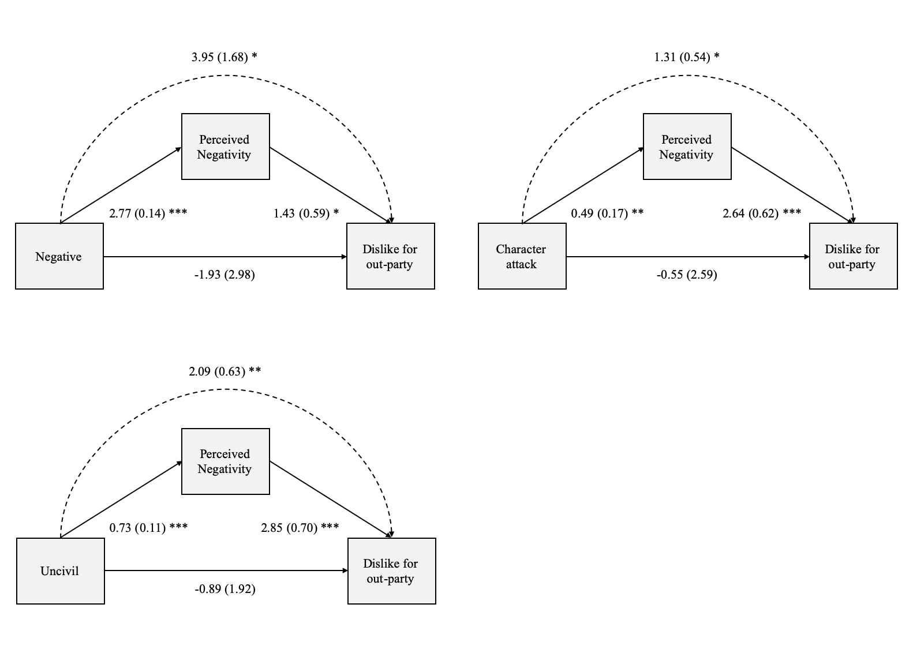

Note. Coefficients are bootstrapped unstandardized regression coefficients (1000 iterations). The dashed arrow represents the indirect effect. Dependent variable in all models is dislike for the out-party (0-100).
*** p<0.001, ** p<0.01, * p<0.05, † p<0.1

Figure A2. Mediated effects by perceived negativity, by party affiliation (alternative DV: dislike for out-party)

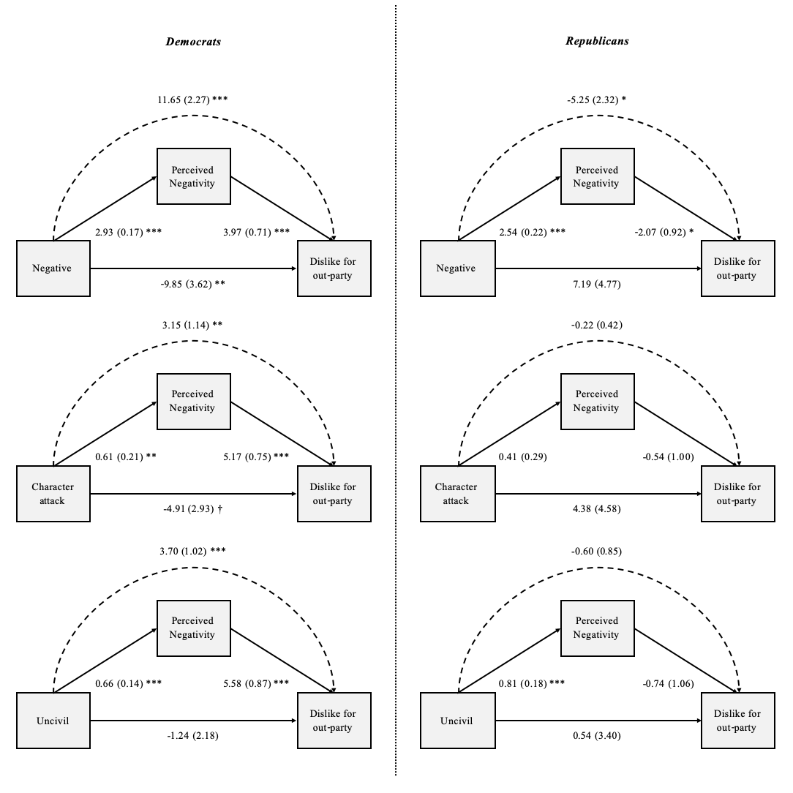

Note. Coefficients are bootstrapped unstandardized regression coefficients (1000 iterations). The dashed arrow represents the indirect effect. Dependent variable in all models is dislike for the out-party (0-100).
Left-hand panels are run only for respondents declaring a partisan affiliation with the Democrats (outgroup with the attacker, ingroup with the target of the attacks). Right-hand panels are run only for respondents declaring a partisan affiliation with the Republicans (ingroup with the attacker, outgroup with the target of the attacks).
*** p<0.001, ** p<0.01, * p<0.05, † p<0.1

Appendix B. Treatments and materials

Figure B1. Experimental groups and observations

Stimuli text

(highlights are as presented to the respondents)

* Introduction to the stimulus (all participants):

On the following page you will read some information about two candidates, who will compete next year for a seat in the US House of Representatives for Minnesota's 9th Congressional district: Republican Paul A. Bauer, and Democrat Carl B. Meyer.
Please read the information on the following page carefully.

[page break]

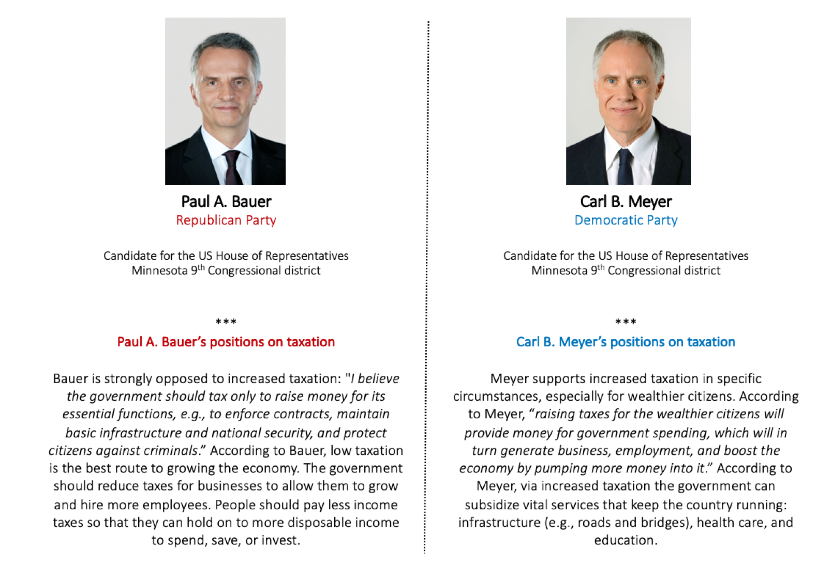

[page break]

In the next page we will show you a newspaper clipping, containing a statement from Paul A. Bauer (Republican) on the issue of taxation for the automobile industry. Please read the text carefully.

[page break]

* Positive policy

“Bauer promotes Republicans’ tax policy”
Yesterday, Republican candidate for Congress Paul A. Bauer gave a speech in front of his supporters in Little Rock, Minnesota. One of his key messages was on the economy. He described his plans: “If I win the next election, I will work in the House of Representatives to substantially decrease taxes for the auto- mobile industry. This is good news.Automobile factories are an important economic actor in our state, providing jobs for tens of thousands of people. Lower taxes will keep these companies in our country, instead of moving abroad. The result would be lower unemployment and higher tax revenues. The Republicans’ low taxation policies will benefit the country.” Today, Bauer will continue his rally visiting a plant in New Venice and talking with workers.

* Positive character

“Bauer promotes Republicans’ tax policy”
Yesterday, Republican candidate for Congress Paul A. Bauer gave a speech in front of his supporters in Little Rock, Minnesota. One of his key messages was on the economy. He described his plans: “If I win the next election, I will work in the House of Representatives to substantially decrease taxes for the automobile industry. My strong experience on this issue is good news. Automobile factories are an important economic actor in our state, providing jobs for tens of thousands of people. Lower taxes will keep these companies in our country, instead of moving abroad. The result would be lower unemployment and higher tax revenues. My low taxation policies will benefit the country.” Today, Bauer will continue his rally visiting a plant in New Venice and talking with workers.

* Negative policy civil, no fear, no populism

“Bauer attacks Democrats on tax policy”
Yesterday, Republican candidate for Congress Paul A. Bauer gave a speech in front of his supporters in Little Rock, Minnesota. One of his key messages was on the economy. He attacked his competitor, Carl B. Meyer. “Democrat Carl Meyer announced that, if he wins the next election, he will work in the House of Representatives to substantially increase taxes for the automobile industry. This is bad news. Automobile factories are an important economic actor in our state, providing jobs for tens of thousands of people. Higher taxes would cause these companies to migrate to other counties - or even worse, abroad. The result would be rising unemployment and lower tax revenues. The Democrats’ high taxation policies will damage the country.” Today, Bauer will continue his rally visiting a plant in New Venice and talking with workers.

* Negative character civil, no fear, no populism

“Bauer attacks Meyer on tax policy”
Yesterday, Republican candidate for Congress Paul A. Bauer gave a speech in front of his supporters in Little Rock, Minnesota. One of his key messages was on the economy. He attacked his competitor, Carl B. Meyer. “Democrat Carl Meyer announced that, if he wins the next election, he will work in the House of Representatives to substantially increase taxes for the automobile industry. Meyer’s inexperience is bad news. Automobile factories are an important economic actor in our state, providing jobs for tens of thousands of people. Higher taxes would cause these companies to migrate to other counties - or even worse, abroad. The result would be rising unemployment and lower tax revenues. Meyer is wrong, and his high taxation policies will damage the country.” Today, Bauer will continue his rally visiting a plant in New Venice and talking with workers.

* Negative character civil, fear, no populism

“Bauer attacks Meyer on tax policy”
Yesterday, Republican candidate for Congress Paul A. Bauer gave a speech in front of his supporters in Little Rock, Minnesota. One of his key messages was on the economy. He attacked his competitor, Carl B. Meyer. “Democrat Carl Meyer announced that, if he wins the next election, he will work in the House of Representatives to substantially increase taxes for the automobile industry. Meyer’s inexperience is bad news. His ideas will have dramatic consequences. Automobile factories are an important economic actor in our state, providing jobs for tens of thousands of people. Higher taxes would cause these companies to migrate to other counties - or even worse, abroad. The result would be rising unemployment and lower tax revenues. Meyer is wrong, and his high taxation policies will damage the country. Dire times are ahead for all of us, and especially for the more vulnerable citizens.” Today, Bauer will continue his rally visiting a plant in New Venice and talking with workers.

* Negative character civil, no fear, populism

“Bauer attacks Meyer on tax policy”
Yesterday, Republican candidate for Congress Paul A. Bauer gave a speech in front of his supporters in Little Rock, Minnesota. One of his key messages was on the economy. He attacked his competitor, Carl B. Meyer. “Democrat Carl Meyer announced that, if he wins the next election, he will work in the House of Representatives to substantially increase taxes for the automobile industry. Meyer’s inexperience is bad news, especially for us, the American people. Automobile factories are an important economic actor in our state, providing jobs for tens of thousands of people. Higher taxes would cause these companies to migrate to other counties - or even worse, abroad. The result would be rising unemployment and lower tax revenues. Meyer is wrong, and his high taxation policies will damage the country. Meyer is just another example of Washington elite, a politician detached from reality.” Today, Bauer will continue his rally visiting a plant in New Venice and talking with workers.

* Negative character civil, fear, populism

“Bauer attacks Meyer on tax policy”
Yesterday, Republican candidate for Congress Paul A. Bauer gave a speech in front of his supporters in Little Rock, Minnesota. One of his key messages was on the economy. He attacked his competitor, Carl B. Meyer. “Democrat Carl Meyer announced that, if he wins the next election, he will work in the House of Representatives to substantially increase taxes for the automobile industry. Meyer’s inexperience is bad news, especially for us, the American people. His ideas will have dramatic consequences. Automobile factories are an important economic ac- tor in our state, providing jobs for tens of thousands of people. Higher taxes would cause these companies to migrate to other counties - or even worse, abroad. The result would be rising unemployment and lower tax revenues. Meyer is wrong, and his high taxation policies will damage the country. Dire times are ahead for all of us, and especially for the more vulnerable citizens. Meyer is just another example of Washington elite, a politician detached from reality.” Today, Bauer will continue his rally visiting a plant in New Venice and talking with workers.

* Negative character uncivil, no fear, no populism

“Bauer attacks Meyer on tax policy”
Yesterday, Republican candidate for Congress Paul A. Bauer gave a speech in front of his supporters in Little Rock, Minnesota. One of his key messages was on the economy. He attacked his competitor, Carl B. Meyer. “Democrat Carl Meyer announced that, if he wins the next election, he will work in the House of Representatives to substantially increase taxes for the automobile industry. Meyer’s stupidity is bad news. Automobile factories are an important economic ac- tor in our state, providing jobs for tens of thousands of people. Higher taxes would cause these companies to migrate to other counties - or even worse, abroad. The result would be rising unemployment and lower tax revenues. Meyer is an imbecile. His high taxation policies are bullshit and will damage the country.” Today, Bauer will continue his rally visiting a plant in New Venice and talking with workers.

* Negative character uncivil, fear, no populism

“Bauer attacks Meyer on tax policy”
Yesterday, Republican candidate for Congress Paul A. Bauer gave a speech in front of his supporters in Little Rock, Minnesota. One of his key messages was on the economy. He attacked his competitor, Carl B. Meyer. “Democrat Carl Meyer announced that, if he wins the next election, he will work in the House of Representatives to substantially increase taxes for the automobile industry. Meyer’s stupidity is bad news. His ideas will have dramatic consequences. Automobile factories are an important economic ac- tor in our state, providing jobs for tens of thousands of people. Higher taxes would cause these companies to migrate to other counties - or even worse, abroad. The result would be rising unemployment and lower tax revenues. Meyer is an imbecile. His high taxation policies are bullshit and will damage the country. Dire times are ahead for all of us, and especially for the more vulnerable citizens.” Today, Bauer will continue his rally visiting a plant in New Venice and talking with workers.

* Negative character uncivil, no fear, populism

“Bauer attacks Meyer on tax policy”
Yesterday, Republican candidate for Congress Paul A. Bauer gave a speech in front of his supporters in Little Rock, Minnesota. One of his key messages was on the economy. He attacked his competitor, Carl B. Meyer. “Democrat Carl Meyer announced that, if he wins the next election, he will work in the House of Representatives to substantially increase taxes for the automobile industry. Meyer’s stupidity is bad news, especially for us, the American people. Automobile factories are an important economic ac- tor in our state, providing jobs for tens of thousands of people. Higher taxes would cause these companies to migrate to other counties - or even worse, abroad. The result would be rising unemployment and lower tax revenues. Meyer is an imbecile. His high taxation policies are bullshit and will damage the country. Meyer is just another example of Washington elite, a politician detached from reality.” Today, Bauer will continue his rally visiting a plant in New Venice and talking with workers.

* Negative character uncivil, fear, populism

“Bauer attacks Meyer on tax policy”
Yesterday, Republican candidate for Congress Paul A. Bauer gave a speech in front of his supporters in Little Rock, Minnesota. One of his key messages was on the economy. He attacked his competitor, Carl B. Meyer. “Democrat Carl Meyer announced that, if he wins the next election, he will work in the House of Representatives to substantially increase taxes for the automobile industry. Meyer’s stupidity is bad news, especially for us, the American people. His ideas will have dramatic consequences. Automobile factories are an important economic ac- tor in our state, providing jobs for tens of thousands of people. Higher taxes would cause these companies to migrate to other counties - or even worse, abroad. The result would be rising unemployment and lower tax revenues. Meyer is an imbecile. His high taxation policies are bullshit and will damage the country. Dire times are ahead for all of us, and especially for the more vulnerable citizens. Meyer is just another example of Washington elite, a politician detached from reality.” Today, Bauer will continue his rally visiting a plant in New Venice and talking with workers.

Appendix C. Sample composition

Table C1. Sample composition
Fielded | December 6, 2019
Initial N | 1,106
Failed attention check (%) | 25 (2.3)
Final valid N | 1,081
Female, % | 50.8
Age in years, average (SD) | 39.7 (12.4)
English first language, % | 97.2
Race, %
- Hispanic/Latino | 6.2
- White/Caucasian | 75.7
- Black/African American | 13.5
- Native American | 1.7
- Asian origin | 7.2
Education, selected categories, %
- High school | 7.7
- Some college but no degree | 19.1
- Bachelor’s degree | 42.3
- Master’s degree | 16.0
Respondent Big Five, average on 1-7 scale (SD)
- Extraversion | 3.6 (1.7)
- Agreeableness | 5.3 (1.3)
- Conscientiousness | 5.5 (1.4)
- Emotional Stability | 4.9 (1.5)
- Openness | 4.9 (1.3)
Interest in politics, %
- Not at all | 2.0
- Not very | 10.6
- Somewhat | 41.8
- Very | 45.6
Party ID, %
- Strong D | 29.5
- Leaning D | 25.6
- Neither/Independent | 10.6
- Leaning R | 18.0
- Strong R | 16.3
Left-right, average on 0-10 scale (SD) | 4.6 (3.1)
Note. Percentages on all profile variables computed for valid respondents only (having passed the attention check).

Table C2. Sample distribution per state
 | N | %
Alabama | 11 | 1.02
Alaska | 4 | 0.37
Arizona | 25 | 2.31
Arkansas | 7 | 0.65
California | 93 | 8.6
Colorado | 21 | 1.94
Connecticut | 14 | 1.3
Florida | 95 | 8.79
Georgia | 34 | 3.15
Idaho | 2 | 0.19
Illinois | 45 | 4.16
Indiana | 27 | 2.5
Iowa | 12 | 1.11
Kansas | 8 | 0.74
Kentucky | 18 | 1.67
Louisiana | 9 | 0.83
Maine | 7 | 0.65
Maryland | 26 | 2.41
Massachusetts | 31 | 2.87
Michigan | 27 | 2.5
Minnesota ª | 19 | 1.76
Mississippi | 8 | 0.74
Missouri | 21 | 1.94
Montana | 7 | 0.65
Nebraska | 7 | 0.65
Nevada | 15 | 1.39
New Hampshire | 5 | 0.46
New Jersey | 21 | 1.94
New Mexico | 7 | 0.65
New York | 70 | 6.48
North Carolina | 40 | 3.7
North Dakota | 1 | 0.09
Ohio | 49 | 4.53
Oklahoma | 18 | 1.67
Oregon | 11 | 1.02
Pennsylvania | 53 | 4.9
Rhode Island | 2 | 0.19
South Carolina | 19 | 1.76
South Dakota | 2 | 0.19
Tennessee | 26 | 2.41
Texas | 66 | 6.11
Utah | 8 | 0.74
Virginia | 26 | 2.41
Washington State | 32 | 2.96
Washington, DC | 6 | 0.56
West Virginia | 12 | 1.11
Wisconsin | 13 | 1.2
Wyoming | 1 | 0.09
Note. Distribution for valid respondents only (having passed the attention check).
ª Respondents from Minnesota excluded in robustness checks (the fictive candidate used in the experiment is from a made-up Minnesota district).

