The persuadable mind.

Personality traits, dissonant information, and political persuasion

Appendix

**Appendix A.** The two scripts at a glance

**Appendix B.** Additional results

**Appendix A**

Scripts at a glance

**Figure A1**. Persuasion design, script 1 (climate change)

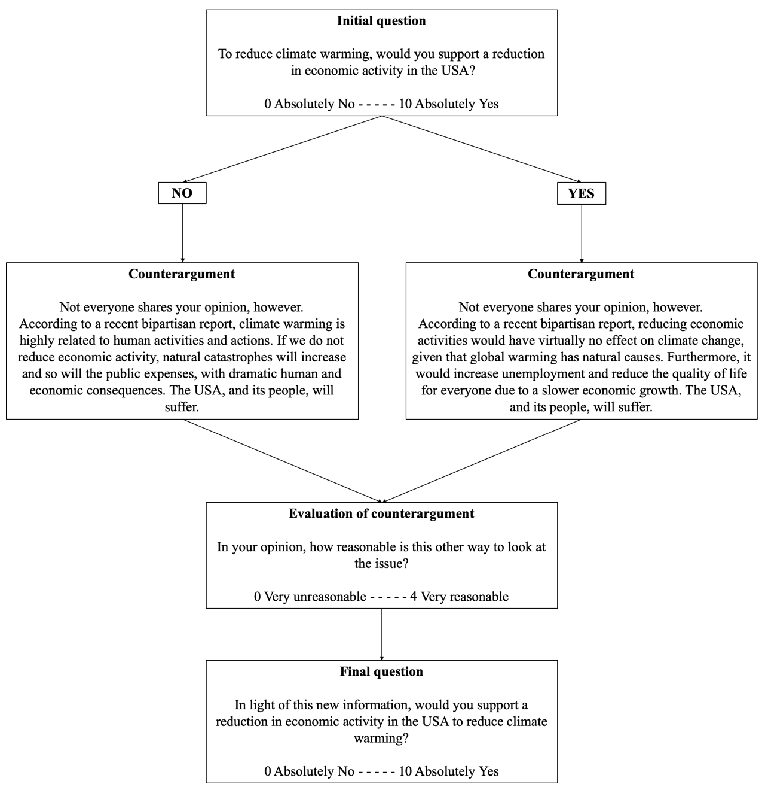

**Figure A2**. Persuasion design, script 2 (free trade)

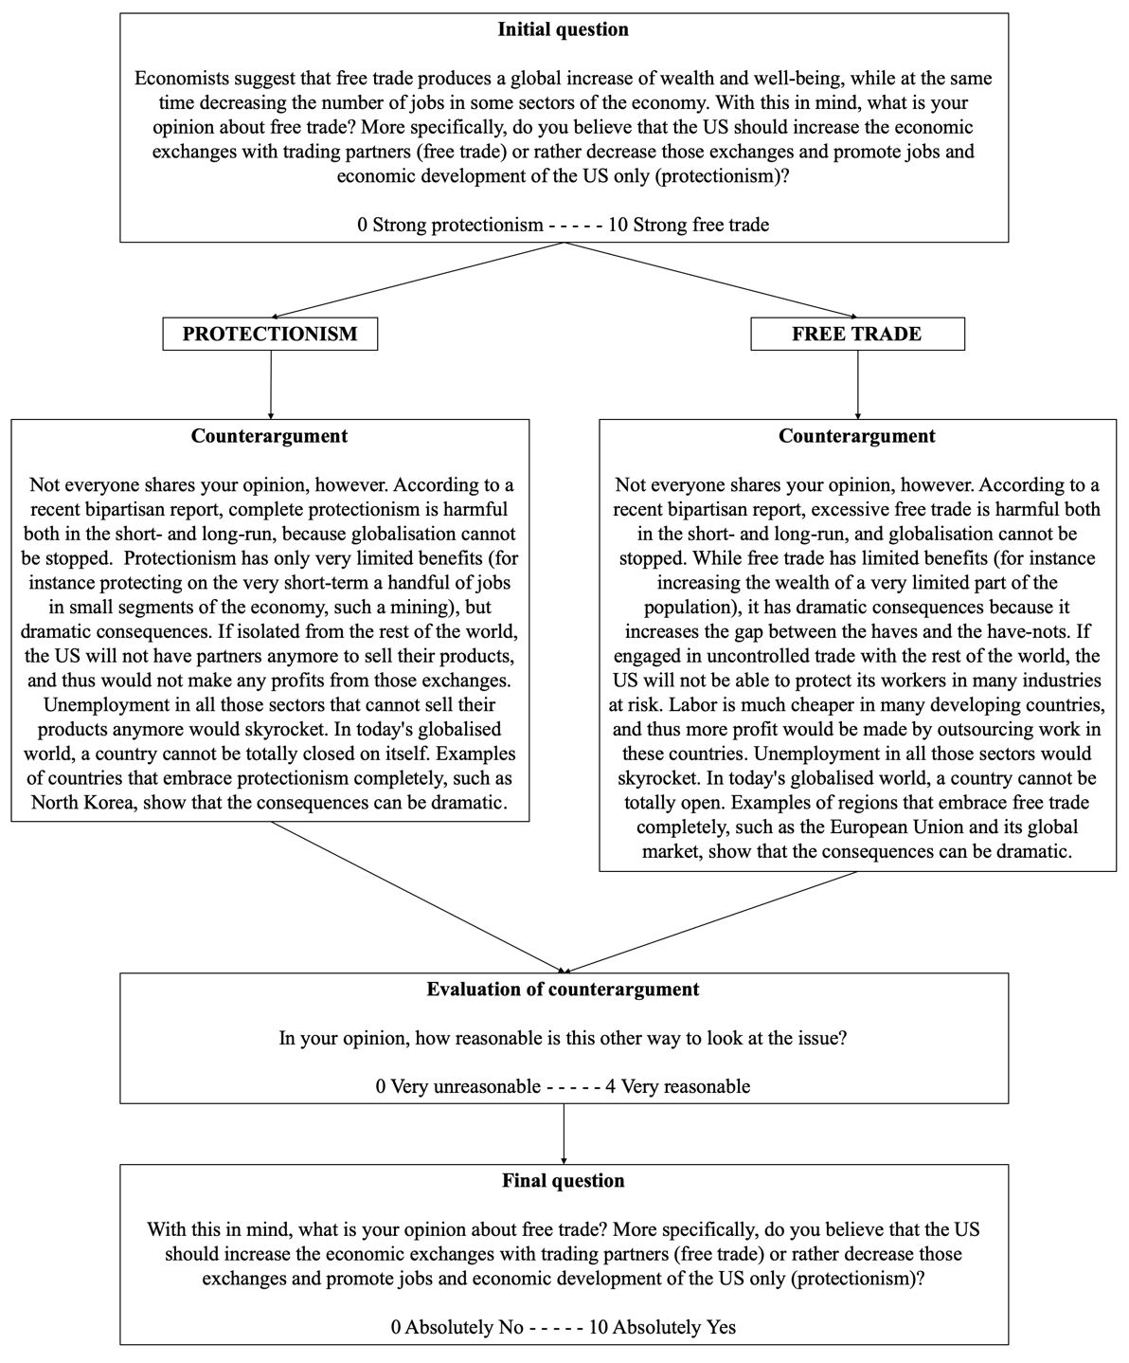

**Appendix B**

Additional results

**Table B1**. Descriptive statistics (pooled data)

|  |  |  |  |  |  |
| --- | --- | --- | --- | --- | --- |
|  |  |  |  |  |  |
| **Variable** | **N** | **Mean** | **SD** | **Min** | **Max** |
|  |  |  |  |  |  |
|  |  |  |  |  |  |
| * Persuasion | 2,186 | 1.13 | 1.65 | 0.00 | 10.00 |
| * Polarization | 1,359 | 0.22 | 0.64 | 0.00 | 5.00 |
| * Evaluation of counterargument | 2,333 | 2.19 | 1.26 | 0.00 | 4.00 |
|  |  |  |  |  |  |
| Initial opinion | 2,396 | 5.65 | 2.89 | 0.00 | 10.00 |
| Opinion extremity | 2,396 | 2.46 | 1.66 | 0.00 | 5.00 |
| Issue knowledge | 2,396 | 1.37 | 0.92 | 0.00 | 3.00 |
| Issue anxiety | 2,342 | 2.29 | 1.35 | 0.00 | 4.00 |
|  |  |  |  |  |  |
| Republican | 2,396 | 2.56 | 1.37 | 1.00 | 5.00 |
| Female | 2,386 | 1.51 | 0.50 | 1.00 | 2.00 |
| Age | 2,396 | 39.60 | 12.59 | 18.00 | 77.00 |
| Education | 2,392 | 11.93 | 1.84 | 1.00 | 16.00 |
| White | 2,396 | 0.79 | 0.40 | 0.00 | 1.00 |
|  |  |  |  |  |  |
| Extraversion | 2,396 | 3.56 | 1.73 | 1.00 | 7.00 |
| Agreeableness | 2,396 | 5.35 | 1.31 | 1.00 | 7.00 |
| Conscientiousness | 2,396 | 5.56 | 1.32 | 1.00 | 7.00 |
| Emotional stability | 2,396 | 4.98 | 1.58 | 1.00 | 7.00 |
| Openness | 2,396 | 5.03 | 1.37 | 1.00 | 7.00 |
|  |  |  |  |  |  |
| Stability a | 2,396 | 5.30 | 1.10 | 1.33 | 7.00 |
| Plasticity b | 2,396 | 4.29 | 1.24 | 1.00 | 7.00 |
|  |  |  |  |  |  |
| Narcissism | 2,396 | 3.15 | 1.44 | 1.00 | 7.00 |
| Psychopathy | 2,396 | 2.49 | 1.28 | 1.00 | 7.00 |
| Machiavellianism | 2,382 | 2.41 | 1.40 | 1.00 | 7.00 |
|  |  |  |  |  |  |
| Dark Core c | 2,382 | 2.68 | 1.11 | 1.00 | 6.50 |
|  |  |  |  |  |  |

* Dependent variable

a Average score of agreeableness, conscientiousness, and emotional stability.

b Average score of extraversion and openness.

c Average score of the three dark traits (narcissism, psychopathy, Machiavellianism).

**Table B2**. Zero-order correlations (script 1)

|  |  |  |  |  |  |  |  |  |  |  |  |  |  |  |  |  |  |  |  |
| --- | --- | --- | --- | --- | --- | --- | --- | --- | --- | --- | --- | --- | --- | --- | --- | --- | --- | --- | --- |
|  |  |  |  |  |  |  |  |  |  |  |  |  |  |  |  |  |  |  |  |
|  |  | 1. | 2. | 3. | 4. | 5. | 6. | 7. | 8. | 9. | 10. | 11. | 12. | 13. | 14. | 15. | 16. | 17. | 18. |
|  |  |  |  |  |  |  |  |  |  |  |  |  |  |  |  |  |  |  |  |
|  |  |  |  |  |  |  |  |  |  |  |  |  |  |  |  |  |  |  |  |
| 1. Extraversion | R | . |  |  |  |  |  |  |  |  |  |  |  |  |  |  |  |  |  |
|  | *sig* |  |  |  |  |  |  |  |  |  |  |  |  |  |  |  |  |  |  |
|  |  |  |  |  |  |  |  |  |  |  |  |  |  |  |  |  |  |  |  |
| 2. Agreeableness | R | 0.13 | . |  |  |  |  |  |  |  |  |  |  |  |  |  |  |  |  |
|  | *sig* | 0.000 |  |  |  |  |  |  |  |  |  |  |  |  |  |  |  |  |  |
|  |  |  |  |  |  |  |  |  |  |  |  |  |  |  |  |  |  |  |  |
| 3. Conscient. | R | 0.11 | 0.40 | . |  |  |  |  |  |  |  |  |  |  |  |  |  |  |  |
|  | *sig* | 0.000 | 0.000 |  |  |  |  |  |  |  |  |  |  |  |  |  |  |  |  |
|  |  |  |  |  |  |  |  |  |  |  |  |  |  |  |  |  |  |  |  |
| 4. Emot. stability | R | 0.26 | 0.39 | 0.47 | . |  |  |  |  |  |  |  |  |  |  |  |  |  |  |
|  | *sig* | 0.000 | 0.000 | 0.000 |  |  |  |  |  |  |  |  |  |  |  |  |  |  |  |
|  |  |  |  |  |  |  |  |  |  |  |  |  |  |  |  |  |  |  |  |
| 5. Openness | R | 0.26 | 0.29 | 0.24 | 0.18 | . |  |  |  |  |  |  |  |  |  |  |  |  |  |
|  | *sig* | 0.000 | 0.000 | 0.000 | 0.000 |  |  |  |  |  |  |  |  |  |  |  |  |  |  |
|  |  |  |  |  |  |  |  |  |  |  |  |  |  |  |  |  |  |  |  |
| 6. Stability | R | 0.22 | 0.74 | 0.78 | 0.82 | 0.30 | . |  |  |  |  |  |  |  |  |  |  |  |  |
|  | *sig* | 0.000 | 0.000 | 0.000 | 0.000 | 0.000 |  |  |  |  |  |  |  |  |  |  |  |  |  |
|  |  |  |  |  |  |  |  |  |  |  |  |  |  |  |  |  |  |  |  |
| 7. Plasticity | R | 0.85 | 0.25 | 0.21 | 0.29 | 0.74 | 0.32 | . |  |  |  |  |  |  |  |  |  |  |  |
|  | *sig* | 0.000 | 0.000 | 0.000 | 0.000 | 0.000 | 0.000 |  |  |  |  |  |  |  |  |  |  |  |  |
|  |  |  |  |  |  |  |  |  |  |  |  |  |  |  |  |  |  |  |  |
| 8. Narcissism | R | 0.26 | -0.17 | -0.15 | -0.12 | 0.02 | -0.18 | 0.19 | . |  |  |  |  |  |  |  |  |  |  |
|  | *sig* | 0.000 | 0.000 | 0.000 | 0.000 | 0.577 | 0.000 | 0.000 |  |  |  |  |  |  |  |  |  |  |  |
|  |  |  |  |  |  |  |  |  |  |  |  |  |  |  |  |  |  |  |  |
| 9. Psychopathy | R | -0.12 | -0.62 | -0.41 | -0.29 | -0.23 | -0.55 | -0.21 | 0.31 | . |  |  |  |  |  |  |  |  |  |
|  | *sig* | 0.000 | 0.000 | 0.000 | 0.000 | 0.000 | 0.000 | 0.000 | 0.000 |  |  |  |  |  |  |  |  |  |  |
|  |  |  |  |  |  |  |  |  |  |  |  |  |  |  |  |  |  |  |  |
| 10. Machiav. | R | 0.04 | -0.43 | -0.37 | -0.25 | -0.18 | -0.44 | -0.07 | 0.46 | 0.66 | . |  |  |  |  |  |  |  |  |
|  | *sig* | 0.174 | 0.000 | 0.000 | 0.000 | 0.000 | 0.000 | 0.016 | 0.000 | 0.000 |  |  |  |  |  |  |  |  |  |
|  |  |  |  |  |  |  |  |  |  |  |  |  |  |  |  |  |  |  |  |
| 11. Dark Core | R | 0.08 | -0.50 | -0.37 | -0.27 | -0.16 | -0.47 | -0.03 | 0.74 | 0.80 | 0.88 | . |  |  |  |  |  |  |  |
|  | *sig* | 0.004 | 0.000 | 0.000 | 0.000 | 0.000 | 0.000 | 0.326 | 0.000 | 0.000 | 0.000 |  |  |  |  |  |  |  |  |
|  |  |  |  |  |  |  |  |  |  |  |  |  |  |  |  |  |  |  |  |
|  |  |  |  |  |  |  |  |  |  |  |  |  |  |  |  |  |  |  |  |
| 12. Republican | R | 0.04 | -0.07 | 0.09 | 0.07 | -0.21 | 0.04 | -0.09 | 0.01 | 0.01 | 0.02 | 0.02 | . |  |  |  |  |  |  |
|  | *sig* | 0.194 | 0.014 | 0.003 | 0.017 | 0.000 | 0.171 | 0.002 | 0.715 | 0.652 | 0.545 | 0.519 |  |  |  |  |  |  |  |
|  |  |  |  |  |  |  |  |  |  |  |  |  |  |  |  |  |  |  |  |
| 13. Issue know. | R | -0.06 | 0.01 | 0.09 | 0.10 | 0.10 | 0.08 | 0.02 | -0.06 | -0.02 | -0.06 | -0.06 | -0.14 | . |  |  |  |  |  |
|  | *sig* | 0.046 | 0.863 | 0.002 | 0.001 | 0.001 | 0.003 | 0.590 | 0.033 | 0.527 | 0.046 | 0.048 | 0.000 |  |  |  |  |  |  |
|  |  |  |  |  |  |  |  |  |  |  |  |  |  |  |  |  |  |  |  |
| 14. Issue anxiety | R | -0.06 | 0.07 | -0.04 | -0.17 | 0.14 | -0.07 | 0.04 | 0.07 | -0.05 | -0.02 | 0.01 | -0.38 | 0.08 | . |  |  |  |  |
|  | *sig* | 0.041 | 0.014 | 0.224 | 0.000 | 0.000 | 0.021 | 0.206 | 0.019 | 0.116 | 0.573 | 0.860 | 0.000 | 0.004 |  |  |  |  |  |
|  |  |  |  |  |  |  |  |  |  |  |  |  |  |  |  |  |  |  |  |
| 15. Female | R | -0.01 | 0.17 | 0.07 | -0.16 | 0.06 | 0.02 | 0.02 | -0.09 | -0.22 | -0.20 | -0.21 | -0.06 | -0.19 | 0.17 | . |  |  |  |
|  | *sig* | 0.659 | 0.000 | 0.019 | 0.000 | 0.048 | 0.550 | 0.432 | 0.003 | 0.000 | 0.000 | 0.000 | 0.031 | 0.000 | 0.000 |  |  |  |  |
|  |  |  |  |  |  |  |  |  |  |  |  |  |  |  |  |  |  |  |  |
| 16. Age | R | 0.03 | 0.20 | 0.16 | 0.20 | 0.07 | 0.24 | 0.06 | -0.23 | -0.18 | -0.20 | -0.25 | 0.08 | 0.04 | -0.07 | 0.07 | . |  |  |
|  | *sig* | 0.245 | 0.000 | 0.000 | 0.000 | 0.021 | 0.000 | 0.037 | 0.000 | 0.000 | 0.000 | 0.000 | 0.008 | 0.167 | 0.012 | 0.010 |  |  |  |
|  |  |  |  |  |  |  |  |  |  |  |  |  |  |  |  |  |  |  |  |
| 17. Education | R | 0.00 | 0.05 | 0.09 | 0.07 | 0.03 | 0.09 | 0.01 | 0.08 | 0.02 | 0.00 | 0.04 | -0.09 | 0.17 | 0.05 | 0.04 | 0.11 | . |  |
|  | *sig* | 0.872 | 0.065 | 0.001 | 0.019 | 0.312 | 0.002 | 0.655 | 0.007 | 0.501 | 0.903 | 0.207 | 0.002 | 0.000 | 0.097 | 0.216 | 0.000 |  |  |
|  |  |  |  |  |  |  |  |  |  |  |  |  |  |  |  |  |  |  |  |
| 18. Initial opin. | R | -0.01 | 0.04 | -0.13 | -0.07 | 0.15 | -0.07 | 0.08 | 0.03 | 0.00 | 0.02 | 0.02 | -0.41 | 0.04 | 0.41 | 0.12 | -0.14 | -0.01 | . |
|  | *sig* | 0.820 | 0.175 | 0.000 | 0.012 | 0.000 | 0.012 | 0.008 | 0.386 | 0.928 | 0.518 | 0.559 | 0.000 | 0.134 | 0.000 | 0.000 | 0.000 | 0.732 |  |
|  |  |  |  |  |  |  |  |  |  |  |  |  |  |  |  |  |  |  |  |
| 19. Opinion extr. | R | 0.02 | 0.04 | 0.10 | 0.10 | 0.07 | 0.10 | 0.06 | -0.10 | -0.05 | -0.11 | -0.11 | 0.09 | 0.15 | -0.08 | -0.06 | 0.11 | 0.01 | -0.04 |
|  | *sig* | 0.403 | 0.142 | 0.001 | 0.001 | 0.010 | 0.000 | 0.045 | 0.001 | 0.063 | 0.000 | 0.000 | 0.003 | 0.000 | 0.005 | 0.056 | 0.000 | 0.776 | 0.187 |
|  |  |  |  |  |  |  |  |  |  |  |  |  |  |  |  |  |  |  |  |

*N* = 1,199 (some missing values on issue anxiety, gender, education).

**Table B3**. Evaluation of the counterargument; OLS (script 1)

|  |  |  |  |  |  |  |
| --- | --- | --- | --- | --- | --- | --- |
|  |  |  |  |  |  |  |
|  | **M1** |  |  | **M2** |  |  |
|  | coef | Se | p | coef | Se | p |
|  |  |  |  |  |  |  |
|  |  |  |  |  |  |  |
| Republican a | -0.02 | (0.03) |  | -0.02 | (0.03) |  |
| Issue knowledge | -0.07 | (0.04) | † | -0.08 | (0.04) | † |
| Issue Anxiety | 0.15 | (0.03) | *** | 0.17 | (0.03) | *** |
| Female | 0.08 | (0.08) |  | 0.13 | (0.08) |  |
| Age | -0.01 | (0.00) | † | -0.01 | (0.00) | * |
| Education | 0.02 | (0.02) |  | 0.02 | (0.02) |  |
| White | -0.13 | (0.09) |  | -0.11 | (0.09) |  |
| Initial opinion b | 0.00 | (0.01) |  | -0.00 | (0.01) |  |
| Opinion extremity c | -0.22 | (0.02) | *** | -0.22 | (0.02) | *** |
|  |  |  |  |  |  |  |
| Extraversion | -0.05 | (0.02) | † |  |  |  |
| Agreeableness | 0.04 | (0.04) |  |  |  |  |
| Conscientiousness | 0.08 | (0.04) | * |  |  |  |
| Emotional stability | -0.04 | (0.03) |  |  |  |  |
| Openness | -0.05 | (0.03) | † |  |  |  |
|  |  |  |  |  |  |  |
| Stability d |  |  |  | 0.08 | (0.04) | † |
| Plasticity e |  |  |  | -0.09 | (0.03) | ** |
|  |  |  |  |  |  |  |
| Narcissism | 0.05 | (0.03) | † |  |  |  |
| Psychopathy | -0.00 | (0.04) |  |  |  |  |
| Machiavellianism | 0.05 | (0.04) |  |  |  |  |
|  |  |  |  |  |  |  |
| Dark Core f |  |  |  | 0.10 | (0.04) | * |
|  |  |  |  |  |  |  |
| Constant | 2.01 | (0.44) | *** | 2.00 | (0.41) | *** |
|  |  |  |  |  |  |  |
|  |  |  |  |  |  |  |
| Observations | 1,124 |  |  | 1,124 |  |  |
| R2 | 0.16 |  |  | 0.16 |  |  |
|  |  |  |  |  |  |  |

Note: In all models the dependent variable is evaluation of the counterargument and varies between 0 “Very unreasonable” and 4 “Very reasonable”.

a Varies between 1 “Strong Democrat” and 5 “Strong Republican”.

b Varies between 0 “Initially very against economic slowdown” and 10 “Initially very in favour of economic slowdown”.

c Varies between 0 “very moderated initial opinion” and 5 “very extreme initial opinion.”

d Average score of agreeableness, conscientiousness, and emotional stability.

e Average score of extraversion and openness.

f Average score of the three dark traits (narcissism, psychopathy, Machiavellianism).

*** p<0.001, ** p<0.01, * p<0.05, † p<0.1

**Table B4**. Evaluation of the counterargument; OLS (script 2)

|  |  |  |  |  |  |  |
| --- | --- | --- | --- | --- | --- | --- |
|  |  |  |  |  |  |  |
|  | **M1** |  |  | **M2** |  |  |
|  | coef | Se | p | coef | Se | p |
|  |  |  |  |  |  |  |
|  |  |  |  |  |  |  |
| Republican a | -0.03 | (0.03) |  | -0.04 | (0.03) |  |
| Issue knowledge | -0.03 | (0.04) |  | -0.02 | (0.04) |  |
| Issue Anxiety | 0.03 | (0.03) |  | 0.03 | (0.03) |  |
| Female | 0.13 | (0.07) | † | 0.19 | (0.07) | ** |
| Age | -0.00 | (0.00) |  | -0.00 | (0.00) |  |
| Education | 0.03 | (0.02) |  | 0.03 | (0.02) |  |
| White | -0.17 | (0.09) | † | -0.14 | (0.09) |  |
| Initial opinion b | -0.04 | (0.02) | * | -0.04 | (0.02) | * |
| Opinion extremity c | -0.15 | (0.02) | *** | -0.15 | (0.02) | *** |
|  |  |  |  |  |  |  |
| Extraversion | -0.06 | (0.02) | ** |  |  |  |
| Agreeableness | 0.05 | (0.04) |  |  |  |  |
| Conscientiousness | 0.08 | (0.03) | ** |  |  |  |
| Emotional stability | -0.08 | (0.03) | ** |  |  |  |
| Openness | 0.02 | (0.03) |  |  |  |  |
|  |  |  |  |  |  |  |
| Stability d |  |  |  | 0.02 | (0.04) |  |
| Plasticity e |  |  |  | -0.07 | (0.03) | * |
|  |  |  |  |  |  |  |
| Narcissism | 0.02 | (0.03) |  |  |  |  |
| Psychopathy | -0.00 | (0.04) |  |  |  |  |
| Machiavellianism | 0.06 | (0.03) | † |  |  |  |
|  |  |  |  |  |  |  |
| Dark Core f |  |  |  | 0.05 | (0.04) |  |
|  |  |  |  |  |  |  |
| Constant | 2.31 | (0.40) | *** | 2.62 | (0.38) | *** |
|  |  |  |  |  |  |  |
|  |  |  |  |  |  |  |
| Observations | 1,132 |  |  | 1,132 |  |  |
| R2 | 0.10 |  |  | 0.09 |  |  |
|  |  |  |  |  |  |  |

Note: In all models the dependent variable is evaluation of the counterargument and varies between 0 “Very unreasonable” and 4 “Very reasonable”.

a Varies between 1 “Strong Democrat” and 5 “Strong Republican”.

b Varies between 0 “Initially very in favor of protectionism” and 10 “Initially very in favor of free market.”

c Varies between 0 “very moderated initial opinion” and 5 “very extreme initial opinion.”

d Average score of agreeableness, conscientiousness, and emotional stability.

e Average score of extraversion and openness.

f Average score of the three dark traits (narcissism, psychopathy, Machiavellianism).

*** p<0.001, ** p<0.01, * p<0.05, † p<0.1

**Table B5**. Opinion change; categorical variable, multinomial logistic regressions (script 1)

|  |  |  |  |  |  |  |  |
| --- | --- | --- | --- | --- | --- | --- | --- |
|  |  |  |  |  |  |  |  |
|  |  | **M1** |  |  | **M2** |  |  |
| Outcome |  | coef | Se | p | coef | Se | p |
|  |  |  |  |  |  |  |  |
|  |  |  |  |  |  |  |  |
| Persuasion g | Republican a | -0.08 | (0.06) |  | -0.08 | (0.06) |  |
|  | Issue knowledge | -0.13 | (0.08) |  | -0.13 | (0.08) | † |
|  | Issue Anxiety | 0.05 | (0.07) |  | 0.09 | (0.06) |  |
|  | Female | 0.40 | (0.16) | * | 0.49 | (0.15) | ** |
|  | Age | -0.02 | (0.01) | *** | -0.02 | (0.01) | *** |
|  | Education | -0.02 | (0.04) |  | -0.01 | (0.04) |  |
|  | White | -0.15 | (0.18) |  | -0.16 | (0.18) |  |
|  | Initial opinion b | 0.13 | (0.03) | *** | 0.13 | (0.03) | *** |
|  | Opinion extremity c | -0.05 | (0.05) |  | -0.05 | (0.05) |  |
|  | Evaluation of counterargument | 0.64 | (0.06) | *** | 0.65 | (0.06) | *** |
|  |  |  |  |  |  |  |  |
|  | Extraversion | -0.04 | (0.05) |  |  |  |  |
|  | Agreeableness | 0.05 | (0.08) |  |  |  |  |
|  | Conscientiousness | -0.06 | (0.07) |  |  |  |  |
|  | Emotional stability | -0.13 | (0.06) | * |  |  |  |
|  | Openness | 0.02 | (0.06) |  |  |  |  |
|  |  |  |  |  |  |  |  |
|  | Stability d |  |  |  | -0.14 | (0.08) | † |
|  | Plasticity e |  |  |  | 0.01 | (0.06) |  |
|  |  |  |  |  |  |  |  |
|  | Narcissism | 0.13 | (0.06) | * |  |  |  |
|  | Psychopathy | -0.07 | (0.09) |  |  |  |  |
|  | Machiavellianism | -0.08 | (0.07) |  |  |  |  |
|  |  |  |  |  |  |  |  |
|  | Dark Core f |  |  |  | -0.05 | (0.08) |  |
|  |  |  |  |  |  |  |  |
|  | Constant | -0.50 | (0.89) |  | -0.61 | (0.82) |  |
|  |  |  |  |  |  |  |  |
|  |  |  |  |  |  |  |  |
| Polarization g | Republican a | 0.16 | (0.10) |  | 0.18 | (0.10) | † |
|  | Issue knowledge | -0.17 | (0.13) |  | -0.18 | (0.13) |  |
|  | Issue Anxiety | -0.15 | (0.10) |  | -0.12 | (0.10) |  |
|  | Female | -0.68 | (0.28) | * | -0.67 | (0.27) | * |
|  | Age | -0.03 | (0.01) | ** | -0.04 | (0.01) | ** |
|  | Education | 0.04 | (0.07) |  | 0.05 | (0.07) |  |
|  | White | -0.41 | (0.30) |  | -0.46 | (0.29) |  |
|  | Initial opinion b | -0.02 | (0.06) |  | -0.03 | (0.06) |  |
|  | Opinion extremity c | -0.57 | (0.09) | *** | -0.57 | (0.09) | *** |
|  | Evaluation of counterargument | -0.13 | (0.11) |  | -0.13 | (0.11) |  |
|  |  |  |  |  |  |  |  |
|  | Extraversion | 0.06 | (0.09) |  |  |  |  |
|  | Agreeableness | -0.07 | (0.13) |  |  |  |  |
|  | Conscientiousness | -0.03 | (0.13) |  |  |  |  |
|  | Emotional stability | 0.04 | (0.11) |  |  |  |  |
|  | Openness | -0.05 | (0.10) |  |  |  |  |
|  |  |  |  |  |  |  |  |
|  | Stability d |  |  |  | 0.04 | (0.15) |  |
|  | Plasticity e |  |  |  | 0.11 | (0.11) |  |
|  |  |  |  |  |  |  |  |
|  | Narcissism | 0.11 | (0.10) |  |  |  |  |
|  | Psychopathy | -0.29 | (0.17) | † |  |  |  |
|  | Machiavellianism | -0.19 | (0.14) |  |  |  |  |
|  |  |  |  |  |  |  |  |
|  | Dark Core f |  |  |  | -0.29 | (0.14) | * |
|  |  |  |  |  |  |  |  |
|  | Constant | 3.16 | (1.42) | * | 2.00 | (1.30) |  |
|  |  |  |  |  |  |  |  |
|  |  |  |  |  |  |  |  |
|  | Observations | 1,124 |  |  | 1,124 |  |  |
|  | Pseudo-R2 | 0.190 |  |  | 0.182 |  |  |
|  | Log likelihood | -828.3 |  |  | -836.7 |  |  |
|  |  |  |  |  |  |  |  |

Note: In all models the dependent variable is categorical and takes the values -1 for “Polarization” (opinion change against the counterargument), 0 for “No opinion change” (which is the reference category) and 1 for “Persuasion” (opinion change in the direction of the counterargument). Models are multinomial logistic regressions.

a Varies between 1 “Strong Democrat” and 5 “Strong Republican”.

b Varies between 0 “Initially very against economic slowdown” and 10 “Initially very in favour of economic slowdown”.

c Varies between 0 “very moderated initial opinion” and 5 “very extreme initial opinion.”

d Average score of agreeableness, conscientiousness, and emotional stability.

e Average score of extraversion and openness.

f Average score of the three dark traits (narcissism, psychopathy, Machiavellianism).

g Reference category is “No opinion change”

*** p<0.001, ** p<0.01, * p<0.05, † p<0.1

**Table B6**. Opinion change; categorical variable, multinomial logistic regressions (script 2)

|  |  |  |  |  |  |  |  |
| --- | --- | --- | --- | --- | --- | --- | --- |
|  |  |  |  |  |  |  |  |
|  |  | **M1** |  |  | **M2** |  |  |
| Outcome |  | coef | Se | p | coef | Se | p |
|  |  |  |  |  |  |  |  |
|  |  |  |  |  |  |  |  |
| Persuasion g | Republican a | 0.01 | (0.05) |  | -0.01 | (0.05) |  |
|  | Issue knowledge | -0.02 | (0.09) |  | -0.03 | (0.09) |  |
|  | Issue Anxiety | 0.03 | (0.05) |  | 0.04 | (0.05) |  |
|  | Female | 0.44 | (0.15) | ** | 0.46 | (0.14) | *** |
|  | Age | -0.01 | (0.01) |  | -0.01 | (0.01) |  |
|  | Education | -0.08 | (0.04) | * | -0.08 | (0.04) | * |
|  | White | -0.07 | (0.17) |  | -0.08 | (0.17) |  |
|  | Initial opinion b | -0.07 | (0.03) | * | -0.06 | (0.03) | † |
|  | Opinion extremity c | 0.21 | (0.05) | *** | 0.20 | (0.05) | *** |
|  | Evaluation of counterargument | 0.55 | (0.06) | *** | 0.55 | (0.06) | *** |
|  |  |  |  |  |  |  |  |
|  | Extraversion | -0.03 | (0.04) |  |  |  |  |
|  | Agreeableness | 0.04 | (0.07) |  |  |  |  |
|  | Conscientiousness | -0.15 | (0.06) | * |  |  |  |
|  | Emotional stability | -0.00 | (0.05) |  |  |  |  |
|  | Openness | 0.04 | (0.05) |  |  |  |  |
|  |  |  |  |  |  |  |  |
|  | Stability d |  |  |  | -0.08 | (0.08) |  |
|  | Plasticity e |  |  |  | 0.04 | (0.06) |  |
|  |  |  |  |  |  |  |  |
|  | Narcissism | 0.03 | (0.06) |  |  |  |  |
|  | Psychopathy | -0.15 | (0.08) | † |  |  |  |
|  | Machiavellianism | 0.00 | (0.07) |  |  |  |  |
|  |  |  |  |  |  |  |  |
|  | Dark Core f |  |  |  | -0.11 | (0.07) |  |
|  |  |  |  |  |  |  |  |
|  | Constant | -0.07 | (0.81) |  | -0.27 | (0.76) |  |
|  |  |  |  |  |  |  |  |
|  |  |  |  |  |  |  |  |
| Polarization g | Republican a | 0.03 | (0.09) |  | 0.03 | (0.09) |  |
|  | Issue knowledge | -0.05 | (0.14) |  | -0.03 | (0.14) |  |
|  | Issue Anxiety | 0.09 | (0.09) |  | 0.09 | (0.09) |  |
|  | Female | -0.08 | (0.24) |  | -0.05 | (0.23) |  |
|  | Age | -0.01 | (0.01) |  | -0.01 | (0.01) |  |
|  | Education | -0.03 | (0.06) |  | -0.03 | (0.06) |  |
|  | White | 0.34 | (0.30) |  | 0.33 | (0.30) |  |
|  | Initial opinion b | 0.09 | (0.08) |  | 0.09 | (0.08) |  |
|  | Opinion extremity c | -0.55 | (0.10) | *** | -0.54 | (0.10) | *** |
|  | Evaluation of counterargument | -0.20 | (0.10) | † | -0.20 | (0.10) | † |
|  |  |  |  |  |  |  |  |
|  | Extraversion | 0.02 | (0.08) |  |  |  |  |
|  | Agreeableness | 0.07 | (0.12) |  |  |  |  |
|  | Conscientiousness | 0.20 | (0.12) | † |  |  |  |
|  | Emotional stability | 0.07 | (0.10) |  |  |  |  |
|  | Openness | 0.06 | (0.10) |  |  |  |  |
|  |  |  |  |  |  |  |  |
|  | Stability d |  |  |  | 0.32 | (0.13) | * |
|  | Plasticity e |  |  |  | 0.05 | (0.10) |  |
|  |  |  |  |  |  |  |  |
|  | Narcissism | 0.05 | (0.09) |  |  |  |  |
|  | Psychopathy | 0.16 | (0.14) |  |  |  |  |
|  | Machiavellianism | -0.04 | (0.11) |  |  |  |  |
|  |  |  |  |  |  |  |  |
|  | Dark Core f |  |  |  | 0.14 | (0.12) |  |
|  |  |  |  |  |  |  |  |
|  | Constant | -3.04 | (1.39) | * | -2.73 | (1.30) | * |
|  |  |  |  |  |  |  |  |
|  |  |  |  |  |  |  |  |
|  | Observations | 1,132 |  |  | 1,132 |  |  |
|  | Pseudo-R2 | 0.0990 |  |  | 0.0932 |  |  |
|  | Log likelihood | -956.8 |  |  | -962.9 |  |  |
|  |  |  |  |  |  |  |  |

Note: In all models the dependent variable is categorical and takes the values -1 for “Polarization” (opinion change against the counterargument), 0 for “No opinion change” (which is the reference category) and 1 for “Persuasion” (opinion change in the direction of the counterargument). Models are multinomial logistic regressions.

a Varies between 1 “Strong Democrat” and 5 “Strong Republican”.

b Varies between 0 “Initially very in favor of protectionism” and 10 “Initially very in favor of free market.”

c Varies between 0 “very moderated initial opinion” and 5 “very extreme initial opinion.”

d Average score of agreeableness, conscientiousness, and emotional stability.

e Average score of extraversion and openness.

f Average score of the three dark traits (narcissism, psychopathy, Machiavellianism).

g Reference category is “No opinion change”

*** p<0.001, ** p<0.01, * p<0.05, † p<0.1

**Table B7**. Persuasion; continuous variable, negative binomial regressions (script 1)

|  |  |  |  |  |  |  |
| --- | --- | --- | --- | --- | --- | --- |
|  |  |  |  |  |  |  |
|  | **M1** |  |  | **M2** |  |  |
|  | coef | Se | p | coef | Se | p |
|  |  |  |  |  |  |  |
|  |  |  |  |  |  |  |
| Republican a | -0.05 | (0.04) |  | -0.05 | (0.04) |  |
| Issue knowledge | -0.12 | (0.05) | * | -0.13 | (0.05) | ** |
| Issue Anxiety | 0.03 | (0.04) |  | 0.04 | (0.04) |  |
| Female | 0.36 | (0.10) | *** | 0.39 | (0.09) | *** |
| Age | -0.02 | (0.00) | *** | -0.02 | (0.00) | *** |
| Education | -0.00 | (0.03) |  | -0.00 | (0.03) |  |
| White | -0.04 | (0.11) |  | -0.07 | (0.11) |  |
| Initial opinion b | 0.10 | (0.02) | *** | 0.09 | (0.02) | *** |
| Opinion extremity c | 0.02 | (0.03) |  | 0.02 | (0.03) |  |
| Evaluation of counterargument | 0.40 | (0.04) | *** | 0.40 | (0.04) | *** |
|  |  |  |  |  |  |  |
| Extraversion | 0.01 | (0.03) |  |  |  |  |
| Agreeableness | -0.02 | (0.05) |  |  |  |  |
| Conscientiousness | -0.05 | (0.04) |  |  |  |  |
| Emotional stability | -0.02 | (0.04) |  |  |  |  |
| Openness | 0.01 | (0.04) |  |  |  |  |
|  |  |  |  |  |  |  |
| Stability d |  |  |  | -0.07 | (0.05) |  |
| Plasticity e |  |  |  | 0.04 | (0.04) |  |
|  |  |  |  |  |  |  |
| Narcissism | 0.10 | (0.04) | ** |  |  |  |
| Psychopathy | -0.02 | (0.05) |  |  |  |  |
| Machiavellianism | -0.05 | (0.04) |  |  |  |  |
|  |  |  |  |  |  |  |
| Dark Core f |  |  |  | 0.03 | (0.05) |  |
|  |  |  |  |  |  |  |
| Constant | -0.74 | (0.55) |  | -0.99 | (0.52) | † |
|  |  |  |  |  |  |  |
|  |  |  |  |  |  |  |
| Observations | 1,037 |  |  | 1,037 |  |  |
| Pseudo-R2 | 0.0812 |  |  | 0.0786 |  |  |
| Log likelihood | -1440 |  |  | -1444 |  |  |
|  |  |  |  |  |  |  |

Note: In all models the dependent variable is opinion change in the direction of the counterargument (“persuasion”) and varies between 0 “No persuasion” and 10 “Maximum persuasion.” Models are negative binomial regressions.

a Varies between 1 “Strong Democrat” and 5 “Strong Republican”.

b Varies between 0 “Initially very against economic slowdown” and 10 “Initially very in favour of economic slowdown”.

c Varies between 0 “very moderated initial opinion” and 5 “very extreme initial opinion.”

d Average score of agreeableness, conscientiousness, and emotional stability.

e Average score of extraversion and openness.

f Average score of the three dark traits (narcissism, psychopathy, Machiavellianism).

*** p<0.001, ** p<0.01, * p<0.05, † p<0.1

**Table B8**. Persuasion; continuous variable, negative binomial regressions (script 2)

|  |  |  |  |  |  |  |
| --- | --- | --- | --- | --- | --- | --- |
|  |  |  |  |  |  |  |
|  | **M1** |  |  | **M2** |  |  |
|  | coef | Se | p | coef | Se | p |
|  |  |  |  |  |  |  |
|  |  |  |  |  |  |  |
| Republican a | 0.03 | (0.04) |  | 0.03 | (0.03) |  |
| Issue knowledge | -0.07 | (0.06) |  | -0.07 | (0.06) |  |
| Issue Anxiety | 0.06 | (0.03) |  | 0.05 | (0.03) |  |
| Female | 0.20 | (0.10) | * | 0.20 | (0.09) | * |
| Age | -0.00 | (0.00) |  | -0.00 | (0.00) |  |
| Education | -0.07 | (0.03) | ** | -0.07 | (0.03) | ** |
| White | -0.23 | (0.11) | * | -0.22 | (0.11) | * |
| Initial opinion b | -0.05 | (0.02) | ** | -0.05 | (0.02) | ** |
| Opinion extremity c | 0.21 | (0.03) | *** | 0.21 | (0.03) | *** |
| Evaluation of counterargument | 0.35 | (0.04) | *** | 0.35 | (0.04) | *** |
|  |  |  |  |  |  |  |
| Extraversion | 0.03 | (0.03) |  |  |  |  |
| Agreeableness | 0.02 | (0.05) |  |  |  |  |
| Conscientiousness | -0.04 | (0.04) |  |  |  |  |
| Emotional stability | -0.00 | (0.03) |  |  |  |  |
| Openness | 0.03 | (0.04) |  |  |  |  |
|  |  |  |  |  |  |  |
| Stability d |  |  |  | -0.04 | (0.05) |  |
| Plasticity e |  |  |  | 0.06 | (0.04) |  |
|  |  |  |  |  |  |  |
| Narcissism | -0.03 | (0.04) |  |  |  |  |
| Psychopathy | -0.02 | (0.05) |  |  |  |  |
| Machiavellianism | 0.04 | (0.05) |  |  |  |  |
|  |  |  |  |  |  |  |
| Dark Core f |  |  |  | -0.01 | (0.05) |  |
|  |  |  |  |  |  |  |
| Constant | -0.48 | (0.53) |  | -0.44 | (0.49) |  |
|  |  |  |  |  |  |  |
|  |  |  |  |  |  |  |
| Observations | 1,026 |  |  | 1,026 |  |  |
| Pseudo-R2 | 0.0443 |  |  | 0.0435 |  |  |
| Log likelihood | -1368 |  |  | -1369 |  |  |
|  |  |  |  |  |  |  |

Note: In all models the dependent variable is opinion change in the direction of the counterargument (“persuasion”) and varies between 0 “No persuasion” and 10 “Maximum persuasion.” Models are negative binomial regressions.

a Varies between 1 “Strong Democrat” and 5 “Strong Republican”.

b Varies between 0 “Initially very in favor of protectionism” and 10 “Initially very in favor of free market.”

c Varies between 0 “very moderated initial opinion” and 5 “very extreme initial opinion.”

d Average score of agreeableness, conscientiousness, and emotional stability.

e Average score of extraversion and openness.

f Average score of the three dark traits (narcissism, psychopathy, Machiavellianism).

*** p<0.001, ** p<0.01, * p<0.05, † p<0.1

**Table B9**. Polarization; continuous variable, negative binomial regressions (script 1)

|  |  |  |  |  |  |  |
| --- | --- | --- | --- | --- | --- | --- |
|  |  |  |  |  |  |  |
|  | **M1** |  |  | **M2** |  |  |
|  | coef | Se | p | coef | Se | p |
|  |  |  |  |  |  |  |
|  |  |  |  |  |  |  |
| Republican a | 0.12 | (0.09) |  | 0.16 | (0.09) | † |
| Issue knowledge | -0.12 | (0.12) |  | -0.18 | (0.12) |  |
| Issue Anxiety | -0.20 | (0.09) | * | -0.17 | (0.09) | † |
| Female | -0.58 | (0.25) | * | -0.53 | (0.26) | * |
| Age | -0.02 | (0.01) | † | -0.02 | (0.01) | * |
| Education | 0.01 | (0.06) |  | 0.02 | (0.06) |  |
| White | -0.34 | (0.27) |  | -0.38 | (0.27) |  |
| Initial opinion b | 0.02 | (0.06) |  | 0.01 | (0.05) |  |
| Opinion extremity c | -0.59 | (0.08) | *** | -0.60 | (0.08) | *** |
| Evaluation of counterargument | -0.16 | (0.10) | † | -0.14 | (0.10) |  |
|  |  |  |  |  |  |  |
| Extraversion | 0.07 | (0.08) |  |  |  |  |
| Agreeableness | 0.00 | (0.13) |  |  |  |  |
| Conscientiousness | -0.07 | (0.11) |  |  |  |  |
| Emotional stability | 0.05 | (0.10) |  |  |  |  |
| Openness | -0.14 | (0.09) |  |  |  |  |
|  |  |  |  |  |  |  |
| Stability d |  |  |  | 0.14 | (0.14) |  |
| Plasticity e |  |  |  | 0.08 | (0.10) |  |
|  |  |  |  |  |  |  |
| Narcissism | 0.19 | (0.09) | * |  |  |  |
| Psychopathy | -0.34 | (0.16) | * |  |  |  |
| Machiavellianism | -0.27 | (0.13) | * |  |  |  |
|  |  |  |  |  |  |  |
| Dark Core f |  |  |  | -0.25 | (0.13) | † |
|  |  |  |  |  |  |  |
| Constant | 3.05 | (1.31) | * | 1.22 | (1.22) |  |
|  |  |  |  |  |  |  |
|  |  |  |  |  |  |  |
| Observations | 638 |  |  | 638 |  |  |
| Pseudo-R2 | 0.167 |  |  | 0.141 |  |  |
| Log likelihood | -282.1 |  |  | -291 |  |  |
|  |  |  |  |  |  |  |

Note: In all models the dependent variable is opinion change against the counterargument (“polarization”) and varies between 0 “No polarization” and 10 “Maximum polarization.” Models are negative binomial regressions.

a Varies between 1 “Strong Democrat” and 5 “Strong Republican”.

b Varies between 0 “Initially very against economic slowdown” and 10 “Initially very in favour of economic slowdown”.

c Varies between 0 “very moderated initial opinion” and 5 “very extreme initial opinion.”

d Average score of agreeableness, conscientiousness, and emotional stability.

e Average score of extraversion and openness.

f Average score of the three dark traits (narcissism, psychopathy, Machiavellianism).

*** p<0.001, ** p<0.01, * p<0.05, † p<0.1

**Table B10**. Polarization; continuous variable, negative binomial regressions (script 2)

|  |  |  |  |  |  |  |
| --- | --- | --- | --- | --- | --- | --- |
|  |  |  |  |  |  |  |
|  | **M1** |  |  | **M2** |  |  |
|  | coef | Se | p | coef | Se | p |
|  |  |  |  |  |  |  |
|  |  |  |  |  |  |  |
| Republican a | 0.00 | (0.08) |  | 0.01 | (0.08) |  |
| Issue knowledge | -0.25 | (0.13) | † | -0.23 | (0.13) | † |
| Issue Anxiety | 0.09 | (0.08) |  | 0.08 | (0.08) |  |
| Female | -0.13 | (0.22) |  | -0.07 | (0.22) |  |
| Age | -0.01 | (0.01) |  | -0.01 | (0.01) |  |
| Education | -0.00 | (0.06) |  | -0.00 | (0.06) |  |
| White | 0.14 | (0.27) |  | 0.18 | (0.27) |  |
| Initial opinion b | 0.07 | (0.08) |  | 0.07 | (0.07) |  |
| Opinion extremity c | -0.56 | (0.10) | *** | -0.55 | (0.10) | *** |
| Evaluation of counterargument | -0.24 | (0.10) | * | -0.23 | (0.10) | * |
|  |  |  |  |  |  |  |
| Extraversion | 0.01 | (0.07) |  |  |  |  |
| Agreeableness | 0.11 | (0.12) |  |  |  |  |
| Conscientiousness | 0.18 | (0.12) |  |  |  |  |
| Emotional stability | 0.04 | (0.08) |  |  |  |  |
| Openness | 0.04 | (0.09) |  |  |  |  |
|  |  |  |  |  |  |  |
| Stability d |  |  |  | 0.27 | (0.12) | * |
| Plasticity e |  |  |  | 0.02 | (0.09) |  |
|  |  |  |  |  |  |  |
| Narcissism | 0.01 | (0.09) |  |  |  |  |
| Psychopathy | 0.15 | (0.13) |  |  |  |  |
| Machiavellianism | -0.04 | (0.11) |  |  |  |  |
|  |  |  |  |  |  |  |
| Dark Core f |  |  |  | 0.08 | (0.11) |  |
|  |  |  |  |  |  |  |
| Constant | -2.51 | (1.27) | * | -2.09 | (1.19) | † |
|  |  |  |  |  |  |  |
|  |  |  |  |  |  |  |
| Observations | 644 |  |  | 644 |  |  |
| Pseudo-R2 | 0.0849 |  |  | 0.0823 |  |  |
| Log likelihood | -343.7 |  |  | -344.7 |  |  |
|  |  |  |  |  |  |  |

Note: In all models the dependent variable is opinion change against the counterargument (“polarization”) and varies between 0 “No polarization” and 10 “Maximum polarization.” Models are negative binomial regressions.

a Varies between 1 “Strong Democrat” and 5 “Strong Republican”.

b Varies between 0 “Initially very in favor of protectionism” and 10 “Initially very in favor of free market.”

c Varies between 0 “very moderated initial opinion” and 5 “very extreme initial opinion.”

d Average score of agreeableness, conscientiousness, and emotional stability.

e Average score of extraversion and openness.

f Average score of the three dark traits (narcissism, psychopathy, Machiavellianism).

*** p<0.001, ** p<0.01, * p<0.05, † p<0.1