Jonathan Gray, Dislike-Minded: Media, Audiences, and the Dynamics of Taste, New York, NY: New York University Press, 2021, 269pp., $29.00 (paperback).

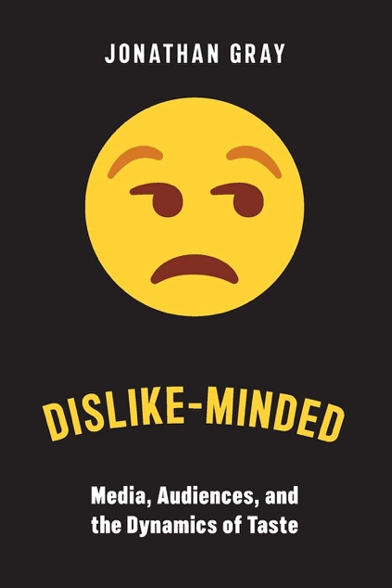
Reviewed by
Katerina Girginova
University of Pennsylvania

“As a society, I pose, we are disgracefully bad at understanding how dislike works,” (p. 18).

Gray is one of the first contemporary media studies scholars to systematically turn our attention to the role of dislike in content consumption. In his new book, Dislike-Minded: Media, Audiences, and the Dynamics of Taste, Gray convincingly argues for the need to pay attention to this often subdued emotion. Gray uncovers several discursive strategies audiences use to talk about dislike, and offers an interpretation of what their dislikes actually tell us. Based on 216 qualitative interviews, Dislike-Minded offers a thought-provoking analysis of the ubiquity of dislike in media consumption, while paying particular attention to the dislikes of marginalized groups and the resulting power dynamics of who is able to openly dislike and how. Dislike-Minded also foreshadows numerous paths for the future work of its own audiences; media, audience, fan and cultural studies scholars.

The rationale for this book stems from two omissions: first, Gray contributes to a chorus of other scholars who rightly point out that our media metrics tell us little about the reception of a text (Ang, 2006). For example, the media industry readily uses viewer metrics to equate watching with liking and the success of a product. Similarly, social media platforms predominantly offer us metrics based around viewing, sharing, liking and loving (van Dijck, 2013). Indeed, the media industry strategically leaves little room for the possibility of audiences disliking the content they consume. However, Gray departs from this line of critique to offer an original exploration of a second, equally notable omission; despite the active audience and affective turn in media and audience studies, research too, has left little room for the exploration of dislike (whereby dislike is ontologically distinct from hate). Thus, through conversation with Bourdieu’s Distinction: A Social Critique of the Judgement of Taste (1984), Gray sets up the need for Dislike-Minded and proceeds by exploring why academia has largely left dislike in the shadows before delving into an interwoven examination of eight case studies to illustrate some of its discursive mechanics.

Chapter one sets out to theoretically and practically legitimize the study of disliked media objects, as well as those doing the disliking. To do this, Gray engages in a disentanglement of vocabulary by drawing distinctions between dislike and hate. Whereas the destructive passion driving hate goes as far as to seek the harm or elimination of the authors of a media text, dislike, its tamer and more rational cousin, often stops at a discursive critique of a text and its context or, at most, at the desire to eliminate the text. The book broadly defines dislike as a constructive and often critical emotion within its own right – not as an absence of like – whereby listening to dislike “gives voice to a potential wealth of grievances that are about texts, representational systems, and ethics,” (p. 7). This step toward logically and empirically parsing out often conflated vocabulary is helpful for future researchers. It also builds upon the work of scholars of affect, like Papacharissi (2014), who see affect as the pre-fully conscious, pre-language structures of feeling of various intensities. By defining dislike as an emotion, Gray gives it a more conscious and vocal rendering although I do wonder, for analytical and practical purposes, where the tipping point for Gray lies between dislike as an emotion and dislike as an act?

Chapter one also turns to a (re)definition of the texts that are subject to dislike by drawing on Barthes’ definition of a text as encompassing more than the entirety of a single work (1973). Through the study of dislike, which often presents textual consumption as involuntary, incomplete and interwoven within whole genres and social contexts, Gray asks us to reconsider how we define textuality and, by extension, the act of audiencing to account for these elements of consumption, too.

Chapter two explores two common discourses encountered across the myriad of interviews: “worst-violator” and “letdown” narratives. This leads to the insight that contrary to more traditional scripts offered by audience studies, discourses on dislike often focus on what is not there in a text versus what is. Notably, Gray points out that discourses of disappointment were particularly prominent amongst marginalized groups, and female respondents were generally more self-reflexive about voicing their dislikes. Gray also illustrates that people’s responses offer a rich commentary on their understandings and expectations of media writ large, and were frequently indicative of broader patterns of consumption.

Chapter three explores sequels, adaptations and extensions of popular media products, such as Gilmore Girls and Lord of the Rings, from the perspective of audiences and critics. This chapter applies refractive audience analysis, which examines critiques of the extensions of original media products in order to understand what was truly valued in their originals. Chapter three also briefly considers more toxic, racist and sexist commentary that slides down the slippery slope from dislike toward hate.

Chapter four examines dislike as a performance of self and turns specifically to how its discourses construct race, gender, culture and nation within one’s own identity. In this chapter Gray also returns to the powerful intellectual legacy of Bourdieu’s Distinction and offers a more thorough answer to why dislike has been disliked by academia. According to Bourdieu taste, and by extension dislike, become a social function for legitimating social difference and class. Gray argues that the canonization of Bourdieu has helped will in us a suspicion of dislike as a negative act itself, predicated upon snobbery and further marginalization of already marginalized groups. In turn, this has often resulted in the unquestioning acceptance of like. Gray strives to reclaim dislike as a constructive emotion and to expand its purview by showing that it serves as a broader marker of identity.

Chapter five explores the multiplicities of dislike. This includes instances where like and dislike co-mingle, such as the pleasure we experience at seeing spectacles of failure. It also includes layers of dislike and the overlapping, sometimes conflicting reasons we give ourselves and others for its presence. Finally, the chapter briefly considers the sociality of dislike and acknowledges that despite the book’s predominant focus on individual experiences, dislike is a deeply relational emotion. Indeed, as the book illustrates, media consumption often takes place in social settings and our reception of media texts is conditioned by our social and cultural milieu.

Chapter six concludes the book by zooming out from the popular media texts exemplified throughout to look at the broader role of dislike in civic discourse and to ground it as a quotidian political act. This move serves to further justify the importance of studying dislike and highlights some of the implications of its voicing and silencing. It also gives a nod to presently popular topics such as hate speech and the polarization of political parties.

I personally would have been curious to see a return to the issue of how we understand textuality – one of the theoretical contributions of this book. For example, Gray argues that understanding dislike demands its own reading skills, approaches and modes (p. 11). Thus, a synthesis of some of the discursive skills necessary to deal with dislike, and their broader place within theories of textuality, would certainly have been a useful platform for future scholars. Nonetheless, one of the strengths of Dislike-Minded is that it sparks curiosity and hints at many interesting routes for future work; the aforementioned is just one such avenue.

In short, I liked reading this book. It was eloquently and self-reflexively written, and it entertained a certain air of playfulness and humor about itself. The book also offers its readers a useful backstage perspective of the author’s own intellectual journey in the formation of this manuscript by building upon and critiquing his own assumptions from previous publications. Dislike-Minded aims and succeeds in illustrating the dislike of media texts as a legitimate, complex, and often constructive emotion that fundamentally expresses one’s yearning for what they perceive to be more just media products and representations.

The book highlights the ubiquity of dislike, frequently felt most bitterly by marginalized groups, and illustrates that it is often the result of a perceived lack of control over media texts and their consumption. Perhaps, more importantly, this book sets the stage for future work by discursively disentangling dislike from its close relative of hate, arguing for a broader understanding of textuality, and illustrating a spectrum of possible ways to stratify the study of dislike. I am sure readers will anticipate a sequel and I hope future scholars heed to Gray’s call to contribute toward its writing.

References
Ang, I. (2006). Desperately seeking the audience. London, UK: Routledge.
Barthes, R. (1973). Mythologies. (A. Lavers, Trans.). St. Albans, UK: Paladin. (Original work published 1957)
Bourdieu, P. (1984). Distinction: A Social Critique of the Judgement of Taste. ( R. Nice, Trans.). London: Routledge and Kegan Paul. (Original work published 1979)
Van Dijck, J. (2013). The culture of connectivity: A critical history of social media. Oxford, UK: Oxford University Press.
Papacharissi, Z. (2014). Affective publics: Sentiment, technology, and politics. Oxford, UK: Oxford University Press.

