Supplemental Material Document
Correlation Table
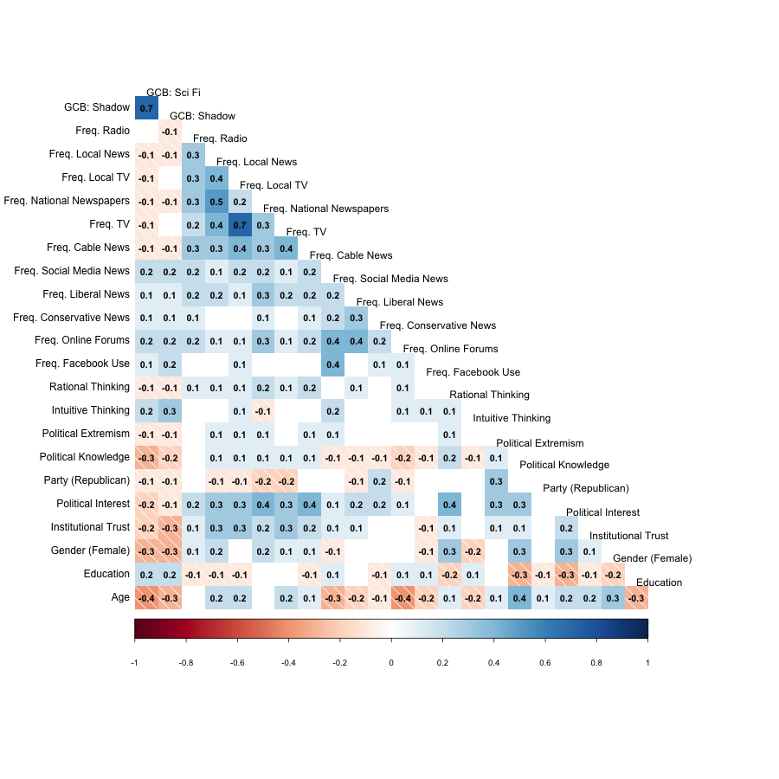
Note: The table only displays correlations with p < 0.05.

