Supplementary File

To the Manuscript

How misinformation as accessed through Google varies with input language and geolocation: A comparison of Covid-19 conspiracy narratives retrieved from five countries in response to Russian versus English language queries

Content

1. Search terms deployed in the original languages 3

2. Code 3

3. Data set 3

4. Intercoder reliability tests 4

5. Additional Analysis 5

RQ2a. How Source Pages Connected With Russia’s Ruling Elites Contribute to the Spread of Conspiracy Theories 5

RQ2b. Proportion of Conspiracy Narratives Spread by Source Type 6

H1a. Sources affiliated with Russia’s ruling elites by query language 7

H1b. Undebunked Conspiracy Theories in English and Russian Language Query Results 8

H1c: Proportion of US Plotters Blamed in Search Result Pages by Language 9

# Search terms deployed in the original languages

* English   
  “covid+19”, “covid+19+origin”, "covid+19+truth", "covid+19+conspiracy+theories";
* Russia:  
  “коронавирус”, “коронавирус+происхождение”, "коронавирус+правда", "коронавирус+теории+заговора".

# Code

The Python code used to collect data for this study is openly available in the following GitHub repository:

ANONYMIZED FOR REVIEW

# Data set

The following data set is provided as supplementary files to the manuscript: DS_Full_RU_EN.sav (N = 8,800).

# Intercoder reliability tests

In total, three intercoder reliability tests were conducted by two researchers, consisting of a total of 175 unique English-language search results. The following table summarizes the highest values (percent agreement and Krippendorff‘s alpha) we achieved across all three reliability tests.

|  |  |  |
| --- | --- | --- |
| Variable | Percent agreement | Krippendorff‘s alpha |
| V8: Type of Source | 85.7% | .842 |
| V9: Geographical Origin of Source | 87.9% | .832 |
| V10: Russia‘s Influence on Source | 95.9% | .915 |
| V11: Accessibility of Website | 100% | 1 |
| V12: Actual Item Language | 99.0% | .663 |
| V13: Date of Publication | 100% | 1 |
| V14: Title of the Item | 100% | 1 |
| V15: Presence of Pay Wall | 97.0% | .388 |
| V16: Presence of Conspiracy Theories | 91.8% | .862 |
| V17: Specific Conspiracy Plots |  |  |
| V17a: Biological Weapon | 92.6% | .854 |
| V17b: 5G Towers | 96.3% | .784 |
| V17c: Control Through Vaccine | 96.3% | .839 |
| V17d: Different Origin | 81.5% | .618 |
| V17e: Distortion of Information | 74.1% | .442 |
| V18: Geographical Origin of Plotter | 81.5% | .723 |
| V19: Geographical Origin of Victim | 63% | .447 |

# Additional Analysis

## RQ2a. How Source Pages Connected With Russia’s Ruling Elites Contribute to the Spread of Conspiracy Theories

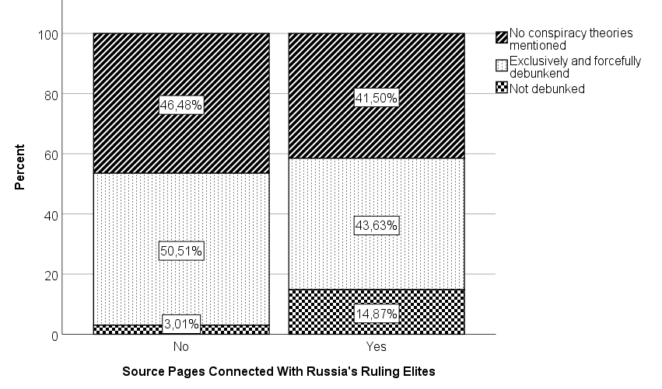

Note: Total N = 8800 results

## RQ2b. Proportion of Conspiracy Narratives Spread by Source Type

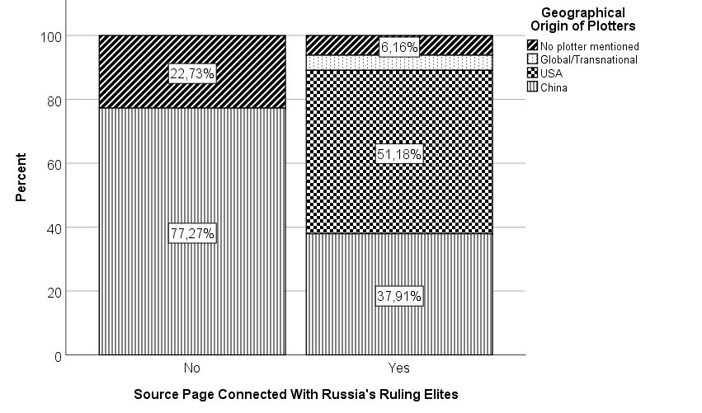

Note: N1 = 68 results featuring conspiracy theories (source pages not connected to Russia’s elites). N2 = 216 results featuring conspiracy theories (source pages connected to Russia’s elites).

## H1a. Sources affiliated with Russia’s ruling elites by query language

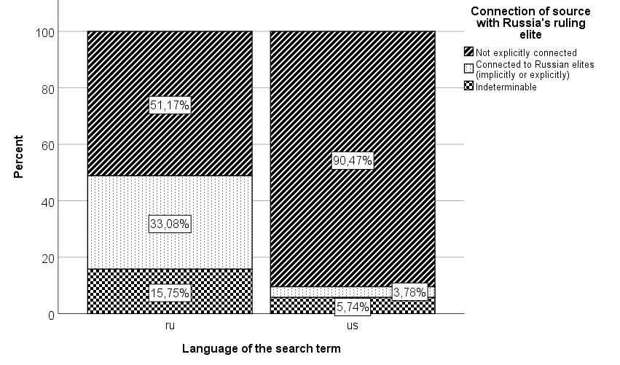

Note: N1 = 4399 Russian language results. N2 = 4388 English language results.

## H1b. Undebunked Conspiracy Theories in English and Russian Language Query Results

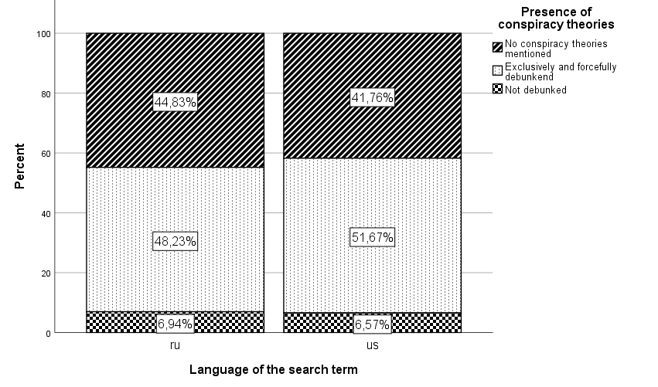

Note: N1 = 4379 Russian language results; N2 = 4229 English language results.

## H1c: Proportion of US Plotters Blamed in Search Result Pages by Language

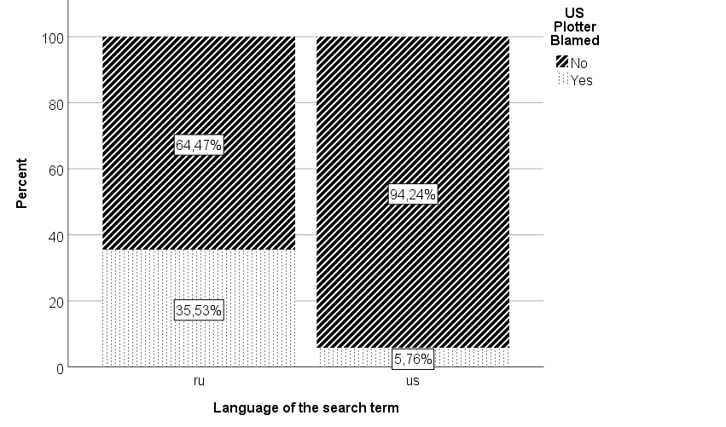

Note: N1 = 304 (Russian language results); N2 = 582 (English language results)