Table of Contents

Table S1: Main effects of message conditions (full sample) 2
Table S2: Interactions between message conditions and political party 3
Table S3: Subgroup analyses (belief in climate change) 4
Table S4: Subgroup analyses (perceived risk) 5
Table S5: Interactions between message conditions and political ideology 6
Figure S1: Interaction plots with political ideology as a moderator 7
Table S6: Zero-order correlation matrix among study variables 8
Summary of Message Framing Findings 9
References 10

Table S1: Main effects of message conditions (full sample)
 | Belief in climate change | Perceived risk | Policy support | Activism intentions | Personal mitigation behavior intentions
 | b (SE) | b (SE) | b (SE) | b (SE) | b (SE)
Emotional appeals
Humor (vs. awe) | -.06 (.11)† | -.04 (.11) | -.08 (.08)** | -.11 (.12)*** | -.10 (.08)***
Control (vs. awe) | -.12 (.11)*** | -.11 (.11)*** | -.11 (.08)*** | -.16 (.12)*** | -.11 (.08)***
Humor (vs. control)ª | .06 (.11)* | .07 (.11)* | .03 (.08) | .05 (.12)† | .08 (.08)
Framing | -.01 (.09) | .04 (.09) | .02 (.06) | .001 (.10) | .02 (.07)
F | 5.21 | 4.86 | 4.93 | 10.01 | 5.88
R² | .01 | .01 | .01 | .02 | .01
Note. ª Estimates for the humor vs. control contrast come from an analogous set of regressions were we set the control group as the reference group; we include these estimates in this table to simplify our presentation of the results. Betas are standardized coefficients. Framing is coded as “climate change” = 1 and “air pollution” = 0. N = 1507.
† p ≤ .10. * p ≤ .05. ** p ≤ .01. *** p ≤ .001.

Table S2: Interactions between message conditions and political party
 | Belief in climate change |  |  | Perceived risk |  |  |  | Policy support |  |  |  | Activism intentions |  |  |  | Personal mitigation behavior intentions
 | b (SE) | b (SE) |  | b (SE) |  | b (SE) |  | b (SE) |  | b (SE) |  | b (SE) |  | b (SE) |  | b (SE) | b (SE)
Emotional appeals (vs. control)
Awe | .11 (.11)*** | .23 (.19)*** |  | .08 (.10)** |  | .17 (.18)*** |  | .09 (.08)** |  | .15 (.13)** |  | .15 (.12)*** |  | .16 (.20)** |  | .11 (.08)*** | .11 (.14)*
Humor | .06 (.11)* | .14 (.18)** |  | .07 (.11)* |  | .10 (.17)* |  | .03 (.08) |  | .00 (.13) |  | .06 (.12)* |  | .07 (.20) |  | .03 (.08) | -.01 (.14)
Framing | .00 (.09) | .01 (.15) |  | .03 (.09) |  | .00 (.15) |  | .02 (.06) |  | -.03 (.11) |  | .00 (.10) |  | -.06 (.16) |  | .01 (.07) | .01 (.11)
Party affiliation (vs. Republican)
Democrat | .30 (.11)*** | .36 (.22)*** |  | .31 (.10)*** |  | .31 (.21)*** |  | .24 (.08)*** |  | .21(.15)*** |  | .20 (.12)*** |  | .15 (.23)* |  | .13 (.08)*** | .13 (.16)*
Independent | .15 (.11)*** | .30 (.22)*** |  | .10 (.11)*** |  | .20 (.20)*** |  | .05 (.08) |  | .04 (.16) |  | -.04 (.12) |  | -.06 (.24) |  | -.01 (.08) | -.04 (.17)
Interaction terms
Awe $×$Dem. | -- | -.10 (.26)* |  | -- |  | -.06 (.25) |  | -- |  | -.05 (.19) |  | -- |  | .00 (.28) |  | -- | -.01 (.20)
Awe $×$Ind. | -- | -.14 (.28)** |  | -- |  | -.11 (.26)* |  | -- |  | -.07 (.19) |  | -- |  | -.03 (.29) |  | -- | -.01 (.20)
Humor $×$Dem. | -- | -.05 (.26) |  | -- |  | -.01 (.25) |  | -- |  | .06 (.19) |  | -- |  | .02 (.28) |  | -- | .07 (.19)
Humor $×$Ind. | -- | -.11 (.28)* |  | -- |  | -.07 (.26) |  | -- |  | -.01 (.19) |  | -- |  | -.04 (.30) |  | -- | .00 (.20)
Framing $×$Dem. | -- | .02 (.22) |  | -- |  | .06 (.20) |  | -- |  | .04 (.15) |  | -- |  | .06 (.23) |  | -- | -.05 (.16)
Framing $×$Ind. | -- | -.04 (.23) |  | -- |  | -.01 (.21) |  | -- |  | .07 (.16) |  | -- |  | .08 (.24)† |  | -- | .05 (.17)
F | 23.84 | 12.07 |  | 26.62 |  | 12.95 |  | 17.52 |  | 8.76 |  | 19.70 |  | 9.39 |  | 8.25 | 4.38
R² | .078 | .086 |  | .086 |  | .092 |  | .058 |  | .064 |  | .065 |  | .068 |  | .028 | .033
Note. Betas are standardized coefficients. Framing is coded as “climate change” = 1 and “air pollution” = 0. N = 1417.

† p ≤ .10. * p ≤ .05. ** p ≤ .01. *** p ≤ .001.

Table S3: Subgroup analyses (belief in climate change)
 | Republicans | Democrats | Independents
 | b (SE) | b (SE) | b (SE)
Emotional appeals
Humor (vs. awe) | -.08 (.21) | -.03 (.15) | -.05 (.21)
Control (vs. awe) | -.21 (.22)*** | -.11 (.15)* | -.01 (.21)
Humor (vs. control)ª | .13 (.21)* | .08 (.15) | -.04 (.22)
Framing | .01 (.17) | .04 (.12) | -.05 (.17)
F | 5.39 | 1.96 | .65
R² | .03 | .01 | .005
N | 497 | 500 | 420
Note. ª Estimates for the humor vs. control contrast come from an analogous set of regressions were we set the control group as the reference group; we include those estimates in this table to simplify our presentation of the results. Betas are standardized coefficients. Framing is coded as “climate change” = 1 and “air pollution” = 0.

† p ≤ .10. * p ≤ .05. ** p ≤ .01. *** p ≤ .001.

Table S4: Subgroup analyses (perceived risk)
 | Republicans | Democrats | Independents
 | b (SE) | b (SE) | b (SE)
Emotional appeals
Humor (vs. awe) | -.06 (.21) | .02 (.14) | .001 (.20)
Control (vs. awe) | -.15 (.21)** | -.11 (.14)* | .007 (.19)
Humor (vs. control)ª | .09 (.21)† | .13 (.14)* | -.006 (.20)
Framing | .004 (.17) | .11 (.11)* | -.01 (.16)
F | 2.80 | 4.13 | .02
R² | .02 | .02 | .00
N | 497 | 500 | 420
Note. ª Estimates for the humor vs. control contrast come from an analogous set of regressions were we set the control group as the reference group; we include those estimates in this table to simplify our presentation of the results. Betas are standardized coefficients. Framing is coded as “climate change” = 1 and “air pollution” = 0.

† p ≤ .10. * p ≤ .05. ** p ≤ .01. *** p ≤ .001.

Table S5: Interactions between message conditions and political ideology
 | Belief in climate change |  | Perceived risk |  | Policy support |  | Activism intentions |  | Personal mitigation behavior intentions
 | b (SE) | b (SE) | b (SE) | b (SE) | b (SE) | b (SE) | b (SE) | b (SE) | b (SE) | b (SE)
Emotional appeals (vs. control)
Awe | .12 (.11)*** | -.08 (.27) | .08 (.10)** | -.05 (.26) | .09 (.08)** | .02 (.19) | .14(.12)*** | .10 (.29) | .10 (.08)*** | .05 (.20)
Humor | .07 (.11)* | -.02 (.28) | .07 (.10)* | .03 (.26) | .03 (.08) | .03 (.19) | .06 (.12)* | .06 (.29) | .02 (.08) | .05 (.21)
Framing | .01 (.09) | .08 (.22) | .03 (.08) | .14 (.21)* | .03 (.06) | .10 (.15) | .00 (.10) | .02 (.24) | .02 (.07) | .04 (.16)
Conservatism | -.29 (.02)*** | -.35 (.05)*** | -.31 (.02)*** | -.32 (.05)*** | -.30 (.02)*** | -.29(.04)*** | -.25(.03)*** | -.25(.05)*** | -.19 (.02)*** | -.19 (.04)***
Interactions with conservatism
Awe | -- | .22 (.06)*** | -- | .15 (.06)* | -- | .08 (.04) | -- | .05 (.07) | -- | .05 (.05)
Humor | -- | .10 (.06) | -- | .05 (.05) | -- | .00 (.04) | -- | .00 (.07) | -- | -.03 (.05)
Framing | -- | -.09 (.05) | -- | -.13 (.05)† | -- | -.09 (.03) | -- | -.03 (.05) | -- | -.02 (.04)
F | 39.12 | 24.19 | 42.12 | 25.37 | 38.97 | 22.76 | 32.18 | 18.46 | 18.25 | 10.63
R² | .098 | .106 | .105 | .110 | .098 | .100 | .082 | .083 | .048 | .049
Note. Betas are standardized coefficients. Framing is coded as “climate change” = 1 and “air pollution” = 0. N = 1442.

† p ≤ .10. * p ≤ .05. ** p ≤ .01. *** p ≤ .001.

Figure S1: Interaction plots with political ideology as a moderator

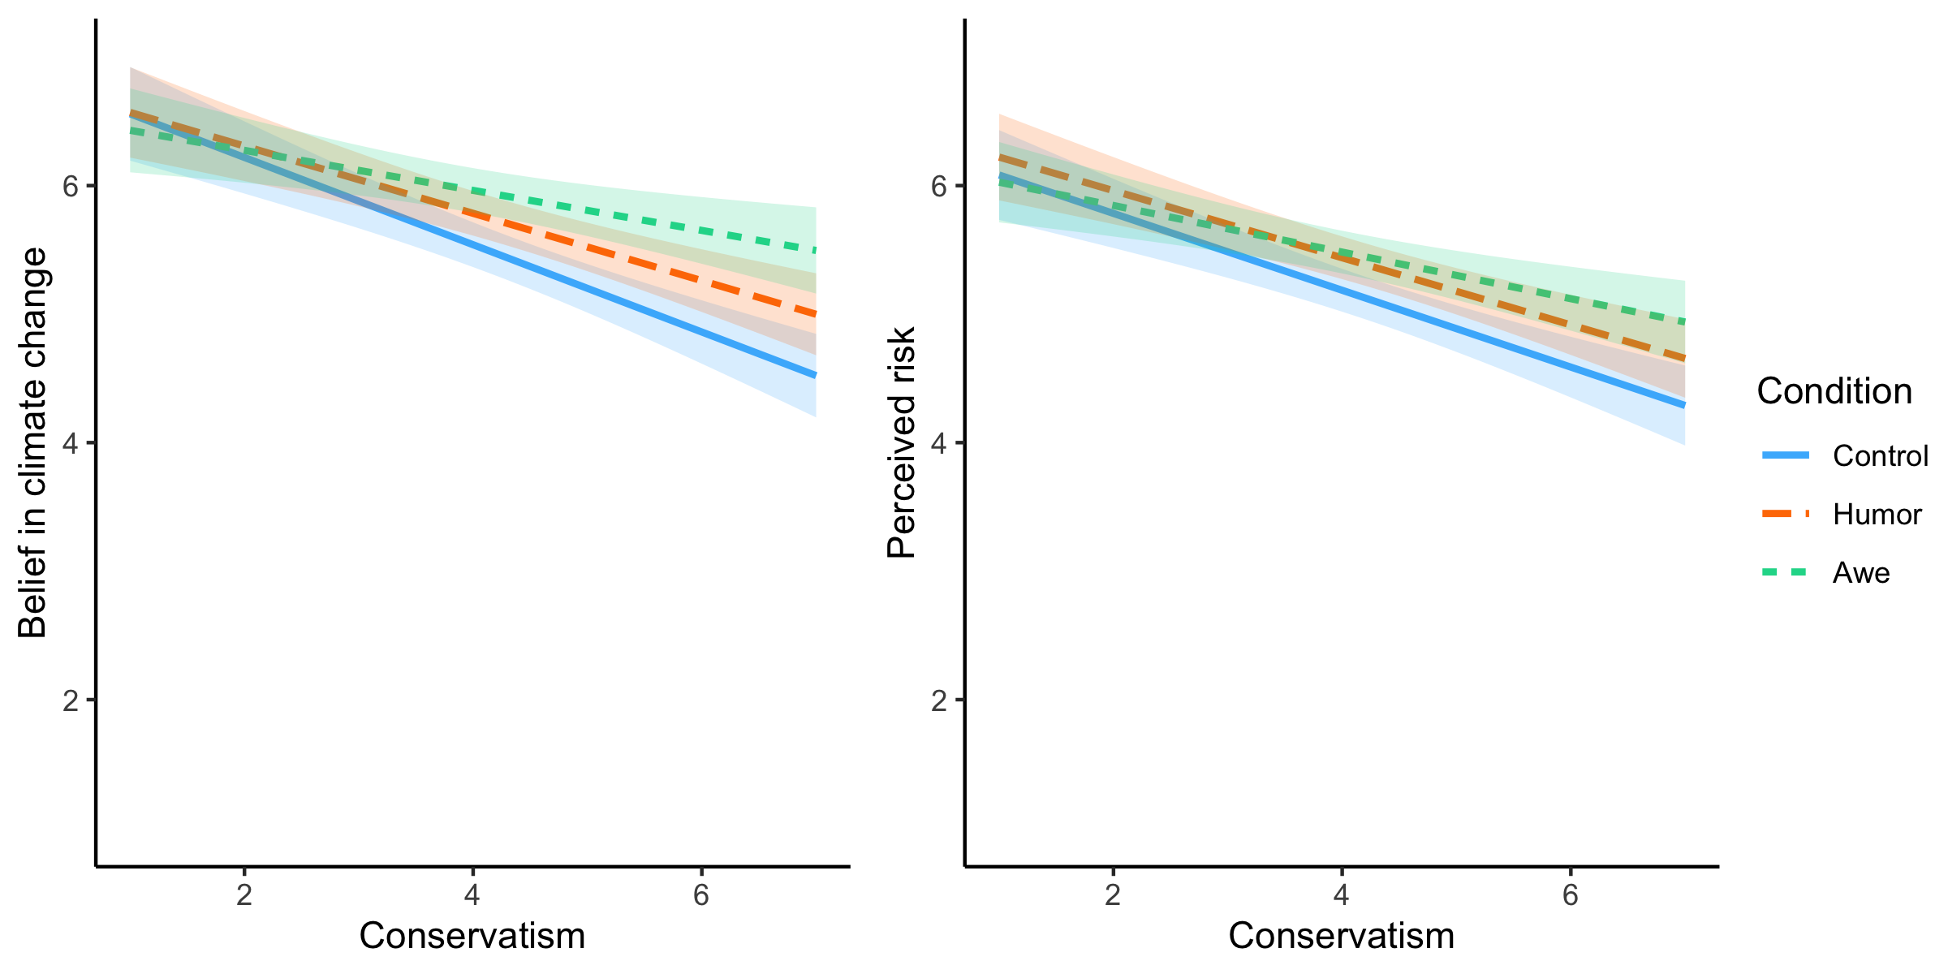
Note. Bands reflect 95% confidence intervals.

We probed these interactions using the PROCESS macro for SPSS (Hayes, 2013) with model 1. We first looked at belief in climate change. For political liberals (ideology = 2), neither the humor appeals (effect = .08, SE = .17, p = .64) nor awe appeals (effect = .04, SE = .17, p = .81) influenced belief in climate change compared to control. For political moderates (ideology = 4), both the humor appeals (effect = .24, SE = .11, p = .025) and awe appeals (effect = .42, SE = .11, p < .001) boosted belief in climate change compared to control. For political conservatives (ideology = 6), both the humor appeals (effect = .40, SE = .15, p = .008) and awe appeals (effect = .79, SE = .16, p < .001) increased belief in climate change compared to control. We note, however, that only the awe $×$ ideology interaction term was significant (see Table S5), meaning that even though significant effects of the humor appeals only emerged for moderates and conservatives, the humor appeals’ effects were statistically indistinguishable across the political spectrum.
The same pattern emerged for perceived risk. Among liberals (ideology = 2), neither the humor appeals (effect = .16, SE = .16, p = .31) nor awe appeals (effect = .04, SE = .16, p = .80) affected perceived risk compared to control. For moderates (ideology = 4), both the humor appeals (effect = .25, SE = .10, p = .016) and awe appeals (effect = .29, SE = .10, p = .006) promoted perceived risk compared to control. For conservatives (ideology = 6), the humor appeals (effect = .33, SE = .15, p = .022) and awe appeals (effect = .54, SE = .15, p < .001) both increased perceived risk compared to control. Again, we note that only the awe $×$ ideology interaction term was significant (see Table S5).
Together, these results suggest the awe appeals’ positive influence on belief in climate change and perceived risk was increasingly more pronounced at greater levels of political conservatism.

Table S6: Zero-order correlation matrix among study variables

 | 1 | 2 | 3 | 4 | 5 | 6 | 7
1. Awe | --
2. Amusement | .16*** | --
3. Belief in climate change | .14*** | .01 | --
4. Perceived risk | .18*** | .07** | .66*** | --
5. Policy support | .27*** | .12*** | .44*** | .52*** | --
6. Activism intentions | .37*** | .26*** | .29*** | .42*** | .52*** | --
7. Personal mitigation intentions | .33*** | .15*** | .33*** | .41*** | .53*** | .68*** | --
8. Conservatism | -.05* | -.03 | -.30*** | -.31*** | -.30*** | -.26*** | -.20***
* p < .05. ** p < .01. *** p < .001.

Summary of Message Framing Findings

As mentioned in a footnote in the manuscript and in the preregistration form, we also manipulated the language in the videos’ call-to-action, framing the issue as “climate change” or “air pollution.” This was done as a test of another potential boundary condition for the effects of awe appeals. Upon the recommendation of reviewers, however, we removed this element from the paper. Specifically, reviewers took issue with (a) the conceptual underpinning of this manipulation and (b) the lack of a manipulation check. For the sake of transparency, however, we felt it important to briefly address the hypothesis and research question that we laid out in the preregistration form which involve the framing manipulation.
In our preregistration, we asked: Will the persuasive effects of the emotional appeals by moderated by how the issue is framed: climate change or air pollution (RQ2 in the preregistration)? As shown in Tables S2 and S5, none of the interaction terms between framing and participants’ political leaning (party affiliation or ideology) were significant. We also hypothesized that Republicans would be more persuaded by an air pollution frame than a climate change frame (H2 in the preregistration). The interaction terms were not significant for any of the outcomes assessed (Table S2). Considered with the lack of main effects for message framing (Table S1), these results do not support this hypothesis. We also tested three-way interactions for emotion condition $×$ political party $×$ framing (see data and syntax), none of which were significant.

References

Hayes, A. F. (2013). Introduction to mediation, moderation, and conditional process analysis: A regression-based approach. Guilford.

