**Title:**

Online pre-events during the Covid-19 pandemic

**Abstract:**

In the wake of the COVID-19 pandemic, mega events such as the Olympics and Expo have been postponed, prolonging the build-up phase and thus the opportunity to organise pre-events. Covid restrictions and limitations on movement have forced these pre-events online. Examining the case of pre-events leading up to Dubai EXPO 2020, we argue that, as an emerging and growing phenomenon, pre-events create spaces for experimenting and re-engineering new communication approaches. Applying a typology of pre-events based on format, function, audiences and interactivity, our analysis shows that the main roles of pre-events are to engage with stakeholders, create and re-present event narratives, and plan the main event. Despite the possibility provided by digital platforms and the growing acceptance by publics of online formats such as webinars and online forums, pre-events usually lack interactivity, even when the aim is to engage publics. Our findings indicate that the explicit functions and goals of these pre-events are rarely articulated by organizers, despite their popularity. The article not only contributes to our knowledge about this promotional phenomenon, but also provides recommendations for practitioners developing pre-events.

**Keywords:**

pre-event, mega event, expo, Covid-19

**Introduction**

The COVID-19 pandemic – an ongoing global health emergency that has revealed “fractures in the fragile skeleton of the societies we have built” (Guterres in Katongole, 2020) – continues to force individuals and groups to change their socio-cultural practices, among them the organization of events. Organizers have to re-engineer practices, policies, and modalities. All kinds of events have been impacted, including sport mega events such as the Euro Cup 2020 and the Olympics 2020 and international exhibitions such as Expo 2020. In order to tackle the challenges brought by the pandemic, organizers have created Olympics “bubbles” for athletes, new protocols (e.g. social distancing, mask-wearing, limits of crowds etc.) and banned spectators from events.

The pandemic has also affected pre-events, which were steadily becoming increasingly valuable promotional tools, but have become even more important due to the impacts of lockdowns and border closures that have kept individuals and groups sequestered within their home communities. In straightforward terms, pre-events can be understood simply as “opportunities that event planners can create for people to share time together before … the [main] event” (Chalip, 2004). In more complex terms, drawing on the event studies definition of planned events developed by Getz and Page (2020, p. 58), a pre-event can be defined as a live social event, held before a more significant corresponding event, that is purposefully created, designed and implemented to achieve specific outcomes. Examples of pre-events include mixed gender team events prior to the Olympic Games in Tokyo in 2021 or pre-tournament friendlies in preparation of the European and World soccer cup.

Practitioner commentary about the pre-event is also continuing to grow as event organizers around the world increasingly use this promotional tool. A significant amount of that commentary offers advice for other practitioners wishing to undertake pre-events. For instance, Sheth (2018), providing “takeaways” from the MOVE Global Mobility Summit 2018, writes: “With planners who opt for pre-events within their event promotion strategy, it is a must to categorize and leverage all these events accordingly. Taking the example of the MOVE Summit, all the pre-events had a separate space on the main event’s website.” On the whole, Sheth adds: “Each event can add on to the promotion and participation for the main event and can increase the footfall for the main event when leveraged properly.” Similarly, Lucas (2021) provides various pieces of advice for considering the pre-event’s purpose, approach to linking with the main event, use of venue, and team engagement, as well as promotion and communication tactics. Practitioner advice like this abounds.

This paper examines pre-events in a COVID-19 era, focusing on digital pre-events. It argues that these events have become increasingly important as promotional tools due to border restrictions and lockdowns, although digital pre-events are often poorly executed and attended; more broadly, despite their value as strategic promotional occasions, they will continue to be a marginalized form of social gathering due to access issues connected with social media and their secondary importance in comparison with the more significant (main) events that they precede. To illustrate this argument, the paper uses a case study of the Expo 2020 Dubai digital pre-events, which are being organized by multiple countries ahead of the main event (the Expo itself, running from 1 October, 2021, to 31 March, 2022). This case provides a wealth of insights, as it sheds light on the dynamics of many different pre-events being organised by different cultures. In other words, this single instrumental case study (Stake, 1995) provides a robust way of understanding the principles that apply from it to multiple other settings (Yin, 1981). Qualitative content analysis (Hsieh & Shannon, 2005) has been used to analyze the different digital pre-events being held before the Expo.

The paper provides several contributions to knowledge, as well as a set of contributions to practice. It builds on the current scholarly knowledge about pre-events, and particularly digital pre-events. This knowledge is growing but limited (Robertson, 2018), and will continue to be important during the COVID-19 pandemic, as well as after it, in light of the recognition that digital will be the new normal for societies after the pandemic ends (UN DESA, 2020). Pre-events have continued to grow in size and importance over the years; they have become increasingly significant social occasions in their own right, giving like-minded individuals and groups the chance to convene for shared purposes, as well as significant instrumental promotional opportunities. The paper helps to build our knowledge in both of these respects. Also, more specifically, it contributes to expanding our understanding of the configurations and purposes of pre-events. Additionally, it adds insights about best practices in digital pre-event organization and execution. Against the backdrop of these primary contributions to knowledge, the paper also provides a secondary contribution in the form of helping build our understanding of the role and value of traditional physical events (such as EXPO).

The remainder of this paper is divided into five sections. The background and literature review first provide details about digital pre-events in relation to planned events more broadly. The method section then outlines the research design – including the case study of EXPO 2021 digital pre-events - in answer to the research question: what is the form and function of the digital pre-event? Next, the results section outlines the findings of the original research. After that, the discussion section interrogates the findings critically, and provides recommendations for practitioners (such as event managers and other professional communicators). The conclusion notes the limitations of the research and outlines avenues for further investigation.

**Background and literature review**

Digital pre-events are, collectively, one the latest outcomes in a long history of evolutions of planned events. Drawing on Getz (2020, p. 32), these types of events:

are created to achieve specific outcomes, including those related to the economy, culture, society and environment. Event planning involves the design and implementation of themes, settings, consumables, services and programmes that suggest, facilitate or constrain experiences for participants, guests, spectators and other stakeholders. Every event-goers experience is personal and unique, arising from the interactions of setting, program, and people, but event experiences also have broader social and cultural meanings.

(Unplanned events, by contrast, can be understood as “unpredictable happenings” that range from the unpleasant, such as forces of nature and wars, to the more pleasant, such as large spontaneous celebrations (Getz & Page, 2020, p. 68).) Both planned and unplanned events have been occurring throughout recorded history, even though most events have been informal and organic until (comparatively) recently (Getz, 2020, p. 31); nevertheless, planned events “have been an essential part of human civilization”, helping to bind communities together, define cultures, and shape the identities of people, places and social activities.

Pre-events, too, have far-reaching antecedents. Examples range from the oath-taking at Olympia that preceded the ancient Olympic games (Potter, 2011) to the more recent annual ‘Nobel Week Dialogue’ meeting that precedes the Nobel Prize awarding ceremony (Nobel Outreach, 2021). History is littered with such precursors to today’s pre-events, even though main events have traditionally been the focus of publics’ (and scholars’) attention. Indeed, in this respect, Robertson (2018, p. 3209) notes that: “The focus of the media event literature has been the live phase—the peak intensity of media “thickenings” as the scripted event is covered live”; however, the contestation around the main, planned event’s narratives actually begins earlier, in what has been termed the ‘build-up phase’ (Robertson, 2018). This concept aligns with the ‘pre-events period’ identified in Kuusik et. al’s (2014) study about tourism events. In this period, social media marketing can be used to promote ticket sales to the main event (Tolvanen, 2016). Although the ‘build-up phase’, the ‘pre-events period’ and the pre-event itself are three dissimilar things, they all highlight the (often-overlooked) importance of events that precede a main event.

The outcomes that pre-events aim to achieve differ from pre-event to pre-event. Some outcomes are limited. For instance, Hutton and Jaensch (2015) have noted that the participants of outdoor music festivals use pre-events as opportunities to catch up with their friends, also (unintentionally) using those events as opportunities for ‘pre-loading’: drinking alcohol before a main event. Other outcomes are larger and cross multiple pre-events. For example, Knight (2014, p. 3) notes that the events preceding the annual Academy Awards or Oscars telecast serve multiple functions, explaining that: “Pre-events include interviews, talk about possible nominations, prediction of winners, past Academy Awards happenings, and speculations about who will host the show. In the hours before the main event, the paparazzi cover the red carpet.”

Analysts have increasingly been recommending that pre-events be used strategically, especially in ways that fulfil organizations’ and groups’ social responsibility requirements. For instance, Hahm, Ro and Olson (2018), in their analysis of an LGBTQI+ event, have suggested that the event organizers deliberately “create pre-events, or for national/international events, create geographically specific pre-events, to facilitate bond-building”. This aligns with Chalip’s (2004) observation that an event can be deliberately elongated by adding pre- and post-events that enable participants to share time together. In line with advice to ‘green’ events, or make them sustainable (see, for example, Jones, 2018), Moise and Macovei (2014) have argued that the organizers of pre-events (as well as events and post-events) must take into account those events’ impacts on participants and the environment; they have also commented that the responsibility to make events environmentally friendly should rest not with organizations alone, but with both organizers and participants.

The existing scholarship has also increasingly been emphasizing the need to understand the impacts of pre-events. Some proposed impact analyses are straightforward; Ma et. al. (2013), for example, used questionnaires in their analysis, which sought to understand how residents living in close proximity to a survey site were affected by various occurrences (including pre-events) before a main event. Other impact analyses are more complex. Zuev (2016) has argued that it is important to examine the visual production stages of a pre-event (as well as main event and post-event), while Guo, Huang and Jia (2020) have suggested using the real options valuation method in evaluating risk in connection with pre-events. One the most comprehensive impact evaluation approaches, though, has been offered by Ma et. al. (2011), who have drawn on the triple bottom line (social, environmental and financial) approach to understanding pre-event impacts. In their study, the authors identified both the pre-event impacts and the criteria to assess those impacts.

The scholarship about pre-events has also drawn on work about media events. These types of events – which can be understood as “situated, thickened, centering performances of mediated communication that are focused on a specific thematic core” Couldry and Hepp (2017, p. 3) – help to understand not only pre-events, but also media events themselves. However, pre-events have not been studied in depth from a media events perspective. For instance, Lin et. al. (2014) have examined audience dynamics on Twitter to understand user behaviour during media events as opposed to other events (such as pre-events and news events). In a similar vein, Robertson (2018), has examined the highly contested nature of the build-up phase of planned media events; her study countered the suggestion of Katz and Liebes (2007, p. 160) that the preplanning of a media event allows for the “comfort of orderliness”. This countering is also evident in the work of Rivenburgh (2009), who noted that hosts of global media events must be prepared to respond to pre-event developments, such as surprise news events and unsurprising reporting topics. The need to understand pre-events in relation to media events more effectively is just one of the areas in which further knowledge about pre-events is needed.

**Digital events and the Covid-19 pandemic**

Digital events have been growing for years, but have proliferated during the COVID-19 pandemic as individuals, groups and organizations found themselves switching to digital forms of engagement in order to avoid face-to-face interaction. According to one Australian industry study, undertaken by a firm specializing in event management, almost two in three Australian respondents reported attending six or more digital events a month just one year into the start of the pandemic; live engagement was also increasing, with four in five respondents attending at least half of all digital events live (rather than on-demand) (Page, 2020). Looking ahead, a different, global study has found that the virtual event platform market is expected to grow at a compound annual growth rate of 12.7%, reaching USD 18.9 billion in 2026, up from USD 10.4 billion in 2021; the factors driving this growth include the rise in the popularity of online meetings, replacing physical get-togethers, and the continuing transition of businesses to remote working approaches (ReportLinker, 2021). These findings, about distinct time-periods, highlight the ongoing desire and need – at both the individual country and international levels – to continue using digital events.

The scholarly research that has been undertaken (so far) about these events in relation to the COVID-19 pandemic also highlights an ongoing appetite for the use of the events in various settings, although researchers have also pointed out the limitations of hosting various occasions online. One of the most significant benefits of digital events is their removal of geographical boundaries to engagement by individuals of different socio-economic backgrounds; Westgarth (2021, p. 18) pointedly asks: “Is it absolutely necessary to travel across the country to … an event or seminar?” Werner, Junek and Wang (2021) have pointed out that, in terms of the event management skills that will be needed in the post COVID-19 world, different skill sets will be required for planning and managing digital events, given the distinct requirements of staging online (as opposed to physical, face-to-face) events. In their analysis of digital and non-digital interaction formats, Schwarz et al. (2020) note that digital events of different kinds require less preparation time, have lower costs, and minimise the wastage of typical physical event components (such as food, plastic, and paper). However, they also find that digital events inadequately replicate the multiple informal discussions held during physical events, have the potential to affect personal well-being (due to the lack of in-person interactions), raise issues relating to data security, and may lead only to limited carbon emission savings.

The communication impacts of digital events are varied, and many individuals’ desire to return to face-to-face events, or engage in hybrid events, also speaks to the limitations of planning and running online-only occasions. The idea of ‘information richness’ (Daft & Lengel, 1986) reminds us that face-to-face (verbal) communication is, and will remain (for a very long time, at least), the most effective way to communicate. The use of communication technology also often fails due to issues with hardware or software, but also, as Koch et. al. (2012) point out, due to participants’ lack of knowledge about the technology and the processes that it involves. Consequently, it is little wonder that an appetite has been growing for hybrid events that “make the best of both worlds” – that is, of digital and physical interactions – with event organizers likely to be mindful of organizing ‘digital twin’ events in future (Feeley, 2021). Nevertheless, digital events in various forms are more than likely to continue being held given the concerns (for the time being, at least) of populations around the world over face-to-face interactions, and given the world’s continuing, careful watchfulness for outbreaks of new strains of the virus. Additionally, given the existing benefits that digital events have provided to organizations – and especially the enhancements in efficiency and effectiveness that they have provided – these events are likely to continue being used by organizations, in particular.

**Methodology and Method**

As the literature review has demonstrated, there is currently a lack of knowledge about digital pre-events. To fill this lacuna, the present study sought to understand the shapes that pre-events take, as well as the uses to which they are put; as such, its research question was: what is the form and function of the digital pre-event? This single research question was sufficient to understand both the components of pre-events and the purposes that they serve. The online pre-events connected to the Dubai 2021-2022 EXPO were chosen, collectively, as the case study for the analysis. This choice was made given the varying nature of the online pre-events: specifically, their varying cultural backgrounds, and multiple organizing teams, which all had different approaches to organizing and running their pre-events. These events, preceding the Dubai EXPO, would enable rich insights to be formed about other pre-events; in other words, this single instrumental case study (Stake, 1995) was deemed to provide a robust way of enabling other settings to be understood (Yin, 1981).

The Dubai EXPO is the most recent of the global EXPOs that have been taking place since 1985. According to the organization in charge of regulating the events, the Bureau International des Expositions (BIE), each EXPO “aims at educating the public, sharing innovation, promoting progress and fostering cooperation” (BIE n.d.-a). The event usually lasts six months, involves multiple publics and various institutional actors – such as governments, companies, and intergovernmental organizations – and is hosted (and organized) by a different country every three to five years, approximately. Each EXPO also has its own theme, which aims to “raise awareness of and find responses to universal challenges of our time” (BIE n.d.-b). Due to COVID-19-related delays, the Dubai EXPO began on October 1, 2021.

The pre-events examined in this study were identified through a two-step search. First, the web-page of each individual country pavilion was found on the official EXPO website (Expo 2020 Dubai, 2021). Second, the social media channels of the pavilions were searched to find online pre-events (organized by those pavilions); this second step (and the use of the social media channels) was needed, as the pavilions’ web-pages on the official Dubai EXPO website did not list individual online pre-events. Most pavilions had dedicated social media channels for the Dubai Expo, but some did not. The data gathering took place from March to September 2021. At the time of data-gathering (following the steps outlined here), of the 58 countries listed on the Dubai EXPO website, 23 countries’ EXPO-focused social media channels were searched, and pre-events were identified on 10 channels. The appendix provides a list of the countries that had EXPO-focused social media channels at the time of data-gathering, as well as a list of the online pre-events held by particular countries.

Qualitative content analysis was used to examine the pre-events. Specifically, conventional qualitative content analysis (following Hsieh & Shannon, 2005) was employed. This method enabled emerging themes and patterns to be identified in the data, then allowing “categories and names for categories to flow from the data” (Hsieh & Shannon 2005, p. 1279). This method was highly suitable for answering the research question. Specifically, using conventional qualitative content analysis, both the forms and functions of different types of pre-events were able to be identified and classed into emerging patterns that provided insights into the events (and, thus, answered the research question). The goal of the analysis was not to provide a fine-grained analysis of every moment of each event; rather, as previously mentioned, it was to understand the events in a more holistic way by categorizing them and noting their salient features. The following section outlines the results of the analysis.

**A typology of pre-events**

The codes that have emerged in the content analysis have been organized in Table 1, which represents a typology of pre-events based on their configuration, function, target audience, availability, interactivity and platform.

* *Configuration* refers to whether the pre-event is a one-off, individual occurrence or a series of events that follow the same format and/or similar and connected topics.
* *Function* represents the role of the pre-event in relation to the main event. In this sense, pre-events can support the engagement with stakeholders; they can help to create, shape and experiment with narratives for the main event or they can constitute an opportunity to re-present and establish narratives for the main event; they can also have a more practical purpose, as planning the main event or select/involve volunteers for the main event.
* The *target audience* can be insiders (people already involved or to be involved in the organization), stakeholders and publics. This dimension is directly related to the function of the digital pre-event.
* The *availability* of the pre-event can be live or both live and on-demand. Our analysis shows that even the on-demand events have been first broadcasted live and then made available as a recording.
* Finally, the *interactivity* of pre-events indicates whether publics or stakeholders are allowed to intervene and actively participate in the event. Two levels of interactivity have been identified: pre-events can be either open to stakeholders or closed.

These dimensions have been applied and used to categorize the Expo 2020 pre-events.

|  |  |
| --- | --- |
| Configuration | * One-off * A series of events |
| Function | * Engagement with stakeholders * Re-presenting narratives * Creating content/narratives * Planning the event |
| Target audience | * Insiders * Stakeholders * Publics |
| Availability | * Live * Live and on-demand |
| Interactivity | * Planned interactions * Open to stakeholders * Closed |

*Table 1: A typology of pre-events based on their configuration, function, target audience, availability, and interactivity*

**Expo 2020’s pre-events**

Figure 1 categorizes the Expo 2020 digital pre-events in relation to function, interactivity and target audience. The diagram shows the frequency for each of the categories. From an analytical point of view, it shows the relations between function, target audience and interactivities of pre-events.

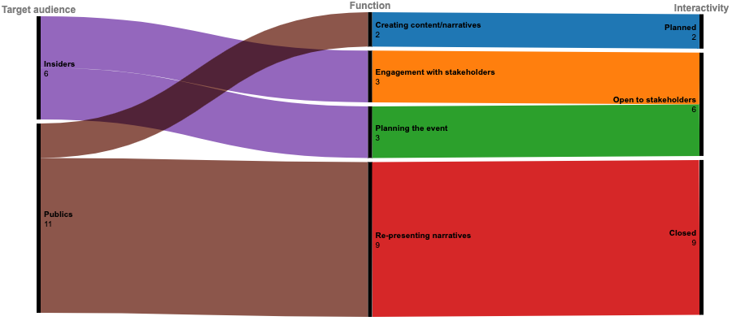

*Figure 1: Expo 2020 digital pre-events in relation to function, interactivity and target audience*

The group of nine pre-events in brown and red constitutes the majority. Pre-events are generally used as tools to re-present narratives to publics in closed contexts. An example of pre-events that falls into this group is the “Architect Talk: Italy x Germany”, a webinar organized by the German Pavilion’s team in which the architects of the Italian and German Pavilions discuss and describe the architectural features of the two pavilions (Figure 2).

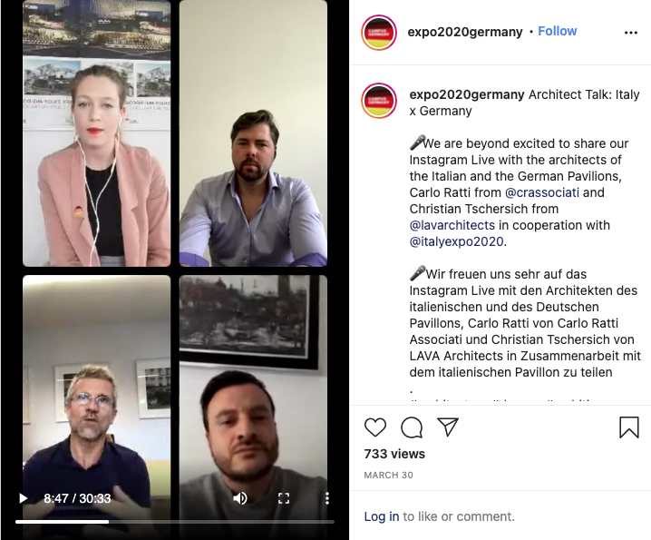

*Figure 2 - a screenshot of the online pre-event organised by the German Pavilion team titled “Architect Talk: Italy x Germany”.*

Interestingly, these events are usually recorded “live” and then the recording is made available to publics without any editing. This indicates that, despite the fact that the function of these events is to re-present narratives for publics, the actual crafting of the event tends to be rudimental. There are two main reasons that explain this phenomenon. Firstly, we believe that the lack of editing suggests an underlining lack of resources. Indeed, as the main event is still far off, it seems that countries’ communication teams are lacking in human and economic resources that may become available closer to the main event. Secondly, the practice of making video recordings of live webinars available to publics (so that it can be re-watched after the event) is becoming increasingly more acceptable for publics during the Covid-19 pandemic. Publics are getting increasingly used to “new temporalities” by applying strategies such as fast forwarding, increasing the speed of the video (“speed watching”), or skimming content (Alexander 2017). At the same time, publics tend to welcome unedited video content if it is authentic.

Referring back to Figure 1, the six pre-events in purple are “open-to-stakeholders” events. This means that they allow the audience to participate in the event by, for example, providing a Q&A session and opening up the floor for questions. The findings clearly indicate that pre-events with a specific target audience (experts and insiders, for example) are more likely to take advantage of the interactivity offered by video conferencing platforms such as Zoom. One of the events that falls into this category is “Expo 2020 Dubai: A Regional Platform of Opportunity for U.S. States and Businesses” organized by the United States pavilion. This seminar targeted states and businesses interested in participating in Expo 2020. This one-off event provided key information about the exposition and the American pavilion to potential stakeholders, presenting the different opportunities for states and businesses to get involved. The event had a Q&A session in which potential partners could ask questions and seek clarifications. As part of this event, key contacts were also provided to the participants indicating the willingness by the organizers to keep the conversation with their stakeholders alive even after the pre-event.

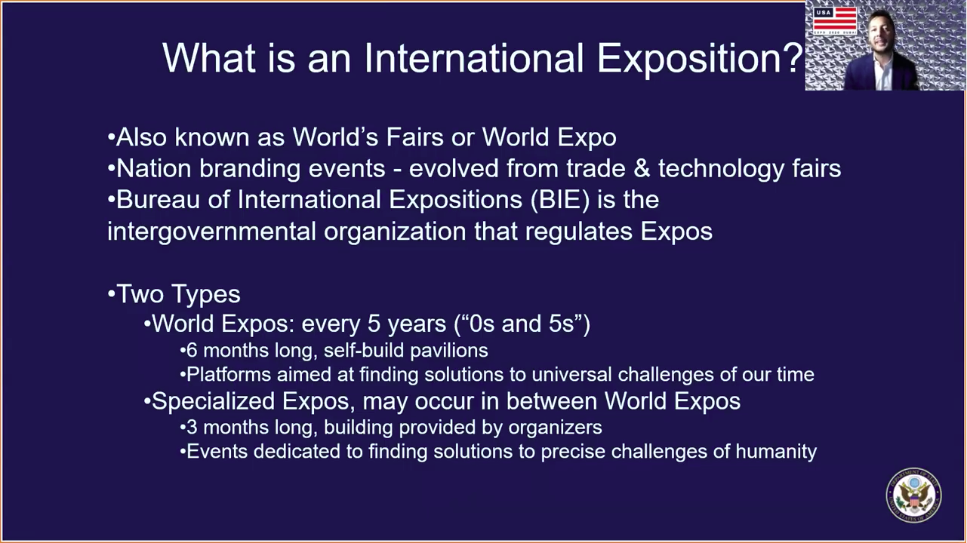

*Figure 3: a screenshot of the online pre-event organised by the USA Pavilion Team titled “Expo 2020 Dubai: A Regional Platform of Opportunity for U.S. States and Businesses”.*

Finally, the remaining small group of two pre-events in Figure 1, marked in brown and blue, allow for planned interactions with partners and stakeholders in order to create content for the main event. For example, in the case of the Italian Pavilion in Figure 4, students pitch their ideas and solutions in response to specific challenges such as “education after the pandemic”. Then, a panel of experts select the finalists who showcase their ideas in the Italian Pavilion during the main event. An interesting characteristic of these pre-events is that they are not made available to publics. However, finalist projects and ideas are then showcased in the pavilion during the Expo. Thus, while these events provide opportunities for participation and dialogue between students and experts, the pre-events take place largely behind closed doors. This seems to suggest that the primary goal of these pre-events is to produce content and ideas that can be showcased in the pavilion during the main event.

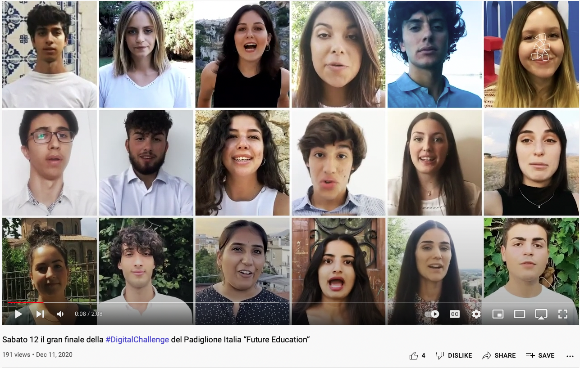

*Figure 4: a screenshot of the promotional video the finals of the “Future Education #DigitalChallenge” - Italian Pavilion Team.*

**Discussion**

A range of insights emerges from the analysis of the digital pre-events held before the 2021-22 EXPO; these insights shed light on digital pre-events more broadly. The analysis shows that these events are vital spaces for generating engagement in the lead-up to the main event. This highlights the fact that the ‘lead-time’ – the length of time between the initiation of the planning process for an event and the date on which it is actually held (Davidson, 2019) – is now more important than ever in engaging publics as deeply as possible, and that auxiliary events (Goldblatt & Lee, 2020) have also become more and more important to event-planners and organizations in communicating in diverse, rich ways with target publics in particular parts of the world. Given the ongoing challenges created by the COVID-19 pandemic in various parts of the world – challenges that are likely to persist for some time yet, sadly – the use of varied ways of engaging individuals and groups around the world becomes yet more important.

As the analysis also showed, the use of varied, creative approaches for communicating with stakeholders maximized the effectiveness of the digital pre-events, and would be significantly important for other digital pre-events, as well. An event’s capacity to help stakeholders, and wider publics, engage in novelty-seeking is only of the key aspects of the attractiveness of any event; other aspects include the loyalty of participants and other ‘pull factors’ that entice individuals and groups (Getz, 2020). As event-goers increasingly seek novel experiences, creativity in programming diverse pre-events will help to distinguish these events from each other and attract participants. However, this sort of inventive programming exacerbates the predisposition, at best, and fixation, at worst, of today’s ‘entertainment subjects’ (Samuels, 2021), who are relentlessly seeking increasingly engaging, novel forms of entertainment.

The analysis also brought to the fore other noteworthy aspects of digital pre-events. These occasions can be (and are) organized individually or in clusters; the choice of event type aligns with organizers’ (and organizations’) strategic intentions for the events and other communication approaches. The events are also most effective when they have specific functions (such as logistical functions) and target specific small-scale audience (like particular stakeholders, or publics with particular backgrounds). They also tend to be most successful – as with all planned events – when they feature dedicated infrastructure (as in the case of Finland’s pre-event, for example, and its page for its Forum), with the infrastructure stretching through multiple a range of different media types: web-pages, embedded videos, freely available downloadable materials, and the like. At the same time, as the analysis also found, a simple element often lacking in many pre-events is the need for those events to engage individuals and groups; this aspect of the events is in line with digital media communication more broadly, requiring dialogue and interactivity rather than the unidirectional transmission of content (Kim, 2019).

**Conclusion**

Digital pre-events will only continue to grow in number over the coming years as the world recovers from the COVID-19 pandemic and the use of digital communication tools gains even wider, daily acceptance. This paper has argued that, as an emerging and growing phenomenon, pre-events create spaces for experimenting and re-engineering new communication approaches. It has developed a novel typology of pre-events based on format, function, audiences and interactivity; this typology, drawing on findings related to the 2021-22 EXPO, would be applicable to many other pre-events. Our analysis has also shown that the main roles of pre-events are to engage with stakeholders, create and re-present event narratives, and plan the main event. However, despite the possibility provided by digital platforms and the growing acceptance by publics of online formats such as webinars and online forums, pre-events usually lack interactivity, even when the aim is to engage publics.

The examples explored in this paper indicate that online pre-events are still mostly rudimental and experimental as organizers struggle to clearly define their function and target audience. Nevertheless, the pandemic and the postponement of EXPO have provided nations’ communication teams with an opportunity to experiment a new canon of online events which may become more systematic and codified in the next edition of EXPO.

The research opens a number of avenues for further investigations related to pre-events. This paper has used just the one case study to understand the configurations of these events; other analyses could draw on different cases to gain deeper insights into pre-events and their configurations. The EXPO, as a case, has its own features; for example, it is a large-scale event with sub-events that feature social actors from various countries. The analysis of a smaller, more contained case would likely yield different understandings of pre-events. Also, this paper has only required the use of conventional qualitative content analysis as its method; the use of different methods – such as textual analysis focusing on understanding meaning-making – would yield richer insights into pre-events, and especially the digital versions of these events. Interviews or focus groups with event organizers could also be undertaken to understand the motivations of these individuals, the tools and techniques that they use, as well as the successes and failures that they have encountered, in planning and running the events.

**References**

Alexander, N. (2017). Speed watching, efficiency, and the new temporalities of digital spectatorship. *Compact cinematics: The moving image in the age of bit-sized media*, 103-112.

BIE, n.d.-a., What is an Expo?, Bureau International des Expositions, http://www.bie-paris.org/site/en/expos/about-expos/what-is-an-expo

BIE, n.d.-b., EXPO 2025 OSAKA, Bureau International des Expositions, http://www.bie-paris.org/site/en/world-expo-2025

Chalip, L. (2004). Beyond Impact: A General Model for Sport Event Leverage. In W. B. Ritchie & D. Adair (Eds.), Sport Tourism, Interrelationships, Impacts and Issues (pp. 226-252). Clevedon: Channel View Publications

Couldry, N., & Hepp, A. (2018). The continuing lure of the mediated centre in times of deep mediatization: Media Events and its enduring legacy. Media, Culture & Society, 40(1), 114-117. https://doi.org/10.1177/0163443717726009

Daft, R.L. & Lengel, R.H. (1984). Information richness: a new approach to managerial behavior and organizational design. In: Cummings, L.L. & Staw, B.M. (Eds.), Research in organizational behavior 6, (191-233). Homewood, IL: JAI Press

Davidson, R. (2019). *Business Events*. Routledge. https://doi.org/10.4324/9781315186344

Expo 2020 Dubai (2021). Expo 2020 Dubai. https://www.expo2020dubai.com/

Feeley, M. (2021, November 2). Hybrid events in 2022: blending the best of live and virtual in a post-pandemic world. The Drum. https://www.thedrum.com/news/2021/11/02/hybrid-events-2022-blending-the-best-live-and-virtual-post-pandemic-world

Getz, D. (2020). Event studies. In S. J. Page & J. Connell (Eds.), *The Routledge Handbook of Events* (2nd edn., pp. 31-56). Abingdon: Routledge. https://doi.org/10.4324/9780429280993

Getz, D., & Page, S. J. (2020). *Event studies: Theory, research and policy for planned events* (4th edn.). Abingdon: Routledge. https://doi.org/10.4324/9780429023002

Goldblatt, J., & Lee, ‎S. (2020). *Special Events: A New Generation and the Next Frontier*. Wiley

Guo, C., Huang, X., & Jia, F. (2020). Investment valuation of natural tourist attractions under the uncertainty of multiple unexpected events: an ROV method. Current Issues in Tourism, 23(19), 2440-2460.

Hahm, J., Ro, H., & Olson, E. D. (2018). Sense of belonging to a lesbian, gay, bisexual, and transgender event: the examination of affective bond and collective self-esteem. Journal of Travel & Tourism Marketing, 35(2), 244-256.

Hsieh, Hsiu-Fang, and Sarah E. Shannon. 2005. “Three approaches to qualitative content analysis.” Qualitative Health Research 15, no. 9: 1277–1288. https://doi.org/10.1177/1049732305276687

Hutton, A., & Jaensch, J. (2015). Alcohol use at outdoor music festivals. Australian Nursing and Midwifery Journal, 22(10), 42.

Jones, M. (2018). Sustainable Event Management: A Practical Guide (3rd edn.). Earthscan.

Katongole, E. (2020, October 2). A kairos moment: Prophecy and hope in the time of COVID-19. Keough School of Global Affairs. University of Notre Dame. https://keough.nd.edu/a-kairos-moment-prophecy-and-hope-in-the-time-of-covid-19/

Katz, E., & Liebes, T. (2007). “No more peace!” How disaster, terror and war have upstaged media events. International Journal of Communication, 1(2007), 157–166.

Kim, C. M. (2016). *Social Media Campaigns: Strategies for Public Relations and Marketing*. New York: Routledge

Knight, G. L. (2014). Pop Culture Places: An Encyclopedia of Places in American Popular Culture [3 volumes]. ABC-CLIO

Koch, M., Fischer, M. R., Tipold, A., & Ehlers, J. P. (2012). Can online conference systems improve veterinary education? A study about the capability of online conferencing and its acceptance. Journal of Veterinary Medical Education, 39(3), 283-296, https://doi.org/10.3138/jvme.0911-097R

Kuusik, A., Nilbe, K., Mehine, T., & Ahas, R. (2014). Country as a free sample: the ability of tourism events to generate repeat visits. Case study with mobile positioning data in Estonia. Procedia-Social and Behavioral Sciences, 148, 262-270.

Lin, Y. R., Keegan, B., Margolin, D., & Lazer, D. (2014). Rising tides or rising stars?: Dynamics of shared attention on Twitter during media events. PloS one, 9(5), e94093.

Lucas, R. (2021, June 9). *Why “Pre-Events” before TEDx (or other) events?* Richard Lucas. https://www.richardlucas.com/2021/06/why-pre-events-before-tedx-or-other-events/

Ma, S. C., Egan, D., Rotherham, I., & Ma, S. M. (2011). A framework for monitoring during the planning stage for a sports mega-event. Journal of Sustainable Tourism, 19(1), 79-96.

Ma, S. C., Ma, S. M., Wu, J. H., & Rotherham, I. D. (2013). Host residents' perception changes on major sport events. European Sport Management Quarterly, 13(5), 511-536.

Moise, D., & Macovei, O. I. (2014). Green Events-The New Responsibility of the Organizations. Romanian Journal of Marketing, 3, 35-39.

Nobel Outreach (2021). *Nobel Week Dialogue*. Nobel Outreach AB. https://www.nobelprize.org/events/nobel-prize-dialogue/

Page, R. (2020, August 27). Report: Covid effect sees digital events on the rise long-term. CMO. https://www.cmo.com.au/article/682469/report-covid-effect-sees-digital-events-rise-long-term/

Potter, D. (2011). *The Victor’s Crown*. London: Quercus

ReportLinker. (2021, July 12). The global virtual event platform market size is expected to grow at a Compound Annual Growth Rate (CAGR) of 12.7%. GlobalNewswire. https://www.globenewswire.com/news-release/2021/07/12/2261222/0/en/The-global-virtual-event-platform-market-size-is-expected-to-grow-at-a-Compound-Annual-Growth-Rate-CAGR-of-12-7.html

Rivenburgh, N. K. (2009). In pursuit of a global image: media events as political communication. In N. Couldry, A. Hepp & F. Krotz (eds.), Media events in a global age (pp. 193-208). Routledge.

Robertson, C. (2018). The Media Event Build-Up Phase: A Site of Contestation and Counternarratives. International Journal of Communication, 12, 3207–3226.

Samuels, R. (2021). *Generation X and the Rise of the Entertainment Subject*. Lexington Books.

Sheth, H. (2018, September 18, 2018). Takeaways from MOVE Global Mobility Summit 2018. *Hubilo*. https://blog.hubilo.com/takeaways-hubilo-move-global-mobility-summit-2018/

Stake, R. E. (1995), The Art of Case Study Research, Sage

Tolvanen, N. (2016). Pre-event Social Media Marketing To Promote Ticket Sales: Case: Eläköön koirat!. Bachelor’s thesis. https://www.theseus.fi/handle/10024/118506

UN DESA. (2020). *The new normal is digital*. United Nations Department of Economic and Social Affairs. https://www.un.org/en/desa/new-normal-digital

Yin, R. K. 1981, ‘The Case Study as a Serious Research Strategy’, Science Communication, 3(97), 97–114. https://doi.org/10.1177/107554708100300106

Zuev, D. (2016). Visual methods in event studies. Approaches and methods in event studies, 96-119.

**Appendix**

The following countries had EXPO-focused social media channels (as found during the data-gathering stage).

1. Australia
2. Burundi
3. Finland
4. France
5. India [website available, but not working at the time of data-gathering]
6. Indonesia
7. Iran
8. Ireland
9. Italy
10. Luxembourg
11. Peru
12. Portugal
13. Singapore
14. Switzerland
15. UK
16. USA