***Restorative Power of Empathetic Communication for Participatory Governance***

***and Community Wellbeing***

**Figure 1: Proposed Conceptual Framework**

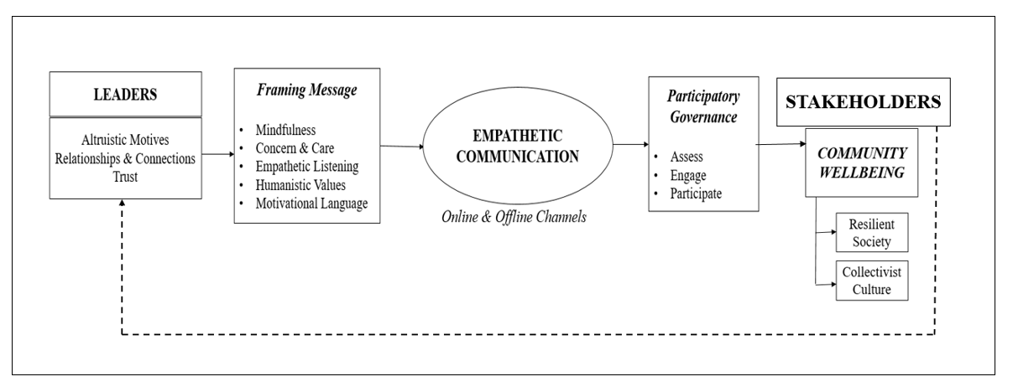

***Figure 2: Focus areas of the interview protocol***

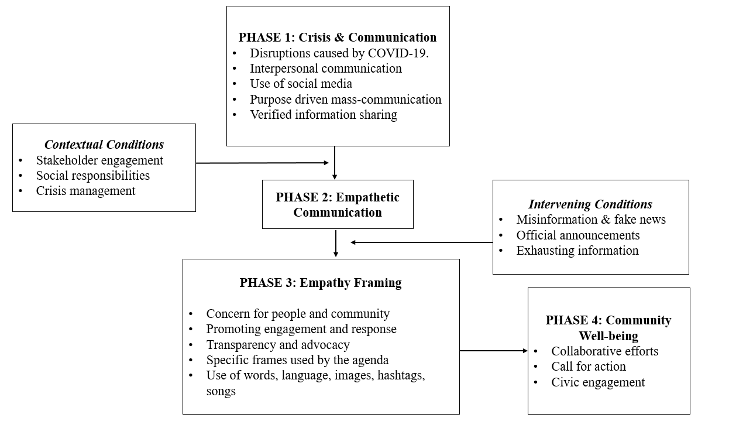

***Table 1: Coding Template for Identifying the Categories***

|  |  |  |  |
| --- | --- | --- | --- |
| ***Focus Areas*** | ***Elements*** | ***Keywords*** | ***Categories*** |
| Best communication practices adopted during the Pandemic to handle the crisis. | Exploring alternatives  Analyzing benefits  Evaluating challenges  Communicating the possibilities | Constant communication, empathy, mindfulness, relationships | Leaders’ vision, traits, and attitude played a key role in curating messages. |
| The organizational culture and relationships were equally important in the communication process. |
| Stakeholder engagement and management during the crisis. | Building upon the core values  Seeking suggestions  Promoting online communication  Creating other channels of communication | Using social media, breaking barriers of hierarchy, encouraging participation, creating an open culture, giving them time to heal, providing resources | Building on stakeholders’ experiences and enhancing engagement by involving them in planning and decision making. |
| An open mindset and creating a culture of belongingness based on mutual respect and trust. |
| Framing and agenda setting to deal with the crisis | Leading by example  Analyzing before communicating  Avoiding fake news  Optimizing all communication channels  Using positive language | Involving the people, using all channels to communicate, selected responsible words, images, hashtags | Leaders tend to encourage the stakeholders to empathize and understand the motive behind the message. |
| Mindfulness for leaders | Empathy and Compassion  Seeking solutions  Optimistic outlook  Empathetic listening | Handling the situation and balancing the emotions, ensuring optimistic approach, agility, mental peace, work for all and take right initiatives | Leadership during a crisis demands a blend of knowledge and critical thinking. |
| Mindfulness is a holistic approach optimal outcomes. |
| Community well-being as a collective responsibility. | Identifying issues  Framing a holistic plan of action  Strategizing for common good  Being humanist | Emotional, mental, spiritual, financial, digital well-being, co-learning, and co-building | Leaders and people should embrace the changes and work towards the benefit of society. It is a mutual aid for all. |

***Table 2 Coding Table***

|  |  |  |
| --- | --- | --- |
| **INITIAL THEMES** | **SUB-THEMES** | **MAIN THEMES** |
| 1.Relationship with stakeholders (n=45) | Connections and Networks | **Motivation for Empathetic Communication:**  *"We are all connected and interdependent one another. This makes us a family. In a family you respect others. Similarly during crisis we had to show a united front” (Participant 04).*  *“Communication is a two-way process only when you feel for someone or understand the situation well is when you are able to communicate well….I mean think of a message that needs to be communicated during such times, I will have to first keep the interest of others above my personal choices” (Participant, 28).* |
| 2. Previous networks (n=23) |
| 3. Understanding each other (n=20) |
| 4. Dependency (n=28) | Trust |
| 5. Guidance and directions (n=29) |
| 6. Transparency (n=55) |
| 7. Prosocial motives (n=39) | Self-less motives |
| 8. Selfless goals (n=46) |
| 9. Social and moral obligations (n=40) |
| 10. Positive message (n=53) | Positive Frame | **Empathetic Frames and Framing of Messages**  *"Empathy is an internal quality. However, to use it while communicating is only going to be effective… It can increase positivity and calm for another person" (Participant 15).*  *“As leaders, the representatives of our organization we were expected to be wise in our words and actions during the pandemic. I insisted that our teams should have sessions to listen to each other and feel for the challenges that we were facing. This helped us when we would communicate, as we became more open minded and conscious in the choice of our words or like you asked the language that we used to communicate” (Participant 19)* |
| 11. Encouragement (n=36) |
| 12. Giving hope (n=43) |
| 13. Verified messages (n=35) | Sense-making |
| 14. Clear message (n=43) |
| 15. Revisiting posts, stories (n=22) | Empathetic Listening |
| 16. Talking to people (n=57) |
| 17. Inspiring words (n=55) | Motivational Language |
| 18. Discussing possible solutions (n=23) |
| 19. Giving good examples (n=52) |
| 20. Online poles & webinars (n=46) | Sharing information and seeking opinion | **Participatory Governance**  *“We have always encouraged participation of stakeholder but during the pandemic it was difficult as people were dealing with a lot of issues both mentally and physically. So, we decided to organize small initiatives where their suggestions could be value and they feel better We spoke to the local authorities and it got some of our employees very excited to help in teaching school children. We believe it was our first step” (Participant, 06)*  *“Only when the people realize that we have a responsibility towards each other something can happen. We used communication for this and shared a lot of posts helping local labs with online education. It motivated some local residents who then donated their old laptops and books ” (Participant 10)* |
| 21. Collective decision making (n=45) |
| 22. Co-creative activities (n=23) |
| 23. Virtual events (n=16) | Collaborative initiatives |
| 24. Supporting good initiatives (n=17) |
| 25. Helping state-actors (n=25) |
| 26. Encouraging teamwork (n=25) | Voluntarism |
| 27. Sensitizing on the current situation (n=26) |
| 28. Moral grounds (n=43) |
| 29. Digital citizenship (n=34) |
| 30. Involvement of stakeholders (n=45) | Engagement |
| 31. Mutual benefits (n=38) |
| 32. Increasing online engagement (n=28) | Collective responsibility | **Empathetic Communication for Community wellbeing**  *“While we were sharing images of our employees who were relentlessly working from home, we did not realize the impact we were creating on others. We were hinting towards a future which will have professionals and trained individuals who are resilient” (Participant 03)*  *“Respecting each other as humans who are all same and taking our responsibilities seriously can help in building a strong future. We need to become more humanistic and polite” (Participant 12)* |
| 33. Helping others (n=36) |
| 34. Creating possible opportunities (n=47) |
| 35. Economic contributions (n=27) | Value building |
| 36. Encouraging online education (n=55) |
| 37. Spreading a positive message (n=28) |
| 38. Celebrating life (n=40) |
| 39. Valuing interdependencies (n=33) | Communication for change |
| 40. Self-reinforcement (n=39) |