# Appendix A. Statistic Summaries

## **Table A1. Manipulation check**

Kendall’s *tau*s for treatment groups

|  |  |  |  |
| --- | --- | --- | --- |
|  | Min | Max | Mean |
| US treatment | -0.14 | 1.00 | 0.74 |
| Singapore treatment | -0.05 | 1.00 | 0.78 |

## **Table A2. Demographic summaries**

|  |  |  |  |  |  |
| --- | --- | --- | --- | --- | --- |
|  | Control Group in Singapore Context | Treatment Group in Singapore Context | Control Group in US Context | Treatment Group in US Context | Total |
| *Race* |  |  |  |  |  |
| Asian/Pacific Islander | 14 (15%) | 20 (26%) | 21 (24%) | 10 (14%) | 65 (20%) |
| Black/African-American | 12 (13%) | 8 (10%) | 8 (9) | 5 (7%) | 33 (10%) |
| Hispanic/Latino/Latina | 8 (9%) | 8 (10%) | 11 (12%) | 12 (16%) | 39 (12%) |
| White/Caucasian | 56 (60%) | 37 (48%) | 41 (47%) | 39 (53%) | 173 (52%) |
| Other/Multiracial/Prefer not to respond | 3 (3%) | 4 (5%) | 7 (8%) | 7 (10%) | 21 (6%) |
| *Age* |  |  |  |  |  |
| 18~30 | 93 (100%) | 76 (99%) | 87 (99%) | 73 (100%) | 329 (100%) |
| *Gender* |  |  |  |  |  |
| Female | 72 (77%) | 48 (62%) | 63 (72%) | 49 (67%) | 232 (70%) |
| Male | 19 (20%) | 29 (38%) | 22 (25%) | 23 (32%) | 93 (28%) |
| Transgender/Other/Non-binary/Prefer not to respond | 2 (2%) | 0 (0%) | 3 (3%) | 1 (1%) | 6 (2%) |
| N | 93 | 77 | 88 | 73 | 331 |

# 

# Appendix B. Methodological Details About Statistical Analysis of Rank Order Data

The major methodological challenge in this study is to conduct statistical analysis on rank order data. Previous studies, especially among agenda-setting research, often just compare two lists of rank orders. Such a scenario can be simplified in the following form: descriptive analysis and inferential analysis on two lists of rank orders:

list 1 = {A, B, C, D, E, F, G, …} and list 2 = {C, E, A, F, M, O, …}.

In this study, the scenario is much more complicated: suppose there are two groups of participants: Group O and Group P. Each participant ranked *k* different terms which yielded two sets of rank order lists: Group O has *m* observations and each observation is a permutation of the rank with these *k* items; following the same logic, Group P has *n* observations with each being a permutation of the rank with these *k* items.

Group O

O1: permu\_o1 - {D,E,A,B,F,G,C}

O2: permu\_o2 - {......}

O3: permu\_o3 - {......}

O4: permu\_o4 - {......}

…

Om: permu\_om - {......}

Group P

P1: permu\_p1 - {A,D,C,B,F,E,G}

P2: permu\_p2 - {......}

P3: permu\_p3 - {......}

P4: permu\_p4 - {......}

…

Pn: permu\_pn - {......}

Figure B1. The scenario of rank order list

The analysis process goes as follows:

1. We treat each response, which is a rank order list, as a single point in a high-dimension space. There will be *k!* possible outcomes, where *k* denotes the rank term, therefore we know our sample pool has a size of *k!*.
2. The sample pool is of finite size and discrete in form. Each rank set (each point) should have the same possibility of being selected during random selection.
3. In this study, we chose Kendall’s *tau* to calculate the similarity between two rank order lists. Kendall’s *tau* is defined as:

*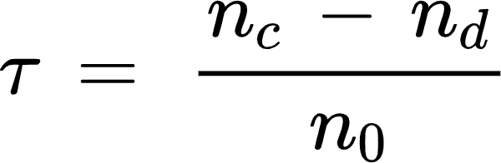*

*{"backgroundColorModified":null,"backgroundColor":"#ffffff","id":"3","aid":null,"font":{"family":"Times New Roman","color":"#000000","size":12},"code":"\\begin{align*}\n{n_{c}\\,}&={\\,\\text{number}\\;\\text{of}\\;\\text{concordant}\\;\\text{pairs;}\\;n_{d}\\,=\\,\\text{number}\\;\\text{of}\\;\\text{disconcordant}\\;\\text{pairs}}\t\n\\end{align*}","type":"align*","ts":1641589046035,"cs":"C+wh/C+2zUyK/zVHuB4TUw==","size":{"width":498,"height":14}}*

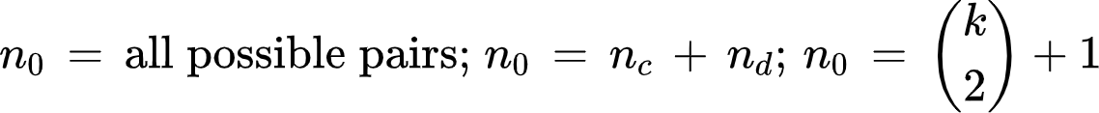

Therefore, there are in total {"code":"$$n_{0}$$","id":"6","type":"$$","aid":null,"backgroundColorModified":null,"backgroundColor":"#ffffff","font":{"color":"#000000","family":"Times New Roman","size":12},"ts":1641589283244,"cs":"riG3MrX6PlwUwNisN1tHYQ==","size":{"width":13,"height":8}} possible *tau* values. Moreover, we could derive the probability mass function (PMF) for all possible *tau* values if the rank set comes from a randomly generated process. For any given *k*, it essentially follows a discrete distribution with *k(k-1)/2+1* possible values. With the help of computer-assisted randomization, we computed the exact PMF when *k* = 7 shown in Figure 1.

The procedure for producing it is as follows:

1. First, generate the full list of all possible permutations of {A, B, C, D, E, F, G} which totals 5040 (that is 7!). For any given permutation, calculate Kendall’s *tau* between this specific permutation set (target set) and all other 5040 permutations. Essentially, it does not matter which specific permutation set we use as the target set. The final results are the same. We can obtain 5040 taus and therefore generate a frequency table with 22 unique tau values (7\*(7-1)/2 + 1) and their corresponding frequencies.
2. Then, the probability distribution can be observed.

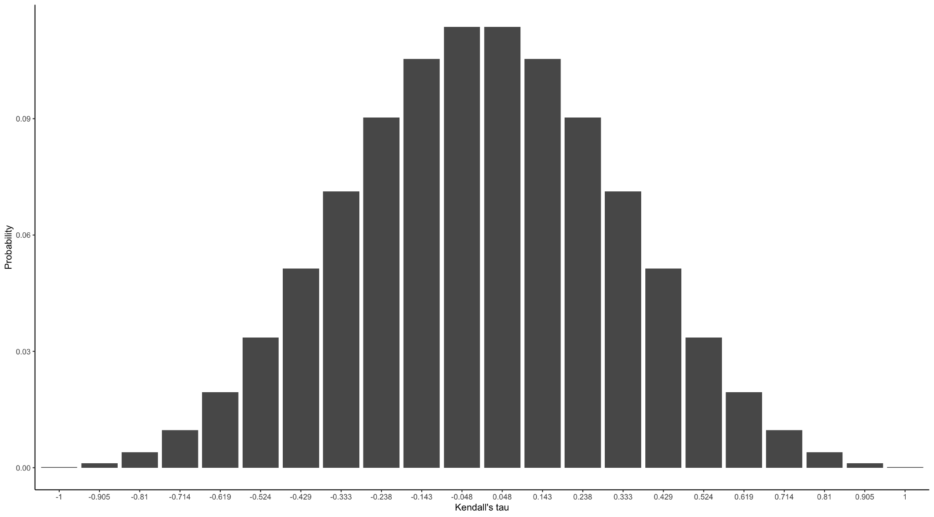

Fig 1. Probability Distribution of Kendall’s Tau When *k* = 7

Although we are aware that the choice of the specific target permutation set does not influence the distribution of Kendall’s *tau*, it is still essential for researchers to choose a permutation set to compute Kendall’s *tau*. The target permutation set acts as a baseline to compare with. Therefore, when doing hypothesis testing, researchers should have theoretical foundations to support the choice of the target permutation set, i.e., a hypothesis should be set up before the collection of data to serve as the basis for analyzing rank-order data. In this study, the target permutation set is very clear—the actual ranking of the Twitter Trends.

Kendall’s *tau* has the range of 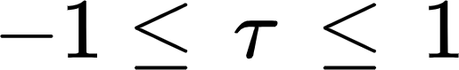. The distribution of Kendall’s *tau* is a discrete function and can be approximated using a normal distribution with mean 0 and standard deviation 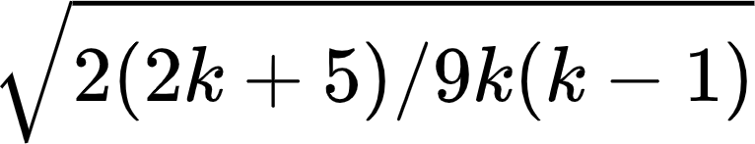 where *k* is the number of items in the rank. Table 2 shows the mean and *SD* of Kendall’s *tau* in each group.

Furthermore, in order to see if the treatment works, we also need to make comparisons between the treatment group and the control group. Since we already know the distribution of Kendall’s tau is an approximation of normal distribution, we can use the T-test to see if there is a significant difference between the treatment and control groups. Therefore the right-tailed T-test results are also provided to see whether, in the treatment group, the rank similarity between self-reported issue salience rank and the true rank in Twitter Trends is significantly higher than that in the control group.

# Appendix C. Stimulus

Source of Twitter Trends in the US context:

* #SOTU: <https://getdaytrends.com/united-states/trend/%23SOTU/>
* #UkraineRussiaWar: <https://getdaytrends.com/united-states/trend/%23UkraineRussiaWar/>
* #HAECHAN\_GoodPerson: <https://getdaytrends.com/united-states/trend/%23HAECHAN_GoodPerson/>
* #UFC272: <https://getdaytrends.com/united-states/trend/%23UFC272/>
* #shanewarne: <https://getdaytrends.com/united-states/trend/%23shanewarne/>
* #TheBatman: <https://getdaytrends.com/united-states/trend/%23TheBatman/>
* #TruckersConvoy2022: <https://getdaytrends.com/united-states/trend/%23TruckersConvoy2022/>

Source of Twitter Trends in Singapore context:

* #UkraineRussiaWar: <https://getdaytrends.com/singapore/trend/%23UkraineRussiaWar/>
* #SOTU: https://getdaytrends.com/singapore/trend/%23SOTU/
* #HAECHAN\_GoodPerson: https://getdaytrends.com/singapore/trend/%23HAECHAN\_GoodPerson/
* #UFC272: https://getdaytrends.com/singapore/trend/%23UFC272/
* #TheBatman: https://getdaytrends.com/singapore/trend/%23TheBatman/
* Leni: https://getdaytrends.com/singapore/trend/Leni/
* #shanewarne: https://getdaytrends.com/singapore/trend/%23shanewarne/