Were online media biased? An assessment of statement and actor bias during the 2015 referendum in Greece

**Abstract**

Referendum campaigns are highly mediated events likely to influence voters’ propensity to opt for ‘Yes’ or ‘No’. Media bias commonly refers to coverage that deviates from the norms of balance, fairness and impartiality. Despite its widespread use, the notion of bias is quite complex carrying multiple meanings and measurements. We define overall bias as the advocacy of ‘Yes’ and ‘No’ vote choices as expressed through statement and actor bias. Drawing on a quantitative analysis of the 2015 bailout referendum in Greece, we show that although overall online coverage was not biased, the type of media had significant effect on the presence of bias. Legacy media favored the ‘Yes’ vote choice, alternative media skewed toward the ‘No’ vote choice while web natives and the public broadcaster kept a balanced approach. Probing further we find that alternative media produced biased content mainly through statement bias, while legacy media’s pro-yes tilt was predominantly performed through actor bias.

**Keywords:** media bias; referendum campaign; statement bias; actor bias; objectivity; sources; Greek bailout referendum

# Introduction

Referendums are important means of enacting or preventing legislation; their use is consistently advocated against citizen disengagement and cynicism toward political processes. The outcome of a referendum depends largely on the campaign often being “decisive for defining the issue and crystallising public opinion” (de Vreese and Semetko, 2004a: x). The quality of media debate during a referendum campaign is critical for providing citizens with sufficient and balanced information to make enlightened voting choices (Renwick and Lamb, 2013). Although research on news bias is ample, it remains a complex concept regarding its meaning, measurement and impact (Lichter, 2017), while its real-life manifestation is understated in relevant scholarship (Zelizer, Park and Gudelunas, 2002). Bias is commonly understood through its opposite(s), namely impartiality, balance or fairness. The norm of impartiality is closely connected to the norm of objectivity, a core value of Western journalism (Schudson, 2001). Although massively invoked by professionals to certify the ‘truthiness’ of journalistic information (McNair, 2017), the objectivity norm has been heavily criticized as unattainable, or as a strategic ritual that produces bias itself (Tuchman, 1972). In general terms, an unbiased news report is a neutral or balanced report, thus one that is not strongly slanted in favor of or against any political side (Eberl, Boomgaarden and Wagner, 2017).

Prior research on media bias has predominantly focused on traditional media; however, the rise of diverse types of digital media has resulted in a complicated media ecology encompassing ‘newer’ and ‘older’ media logics (Chadwick, 2013). These emergent media types contest the power of legacy outlets (Vargo and Guo, 2017) while alternative media are increasingly taking up space in the media landscape (Baluff et al., 2022). This article sets out to explore online coverage of the Greek 2015 bailout referendum. Media coverage provoked a public outcry for biased reporting on traditional media (especially TV) (Nikolaidis, 2015). Thus, evidence to support or disprove such claims is important for assessing the role of the media during a decisive referendum for the country. Looking for bias in different types of online media and drawing upon the concept of partisan bias operationalized as statement bias (D’Alessio and Allen, 2000) and actor bias (Eberl, Boomgaarden and Wagner, 2017), we argue that overall online coverage did not exhibit significant levels of bias. When controlling however for the media type, we found that legacy media favored the ‘Yes’ vote choice as opposed to alternative media where coverage slanted toward the ‘No’ vote choice, while web natives kept the most balanced approach.

# What is bias? Definitions and typologies

Despite the prevalent position of media bias in public discourse, and as a concept to analyze media power, its theoretical and empirical treatment, is not clear-cut in the literature (Cline, 2009; Lichter, 2017; Marquis, Schaub and Gerber, 2011). Indeed, multiple and sometimes overlapping definitions and typologies render its study challenging. Most attempts to define bias in a news report mention favoritism, one-sidedness or unfairness when presenting events and political debates (McQuail, 2010; Boudana, 2016). Entman (2007) provides a comprehensive account of media bias considering three types: *distortion bias*, referring to news that purportedly distorts or falsifies reality; however, he argues that this type of bias is hard to assess given the “irresolvable questions about truth and reality” (p. 166); *content bias*, namely news that favors one side in a political conflict, and *decision-making bias*, which considers the motivations and mindsets of journalists who produce the biased content (p. 163). Critical theorists also speak of media bias (often in terms of media hegemony) and attempt to explain it by emphasizing ownership and commercial interests that shape professional news production toward skewed patterns of news reporting (McChesney, 2008).

In the case of election coverage, Stevenson and Greene (1980) define bias as “the systematic differential treatment of one candidate, one party, one side of an issue over an extended period of time” (p. 116). Other studies (Lindalh, 1983; Sheafer, 2005) posit similar views emphasizing balanced coverage as the extent of coverage dedicated to vote choices and the stance of news coverage toward them. Pilon (2009) assesses media performance drawing on concepts from the Habermasian ‘ideal speech situation’, namely inclusion and balance, as well as validity claims. Drawing on the complicated notion of truth Porpola and Sekalala (2019) argue that fairness remains a core starting point but emphasize deliberation rooted in contextualisation and the provision of arguments and counter-arguments as important mechanisms to make it more efficacious. Moving a step further, Marquis, Schaub and Gerber (2011) mention seven criteria to appraise the fairness of media campaign coverage: intensity (sufficient information); duration (sufficient time for deliberation); unbiased coverage (balance or issue neutrality); autonomy (independence from official sources); source inclusiveness (diversity of viewpoints, arguments, and actors), substantive coverage (issue framing vs. horserace framing); and spatial homogeneity (between-region variations) (pp. 131-134). Regardless of the prism used to examine it, bias is considered harmful to democracy as it deprives audiences the opportunity to make rational and informed decisions (Gil de Zúñiga, 2015).

**Partisan and structural bias**

Two types of bias loom large in the literature: partisan bias and structural bias (Schiffer, 2006). Partisan bias (or ideological bias) is understood as the conscious or unconscious tilt of coverage due to journalists’ personal attitudes and political opinions (Lichter, 2017; Schiffer, 2006) associated with partisanship, advocacy and ideological standpoints (McQuail, 2010). It occurs when news outlets systematically give more favorable attention to one political party or block another (van Dalen, 2012). Similarly, Entman (2010) defines content bias as “consistently slanted framing […] that promotes the success of a specific interest, party or ideology” (p. 393). Partisan bias is discussed in terms of liberal or conservative bias and has produced heated debates, especially in the US (Niven, 2002). A large part of the literature argues that regardless of its left- or right-leaning tilt, partisan media bias has generally not been substantiated by empirical findings (see D’Alessio and Allen, 2000; Gulati, Just and Crigler, 2004; Lichter, 2017; Strömbäck and Shehata, 2007). Others, however, argue for an ideological ordering of media outlets (Niven, 1999; Budak, Goel and Rao, 2016). Yet, partisan bias tends to not be explicit; often, news organisations indulge in biased reporting through issue diversion and by disproportionately criticising one side (Budak et al, 2016; Tandoc, Takahashi and Thomas, 2018; Lee et al, 2022).

Structural bias approaches news as a form of discourse and focuses on its inherent qualities. If partisan bias reflects ideological judgments, “structural bias reflects the circumstances of news production” (Graber and Dunaway, 2018: 411). According to McQuail (2010) structural bias constitutes an unintended deviation from a balanced representation set off by journalistic routines, norms and news values deeply embedded in the operation of journalism (e.g. economic environment, organizational processes, regulation, relations with the government, newsroom cultures). Cline (2009, pp. 483-484) lists ten types of structural media biases: *commercial*, *temporal,* *visual*, *bad* *news, narrative, status quo, fairness, expediency, glory* and *class* bias. If we look closely at these types, we can discern patterns that connect them to each other as well as causal relations. For instance, *commercial bias* is often the root cause of other structural biases such as *negativity bias* (Hermans and Drok, 2018) or *narrative bias* emphasising controversy and drama (Bennett, 2016). Page and Shapiro (1992) refer to other biases stemming from the commercial nature of the media: a *pro-capitalist*, *anti-communist*, *minimal government* and *nationalistic* bias. The *status quo bias* is also fundamental referring to media representations that ‘the system works’ and explains the media’s reluctance “to question the structure of the political system” (Cline, 2009: 484).

Following a meta-analysis of quantitative studies on media bias, D’Alessio and Allen (2000) suggest three types of media bias: *gatekeeping bias* referring to the specific selection of stories; *coverage bias* measuring the physical amount of coverage each side of an issue receives, and *statement bias* when journalists interject an opinion into the text. Statement bias theorized as structural bias can be empirically assessed in terms of favorable/unfavorable coverage or positive/negative or neutral/balanced in case it contains equally biased statements or no biased statements at all (pp. 136-137). Studies exploring election news coverage in different European countries found that beyond media system (Strömback and Luengo, 2008), media type is an antecedent of structural bias in political news coverage (Dimitrova and Kostadinova, 2013; Strömback and van Aelst, 2010). Analyzing the two types, Strömbäck and Shehata (2007) note adifference of intentions between partisan and structural bias.

Although the current work does not touch upon media bias effects, it is important to briefly outline the differential impact on audiences, emphasizing features of the media texts rather than those of voters. Generally, media effects on voter perceptions are supported (e.g. DellaVigna & Kaplan, 2007; Lott & Hassett, 2010). Having studied US newspapers endorsements of candidates, Chiang and Knight (2011) confirmed their influence on voters, but found that they were more influential when deriving from neutral media or media with an ideological tilt from the opposite ‘camp’. Eberl and colleagues (2017) concluded that tonality or statement bias and agenda bias influenced voters but visibility or coverage bias had no clear impact in the Austrian context. Focusing on voter perceptions of candidates’ traits Eberl, Wagner and Boomgaarden (2017) found the same effects regarding tonality/statement and agenda bias; visibility bias had no direct impact but it moderated the effects of tonality/statement bias. These findings are partly contradicted by an earlier study in the Danish context: Hopmann et al. (2010) found that, while the cumulative information environment (television coverage) had an influence on party choice, in the case of direct individual exposure, visibility was influential but not the tone of coverage.

# Covering referendums: Issues and problems

The media have always occupied a central position in strategic political communication as the main source of information for the public (Hopmann et al, 2010), and as the terrain where the struggle over the meaning of the referendum takes place (Hänggli and Kriesi, 2010). The increasing sophistication of campaign techniques (DeKavalla, 2016) can influence the final outcome by fostering changes in public opinion, political participation and voters’ choice to say ‘Yes’ or ‘No’ (de Vreese and Semetko, 2004a). In referendums held under conditions of information complexity and conflicting opinions among elites, the struggle over meaning making in the media becomes particularly important (de Vreese, 2007). Evidence shows that exposure to media stories advocating a vote choice or emphazising a particular frame of an issue has a strong impact on audiences’ perceptions regarding issues and vote choices (de Vreese and Semetko, 2004a; Wettstein, 2011).

Scholars have documented problematic aspects of news making during political campaigns. D’Alessio and Allen (2000) concluded a limited but consistent pro-Democratic statement bias in television news. Exploring the deliberative quality of the media in the case of the Ontario referendum debate, Pilon (2009) found that print media failed to provide a balanced coverage of competing views. Using seven criteria to judge how news coverage compares to idealized notions of the media’s role in the democratic process, Marquis et al. (2011) claim an overall fair coverage by the Swiss press; however they note evidence of reasonable bias as media coverage appears to largely reflect the issue agenda of the major political forces involved in the campaigns. Analyzing print media coverage during the UK’s 2011 electoral reform referendum, Renwick and Lamb (2013) found that newspaper coverage was biased as most newspapers showed a strong leaning in one direction or the other. In the case of the Brexit referendum, Levy, Aslan and Bironzo (2016) advocate a heavily skewed reporting in favor of Brexit: 41% of the articles were pro-Leave against 27% that were pro-Remain.

# The 2015 bailout referendum: Context and Greek media traits

After protracted and heated negotiations with the Troika failed, the Greek coalition government led by SYRIZA announced the July 5th referendum. During its time in office, it attempted to reach an agreement based on less austerity. Yet, the standoff between the Greek authorities and the country’s lenders led to the controversial decision of holding a referendum to accept or reject the latest proposal by the EU/IMF. The referendum was announced by Prime Minister Alexis Tsipras on June 27 without prior notice to the Eurogroup.

The referendum framed as a ‘Yes’ or ‘No’ question asked the Greek people whether they approve or reject the latest take-it-or-leave-it proposal for another financial rescue package. The referendum triggered a polarizing debate regarding the reasons why it was called and its potential consequences. Following a typology of European referendums (Author, 2014), the Greek bailout referendum fits better the logic of ‘partisan calculus’. The ultra-short campaign (nine days) took place with banks closed, capital controls imposed and the entire EU against the government (The Guardian, 2015). Foreign intervention in the referendum campaign was unusually high and the likely consequences of a noncooperative referendum outcome were a hotly debated issue during the campaign (Walter et al, 2018). The parties of the coalition government, SYRIZA (left-wing) and ANEL (right-wing), along with Golden Dawn (the extreme right-wing party) urged its supporters to vote ‘No’. They argued that a rejection of the agreement would enhance Greece’s bargaining and emphasized that membership in the eurozone was not at risk because Europeans would not want to damage the monetary union.

The opposition parties of *New Democracy* (right-wing), *PASOK* (Panhellenic Socialist Party), *To Potami*, a newly formed center-left party, and *KIDISO* led by ex-prime minister George Papandreou, sided with the ‘Yes’ camp which warned that a vote against the bailout proposal would inevitably result in Greece’s exit from the eurozone (Walter et al, 2018). The Communist party rejected the referendum altogether. Amidst an environment of impending state default, the electorate resoundingly rejected the proposed agreement: with an estimated turnout of 62.5%, 61.3% voted ‘No’, while 38.7% voted ‘Yes’. Despite the result of the referendum, the SYRIZA government succumbed to pressure and made a U-turn; approximately one month later it signed a third bailout deal (Tsatsanis and Teperoglou, 2016).

The campaign provoked numerous complaints as major private TV channels ran continuous broadcasts and hosted experts advising viewers to vote ‘Yes’ (Patrikarakos, 2015). It has been argued that during the crisis, legacy media promoted a pro-austerity agenda by supporting the bailout agreements and overly criticizing or silencing dissenting voices (Author, 2016). Major private outlets (TV stations and newspapers) hold ties with political and economic elites and tend to report with partisan bias (Freedom of the Press, Greece, 2015). The public broadcaster (ERT) stands out as a strong case of “a ‘state’ rather than ‘public’ broadcaster” (Iosifidis and Papathanassopoulos, 2019: 129). A weak organizational culture and low accountability levels (Author, 2016) have been long-standing traits of professional journalism in Greece. Mainstream media have been in serious trouble since 2010 as the crisis resulted in a dramatic loss of advertising revenue and other subsidies (Siapera, Papadopoulou and Archontakis, 2015). Lay-offs have boomed, while flexible labour and insecurity is on the rise (Author, 2013). Trust levels for traditional media have dropped significantly (Eurobarometer, 2016), while online ventures attempting to provide counter information have proliferated (Siapera, et al, 2015). Not surprisingly, Greek users tend to prefer or even trust pure digital outlets more than the traditional mainstream media (Newman et al, 2022).

# Data and methods

In today’s high-choice media environment legacy media no longer enjoy the monopoly of publicity (Faris et al., 2017) as citizens receive their political information from a diverse set of sources. Chadwick (2013) speaks of a hybrid media system, in which legacy and new digital media compete and cooperate allowing new hubs to emerge and yield considerable influence. In Greece, 55 percent of users get news from social networks, while 44 percent choose to visit the website or the application of a news outlet (Reuters Institute, 2016). Thus, to monitor the media coverage, it is important to pay attention to online news, rather than merely look at traditional legacy media.

The data for this study consists of online news articles referring to the referendum and published in eleven outlets during the nine-day campaign (June 27- July 5, 2015). To have a comprehensive account of the online news landscape, we used the criteria of platform, temporality, topic, scope, ownership and approach (Salaverría, 2017). Regarding temporality, all websites are continuously updated, they are general news outlets (topic), and their scope is national. Additionally, with the exception of the public broadcaster, the outlets were chosen on the basis of popularity in their category. Our sample represents four distinct media types: The first type represents the legacy media referring to media organizations that were born offline, they are privately owned and profit-oriented, and in the case of Greece are said to have been affiliated with political and economic interests (Iosifidis and Papathanassopoulos, 2019). The four legacy media selected are: *To Vima* and *Kathimerini*, which are long-established, elite-oriented print and online newspapers, and *Proto Thema* and *Eleftheros Typos* which represent the mainstream tabloid newspapers. The second type includes the public broadcaster which is represented by *ert.gr.* The public broadcaster has traditionally been in close agreement with the government’s stance. Even the ‘new ERT’, re-launched in 2015 by the left-wing Syriza government after a two-year closure, has been criticised for government interference (Iosifidis and Papathanassopoulos, 2019).

The third type refers to web natives which have no offline counterpart. Native online media are believed to publish more cutting-edge content (García-Perdomo et al, 2018). In their effort to distinguish themselves from legacy media, and although more traffic-oriented, web natives try to “include various editorial layers” (Miel and Faris, 2008: 27). This category includes: *Huffington Post Greece,* the local edition of the international news organization; *in.gr*, a well-established mainstream news portal; and *Newsit*, a tabloid news website. Lastly, the fourth type represents media outlets that fall into the category of alternative media. Although ‘alternativeness’ is hard to define, for the purposes of the present study alternative was defined in terms of the media’s approach (offering critical, counter-hegemonic content), ownership (independent of major news corporations) and funding (self-managed and collectively-organized by journalists) (see Harlow and Salaverría, 2016 for the relevant typology of alternativeness). This category includes three outlets: *TVXS*, *The Press Project* and *EFSYN*.

Data collection proved a laborious process involving repeated visits to the media websites several times a day. The total dataset amounted to 6,588 news articles (Appendix, Tables 1 and 2). A subset of 80 news articles per outlet, equally distributed to the nine days of the campaign was selected using random stratified sampling. The exception was *The Press Project*, which published in total 59 articles in the selected period. The final sample comprised of 912 news articles (14% of the population), distributed equally to each day (Appendix, Table 3). After numerous training sessions the sample was coded by eight coders working in pairs and according to a detailed coding scheme. Each pair coded part of the sample independently. The overall intercoder reliability score was satisfactory (Krippendorff Alpha=0.8397). Their disagreements were then resolved by a third coder.

The study explores the presence of partisan bias operationalized as statement bias. Statement bias refers to the favorability or non-favorability of media coverage on a specific issue (D’Alessio and Allen, 2000: 137). The notion of overall bias in the present study is understood as the advocacy of either the ‘Yes’ or the ‘No’ vote choices in the referendum. More precisely, partisan bias is investigated at the level of journalists/editors thrust toward vote choices as manifested in the news articles, and also at the level of actors’ issue statements regarding the referendum vote choices. Therefore, partisan bias is broken down into two subtypes: a) statement bias and b) actor bias. *Statement bias* is understood in terms of a directed advocacy in the overall message of an article toward the ‘Yes’ or the ‘No’ vote. It is measured both at the level of individual articles as well as at the aggregate level. To measure statement bias, news articles were coded according to whether they supported a vote choice *openly* (when the editor’s opinion is clearly discernible by open advocacy, by presenting a vote choice in an overly positive manner or by disparaging a vote choice etc.); *indirectly or covertly* (e.g. more space devoted to one camp, more prominence in the title, lead or/and photo accompanying the article, negative evaluations of actors supporting a vote choice); *balanced* (e.g. even-handed presentation of the two camps’ positions, neutral coverage of actors); or as pure *factual reporting* (for a similar operationalisation of balance see Marquis et al, 2011: 132). Subsequently, these articles were attributed with a value depending on a manifested tendency to support the ‘No’ vote, the ‘Yes’ vote while a news article that did not take any position or employed balanced coverage was coded as *taking no position*.

At the aggregate level and considering the four media types and their traits, we tested the null hypothesis:

*H1 At the aggregate level, there will be no substantial[1] statement bias*

The second subtype of partisan bias, namely *actor bias*, is understood as the ‘voices’ (sources) used for reporting on the referendum’s vote choices (i.e. whose issue statements regarding vote choices are used by the media) (Cline, 2009; Eberl, Boomgaarden and Wagner, 2017). Source selection is a key component of the final news product (Hall et al, 1978). Who gets to speak in the media and who is excluded determines not merely the information offered but also meaning-making. Sources have an agenda-setting function and can introduce their own frames into media coverage (Lecheler and Kruikemeier, 2016). Evidence suggests that quotations affect readers’ judgement on news balance; “these quotations work more directly than other structural elements of a news report in creating perceptions of bias in readers who disagree with them” (D’Alessio, 2003: 291).

To operationalize *actor bias*, we identified the actors used in the articles and their positions regarding the vote choices (expressed as issue statements and quoted directly or indirectly). The unit of analysis in this case is actor presence and his/her position towards the referendum in each individual article as well as at the aggregate level. The editor or journalist was not registered as source/actor. The coding scheme consisted of four categories: a) dominance of actors who backed the ‘Yes’ vote, b) dominance of actors who backed the ‘No’ vote, c) balanced presence of actors’ advocating for the vote’s choices (no position), and d) no use of actors (no actors). Hence, the null hypothesis regarding the actors was formed as follows:

*H2 At the aggregate level, there will be no substantial actor bias.*

Testing the hypotheses regarding both statement and actor bias permits a more comprehensive account of how the Greek online media covered the referendum vote choices as both subtypes of bias unfold different sides of coverage. Statement bias assesses the overall message of an article while actor bias allows us to register all voices in favour or against the vote choices. So, while statement bias measures the overall deviation of a news report from a balanced or neutral benchmark, actor bias allows us to delve further into the narrative techniques employed by journalists.

## Control variables

In our analysis we test for the effect of media type on both statement and actor bias, and thus formulated the following hypotheses:

*H3 At the level of individual articles, legacy media will be biased in favor of the ‘Yes’ vote choice, while alternative media and the public broadcaster will be biased in favor of the ‘No’ vote choice.*

*H4 At the level of individual articles, actors supporting the ‘Yes’ vote choice will be used as sources more frequently in legacy media than in alternative media and the public broadcaster, while in alternative media and the public broadcaster actors supporting the ‘No’ vote choice will be used as sources more frequently.*

Given that web natives are rather recent in the Greek media landscape, and due to the lack of previous studies as well as the variation of media outlets included in this category, instead of formulating a hypothesis, we attempt to explore the position that prevailed (if any) and the use of actors advocating for a vote choice.

The second control variable refers to the time of the campaign. Previous research illustrated that closer to the end of the campaign, media information matters most in affecting how citizens will vote (de Vreese and Semetko 2004b). That said and given the short and polarised campaign of the Greek referendum, it is relevant to expect the presence of either statement or actor bias towards the climax of the campaign. In line with this argument the following hypothesis was formulated.

*H5* *At the level of individual articles, statement and/or actor bias are expected to be more frequent during the last days of the referendum campaign*.

# Results

# *Statement bias*

The descriptive statistics (Table 1) show that at the aggregate level the majority of articles takes no position. Only one-quarter of the sample actually takes a position toward the ‘Yes’ or the ‘No’ vote choice. This result confirms the first hypothesis (H1), that no substantial bias exists in the overall online coverage of the referendum. A second step in this exploratory part of the analysis was to run some cross-tabulations to see how these numbers break down at the level of media type. In observing the results in Table 1, the most telling aspect appears in the first column. Across all media types the overwhelming majority of articles express no position. This is starkly so in the public broadcasting category where 96.4% of the articles did not support any vote choice. Indeed, the public broadcaster seems neutral in terms of statement bias.

**Table 1**. Statement bias (%) by media type. In parenthesis the actual number (n) of articles.

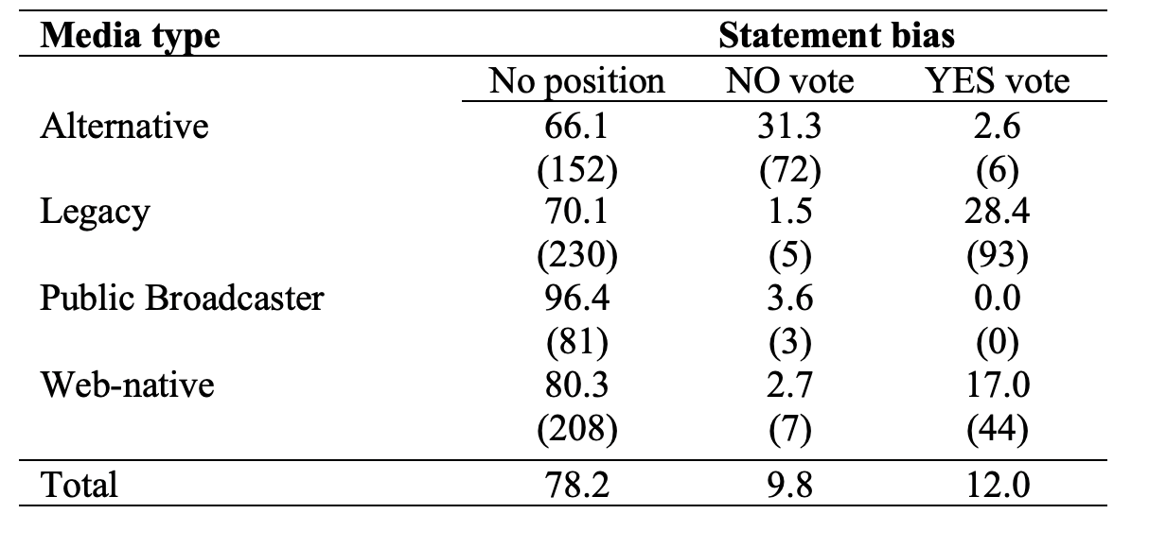

In the remaining articles in which statement bias is detected, a clear pattern emerges: identified bias exclusively takes either a ‘Yes’ or ‘No’ position, indicating lack of internal media pluralism. For further probing we removed the public broadcaster category given the extremely small number of articles that contain a ‘No’ statement bias and the absence of a ‘Yes’ bias[2]. Table 2 presents the chi square test residuals. Not surprisingly, given the cross-tabulations presented above, there is a significant association χ² (4, N= 817) =192.8, p<0.0001) between the media categories. More specifically, the standardised residuals direct us to the most significant interactions among the categories. As a general rule, residuals above 2 or below -2 point to significant deviations in the expected count. Table 2 clearly shows that the ‘Yes’/’No’ bias positions are driving this result (no significant deviations for the ‘no position’ count). Indeed, there are some particularly large residuals for the alternative media and the legacy media categories.

**Table 2.** Standardised residuals for statement bias per media type (except for the public broadcaster). The second set of columns presents only the articles that contain a No/Yes vote position

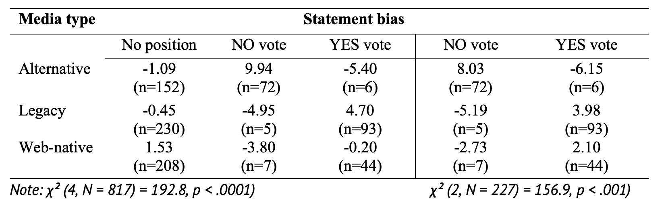

The same test is run on the smaller subset of articles from each media type where a biased statement position either toward the ‘Yes’ or the ‘No’ choice is contained. The cross-tabulation for this subset of articles (N=227) is also provided in Table 2, in the second set of columns. The chi-square test reveals a high association, χ² (2, N=227) =156.9, p<0.001). Again, the residuals show where the difference is largest among the media categories, in this case the alternative media category and to a lesser extent the legacy media.

Although the chi square tests provide a view of the degree of statement bias contained in the individual articles across media types, we also run logistic regression models to test the variable relationships while controlling for other factors. One putative variable that could have an impact is the time dimension: three media types (legacy, alternative and web-natives) would be more likely to exhibit increased statement bias during the climax of the campaign when polarisation was more prevalent (H5). To test the latter as well as H3, a multinomial regression was run. The dependent variable, namely statement bias, has three categories: ‘no position’, ‘Yes’ bias and ‘No’ bias. In this case, it makes sense to use the ‘no position’ as the reference category. Similarly, in terms of the key explanatory variable (media type), using ‘web natives’ as the reference category is appropriate since it was the least biased among the three media types. Table 3 presents the multinomial regression results, which reveal what was already evident in the cross-tabulations. Using web natives as the reference category, the largest difference is found in alternative media (i.e. it has the largest logit coefficients). Expressed in terms of the more intuitive odds ratio, we find that alternative media is approximately 14 times more likely to exhibit a ‘No’ vote bias than web natives and 5.4 times less likely to exhibit a ‘Yes’ vote bias. The difference between web natives and legacy media is less pronounced. Nonetheless, legacy media is about twice as likely to produce a ‘Yes’ statement bias compared to web natives.

**Table** **3.** Multinomial regression on statement bias

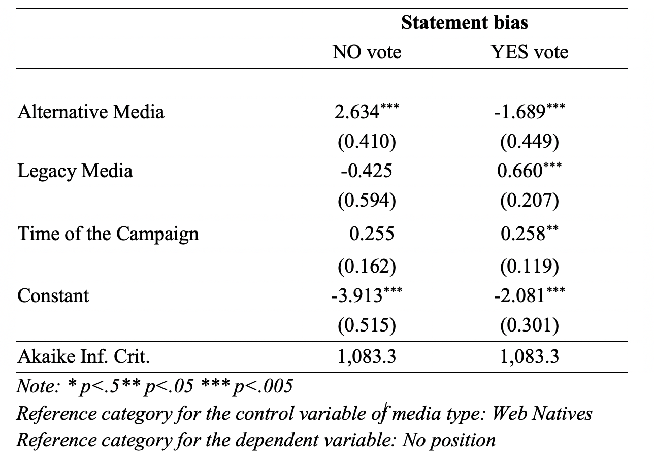

Controlling for the time dimension we find that there was a temporal impact, albeit a rather weak one. Bias towards the ‘Yes’ vote was more likely to appear in media coverage towards the end of the campaign. In sum, legacy media were likely to back the ‘Yes’ vote in contrast to alternative media that were more likely to exhibit a bias toward the ‘No’ vote. This outcome lends partial support to hypothesis H3 since the public broadcaster was found essentially neutral, in contrast to what H3 assumed. Finally, concerning web natives, the analysis shows that these media were less likely to adopt a favorable position towards either vote choice.

# *Actor bias*

The second step in the analysis concerns *actor bias*, namely the use of actors and their position towards the referendum vote. Descriptive statistics (Table 4) show that approximately half of the sample quotes (directly or indirectly) actors, whereas the other half (49.06%) does not. The latter is shown in the first two columns of Table 4. More specifically, the first column (‘no position’) presents the number of articles that used actors yet in a balanced manner (no specific position dominated). The subtraction of the two camps is 0, which is noted as no dominant position. The second column (‘no actors’) shows the number of articles that did not use any sources/actors at all. Based on this result the respective hypothesis (H2) is confirmed; the sample is not skewed regarding the use of actors and their expressed position. Additionally, Table 4 shows the distribution of articles across media types. The marginal proportions are displayed column-wise for the media types. Clearly, in all four media types, the ‘no actors’ category accounts for the majority of articles, yet in the case of the alternative media, this finding is marginal. The basic finding that emerges from Table 4 is that a high proportion of the sample (ranging from 45.2 percent for alternative media to 57.5 percent for the web natives) do not exhibit actor bias; the use of actors is either balanced or they do not quote actors.

**Table 4.** Actor bias in percentage by media type. In parenthesis the actual number (n) of articles in each category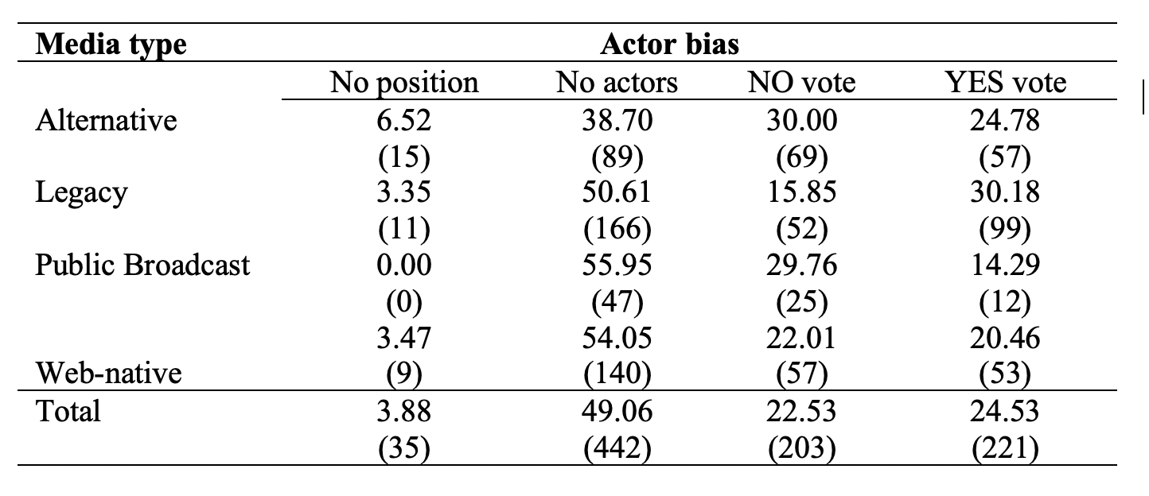

That said, we can direct our attention to those articles that do exhibit a form of actor bias. Unlike statement bias, there is greater balance in the use of actors backing either the ‘Yes’ or the ‘No’ vote choice. At this point we can take a look at the chi square test in Table 5. As we observe, there are significant dependencies between the categories, χ² (3, N=424) =19.7, p<0.001). Again, the residuals reveal where the difference is largest among the categories. To visualize this finding, we plot these Pearson residuals in a mosaic plot (Figure 1). The plot reveals that one media type is driving the result. While most media types are within the observed/expected range (shaded in grey), the legacy media departs from the expected distribution; legacy media tend to source significantly less ‘No vote’ actors (red shading) and significantly more ‘Yes vote’ actors than expected (blue shading).

**Table 5.** Standardized residuals for actor bias. Αrticles that do not use actors as sources (‘no actors’) and articles in which actors’ use is balanced (‘no position’) are excluded

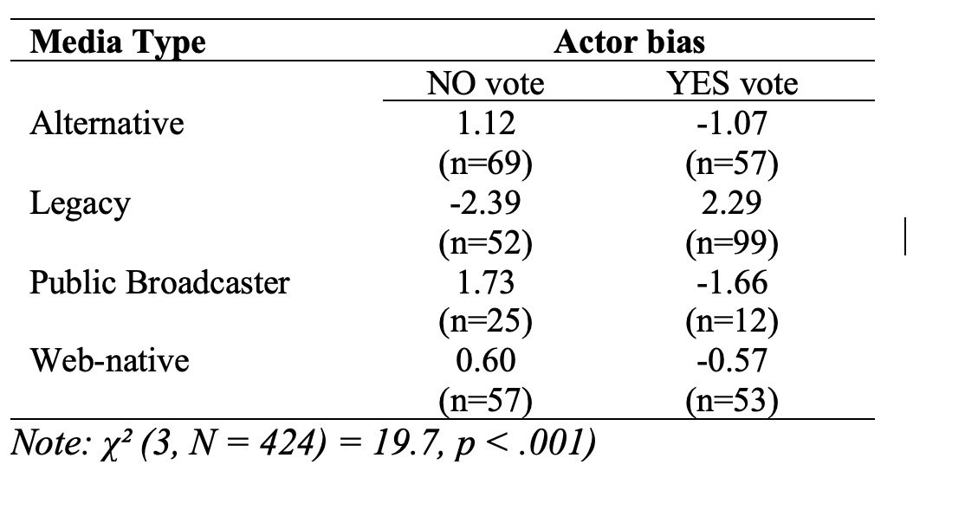

**Figure 1.** Mosaic plot of chi square residuals for actor bias per media type

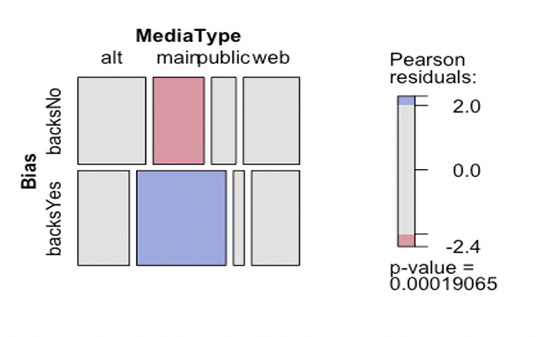

The next step is to run a logistic regression. Here, since our outcome variable is now binary, we can fit a simpler binomial logistic regression. We can also see that the web natives category is the most balanced, with more or less equal proportions. This makes the web native media type a useful reference category. The model’s outcome variable is actor bias favoring the ‘Yes’ choice. In the logistic regression (Table 6) we can test further associations in the modelling. Specifically, we can control for the campaign time. The results of the two models show no significant effect from the control variables. Compared to the more neutral and balanced web natives, only one media type generates significant effects in terms of actor bias: legacy media. Specifically, legacy media is approximately 2.5 times more likely to employ actors advocating the ‘Yes’ vote compared to web natives. This finding partially confirms H4: the use of actors supporting the ‘Yes’ vote choice was more frequent in legacy media. However, H4 is challenged in the case of the public broadcaster and alternative media, as sourcing proved balanced between the ‘No’ and the ‘Yes’ vote choice, disproving the assumption that these two media types would favor actors supporting the ‘No’ vote choice.

**Table 6.** Logistic regression on Actor bias

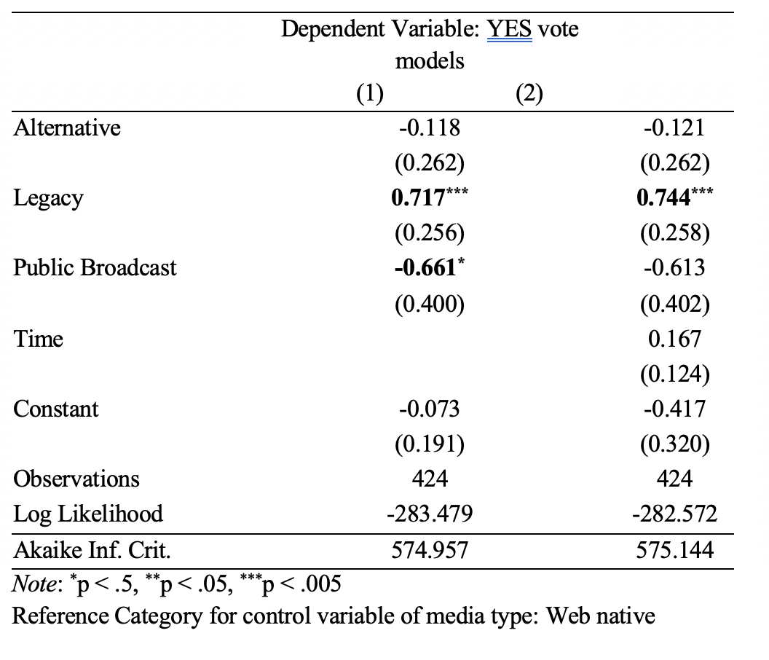

***Combined models***

Finally, we seek to unveil whether the two subtypes of partisan bias, namely statement and actor bias, are present in a systematic way in a specific media type. To undertake this analysis, we created acombined model of bias (new variable). The new variable would take on three values: 0=no bias detected; 1=one type of bias detected (either statement or actor bias) and 2=both types of bias is present. We use the labels ‘Zero bias’, ‘One bias type’ and ‘Two bias types’ (combined bias) to denote these three types of count data. The mosaic plot of chi square residuals (Figure 2) reveals the association between each media type and the degree of bias more vividly: alternative media significantly deviates from the expected distribution. Compared to the other media categories, alternative media include a lower proportion of articles with no bias and a higher proportion of articles with combined bias. Web natives are the more impartial compared to the rest, containing a larger proportion of stories with no bias, in contrast to the public broadcaster that has a less than expected count in the combined bias category.

**Figure 2.** Mosaic Plot of chi square residuals for combined types of bias per media type

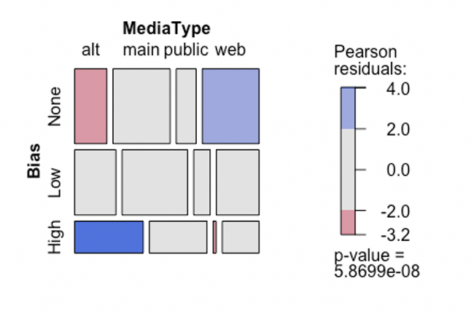

Although the basic test is quite revealing, it would be useful to go beyond simple chi square tests and fit more sophisticated models. This requires specifying the outcome variable more fully. The combined bias variable is essentially a count variable with three possible count values. As such it can be modelled using a Poisson regression, which is well suited for analysing count data (Table 7). The results do not add much to the simple chi-square. The most ‘bias contaminated’ articles are those published by alternative media (using web natives as the reference category). More specifically, what emerges from the regression is that alternative media are more likely to have a higher count of bias (when compared to web native media) unlike the rest of the media types.

**Table 7.** Poisson regression of Combined Bias (statement and actor)

# 

# Conclusions and Discussion

With the media holding a key role in referendum campaigns, special attention needs to be paid to media coverage, especially in cases of anecdotal allegations for biased reporting. The presumption underlying the study of media bias is that if news is slanted, public opinion could be affected. This study understands bias as the advocacy of the ‘Yes’ and ‘No’ vote choices as expressed through statement and actor bias. Drawing on quantitative analysis of online coverage during the 2015 bailout referendum in Greece, our findings suggest that the majority of articles are free of bias (at least from bias as currently defined). This finding lines up with existing research (D’Alessio and Allen, 2000; Gulati et al., 2004; Lichter, 2017; Strömbäck and Shehata, 2007) arguing that partisan bias is more frequently sought after rather than empirically confirmed.

While taking this result into account, it has been nonetheless revealing to probe those articles where bias was detected. In this case, the study provides support to other research (Niven, 1999; Levy Aslan and Bironzo, 2016) claiming a partisan ordering of media outlets (Dimitrova and Kostadinova, 2013; Strömback and van Aelst, 2010) especially in relation to media type. In particular, when exploring statement bias in the 21.8 percent of the sample where statement bias was identified, we detect a consistent bias toward either the ‘Yes’ or the ‘No’ vote positions in relation to the media type; alternative media favored the ‘No’ vote choice in contrast to legacy media where coverage skewed toward the ‘Yes’ vote choice. The exception was the public broadcaster which can be considered exceptionally neutral, refuting relevant research that public service media tend to operate as the mouthpiece of the government (Tambini, 2015). However, the analysis revealed different results in the case of actor bias. While alternative media, web natives and the public broadcaster were found to engage in relative balanced sourcing practices, legacy media quoted actors advocating the ‘Yes’ vote choice more frequently. This finding supports previous research arguing that the visibility of specific actors in the news is conditional upon the tone of the coverage (De Vreese and Semetko, 2004b; Van Dalen, 2012). Lastly, when assessing a combined bias outcome we found that the alternative media proved the most biased media category.

In an attempt to interpret the findings, a key takeaway is the partisan inclination of legacy and alternative media. In the former case it is predominantly performed through sourcing practices. By quoting sources (directly or indirectly) and organizing it into a cohesive narrative legacy media proved supportive of the status quo (Cline, 2009) and promoted the acceptance of the Troika’s take-it-or-leave-it bailout proposal. Essentially, the findings corroborate the objectivity-oriented model, where reporters gather (authoritative) information and then present it without explicitly taking a position. It is worth noting that the relative presence of statement bias toward the ‘Yes’ vote shows that legacy media were consistent with their general ideological orientation, as all outlets are rather conservative. Moreover, favorable to the ‘Yes’ vote choice reporting increased during the climax of the campaign, probably in an effort to help the ‘Yes’ camp confirming relevant research (de Vreese and Semetko, 2004b). Alternative media, on the other hand, rejected the norm of professional objectivity, and engaged in what Atton (2010) calls ‘journalism of commitment’; being against the continuation of the implemented economic policies, alternative media infused their reporting with a systematic bias in favor of the ‘No’ vote choice, which was again consistent with their overall ideological (left-wing) leaning. This finding empirically supports arguments of alternative media embracing advocacy roles and countering hegemonic discourse as constructed by legacy mainstream media (Holt, Figenschou and Frischlich, 2019). The prevalence of statement bias over actor bias in the case of alternative media can also be associated with the production of more analytical and explanatory news stories as opposed to timely, short-form and epidermic reporting encountered in legacy media and web-natives.

Regarding web natives, the study confirms germinal evidence for multiple editorial layering (García-Perdomo et al., 2018) possibly to serve a wider segment for users and also to establish themselves as non-partisan affiliated, a common criticism against legacy media, especially in Greece. Here, we provide evidence reinforcing Bennett’s (2016) argument that in today’s high-choice media environment, commercial pressures to grab the attention of wider audiences is more important than political slant. Lastly, the absence of statement bias in the public broadcaster, and its balanced approach regarding actor visibility, should be noted. We believe this is the result of the conscious and attentive efforts by the public broadcaster to shield itself against perpetual criticism of its assumed role as a government mouthpiece (regardless of the party in power). At the same time, the relative predominance of the actors advocating the ‘No’ vote in the public broadcaster, may have had important effects, since advocacy by neutral media has been shown to be more influential for voters compared to ‘expected’ endorsements (Chiang and Knight, 2011).

Taken together, our results provide empirical evidence that in the realm of political information, partisanship is one of the key lines of demarcation among legacy and alternative websites. Although this is not new, partisanship nowadays is also associated with the media’s effort to attract a relatively loyal audience (Baum and Groeling, 2008) as people prefer to consume news that aligns with their political views (Tsfati, 2016). All in all, the results suggest that the commercially-driven online news landscape (Carlson, 2018) and the presence of multiple news players eroding the monopoly of legacy media, create new conditions and values in online news-making. Additionally, it could be argued that the production of more neutral reporting is also associated with media attempts to reverse declining trust levels (Newman et al, 2022) and preserve their influence as meaning-makers.

The study is not without limitations. One drawback refers to the category of web natives, which may include diverse cases of media outlets (in terms of editorial stance, sourcing practices, ownership etc.) that the possible bias present in each outlet may be cancelled out at the aggregate level, so that the overall category appears unbiased. This potential difficulty extends beyond the specific case study, as this recently emerged media type is characterized by diversity and contingency across countries and media systems. Second, the study does not account for the institutional power assigned to different categories of actors, which tend to be the primary definers of events (Hall et al., 1978) irrespectively of their editorial stances. Finally, future research should consider the reach of the outlets under scrutiny to provide a more nuanced account of potential effects on public opinion.

# References

Atton, C. (2010). Alternative journalism: Ideology and practice. In S. Allan (ed.), *The Routledge Companion to News and Journalism*, (pp. 169-178). New York: Routledge.

Bailard, C. (2016). Corporate ownership and news bias revisited: Newspaper coverage of the Supreme Court’s citizens united ruling. *Political Communication,* 33(4), 583-604.

Baluff, P., Lind, F., Boomgaarden, H. & Waldherr, A. (2022). Mapping the European media landscape – Meteor, a curated and community-coded inventory of news sources. *European Journal of Communication,* DOI: 10.1177/02673231221112006.

Baum, M. & Groeling, T. (2008). New Media and the Polarization of American

Political Discourse. *Political Communication*, 25 (4), 345–365.

Beckers, K., Walgrace, S., Wolf, H.V., Lamot, K. & Van Aelst, P. (2021). Right-wing bias in journalists’ perceptions of public opinion. *Journalism Practice*, 15(2), 243-258**.**

Bennett, W.L. (20016). *News:* *The politics of illusion*. 10th edition, New York: Pearson/Longman.

Budak, C., Goel, S. & Rao, J. (2016). Fair and balanced? Quantifying media bias through crowdsourced content analysis. *Public Opinion Quarterly*, 80(1), 250-271.

Chadwick, A. (2013). *The hybrid media system*. Oxford University Press.

Chiang, C-F. & Knight, B. (2011). Media Bias and Influence: Evidence from Newspaper Endorsements. *Review of Economic Studies*, 78, 795-820.

Cline, A. (2009). Bias. In W. Eadie (ed.), *21st Century Communication: A Reference Handbook* (pp. 479-486). London: Sage.

D’Alessio, D. (2003). An experimental examination of readers' perceptions of media bias. *Journalism & Mass Communication Quarterly,* 80(2), 282-294.

D’Alessio, D. & Allen, M. (2000). Media bias in presidential elections: A meta-analysis. *Journal of Communication,* 50(4), 133-156.

de Vreese, C. (2007). Context, elites, media and public opinion in referendums: When campaigns really matter. In *C.* de Vreese(ed.), *The dynamics of referendum campaigns. An international perspective (pp.* 1-20). New York: Palgrave McMillan.

de Vreese, C. & Semetko, H. (2004a). *Political campaigning in referendums. Framing the referendum issue*, New York: Routledge.

de Vreese, C. & Semetko, H. (2004b). News matters: Influences on the vote in the Danish 2000 Euro referendum campaign. *European Journal of Political Research,* 43(5): 699–722.

DeKavalla, M. (2016). Framing referendum campaigns: The 2014 Scottish independence referendum in the Press. *Media, Culture & Society,* 38(6), 793–810.

DellaVigna, S. & Kaplan, E. (2007). The Fox news effect: Media bias and voting. *The Quarterly Journal of Economics*, 122(3), 1187-1234.

Dimitrova, D. & Kostadinova, P. (2013). Identifying antecedents of the strategic game frame: A longitudinal analysis. *Journalism & Mass Communication Quarterly,* 90(1), 75–88.

Eberl, J., Boomgaarden, H. & Wagner, M. (2017). One bias fits all? Three types of media bias and their effects on party preferences. *Communication Research,* 44(8), 1125-1148.

Eberl, J., Wagner, M. & Boomgaarden, H. (2017). Are Perceptions of Candidate Traits Shaped by the Media? The Effects of Three Types of Media Bias. *The International Journal of Press/Politics,* 22(1), 111-132.

Entman, R. (2010). Media framing, biases and political power: Explaining slant in news of Campaign 2008. *Journalism* 11(4), 389-408.

Eurobarometer (2016). *Standard Eurobarometer 86*. Media Use in the European Union.

Faris, R., Roberts, H., Etling, B., Bourassa, N., Zuckerman, E. & Benkler, Y. (2017). *Partisanship, propaganda, and disinformation: Online media and the 2016 U.S. presidential election*. Berkman Klein Center for Internet & Society. Retrieved from: <https://dash.harvard.edu/handle/1/33759251>

Freedom of the Press, Greece (2015) Freedom House, published August 7, 2015. Retrieved from: <https://www.refworld.org/docid/55c8587224.html>

Gans, H.J. (1979). *Deciding what’s news: A study of CBS evening news, NBC nightly news, Newsweek, and Time*. New York, NY: Pantheon Books.

García-Perdomo V, Salaverría, R., Kilgo, D. & Harlow, S. (2018). To share or not to share. *Journalism Studies,* 19(8), 1180-1201.

Gil de Zúñiga, H. (2015). Toward a European public sphere? The promise and perils of modern democracy in the age of digital and social media. *International Journal of Communication*, 9, 3152-3160.

Graber, D. & Dunaway, J. (2018). *Mass media and American politics*, 10th edition, London: CQ Press (Sage).

Gulati, G., Just, M. & Crigler, A. (2004). News coverage of political campaigns. In L. Kaid (ed.), *Handbook of Political Communication Research* (pp.237-256). Mahwah, NJ: Lawrence Erlbaum.

Hall, S., Critcher, C., Jefferson, T., Clarke, J. & Roberts, B. (1978). *Policing the crisis: Mugging, the State, law and order*. London: Macmillan.

Hänggli, R. & Kriesi, H. (2010). Political framing strategies and their impact on media framing in a Swiss direct-democratic campaign. *Political Communication* 27(2), 141–157.

Harlow, S. & Salaverría, R. (2016). Regenerating Journalism, *Digital Journalism*. 4(8), 1001-1019.

Hermans, L. & Drok, N. (2018). Placing constructive journalism in context. *Journalism Practice*, 12(6), 679-694.

Holt, K., Figenschou, T.U. & Frischlich, L. (2019). Key dimensions of alternative news media. *Digital Journalism*, 7(7), 860–869.

Hopmann, D., Vliegenthart, R., de Vreese, C. & Albæk, E. (2010). Effects of election news coverage: How visibility and tone influence party choice. *Political Communication*, 27(4), 389-405.

Iosifidis, P. & Papathanassopoulos, S. (2019). Media, politics and state broadcasting in Greece. *European Journal of Communication*, 34(4), 345-359.

Lee, H., Hur, J., Yeon, J. & Shim, H. (2022). Biased coverage of political rumors: Partisan bias in the media’s coverage of political rumors in the 2017 Presidential election in South Korea through issue filtering and framing. *International Journal of Communication,* 16, 1969–1989.

Levy, D., Aslan, B. & Bironzo, D. (2016). *UK press coverage of the EU referendum*. Reuters Institute for the Study of Journalism*.* Retrieved from: <https://reutersinstitute.politics.ox.ac.uk/sites/default/files/2018-11/UK_Press_Coverage_of_the_%20EU_Referendum.pdf>

Lichter, S. (2017). Theories of media bias. In K. Kenski & H. Jamieson (eds.), *The Oxford Handbook of Political Communication*, (pp. 403-416). Oxford: Oxford University Press.

Lindalh, R. (1983). Media concentration on local political campaigns: A study on local newspapers and campaign organizations during the 1980 nuclear power referendum in Sweden. *Gazette* 31, 99-115.

Lott, J.R. & Hassett, K.A. (2014). Is newspaper coverage of economic events politically biased? *Public Choice*, 160, 65-108.

Marquis, L., Schaub, H. & Gerber, M. (2011). The fairness of media coverage in question: An analysis of referendum campaigns on welfare state issues in Switzerland. *Swiss Political Science Review,* 17(2), 128-163.

McChesney, R. (2008). *The political economy of media*. New York: Monthly Review Press.

McNair, B. (2017). After objectivity?. *Journalism Studies,* 18(10), 1318-1333.

McQuail, D. (2010). *McQuail’s mass communication theory* (6th Edition). London: Sage.

Miel, P. & Faris, R. (2008). *News and information as digital news come of age*, The Berkman Center for Internet & Society, Harvard University. Retrieved from: <https://cyber.harvard.edu/sites/cyber.law.harvard.edu/files/Overview_MR.pdf>

Newman, N., Fletcher, R., Robertson, C., Eddy, K. & Nielsen, R.K. (2022). Reuters Institute Digital News Report 2022, <https://reutersinstitute.politics.ox.ac.uk/sites/default/files/2022-06/Digital_News-Report_2022.pdf>

Nikolaidis, A. (2015)*. The Impact of austerity on the Greek news media and public sphere*, PERC Papers Series, Goldsmiths. Retrieved from: <https://www.perc.org.uk/project_posts/perc-paper-12-the-impact-of-austerity-on-the-greek-news-media-and-public-sphere/>

Niven, D. (1999). Partisan bias in the media? A new test. Social Science Quarterly, 80(4), 847-857.

Niven, D. (2002). *Tilt? The search for media bias*. Westport: Praeger

Page, B.I. & Shapiro, R.Y. (1992). *The rational public*. Chicago: University of Chicago Press.

Pilon, D. (2009). Investigating media as a deliberative space: Newspaper opinions about voting systems in the 2007 Ontario Provincial Referendum. *Canadian Political Science Review,* 3(3), 1-23.

Porpora, D. and Sekalala, S. (2019). Truth, communication, and democracy. *International Journal of Communication*, 13, Feature 938–955.

Renwick, A. & Lamb, M. (2013). The quality of referendum debate: The UK’s electoral system referendum in the print media. *Electoral Studies,* 32(2), 294-304.

Reuters Institute (2016) *Digital news research – Greece*, Retrieved from: <https://www.jour.auth.gr/wp-content/uploads/2016/12/ReutersGreekReport2016digitaledition-v1.pdf> [in Greek].

Salaverría, R. (2017). Typology of digital news media: Theoretical bases for their classification. *Mediterranean Journal of Communication,* 8(1), 19-32.

Schiffer, A. (2006). Assessing partisan bias in political news: The case(s) of local senate election coverage. *Political Communication,* 23(1), 23-39.

Schudson, M. (2001). The objectivity norm in American journalism. *Journalism* 2(2), 149-170.

Sheafer, T. (2005). Detecting campaign effects in imbalanced campaigns: The Likud’s intraparty referendum over Sharon’s Sisengagement plan. *Press/Politics* 10(2), 85-93.

Siapera, E., Papadopoulou, L. & Archontakis, F. (2015). Post-Crisis Journalism. *Journalism Studies* 16(3), 449-465.

Stevenson, R.L. & Greene, M.T. (1980). A reconsideration of bias in the news. *Journalism & Mass Communication Quarterly,* 57(1), 115–121.

Strömbäck, J. & Luengo, Ó. (2008). Polarized pluralist and democratic corporatist models. A Comparison of Election News Coverage in Spain and Sweden. the International Communication Gazette, 70(6), 547–562

Strömbäck, J. & Shehata, A. (2007). Structural biases in British and Swedish election news coverage. *Journalism Studies,* 8(5), 798-812.

Strömback, J. & van Aelst, P. (2010). Exploring some antecedents of the media’s framing of election news: A comparison of Swedish and Belgian election news. *International Journal of Press/Politics,* 15(1), 41–59.

Tambini, D. (2015). Five theses on public media and digitization: From a 56-country Study. *International Journal of Communication,* 9(1), 1400–24.

Tandoc Jr, E., Takahashi, B. & Thomas, R. (2018). Bias vs. Bias. *Journalism Practice* 12(7), 834-849

Tsatsanis, E. & Teperoglou, E. (2016). Realignment under stress: The July 2015 referendum and the September parliamentary election in Greece. *South European Society and Politics* 21(4), 427-450.

Tsfati, Y. (2016). A new measure for the tendency to select ideologically congruent political information: Scale development and validation. *International Journal of Communication,* 10, 200–225.

Tuchman, G. (1972). Objectivity as strategic ritual. *American Journal of Sociology* 77(4), 660-679.

van Dalen, A. (2012). Structural bias in cross-national perspective: How political systems and journalism cultures influence government dominance in the news. *The International Journal of Press/Politics,* 17(1), 32-55.

Vargo, C.J. & Guo, L. (2017). Networks, big data, and intermedia agenda setting: An analysis of traditional, partisan, and emerging online U.S. news. *Journalism & Mass Communication Quarterly,* 94(4), 1031–1055.

Wettstein, M. (2011). Frame adoption in referendum campaigns: The effect of news coverage on the public salience of issue interpretations. *American Behavioral Scientist* 56(3), 1–16.

Zelizer, B., Park, D. & Gudelunas, D. (2002). How bias shapes the news. *Journalism*, 3(3), 283–307.

**APPENDIX**

**Table 1**. Number of collected news articles about the bailout referendum distributed across the eleven news outlets

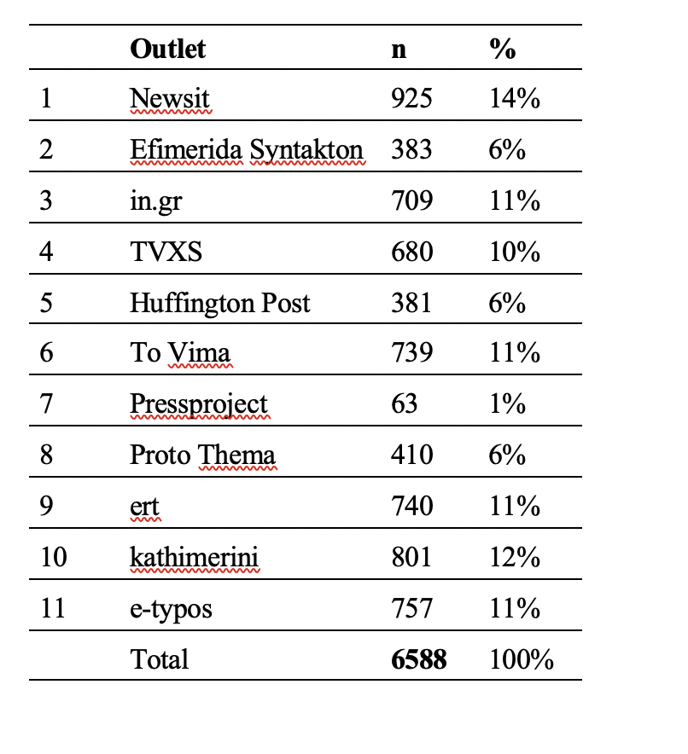

**Table 2.** Number of collected news articles distributed across the nine days of the campaign

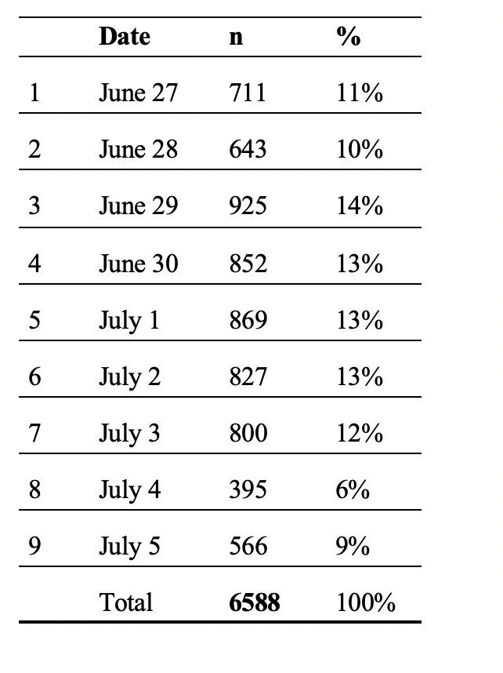

**Table 3.** Random sample of articles on the Greek bailout referendum selected from eleven news outlets during nine days of the campaign

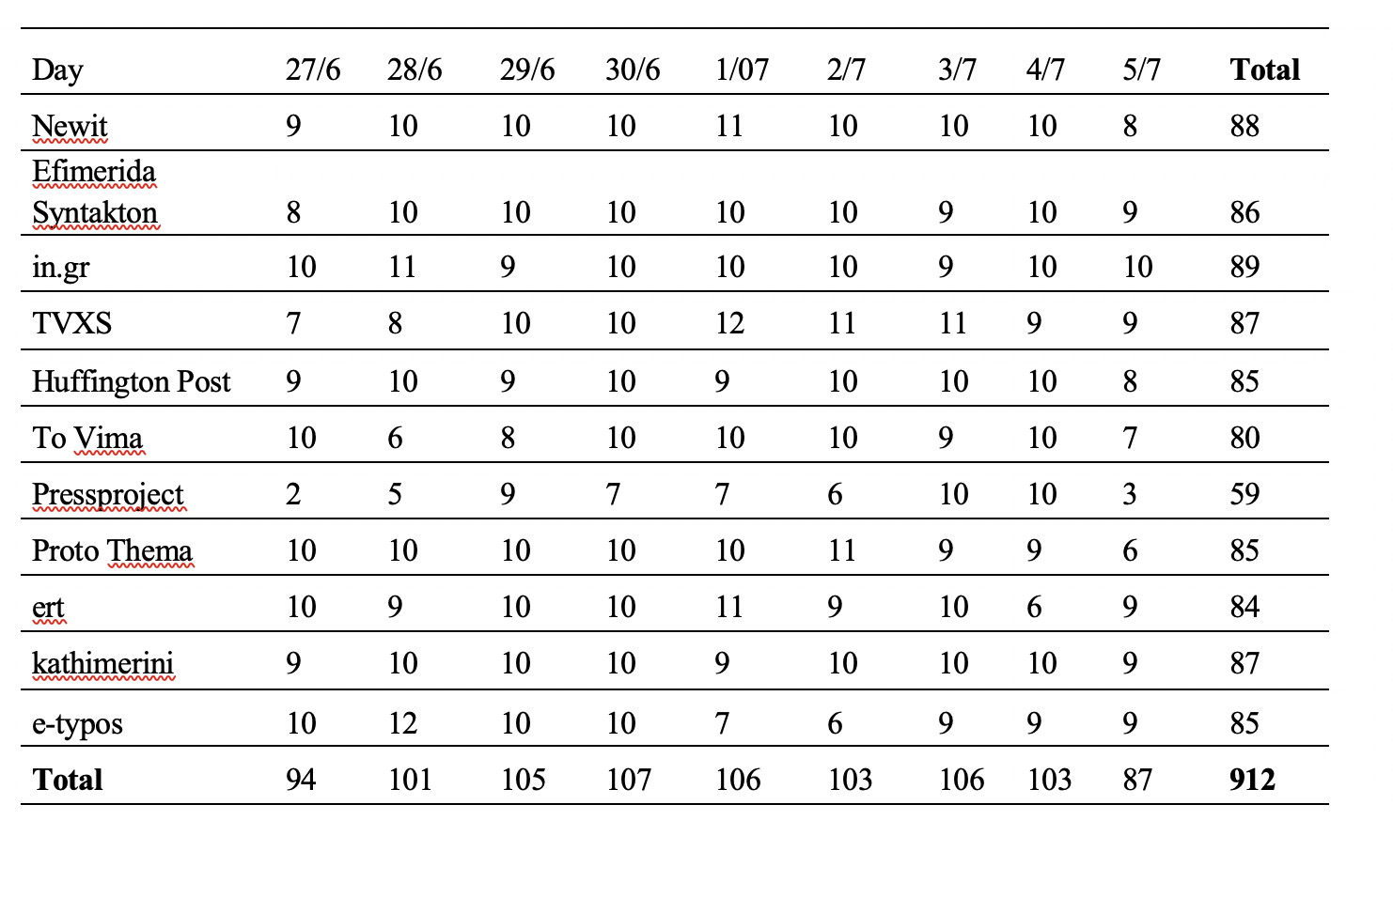

1. Some biasis inevitable provided that it is not systematic across media outlets and issues (Marquis, Schaub and Gerber, 2011). Similarly, Bailard (2016: 585) notes that “there is no objective and absolute standard of what unbiased coverage would look like with which to compare the news coverage”.
2. It can be problematic for a chi square test (as well as for regression analyses) to have such a category, i.e., one with zero observations in a cell and virtually none in the other.