**Communication network characteristics of the Mass Entrepreneurship and Innovation policy on social media: A social network analysis**

Zenglei Yue, Guang Yu*, Jing Shan, Guangwu Liu, Lie Chen, Donghui Yang

*Zenglei Yue*, School of Management, Harbin Institute of Technology, Harbin, China; Heilongjiang Institute of Science and Technology Information, Harbin, China.

*Guang Yu*, School of Management, Harbin Institute of Technology, Harbin, China.

*Jing Shan*, Heilongjiang Institute of Science and Technology Information, Harbin, China.

*Guangwu Liu*, Heilongjiang Institute of Science and Technology Information, Harbin, China.

*Lie Chen*,Heilongjiang Institute of Science and Technology Information, Harbin, China*.*

*Donghui Yang*, Southeast University, Nanjing, China.

**Corresponding author:** Guang Yu, yug@hit.edu.cn.

**Word count:** 6254 words.

**Funding details**: This work was not supported by any funding.

**Disclosure statement**: The authors report there are no competing interests to declare.

**Biographical note**:

*Zenglei Yue* is currently pursuing the Ph.D. degree with the School of Management, Harbin Institute of Technology. She is also an assistant researcher of Heilongjiang Institute of Science and Technology Information. Her research focuses on the fields of policy communication and evaluation. No. 92, Xidazhi Street, Nangang District, Harbin, Heilongjiang, China, yuezenglei@stu.hit.edu.cn.

*Guang Yu* is currently a Professor with the School of Management, Harbin Institute of Technology, China. She has a number of publications in international journals and conferences. Her current research interests include information retrieve, data mining, and scientometrics. She is a reviewer of several international journals. No. 92, Xidazhi Street, Nangang District, Harbin, Heilongjiang, China, yug@hit.edu.cn.

*Jing Shan* is currently vice president of Heilongjiang Institute of Science and Technology Information. Her research interests include information analysis, information consultation, science and technology services, and innovative methods.

*Guangwu Liu* is currently president of Heilongjiang Institute of Science and Technology Information. His research interests include science and technology management, and strategy research.

*Lie Chen* is currently director of the Research Center, Heilongjiang Institute of Science and Technology Information. His research focuses on science and technology management.

*Donghui Yang* is currently an associate professor and doctoral supervisor of the School of Economics and Management of Southeast University. His research interests include business intelligence analysis and data mining, social network analysis and knowledge management, and supply chain management.

**Communication network characteristics of the Mass Entrepreneurship and Innovation policy on social media: A social network analysis**

Policy communication network structure can be taken as a result as well as a target of policy communication on social media. This study explores the communication network of the Mass Entrepreneurship and Innovation policy on social media, using social network analysis, to investigate the relationships that were constructed as a result of policy-related interactions, through visual and quantitative means. The results revealed that the entire network structure comprised a relatively concentrated interactive group, some numerous scattered subgroups, and independent nodes. In the core network structure, different user nodes had differential influences in the policy network structure. Nodes associated with government sectors and media played relatively important roles in expanding the scope of communication and displayed more advantages in deepening interaction. These findings have implications for the effective communication of policies. Measures should be adopted to avoid or minimize negative impacts in the policy communication on social media.

Keywords: policy communication network, social media, Mass Entrepreneurship and Innovation policy, social network analysis, network structure

**Introduction**

Social network analysis (SNA) describes the social structure (Farine & Whitehead, 2015) by mapping and measuring the relationships (Dieter & Gavin, 2015; Malathi & Radha, 2016) and provides visual representations of complex relationships within networks. The key distinctive feature of SNA is its focus on the relationships between actors, rather than their individual characteristics, thereby fully clarifying the relationships and roles in social change communications (Davies, 2015). SNA can be used for participatory monitoring and evaluation as it depicts the relationships that have been built between individuals, groups, and organizations over time (Gibbon & Pokhrel, 1999). SNA illustrates how patterns of interpersonal relations are associated with diverse behavioral, cognitive, and emotional outcomes (Burt, Kilduff, & Tasselli, 2013). Using SNA to evaluate a complex policy network facilitates documentation and analysis of inter-relationships between individuals and organizations, pointing to potential gaps as well as areas of development (Drew, Aggleton, Chalmers, & Wood, 2011).

SNA conceptualizes the policy-making process as a network of actors (Varone, Ingold, Jourdain, & Schneider, 2017), revealing the resource exchange, information transmission, political power relationship, boundary penetration, and emotional attachment in the policy network (Knoke, 2018). Mcintyre, Jessiman-Perreault, Mah, and Godley (2018) visualize the networks of food insecurity policy actors in Canada, and the findings showed that networks of Canadian food insecurity policy actors exist but are limited in scope and reach, with a paucity of policy entrepreneurs from political, private, or governmental jurisdictions. Kalantari, Montazer, and Ghazinoory (2021) analyzed the science and technology policy making network in Iran using SNA, focusing on the most pivotal science and technology policy making institutions in Iran, the interactions between whom were determined from the network viewpoint.

The Internet has evolved into a ubiquitous and indispensable digital environment (Kozyreva, Lewandowsky, & Hertwig, 2020), becoming a particularly subversive force (Vromen, 2008), which has given birth to a new mode of political communication. In the field of politics and policy, the Internet enables unprecedented levels of political and policy communication among public officials, organizations, and citizens (Rethemeyer & Hatmaker, 2007), and it is possible for actors to challenge structural power holders (Knoke, 2004). Social media establishes a corresponding relationship of policy networks on the Internet, since it enables people to benefit from greater global connectivity and interaction and generate conversations on specific areas of concern such as social issues (Charalambous, 2019; Zhang & Counts, 2016), obtain peer support (Williams, Hamm, Shulhan, Vandermeer, & Hartling, 2014), and participate in political activities (Glassman, Straus, & Shogan, 2010). Social media has gradually become a means to encourage government transparency, communication, and engagement with the public (Bou-Karroum et al., 2017; Kapp, Hensel, & Schnoring, 2015). Social media is also used in understanding the information needs of the public, disclosing essential information, re-designing policy making as keys for the local government to develop crisis management (Wang & Wei, 2019).

In June 2015, the State Council of issued the *Opinions on Several Policies and Measures to Vigorously Promote Mass Entrepreneurship and Innovation* (i.e., the Mass Entrepreneurship and Innovation policy) to promote entrepreneurship and innovation. This policy aims to modernize entrepreneurship and innovation, thereby fostering a powerful new driving force for economic and social development. After the policy was officially released and implemented, several media sources on the Internet reprinted the full text of the policy and published numerous reports, which triggered a heated debate among netizens (Huang, Zhao, Liu, Fei-Fei, & Xiao-Yu, 2018). Up to the end of July 2015, the total amount of the policy information disseminated on the Internet exceeded 2.71 million items, and the amount of uploaded and broadcasted on social media reached 1.66 million items (Wang, Tong, & Yi, 2019). In recent years, this policy has been continuously optimized. At the same time, discussions on policy topics are still accumulating on social media. Scholars place differential emphasis on the evaluation of this policy communication on social media. Huang et al. (2018) provided insights into the Microblog-Oriented sentiment analysis, while Chen and Ruo-Yu (2019) investigated hot spots based on co-word analysis. Wang et al. (2019) analyzed the network communication effect of this policy, including communication volume, attention, and satisfaction. To the best of our knowledge, up to now, few scholars have analyzed the network structure of this policy communication on social media. Therefore, this study aims to construct the communication network of this policy using SNA to clearly describe and visualize the relationships underlying the communication of the Mass Entrepreneurship and Innovation policy policy on social media. The results of this study are expected to help policy makers in formulating policy communication strategies.

In sum, this study focuses on the communication network structure of the Mass Entrepreneurship and Innovation policy on social media platforms. The next section presents the research methodology of this study. This is followed by the description of the communication network structure. Thereafter, the results are reported and discussed in detail, and finally, the conclusion is presented.

**Methology**

***Definitions***

**Nodes and edges.** We used SNA to study the policy communication network on social media. The network presented by the graph is composed of nodes and edges. These nodes are the actors engaging in policy formulation and implementation, and the edges refer to the relationships among the actors. However, unlike other social networks, on social media, nodes and edges reflect the unique attributes of social media. Primarily, actors from different backgrounds or identities can participate in this network directly without functional constraints. First, in this study, we define a user ID on social media as a node, regardless of identity. For example, government sectors, organizations, groups, media or individuals are all policy actors, and they can be regarded as nodes in this network as long as they participate in the interaction and discussion of policy topics. Second, the relationship between social media users arises from the interaction or connection between them. Social media platforms provide users with many functions to establish connections and interact with other users. Comments, forwarding, and giving likes are the basic forms of direct connection between users. The relationships realized by these functions are defined as edges. Third, to explicitly define the research scope, we need to give a boundary to this network. All the nodes that enter the discussion of policy topics and the resultant edges are included in this network. However, the links established between these nodes (those entering the discussion) that are not related to policy topics are not included in the policy communication network; they belong to the broader network relationship between nodes.

**Policy communication network.** Interactivity is one of the main characteristics of social media. Users can exchange information, opinions, and views with other users through interactive actions. In the interaction based on policy topics, users can freely share policy information and express their understanding towards policy content. The more interactive their behaviors, the more edges are formed between user nodes. These nodes and edges together construct an interactive network based on policy. In this interactive network, policy information flow from one node to another along the edge. Policy information gradually spreads on social media along this interactive network. Therefore, the interactive network formed by user nodes based on policies is the policy communication network. In this policy communication network, the nodes and paths (edges) of policy communication are formed, and the views of users on policy are absorbed in the process of policy communication. This highlights the need to analyze the network structure of policy communication on social media, so as to better understand the characteristics and effects of policy communication on social media. Another significant point is that individual users play a very important role in the process of policy communication on social media. They can communicate and discuss directly with government sectors, organizations, groups, or media and establish a connection without any intermediaries. Because there is no difference at the user node level, they are all regarded as single nodes. The only difference is that there may be innate connections among government sectors, organizations, groups, and media, and these relationships are likely to be closely related to policy topics.

***Policy selection***

“Mass entrepreneurship and innovation” comes from Premier Li Keqiang’s speech at the summer Davos Forum in September 2014. Li Keqiang proposed to set off a new wave of “mass entrepreneurship” and “grassroots entrepreneurship” on a land of 9.6 million square kilometers, promoting a new trend of “mass innovation” and “everyone innovation.” Since then, he has frequently explained this keyword in the first World Internet Conference, the executive meeting of the State Council and the 2015 government work report. In June 2015, the State Council issued the Mass Entrepreneurship and Innovation policy to promote entrepreneurship and innovation. The purpose of this policy is to make entrepreneurship and innovation up to speed with the trend of the times and to nurture a powerful new driving force for economic and social development. In September 2018, the State Council issued the *Opinions on Promoting the High-quality Development of Innovation and Entrepreneurship and Creating an Upgraded Version of “Mass Entrepreneurship and Innovation.”* In May 2022, the State Administration of Taxation updated and issued the *Guidance on Preferential Tax Policies for “Mass Entrepreneurship and Innovation,”* focusing on the main links and key fields of innovation and entrepreneurship, and further sorted and merged into 120 preferential tax policies and measures. We choose this policy as the research object of policy communication on social media because it affects all aspects of social innovation and development, and relates to more policy audiences, especially the policy audiences at the individual level. After the introduction of the policy, there was a heated discussion on social media. To implement this policy, the state, ministries and local governments have issued a number of policies and measures to promote innovation and entrepreneurship. These policies have become a set of policy systems, and their influence continues. Therefore, this policy is a suitable research object for this study.

***Data collection*** ***and preprocessing***

We chose Sina Weibo, which is one of the biggest Chinese microblogging platforms, for data collection. This was a pragmatic choice because Sina Weibo provides greater accessibility to research data compared to other social media platforms, which restrict data accessibility due to privacy concerns. Moreover, we can easily obtain a user's authentication identity, which can be used to classify and analyze the audiences. Most importantly, on Sina Weibo, users can openly interact, discuss, and transmit information. These data are the key to this study and they are readily available.

We collected Weibo data from June 2015 until May 2016, which represents the one-year period after the implementation of Mass Entrepreneurship and Innovation policy. We use this dataset to construct the communication interaction network of the policy and elucidate the policy communication structure on social media. Sina Weibo provides the topic discussion function, and users can participate in the topic discussion of their interest as long as they bring ##. For this reason, we searched the data using the keywords with ##. “#Mass Entrepreneurship and Innovation Policy#” and “Double Creation” were the most frequent keywords in the policy text and abbreviation of policy. We have also considered the particularity of Chinese expressions and have collected topics based on keywords with links such as spaces, colons, and commas in the middle. Thereafter, we performed manual screening, excluding the following items: if they were posted repeatedly, if they were advertisements or commercial information, or if they were irrelevant to the policy. Finally, 7187 items were used, including 1512 posts, 1908 comments, 2922 instances of forwarding, and 845 likes.

***SNA***

In network analysis, the interaction of policy communication network can be quantified by degree, which refers to the interaction frequency. A node gets 1 out-degree if it initiates an interaction toward another node, and 1 in-degree if it accepts one from others. For example, audience member A comments on B’s post, then the output degree of A and the input degree of B is 1 simultaneously. The total degree of each node is then calculated, that is, the sum of out-degree and in-degree, which represents the total interaction frequency of one node. We can identify key nodes by calculating their degree, as we believe the higher the degree, the higher the importance of the node in the network structure. This identification enhances the analysis of the behavior patterns of the entire network, particularly the behavior patterns of each node and connections in the network, and reveals the high-value nodes from the perspective of network measurement. In addition, we compare some key indicators to conduct a further analysis.

The SNA process in this study follows these steps: First, we crawled the policy topic data on Sina Weibo and conducted preprocessing. Second, we constructed an interaction matrix and explored the interactive network for the policy topic using Pajek (a software for analysis and visualization of large networks). Third, we analyzed and explained the characteristics of the policy communication network according to key indicators.

**Clustering coefficient.** Clustering coefficient is used to indicate the transitivity of a graph: the proportion of all closed dual paths in the network. The Watts–Strogatz clustering coefficient is calculated by averaging the clustering coefficients of all nodes with a degree of at least 2.  denotes the clustering coefficient, and  denotes the Watts–Strogatz clustering coefficient; is the number of subgraphs with three edges and three nodes in the network, and  is one of the nodes, while  is the number of triples with three nodes connected by two or three undirected edges.





**Degree centrality.** Degree centrality refers to the number of connections (edges) a vertex has to other vertices. In the network, the greater the degree of a node, the higher the degree centrality of the node, which means that the node is more important in the network. We use  to represent the degree centrality of a node, where  is the number of nodes and  indicates the degree of the node, that is the sum of in-degree and out-degree. is defined as follows:



**Betweenness centrality.** Betweenness centrality is an index that describes the importance of a node by the number of shortest paths through a node. It measures the extent to which a node is located in the middle of other node pairs in the network structure so that it plays an important intermediary role. We use  to represent the between centrality of a node **, where  is the number of shortest paths from  to, and  indicates the number of nodes in the shortest path from  to  that pass through node **.  is shown in the following formula:



**Closeness centrality.** Closeness centrality reflects the proximity between a certain node and other nodes in the network structure. If a node is close to other nodes, it does not need to rely on other nodes when transmitting information, which indicates that this node is important. We take  as the closeness centrality of node ;  is based on average shortest path length .  is shown in the following formula:



**Analysis and Results**

***Interactive network structure***

Based on the dataset, we constructed an interaction matrix of 2979* 2979 and explored the interactive network of the policy topic using Pajek. Figure 1 presents the entire interactive network structure. There were a relatively concentrated interactive group (inside the black dotted line) and numerous scattered subgroups. There are also some independent nodes without any relations with others.

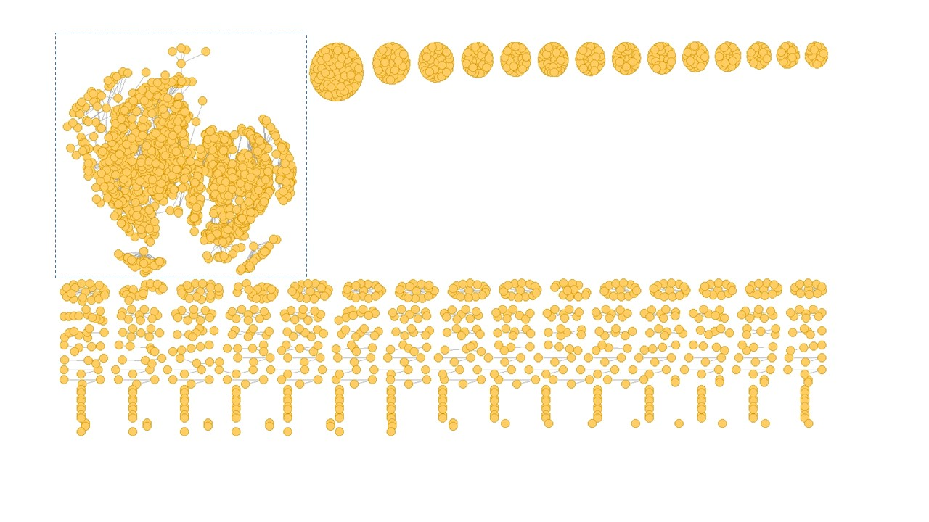Figure 1. The entire interactive network structure of the Mass Entrepreneurship and Innovation policy topic by the end of the first year

For the concentrated interactive group, these nodes indicated the interaction among users participated in the policy topic. Some interactions are one-time while some are repeated. There were many interactions and deeper communication on the policy topic, which can better reflect the public’s thinking and feedback on the policy. Their interactive behavior greatly promotes the communication of policy information in the interactive network structure. In this way, we will conduct deeper research on the concentrated interactive group later.

For the numerous scattered subgroups, we found that unlike concentrated interactive group, almost all subgroups have a core node. The core nodes had point-to-point relationships with other nodes. In other words, there is no connection between other nodes. Consequently, the core nodes had become the central nodes of each subgroup because they had received more attention from other users. Therefore, we thought that these core nodes help to expand the dissemination of policy information in the interactive network, but there was a lack of deep interaction among members of such subgroups.

Furthermore, we also found that there were some independent nodes in the entire interactive network structure. Those independent nodes represented those users who posted an item under the policy topic, but did not produce any interaction with other users. These users only randomly participated in the discussion of the policy topics, but did not communicate with other users. In other words, they did not promote the communication of the policy information in this structure. However, if considered in the whole social media network, they have made certain contributions to policy communication.

***Core network structure***

As mentioned above, there were many interactions and a deeper communication on the policy topic in the concentrated interactive group. To examine how the interactive behavior promotes the communication of policy information in the network structure, we conducted a deeper analysis of the concentrated interactive group.

First, we separated the concentrated interactive group from other subgroups and independent nodes. Thereafter, in the remaining data sets, we removed the nodes with degree = 1 (in-degree = 1 or out-degree = 1) and their interaction with other nodes. This was done to simplify the core network structure, only retaining the more important relationships and nodes with multiple interactions. Additionally, it reduces the impact of interactions that may occur randomly. We believe that if a user wants to participate in the topic discussion in depth, they are more likely to continuously pay attention to and trigger the interaction behavior many times. After these processes, the core network matrix was 210*210; the core network structure of policy topics we obtained is 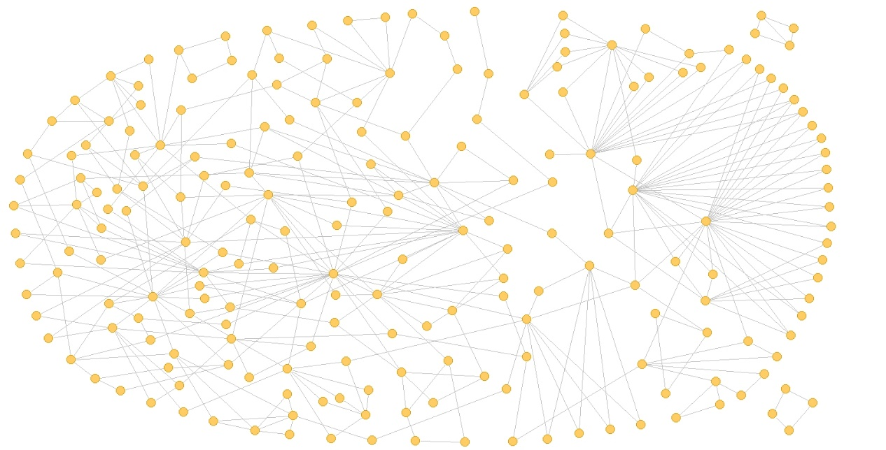shown in Figure 2.

Figure 2. The core network structure of the Mass Entrepreneurship and Innovation policy topic by the end of the first year

We found that there were two separated subgroups in the core network structure as a result of moving the nodes of a single relationship and their edges. However, since their degree is still higher than that of other nodes, we retained them in the core network structure.

To further analyze these nodes and relationships, we performed the following steps for processing: First, we set the size of nodes according to the degree of nodes. Second, we introduced directed edges according to the triggering and receiving of interactive actions. Third, we numbered each node to facilitate description and analysis. Finally, we obtained the processed core structure shown in Figure 3.

Figure 3. The processed core network structure of the Mass Entrepreneurship and Innovation policy topic by the end of the first year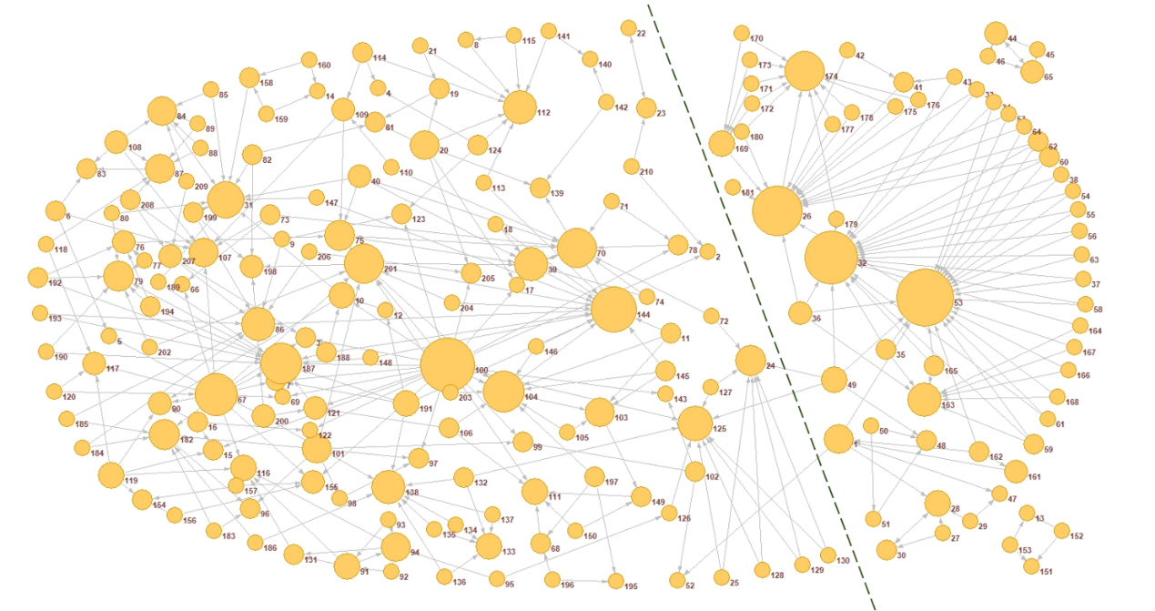

We calculated the clustering coefficients of both the entire network and core network. Table 1 reports the results, which revealed that nodes in the core network structure converged more closely than those in the entire network structure. This means that users in the core network structure had built closer relations based on the policy topic.

Table 1. Clustering coefficients of the entire network structure and the core network structure

|  |  |  |
| --- | --- | --- |
|  | Entire Network Structure | Core Network Structure |
| Watts–Strogatz Clustering Coefficient | 0.05305657 | 0.12523657 |

As can be seen in Figure 3, the top five nodes were No.53, No.100, No.32, No.26, and No.144 (based on degree; in-degree and out-degree). Media and organization nodes, with the latter comprising student groups in university, had greater advantages in the core network structure. We compared the degrees of both in the entire interactive network structure and the core network structure (Table 2). The results showed that those media nodes (No. 53, No. 32, No. 26) tended to receive attention from a large number of other users, so their participation is higher. However, these relations often happened one-time, and there were few nodes that can further interact with them. In contrast, although those organization nodes (student groups) did not receive a lot of attention in the entire interactive network structure, their interactions were deepening and continuous, that was why they stood out in the core network structure.

Table 2. Comparison of the top five nodes based on degree

|  |  |  |  |  |
| --- | --- | --- | --- | --- |
|  | In-degree in the entire structure | Out-degree in the entire structure | All in the entire structure | All in the core structure |
| No. 53 | 257 | 2 | 259 | 24 |
| No. 100 | 0 | 23 | 23 | 21 |
| No. 32 | 261 | 0 | 261 | 20 |
| No. 26 | 121 | 2 | 123 | 18 |
| No. 144 | 21 | 3 | 24 | 15 |

We also found that most nodes in the left part of the core network structure came from Fuzhou University, China. These were student groups and individual student users. The nodes in the right part of the core network structure belonged to media, organizations, government sectors, enterprises, and individuals. We paid special attention to nodes No. 1, No. 24, No. 49, No. 52, and No. 125. These five nodes act as three bridges (three edges) connecting the two parts. When we regarded the left and right parts as a whole respectively, these five nodes enabled the flow of policy information and views across the two parts via these three edges, thereby forming the core network structure.

The nodes that showed importance in the core network structure should also have certain importance in the entire network structure. For this reason, we placed these ten nodes back into the entire structure to investigate their importance in the policy network structure. Table 3 reveals that the degree centrality of No. 32 and No. 53 were significantly higher than others. This implies that the propagation volumes of media and government sectors nodes are larger. Only No. 1, No. 26, No. 53, and No. 144 exhibited betweenness in the structure. In other words, the betweenness centrality of student groups was higher than that of the government sector, media, and enterprises. With regard to closeness centrality, these ten nodes showed their closeness to other nodes in the structure. Therefore, they were important nodes in the policy network structure. From these three indicators, we can say that government sectors and media nodes played a relatively important role in the policy network structure, and student groups nodes showed a certain role in promoting policy communication. However, individual influence was not obvious.

Table 3. Comparison of nodes in the entire structure

|  |  |  |  |  |
| --- | --- | --- | --- | --- |
|  | Attribute | Degree Centrality | Between Centrality | Closeness Centrality |
| No. 1 | Enterprise | 0.016454 | 0.000276 | 0.120148 |
| No. 24 | Student Group | 0.008731 | 0 | 0.106392 |
| No. 26 | Media | 0.041303 | **0.001610** | 0.107283 |
| No. 32 | Media | **0.087643** | 0 | 0.111987 |
| No. 49 | Government Sector | 0.007052 | 0 | 0.126875 |
| No. 52 | Media | 0.010074 | 0 | 0.103030 |
| No. 53 | Government Sector | **0.086971** | **0.001311** | 0.120148 |
| No. 100 | Student Group | 0.007723 | 0 | 0.126675 |
| No. 125 | Student Group | 0.014775 | 0 | 0.128294 |
| No. 144 | Student Group | 0.008059 | **0.003497** | 0.099024 |

**Discussion**

The entire communication network of the Mass Entrepreneurship and Innovation policy on social media was constructed by the user nodes and their relationships. These nodes included media, government sectors, organizations, enterprises, and individual users. They interacted on social media based on their concerns about the policy topic and built relationships through comments, forwarding, and likes. With the continuous deepening of interactions, some connections had become closer, and the exchange of policy information had also deepened. Consequently, a core network appeared and promoted the communication of the policy on social media. We studied the entire communication network structure and the core network structure. The findings revealed the characteristics of the policy communication network.

First, the study results showed the composition of the entire network structure: it comprised a core network structure, some numerous scattered subgroups, and independent nodes. This may be due to the different ways and degrees of users’ participation in their interaction regarding policy topics. For example, the nodes of media and government sectors are more outstanding in terms of degree centrality (highest DC of media = 0.087643 vs. highest DC of the government sector = 0.086971). Government sectors are the issuing agencies of policies, while media users may pay more attention to official news. However, individual users may tend to get information from people around them (Gibbon & Pokhrel, 1996). As for the core network structure, nodes converged more closely than those in the entire network structure. Users in the core network structure had built closer relations based on the policy topic and their interactive behavior greatly promotes the communication of policy information in the interactive network structure. For the numerous scattered subgroups, these core nodes help to expand the dissemination of policy information in the interactive network, but there was a lack of deep interaction among members of such subgroups. Meanwhile, some users may have just browsed the policy information and simply participated in the discussion without paying too much attention to the policy contents; consequently, they become independent nodes. Although they were also involved in the interaction as a whole, their contribution to policy communication was very limited.

Second, the results suggested that different user nodes had different roles in the policy network structure. We found that the media and student group nodes had greater advantages in the core network structure. They both showed their characteristics in terms of betweenness centrality (highest BC of media = 0.001610, highest BC of Student Group = 0.003497). However, their influences were different. Media nodes tended to receive attention from a large number of other users, and these relations often happened one-time. In contrast, although the student group nodes did not receive a lot of attention in the entire interactive network structure, their interactions were deepening and continuous. This may be because the media nodes pay more attention to the coverage or the amount of communication, while in student groups, members pay more attention to the degree of connection between each other. Connections will be closer among members who share the same background or attributes. Moreover, they will be more willing to conduct multiple interactions to strengthen their connection (Ellison, Steinfield, & Lampe, 2007; Helliwell & Putnam, 2004).

To our surprise, most nodes in the core network structure were from Fuzhou University. Out of 210 nodes in the core network, we observed higher activity among 98 nodes, consisting of student groups and individuals within these groups. We tried to investigate the underlying reasons by searching the portal and campus forum of Fuzhou University. It was found that in 2015, Fuzhou University organized many training programs, lectures, and practical activities related to entrepreneurship among college students. Another noteworthy aspect is that the management departments of Fuzhou University also registered accounts on the Sina Weibo platform. Thus, they employed Sina Weibo as a tool to release entrepreneurship policies and information related to college students, similar to what the governments have done in recent years (Mickoleit, 2014). These were major reason why students were more likely to participate in the policy discussions, so much so that it had caused a strong reaction.

In addition, we carried out statistical analysis of the key nodes in the core network structure. Based on degree centrality, betweenness centrality, and closeness centrality, we found that the government and media nodes played a relatively important role in the policy network structure, while student group nodes played a role in promoting policy communication. These highly central nodes were at a structural advantage to exchange policy information (Borgatti & Everett, 2000) and may serve as points of contact to lesser-connected nodes to support efforts at understanding and implementing the policy (Honig, 2008; Wasseman & Faust, 1994). In effect, while a policy may prescribe particular implementation processes, it is ultimately the social ties between individuals that may determine the shape, diffusion, and success of any policy (Spillane, Reiser, & Reimer, 2002). However, in this study, individual influence was not evident. We believe that this is due to the restrictive nature of social media platforms where, for example, compared to media, government sectors, and other types of users, personal posts have relatively few opportunities to receive attention because of their small number of fans/followers.

**Conclusion**

We used SNA to analyze the communication network structure of the Mass Entrepreneurship and Innovation policy on social media. SNA helps in perceiving and investigating, through visual means and quantitative measures, the relationships that were constructed as a result of interactions related to the policy. We can consider this network structure to be a result of policy communication on social media. At the same time, it can also be regarded as a target of policy communication, because policy makers want to establish such a network structure on social media to disseminate the policy. The results highlighted that a relatively concentrated interactive group, some numerous scattered subgroups, and independent nodes constitute the entire network structure. In the core network structure, different user nodes played different roles in the policy network structure. Nodes associated with government sectors and the media played a relatively important role in expanding the scope of communication and are at a more advantageous position with regard to deepening interaction.

For policy makers, we argue that SNA can be taken as an appropriate tool to clarify the policy communication network, since the fission of subgroups in the Internet communication network further challenges the local government’s crisis management, policy making, and integration capability (Wang & Wei, 2019); moreover, continuous attention needs to be paid to these subgroups. Key features can be clearly revealed and nodes that have a greater impact on the network structure can be identified along with their relationships. The findings in our study provide important reference for the effective communication of policies and certain measures should be adopted to avoid or minimize negative impacts in the policy communication on social media. For example, on account of the relatively important role government sectors and media nodes played in the policy network structure, it is possible to expand the boundaries of the policy communication network through continuous and large-scale reports. It is necessary to adopt different communication strategies for policy audiences with different attributes. As innovation and entrepreneurship is an important topic for college students, they largely constitute the student group nodes. Therefore, the student group nodes should carry out positive publicity to stimulate their enthusiasm of innovation and entrepreneurship. Positive guidance across student group nodes may generate interest among policy topic participants regarding policy themes (Petridou, Becker, & Sparf, 2021).

However, one of the limitations is that this study did not show the entire network dynamics or the evolution; moreover, insights were provided only for the first year after the policy release. Another limitation is that because users can change their privacy rights on Sina Weibo, certain data prior to six years cannot be obtained. Further studies could follow up with a long-term effect evaluation with real-time data acquisition. Moreover, for a future study, we hope to add the sentiment tags to the nodes in the core network and focus on connections with more negative emotions. We believe that monitoring the emotions of participants on policy topics will also help to find out possible problems in the process of policy communication.

**References**

Borgatti, S. P., & Everett, M. G. (2000). Models of core/periphery structures*. Social Networks*, *21*(4), 375–395. doi:[10.1016/S0378-8733(99)00019-2](https://doi.org/10.1016/s0378-8733(99)00019-2).

Bou-Karroum, L., El-Jardali, F., Hemadi, N., Faraj, Y., Ojha, U., Shahrour, M., . . . Akl, E. A. (2017). Using media to impact health policy-making: An integrative systematic review. *Implementation Science: IS*, *12*(1), 52. doi:[10.1186/s13012-017-0581-0](https://doi.org/10.1186/s13012-017-0581-0).

Burt, R. S., Kilduff, M., & Tasselli, S. (2013). Social network analysis: Foundations and frontiers on advantage. *Annual Review of Psychology*, *64*, 527–547. doi:[10.1146/annurev-psych-113011-143828](https://doi.org/10.1146/annurev-psych-113011-143828).

Charalambous, A. (2019). Social media and health policy. *Asia-Pacific Journal of Oncology Nursing*, *6*(1), 24–27. doi:[10.4103/apjon.apjon_60_18](https://doi.org/10.4103/apjon.apjon_60_18).

Chen, X. L., & Ruo-Yu, L. U. (2019). Hot spots research on China’s policy of “mass entrepreneurship and innovation” based on co-word analysis. *Journal of University of Electronic Science and Technology of China (Social Sciences Edition)*.

Davies, R. (2015), *The use of social network analysis Tools in the evaluation of social change communication*.

Dieter, V., & Gavin, Y. (2015). Social network analysis as a tool for research policy. *PLOS Neglected Tropical Diseases*, *9*.

Drew, R., Aggleton, P., Chalmers, H., & Wood, K. (2011). Using social network analysis to evaluate a complex Policy Network. *Evaluation*, *17*(4), 383–394. doi:[10.1177/1356389011421699](https://doi.org/10.1177/1356389011421699).

Ellison, N. B., Steinfield, C., & Lampe, C. (2007). ‘The Benefits of Facebook “Friends:’ social capital and college students’ use of online social network sites. *Journal of Computer‐Mediated Communication*, *12*(4), 1143–1168. doi:[10.1111/j.1083-6101.2007.00367.x](https://doi.org/10.1111/j.1083-6101.2007.00367.x).

Farine, D. R., & Whitehead, H. (2015). Constructing, conducting and interpreting animal social network analysis. *Journal of Animal Ecology*, *84*(5), 1144–1163. doi:[10.1111/1365-2656.12418](https://doi.org/10.1111/1365-2656.12418).

Gibbon, M., & Pokhrel, D. (1999). Social network analysis, social capital and their policy implications, *PLA Notes (1999)*, *36*, 29–33, IIED London.

Glassman, M., Straus, J. R., & Shogan, C. (2013), *Social Networking and Constituent Communications: Member Use of Twitter during a two-month Period in the 111th Congress*. *Washington DC: Congressional Research Service, CRS Report for Congress*.

Helliwell, J. F., & Putnam, R. D. (2004). The social context of well-being. *Philosophical Transactions of the Royal Society of London. Series B, Biological Sciences*, *359*(1449), 1435–1446. doi:[10.1098/rstb.2004.1522](https://doi.org/10.1098/rstb.2004.1522).

Honig, M. I. (2008). District central offices as learning organizations: How sociocultural and organizational learning theories elaborate district central office administrators’ participation in teaching and learning improvement efforts. *American Journal of Education*, *114*(4), 627–664. doi:[10.1086/589317](https://doi.org/10.1086/589317).

Huang, L. C., Zhao, Y. P., Liu, C. W., Fei-Fei, W. U., & Xiao-Yu, L. I. (2018). Microblog-oriented public “mass innovation and entrepreneurship” hotspot identification and sentiment analysis and policy suggestions/*2018 International Conference on Management Science and Engineering (ICMSE)*.

Kalantari, E., Montazer, G., & Ghazinoory, S. (2021). Mapping of a science and technology Policy Network based on social network analysis. *Journal of Entrepreneurship, Management and Innovation*, *17*(3), 37–66. doi:[10.7341/20211734](https://doi.org/10.7341/20211734).

Kapp, J. M., Hensel, B., & Schnoring, K. T. (2015). Is Twitter a forum for disseminating research to health policy makers? *Annals of Epidemiology*, *25*(12), 883–887. doi:[10.1016/j.annepidem.2015.09.002](https://doi.org/10.1016/j.annepidem.2015.09.002).

Knoke, D. (2004). The sociopolitical construction of national policy domains. In C. H. C. A. Henning & C. Melbeck (Eds.), *Interdisziplinare Sozialforschung: Theorie und Empirische Anwendungen* (pp. 81–96)*. Frankfurt: Campus Verlag*.

Knoke, D. (2018), *Changing organizations: Business networks in the new political economy*.

Kozyreva, A., Lewandowsky, S., & Hertwig, R. (2020). Citizens versus the Internet: Confronting Digital Challenges with Cognitive Tools. *Psychological Science in the Public Interest*, *21*(3), 103–156. doi:[10.1177/1529100620946707](https://doi.org/10.1177/1529100620946707).

Malathi, A., & Radha, D. (2016). ‘Analysis and Visualization of Social Media Networks’// 2016 *international conference on Computation System and Information Technology for Sustainable Solutions (CSITSS)*. IEEE Publications. doi: 10.1109/CSITSS.2016.7779440

Mcintyre, L., Jessiman-Perreault, G., Mah, C. L., & Godley, J. (2018). A social network analysis of Canadian food insecurity policy actors. *Canadian Journal of Dietetic Practice and Research*, *79*(2), 60–66. doi:[10.3148/cjdpr-2017-034](https://doi.org/10.3148/cjdpr-2017-034).

Mickoleit, A. (2014), *Social media use by governments: A policy primer to discuss trends, identify policy opportunities and guide decision makers*. *OECD Publishing*. www.oecd-ilibrary.org/docserver/5jxrcmghmk0s-en.pdf?expires=1665973627&id=id&accname=guest&checksum=2351936E4186B35B9D7B62B71A6399F5.

Petridou, E., Becker, P., & Sparf, J. (2021). Policy entrepreneurs in public administration: A social network analysis. *Politics and Policy*, *49*(2), 414–445. doi:[10.1111/polp.12400](https://doi.org/10.1111/polp.12400).

Rethemeyer, R. K., & Hatmaker, D. M. (2007). Network management reconsidered: An inquiry into management of network structures in public sector service provision. *Journal of Public Administration Research and Theory*, *18*(4), 617–646. doi:[10.1093/jopart/mum027](https://doi.org/10.1093/jopart/mum027).

Spillane, J. P., Reiser, B. J., & Reimer, T. (2002). Policy implementation and cognition: Reframing and refocusing implementation research. *Review of Educational Research*, *72*(3), 387–431. doi:[10.3102/00346543072003387](https://doi.org/10.3102/00346543072003387).

Varone, f, Ingold, k, Jourdain, c, & Schneider, v. (2017). Studying policy advocacy through social network analysis. *European Political Science*, *16*(3), 322–336. doi:[10.1057/eps.2016.16](https://doi.org/10.1057/eps.2016.16).

Vromen, A. (2008). Building virtual spaces: Young people, participation and the Internet. *Australian Journal of Political Science*, *43*(1), 79–97. doi:[10.1080/10361140701842581](https://doi.org/10.1080/10361140701842581).

Wang, J. D., Tong, N. N., & Yi, C. Q. (2019). The transformation of public policy assessment in the age of big. *Data*[M]. China: *Social Science Literature Press*.

Wang, L., & Wei, Y. (2019). ‘Hyper-network Analysis of Policy Communication on Social Media’// *20th Annual International Conference on Digital Government Research*.

Wasseman, S., & Faust, K. (1994), *Social network analysis: Methods and applications*. *Cambridge: Cambridge University Press*.

Williams, G., Hamm, M. P., Shulhan, J., Vandermeer, B., & Hartling, L. (2014). Social media interventions for diet and exercise behaviours: A systematic review and meta-analysis of randomised controlled trials. *BMJ Open*, *4*(2), e003926. doi:[10.1136/bmjopen-2013-003926](https://doi.org/10.1136/bmjopen-2013-003926).

Zhang, A. X., & Counts, S. (2015). Modeling ideology and predicting policy change with social media: Case of same-sex marriage*, Proceedings of the 33rd annual ACM conference on human factors in computing systems. Seattle, WA, 2015*. *Chi*.