

**“Power to the People!”**

**Mobiles, Migrants, and Social Movements in Asia**

JACK LINCHUAN QIU[1]♦

The Chinese University of Hong Kong

Is the diffusion of information and communication technologies (ICTs)—especially mobile technologies, such as the mobile phone and mobile services—causing power shifts of global media networks to working-class populations, particularly migrant workers? This article addresses this question by examining social movements in China and Asia that have led to empowering (or disempowering) working-class people since the beginning of the century. It also draws on both classic and recent volumes about communication technology, power, and social development. Mobiles have become almost ubiquitous among Chinese domestic migrant workers and international migrants in most Asian countries. What does this mean for migrant workers, especially for their social lives that may serve as the basis for new formations of solidarity, both wirelessly and face-to-face? How do grassroots networks of migrants make use of mobile phones in their work and lives, in their cultural expression, and in the organization of social movements? After examining these questions in the context of China and selected Asian countries, this article discusses the broader implications for future ICT studies in the contexts of migrant populations, social movements, and social change.

**Introduction**

Paul Mason, an award-winning BBC journalist, started his book, *Live Working or Die Fighting: How the Working Class Went Global* (2007), in Gangxia, a migrant enclave or *chengzhongcun* in downtown Shenzhen, Guangdong Province, in South China. In 1980 Gangxia was a rural village surrounded by red-earth agricultural fields. But by 2003, Mason writes:

In just 20 years, Gangxia workers have built a community as tightly knit as in the fearsome slums that terrified English social reformers during the Industrial Revolution. The big difference is the total absence of a political public space. There is a chalk mural in Gangxia extolling the virtues of the PLA, but nothing else. The public area, such as it exists, is the mobile phone network or the Internet café. (p. 6)

Mason then discusses a major strike in 2005 and the participating workers’ struggle against violent suppression in an Italian-owned furniture factory. Then he notes, “Shenzhen’s workers are to global capitalism what Manchester’s workers were 200 years ago. What they do next will shape the century” (2007, p. 7).

I have discussed elsewhere the evolution of Internet café in China and its relationship to migrant workers and social movements (Qiu, 2009; Qiu & Zhou, 2005). In this article, I shall focus on the mobile phone network that, according to Mason (2007), constitutes a central “public area, such as it exists” in migrant-worker communities.

Is the diffusion of information and communication technologies (ICTs)—especially mobiles—causing power shifts of global media networks to working-class populations, particularly migrants? Mobiles have become almost ubiquitous among Chinese domestic migrant workers and international migrants in most Asian countries. Is this really causing a power shift, or bestowing “power to the people,” as John Lennon wrote in his 1971 song? What does this actually mean for migrant workers with regard to their social life that may serve as the basis for new formations of solidarity, both wirelessly and face-to-face? How do grassroots networks of migrants make use of mobile phones in their daily work and lives, in cultural expression, and in the organization of social movements?

**Contexts: Global and Regional**

The arrival of mobile phones in Asia coincided with the end of the Cold War in the 1990s. The decade began with the collapse of the Soviet Union, marking the beginning of a neoliberal era when Western models of deregulation and privatization spread and became dominant in non-Western societies, including many Asian countries. Various economic and social sectors, including telecommunications, came under neoliberal influence worldwide. This was the case for telecom restructuring in China (Harwitt, 2004; Mueller & Tan, 1997) and India (Chakravartty, 2004), as well as in many other Asian societies (Samarajiva & Zainudeen, 2008).

As the decade drew to its end, Asia fell into an abyss known as the 1997-1998 Asian Financial Crisis. From Thailand to South Korea, currencies were dramatically devalued overnight. Economic hardship resulted in social turmoil, such as the toppling of Suharto’s regime in Indonesia. The general weakening of Asian strengths at this historic moment was reflected in the West-dominated process through which the mobile phone was first introduced to Asia. Western companies—handset makers (e.g., Nokia, Motorola, Ericsson) and equipment providers (e.g., Cisco, Siemens, Lucent)—played the most decisive role in bringing first-generation analogue mobiles and second-generation GSM or CDMA phones to Asia. This is surely not a new phenomenon, historically or globally. Since the beginning of the telegraph in the mid-19th century, Western players have been dominant in Asian’s telecom development, as they are in most parts of the Global South. The pattern has been basically consistent for landline telephone buildup.

Yet as the first decade of the new century unfolded and as mobile technology evolved into 3G services and beyond, this long-standing pattern was disrupted in Asia. Overall, the continent has not only recovered rapidly from the Asian Financial Crisis, but it has also become a major force in mobile communication industries, regionally and globally. Emerging companies—Infosys and TCS of India’s software sector and Huawei and ZTE of China’s hardware sector—have made a global impact by reducing market share of Western companies not only in Asia, but also worldwide and even on the “home turf” of some Western players. In other cases, Asian companies have acquired Western companies and renamed their brands, for example, Sony-Ericsson. Meanwhile, Asian brands, such as Samsung and HTC, have also become global leaders, outcompeting Nokia among other Western brands.

In addition to the rise of Japanese, South Korean, and Taiwanese brands in the handset market, the world’s mobile industry has also grown increasingly dependent on Asian workers, Asian consumers, Asian capital, and state initiatives in Asia. Apple products, from iPod to iPad to iPhone, are produced by Foxconn workers—more than one million of them working in China alone, which boasts the world’s largest-ever factory plant—Foxconn’s Longhua campus in Shenzhen once had more than 400,000 workers—but which is also associated with the tragic worker suicides in 2010 (Chan & Pun, 2000; Qiu, 2012). Foxconn is now the world’s unquestionable behemoth in electronics manufacturing, with more than half of the global market share. Meanwhile, as global “digital capitalism” (Schiller, 2000) scans the planet for new zones of capital accumulation, Asia—particularly China—stands out due to its huge domestic market and the input of its numerous IT talents, although this is quite often complicated, even unpredictable, when impacted by national and local state initiatives (Schiller, 2005).

Asia’s IT workforce brought down the cost of mobile communication for everyone, not just middle-class iPhone users in the West but also low-income workers and farmers of Asia, Africa, and Latin America. Over the more than 150 years since its inception, traditional landline phone use has diffused to only about half of the world’s population, meaning that the poorer half of humanity still has no access to landline phones. Yet the incredible growth of mobile penetration has been recorded in Southern societies since around 2005 (Wallis & Qiu, 2012) primarily due to Asian players, like Chinese and Indian companies building up mobile phone infrastructures in Africa, but arguably (and most importantly) due to the massive export of Shanzhai mobile phones from China. According to International Telecommunications Union (ITU), the world’s average mobile penetration—measured by the number of subscriptions divided by total population—surpassed 75% in 2012. In many communities, even where residents do not have access to proper toilet facilities, people have their own mobile phones. In 2009 we observed the sales of used mobile handsets in downtown Shenzhen, where the asking price was 10 yuan, and the phones, which used to belong to factory girls in the export production zones, were perfectly functional in handling voice calls or text messaging.

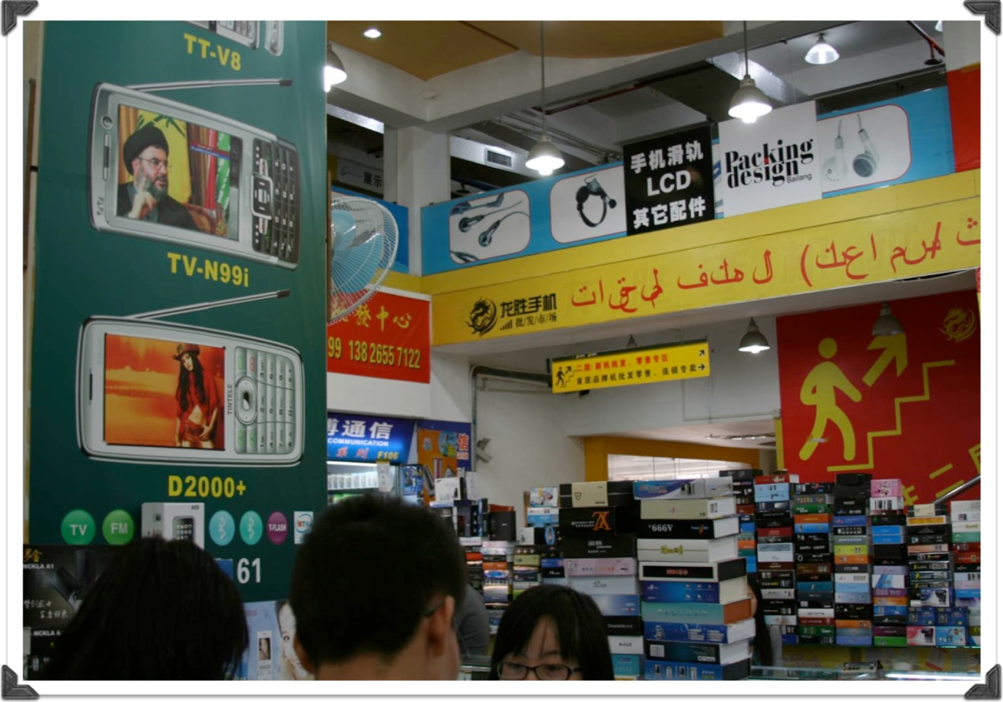***Figure 1. A store in Huaqiangbei, Shenzhen, selling Shanzhai mobile   
phones to traders from the Middle East. Source: Author.***

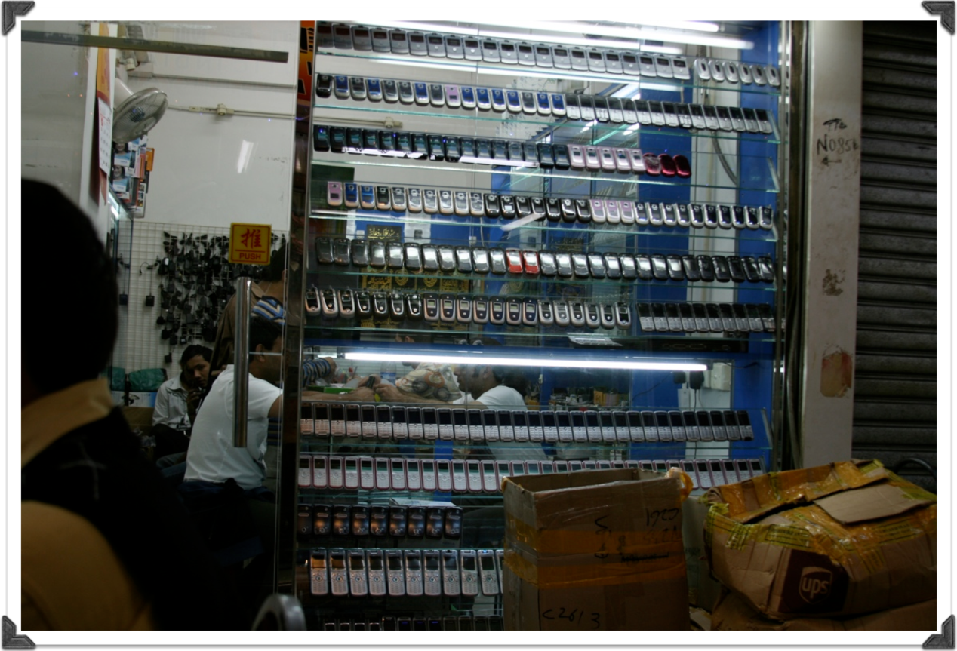

***Figure 2. A whole-sale store in Chunking Mansion, Hong Kong, selling second-hand   
mobile phones to mostly African traders. Source: Author.***

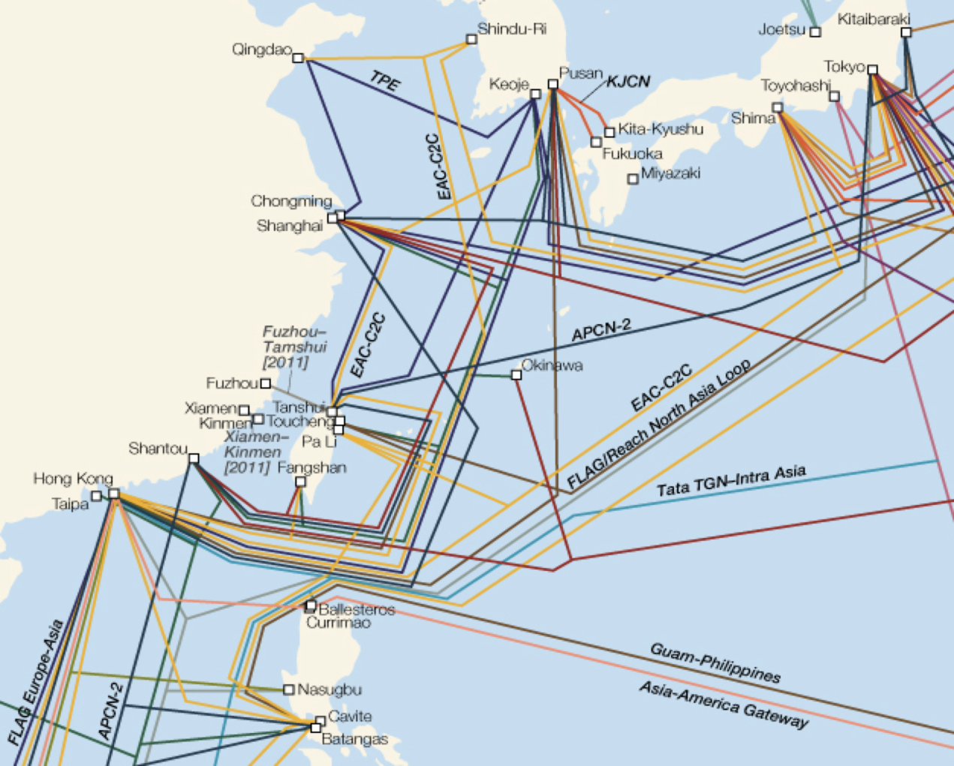

***Figure 3. The dense network of fiber optic cables in East Asia forms the backbone of a   
regional system for mobile and Internet communications (2010). Source: Chartsbin.com***

As the decade of 2010 progresses, much of the world is still recovering from the Global Financial Crisis that began in 2007–2008. Unemployment remains high in the United States. The Euro zone has its own debt crisis. Asia—not just China and India but also South Korea, Indonesia, and Vietnam—emerges from the financial tsunami with more relative strength the world over. In the mobile sector, Asia now has the world’s largest handset manufacturer (Foxconn), the leading m-commerce market (Japan, with 10 times the size of m-commerce of that of the United States), and the largest mobile subscriber population, which supports major mobile operators, such as China Mobile (the world’s largest), Airtel (India, the world’s third largest), Telkomsel (Indonesia), Maxis (Malaysia), Smart Communications (the Philippines), SK Telecom (South Korea), and NTT Docomo (Japan). In 2011 China had 859 million mobile subscriptions or about 73.2% of its national population; India totaled about 752 million subscriptions or 72% of its population. They are by far the world’s leaders in terms of mobile phone user population, followed by the United States, with the third largest mobile phone population of some 285 million subscriptions (ITU, 2013).

Yet it is also in Asia that we see the world’s most uneven landscape in mobile development. On the one hand, societies like Macao (243.5% penetration rate in 2011), Hong Kong (214.7%) and Singapore (150.2%) are among the most mobile-connected which are often highly urbanized city-states (ITU, 2013). On the other hand, North Korea and Myanmar, whose mobile penetration rates in 2011 stood at 4.1% and 2.6%, respectively, trail even Somalia (6.9%) and Cuba (11.7%) as by far the least mobile-penetrated countries worldwide (ibid.). Here, though, the reasons are more political than they are economic, with the fear of mobile-facilitated social movements being an important factor. Authorities in Asia had shut down mobile networks nationally in Nepal during the Maoist insurgency of 2005 (Ang, Shyam, & Wang, 2012) and regionally during ethnic conflicts in Australia (following the 2005 Cronulla riots) and in China (2009 Xinjiang riots).

The combination of uneven economic development and political constraints in parts of Asia influences not only mobile penetration, but also reflects the vast social inequality and systematic injustice that prevail in the region. On its neoliberal path toward urbanization, industrialization, and modernization, Asia is making “progress” based on the willing or unwilling sacrifices made by its social backbone—the working-class people, their families, and communities. These are processes of tremendous inequalities, during which hundreds of millions of workers and farmers have to migrate away from their homes, to big cities, even overseas. Some of them are forced off their land; others choose to do so, under structural constraints. Most of them have grievances and mobile phones. Does the new wave of ICT diffusion mean more “power to the people”?

**Ideas: Classic and Contemporary**

The idea that new ICT tools empower ordinary people is not new. But it is seldom articulated in relation to the working class or class inequalities, especially when it comes to poor migrants in non-Western contexts. Most popular are ideas stating that new media technologies empower “everyone,,” for example, in works of futurology (Toffler, 1990), media ecology (McLuhan, 1962), and citizen journalism (Gillmor, 2004). Political scientist Ithiel de Sola Pool (1984) made the connection between media and social movements the center of his study. So do prominent sociologists like Bell (1973) and Castells (1996, 2009), whose research on information/network society is highly influential across disciplinary boundaries (Webster, 2002). Yet these are usually general theories about power, social change, and class structures in developed Western countries or worldwide. Although there are an increasing number of books that highlight ICTs and social movements in Asia (e.g., Rheingold, 2002), they often rely on a transnational middle-class perspective and seldom focus on migrants at the bottom of the social pyramid.

Therefore, it is perhaps more productive to approach mobiles and working-class migrants in Asia’s social movements from the tradition of “communication and social development,” whose extension in the digital era is termed ICT4D (ICT for development) (Sparks, 2007; Unwin, 2009).

An influential, albeit often criticized, book in the founding years of the field is Lerner’s *The Passing of Traditional Society* (1958), which began with observations among Turkish farmers migrating from villages to nearby cities. “New media” at the time were mostly radio and cinema/film. As the book title indicates, Lerner argues that the spread of new electronic media will bring an end to traditional ways of life by enabling “empathy” or “psychological mobility” among the people. This is the cognitive ability to imagine oneself living a modern life, being in the position of the rich and powerful, and then aspiring to move “upward,” away from one’s non-Western cultural traditions and toward Western lifestyles, including political movements and democracy. Calling new media the “mobility multiplier” and using survey data, Lerner had a linear model: first, people with empathy acquire mobility—cognitively, physically, and socially—to change their societies from “traditional” to “transitional” ones, then from transitional ones to modern/Western societies.

Lerner’s model was later elaborated and applied as the so-called “dominant paradigm” in development communication studies, which has been, however, severely criticized since the 1970s (Rogers, 1976; Sparks, 2007, pp. 38–56). One charge is techno-determinism, that is, the assumption that new media technology is inherently inconsistent with cultural traditions. Lerner’s model is also criticized as being too idealistic to be practically useful in changing behavioral patterns in traditional communities, for example, through the phenomenal Satellite Instructional Television Experiment (SITE) in India. More fundamental is the critique of ethnocentrism as Western-style, especially American-style, modernity, which is deemed as the superior destination of techno-social evolution.

The most profound limitation, for this analysis, is the lack of sensitivity for structural inequality and class differentiation within the society. For instance, Lerner only used the crude measurement of per capita income without considering the widening gap between the rich and the poor, which made short-term economic growth unsustainable in the long run, as shown in the 1998 Indonesian riots. Moreover, according to Sparks (2007),

[T]he relentless pursuit of modernity in disregard of social structures had another, and more dangerous side, since it could lead to the destruction of alternative paths of social change, and thus to the reemergence of resolutely anti-modern and anti-developmental forces as the sole viable alternatives to continued uncontrollable change. (p. 43)

The most powerful example of the above is the 1979 Islamic Revolution in Iran.

All critiques considered, Lerner’s (1958) classic ideas remain seminal for us to consider the relationship between mobiles and migrants in contemporary China and Asia. In my most recent book in English (Qiu, 2009), I maintained the following:

In many ways, working-class ICTs can be seen as the twenty-first-century equivalent of mobility multipliers because they facilitate the expansion and acceleration of mobility patterns created by urban growth and industrialization in a global context. Surging mobility leads to more informational needs among migrants that are now met primarily by working-class ICTs . . . due to the disappointing role of mainstream mass media. (p. 123)

Several modifications of the classic “mobility multiplier” idea have been made here. First, not all “modern” media are mobility multipliers. Chinese mass media largely fail to perform such a role due to market-driven orientations and institutional constraints. Yet working-class ICTs—especially mobile phones—tend to resemble the mobility multiplier much more closely because they are low-cost, almost ubiquitous, and operated by migrants themselves to meet their existential needs such as finding employment or housing information. “Working-class ICTs are, in this sense, microsolutions for macroproblems faced by have-less migrants by directing migration flow, disseminating job information, and providing badly needed social support” (Qui, 2009, p. 123).

Second, mobility-multiplier media are not just about outsider experts offering one-way information that is passively received by migrants and those who start to think about migrating. It is not just cognitive empathy but also more concrete networked connectivity that links migrants to real-world jobs in the manufacture and service industries, including those making or selling mobiles and prepaid cards, as well as jobs in small business enterprises. In so doing, bottom-up social innovation becomes commonplace, which may subvert the original “rule of game” embedded in the mobile device, including all rules supposedly representing modernity. This is most clearly evident in the informal economy of Shanzhai mobile business that has given rise to a wide range of “alternative practices” in the R&D, manufacture, and all cash-based marketing of high-quality, inexpensive mobile phones in China, Asia, and much of the Global South (Wallis & Qiu, 2012). The most subversive components of the Shanzhai business include its rejection of the Western-style intellectual property rights (IPR) regime and its reliance on traditional mercantile networks in Greater China, South China, the Arab world, and beyond.

And third, as I noted in 2009,

[T]he rise of working-class ICTs is a harbinger of new class dynamics, whose centerpiece is the emergence of network labor in not only occupational but also cultural and political terms. Essential to China’s urbanization and its ascendance as a global industrial power is its burgeoning electronics manufacture and IT services provision sector . . . impossible without a systematic reorganization of Chinese migrant labor. (p. 124)

It is important to note that the new class dynamics, including network labor itself, are still in an incipient stage, meaning that it is premature to conclude that there will be a power shift in favor of migrant power at the end. It is not guaranteed that the mobility multiplier will produce more upward social mobility among migrants as originally hypothesized by Lerner and modernization theorists, including their followers, in the study of ICT4D. On the contrary, it is also likely that the new class dynamics, now extended and facilitated by mobiles, may disempower migrants through new or old structures of inequality, from repressive companies to violent gangs.

So exactly how do mobiles play a role in the life of migrants? Answers to this question vary greatly due to tremendous heterogeneity within migrant populations. Madianou and Miller (2012) choose to focus on Filipino domestic helpers, whose earnings amount to about 10% of the country’s GDP. Unlike Chinese domestic migrants examined in Qiu (2009), the Filipino helpers migrate internationally to more affluent societies of Asia, Europe, and North America. Almost all are female, many leaving their children behind. Therefore, maintaining relationship with family members, especially children, back home (remote parenting or mothering) becomes a paramount existential need. Madianou and Miller then zoom in to the role of “polymedia” in these international relationships that depend increasingly on mobile phones and associated services, such as mobile voice telephony, VoIP (Skype), text-messaging, and Facebook.

Polymedia encompasses more than multimedia. The concept emphasizes the patterns of multimodal communication that result from bottom-up media convergence practices whose nature is undetermined. Madianou and Miller began recording the origins of polymedia among Filipino domestic helpers in the 1970s, when international phone calling was extremely expensive, yet there were already millions of migrant Filipino helpers worldwide. A typical polymedia practice at the time was to write a hand-written letter—Filipino helpers tended to be better educated than were other Asian migrants at the time—while also recording one’s voice (e.g., a mother speaking to son) on a cassette tape. Then the letter and tape were mailed in a single package back home, where families with different education attainment and new media access (to cassette players) would consume the content differently. This type of polymedia has shaped today’s patterns of texting, Friendster, and Facebook usage in ways that bring the domestic helpers closer to their traditional roles as mothers or caregivers, even in their physical absence (Madianou & Miller, 2012).

In their analysis, Madianou and Miller (2012) emphasize three key arguments that are not very often found in studies about mobiles in Asia or China. First is the centrality of family, because these mobile users are mostly women trying to stay close to their traditional roles of mothers and under the influence of not only kinship networks but also religion. Second, is the persisting relevance of the (neoliberal) state. Although the Philippine government seldom exerts direct control over mobile usage or mobile content, they nonetheless set up parameters that constrain both the gendered structure of migration and the growth of mobile services. And third, what is private, and what is public? The boundaries have become rather blurry and negotiation is constantly needed among migrating parents and their children and relatives back home, especially when new media evolves at dazzling speed. At the end of day, are mobiles empowering international domestic helpers? The answer is “yes” when it comes to more personal and private matters, for example, mothering despite prolonged separation. But the answer is “no” if we examine questions of durable structural inequality, of migration and relevant laws, of the national agency facilitating, even exploiting, remittance transfer from domestic helpers back home. In this sense, we also see the pattern of micro empowerment juxtaposed with macro disempowerment, as we have seen in the case of China.

**Movements: Asian and Chines*e***

Going back to the theme of a power shift “to the people,” it is essential to emphasize that Asia experienced massive social movements that involved mobile-phone-based campaigns—that is, “mobi-lization” (Castells, Fernandez-Ardevol, Qiu, & Sey, 2006)—long before the “Twitter revolutions” of Moldova or Iran in 2009 or of the Arab Spring in 2011. The world’s first *mobi-lized* social movement that successfully removed a sitting president of a national government was the People Power 2 movement of 2001 in metro Manila, the Philippines. The world’s first *mobi-lized* campaign that changed the result of a presidential election was the South Korean Nosamo movement of 2002, six years before mobile-equipped campaigners helped put Obama into the White House.

However, these Asian beginnings for the global history of mobile-facilitated social movements are often forgotten or only partially remembered, while the role of working-class people, especially migrants, is largely relegated to oblivion. To rehistoricize these Asian experiences and connect them with recent development in countries like China, we need to bring in the perspectives of migrant population and class differentiation/confrontation, especially what has transpired among the lower classes or the “bottom of pyramid” in the huge Asian mobile communication market. Let us first briefly review what happened in the People Power 2 and the Nosamo movements, with special attention to the sociopolitical function of mobile communication, particularly when it comes to lower-class migrant people. We shall then connect these Asian experiences to more recent Chinese developments, such as the 2009 ethnic conflicts, the 2010 Foxconn suicides, and subsequent civil society movements against Foxconn that include not only professional activists but also ordinary Foxconn workers producing their own worker-generated content (WGC).

Western media reported on People Power 2 (PP2) as if it was peaceful, modern, and democratic, drawing on the cultural and communication resources of Philippines’ mobile-equipped “Generation Txt.” Yet closer examination of the events shows that it was essentially an upper-class revolt (Qiu, 2008; Rafael, 2003). When PP2 occurred in 2001, only 17% of Filipinos had mobile phones; many of the remaining 83% were living below the poverty line. The country was, however, already a constitutional democracy, meaning the poorer bulk of the population had relatively proportionate influence over political power through normal institutional channels, such as the presidential election of 1998, when the pro-poor and more anti-U.S. politician Joseph Estrada was elected. The upper classes, who were defeated in the presidential election by a wide margin, then used PP2 to topple Estrada, who was facing corruption charges, and replace him with a more pro-rich and pro-U.S. president, who turned out to be corrupt as well.

This is a classic “flash mob” campaign that occurred 10 years (Hachigian & Wu, 2003) before the Arab Spring. Like the Arab Spring, PP2 was initially touted as a triumph of pro-West democracy, through which otherwise “powerless” individuals were empowered due to new media technologies. Analysts of PP2 soon determined that the campaign relied on mobile “txting” as much as it did on Catholic radio and commercial TV. Despite the absence of military clashes, the threat of civil war was a factor at play, and Estrada was “escorted” by the armed forces from the presidential palace. The traditional political economic elite was very much the driving force behind the movement, and they benefited the most from this “technological revolution that postponed a social revolution” (Rafael, 2003, p. 210).

We can see these problems of PP2 by spotlighting the participation of lower-class Estrada supporters, including many migrants who came from rural regions but lived on the outskirts of metro Manila at the time. Shortly after Estrada was ousted in PP2, the groups belonging to the 83% majority that did not carry mobile phones nevertheless organized their own pro-Estrada protests that were later known as “poor people power” or “PP3.” According to English-language media reflecting upper-class interests, these poor people were trucked in—they did not own private cars like PP2 participants—and they were drunk, disorderly, and violent, although the same news frame of law and order was never applied to upper-class demonstrators of PP2. PP3 protestors were soon scattered forcefully by riot police. The violent ending of PP3 and the muting of the voices from the Philippines’ poor majority are seldom reflected in the collective memory of PP2 (Qiu, 2008; Rafael, 2003).

Nosamo is the Korean acronym for “fans of Roh Moo-Hyun,” a self-taught labor lawyer who won the South Korean presidential election in 2002 due largely to his loyal fans in the Nosamo movement making effective use of mobile messaging on Election Day. Roh was similar to Estrada in some important ways: Both took a stance against international influence from the United States and against the dominance of conservative corporations over domestic politics; both built the core of their political base among less privileged groups, achieving a cult-like following; resulting in their being deeply resented by the traditional elite. But there were also major differences: Estrada, a movie star before entering politics, basically ignored ICTs while Roh was arguably the most tech-savvy politician in South Korea in the 1990s, when he put digital tools to effective use. As a result, whereas mobi-lization was a weapon against Estrada in 2001, it served Roh’s campaign decisively in 2002.

More important than factors of personality and political strategy is the fundamental difference in terms of social structure between South Korea and the Philippines. After decades of industrialization and democratization, South Korea had a much stronger economy and less appalling income inequality. Its mobile penetration was about 70% by the end of 2002, meaning that the ownership of mobile phone was much less an indicator for class positioning than it was in the Philippines scenario. Most South Koreans, especially those of younger age, already owned mobiles at this point. Consequently, Nosamo *mobi-lization* turned out to be a youth politics movement more than it was anything else.

When the Nosamos started their online fans club (www.nosamo.org), they formed a tightly organized community that not only used an Internet website as its central nervous system, but that also met face-to-face on regular basis. Until then, due to overwhelming dominance of conservative, pro-U.S. forces in South Korean politics and the country’s mass media system—both the conservative press and broadcasting services—young people in the country were usually silenced in political discussions, despite many of them suffering disproportionately from the Asian Financial Crisis of the late 1990s, which was barely over in 2002. A low turnout among young voters can translate into more resourceful, conservative politicians getting more votes from older voters. Alternately, if more young people vote, unconventional candidates like Roh will have a higher chance of winning.

Shortly before the presidential election, the nosamo.org website was closed down because conservative politicians made accusations that its operation broke election laws. The crisis urged Nosamos to take urgent action, and the mobile phone turned out to be the most effective tool to reach out to those young voters throughout the country who had not yet voted on Election Day. Exit polls showed that Roh was trailing in the morning, but at around noon and in the early afternoon, a massive volume of mobile messages went out, mostly to young voters, among whom mobile phone use was almost ubiquitous. By that evening, before voting had even ended, Roh had received enough votes to emerge victorious.

Unlike PP2, the Nosamo movement was not a “flash mob.” It worked within the normal democratic procedure of presidential election, and arguably it had greater impact on South Korean politics, especially its unequal social structure favoring the old and resourceful at the expense of youth interests. Nosamo was also a long-term movement that worked alongside Roh during his presidency, but in a relatively independent way, occasionally criticizing Roh when necessary. Although progressive candidates were later defeated after Roh, this pattern of youth politics, especially among the NEET (Not in Employment, Education, nor Training) youth, remains a defining feature of digital politics in South Korea since the 2008 global financial crisis (Qiu & Kim, 2010).

The PP2 and Nosamo movements marked the beginning of mobile-based social movements in Asia and the world over at the very beginning of the new century. Since then, we have witnessed more upper- and middle-class revolts such as the anti-Thaksin “Yellow Shirt” movement of 2005–2006 and 2008–2010. Meanwhile, working-class and lower-class people have also begun to adopt inexpensive mobile phones, especially after the rise of Shanzhai (copycat) mobile phones in China that became tremendously popular among not only Chinese migrants but also low-income users groups in most Asian countries, as well as in Africa and Latin America. Several notable movements have taken place, such as the Wukan Village uprising in 2011. Despite their internal differences, from lower-class migrants to upper-class protesters, a recent trend is the increasing popularity of the latest mobile SNS services, such as Twitter or its Chinese equivalent, Weibo (micro-blog).

The first decade of the 21st century also saw Asian countries experiencing some of the world’s first incidents of large-scale mobile-phone shutdowns (blocking). In 2005, the same year when several regions of Australia suspended mobile texting to prevent ethnic conflicts from escalating, King Gyanendra of Nepal shut down the country’s national mobile network, along with its landline telephone network and Internet communication for fear of a Maoist insurgency (Ang et al., 2012). Xinjiang Uyghur Autonomous Region, China’s Muslim northwest, also shut down its mobile services, including both voice telephony and messaging after the July 2009 Urumqi riots, when ethnic Han and Uyghur groups clashed, and armed police cracked down, resulting in 197 deaths. The Urumqi incident, often considered as nothing but an ethnic conflict, involved migrant factory workers in South China. Ethnic Han and Uyghur workers at the Xuri Toy Factory in Shaoguan, Guangdong Province, engaged in a brawl that was caught on Shanzhai mobile phone cameras, in still images as well as videos. These images, uploaded to YouTube, ignited large-scale violence in Xinjiang. Many “rioters” in Urumqi were also migrants, either from more remote Muslim communities of the Autonomous Region or from the rest of rural China (Henan migrant worker, personal communication, July, 2010).

A key movement related to mobiles and migrants in China began during the tragic wave of suicides in 2010 at Foxconn, by far the world’s largest electronics manufacturer, known for producing all of Apple’s iPhones, as well as other mobile devices from Samsung tablets to Kindle e-readers. Seventeen Foxconn workers reportedly jumped off high buildings in the first six months of 2010. In July, while authorities started to suppress news coverage of these suicides, a trans-border investigation project went into operation, with more than 60 students and teachers from 20 universities in mainland China, Hong Kong, and Taiwan (Pun, Lu, Guo, & Shen, 2011) participating. In addition to facilitating everyday coordination within the team, mobile phones were also used to record sound and images from within the factory, which were later edited and shared among team members, as well as with concerned citizens and the general public. Activists make good use of ICTs—this is not a China-specific development. We have observed elsewhere, for example, in Cambodia, a similar growth of civil society groups using mobile digital technologies as an essential tool (Praing, 2010).

Besides professional activists, college students, and teachers, ordinary migrant workers are now moving from 2G devices (including many Shanzhai) to smartphones (Farrar, 2012). Therefore, their voices can be heard via what can be called “worker-generated content (WGC),” which gives researchers a new angle from which to understand the lives of workers. It remains premature to draw any conclusion about the social function of WGC, because much of these are images are open texts with no fixed meaning. They may empower these people. Or the opposite may occur, depending on how the mobiles are put to use, for what purposes, and with what cost.

**Concluding Thoughts**

In summary, Asia has the world’s most uneven landscape for mobile diffusion, including some of the most mobile-connected societies like Hong Kong and Singapore, as well as some of the least mobile-penetrated countries like Myanmar and North Korea. How are these mobiles used in social movements, for or against the interests of the people? Answers are not embedded in the ICT itself with innately pro-West orientation. On the contrary, with the spread of mobile devices, especially smart phones, we further approach the participatory ideal in the developmental communication tradition, although there is no guarantee that the more participatory process will turn out to be ultimately beneficial for the lower classes.

Therefore, it would be better for us to conceive of mobiles as a new siteof class politics, rather than as a new tool. This new site is one of “enlarged media ecology” (Qiu, 2008, p. 22) in which mobile phones and services function as connective tissues among previously separated media outlets and individual prosumers. It is a site characterized by continuing relevance of tradition—politically, culturally, and socially—where the boundaries of private/public, age difference, gender, family, community, or ethnic groups have become blurry. This is where a mixed multimedia political culture centered on mobile devices has become a prism for migration politics, youth power, and Asia’s incipient working-class civil society. Despite its potential pitfalls, particularly in situations of tremendous structural inequality and top-down suppression, professional activists, concerned citizens, and low-income groups themselves have used mobiles to create their movements to bring more “power to the people.” In doing so, Asia has become unquestionably an epicenter of global power shift to ICTs, to migrants, and to the Global South.

Let us conclude with a cautionary note on Myanmar, whose 2.57% mobile phone penetration rate in 2011 was the world’s lowest (ITU, 2013). Yet, since April of that year, Myanmar has gone through tremendous change as power was transferred from the junta, media censorship eased, opposition legalized, and Aung San Suu Kyi released (Hammer, 2012). The change is remarkable, much more so than what mobile-facilitated social movements have achieved in neighboring countries, including China. Myanmar’s transformation isn’t complete, and it still faces serious challenges such as ethnic conflicts. But it serves as an excellent reminder that, despite its increasingly central role in social movements, ICTs are not always required to bring about change. What ultimately matters is the people, not the technologies.

**References**

Ang, P. H., Shyam, T., & Wang, G. (2012). Shutting down the mobile phone and the downfall of Nepalese society, economy and politics. *Pacific Affairs*, *85*(3), 547–561.

Bell, D. (1973). *The coming of post-industrial society.* New York, NY: Basic Books.

Castells, M. (1996). *The rise of network society.* Oxford, UK: Blackwell.

Castells, M. (2009). *Communication power.* Oxford, UK: Oxford University Press.

Castells, M., Fernandez-Ardevol, M., Qiu, J. L., & Sey, A. (2006). *Mobile communication and society: A global perspective*. Cambridge, MA: MIT Press.

Chakravartty, P. (2004) Telecom, national development and the Indian state: A postcolonial critique. *Media, Culture & Society*, *26*(2), 227–249.

Chan, J., & Pun, N. (2010) Suicide as protest for the new generation of Chinese migrant workers: Foxconn, global capital, and the state. *The Asian Pacific Journal: Japan Focus.* Retrieved from <http://www.japanfocus.org/-Ngai-Pun/3408>

De Sola Pool, I. (1984). *Technologies of freedom.* Cambridge, MA: Harvard University Press.

Farrer, L. (2012, September 18). Smartphone explosion liberating China’s migrants. CNN.com. Retrieved 5 March 2013 from: http://edition.cnn.com/2012/09/18/tech/china-mobile-internet-migrants/index.html

Gillmor, D. (2004). *We the media*. Sebastopol, CA: O’Reilly.

Hachigian, N., & Wu, L. (2003). *The information revolution in Asia*. Santa Monica, CA: The RAND Corporation.

Hammer, J. (2012, August 5). Myanmar: It’s complicated. *The New York Times,* p. 1.

Harwit, E. (2004). Spreading telecommunications to developing areas in China: Telephones, the Internet and the digital divide. *The China Quarterly*, *180*, 1010–1030.

ITU (International Telecommunication Union). (2013). Key 2000–2011 country data: Mobile-cellular subscriptions (Excel format). Retrieved from <http://www.itu.int/ITU-D/ict/statistics/material/excel/Mobile-cellular2000-2011.xls>

Lerner, D. (1958). *The passing of traditional society.* New York, NY: The Free Press.

Madianou, M., & Miller, D. (2012). *Migration and new media.* London, UK: Routledge.

Mason, P. (2007). *Live working or die fighting: How the working class went global.* London: Harvill Secker.

McLuhan, M. (1962). *The Gutenberg galaxy.* Toronto, Canada: University of Toronto Press.

Mueller, M., & Tan, Z. (1997). *China in the information age: Telecommunications and the dilemmas of reform.* Westport, CN: Praeger.

Praing, M. (2010, April 3). From California to Cambodia, fighting for women. *The New York Times,* p. 5.

Pun, N., Lu, H., Guo, Y., & Shen, Y. (2011). *Series jumps behind the splendor of Foxconn* [Fushikang huihuang beihou de lianhuantiao, in Chinese]*.* Hong Kong: Commercial Press.

Qiu, J. L. (2008). Mobile civil society in Asia: A comparative study of People Power 2 and the Nosamo movement. *Javnost: The Public*, *15*(5), 5–24.

Qiu, J. L. (2009). *Working-class network society.* Cambridge, MA: MIT Press.

Qiu, J. L. (2012). Network labor: Beyond the shadow of Foxconn. In L. Hjorth, J. Burgess, & I. Richardson (Eds.), *Studying mobile media: Cultural technologies, mobile communication and the iPhone* (pp. 173–189). London, UK: Routledge.

Qiu, J. L., & Kim, Y. (2010). Recession and progression? Media, labor, and youth from East Asia. *International Journal of Communication*, *4*, 630–648.

Qiu, J. L., & Zhou, L. (2005). Through the prism of the Internet café: Managing access in an ecology of games. *China Information*, *19*(2), 261–297.

Rafael, V. L. (2003). The cell phone and the crowd: Messianic politics in the contemporary Philippines. *Public Culture*, *15*(3), 399–425.

Rheingold, H. (2002). *Smart mobs*. New York, NY: Basic Books.

Rogers, E. (1976). Communication and development: The passing of a dominant paradigm. *Communication Research*, *3*(2), 213–240.

Samarajiva, R., & Zainudeen, A., (Eds.). (2008). *ICT infrastructure in emerging Asia: Policy and regulatory roadblocks*. New Delhi, India: SAGE Publications.

Schiller, D. (2000). *Digital capitalism.* Cambridge, MA: MIT Press.

Schiller, D. (2005). Poles of market growth? Open questions about China, information and the world economy. *Global media and communication*, *1*(1), 79–103.

Sparks, C. (2007). *Globalization, development and the mass media.* London, UK: SAGE Publications.

Toffler, A. (1990). *Powershift.* New York, NY: Bantam Books.

Unwin, T. (2009). *ICT4D.* Cambridge, MA: Cambridge University Press

Wallis, C., & Qiu, J. L. (2012). Shanzhaiji and the transformation of local mediascape in Shenzhen. In W. Sun & J. Chio (Eds.), *Mapping media in China: Region, province, locality* (pp. 109–126). London, UK: Routledge.

Webster, F. (2002). *Theories of the information society.* London, UK: Routledge.

1. Jack Linchuan Qiu: [jacklqiu@cuhk.edu.hk](mailto:jacklqiu@cuhk.edu.hk)

   Date submitted: 2013–02–15