**Appendix A**

We preferred not to include the monthly number of news coded in the article since it is provided within quartiles in Table 1. The anomaly in 2018m10 occurred because the Al Jazeera archive does not comprise news articles for the period between November 1st-Novemver 20th for that year. Other than that each month is expected to have a number of coded news articles ranging between 20-30 which is observed in the figure for the majority of the periods.

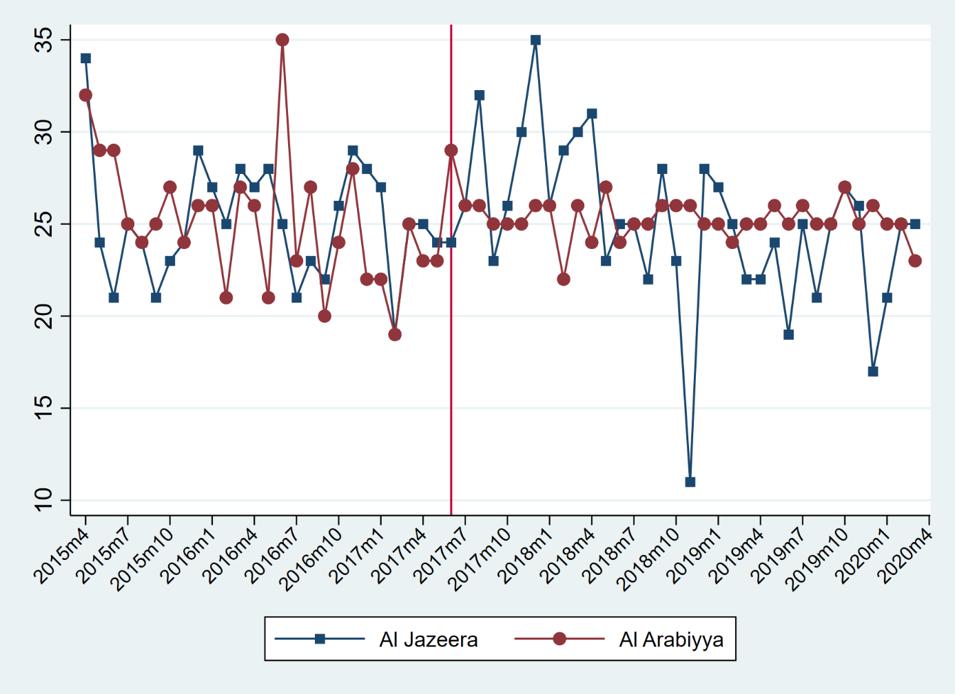

Figure 2: Monthly Distribution of the Coded News Articles

The text presents the monthly distribution of the nature of coverage as it is more detailed and challenging. If we have used this figure, anomalies such as 2019m10 would disappear but we choose to test our unique data set as much as possible. As it is observed Al Arabiya poses an increasing positive tone in the post-crisis period while the opposite occurs in Al Jazeera.

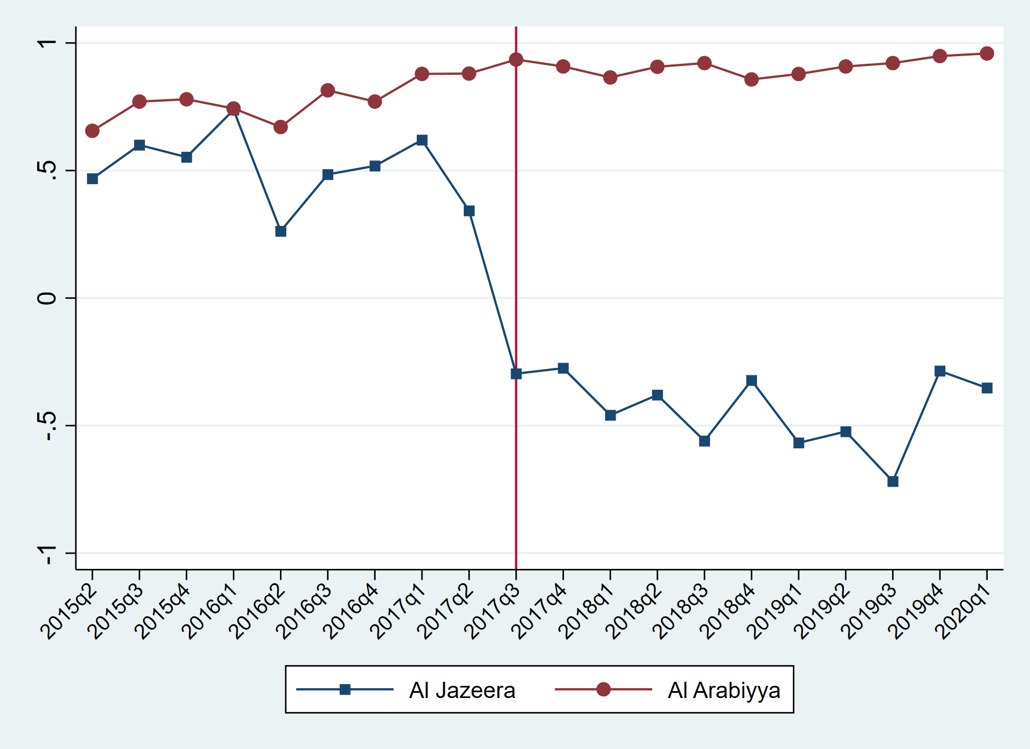

Figure 3: Quarterly Distribution of the Nature of Coverage

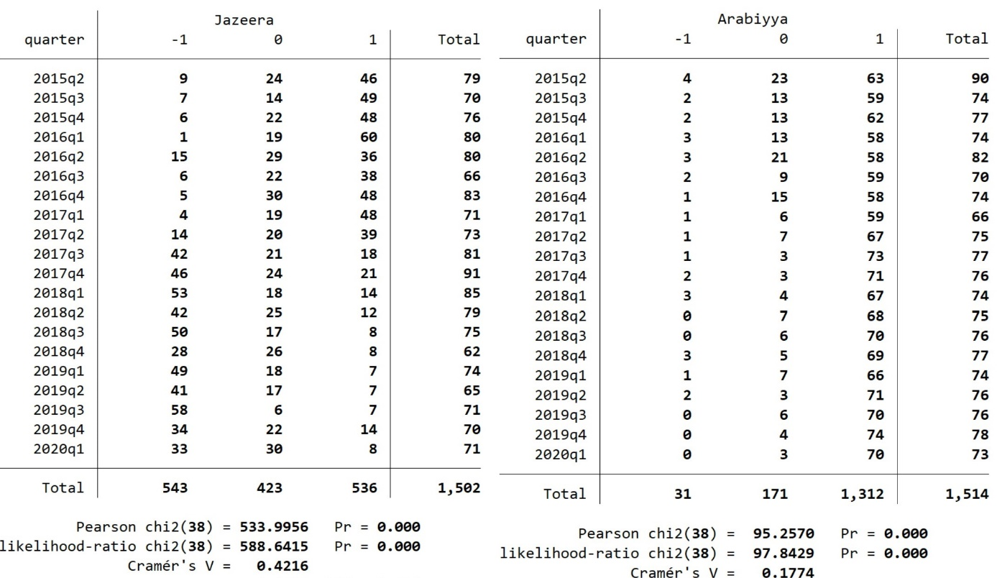

Table 4: Chi-square Tests for Each Media Outlet (Al Jazeera, Left) in Quarterly Periods

The text presents the divided picture of this table as we considered some scholars might want to see the whole. The reason behind out selection of the divided version is that this table does not clearly indicate where the differences occur in terms of news outlets. But the table in the text clearly indicates that the significant differences occurred 4 times out of 40 and 3 of these are for Al Jazeera. As we mentioned below there is a lack of archives for 2018q4 and other 3 anomalies occurred as a result of our attempts on having a uniform distribution. Since crisis and war keywords lacked the abundance of other keywords all of the new published in some quartiles such as 2017q4 and 2019q2 was included to reach the desired number of coded news for each article.

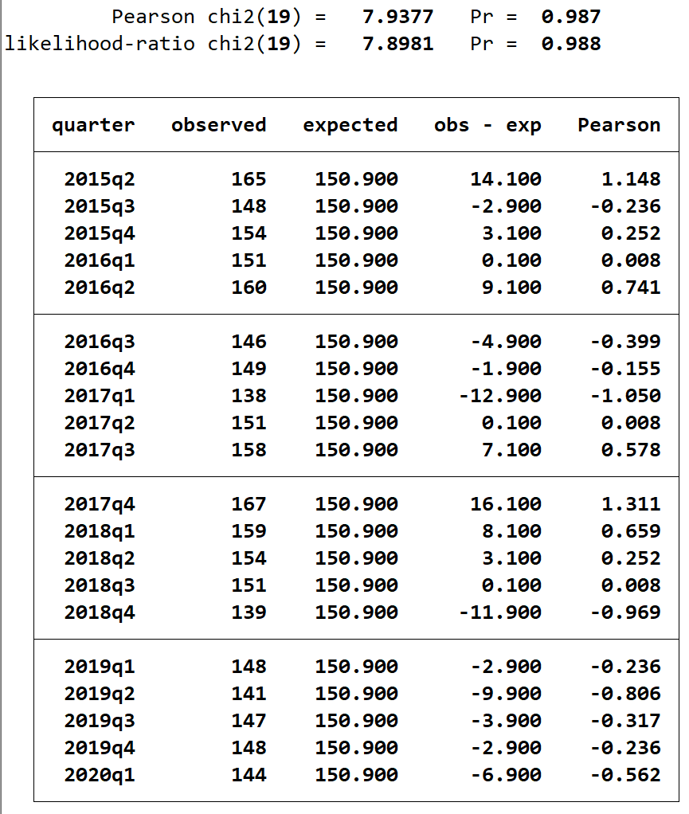

Table 5: Quarterly Presentation of the Frequency Analysis

Figure 4,5,6,7 and 8 illustrate the nature of coverage for the analysed period on a keyword basis.

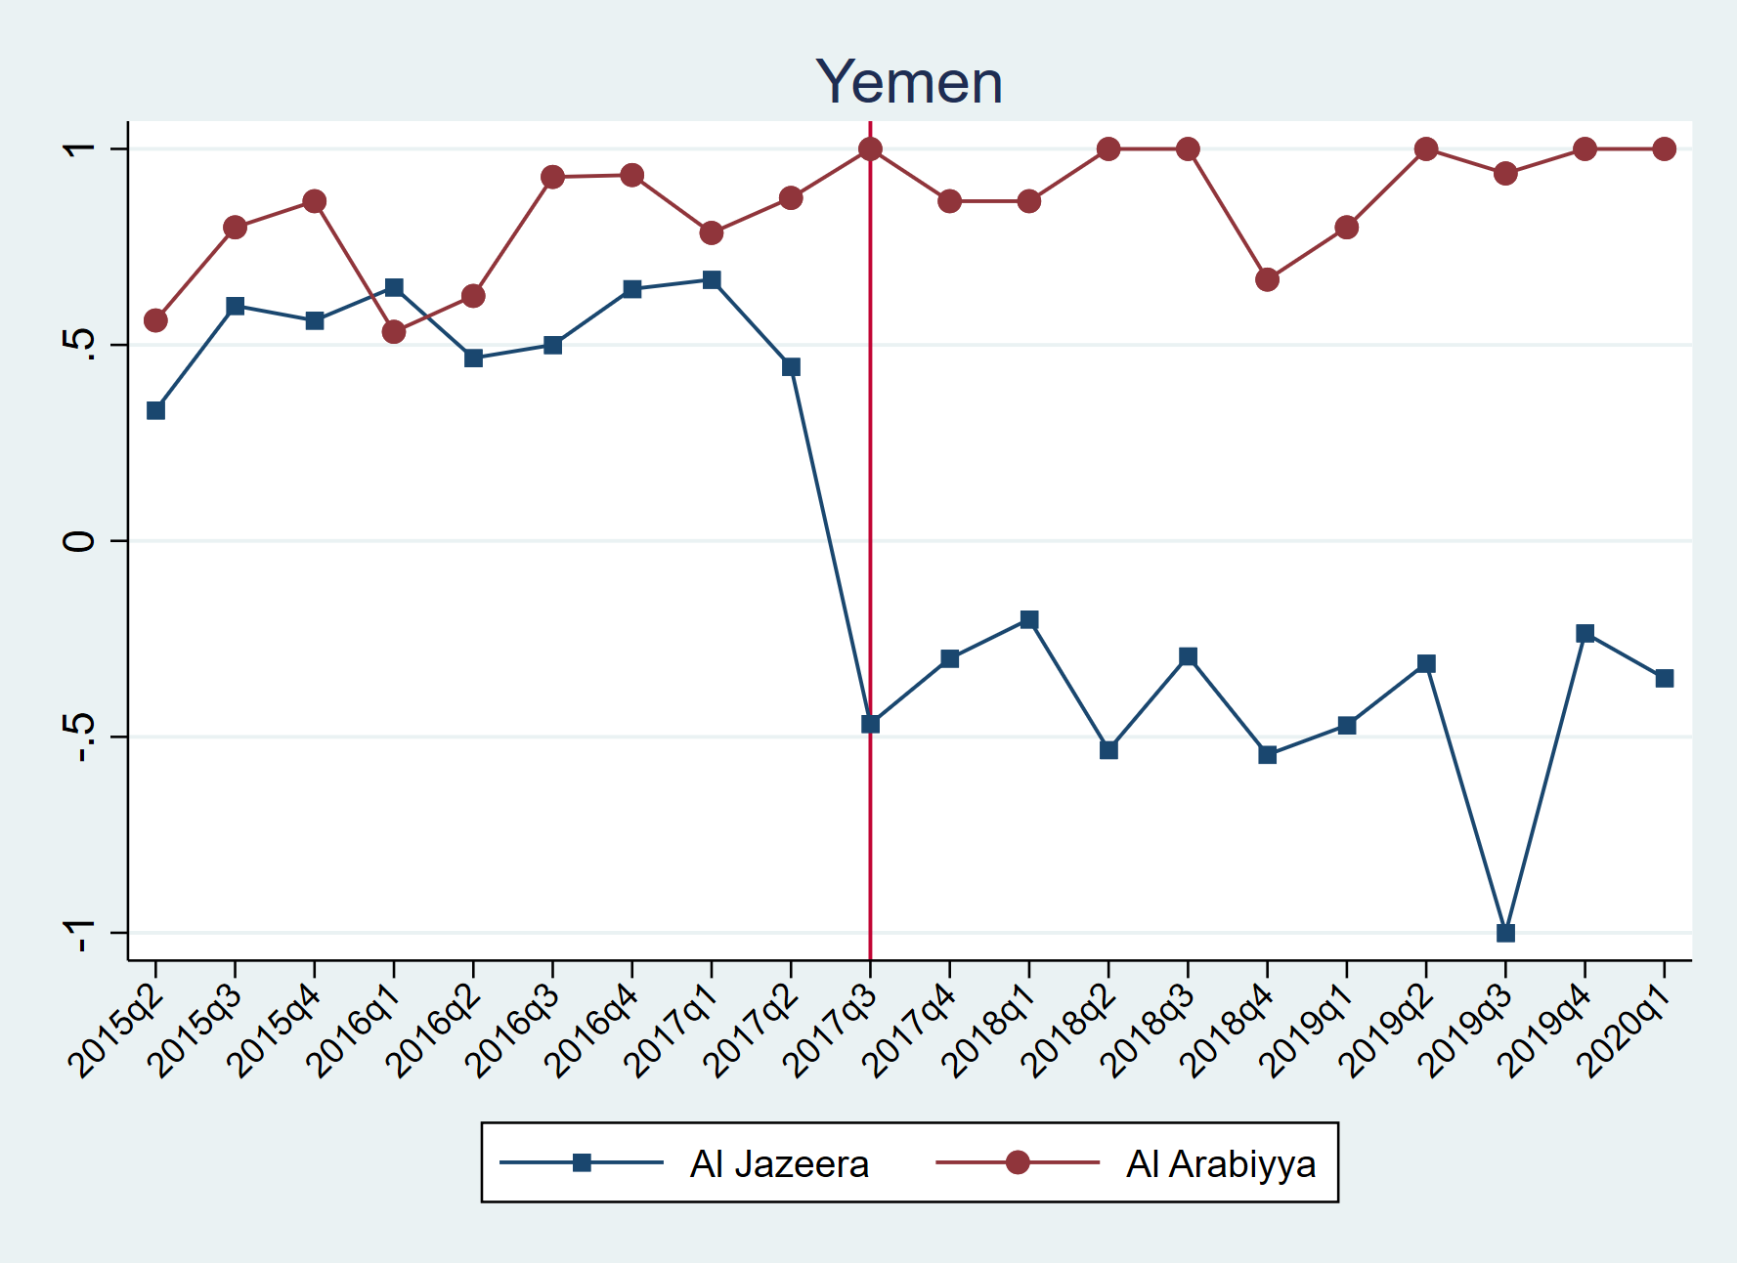

Figure 4: Quarterly Distribution of the Nature of Coded News Articles under Yemen Keyword

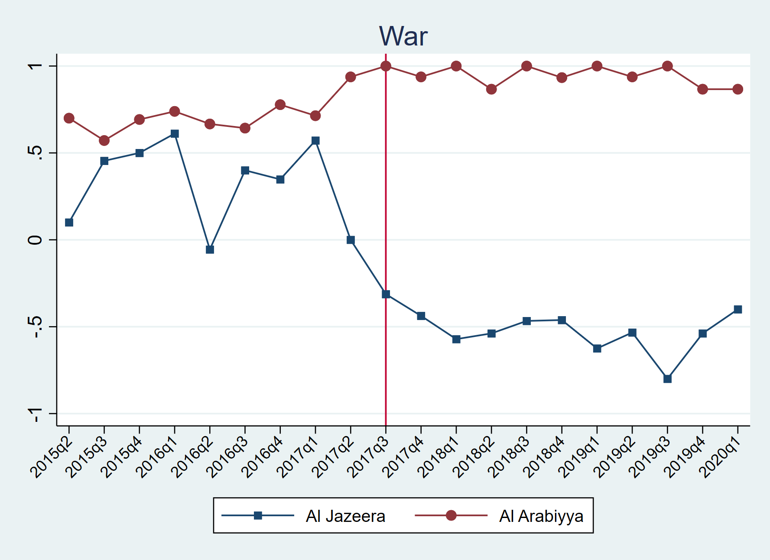

Figure 5: Quarterly Distribution of the Nature of Coded News Articles under War Keyword

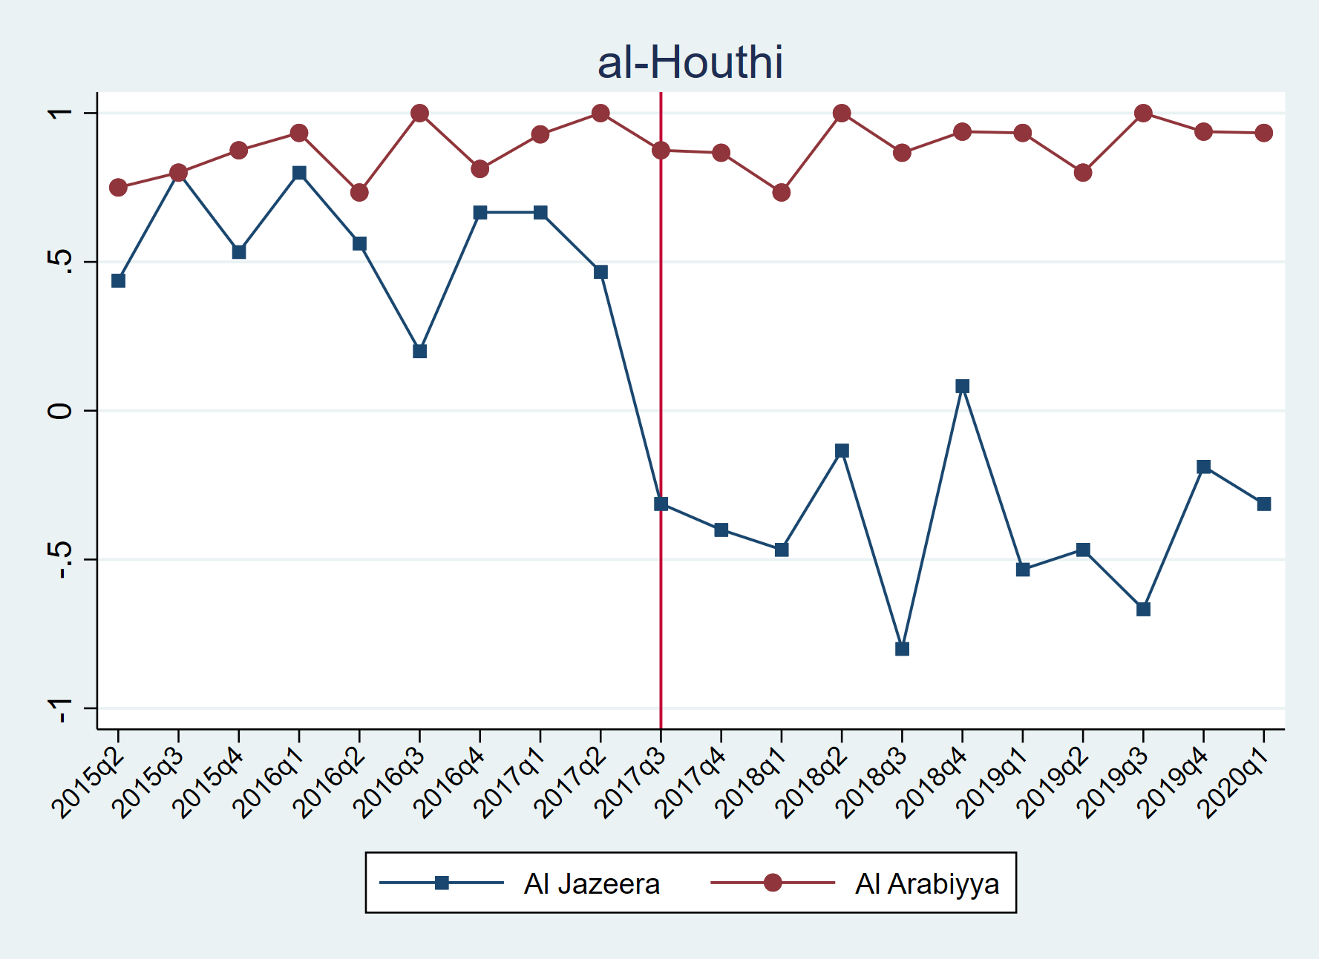

Figure 6: Quarterly Distribution of the Nature of Coded News Articles under al-Houthi Keyword

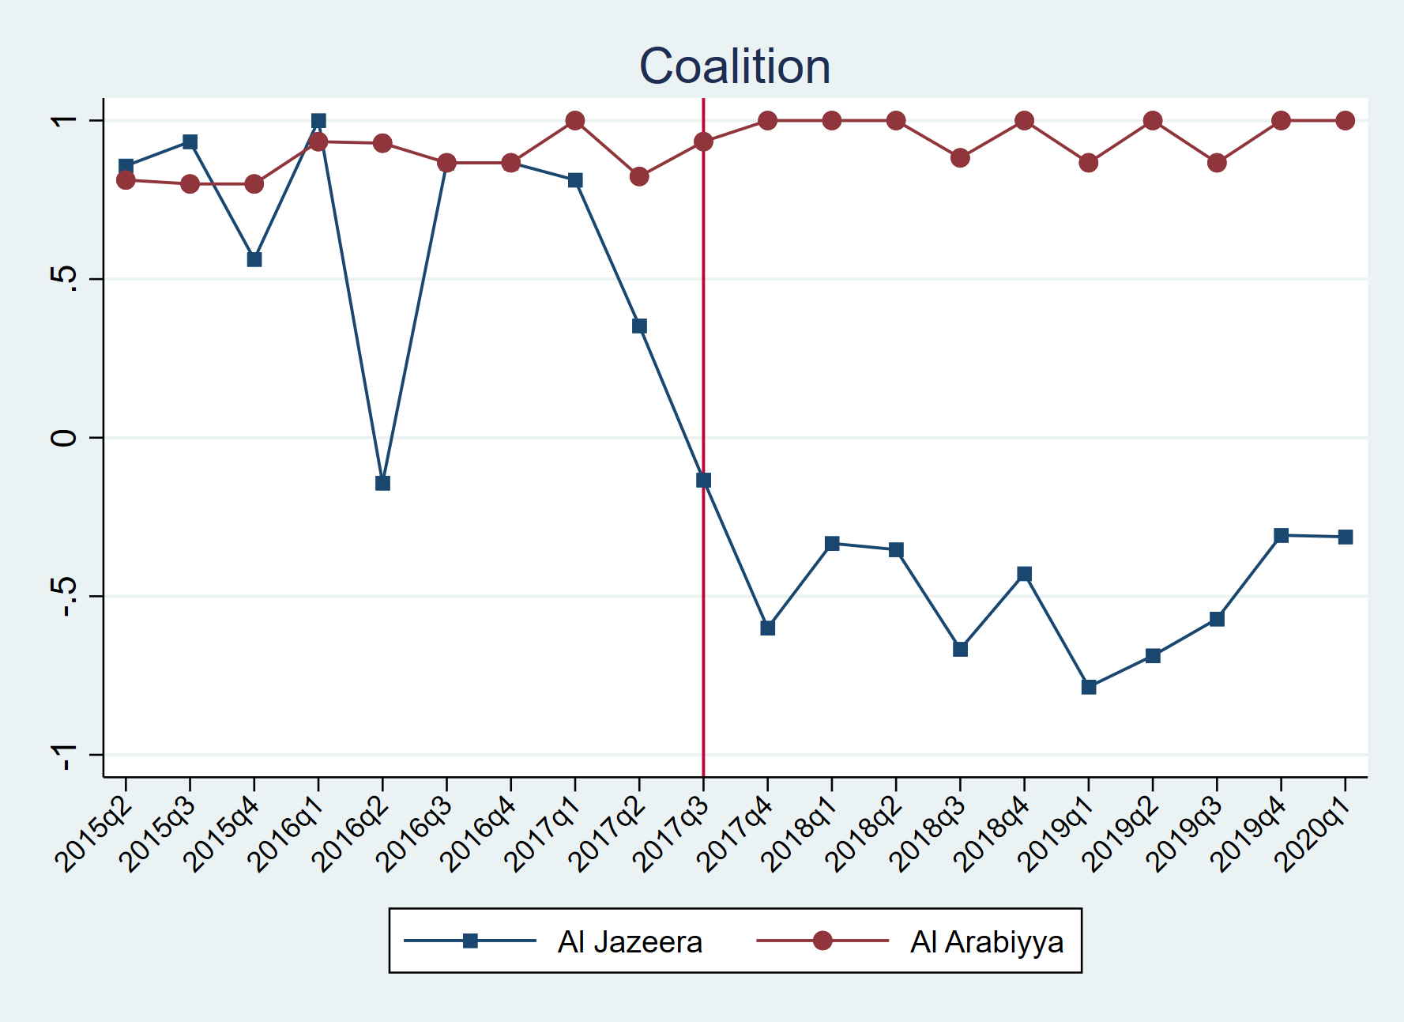

Figure 7: Quarterly Distribution of the Nature of Coded News Articles under Coalition Keyword

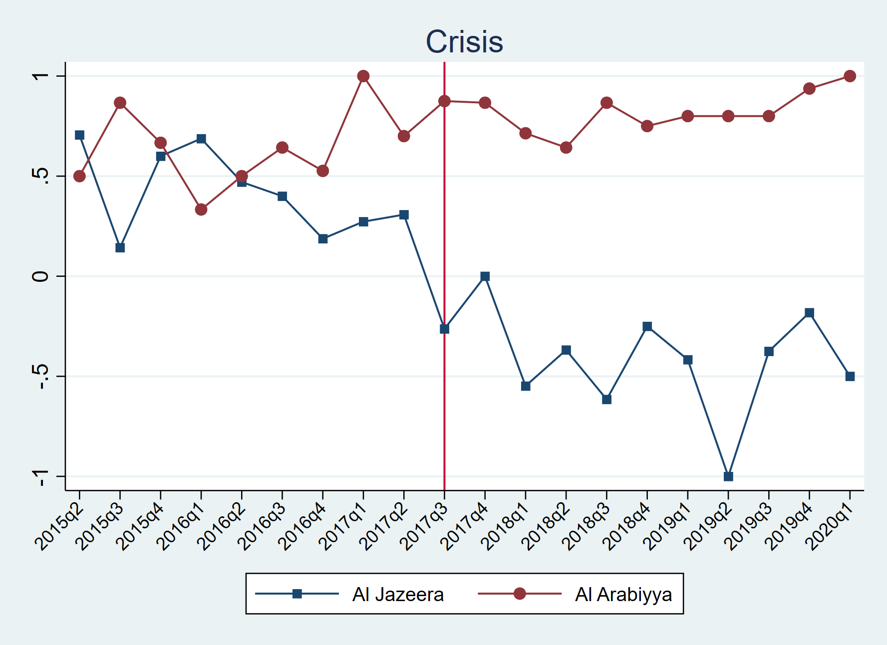

Figure 8: Quarterly Distribution of the Nature of Coded News Articles under Crisis Keyword

Figures 9,10,11,12 and 13 provide the monthly number of news coded in this research on a keyword basis.

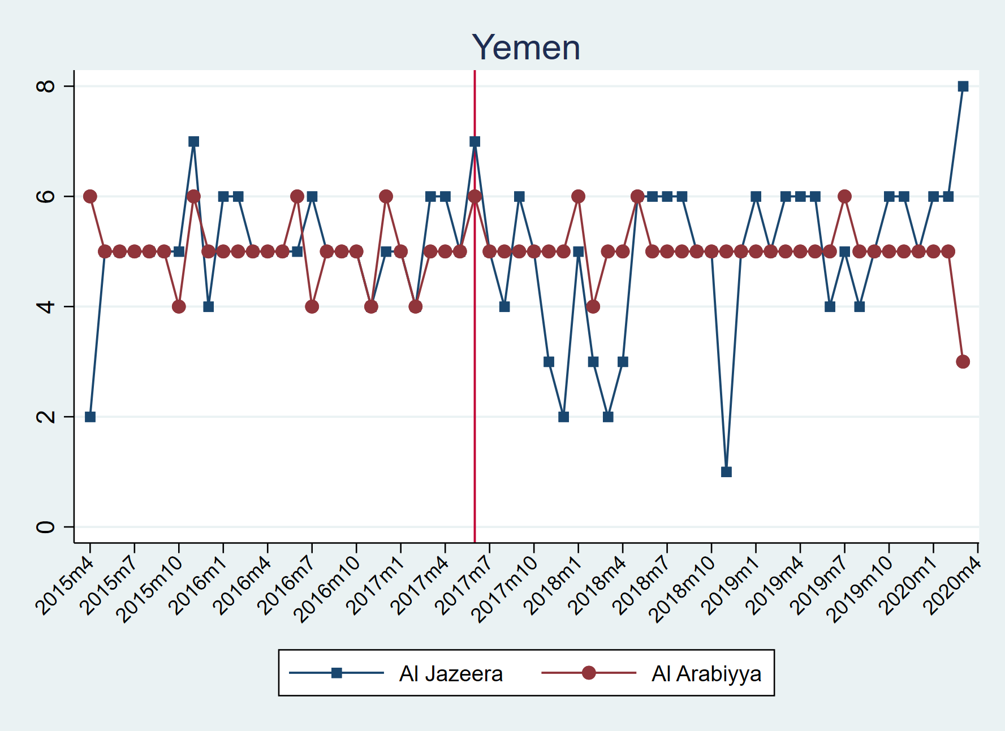

Figure 9: Monthly Distribution of the Coded News Articles under Yemen Keyword

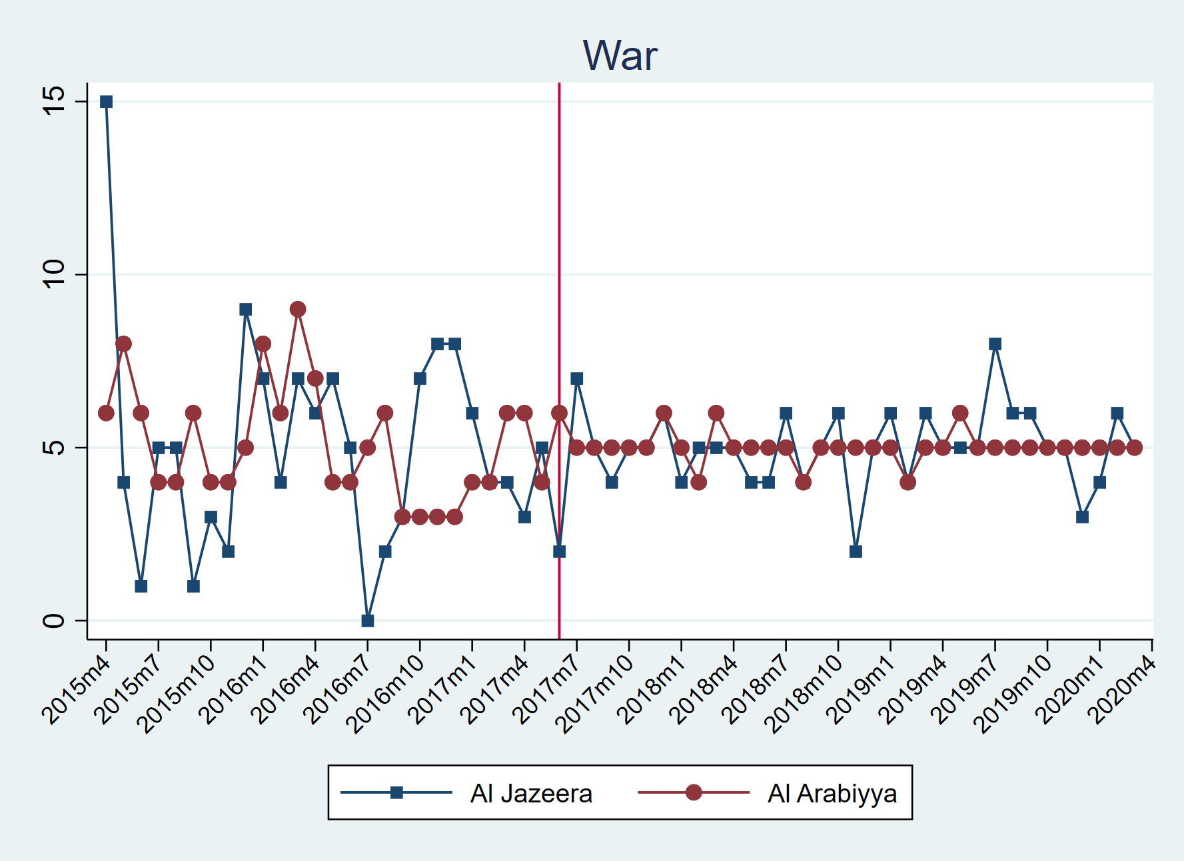

Figure 10: Monthly Distribution of the Coded News Articles under War Keyword

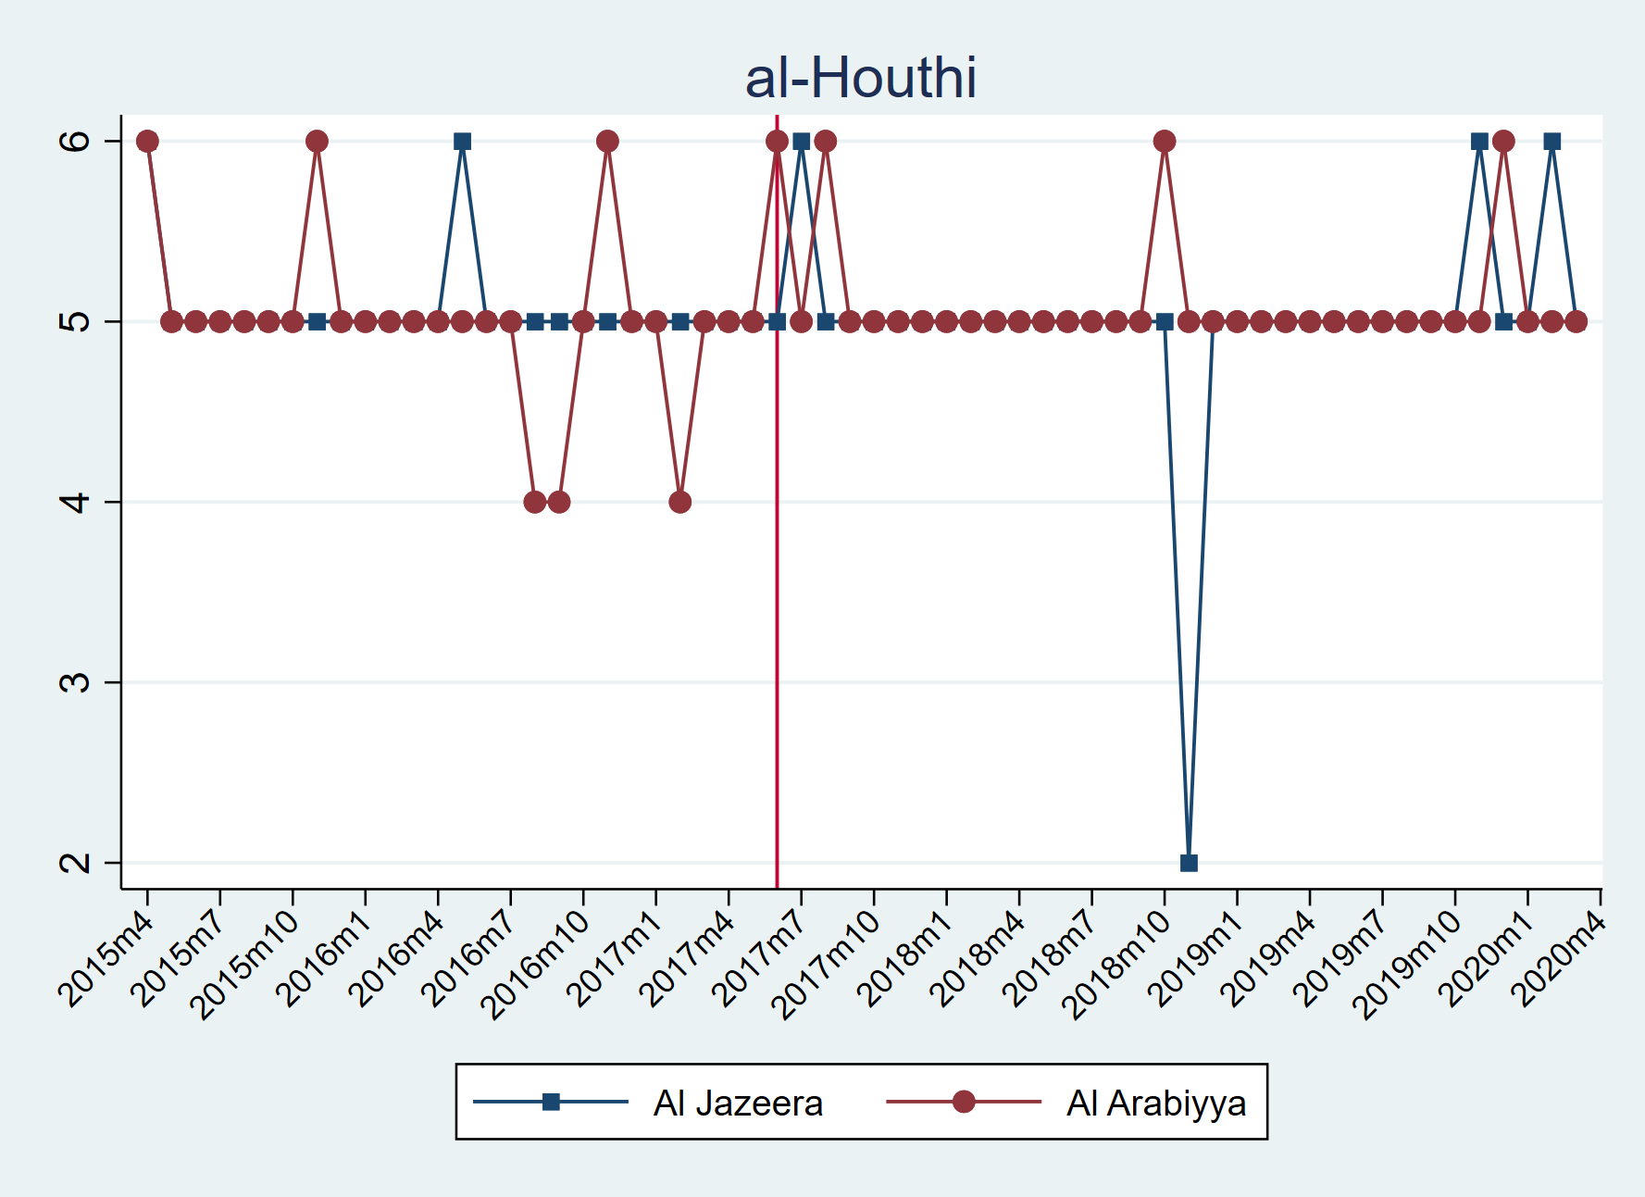

Figure 11: Monthly Distribution of the Coded News Articles under al-Houthi Keyword

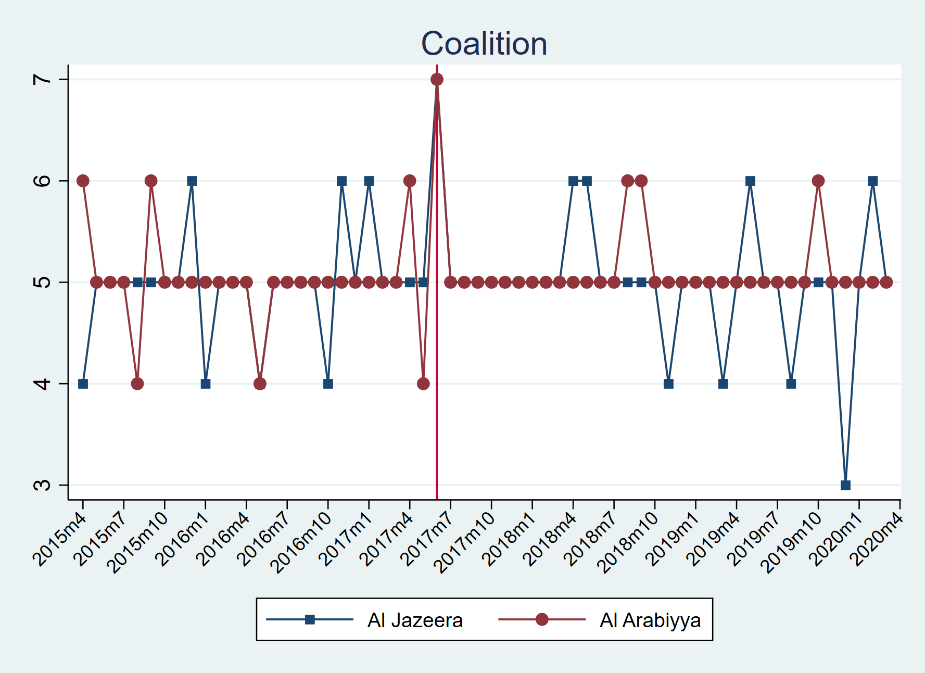

Figure 12: Monthly Distribution of the Coded News Articles under al-Houthi Keyword

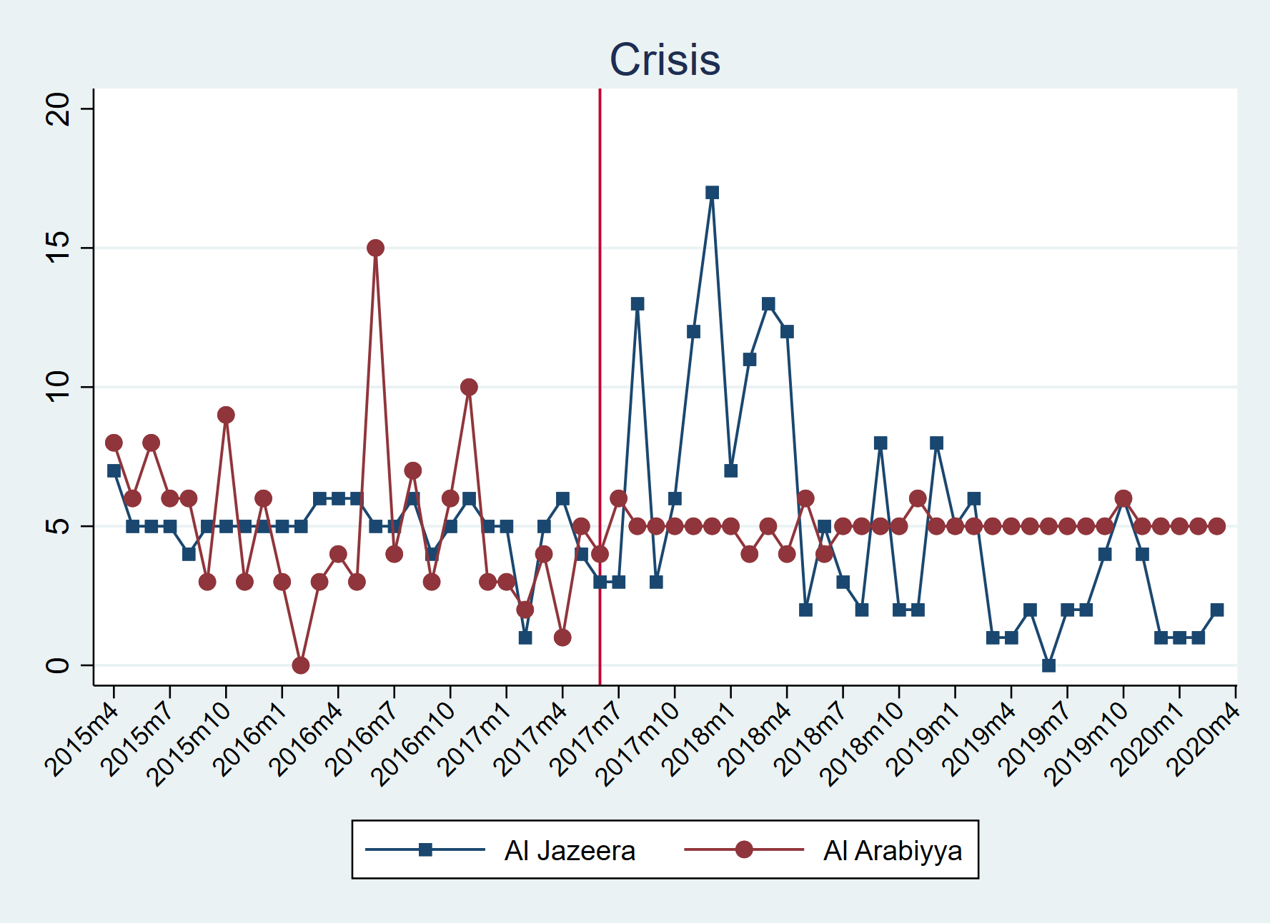

Figure 13: Monthly Distribution of the Coded News Articles under Crisis Keyword