# Appendix A

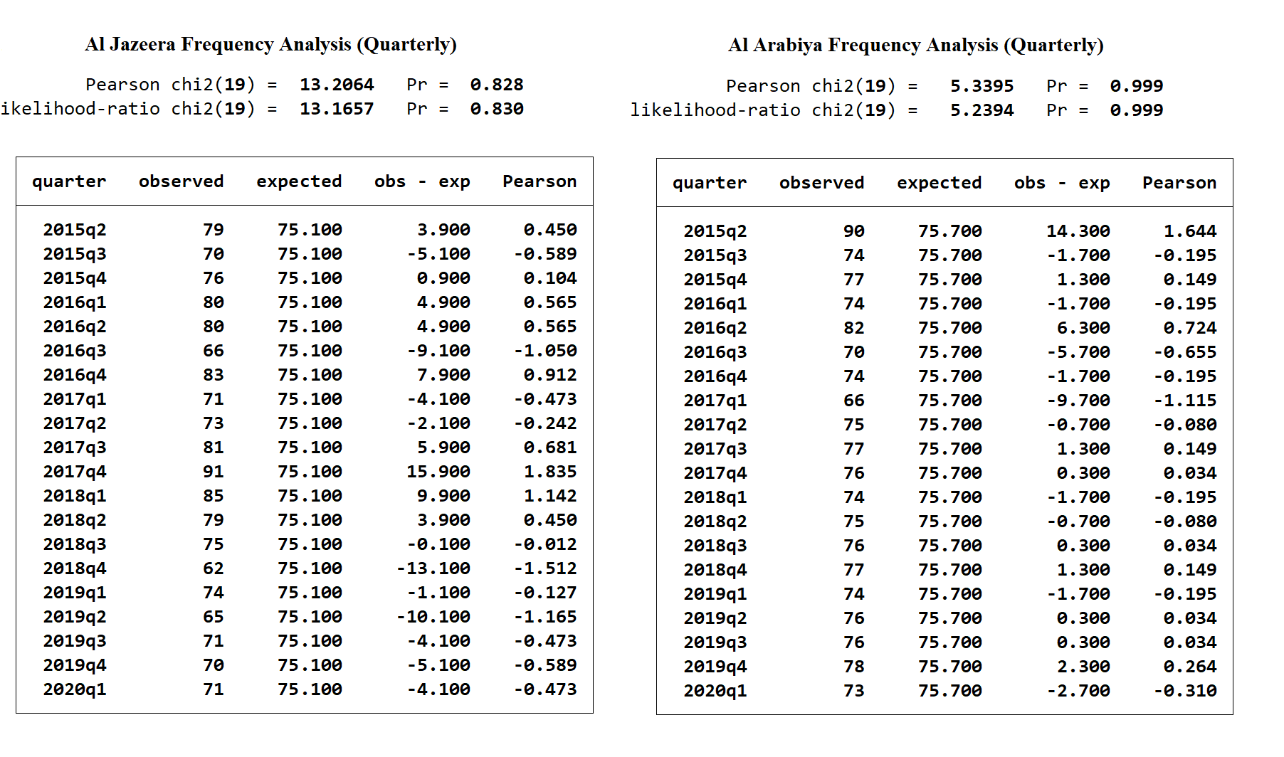

Table 1: The Frequency Test's Results for each Media Outlet

We preferred not to include the monthly number of news coded in the article since it is provided within quartiles in Table 1. The anomaly in 2018m10 occurred because the Al Jazeera archive does not comprise news articles for the period between November 1st-Novemver 20th for that year. Other than that, each month is expected to have a number of coded news articles ranging between 20-30 which is observed in the figure for the majority of the periods.

**Figure 1: Monthly Distribution Regarding Nature of Coverage of News Articles

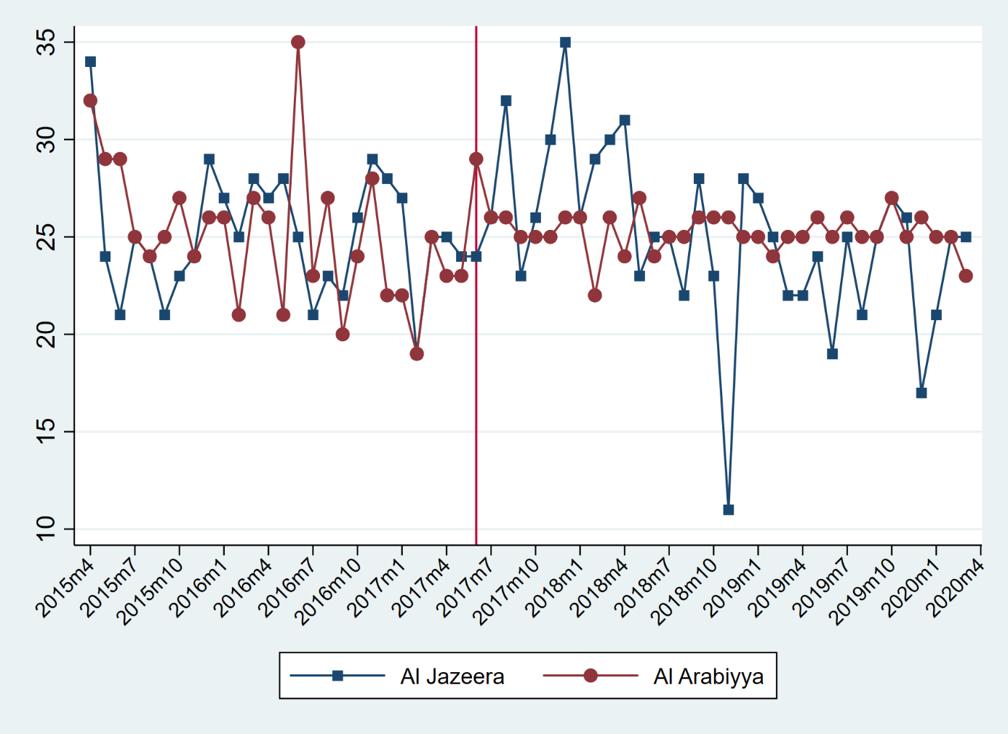

Figure 2: Monthly Distribution of the Coded News Articles

The text presents the monthly distribution of the nature of coverage as it is more detailed and challenging. If we have used this figure, anomalies such as 2019m10 would disappear but we choose to test our unique data set as much as possible. As it is observed Al Arabiya poses an increasing positive tone in the post-crisis period while the opposite occurs in Al Jazeera.

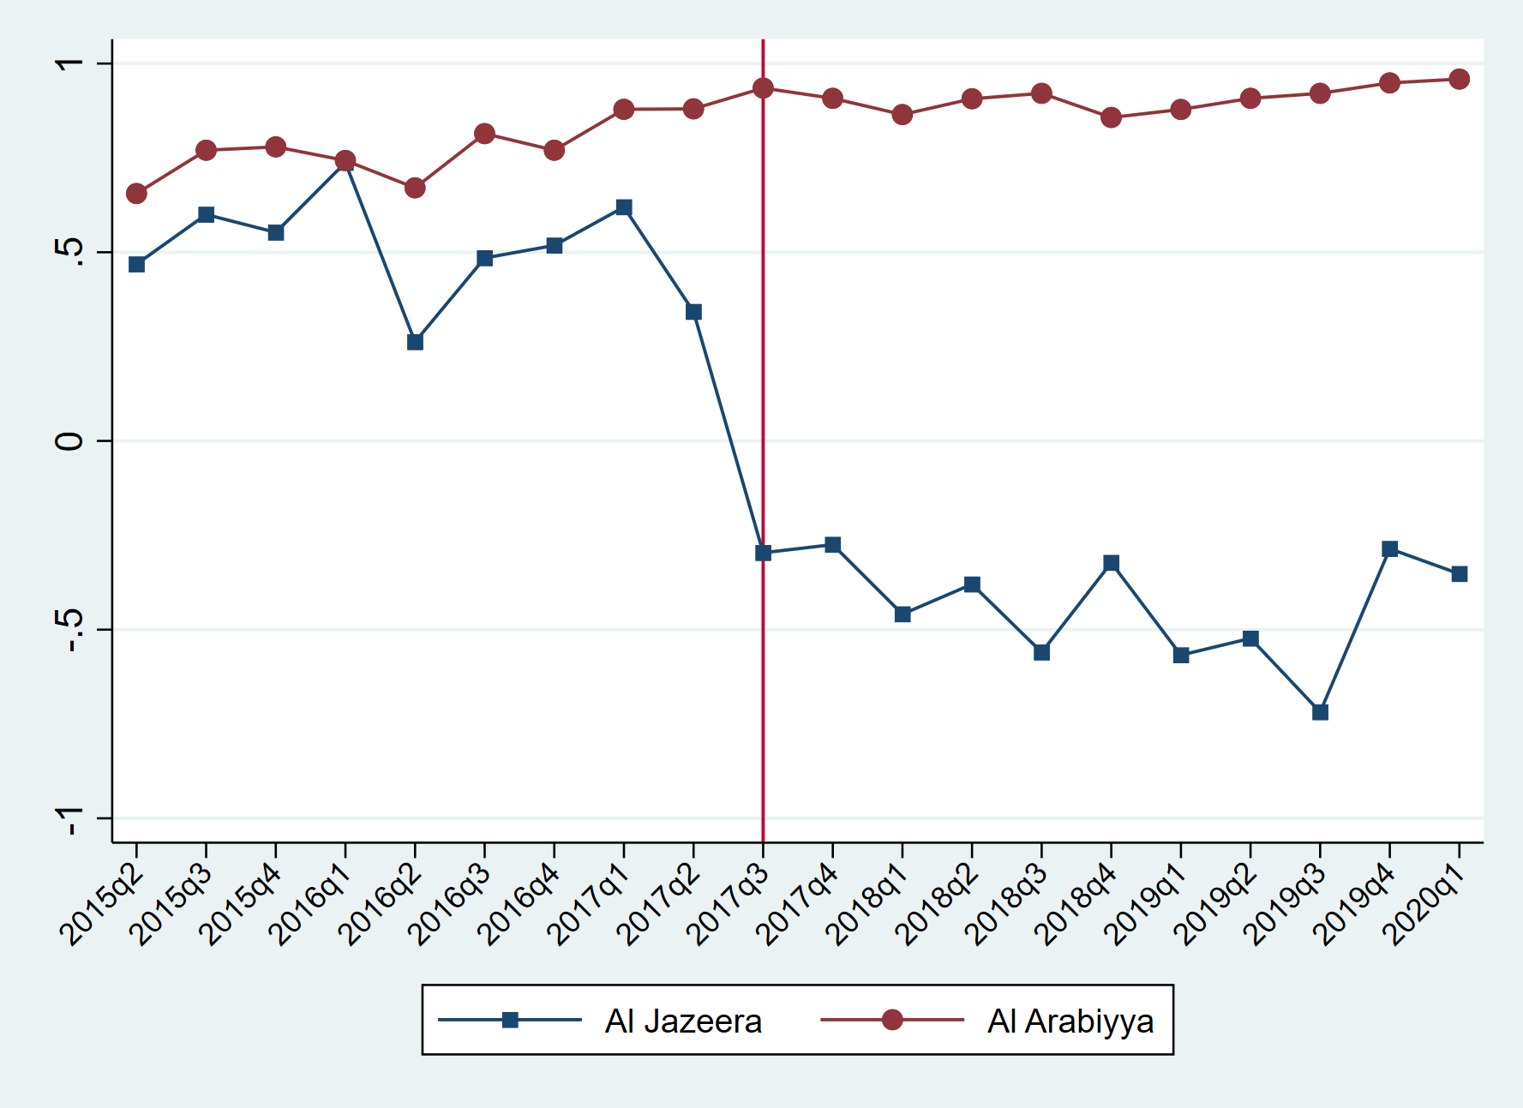

Figure 3: Quarterly Distribution of the Nature of Coverage

# Appendix C

Table 4: Chi-square Tests for Each Media Outlet (Al Jazeera, Left) in Quarterly Periods

The text presents the divided picture of this table as we considered some scholars might want to see the whole. The reason behind out selection of the divided version is that this table does not clearly indicate where the differences occur in terms of news outlets. But the table in the text clearly indicates that the significant differences occurred 4 times out of 40 and 3 of these are for Al Jazeera. As we mentioned below there is a lack of archives for 2018q4 and other 3 anomalies occurred as a result of our attempts on having a uniform distribution. Since crisis and war keywords lacked the abundance of other keywords all of the new published in some quartiles such as 2017q4 and 2019q2 was included to reach the desired number of coded news for each article.

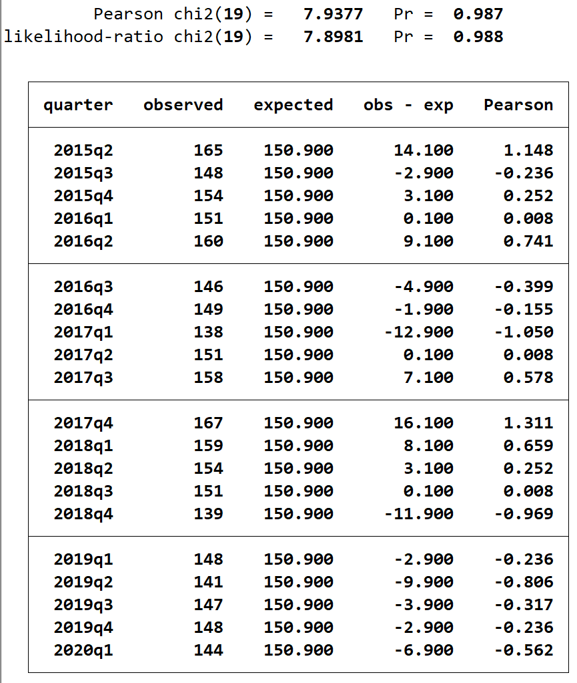

Table 5: Quarterly Presentation of the Frequency Analysis

# Appendix D

Figure 4,5,6,7 and 8 illustrate the nature of coverage for the analysed period on a keyword basis.

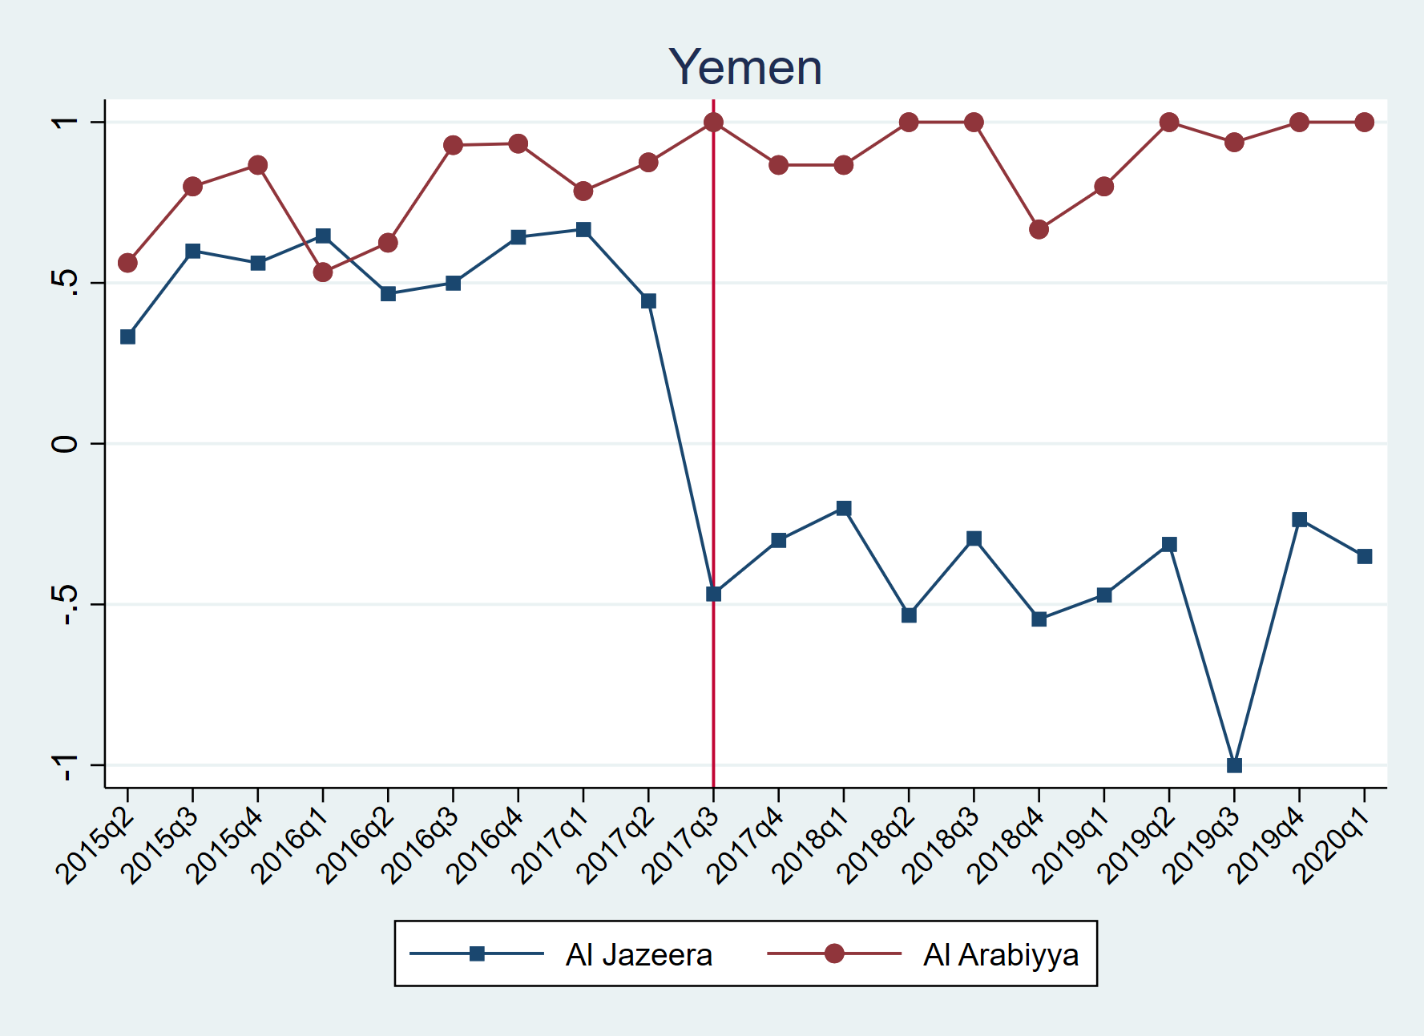

Figure 4: Quarterly Distribution of the Nature of Coded News Articles under Yemen Keyword

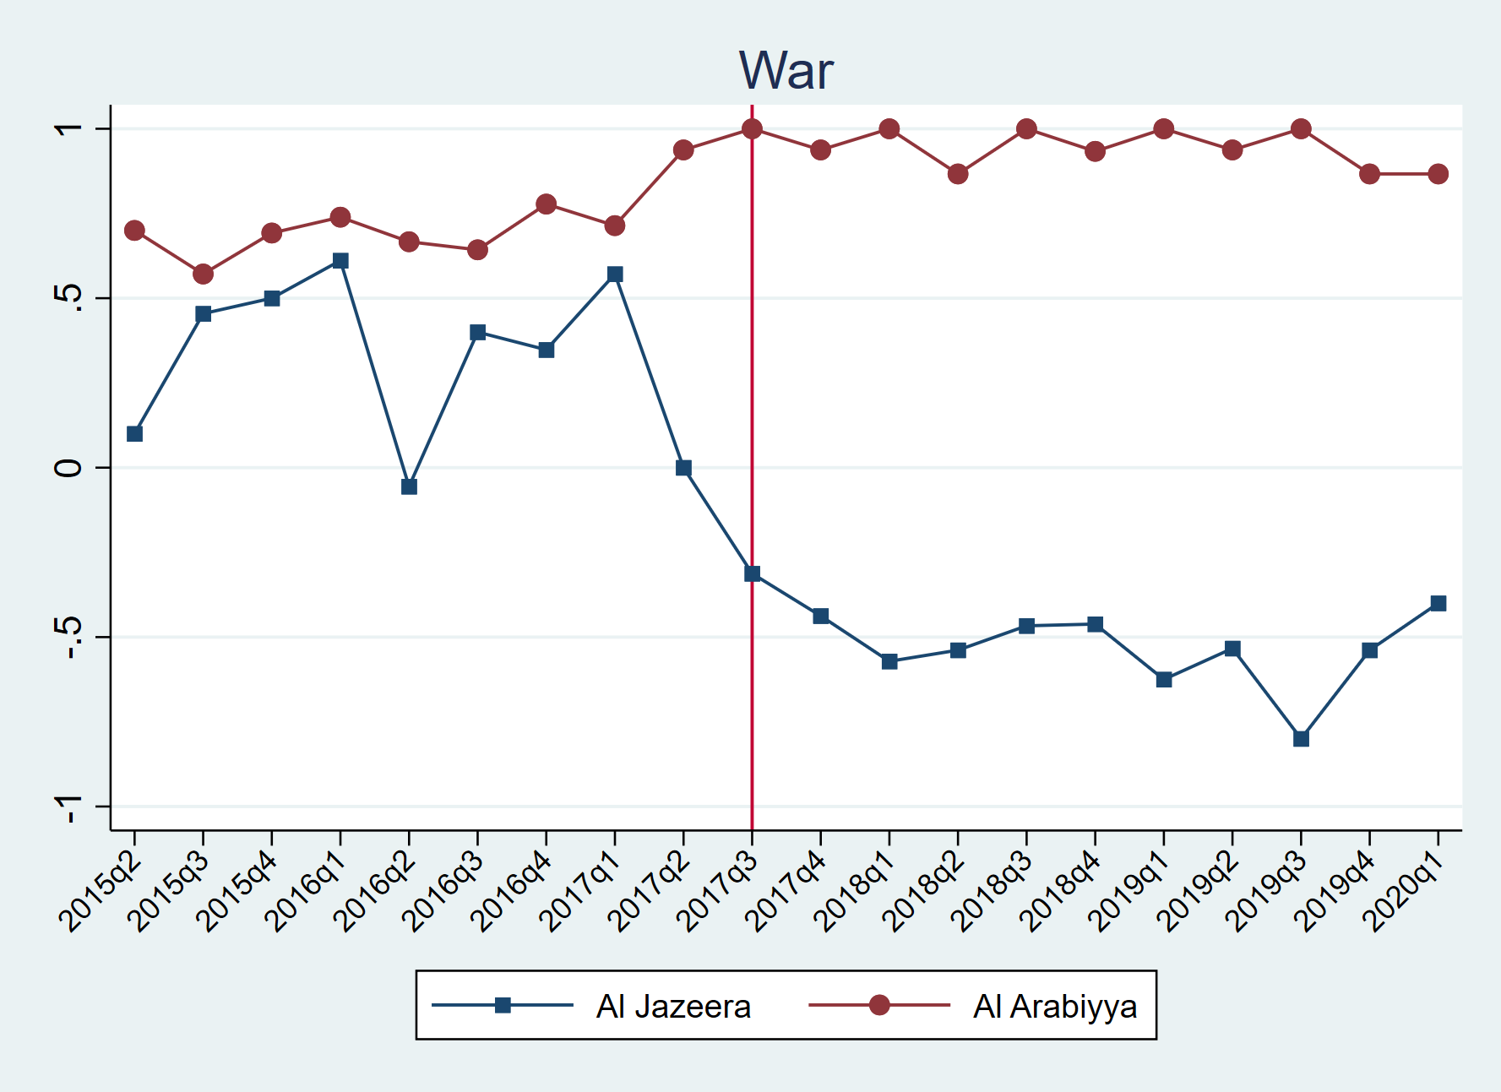

Figure 5: Quarterly Distribution of the Nature of Coded News Articles under War Keyword

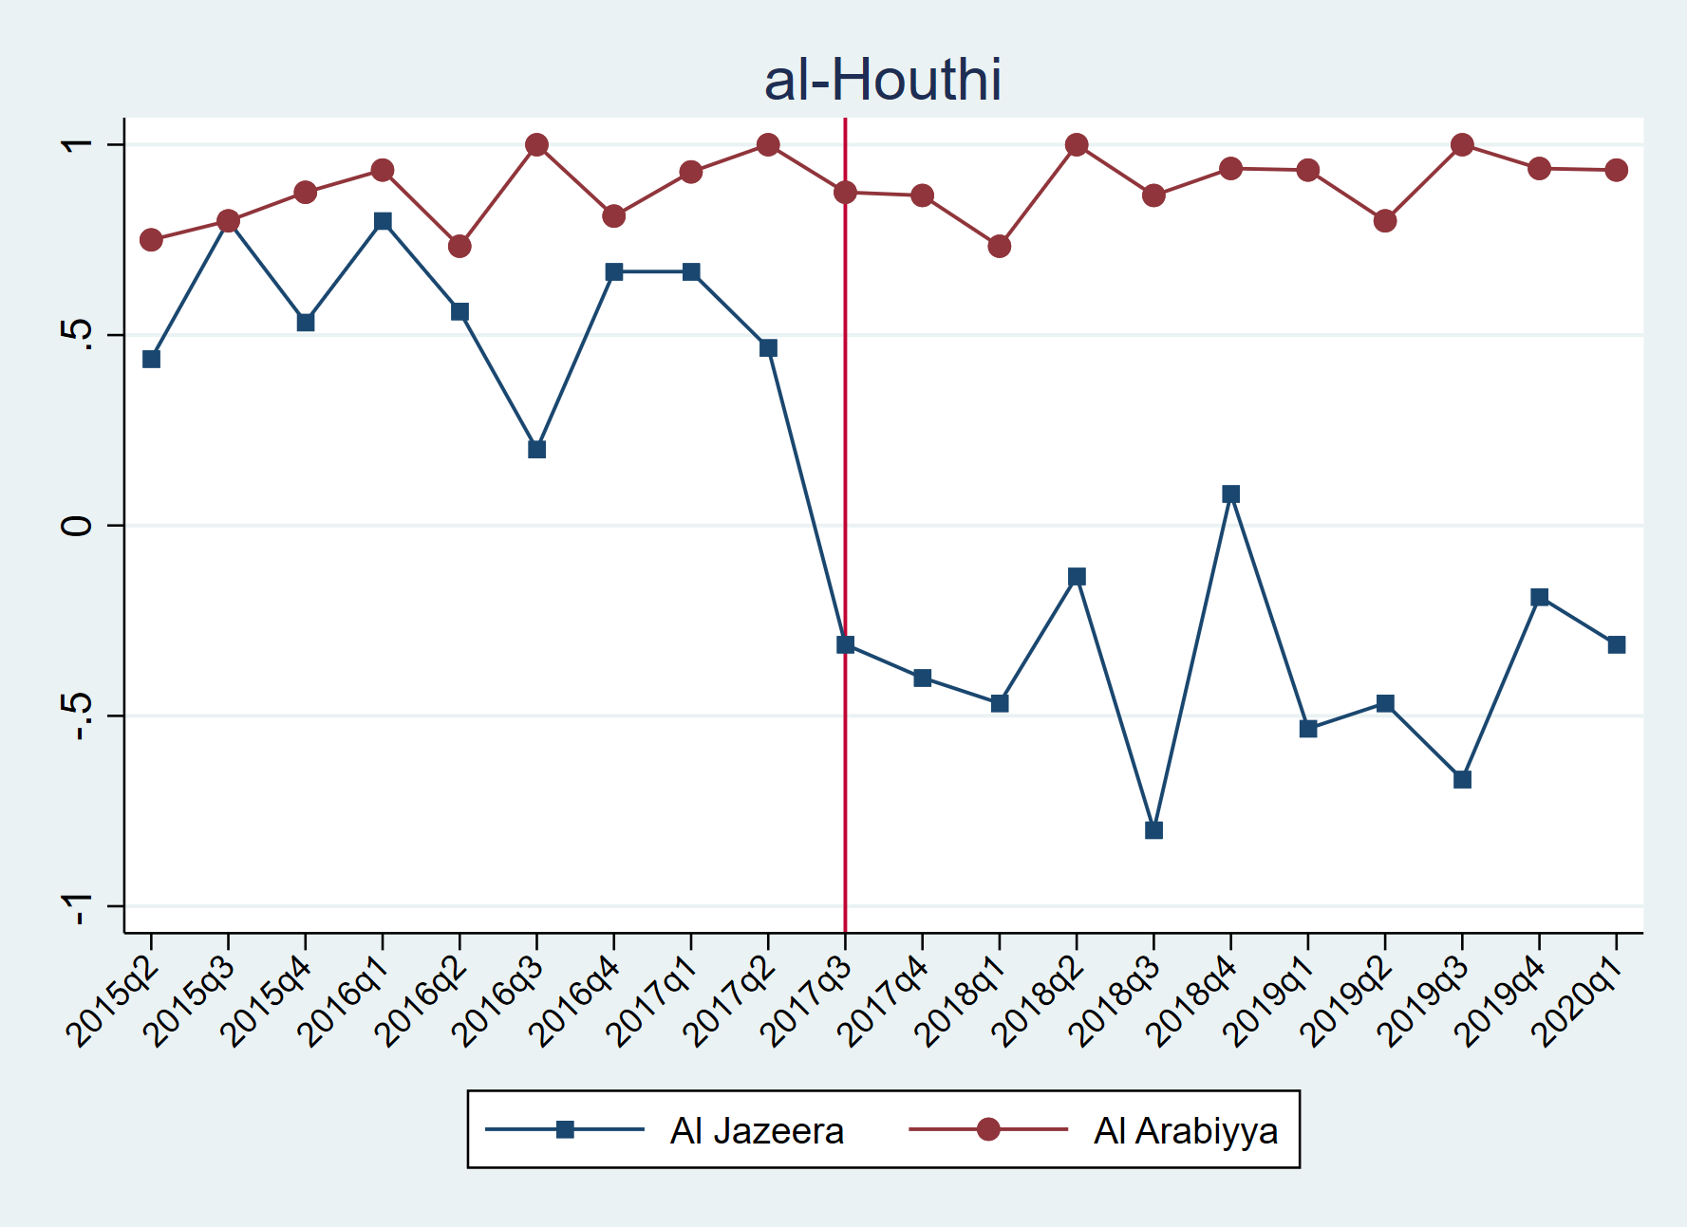

Figure 6: Quarterly Distribution of the Nature of Coded News Articles under al-Houthi Keyword

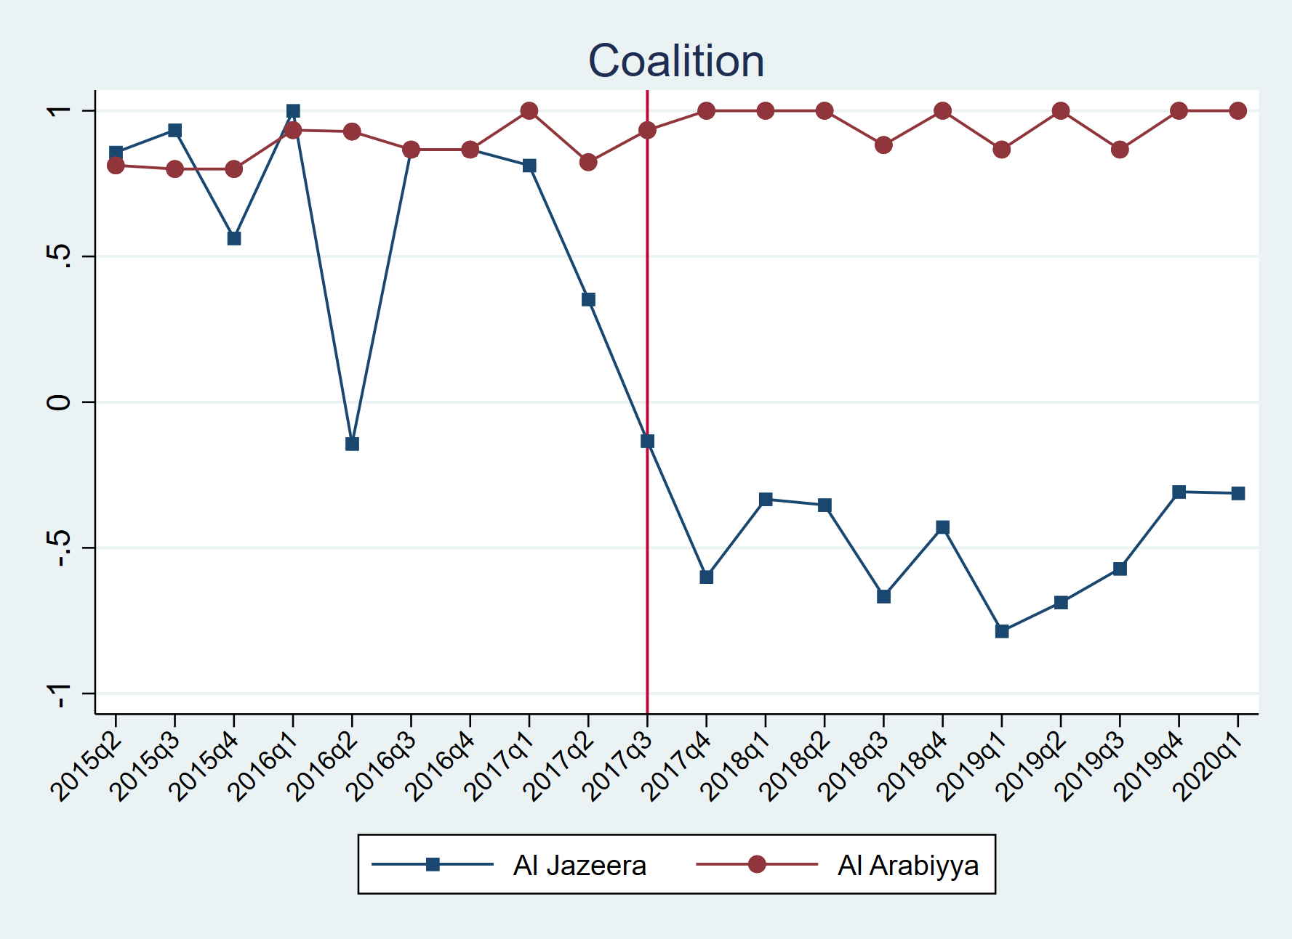

Figure 7: Quarterly Distribution of the Nature of Coded News Articles under Coalition Keyword

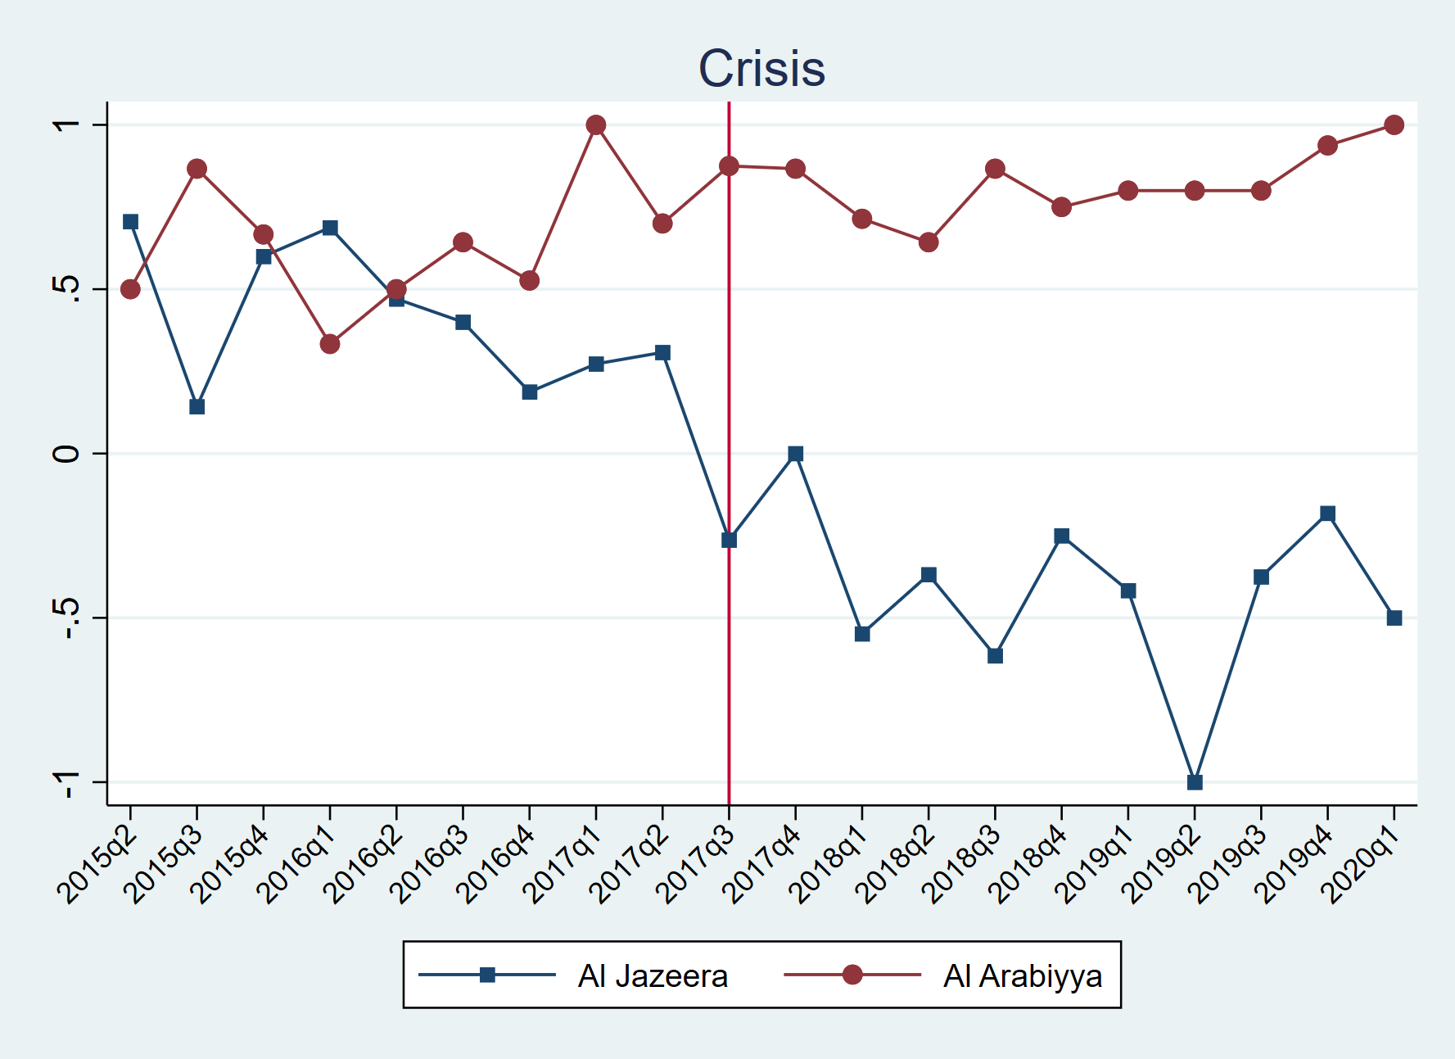

Figure 8: Quarterly Distribution of the Nature of Coded News Articles under Crisis Keyword

# Appendix E

Figures 9,10,11,12 and 13 provide the monthly number of news coded in this research on a keyword basis.

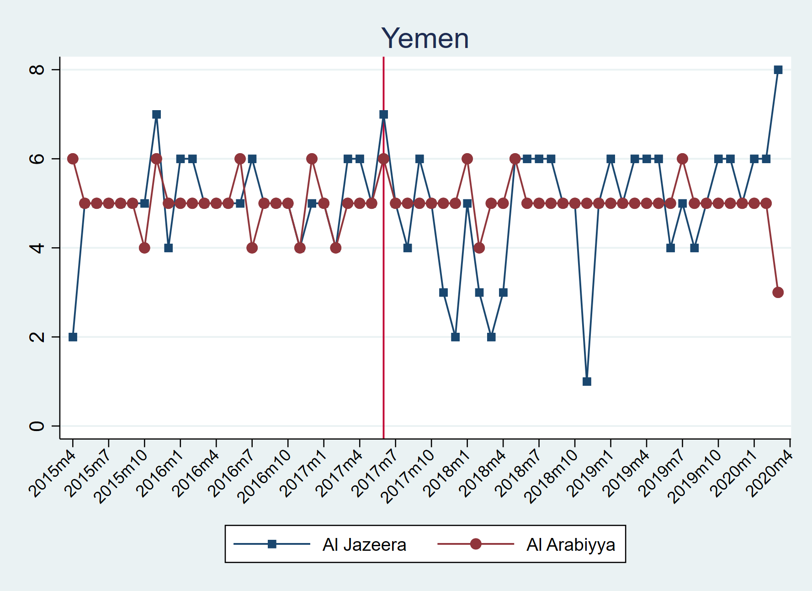

Figure 9: Monthly Distribution of the Coded News Articles under Yemen Keyword

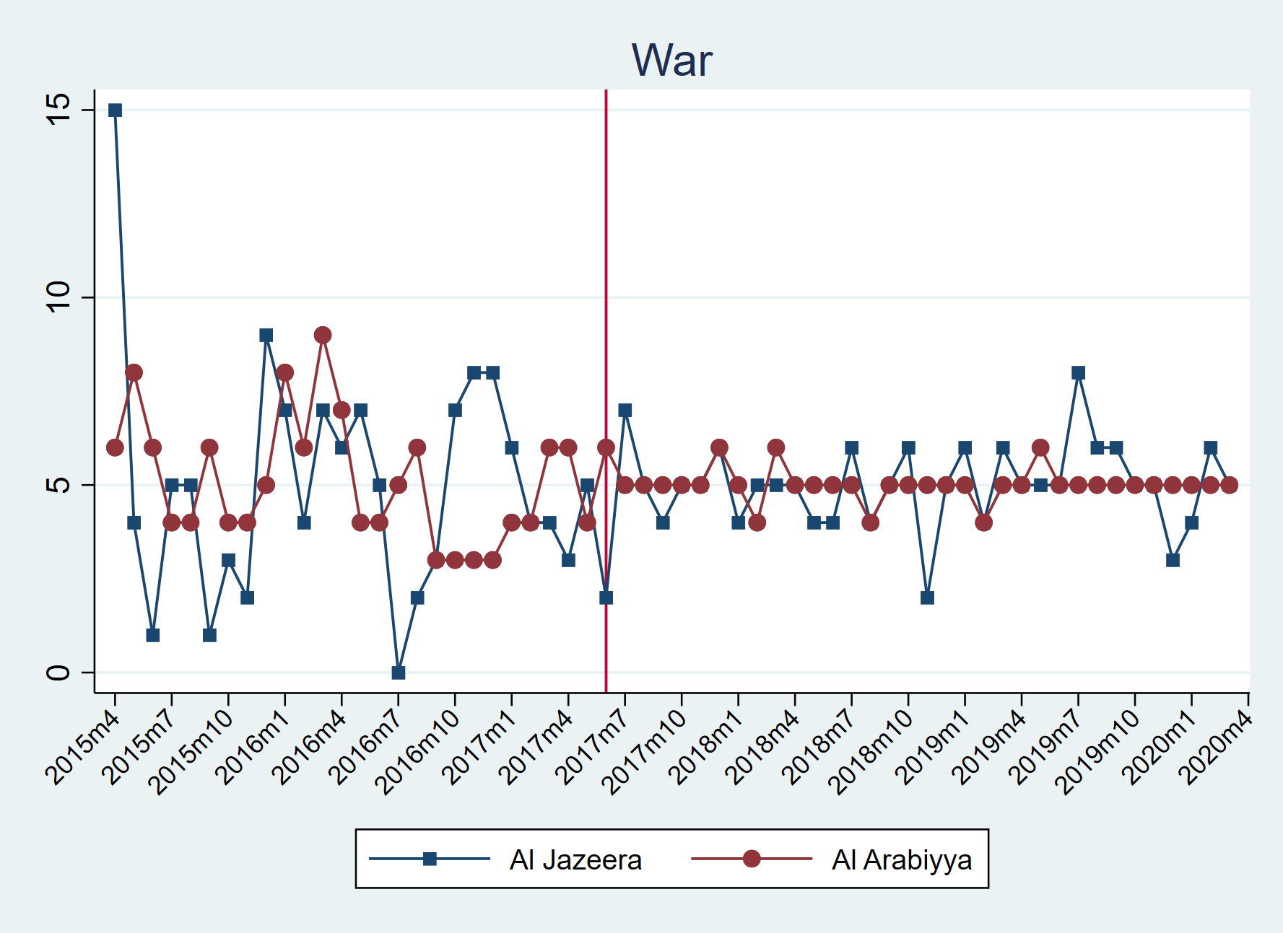

Figure 10: Monthly Distribution of the Coded News Articles under War Keyword

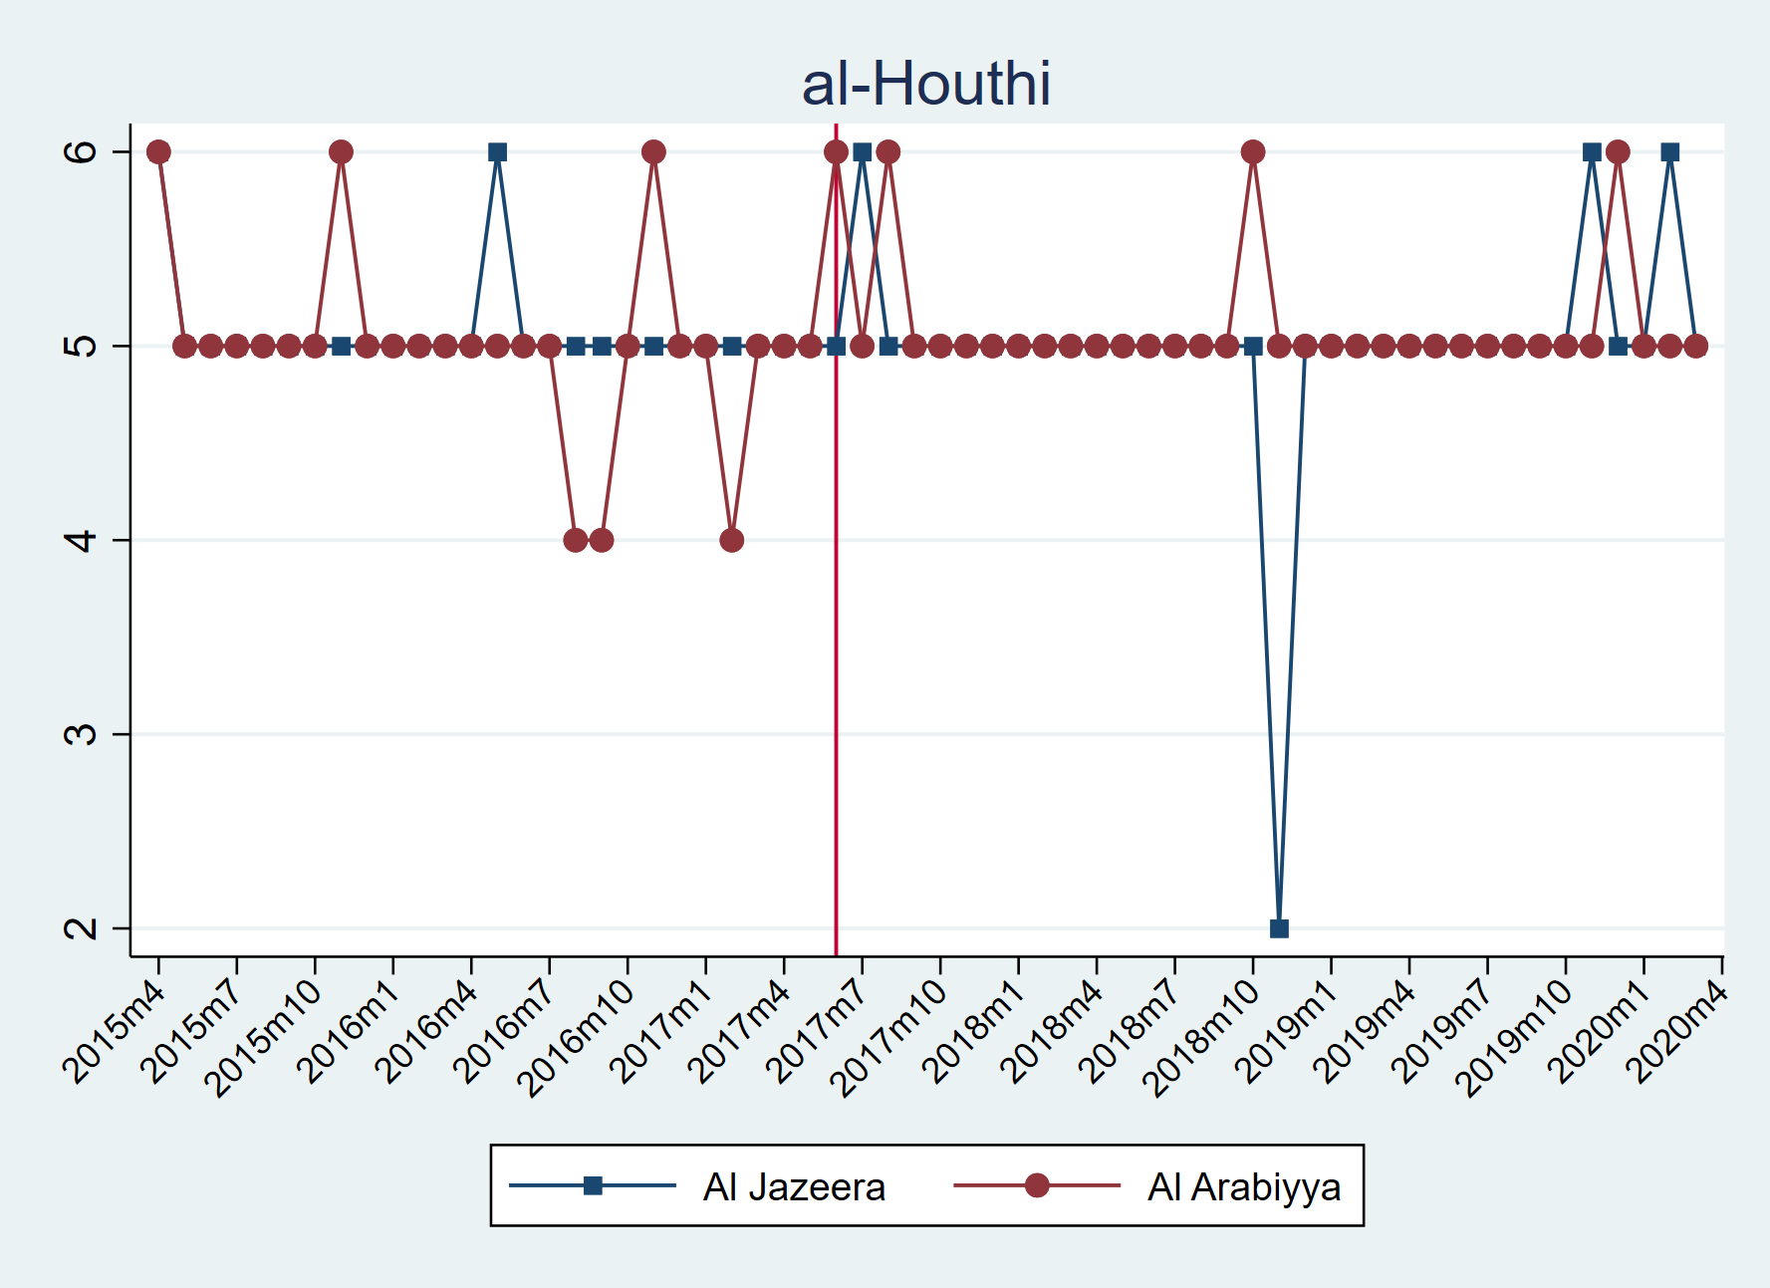

Figure 11: Monthly Distribution of the Coded News Articles under al-Houthi Keyword

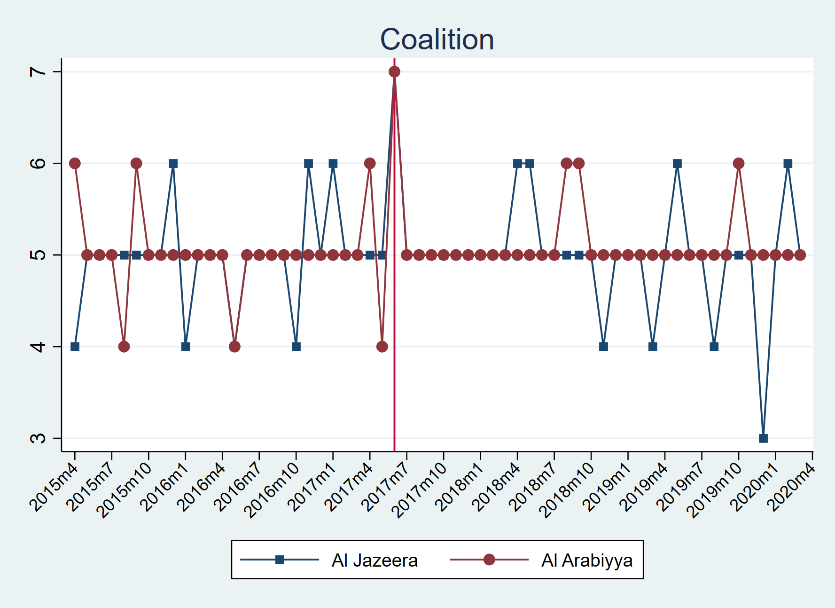

Figure 12: Monthly Distribution of the Coded News Articles under al-Houthi Keyword

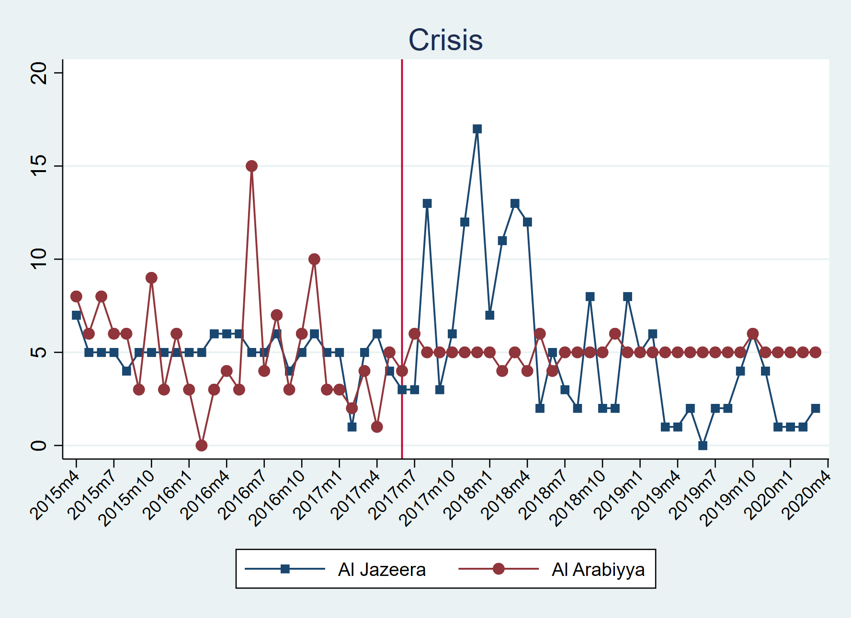

Figure 13: Monthly Distribution of the Coded News Articles under Crisis Keyword

# Appendix F

# Coding Sheet

# Positive/Negative/Mixed News Piece Samples

* Positive News Sample

News Source: Al Arabiyya

Keyword: Houthis

بريطانيا: صواريخ الحوثي على السعودية تهدد السلامTitle:

Link: <https://www.alarabiya.net/ar/arab-and-world/2020/03/30/%D8%A8%D8%B1%D9%8A%D8%B7%D8%A7%D9%86%D9%8A%D8%A7-%D8%B5%D9%88%D8%A7%D8%B1%D9%8A%D8%AE-%D8%A7%D9%84%D8%AD%D9%88%D8%AB%D9%8A-%D8%B9%D9%84%D9%89-%D8%A7%D9%84%D8%B3%D8%B9%D9%88%D8%AF%D9%8A%D8%A9-%D8%AA%D9%87%D8%AF%D8%AF-%D8%A7%D9%84%D8%B3%D9%84%D8%A7%D9%85>

Reason: The coding sheet answers, and the overall piece talks about the Western support for the Saudi role in the war in Yemen.

* Negative News Sample

New Source: Al Jazeera

Keyword: Houthis

ناشونال إنترست: على أميركا محاسبة السعوديين والإماراتيين على أفعالهم باليمن Title:

Link: <https://www.aljazeera.net/news/politics/2019/2/24/%d8%ad%d8%b1%d8%a8-%d8%a7%d9%84%d9%8a%d9%85%d9%86-%d8%a7%d9%84%d8%b3%d8%b9%d9%88%d8%af%d9%8a%d8%a9-%d8%a7%d9%84%d8%a5%d9%85%d8%a7%d8%b1%d8%a7%d8%aa-%d9%83%d8%a7%d8%b1%d8%ab%d8%a9-%d8%a5%d9%86%d8%b3%d8%a7%d9%86%d9%8a%d8%a9>

Reason: The Coding sheet answers, and the overall piece talks about the fading US support fort he coalition and the war crimes of the coalition forces.

* Mixed/Neutral News Sample

News Source: Al Jazeera

Keyword: Crisis

مجلس الأمن يرحب بمحادثات جديدة باليمن Title:

Link: <https://www.aljazeera.net/news/arabic/2015/9/12/%d9%85%d8%ac%d9%84%d8%b3-%d8%a7%d9%84%d8%a3%d9%85%d9%86-%d9%8a%d8%b1%d8%ad%d8%a8-%d8%a8%d9%85%d8%ad%d8%a7%d8%af%d8%ab%d8%a7%d8%aa-%d8%ac%d8%af%d9%8a%d8%af%d8%a9-%d8%a8%d8%a7%d9%84%d9%8a%d9%85%d9%86>

Reason: The Coding sheet answers, and the overall piece talks about the new UNSC Yemen envoy being appointed from an informative and neutral stance.

# Appendix G

* You can also find a random ten rows of raw data with detail for further scrutiny and validation,

|  |  |  |  |  |  |  |  |  |
| --- | --- | --- | --- | --- | --- | --- | --- | --- |
| **Date** | **No.** | **Link** | **Title** | **Positive** | **Negative** | **Mixed** | **Reason/Subject** | **Special word(s)** |
| 6/8/2017 | 1. | <https://www.aljazeera.net/news/humanrights/2017/6/8/%d8%aa%d9%82%d8%b1%d9%8a%d8%b1-%d8%ad%d9%82%d9%88%d9%82%d9%8a-%d9%8a%d9%85%d9%86%d9%8a-%d9%8a%d9%88%d8%ab%d9%82-%d8%ac%d8%b1%d8%a7%d8%a6%d9%85-%d8%a7%d9%84%d8%ad%d9%88%d8%ab%d9%8a%d9%8a%d9%86-%d9%88%d8%b5%d8%a7%d9%84%d8%ad> | تقرير حقوقي يمني يوثق جرائم الحوثيين وصالح | X |  |  | Human Rights Violations by Houthis—War Crimes of Houthis (children-women) | "مليشيا الحوثي", "مسلحي الحوثي", "مسلحي جماعة الحوثي" |
| 6/15/2017 | 2. | <https://www.aljazeera.net/news/arabic/2017/6/15/%d8%aa%d8%ac%d8%af%d8%af-%d8%a7%d9%84%d9%82%d8%aa%d8%a7%d9%84-%d8%a8%d8%aa%d8%b9%d8%b2-%d9%88%d8%aa%d8%b6%d8%b1%d8%b1-%d9%85%d8%b3%d8%aa%d8%b4%d9%81%d9%89-%d8%a8%d9%82%d8%b5%d9%81-%d8%ad%d9%88%d8%ab%d9%8a> | تجدد القتال بتعز وتضرر مستشفى بقصف حوثي | X |  |  | War Crimes of Houthis (bombing of hospital) | "مليشيا الحوثي" |
| 6/20/2017 | 3. | <https://www.aljazeera.net/news/arabic/2017/6/20/%d8%a7%d9%84%d8%a7%d8%aa%d8%ad%d8%a7%d8%af-%d8%a7%d9%84%d8%a3%d9%88%d8%b1%d9%88%d8%a8%d9%8a-%d9%8a%d8%af%d9%8a%d9%86-%d9%85%d9%82%d8%aa%d9%84-%d9%85%d8%af%d9%86%d9%8a%d9%8a%d9%86-%d8%a8%d9%82%d8%b5%d9%81-%d8%b5%d8%b9%d8%af%d8%a9> | الاتحاد الأوروبي يدين مقتل مدنيين بقصف صعدة |  | X |  | Condemnation of War Crimes of Coalition Forces by EU | "الحوثيون" |
| 6/26/2017 | 4. | <https://www.aljazeera.net/news/reportsandinterviews/2017/6/26/%d8%a7%d9%84%d8%ad%d8%b1%d8%a8-%d8%aa%d8%b3%d8%b1%d9%82-%d9%81%d8%b1%d8%ad%d8%a9-%d8%a7%d9%84%d8%b9%d9%8a%d8%af-%d9%85%d9%86-%d8%b3%d9%83%d8%a7%d9%86-%d8%aa%d8%b9%d8%b2-%d8%a7%d9%84%d9%8a%d9%85%d9%86%d9%8a%d8%a9> | الحرب تسرق فرحة العيد من سكان تعز اليمنية | X |  |  | War Waging by Houthis | "مليشيا الحوثي" |
| 7/2/2017 | 5. | <https://www.aljazeera.net/news/arabic/2017/7/2/%d8%aa%d9%82%d8%af%d9%85-%d9%84%d9%84%d8%ac%d9%8a%d8%b4-%d8%a7%d9%84%d9%8a%d9%85%d9%86%d9%8a-%d9%86%d8%ad%d9%88-%d9%85%d8%af%d8%ae%d9%84-%d8%b5%d9%86%d8%b9%d8%a7%d8%a1-%d8%a7%d9%84%d8%b4%d8%b1%d9%82%d9%8a> | تقدم للجيش اليمني نحو مدخل صنعاء الشرقي | X |  |  | Attacks of Coalition Forces, Victories of Yemeni army against Houthis | "مليشيا الحوثي" |
| 7/8/2017 | 6. | <https://www.aljazeera.net/news/arabic/2017/7/8/%d9%81%d8%b5%d8%a7%d8%a6%d9%84-%d8%a8%d8%a7%d9%84%d8%ad%d8%b1%d8%a7%d9%83-%d8%a7%d9%84%d8%ac%d9%86%d9%88%d8%a8%d9%8a-%d8%aa%d8%aa%d9%87%d9%85-%d8%a7%d9%84%d8%a7%d9%86%d8%aa%d9%82%d8%a7%d9%84%d9%8a-%d8%a8%d8%a7%d9%84%d8%aa%d9%81%d8%b1%d8%af> | فصائل بالحراك الجنوبي تتهم "الانتقالي" بالتفرد |  |  | X | Statements of Southern Transnational Council /Disptes in Coalition Forces/ Support for Hadi Government | "جماعة الحوثي" |
| 7/14/2017 | 7. | <https://www.aljazeera.net/news/arabic/2017/7/14/%d9%85%d9%82%d8%aa%d9%84-13-%d9%85%d9%86-%d8%a7%d9%84%d8%ad%d9%88%d8%ab%d9%8a%d9%8a%d9%86-%d8%a8%d9%85%d8%b9%d8%a7%d8%b1%d9%83-%d9%81%d9%8a-%d9%84%d8%ad%d8%ac-%d8%ac%d9%86%d9%88%d8%a8%d9%8a-%d8%a7%d9%84%d9%8a%d9%85%d9%86> | مقتل 13 من الحوثيين بمعارك في لحج جنوبي اليمن | X |  |  | Attacks of Coalition Forces /Victories of Yemeni army against Houthis | "الحوثيون","جماعة الحوثي" |
| 7/20/2017 | 8. | <https://www.aljazeera.net/news/arabic/2017/7/20/%d9%85%d9%86%d8%b9-%d9%88%d9%81%d8%af-%d8%a5%d8%ba%d8%a7%d8%ab%d8%a9-%d8%aa%d8%b1%d9%83%d9%8a-%d9%85%d9%86-%d8%af%d8%ae%d9%88%d9%84-%d9%85%d9%8a%d9%86%d8%a7%d8%a1-%d8%b9%d8%af%d9%86> | منع وفد إغاثة تركي من دخول ميناء عدن |  | X |  | Human Rights Violations by Coalition Forces – War Crimes of Coalition Forces (preventing relief organizations and journalists) | "المتمردون الحوثيون", "أنصار الله" |
| 7/26/2017 | 9. | <https://www.aljazeera.net/news/arabic/2017/7/26/%d9%85%d8%ad%d9%82%d9%82%d9%88%d9%86-%d8%a7%d9%84%d8%aa%d8%ad%d8%a7%d9%84%d9%81-%d8%a7%d9%84%d8%b9%d8%b1%d8%a8%d9%8a-%d9%82%d8%aa%d9%84-42-%d8%b5%d9%88%d9%85%d8%a7%d9%84%d9%8a%d8%a7-%d8%a8%d9%82%d8%b5%d9%81-%d9%82%d8%a7%d8%b1%d8%a8%d9%87%d9%85> | محققون: التحالف العربي قتل 42 صوماليا بقصف قاربهم |  | X |  | War Crimes of Coalition Forces (Somalian immigrants) | " الحوثيين" |
| 7/31/2017 | 10. | <https://www.aljazeera.net/news/arabic/2017/7/31/%d8%a7%d9%84%d8%ad%d9%88%d8%ab%d9%8a-%d9%8a%d8%af%d8%b9%d9%88-%d8%a7%d9%84%d8%b3%d8%b9%d9%88%d8%af%d9%8a%d8%a9-%d9%84%d9%87%d8%af%d9%86%d8%a9-%d8%a8%d9%85%d9%88%d8%b3%d9%85-%d8%a7%d9%84%d8%ad%d8%ac-%d9%88%d8%b9%d8%af%d9%85-%d8%aa%d8%b3%d9%8a%d9%8a%d8%b3%d9%87> | دعوة حوثية للسعودية لهدنة بموسم الحج وعدم تسييسه |  | X |  | Statements of Houthi Leaders for peace/Hajj season | "الحوثيون","جماعة الحوثي" |