Methodological Annex

Here we introduce supplementary information that details some of the information presented in the methodological section of our article.

Spotify chart calculation 1
Information about the podcasts selected for analysis 1

Spotify chart calculation
Spotify calculates charts through the number of streams, which are only counted if an individual listens to the podcast for a minimum of 60 seconds and the number of downloads if a listener chooses to listen offline (Spotify, 2022a). Spotify provides a ranking of the most popular podcast episodes, based on the same criteria mentioned above (Spotify, 2022a). The Spotify podcast charts update daily, so the podcasts were selected based on the amount of time (in weeks) they spent in the top position on the charts throughout the seven-year period of 2014-2021 (Spotify, 2022b). This was conducted using Chartable, a podcast analytics service owned by Spotify that provides podcast episode rank history (Megaphone Spotify (Chartable), 2022).

Information about the podcasts selected for analysis

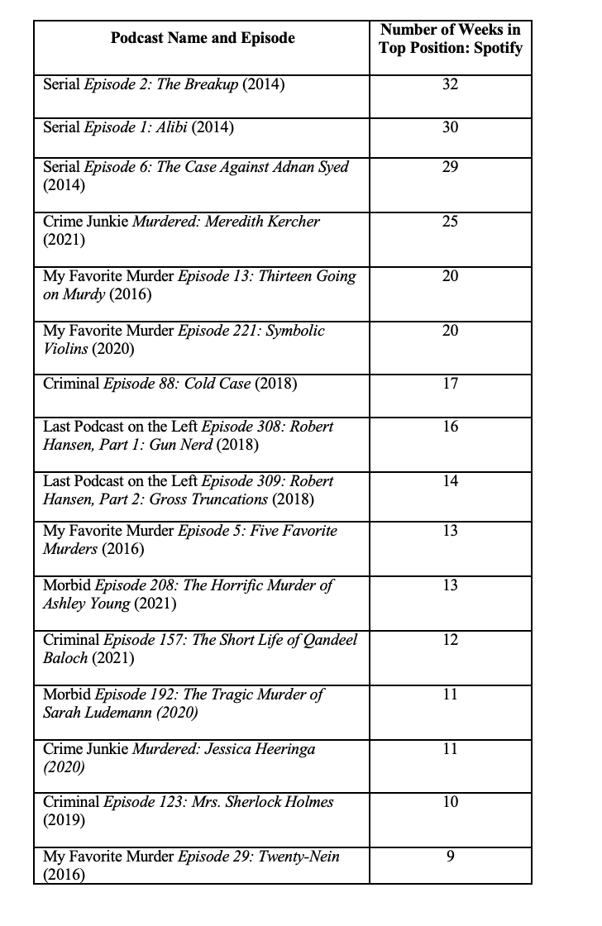
Figure 1 - Number of weeks podcast episode spent in top position on official Spotify true crime chart.

Podcast | Episode
Serial | Episode 1: The Alibi
 | Episode 2: The Breakup
 | Episode 6: The Case Against Adnan Syed
Morbid | Episode 208: The Horrific Murder of Ashley Young
 | Episode 192: The Tragic Murder of Sarah Ludemann
My Favorite Murder | Episode 29: Twenty-Nein
 | Episode 13: Thirteen Going on Murdy
 | Episode 5: Five Favorite Murders
 | Episode 221: Symbolic Violins
Crime Junkie | Murdered: Jessica Heeringa
 | Murdered: Meredith Kercher
Last Podcast on the Left | Episode 308: Robert Hansen, Part 1: Gun Nerd
 | Episode 309: Robert Hansen, Part 2: Gross Truncations
Criminal | Episode 157: The Short Life of Qandeel Baloch
 | Episode 123: Mrs Sherlock Homes
 | Episode 88: Cold Case
Figure 2 - Name of the episodes and podcasts analysed

References
Megaphone Spotify (Chartable), 2022. Chartable: Podcast Analytics & Attribution [WWW Document]. URL https://chartable.com/
Spotify, 2022a. Audience stats – Spotify for Artists [WWW Document]. Audience Stats. URL https://artists.spotify.com/help/audience-stats
Spotify, 2022b. Podcast charts [WWW Document]. Spotify for Podcasters. URL https://support.spotifyforpodcasters.com/hc/en-us/articles/360059417972-Podcast-charts

