Table 1. Debunk news writing structure

^{Structure} | ^{Cycle}
^{Headline} | Negative: displays the hoax in the heading and the disproven in the form of a negation at the beginning or at the end.
^{First paragraph or lead} | Hoax framing: description, origin, and context. Its origin is explained, the last source it came from is identified, its motif is contextualized and the way it has spread is analyzed.
^{Body text} | Display evidence: relation of physical and documentary sources.
 | Verification results: level of affiliation of the sources accessed, official document databases, online trackers, secondary testimonies, and rectifications.
^{Last paragraph} | Verdict (and labelling): the information that has been verified is retaken to determine if it is true/false or its level of reliability.  The truth is presented and suggestions, advise and conclusions are laid out to avoid future hoaxes.  Most of the media have their own labels (from less to more reliable) to qualify the credibility of the information (true, false, mostly true, mostly false, misleading, etc.).
Source: own elaboration

Figure 1. Debunk news writing structure model
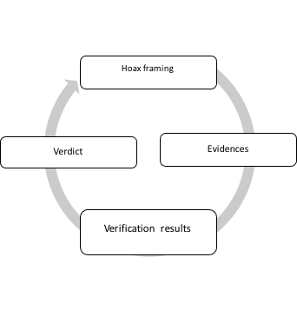

Source: own elaboration

Table 2. Debunk news characteristics

Characteristics | News type
 | Debunk news
Breaking news connection | Non-regular news
Time reference | Timeless
Linguistic style | Teaching and relaxed
Topics variety | Statements (from politicians/celebrities), viral digital contents
Sources number | Unlimited
Sources identity | Opened reference list
Authorship | Journalist specialized in verification: fact-checker
Objective | To verify for alert to audiences or avoid future hoaxes
Transparency | Research process explained
Labelling | Information credibility is rated (from less to more reliable)
Structure | Cycle
Source: own elaboration

