Thomas Klikauer
Media Capitalism: Hegemony in the Age of Mass Deception
Palgrave MacMillan, Switzerland, 2021, 513 pp. $119.99 (paperback).
Reviewed by Author,
Author.

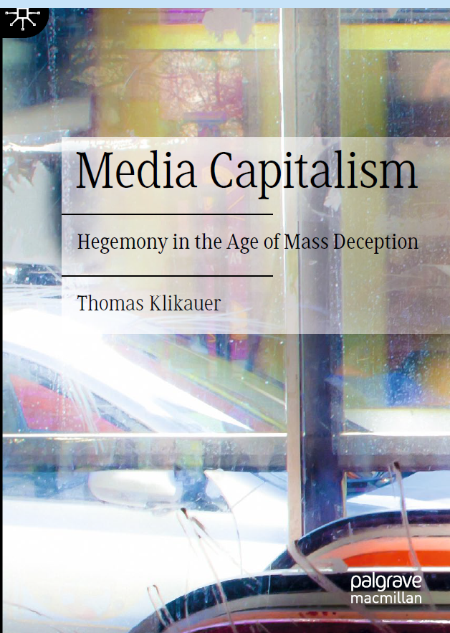
This is a timely book when set in the context of Russia’s special military operation in Ukraine, which began on February 24, 2022. As history will show, the entire enterprise was a misguided proxy war on the part of the United States and NATO to suppress, even break up Russia, assisted by a complex of media and public relations interests. Unfortunately, the reasons for this sad war enterprise are not documented in the mainstream media, although a communication ethicist could focus on the consequentialist aspects of the conflict, if educated about the history of post-Soviet states in the context of geo-politics and hegemonic claims to power by the US and its western allies. Such an approach would provide an understanding of, for example, the benefit of Russia’s demise for the US and the west: to stop the emergence of Eurasia as a major land mass for trade and development connecting Russia with China and India and the former Soviet states. By making such a historical shift in Eurasian geopolitical power an impossibility by immobilizing Russia, the US would continue as the global hegemon. Consequentially, a single global political system, US-style capitalist liberal democracy, would be dominant for generations.

Such an interpretation of events is unlikely to surface in the US, because the coverage provided by the media and communication apparatus aligns US Government departments with the US/UK and western NATO-oriented Military Industrial Complex, to reproduce a unidimensional narrative that does not reflect the pursuit of truthful information upon which the public can rely to make decisions about government, geopolitics and world affairs. Fortunately, a counternarrative to the dominant US/NATO one is provided by independent Internet-based sources.

Meanwhile, the foundational concept of liberal democracy in the US and the west, that free speech generates a knowledge environment within which citizens are capable of making rational decisions about the governments they choose continues, like capitalism, to be universally dominant. As Klikauer argues in this somewhat ungainly book, the nexus of private capital with liberal governments provide limited access to information and hope for democracy across four domains of media capitalism – education, consumerism, work, democracy. Applying aspects of critical media studies scholarship, Klikauer theorizes the way the lop-sided interests of capital seep into academia, Hollywood and civil society in a reinforcing loop that demonizes Russia and China, while remaining confused and disinterested about the Global South.

These interests are grounded in media tools that have been refined in the service of capitalism and liberal democracy, as “the PR-izatin of media,” as the author notes early on, quoting Margaret Duffy’s 2000 article, “There's no two‐way symmetric about it: A postmodern examination of public relations textbooks,” from Critical Studies in Media Communication. This reference and many hundreds of others in this book, indicate that the scholarship offered by Klikauer is well established in the critical traditions of media, communication and cultural studies. In the 15 years since Duffy’s critical assessment of Public Relations, the situation for citizen-centric information flows from established journalism sources has become distressingly unhealthy. Furthermore, social media platforms have inveigled themselves into everyday life, creating “citizens” whose value is assessed through psychographics, to be measured then manipulated for their economic and political value by algorithmic preferences.

In fact, capitalism has shown itself to be a perfect monster, adding individualized social media interactions, while distracting platform users from news, information and analysis that enhances the prospect of emancipation through reform or revolt. In this respect, Klikauer’s thesis that “media capitalism no longer functions without corporate media. Media-free capitalism is no longer possible,” is correct, without being a surprise (457), yet misses the point that media within capitalism can inform, educate and produce its opposite, non-capitalist social relations. Interestingly, a similarly pessimistic, yet up-to-date conclusion is reached by David Arditi, in Digital Feudalism, who applies a Marxist sociological critique to contemporary digital capture.

Taking positive action that is antagonistic to corporate media can be undone by being optimistic about “resistant” theory that promotes human capability to establish and mobilize a revolutionary media model for social survival.

It is this point that Klikauer seeks to arrive at. His use of the term (originally suggested by George Orwell) “Media Capitalism” means the formation of PR that is invisible to the public, yet totally dominates the public’s consciousness and social thought system. There is no alternative to capitalism presented by the PR system argues Klikauer, creating a situation that “is ideologically camouflaged through the hallucination of a democratic marketplace of ideas” (7).

Such domination of the corporate media sphere that combine the three constituents of consumerism, media and ideology has been well established since Noam Chomsky and Edward Herman published Manufacturing Consent: The Political Economy of the Mass Media, their study of the US media as propaganda in 1988. Where Klikauer differs is in his focus on the emergence of totalizing ideologies that make media dysfunctional according to any measures of democratic society. The domination is portrayed as a “global pathology” in which capitalism creates a permanent state of consumerism, without escape, or There Is No Alternative (TINA).

In contrast, reference to Louis Althusser’s State Ideological Apparatus (SIA) model, or something like it, would have helped the author engage with a class-based criticism of media as an institution supported by the capitalist state that facilitates media capitalism. There is inadequate attention paid to this kind of critical material, although myriad quotes inserted in the text suggest a breadth of research yet without media activist options.

Almost collapsing under the weight of the evidence of capitalist supremacy in this all-consuming propaganda system of psychosocial supremacy, the book provides a perspective that is helpful as a historically informed document about capitalism. As noted above, appreciating this comprehensiveness requires effort in terms of the few other options that exist, such as market socialist and communist-inspired models, as well as liberal democratic regulation school methodologies that variously coexist with capitalist media through public service media models.

In proposing that the structural considerations are debilitating, there is an overwhelming sense that there is little to be achieved in any engagement with the news and information media. Of course, this is a defeatist view given that human beings engage with communication through media as a sense making system of symbols and signifiers for sustenance and for survival. An explanation for this view is Klikauer’s location within a business school in Australia, from where there is insufficient appreciation for the resistance that is at play in the US media environment and the effort made at various levels – such as this journal and others and independent internet-based platforms – to analyze and criticize, capitalist media.

Indeed, all is not lost. Klikauer concludes with “a few rudimentary fragments for a possible communicative-emancipatory theory set against media capitalism” (457). The conditionality of the claim is instructive, suggesting that the task is too immense, as the constituents of capitalism are, as Marx noted, in a state of permanent evolutionary transformation. Of more note is the author’s tendency to reiterate points made earlier in the book while giving the impression that nothing can be unwritten, while a concise theory is an impossibility among the ruins of capitalist liberal democracy. The result is a book that would have benefitted from trimming down, so that the normative (sociological) theory is clearly articulated. At best, the concluding theoretical option is a liberal claim that appeals to “a communicative forum disconnected from the imperatives of media capitalism” (484). As a disappointment, this does not rise to the level of theory so much as an extension of already established systems in play in the public service broadcasting model of the BBC and PBS, as well as online independent media.

Perhaps curiously, this limitation offers readers - especially graduate students - the opportunity to use this book as a stepping off point for the development of their own theoretical inventions, crafted with an eye to the radically different options for news and information that have emerged in the digital space, where they create havoc for the propaganda system of mainstream media.

The book illustrates that there are a vast amount of analytical and descriptive research concepts available to inform scholars who seek to engage with media capitalism and locate the tools and the truth. Unfortunately, repeating that material then reiterating a solution within the known communication world, is a wasted opportunity to move beyond the boundaries that have been set.

References
Arditi, David. (2023). Digital Feudalism: Creators, Credit, Consumption, and Capitalism. Bingley, UK: Emerald Publishing Limited.
Duffy, Margaret E. (2000). There's no two‐way symmetric about it: A postmodern examination of public relations textbooks. Critical Studies in Media Communication, (17)3, 294-315. Retrieved from DOI: 10.1080/15295030009388397

