The Magical Neoliberalism of Network Films

After seeing Alejandro González Iñárritu’s Amores perros [Love’s a Bitch] (2000) and Rodrigo García’s Things You Can Tell Just By Looking At Her (2000), Chilean writer Alberto Fuguet confirmed his excitement about being part of the new Latin American literary and cinematic “boom” he called “McOndo.” McOndo, he wrote, had achieved the global recognition of Latin American literature’s previous boom-time, "magical realism," as represented in “Macondo,” the fictional town of Gabriel García Marquez’ Cien años de soledad. But now the “flying abuelitas and the obsessively constructed genealogies” (and the politics) had been replaced with the globalized popular commercial world of “McDonalds”: Macondo was now McOndo. This new generation of cultural producers was immersed in the imbrication of the global and the local produced by the forces that tore through the opening gates of liberalizing market reforms around the world since the 1990s like the “golden arches” and the persistent and emergent forms of human difference in this globalization. Occupied with creating cultural forms to portray this new world, they were more than willing to work within the newly freer market to do so (Fuguet, 2001, p. 71). This cultural movement, representative of the economic, social and cultural realities of “Latin America’s NAFTA—make that FTAA–generation” might be best characterized, Fuguet suggested, as “Magical Neoliberalism” (p. 125).

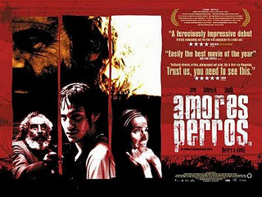

The films that Fuguet referred to – Amores perros, a story urban vulnerability told through the narratives of 3 Mexico City inhabitants of different classes repeatedly brought together in a single car crash, and Things You Can Tell Just By Looking At Her, which explores female lives and labors through the interwoven stories of 5 US women – in addition to dozens of other films of the last two decades, are examples of what became a dominant filmic form of representing the complexities of life in the age of globalization: the network narrative. This cultural form is transnational (in that it crosses national borders in its themes, production and circulation) and international (in that has been produced by the film industries of many nations) and is both a product of and an attempt to represent the ideologies of its moment. While Fuguet uses the phrase “magical neoliberalism” for effect rather than deep analysis, it is worth taking up a serious consideration of those terms because these network narrative films have real elements of both the “magical” and the “neoliberal.” If, as Cuban writer Alejo Carpentier (1995) defined it, “magical realism” emerged from Latin America’s uneven development, the "magical neoliberalism" of these movies at the turn of the twenty-first century suggests that the social and cultural ramifications of the uneven development under neoliberalism “now seems to belong to all of us” (Jameson, 1995, p. 12). The divergent experiences of this unevenness, across its widening gulfs of inequalities as a result of privatization, marketization and the fracturing of social collectivities, are interconnected through the transnational commodity chains, financial markets, communications systems, migration routes, and other transnational networks that produce simultaneous globalization and fragmentation. To suggest there is a filmic “magical neoliberalism,” then, is to aim to interpret these cultural texts in their “history now conceived in its vastest sense of the sequence of modes of production and the succession and destiny of the various human social formations” (Jameson, 2002, p. 60). The trajectory from uneven postcolonial development to uneven neoliberal development is a crucial genealogy of both the modes of representation and production of these network narratives. And, remarkably, this genealogy is familial as well as social on the largest scale: Rodrigo García, one of the most prominent filmmakers of the genre and the director of one of the films that Fuguet was so taken with, is Gabriel García Marquez’s son. But “genealogy” is not meant to imply that “magical neoliberalism” was written in the DNA of its forefathers, as if fated in some sort of deterministic code – such dynamics of chance and inevitability are a powerful conceit in these films themselves. Instead, in recognizing a genealogy of modes of production and representation in these network narratives, we may be able to see them as evidence of the structures and ideologies of the present, and perhaps "archaeologies of the future," imaginings of emergent possibilities visible in our present (Jameson 2005).
"Network films," as defined by film scholar David Bordwell (2008), are multi-protagonist films with multi-linear narratives that intersect. Unlike ensemble films, which also feature multiple protagonists, in network narratives protagonists’ plotlines and projects are “largely decoupled from one another, or only contingently linked" (p. 191, 192). Popular film writing has referred to such movies as “mosaic” and “composite” stories of "interlocking lives," "converging fates," and "the web of life." Critics like Roger Ebert (2007) and Alissa Quart (2005) had commonly called this as “hyperlink cinema.” But that title places emphasis on narrative form and aesthetics (over thematics or industrial production) and implies an exaggerated sense of technological determination by the Internet. Instead, “network films,” referencing Manuel Castells’ (1996) development of the concept of “network society,” suggests not just network aesthetics and technologies, but also the networked social and economic relations of production under which these films are created. These films demonstrate networks on 3 levels: a network narrative form (multi-linear, interconnected plotlines), a theme of network social relations (interconnected problems, shared experiences/events, often transnational), and a networked industrial production (complex, temporary and often transnational links of investment, production and distribution).
The network narrative has become the filmic representation of the political unconscious of globalization in the last two decades. While Bordwell developed a persuasive film analysis of this broad narrative form and traced its development in the history of film, he has been less interested in considering its place in larger socio-historical formations. He notes that there has been a burst in the number of such films, but resists thinking about them in terms of their historical moment because of the "temptation is to talk about all this in a zeitgeisty way" when, he argues, network films seem to have a universal appeal, appearing in various historical moments in numerous cultures (2008, p. 244). But taking Bordwell's remarkable international filmography of network films, which he organizes alphabetically from 1920-2007, and re-organizing them historically, it is clear that the number of network narratives has increased exponentially (below). While Bordwell’s list is a “working filmography,” he aimed to be “comprehensive,” and even as the list misses a number of films in the category, it demonstrates the dramatic upsurge in the number of network films in the last two decades. This is not just an argument about prevalence, though, but also about prominence; network narratives were amongst the most high profile and acclaimed movies of the turn of the millennium, both internationally and in the US, including González Iñárritu’s transnational triptych, Amores perros (2000), 21 Grams (2003) and Babel (2006), (as well as his contribution to 11'09"01 September 11 (2002), which as a portmanteau film has a related logic around an interlocking event), Steven Soderbergh’s Traffic (2000), Paul Haggis’s Crash (2004), and Stephen Gaghan’s Syriana (2005), constituting 23 Academy Award nominations between them.

All of the just named movies are a part specific subset of network films and perhaps the most famous of the form – dramas that address transnational issues of social concern. In fact, network films seem to have become the dominant mode of representing globalization and “global social problems” (de Waard, 2007) on film. Traffic, Amores Perros, Crash, Syriana, Babel, Cidade de Deus [City of God] (Fernando Meirelles, 2002), Fast Food Nation (Richard Linklater, 2006), Auf der anderen Seite [Edge of Heaven] (Faith Akin, 2007), 71 Fragmente einer Chronologie des Zufalls [71 Fragments of a Chronology of Chance] (Michael Haneke, 1994), Code inconnu [Code Unknown] (Michael Haneke, 2000), Rendition (Gavin Hood, 2007), Mammoth (Lukas Moodysson, 2009), Hereafter (Clint Eastwood, 2010), Contagion (2011), 360 (Fernando Meirelles, 2012), to name several but far from all. In their attempt to represent the totality and complexity of globalization, these films strive for a sense of realism over the “magical” in subject matter and aesthetics. But narratively, they spectacularize the reality of social relations by mapping a fantastic network of interconnections, resulting in the magical meeting of multiple and seemingly divergent characters and storylines. These magical neoliberal network narratives fall into two loose groups. The first are contingency narratives, in which the multiple protagonists and storylines are brought together, most often violently, in chance events. The second subset could be called world systems films, as in Immanuel Wallerstein’s proposal for a world systems analysis, that attempts to represent the totality of a large scale system of interrelations that transcends the nation state, such as an industry, commodity chain, pandemic, communications network, etc. that links diverse individuals, while acknowledging, sometimes inadvertently, the differences of power between centers and peripheries.

Narrative Form

As theorists of globalization and neoliberalism have argued, capitalism increasingly functions transnationally since the freeing up of markets from state regulation, the intervention of supranational financial institutions in the developing world, the privatization and commercialization of public goods and services, and the resulting opening up of the second and third worlds to capitalist expansion. Transnational corporations, international organizations, alliances of nation states and the international financialization of capital have created global networks of power that are more decentralized and complexly interrelated than previous organizations of capital like nation state imperialism. New information and communications technologies have allowed for capitalists to organize capital flows and manage labor across vastly dispersed nodes in global networks. Models of just-in-time production, quickly sourcing elements across distance to create material and symbolic commodities that are then traded on international markets, has led to the flexibilization of labor and transitory arrangements of capital investment. The forms of cultural, informational, and financial (immaterial) commodities that represent a growing segment of the economy are created and distributed across international networks of capital and labor.
In this moment, a “structure of feeling” has emerged out of capitalist globalization, often represented through various iterations of “networks,” and attempts to imagine and map its interconnections, as well as its persistent production of difference. In a similar way, Fredric Jameson (1995) argued that as film encountered the problem of representing the complexity of late capitalism’s world system, the result was a wave of conspiratorial movies in the 1970s and 80s that reflected the collective political unconscious of capitalist power: "Conspiracy...is the poor person's cognitive mapping of the postmodern age; it is the degraded figure of the total logic of late capital, a desperate attempt to represent the latter's system, whose failure is marked by its slippage into sheer theme and content" (1988, p. 356). Likewise, in the 2000s, there has been a wave of films attempting to map global capitalism in its neoliberal form, resulting in films that are as complex, transnational, and networked as their subject matter, but still unable to represent the totality of the global system, thus relying on risk and randomness to construct a seemingly magical system of interrelations.

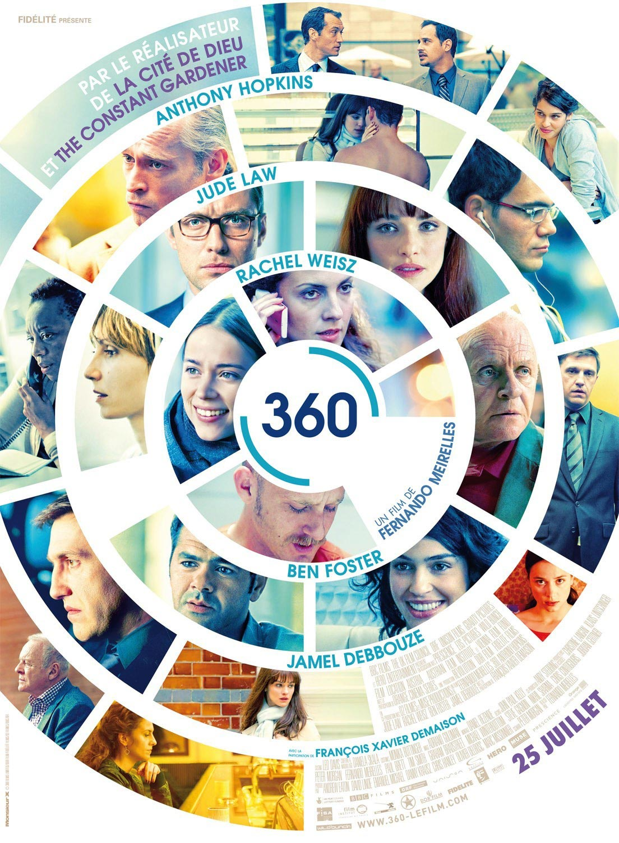

Network narrative films are part of a structure of feeling that includes popular discourses and academic work on human interconnectivity extrapolated to global scale. As Bordwell notes, in the sciences, chaos theory posited unexpected order in what appeared to be random fluctuations and coincidences. The theory entered the vernacular with the idea of the "butterfly effect," with its evocative image of the flapping of a butterfly’s wings causing a hurricane on the other side of the world. "The notion that tiny actions in one person’s life can trigger big consequences in another’s is constantly exploited in network movies" and even directly referenced in the likes of El efecto mariposa (1995), Le battement d'ailes du papillon [“The beating of butterfly’s wings” or Happenstance in its English title] (2000), Free Radicals (2003), and González Iñárritu's 21 Grams (2003) (Bordwell, 2008, p. 198; Everett, 2005, p. 7; Silvey, 2009). Epidemiological modeling of the diffusion of infectious disease through human contact – and the “viral” broadly as a metaphor for the spread of all sorts of phenomena whether cultural, technological, economic, etc. through networks – has diagrammed exponentially growing nodes of contagious interconnection, not surprisingly the subject of another network narrative, Contagion (2011). Similarly, complexity theorists argue that network thinking is at work in the numerous ways in which large scale, systemic behavior emerges from simple interactions amongst myriad individuals (Mitchell, 2009), like neuroscientists’ hypotheses that human brains are hard-wired with mirror neurons that receive and resonate behavior, affect, and emotion suggesting an interconnected, social neurological system (Coles, 2011). Not only has remarking on the ever-shrinking “small world” of social connection and "six-degrees-of-separation" (a phrase disseminated in John Guare's 1990 play and 1993 film) entered into common parlance, but the business discourse of "networking," of forwarding one's career through "connections," has become generalized wisdom (Bordwell, 2008, p. 198). Of course the technological innovations around the Internet have become the master metaphor for the "network" and its uses for social networking have made identifiable and practicable the ties among social groups and have drawn attention to the ways in which ideas and texts can spread virally through them. Closest to our own fields, the social and cultural theory of the past twenty years has paid increasing attention to interconnectivity, horizontality and multiplicity. Manuel Castells (1996, 1997, 1998), as cited above, argued that a networking form of organization in economics, politics, social movements, and identity has become the defining feature of contemporary society. Sociologist Saskia Sassen (1998, 2001) suggested that certain global cities are nodes within global economic, information, migration, and activist systems. Gilles Deleuze and Félix Guattari (1980) theorized the cultural and social possibilities of the nonlinear and non-hierarchical connections of multiplicities of the rhizome. Bruno Latour (1987, 2005) and others in “actor network theory” map relations between people, objects and concepts within social networks. Both social movement theorists and military studies have noted the potentiality of horizontally proliferating cells with political affinities from environmentalists to Zapatistas to the terrorists in al-Qaeda, resulting in the remodeling of state armed forces around networks, because as RAND Corporation analysts John Arquilla and David F. Ronfeldt suggest, “It takes a network to defeat a network” (1998; Jagoda, 2010), a refrain equally repeated by anti-capitalist and anti-state actors. And Michael Hardt and Antonio Negri (2000, 2004) theorized a revolutionary collectivity to challenge empire - the multitude - constituted from the convergence of the subjectivity and social intelligence of heterogeneous groups.
In representing the transnational networks of globalization, network narrative films develop a multilinear form in which seemingly unrelated story lines and multiple protagonists are brought together by various means, often either in the case of contingency narratives by a chance encounter, accident or random event, or as in world systems films, a large scale system of interrelations. These movies’ assertion of interconnection in multiplicity, and the unfolding of their plots to suggest the involvement and responsibility of each character in the others’ stories, at first seems a powerfully utopic statement on human interdependency. The narrative network implies that we are all implicated and complicit in each other’s lives, just as characters appear in and affect the plotlines of others in these films.
But contingency narrative films overwhelmingly emphasize the negative valence to complicity and implicature (Orbe and Kinefuchi, 2008, p. 138), inexorably crashing storylines into each other and throwing characters together into violent encounters so that they seem either deterministically fated for or morally deserving of the terrifying outcomes of human connection, effectively denying both a sense of structural cause as well as the possibility of collective agency. These films, for lack of a better phrase, construct what Jeffrey Sconce calls characters “’fucked by fate.’” (Sconce, 2002, p. 363; Tierney, 2009, p. 107). As in the films Babel, Crash, 21 Grams and Amores Perros, contingency network narratives overwhelm any acknowledgement of the structural power which positions characters and frames their fate. Instead, plots often rely on a chance event that inexplicably crosses characters together, and without larger structural analyses, leaves the audience looking for moralistic explanations. As Skip Willman has argued, an emphasis on contingency “maintains the existing capitalist system by attributing any deviations from the social equilibrium to chance and accident rather than immanent social antagonisms or contradictions” (Willman, 2008, p. 28). Shootings, car accidents, financial crises, crime, even international conflicts are all represented as the outcomes of random individual actions and exceptions in an otherwise functioning society (K., 2010). Contingency, as a theory of historical causality and as a narrative trope, “represents a renunciation of any attempt to grasp the operations of the social totality” (Willman, 2008, p. 33). Instead, these films’ fixation on contingency enacts a personalizing and individualizing of social and sociopolitical conflicts, privatizing such structural issues as racism, immigration policy, class stratification, etc.

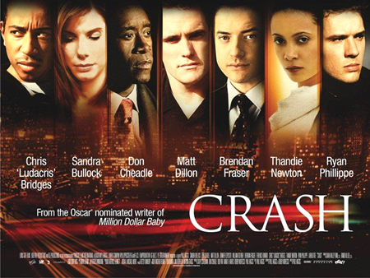

In the contingency narrative films mentioned above, the sequence of events is re-ordered so we see almost in the first moments of the films those events that seemingly randomly and devastatingly drive the networked characters together – shootings in the first two, car crashes in the final two, (and for Crash, the “mobile privatization” of LA and the simultaneous atomization and interconnection of its residents is represented through cars and their repeated crashing together, and the movie begins with an out-of-sequence scene of both a minor car accident and, more significant to the plot, the revelation of a shooting) – and then spend the rest of the movies waiting for the characters to come to the ends we as the audience already know they are fated for. This formal organization of out of sequence scenes (flash-forwards) “links discrete events in a causal pattern, endows events with an aspect of fatalism, and promotes moral didacticism” (Carlsten, 2007, p. 9). Viewers cannot help but look for causal connections and morals to the story, asking as we watch the characters drive towards their ends, what are they doing to deserve this?
With world systems films like Traffic and Syriana, on entering the theater to watch films on the political economy of the drug and oil systems, we already know the characters are “fucked” by the networks they are in. If there was any doubt, high angle extreme long shots dwarf characters within their surroundings and the system itself, while color tones, shaky camera movements and grainy images mark characters for future trouble. These “world systemic” films aspire to an aesthetic of “cognitive mapping,” “a pedagogical political culture which seeks to endow the individual subject with some new heightened sense of its place in the global system” (Jameson, 1991, p. 54). These films attempt "to think the impossible totality of the contemporary world system" (Jameson, 1991, p. 38), identifying the structures, flows, and relationships of states, corporations, commodities, militaries, religious bodies, and transnational organizations. This “mapping” is impossible and incomplete, “to think a system so vast that it cannot be encompassed by the natural and historically developed categories of perception with which human beings normally orient themselves” (1995, p. 2) – and inevitably results in conspiratorial representations of hazily suspicious CIA agents, political organizations, and oil companies, as in the case of Syriana. And the narrative pressures to relevantly interlock plotlines while tackling a social problem like the drug trade as in Traffic, results in moralistic melodrama through the magical personalization of the issue, as in the storyline of a conservative drug czar so focused on cleaning up the streets that he is blind to the drug abuse of his own daughter. The film fails its own (in this case liberal) good intentions, when it relies on the racist trope of the pretty white girl’s sexual subjugation by a black brute to quickly and manipulatively develop a sense of tragedy and moral outrage about the cocaine world system. Network narratives seem especially susceptible to such tropes, with the limitations on the time devoted to any single character’s development amongst the multiple protagonists. But compared to the conspiracy films of the 1970s and the “contingent event” network films, these world systems narratives expand the complexity and complicity of power to include more actors, political economic context and a sense of cause beyond individual morality and vulnerability, even if regularly falling victim to conspiratorial and melodramatic representation.
The ideology of form of these world systems films constructs a critique of capitalism’s current stage perhaps even more powerfully than the films’ politically liberal thematics, discussed below. Their narrative inclusion of elements of contingency and chance within clearly identified networks of power disavows the neoliberal individualism celebrated in political and economic discourses and suggested to rule global political economic systems. These films displace the individual protagonist, so empowered in most film genres, from the center of the story with multiple storylines of various protagonists unfolding in temporal simultaneity. The persistence of contingency – in chance encounters between characters, tragic and lucky accidents, and random events – belies the presumed rationality of the systems they are mapping. By having chance connect its characters and plot lines, these movies challenge the assumption of the agency of the individual to shape his life-course, represented in neoliberal logics of individual freedom, self-betterment and personal choice (Deleyto and Azcona, 2010, p. 30).
But the political possibility of the effacement of neoliberal individual agency is neither replaced with alternative forms of agency nor is it complete. Network films’ overwhelming emphasis on narrative structure produces what New Yorker film critic David Denby criticizes as “closed, even over-determined, forms” (2007). He blames their “pretentious fatalism and structural willfulness” on the filmmakers’ being “too obsessed with the unfair distribution of power and capital in the world to operate freely as radical experimenters in form” (2007). But I think it is the reverse: that their form suggests that they are not radical experimenters in the distribution of power and capital in the world. Within these films there is no multitude created from multiplicity, no production of counter-power within the network (in Castells’ sense). These films could instead, per Jameson (1991), portray a world system that looms so large as to crush protagonists to inspire audience imagination of the actual totality of neoliberal capitalism: “successful spatial representation today need not be some uplifting socialist-realist drama of revolutionary triumph but may be equally inscribed in a narrative of defeat, which sometimes, even more effectively, causes the whole architectonic of postmodern global space to rise up in ghostly profile behind itself, as some ultimate dialectical barrier or invisible limit” (415). But with world systems films made in the mold of the Hollywood form, defeat by the system is moderated by happy endings, however weak and partial, with the homecomings of characters fleeing from the most intensive nodes of the system (Rendition and Syriana) or characters able to make strides in working within and against the system (Traffic). But perhaps most disconcerting is the saturation of the network narrative as a trope for cognitive mapping itself, inuring audiences to the possibility of representing the social relations and power dynamics within capitalism.

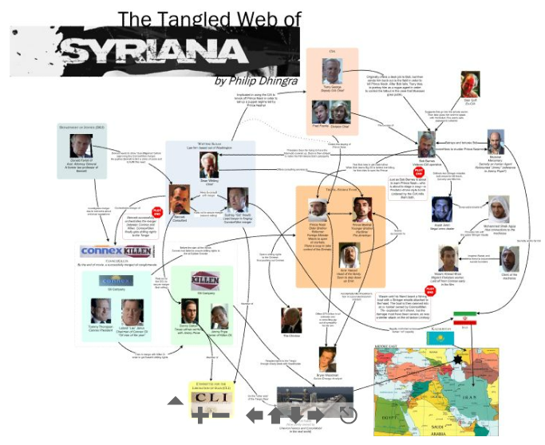

Transnational Network Thematics

The form of multiple seemingly-unrelated characters/narratives is so closely associated with themes of global social problems that a reader of Roger Ebert wrote in to ask him for clarification on the definition of “hyperlink cinema,” a phrase he had used in prior reviews, and whether global themes were a prerequisite: “There is now widespread belief that such films need international flair…and multiple languages,” the reader wrote (2007). We are already talking about content, then, but to make it direct: network narrative films frequently take up contemporary social problems, especially those with a global scope, part of the genre Andrew de Waard conceives as “the global social problem film” (2007). Traffic on the transnational illegal drug trade, Syriana on the global oil industry, Amores Perros on vulnerability and violence in Mexico City, Babel on the challenges of communication, Crash on post-9-11 race relations in the world city of LA, Rendition on the US state’s use of international black sites for torture of terror suspects, Mammoth on transnational networks of reproduction and social reproduction, Contagion on global pandemics, etc. The form allowed films to tackle transnational or “global” topics – connecting geographically remote characters and situations to address international political, economic, social and cultural interrelations, themselves constituting aspects of network society. Reviews have characterized each of these network narrative films as “liberal,” primarily because they address contemporary social issues and include the perspectives of diverse characters, but they could more accurately be termed “neoliberal” in their overall approach to these issues:

Amores Perros reconfirms bourgeois fear about Mexico City’s degradation into familial breakdown and social violence. While recognizing the inequalities produced in post-NAFTA Mexico, the focus is on the punishment of all 3 of its protagonists across their vast differences, each on moralistic grounds for the dissolution of families, but with ultimate blame for the chain of events that produces the violent contingency of their shared car crash resting on lower class Octavio (Gael García Bernal) and his reckless attempt at escape from the familial dysfunction, lack of economic prospects and closed network of his class status. Ignacio Sánchez-Prado (2006) persuasively argues that the film is characteristic of the “imaginary” of Mexico City’s middle class, and its “neoliberal fear” of the excess of violence of urban marginalization in the global south mega-city spilling over and colliding (literally and figuratively) with their lives.

Syriana critiques the political economy of US oil interests in the Persian Gulf, and productively leaves the viewer with a slew of morally ambiguous characters who contribute to its world system. But the film also produces some neoliberal heroes as well. Bob Barnes (George Clooney), Bryan Woodman (Matt Damon) and Prince Nasir (Alexander Siddig) are as close to heroes as they come in Syriana, the first a CIA hitman who has a human side, the second an oil futures analyst with whom the audience empathizes as a result of witnessing the accidental death of his son in the beginning of the film, which interweaves his fate with the third, a reforming Arab prince willing to break with US influence and royal and religious authority to bring women’s rights, democracy, and most importantly, a free market to his country. The latter is so worthy of saving, in the logic of the film, that Barnes breaks with his CIA mission to try to warn him of his imminent assassination by the US state and multinationals scared of real market reforms. Only Woodman survives these dealings in the Persian Gulf, immediately fleeing to his family and the US, with the film closing in a “conservative return to the family and local community” (Jagoda, 2010, p. 80) as a model of escape from the tangled web of power and problems of “foreign oil”.

Crash narrates racial tensions in global Los Angeles. Over the course of the film, every character proves to be racist and every racist character proves to have one redeeming quality. The result is a film that suggests something between “we’re all racists!” and “racists are people too!” David Edelstein, a film critic for Slate, said it this way: “In the end, Crash says, when you push a vicious racist, you get a caring human, but when you push a caring human you get a vicious racist” (2005). Crash develops the theme of racialization and racism through a story that throws its characters together through car crashes and shootings. Their racist actions are given little context, instead represented as individual actions that should be judged as a failure of personal morals thus ignoring the “conditions that produce racial exclusions” and the “systemic forms of white privilege and institutional racism.” Crash has a neoliberal stance on race and racism, as Henry and Susan Searls Giroux argue: it “privatizes and depoliticizes race, drowning out those discourses that reveal how it is mobilised ‘around material resources regarding education, employment conditions, and political power’” (2007, p. 754-755).

These magical neoliberal network narratives deliberately “hail a cosmopolitan audience,” as Rita Barnard (2009, p. 209) has argued about Babel, which is interested in global social problems and open to following them through a story told through diverse global perspectives. In their multiple storylines, network narratives formally bring together very different characters, points of view and contexts into a single film. The recognition of difference and, more rarely, the recognition of the ways in which difference and subalternity is produced within global systems of power, are powerful gestures in these films. This inclusion of multiple storylines and points of view challenges the sense of a narrative center and potentially complicates the dominant, white western perspective privileged in most globally-circulated films (Everett, 2005; Barnard, 2009). Quick transitions between the multiple nodes in the story can produce moments of disorientation in the viewer, as one follows cuts from a storyline with familiar characters and setting, to a seemingly distant but related one, sometimes effectively collapsing “the safe distance between ‘us’ and ‘them’” (Westwell, 2011, p. 827).
But there are real limitations on the potential of these films to radically reframe social issues from the perspectives of those not usually represented in film. Even as these network narratives attempt to decenter dominant positionality, storylines about characters of color and those outside the U.S. or Europe often become subaltern and peripheral in the narrative network being mapped. Next to global stars the likes of Brad Pitt, George Clooney, Matt Damon, Jude Law – themselves products of the dominance of the US film industry on screens around the world – characters played by less internationally known actors become peripheral with their importance dependent on their relation to the centering power of global stars and their storylines in western/northern loci of power. Thus, even if a film attempts to elucidate the ways in which difference and subalternity is produced within global systems of power, it has the risk of reproducing such dynamics.

Industrial Networks

These films are networked also through circuits of transnational capital and labor in an era of globalized, commercial independent film. Here, too, the films deserve their “network” moniker, as Paul Kerr (2010) has argued, for the complex conjunction of numerous financiers, production companies, and multiple sources of temporary labor that come together briefly for a film before dispersing in various directions. While the form is not vulgarly determined by its relations of production, it is difficult to imagine such a full articulation of the transnational network narrative genre without the emergence of global industrial networks in media production in the neoliberal era.
No longer made by a single major Hollywood studio or under the auspices of one nation’s state film subsidy, network narrative films are often complex private sector co-productions, examples of a post-Fordist mode of production and the ‘New International Division of Cultural Labour’ (Miller, et. al., 2005) in the film industry characterized by “subsidiary and subcontractor capitalism” (Wayne, 2003, p. 98). Network narrative films Crash, Babel, Syriana, Contagion and Traffic, for example, were made largely outside of the major studios by a web of independent production companies along with the “major independents,” which arose from the majors’ acquisition of independent production companies and creation of subsidiaries to produce "commercial independent" film. In the 1990s, “every major studio acquired a stable of subsidiaries” out to profit from the notoriety gained through film festivals and awards season. These major independents attempted to negotiate between artistic and commercial imperatives and accumulate the financial, social and cultural capital “for big-budget, celebrity-starring, heavily-marketed films that can still retain their artistic merit and message to thrive within a landscape dominated by blockbuster filmmaking” (de Waard, 2007, 13). In addition to buying up independent studios, the majors also appropriated the network narrative form that had been developed and familiarized in art house and indie films in the 1990s.
The independent-cum-studio network narratives of the 2000s exemplify a networked mode of production by a web of companies and financiers including the major independents: Traffic was developed with Universal’s USA Films (now Focus Features) and Syriana and Contagion were developed by Soderbergh’s own production company Section Eight Ltd. (a partnership with George Clooney) and co-produced and –financed by both Warner Brothers and Participant Productions (a production company that focuses on films which inspire social change founded by Jeffrey Skoll, whose eponymous foundation is concerned with issues such as pandemics and oil dependence). The complexity of the producing and financing (which included several banks and a German tax fund) of the relatively low budget Crash led to a lawsuit and complications in paying out the exponentially large profits (Waxman 2006). And five different companies were involved in the financing of Babel – Iñarritu’s film and advertising production company, Zeta Films; the U.S.-based Media Rights Capital, which is partly owned by a talent agency with additional investment by AT&T and Goldman Sachs; “major independent” Paramount Vantage; an American company that specializes in marketing and packaging talent for commercial independent films; and a French film company (Kerr, 2010, 44-45). As Dixon and Foster describe in their history of the US film industry, Hollywood studios are no longer the “one-stop production centers” they were at mid-century: "they now function basically as distribution and funding entities…[they] are really umbrellas for a variety of smaller production companies, where actors, directors, producers, and writers compete to get their projects funded and distributed to theaters…today everyone is a free agent” (2007, 379).
As in Castells' "network society," the labor of these free agent cultural workers, while globally integrated, is divided by increased differentiation of labor by function as well as geography and made vulnerable through disposability and interchangeability. The networked production of these films is characteristic of postmodernity’s “flexible accumulation” as theorized by David Harvey (1989), in which products for an increasingly segmented market are sourced from a global system of flexibilized, casualized workers contributing elements “just in time.” These films’ productions are complexly organized, dispersed across space, with the essential members of the cast and crew and their corresponding film product moving quickly from locale to locale, where production springs up from the labors of local temporary workers: de Waard (2007) has described these productions as “complex, erratic,” “frantic,” and “light and quick.” Traffic was filmed in 3 months across 10 cities and 110 locations. Syriana was shot in five languages on a 75-day schedule across 4 continents and over 220 locations in Geneva, Dubai, Egypt, Tehran, London, Morocco, New York, Texas, Maryland, and Washington, DC (Jaafar, 2006, p. 18-20). For Babel, four different production companies organized the labor for each of the film’s national locations of Japan, Mexico, Morocco, and the US, while Contagion’s globalized production spanned Hong Kong, Macao, Chicago, Atlanta, San Francisco, Casablanca, London and Geneva (de Waard, 2007, p. 13; de Waard and Tait, 2013, p. 160). In classic post-Fordist terms, the workers on these films are dispersed across space with each site making only a portion of the filmic product, much like the globally-sourced media devices with which we view these films. Unlike the Model Ts or big budget musicals coming off of single assembly lines at Ford plants or Hollywood studios at mid-century, SONYism’s television components are made in various locations around the world and assembled just-in-time in yet another.
This networked industrial production appealed both to stars interested in prestige independent films and producers hoping to ensure box office returns. Directors realized that major stars could be recruited to act in network narratives even with their smaller budgets: stars were interested in the credibility (and sometimes accolades) of working on an indie film without having to commit as much time to the project or having to demand their usual high salaries because theirs was just one of many proportional protagonist roles. That appealed to producers who hoped to ensure a return on investment by casting a wide net with a larger group of talent cast as multiple protagonists (Bordwell, 2008, p. 197). Network narratives were thus ideal vehicles for actors and producers, as well as talent agencies who stood to profit from the “packaging” of a group of talent – actors, directors, etc. – they represented (Kerr, 2010, p. 39). As agencies globalized their stable of talent they provided films with a diverse team of protagonists for their complex and often multiracial and transnational network narratives. And they have also begun investing in independent studios and financing companies. For example, through talent agency Endeavor’s part ownership of independent studio Media Rights Capital, run by former talent agents of Endeavor and Creative Artists Agency, it helped finance Babel and films organized around its client list including González Iñárritu himself (Cieply, 2007).
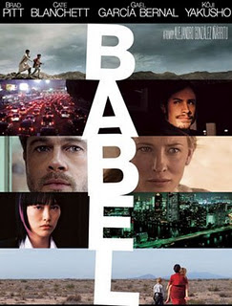

The international economics of cinema in the neoliberal era and the industry's interest in garnering film revenues beyond a single domestic market, especially as the US market provides a decreasing proportion of box office revenue, mirrors if not motivates global network narratives, settings and characters (Kerr, 2010, p. 46). Of Babel’s $135 million worldwide grosses, 75% came from outside the US. Not surprisingly the film’s U.S., Mexican, and Japanese settings and film stars (plus the addition of Australian Cate Blanchett) appealed to some of the largest international media markets and mapped the markets where the film grossed the most, namely the US/Canada, Japan, Spain, Mexico, Germany, and Australia. The multiple protagonists and narratives of these films enable Hollywood to incorporate diversity, both in terms of race and nationality, while also maintaining a visible presence of its mainstream white film stars. For producers, then, these films offer the prospect of bridging market segmentation and appealing to US ethnic and international audiences. In the 2000s, international profits accounted for around half the revenues of the US majors, and significantly more for US indie producers and major independents. As Hollywood’s “cine-capitalism” (Marshall, 2008) drove it to look for forms and voices that might have currency internationally as well as in the domestic market, there was a corresponding rise in multi-location films, international references, and actors from around the world speaking their native languages.
This is, of course, a result of the globalized market for films and international film industries reshaped by neoliberal economic reforms. In many countries around the world in the second half of the twentieth century, governments supported the “protection-preservation” of national cinemas and the celebration of art cinema without concern for commercial potential (Smith, 2003, 394). But the international trade agreements and cuts to state film subsidies in the last few decades have dismantled the statist model of investment in national cinemas in favor of private and increasingly transnational financing. In Mexico, for example, private investment in film exceeded public support for the first time in the early 2000s. González Iñárritu and other filmmakers of this nueva onda [“new wave”] of Mexican cinema came of age in the market: González Iñárritu eschewed the dwindling state film programs instead developing his skills in television production at the Mexican mega-corporation Televisa and directing television commercials to fund his own production company, Zeta Films. He relied on private financing for Amores Perros and his subsequent films and has been critical of the elitism and cronyism of the filmic state apparatus that preceded neoliberal marketization (Menne, 2007, 74; Deleyto and Azcona, 2010, 6). Such filmmakers comprise a select group that have emerged from the marketization of film production in countries like Mexico to comprise a transnational directorial class, making films in the US and Europe as well as Latin America. Different from the generations of émigré filmmakers before them who fled political, economic and cultural nightmares to Los Angeles, these filmmakers are more like sociologist Leslie Sklair’s “transnational capitalist class” (2000) who have cultural (and economic) interests that are “globally linked rather than local or national,” share similar lifestyles, and “seek to project images of themselves as citizens of the world as well as of their places and/or countries of birth.”
In the wake of marketization, media corporations began investing heavily in transnational linguistic markets to create texts that would be marketable to Spanish language audiences resulting in inter-American production companies, Spanish investment in Latin American media companies, and Spain-Latin America co-productions. Transnational finance, production and distribution corporations interested in prospective international markets for Spanish-language film have proliferated – Cha Cha Cha, Costa Films, Buena Onda, Focus Features International, Buena Vista International, AltaVista/CIE – often meaning the inscription of themes, storylines, and stars that incorporate other international audiences. Faced with the threat of marginalization in a more open global media market and the contraction of state investment in film, media firms in smaller national markets have turned to forming alliances with international media companies in the form of joint ventures, which have provided some films with globe-spanning corporate networks for distribution (Kerr, 2010, p. 46-47).
In European filmmaking, there had been a minor cultural tradition of network narratives, but transnational co-productions were increasingly made possible both by sources transnational capital and international funding bodies with the formation of the European Union, and deemed a way to keep European cinema afloat amidst the tide of Hollywood big-budget movies. As European co-productions gained larger subsidies from multiple sources and wider distribution to multiple nations in the European common market, it also became more feasible to shoot actors in their native countries and local languages (Bordwell, 2008, p. 197). European co-production funding bodies like Eurimages, the cinema support fund of the Council of Europe, and MEDIA, the European Union support program for the audiovisual industry, have supported filmic visions of European transnationalism (Silvey, 2011, p. 4; Sieg, 2008, pp. 39-40; Jäckel, 2003, pp. 69-90). But European nations also compete for filmmaking jobs and dollars in the open European market and the era of runaway productions, countries, states, and cities offer producers major incentives to shoot in their locations. Brazilian director Fernando Meirelles’ 2012 movie 360, which follows Slovakian, British, Brazilian, French Algerian, Russian and American characters taking risks for love and sex across Vienna, Paris, London, Bratislava, Rio, Denver and Phoenix, was a co-production between UK, Austrian, French and Brazilian companies (and an American film distributor), receiving a major grant from the film initiative of the Austrian Federal Ministry of the Economy for partnering with an Austrian co-producer and shooting in part in Vienna (Blaney, 2011). This new emphasis on co-productions and resulting network narratives has had the effect of making themes of European unity and difference common in film (Bordwell, 2008, pp. 197-8), resulting at its worse in “Europuddings,” as unwieldy co-productions aiming for a mass European audience by offering “potluck” of nationalities have been disparagingly named (Baldwin 1997; De Vinck 2009, p. 279). This complex interplay stems in part from the mandates of the sources of film funding, as with Eurimages, which states: “it endeavours to support works which reflect the multiple facets of a European society whose common roots are evidence of a single culture” (Eurimages). With their transnational production, casts, and plotlines, network narratives such as Fatih Akin’s Edge of Heaven and Michael Haneke’s Code Unknown as well as the anthology/portmanteau films like Paris, je t’aime have broken from the traditional sense of European “national cinemas” (Silvey, 2011, p. 4).

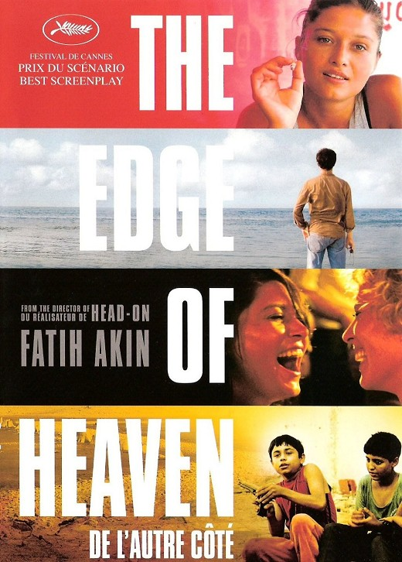

It’s important to reiterate that networked production does not determine networked film form; many films financed/produced this way have fewer protagonists and a more linear narrative and some financed/produced from a smaller number of sources also display a network narrative. A film’s thematic focus also does not always correlate with a network narrative structure: The Social Network, for example, with the exception of the opening scene cutting between shots of Zuckerberg’s misogynistic coding and the viral spread of his new site amongst users as well as the film’s slight manipulation of a linear temporal logic through flashbacks to build the legal drama, demonstrates little narrative innovation for a film meant to capture the networked new economy and its social impact. This is also not to say that all network narratives, even the transnational ones, are “neoliberal.” The network narrative form, in itself, does not determine politics. But there is something appealing about this form to societies in the thrust of globalization, where the free flow of information, people, and commodities is the implicit promise, if not actual outcome, of the global free market.

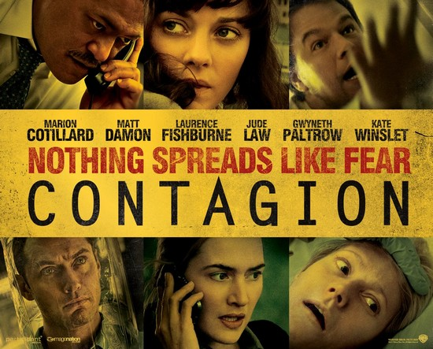

Conclusion

These magical neoliberal network narratives freely flow from node to node of their multiple storylines, crossing national borders with ease and projecting a neoliberal fantasy of cosmopolitan vision even while reproducing inequality and difference in both their production and representation. In their attempt and failure at the admittedly impossible task of representing the total logic of capitalist globalization, they become bound by their formal structure’s emphasis on the inevitability and violent randomness of human interconnection across these differences. But perhaps where they fail individually, they succeed collectively. With films coming out year after year over the last two decades, we have been unable as viewers to escape the systems of network narratives. The act of imagining human interconnectivity and dependency, however incomplete or flawed in these films, holds out the possibility of alternative futures based on these networked relations. And this may win out on the whole over the negative valences of connection. We are stuck to each other, our stories will unfold and be told together, so we might as well make it for better over worse.

Baldwin, D. (1997, April 24). The Proof Will Be in the ‘Europudding’. Los Angeles Times. Retrieved from
http://articles.latimes.com/1997-04-24/business/fi-51831_1_european-films

Barnard, R. (2009). Fictions of the Global. Novel: A Forum on Fiction 42(2), 207-215.

Beal, W. & Lavin, S. (2011). Theorizing Connectivity: Modernism and the Network Narrative. Digital Humanities Quarterly 5(2). Retrieved from http://www.digitalhumanities.org/dhq/vol/5/2/000097/000097.html

Blaney, M. (2011, June 15) Fernando Meirelles’ 360 first English language production to tap Austrian incentive. ScreenDaily.com. Retrieved from
http://www.screendaily.com/news/europe/fernando-meirelles-360-first-english-language-production-to-tap-austrian-incentive/5028791.article

Bordwell, D. (2006). The Way Hollywood Tells It: Story and Style in Modern Movies. Berkeley, CA: University of California.

Bordwell, D. (2008). The Poetics of Cinema. New York, NY: Routledge.

Carlsten, J. (2007). Containing Their Rage: Anger and the Liberal Cinema. Cinephile 3(1), 4-11.

Carpentier, A. (1995). On the Marvellous Real. In Parkinson Zamora, L. and Farris,W. (Eds.) Magical Realism: Theory, History, Community. Durham, NC: Duke UP.

Castells, M. (2000). The Rise of the Network Society, The Information Age: Economy, Society and Culture (2nd ed.) Cambridge, MA; Oxford, UK: Blackwell.

Castells, M. (2004). The Power of Identity, The Information Age: Economy, Society and Culture Vol. II. (2nd ed.) Cambridge, MA; Oxford, UK: Blackwell.

Castells, M. (2000). End of Millennium, The Information Age: Economy, Society and Culture Vol. III. (2nd ed.) Cambridge, MA; Oxford, UK: Blackwell.

Cieply, M. (2007, March 19). Tilting Hollywood’s Balance of Power to Talent Agency Clients. New York Times. Retrieved from
http://www.nytimes.com/2007/03/19/business/media/19fund.html?_r=1&oref=slogin

Coles, R. (2011). The Neuropolitical Habitus of Resonant Receptive Democracy. Ethics & Global Politics. 4 (4), 273-293.

De Vinck, S. (2009). Europudding or Europaradise? A performance evaluation of the Eurimages coproduction filmfund, twenty years after its inception. Communications. 34, 257-285.

Deleuze, G. & Guattari, F. (2004). A Thousand Plateaus. (Massumi, B. Trans.). London and New York: Continuum.

Deleyto, C. & del Mar Azcona, M. (2010). Alejandro González Iñárritu. Urbana, IL: The University of Illinois.

Denby, D. (2007, March 5). The New Disorder. The New Yorker. Retrieved from
http://www.newyorker.com/arts/critics/atlarge/2007/03/05/070305crat_atlarge_denby

Desser, D. (2003). Global Noir: Genre Film in the Age of Transnationalism. In Grant, B. (Ed.), Film Genre Reader III. Austin, TX: University of Texas, 516-536.

de Waard, A. (2007). The Global Social Problem Film. Cinephile 3(1), 12-18.

de Waard, A. & Tait, R. (2013). The Cinema of Steven Soderbergh: Indie Sex, Corporate Lies, and Digital Videotape. New York, NY: Wallflower Press.

Dixon, W. & Foster, G. (2007). A Short History of Film. New Brunswick, New Jersey: Rutgers University Press.

Ebert, R. (2007, September 6). Think Beyond the Top Layer. [Web log post.] Retrieved from
http://www.rogerebert.com/answer-man/think-beyond-the-top-layer

Edelstein, D. (2005, May 5). Crash and Fizzle. Slate. Retrieved from
http://www.slate.com/id/2118119/

Eurimages. What We Do. Retrieved from
http://www.coe.int/t/dg4/eurimages/About/default_en.asp

Everett, W. (2005). Fractal Films and the Architecture of Complexity. Studies in European Cinema 2(3), 159-171.

Fuguet, A. (2001, July-August). Magical Neoliberalism. Foreign Policy 125, 66-73.

Searls Giroux, S. & Giroux, H. (2007). Don’t Worry, We are all Racists! Third Text 21(6), 745-759.

Harvey, D. (1989) The Condition of Postmodernity: An Enquiry into the Origins of Cultural Change. Cambridge, MA: Blackwell.

Jaafar, A. (2006) Interview with Stephen Gaghan. Sight & Sound, 16(3), 18-20.

Kerr, P. (2010) Babel’s Network Narrative: Packaging a Globalized Art Cinema. Transnational Cinemas, 1(1), 37-51.

Jäckel, A. (2003). European Film Industries. London: British Film Institute.

Jagoda, P. (2010) Terror Networks and the Aesthetics of Interconnection. Social Text, 28(4), 65-89.

Jameson, J. (1988). Cognitive Mapping. In Nelson, C. & Grossberg, L. (Eds.) Marxism and the Interpretation of Culture. Urbana, IL: University of Illinois Press, 347-360.

Jameson, F. (1991) Postmodernism, or, The Cultural Logic of Late Capitalism. Durham, NC: Duke UP.

Jameson, F. (1995). The Geopolitical Aesthetic: Cinema and Space in the World System. Bloomington, IN: Indiana UP.

Jameson, F. (2002). The Political Unconscious: Narrative as a Socially Symbolic Act. London: Routledge.

Jameson, F. (2005). Archaeologies of the Future: The Desire Called Utopia and Other Science Fictions. New York: Verso.

K., Jeff (2010, May 8) “Mapping Conspiracy,” Cartographies of the Absolute. [Web log post]. Retrieved from
http://cartographiesoftheabsolute.wordpress.com/2010/05/08/mapping-conspiracy/#_ednref

Latour, B. (1987). Science in Action: How to Follow Scientists and Engineers Through Society. Cambridge, MA: Harvard UP.

Latour, B. (2005). Reassembling the Social: An Introduction to Actor-Network-Theory. Oxford: Oxford UP.

Levine, C. (2009). Narrative Networks: Bleak House and the Affordances of Form. Novel: A Forum on Fiction 42(3), 517-523.

Marshall, L. (2008, January 18). Critical Mass: Foreign Affairs. Screen International.

Menne, J. (2007). A Mexican Nouvelle Vague: The Logic of New Waves under Globalization. Cinema Journal 47(1), 70-92.

Mitchell, M. (2009). Complexity: A Guided Tour. Oxford: Oxford UP.

Morse, M. (1990). An Ontology of Everyday Distraction: The Freeway, the Mall and Television. In Mellencamp, P. (Ed.) Logics of Television.

Miller, P., Govil, N., McMurria, J., & Maxwell, R. (2005). Global Hollywood 2. London: BFI.

Negri, A. & Michael Hardt, M. (2000). Empire. Cambridge, MA: Harvard UP.

Negri, A. & Michael Hardt, M. (2004). Multitude: War and Democracy in the Age of Empire. New York: Penguin.

Orbe, M. & Kinefuchi, E. (2008). Crash Under Investigation: Engaging Complications of Complicity, Coherence, and Implicature Through Critical Analysis. Critical Studies in Media Communication. 25(2), 135-156.

Quart, A. (2005, August 1). Networked: Don Roos and Happy Endings. Film Comment. Retrieved from
http://www.alissaquart.com/articles/2005/08/networked_don_roos_and_happy_e.html

Ronfeldt, D. & Arquilla, J. (1998). The Social Netwar in Mexico. Santa Monica, CA: Rand.

Sánchez-Prado, I. (2006) Amores Perros: Exotic Violence and Neoliberal Fear. Journal of Latin American Cultural Studies 15(1), 39-57.

Sassen, S. (1998) Globalization and its Discontents. Essays on the New Mobility of People and Money. New York: New Press.

Sassen, S. (2001) The Global City: New York, London, Tokyo. (2nd ed.) Princeton: Princeton UP.

Sconce, J. (2002), “Irony, nihilism and the new American ‘smart’ film,” Screen, 43:
4, pp. 349–369.

Silvey, V. (2009, Spring). Not Just Ensemble Films: Six Degrees, Webs, Multiplexity and the Rise of Network Narratives. Forum: The University of Edinburgh Postgraduate Journal of Culture and the Arts, 8.

Silvey, V. (2011, Summer) Paris, Borders and the Concept of Europe in Paris, je t’aime and Code Unknown,” Alphaville: Journal of Film and Screen Media, 1.

Sieg, K. (2008). Choreographing the Global in European Cinema and Theater. New York: Palgrave MacMillan.

Sklair, L. (2000). The Transnational Capitalist Class and the Discourse of Globalization. Cambridge Review of International Affairs 14(1) 67-85.

Smith, P. J. (2003). Transatlantic Traffic in Recent Mexican Films. Journal of Latin American Cultural Studies 12(3), 389-400.

Tierney, D. (2009). Alejandro González Iñárritu: Director Without Borders. New Cinemas: Journal of Contemporary Film, 7(2), 101-117.

Waxman, S. (2006, July 25). ‘Crash’ Principals Still Await Payments for Their Work. New York Times.

Wayne, M. (2003) Post-Fordism, Monopoly Capitalism, and Hollywood’s Media Industrial Complex. International Journal of Cultural Studies 6 (1), 82-103.

Westwell, G. (2011, November) Regarding the Pain of Others: Scenarios of Obligation in Post9/11 US Cinema. Journal of American Studies 45, 815-834.

Williams, R. (1974). Television: Technology and Cultural Form. London: Collins.

Willman, S. (2002) Spinning Paranoia: The Ideologies of Conspiracy and Contingency in Postmodern Culture. In Knight, P. (Ed.) Conspiracy Nation: The Politics of Paranoia in Postwar America. New York: New York UP, 21-39.

Although the film develops themes of divergence and connection, the 5 female protagonists’ whiteness provides a starkly narrow view of the experience of women in the contemporary US.
Note that the network narrative is not a new form, but now a remarkably more prevalent one. Bordwell (2006, p. 100; 2008, p. 194) cites several network narrative films of the past, as well as the form’s long history in literature, from Charles Dickens' Our Mutual Friend (1864) to Ragtime (1975) by E. L. Doctorow. Levine (2009) reads a networked narrative form in the multiplot Victorian novels like Dickens’ Bleak House (1853). There also exists a significant body of scholarship on the interrelated stories of “composite novels” and “short story cycles,” across many periods but especially in modernist 20th century literature and 20th and 21st US ethnic literature dealing with themes of fragmentation and multiplicity. Beal and Lavin (2011) argue that the origins of the network narrative are in modernist American literature and the “collective novel,” as a response to the encounter with the new modern economic order, leading to proto-network meditations on the periods' tensions of "totalization and dispersal,” an argument similar to the one I am making here about the last twenty years.
The network narrative form is present in films from other historical periods, as in early multilinear iterations in Grand Hotel (1932) and Nashville (1975). It became an emergent form in independent and arthouse films in the 1990s like Slacker (1991), Reservoir Dogs (1992), Short Cuts (1993), Trois couleurs [The Three Colors Trilogy] (1993-1994), El callejón de los Milagros [Midaq Alley] (1994), Pulp Fiction (1996), Magnolia (1999) and with its international appearance suggesting both the global conditions of network society and the transnational networks of film festivals in dispersing such texts. The form has since had persistent life as a residual form in mainstream movies like Love Actually (2003), Valentine’s Day (2007), New Year’s Eve (2011), What to Expect When You’re Expecting (2012), etc.
Portmanteau or anthology films, also called omnibus or packaged films, have two or more separate stories tied together by an organizing theme or common event and sometimes feature several different directors. Their storylines feature less connection than network narratives, but may display similar attributes. Recent portmanteau films like 11'09"01 (2002), Tickets (2005), Paris, je t'aime (2006), New York, I Love You (2009), to name a few (as well as the crowd-sourced video compilation movies Life in a Day (2011) and One Day on Earth (2012) that take this form even farther) have been especially transnational in their casts, filmmakers, locations, and funding. Similar to portmanteau films but commonly referred to as a “parallel film” with its telling of different but thematically related stories, D. W. Griffith’s Intolerance (1916) evidences narrative innovations in the early history of feature filmmaking.
Chart – “Network Narrative Feature Films by Decade,” derived from Bordwell, 2008, pp. 245-250. Bordwell’s filmography lists films up to 2007, meaning that a significant number of the high profile recent network narratives like Contagion, Rendition, 360, Edge of Heaven, etc. and the wave of popular movies like Valentine’s Day, New Year’s Eve, etc. are left off, which would further increase the numbers for the 2000s. There are also a few films that Bordwell categorizes as network narratives in the text of his chapter, but seem to be accidentally missing from the list – Syriana, Grand Canyon (1991), and Grand Hotel (1932), for example – which suggests the incompleteness of this filmography, but do not change the relative proportions by decade for this comparison. The last, Grand Hotel (and it’s many international remakes) may be left off, because, along with films like Dinner at Eight (1933) and a series of disaster films around the 1970s like Airport (1969), The Poseidon Adventure (1972), The Towering Inferno (1974), and When Time Ran Out (1980) the multiple characters’ storylines converge in a single locale and their interrelationships are clear (Desser, 2003).
Formally, the network narrative demonstrates the influence of television dramas and melodramas on contemporary film, with their multiple protagonists and complex storylines. Industrially, at least two of the most well known films were crossovers from television: Crash was originally intended for development as a television show and Traffic was inspired by the British miniseries Traffik.
For an excellent analysis of the emergence of multiple storylines and skewed chronologies in film noir in the age of globalization see Desser (2003).
“We Are All Connected,” Film Posters for 360.
de Waard (2007, 2013) interprets the “global social problem” films of Soderbergh as “rhizomatic” in form and production.
See Jagoda (2010) for an excellent analysis of the networks of terrorism and capitalism in Syriana.
Apt terms used by Orbe and Kinefuchi (2008) to describe the racial rhetoric of Crash.
Theorists of neoliberalism have taken up the political economic valences of the concept of “mobile privatization” since the time of its theorization by Williams (1974) and Margaret Morse (1990). Desser similarly argues that cars and Los Angeles are especially significant in the interrelated genre of “global noir.”
Philip Dhingra, “The Tangled Web of Syriana,” July 30th, 2006, http://philosophistry.com/specials/syriana/ [accessed September 7, 2010].
Deleyto and del Mar Azcona point out that Amores Perros’ “very existence can be seen as a consequence of the implementation of the NAFTA agreement” (p. 18): “Its picture of a city plagued by kidnappings, murders, poverty, and homelessness has been related to the social consequences of the signing of the North American Free Trade Agreement (NAFTA) in the 1990s, but so has its box-office success” (p. 5).
See Jagoda (2010) for his interpretation of the progressive interventions of Syriana.
By films like Ringo Lam’s City on Fire (1987), Jim Jarmusch’s Mystery Train (1989), Richard Linklater’s Slacker (1991), Quentin Tarantino’s Pulp Fiction (1996), Michael Haneke’s Code Unknown (2000), and Robert Altman’s Short Cuts (1993).
Ensemble movies have a long history, but they became even more salient after mid-century when the industry attempted to create film “events” to compete with the rise of television. Producers packed stars into sprawling historical epics, adaptations of novels, and small parts and cameos in big budget films in the hopes that extra star power could protect financial investments. But rarely did more than two protagonists get central plotlines with stories simultaneously diverging and converging, as in network narratives (Bordwell, 2006, 95).

