Title: Limitations of Transmedia Storytelling for Children: A Cognitive
Developmental Analysis of Narrative Concepts for Children

Daniel Pietschmann, M.A., Sabine Völkel, M.A., and Peter Ohler, PhD

Chemnitz University of Technology

Author Note

Corresponding author contact information:
Daniel Pietschmann
Institute for Media Research, Chair of Media Psychology
Chemnitz University of Technology
Thueringer Weg 11, 09126 Chemnitz, Germany
Daniel.pietschmann@phil.tu-chemnitz.de

Abstract
Transmedia storytelling involves unfolding narratives across multiple media platforms with each text making a distinctive and valuable contribution to the whole. Transmedia consumers are more involved in the story resulting in more engagement, intrinsic motivation, and media enjoyment. Many modern entertainment franchises are created for a cross-generational appeal, also including child audiences. Combing the notion of transmedia storytelling with learning concepts, transmedia franchises are also created exclusively for child audiences. Several limitations apply when considering transmedia narratives for children as they require advanced media literacy skills and an appropriate cognitive, emotional, and moral development. This paper discusses cognitive limitations and their relevance for transmedia narratives. These limitations are illustrated using an analysis of the transmedia franchise of Disney’s Cars.

Keywords: transmedia storytelling, developmental psychology, child audiences, limitations

Limitations of Transmedia Storytelling for Children: A Cognitive
Developmental Analysis of Narrative Concepts for Children
Digital media is currently reshaping the landscape of children's media more profoundly than ever before. Young children are exposed to media content on a variety of platforms and media channels, and they are often literate with a broad range of media technologies before entering school (Singer & Singer, 2011). Media producers are aware of the potential of child audiences and have implemented concepts from transmedia storytelling for preschool and school children (e.g. Bob the Builder, Sesame Street or Pokémon). In transmedia storytelling a story is unfolded across multiple media platforms with each new text making a distinctive and valuable contribution to the whole (Jenkins, 2006). Transmedia users are more involved in the story, resulting in more engagement, intrinsic motivation and media enjoyment (Dena, 2009; Phillips, 2012). Many modern media franchises are created for a cross-generational appeal and use different media extensions and content to reach a large target audience including younger children (e.g. Harry Potter, Star Wars, SpongeBob SquarePants, The Muppets). Transmedia formats for children may even enrich educational concepts such as game-based learning (Gee, 2003) or experiential learning (Kolb, 1984). High engagement and media enjoyment result in a more elaborative processing of information, encouraging self-regulated learning (Zimmerman, 2000; 2002). Transmedia content can offer that possibility as it allows children to play with and participate in their favorite franchises, combing educational and entertainment experiences via narrative play and constructivist learning goals (Herr-Stephenson, Alper, Reilly, & Jenkins, 2013). Despite this huge potential, there are also several limitations of transmedia storytelling for child audiences: The complex narrative structure of transmedia content cannot simply be adapted to content suitable for children. From the perspective of developmental psychology, especially younger children lack the ability of adults to use, understand and participate in transmedia franchises. The main reason is that they still lack a variety of cognitive and meta-cognitive abilities. Their respective stage of cognitive development limits the narrative content and the complexity of stories they can understand (authors, 2006). Consequently, as transmedia narratives are usually very complex and spread across multiple media, they seem to be an odd choice for children. Content producers have to consider the information processing capabilities, memory capacities, and attention spans of children as well as their language proficiency, narrative knowledge, and the knowledge of media conventions. If producers exceed these limitations, comprehension and learning are compromised. Furthermore, the emotional and moral development also limits the processing of narratives. Younger children cannot naturally recognize an individual’s emotions. As they don’t fully understand the plot of a film yet, they are unable to attribute emotional expressions which are closely tied to the narrative. Well-designed mediated stimuli can be helpful for children to train their understanding of emotions as well as to control and express them in an appropriate way.
This paper focuses on cognitive limitations and discusses whether transmedia storytelling can really be reasonably implemented for child audiences. The paper first addresses transmedia storytelling and the relevance of current cross-generational transmedia franchises for child audiences. Secondly, cognitive development and media use as well as cognitive requirements for transmedia narratives in general are discussed. Finally, the paper illustrates these limitations using the example of Disney’s Cars (Anderson & Lasseter, 2006; Ream & Lasseter, 2011; Rae, Adams, & Lasseter, 2008-2012; Rae, Adams, & Lasseter, 2013), a global transmedia franchise aiming at children and younger tweens.

Transmedia Storytelling and Transmedia Franchises
The idea of transmedia storytelling is the coordinated use of storytelling across multiple media platforms (Jenkins, 2003) with “a particular narrative structure that expands through both different languages (verbal, iconic, etc.) and media (cinema, comics, television, video games, etc.)“ (Scolari, 2009, p. 587). Transmedia storytelling is not just another term for branding or franchising as it focuses on expanding a narrative in its scope and meaning. The stories told in different media are not redundant and help to construct a transmedia narrative story world (Scolari, 2009; Jenkins, 2009a, 2009b, 2011). In contrast to classic media franchises which are often based on reproduction and redundancy, transmedia franchises aim to further develop the story world with each new medium (Jenkins, 2011). “Additive comprehension” (Jenkins, 2011) in the form of smaller pieces of a puzzle refers to the degree with which each text adds to the understanding of the narrative as a whole in the form of a world-building process. These different pieces are often called sub- or paratexts (Gray, 2010), or media extensions to a primary text or “the mother ship” (Jenkins, 2011). They include professional and user-generated content. Whereas classic media franchises are based on licensing content to third parties (who cannot change or add anything beyond the primary text), transmedia franchises encourage co-creation and collaboration. However, coordinating a consistent canonic story world is a huge challenge for producers.
Dinehart (2008) understands transmedia recipients as viewers/users/players (VUP) who interpret the narrative individually different via their own natural cognitive psychological abilities. However, not all consumers are interested in the possibilities of transmedia narratives: Participating in transmedia storytelling requires an investment of resources (e.g. time, money) to piece the puzzle together. Evans (2008; 2011) argues that audiences do not uniformly welcome these new modes of reception - they have to see advantages in them for their own media enjoyment patterns. “If the new services can offer an improvement on what is seen as lacking in television broadcasting they are embraced; if they do not, they are not” (Evans, 2011, p. 178).
Jenkins (2006) mentions the use of attractors (elements that draw together an audience) and activators (elements that give the audience something to do) to engage an audience. Different key components of transmedia narrative strategies have been proposed to fulfill these roles. Scolari (2009) identified the creation of four different components concentrating on stories:
- interstitial micro-stories to fill gaps between periodic installments of content, e.g. television series;
- parallel stories;
- peripheral stories that can transform into spin-offs and
- user-generated content platforms to allow VUPs to enrich the fictional world (e.g. fan fiction;).
Jenkins (2009a, 2009b, 2011) identified seven general principles of good transmedia storytelling. These include (1) spreadability and drillability, (2) immersion and extractability, (3) world building, (4) continuity and multiplicity, (5) seriality, (6) subjectivity and (7) performance/ interaction.
Transmedia consumers require advanced skills in media literacy and multi-literacy (Scolari, 2009) to interpret and process narrative information from different media systems and platforms. Only with appropriate skills can narrative transmedia strategies be fully understood and processed. Depending on their developmental stage, children often lack these skills and can therefore not understand or participate in transmedia experiences like adults.

Child Development and Media Use
Today’s generation of children and youth is surrounded by a variety of media content as never a generation before: Rideout, Foehr, and Roberts (2010) found that children between 8 and 18 years of age spend the most time with media daily (7.5 hours per day on average) and consequently characterize children and youth today as Generation M. Children and adolescents live in a media-enriched environment or message-saturated world (Potter, 2013) which requires them to choose relevant and ignore irrelevant information from a wide range of media content every day.
Herr-Stephenson and colleagues (2013) documented transmedia learning for children aged 5 to 12 years. They argue that transmedia experiences can be designed for learning and “provide fertile grounds for children to explore, experiment, and often contribute as the story unfolds across media” (p. 1). Focusing on transmedia play, a transmedia experience that includes media without storylines (e.g. open-ended videogames), they argue that transmedia productions challenge children to use textual, visual, and media literacy skills to decode and remix media elements. Transmedia storytelling can on the one hand be considered as support for children to align their media choice to a central narrative (e.g. Cars, Star Wars, Harry Potter etc.). The content and the characters of the film are known to child audiences and they are therefore able to expand this narrative knowledge and are motivated to use different media forms like computer games, toys, books, audio books or music CDs to further experience their favorite characters and stories. This structuring on a content level helps children to deal with the plethora of information options as they prefer familiarity. On the other hand however, the transmedia franchise system overwhelms younger children in particular: They cannot accurately assess their own needs and gratifications and the quantity of available media extensions within a transmedia franchise can be too extensive for children. For this reason, preschoolers and school children need mediation from parents, educators and institutions to learn to structure the high amount of media information available. They have to learn to train their skills of selection, evaluation and classification of media, as well as active participation. These skills are described by the term media literacy. Potter characterized media literacy as a developmental ability to take „a perspective from which we expose ourselves to the media and interpret the meanings of the message we encounter“(Potter 1998, p. 5). For children media literacy is a key competence for their participation in our society. They have to acquire knowledge about the media such as how the media system is structured and how to differentiate between media formats providing real or fictional content. In addition to the construction of knowledge patterns children have to train those skills related with reflexive, evaluative and counterfactual thinking as well as the ability of perspective-taking (Potter, 2013). Media literacy plays an essential role for understanding transmedia narratives as they have to be constructed by the user combing information from various media platforms. To comprehend the narrative within a specific medium, the structure and characteristics of the medium have to be fully understood.
The mediating role of parents and educators is essential to help children handle media (i.e. cognitive apprenticeship; Brown, Collins & Duguid, 1989). Moreover, the experience with developmentally appropriate media content enables children to deal with the diversity of narratives, formats, genres, structures and motives in media environments. This is very important because developmentally appropriate media acts as a baseline for children to assess media content and helps children to compare different media experiences with one another. These experiences lie within the zone of proximal development (Zaretskii, 2009), thereby encouraging and advancing their individual learning. Younger children have substantially less real-world or mediated experiences than older children or adults. While growing up the cognitive structures of children must reach a certain level of cognitive, emotional, and moral development in order to process mediated information correctly.
Cognitive Development and Media Use
Nobody is born as a media user. Through maturation and experiences in childhood we have to learn to be competent in processing different content in various real or mediated situations. The cognitive development in childhood and adolescence follows a continuous structure of central developmental stages (Piaget, 1953; Perner, 1993). In his empirical work Piaget (1953) demonstrates that the minds of children mature between birth and 12 years of age. In the first four years they undergo the greatest cognitive development. He identifies four different stages of cognitive development: the sensorimotor stage on the lowest level (birth to 2 years), the preoperational stage (2 to 7 years), the concrete operational stage (7 to 12 years) and the formal operational stage (12 years and up; see Figure 1).
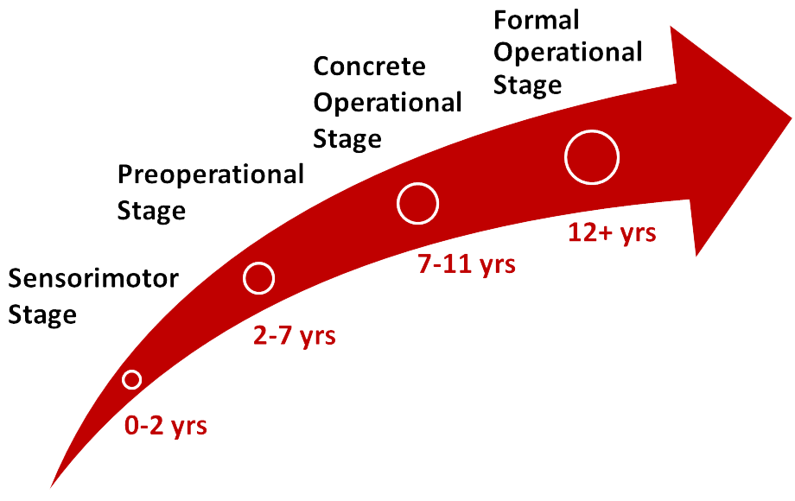
Figure 1. Piaget’s stages of development (illustration based on Piaget, 1953)
In Piaget’s model infants and toddlers up to 2 years of age reside in the sensorimotor stage which is characterized by the increase of motoric and verbal abilities. In Perner's Model of Representational Thinking (1993) he assumes that children (up to 1 ½ years) are limited in their cognitive thinking because their cognition is strongly tied to the actual situation. Children’s thinking at this stage is characterized on the basis of primary representations i.e. infants and toddlers use only environmental information which they represent mentally. Through these experiences they learn more about objects, persons, events, and actions. It therefore makes little sense to use complex media content for children at this stage because they cannot process it as intended. They would need multiple mental models to understand media narratives and the dual nature of media. Media is a construction of reality. The use of multiple mental models in childhood starts in the middle of the second year of life and is characterized by the beginning of thinking in past and future as well as in real and pretend. When presented with mediated information, children at the age of 18 to 24 months are able to use their first stable mental representations which are needed in symbolic play or delayed imitation. Children at this age understand two-dimensional stimuli such as photographs (DeLoache, Pierroutsakos, Uttal, Rosengreen, & Gottlieb, 1998; DeLoache, 2002, authors, 2013) or television pictures (Schmitt & Anderson, 2002). They can also distinguish between narratives and non-narratives in simple stimuli (Anderson & Pempek, 2005; Kirkorian et al., 2005) but are limited in their understanding of complex narrative structures and only understand superficial features in films.
Children between the ages of 2 and 7 years are in the preoperational stage of cognitive development (Piaget, 1953). Children then increasingly use mediated representations on the basis of secondary representations (Perner, 1993). Secondary representations allow children to represent information mentally. At this stage they also begin to understand symbol systems as a source of information. Despite these great advances, children up to the age of 4 years are limited by egocentrism and the lack of perspective-taking. When watching films, 3-year-olds process individual elements such as motion, color, music, or sound effects and are more interested in actions than dialogues. They cannot yet process plot structure and the motives of characters (Wartella, 1981). At the age of 4 years the more exploratory mode of watching changes to a searching mode. The child‘s motives influence his attention and he is able to concentrate on a continuous storyline (Potter, 2013). A major cognitive change takes place around the age of 4 years: thinking in metarepresentations (Perner, 1993). This altered cognitive competence allows children to think about their own representation and the representations of other persons i.e. about intentions, motives, beliefs and desires. This mental capability is described as Theory of Mind (ToM; Premack & Woodruff, 1978; Gopnik & Meltzoff, 1997; Gopnik & Wellman, 1992; Wellman, 1990; Sodian, 2005). At this point children are able to process a wider range of media content because it allows them to understand text structures, characters and their motives. Additionally, 4-year-olds begin to understand the distinction between television programs and commercials. Although children are able to differentiate both, they still struggle to understand the intentional meaning of advertising (Wilson & Weiss, 1992). Furthermore, they develop an understanding of differences in fiction and nonfiction, real and make-belief as well as plot elements (Potter, 2013).
In the concrete operational stage (7 to 12 years) children are able to organize objects into series (Piaget, 1953). They have now overcome the egocentrism and thereby obtain the competence to analyze situations from different viewpoints. This developmental progress greatly contributes to media understanding because children are now able to include more than one dimension in their analyses or evaluations of messages. They can think more rationally about media contents and structures than before. By the age of 8 to 10 years children have a well-developed understanding of fictional plots and are able to recognize the motives of the characters and the influence of the narrative (Potter, 2013). Moreover, children at this age are interested in seeking out information on certain topics, they are more innovative in dealing with media content and they are looking for new challenges in media use, especially emotional, moral and aesthetic experiences.
Between the ages of 10 and 12 years children generate their first understanding of the economic nature of TV, the motives of producers and the influence of the user (Potter, 2013). Following Piaget’s formal operational stage, adolescents of 12 years and older integrate a lot of operators into their own thinking (Piaget, 1953). They now are capable of theoretical, hypothetical and counterfactual thinking. The mental structures reach the level of adults, but this does still not mean that adolescents can process media content like adults. Some advanced skills like reflectivity, global and interdisciplinary thinking, and the ability of generalization have to be developed further until adulthood.
In the course of their development children acquire important cognitive abilities based on cognitive maturation and increasing experience. The ability of processing media fundamentally develops between the ages of 1 and 2 years. In this time span children are empowered to handle mediated information in their minds, e.g. pictures in books and images on screens. Another milestone in cognitive development is achieved at the age of 4 years, when the cognitive abilities of children are extended through metarepresentations. At this stage children can take different perspectives and thereby start to understand motives and intentions of characters. A more reflexive processing of media begins when children reach the stage of concrete operations (age 7 to 12 years). They are able to include more operations in their thinking and so they understand more about the content, modes and economic factors of media productions. Once they reach Piaget's level of formal operations (12 years and up) and the development of advanced skills of media literacy, adolescents should now have developed a critical mindset of thinking about media and their positive and negative effects.

Cognitive Requirements of Transmedia Narratives
The entertainment patterns of children are a “play with information” (Jenkins, 2006, p. 134) - when using media they have other needs, intentions, and interests than adults. Besides the cognitive requirements to fully comprehend und process media narratives, other competences are essential. Per definition transmedia narratives span across multiple media channels, combining television series, films, books, video games or online content. The limitations of technology available to children also limit their participation in transmedia narratives. Computers, smart phones or tablet PCs often act as a second screen for modern television narratives or as a primary medium for online narratives and participatory practices (Winslow, 2013). Although parents can provide access to mobile games and video games through their own devices, it is not reasonable to allow younger children unrestricted or unsupervised access to the internet and potentially unprotected media content. Legal restrictions often require online users to be at least 13 years or older. Content and legal restrictions constrain many complex transmedia concepts to teen and older audiences. Consequently, transmedia producers concentrate on suitable media channels for children and incorporate merchandising in the form of toys and items of everyday use. This strategy is of course not new and helps to sell merchandise to an emotionally engaged audience. Other than that however, many cognitive limitations apply to transmedia narratives targeted at children. We already pointed out that the cognitive development of children encompasses different stages, each enhancing the ability to process media narratives. This also applies to perceptional and motor abilities: Children under the age of 2 years lack the sharp, high-contrast vision (Norcia, Tyler & Hamer, 1990) needed for concentrated media use. At the ages of 6 to 7 years the hand-eye-coordination of children reaches the level of adults, allowing them to manipulate intricate objects or to play more demanding video games (Collins, 1984). At this age they are also able to understand different visual perspectives (changes in size and form in relation to distance and viewpoint) and combine visual-spatial information with the already existing ability to understand narratives based on phonological information (Flavell, 1988).
The narrative understanding of texts is essential for all kinds of transmedia narratives but children under 7 years are mostly limited to comprehend simple narratives, due to their lack of metarepresentations and the building of multiple mental models (Perner, 1993). Jenkins' (2009b) principle of seriality refers to an episodic, evolving narrative. Children prefer single, self-contained stories and have a hard time constructing a narrative from different sources over a longer period of time. Transmedia franchises for children therefore cannot make good use of this episodic structure.
Attention spans are also important for transmedia narratives. Children between the ages of 5 and 7 years have an average attention span for tasks of about 15 minutes. It is argued that television use does not fall under this category and can hold the attention of children for much longer due to attentional inertia (Anderson, Choi & Lorch, 1987). For children to have an active and productive participative role in media narratives, cognitive abilities such as abstract logic and reasoning as well as strategic planning of the concrete operational stage (age 12 years and up) are required. Transmedia narratives for children therefore cannot rely on the same principles of participatory culture as for adults. For example, Jenkins' (2009b) principle of subjectivity is problematic for children: While they can follow a continuous narrative, up to the age of 7 it is hard for them to take over another person’s perspective and experience the same story again. This is true for single medium narratives and even more for transmedia narratives: Perspective-taking requires a stable understanding of the variety of perspectives, theory of mind and counterfactual thinking, which work reliably around the age of eleven years. For younger children a combination of different subplots within a narrative is very demanding and may overtax them, depending on the complexity of the plots. References to books within a film are processed on the surface of the text only e.g. the appearance of the same characters or locations. The intention of spreading a narrative via transmedia storytelling is not apparent or comprehensible for preschoolers as it requires advanced media literacy skills only acquired in early adolescent years. Even more complicated to follow is a retelling of the same story (i.e. the principle of multiplicity). Variations in the personality or appearance of characters cannot be integrated well into their knowledge of a given story world as children perceive characters as unfamiliar, resulting in their having to process the story as something completely new. It may even conflict with prior knowledge of the narrative. Only with the development of advanced media literacy skills can transmedia storytelling be processed accordingly on a global level. Nevertheless, parts of the transmedia narrative can still be very enjoyable for children, even if they do not fully comprehend the narrative on a global level.

Transmedia franchise analysis: Disney’s Cars
In our analysis of Disney’s Cars, we discuss which narrative strategies of the franchise are suited for children and which are better suited for older audiences. The franchise is designed to appeal not only to child audiences but to a broader cross-generational “family” audience. Disney’s new diversification strategies under CEO Bob Iger began with the purchase and integration of Pixar. Marvel Entertainment (2009) and Lucasfilm (2012) also became subsidiaries of Disney, further moving away from younger children to the rapidly growing market of tweens. Disney’s cross platform franchising allows them to target completely different market segments. Cars is a good example of the marketing mix for these huge media franchises which, instead of just reaching younger children like Disney’s princess movies, are able to appeal to a bigger market segment. By November 2013, the Cars franchise included two feature films, two television series, short films, nine video games and mobile applications, two theme park attractions and a spin-off film (Planes). A third film is currently in development (Warnick, 2013).

Narrative and Characters in Cars
The first movie Cars (Anderson & Lasseter, 2006; rated with no age restrictions in the US and Europe) features a story about a racecar (Lightning McQueen) who gets lost on the way to a famous race and ends up in a small town on Route 66. There McQueen has to help the locals to get to the race. The narrative includes many subplots but their support of the main narrative is not always apparent. It is very demanding for younger children to connect the plots. The main narrative follows a classic three-act structure (setup, confrontation, resolution), which is easy to follow and predict and is suited for a broad audience. Children’s stories and fairy tales almost exclusively follow this structure. There are few important characters which all have unique features (e.g. colors, voice, quirks) and relatively one-dimensional personalities. But in most subplots new characters are installed: Twelve new characters are introduced in Radiator Springs alone; altogether there are over 40 individual characters shown in the film. It requires multiple receptions to understand the role of all the characters in the narrative and their relation to each subplot and the general plot. However, from a transmedia storytelling as well as a media literacy acquisition point of view, this is great: It is worth watching the film again as there is always something new to notice. But there is a tradeoff between plot comprehension and the possibility to dig deep into the film. Lightning McQueen, the protagonist, is an up-and-coming rookie racer based on generic NASCAR vehicles with features from the Dodge Viper and the Chevrolet Corvette. His personality is depicted as very focused but also arrogant and self-centered at the beginning of the movie. He learns to appreciate others during his stay in Radiator Springs and forms friendships that eventually help him in the important race at the end of the film. Instead of winning the race, McQueen helps an injured race car friend and becomes the likeable hero of the crowd. He is colored in bright red and features racing wheels and lightning bolt decals, a very memorable appearance for children. Additionally, he portrays a great role model (Figure 2). McQueen is the face of the franchise which is also why the franchise is mostly associated with him and the leading color red. The repetition of colors, forms, music, and perspectives within the different media extensions facilitates familiarity for children.

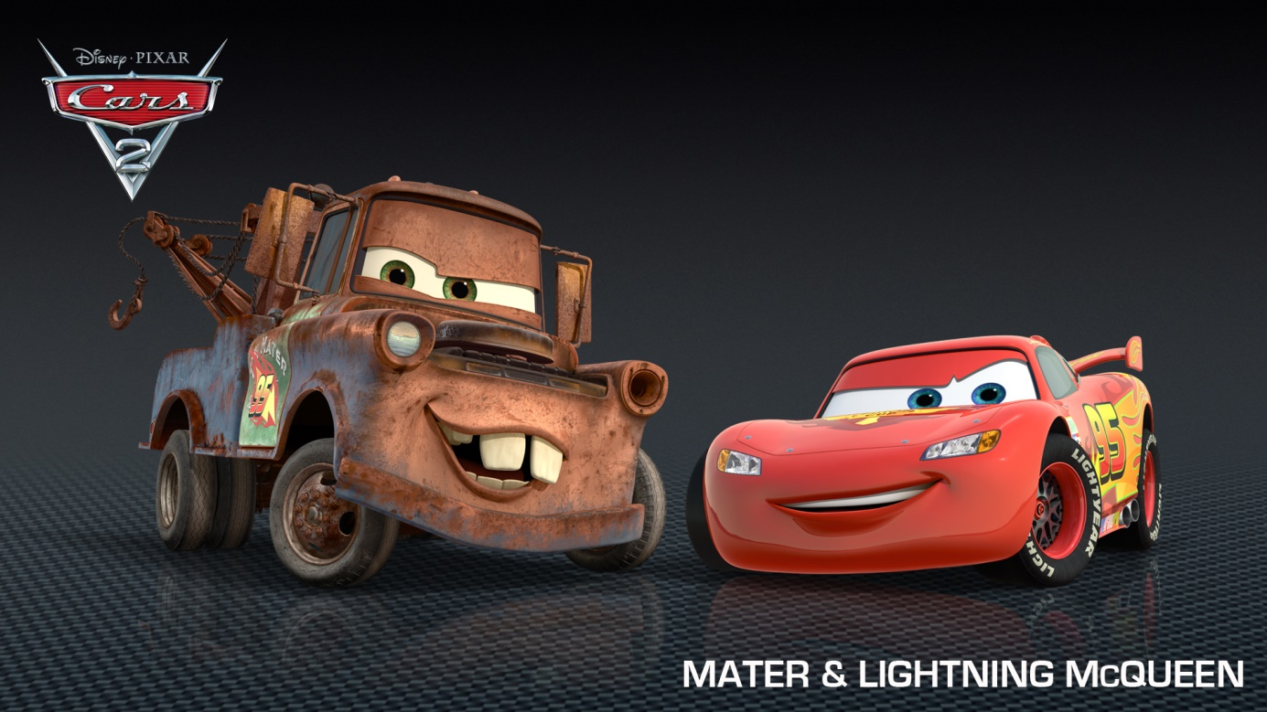
Figure 2. Lightning McQueen and his best friend Mater (Disney, 2013)

Another important character of the film is Mater, a tow truck that quickly becomes best friends with McQueen and acts as his sidekick in the franchise (Figure 2). The character speaks with a Southern accent and frequently uses incorrect syntax. He is depicted as a loyal and supporting, but clumsy friend. The fact that Mater is a tow truck also underscores the function as a supporting character for the protagonist as Mater can help McQueen with his hook and his strength. Furthermore, this concept also makes for a great toy car for children. His rusty color, broken headlight and crooked teeth clearly differentiate Mater from the other cars. The combination of personality and appearance make for another very memorable and easy identifiable character for children. The character is very popular and later received more spotlight in the second film (Ream & Lasseter, 2011) and the television series “Car Toons: Mater’s Tall Tales” (Rae, Adams, & Lasseter, 2008-2012; Rae, Adams, & Lasseter, 2013).
The Cars characters are well-suited for children and are easily recognizable by shape or color alone (Figure 3). Other important characters include lawyer Sally Carrera, a love interest for McQueen (colored in light metallic blue) as well as Doc Hudson (royal blue), a retired race car and mentor character. All characters also feature individually recognizable patterns of nonverbal behavior which make the Cars franchise stand out. The cars transport emotional states and moods very well.

 Figure 3. Shapes and colors of the Cars characters are memorable and easy to identify for children (Source: authors)

With almost two hours' playtime, the film is rather long for child audiences and overtaxes the concentration and attention span of smaller children. The rapid pacing is sometimes too fast for younger children under the age of 6 years. It may be effective to hold attention or to regain it but it complicates comprehension. The film also employs split-screen information during the races which overwhelms younger children with a flood of pictures.
Furthermore, the children need a high degree of world knowledge to understand the references
in the film. The narrative involves many details on car racing and economic factors as well as media staging of racing events or sport events in general. Children lacking the ability of abstract logic, reasoning and counterfactual thinking (concrete operational stage, 7 to 12 years; Piaget, 1953) have problems understanding these media or economic factors, but they are able to learn them by mediating through parents. Verbal allusions and references are also problematic for children as they require specific world and language knowledge which cannot always be mediated by parents. One inhabitant of Radiator Springs is Luigi, an Italian Fiat 500, who owns a tire shop which is known for its “Leaning Tower of Tires”—a reference to the “Leaning Tower of Pisa”. Luigi also worships Ferrari which is often referenced in the film. These references are not understandable for younger children and the support of parents is not very effective but the parental co-viewing is entertaining and makes the film very enjoyable for older audiences. Nevertheless, the lack of understanding the references does not hinder the understanding of the main narrative. Younger children are more concentrated on the surface structure of films like color, sound, movements, and main characters. A complete understanding of the narration, the motives of single characters, the development in personality etc. are fully understood only in later childhood.

Media Extensions and Merchandising
The first film was released in movie theaters alongside the introduction of their cartoon car characters on a wide range of merchandise (Figure 4). Disney’s strategy included releasing Cars toys, lunch boxes, and pajamas just before the movie hit the theaters and thus, emotionally engaging the target audience in the franchise. As the movie was a big success, more merchandise and media extensions soon followed. There are toys for toddlers (e.g. slide cars), preschoolers (e.g. coloring pictures, toy cars, children’s books), and school children (e.g. school bags, pens), but only some of the merchandise contributes to the narrative of the franchise. However, the distinctive design—the color Red of the protagonist is omnipresent in almost all merchandise, as well as the cartoonish design of the cars itself)—allows for excellent brand recognition.
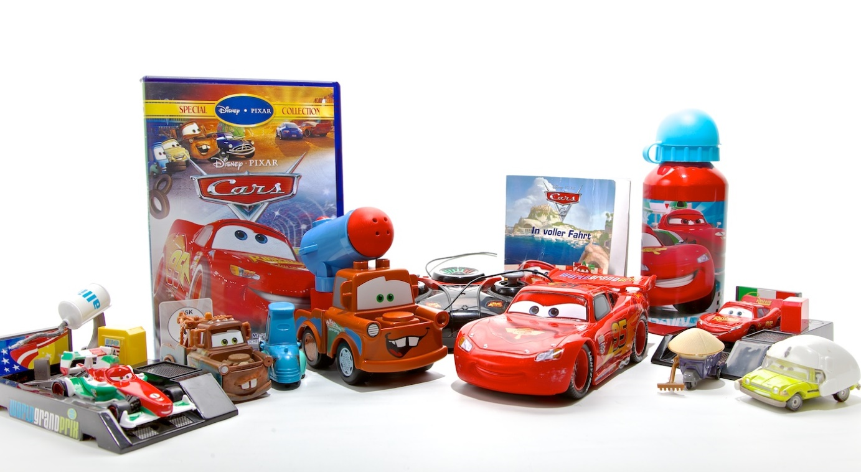 Figure 4. Some of the merchandise of the Cars franchise (Photograph by authors)

In terms of transmedia storytelling, children can play with their favorite characters and construct stories of their own or reenact scenes from the films or television series (symbolic play, imaginative play) which is basically a good thing. In terms of Jenkins’ principles of transmedia storytelling (2009a, 2009b), performance and interaction should also allow recipients to share their own stories with each other, which is limited to local sharing with an audience who cannot use the Internet. But children can exchange their individual knowledge and views of the Cars story world by playing with each other using the toys.
Media extensions, such as the children’s books, retell the story of the film and also expand the narrative with new short stories. The “Cars Storybook Collection” (Disney Book Group, 2011a; target audience aged 3 to 7 years) features short stories (about five to ten minutes) about minor characters and challenges for the main protagonist, Lightning McQueen. Lots of pictures and small story-bits allow for additive comprehension and build a consistent story world. Other books, such as “Meet the Cars” (Disney Book Group, 2011b) reveal more characters from the franchise not shown in the films, thus also adding to the world building process. Besides these transmedia extensions, there are also books that work as classic cross-media extensions, just retelling the story in another medium (Disney Book Group, 2006; 2011c).
The video games allow the players to explore the world of Radiator Springs. The first game (Rainbow Studios, Inc., 2006) is an open-world racing game where players can roam freely, talk to other characters and accept race challenges to advance the narrative. The story is a continuation of the original film’s story, where McQueen finds himself at the start of the next Piston Cup season. The game is rated without age restrictions, but requires a lot of coordination and skill from the players. Smaller Children may like to drive around and look at the open world of Radiator Springs, but well-developed sensorimotor skills are required to master the races in the game. Only children at the age of 7 and up have the necessary skills of the preoperational developmental stage (Piaget, 1953) to fully comprehend the narrative of the game. The game’s narrative is basically a sequel to the film, using the same memorable elements (e.g. characters and locations) to facilitate familiarity, while telling a new, but very similar story. The game makes lots of references to the first film and enables children to play with their favorite characters.

Transmedia Campaigns and Cars 2
The second film (Cars 2, Ream & Lasseter, 2011) was accompanied by multiple transmedia campaigns, such as the Australian launch campaign (ACP Digital & Disney Pictures, 2013). “Bright minded young kids” were the target audience for the campaign, where they were encouraged to participate in missions set by a spy character from the movie. The users took the role of individual spy agents and were thus tied to the core plot of the move on a narrative level. The missions were spread over a wide range of media, including popular magazines, television, online quizzes or mobile phones. After the completion of a mission, a specific code was generated, which allowed access to a micro-site for a competition to win a trip to the Cars theme park in Paris. The website also showcased the movies’ characters and allowed users to pre-purchase tickets for the cinema.
Cars 2 debuted five years after the first film, building on a large fan base. The film opened to mixed/average reviews from critics, and is Pixar's worst reviewed feature film to date (IMDB score 6.3; IMDB, 2013). The story begins with McQueen having won four Piston Cup titles and continues with a spy story and car races all over the world. In contrast to the first film, Cars 2 has an age six rating and is generally harder to understand for children. It has also been criticized for being very fast and having many action scenes with explosions, gunfire and even a death scene, where the antagonist in form of a mad scientist tortures another race car character for information and kills him in the process (Curiouser Institute, 2012). Many jokes and references in the film (e.g. the homage to the spy agent film genre and James Bond movies) are clearly targeted at older audiences and are not comprehensible for children. On the up side, the narrative of the film also involves renewable energy sources and bio fuels and climate change, which can be a good starting point for children to discuss about with parents or teachers in school.

Discussion of the Cars Franchise
Both films act as primary texts as they do not reference or acknowledge other media extensions. Although some media extensions are produced by Disney themselves (they have full creative control) some extensions are licensed out to third parties like in classic media franchises. Cars and Cars 2 can be watched without any other knowledge of the Cars story world, there are no visible gaps in the story. The films are targeted at a broader audience, including adults. Media references to other genres or jokes which children cannot possibly understand emphasize this clearly. Most extensions, however, target children. They can build a better understanding of the characters and narratives with the television series (Rae, Adams, & Lasseter, 2008-2012; Rae, Adams, & Lasseter, 2013), books and video games. Disney has done a great job with world building with a lot of story opportunities and characters to tell stories with. The video game tells a story between the events of both films (interstitial microstories, Scolari, 2009). The story is very similar to the first film, but that is probably exactly what children want, as they can engage in narrative play with their favorite characters. There are storybooks that retell the main narrative of the films without adding new elements to them (classic cross-media; Disney Book Group, 2006; 2011c) but also many books with new stories and elements (Disney Book Group, 2011a; 2011b), fostering an additive comprehension (peripheral stories, Scolari, 2009). The stories within the franchise are self-contained and not episodic. Jenkins (2009b) principle of seriality refers to chunking of narratives (e.g. television series, episodic updates etc.) for good transmedia storytelling, which would probably overburden especially the concentration ability and attention of younger children. The principles of immersion and extractability as well as drillability and spreadability work well within the franchise as there are countless toys and media extensions to engage in. There are even theme park attractions (Cars Land in Disney California Adventure Park and Cars Quatre Roues Rallye in Disneyland Paris) where children can experience and interact with the story world in the flesh.
Altogether, the Cars franchise is a very good example of a modern transmedia franchise. Disney incorporated many key components of transmedia storytelling to build an engaging story world that transcends the boundaries of classic franchises. The primary texts are the films, designed to appeal to a broad audience and not only to children. To achieve this general appeal the films include many references, allusions and characters as well as fast cinematography that overtax the narrative understanding and attention capabilities of smaller children. It is doubtful that a broader appeal would still be achieved if the films were designed specifically to be appropriate for smaller children on a cognitive developmental level. Children still have fun watching and re-watching the films, even if they do not understand the narrative fully. Countless media extensions enrich the main narrative of the films, each specifically designed to target an age segment that can process the narrative well enough.

General Discussion and Implications
What does all of this mean for transmedia narratives for children? In general, media productions have to be adapted formally, legally, and content-wise to the developmental stage of child audiences. Concentration and attention spans are shorter than in adults: Information has to be presented in short, simple, and possibly colorful terms. The example of Cars shows that, with the exception of both the main films which are targeted not only at children but at a broader audience, this can be easily achieved with different media extensions for different age groups. The repetition of colors, forms, music, perspectives, and narratives facilitates familiarity for children. Visual references between different media do not require a coherent understanding of the text, but allow for the recognition of characters, especially for younger children (ages 2 to 6 years). Older children (ages 6 to 8 years) can build on a coherent understanding of the text and therefore content references between different media can be understood and enjoyed. As additive comprehension is possible at this stage, the idea of real transmedia narratives can be utilized. Participatory practices require advanced media literacy skills which are acquired during adolescence. Although Cars does not fully apply all Jenkins' (2009a, 2009b) transmedia principles or Scolaris' (2009) strategies, it works well as transmedia storytelling. Transmedia narratives can be designed for children if producers consider cognitive limitations for children and design appropriately.

References
ACP Digital & Disney Pictures (2013). Disney Cars2 Transmedia Campaign. Retrieved November 18, 2013 from http://www.behance.net/gallery/Disney-Cars2-transmedia-campaign/1682300
Anderson, D. K. (Producer), & Lasseter, J. (Director). (2006). Cars [Motion picture]. USA: Walt Disney Pictures/Pixar Animation Studios.
Anderson, D. R. & Pempek, T. (2005). Television and very young children. American Behavioral Scientist, 48, 505-522.
Anderson, D. R., Choi, H. P., & Lorch, E. P. (1987). Attentional inertia reduces distractibility during young children's TV viewing. Child Development, 58 (3), 798–806. doi: http://www.jstor.org/stable/1130217
Authors, (2006).
Authors, (2013).
Brown, J. S., Collins, A., & Duguid, P. (1989). Situated Cognition and the Culture of Learning. Educational Researcher, 18 (1), pp. 32-42.
Cars 2 (2013). Retrieved November 21, 2013, from http://www.imdb.com/title/tt1216475/
Collins, W. A. (1984). Development During Middle Childshood: The Years from Six to Twelve. Washington DC: National Academy Press.
Curiouser Institute. (2012, January 16). Shallowness in Children’s Fiction: Cars 2 [Blog post]. Retrieved November 16, 2013 from http://www.curiouserinstitute.com/blog/curiouser/shallowness-childrens-fiction-cars-2
DeLoache, J. S. (2002). The Symbol-Mindedness of Young Children. In W. W. Hartup & R. A. Weinberg (Eds.), Child Psychology in Retrospect and Prospect. Mahwah, NJ: Lawrence Erlbaum Associates.
DeLoache, J. S., Pierroutsakos, S. L., Uttal, D. H., Rosengreen, K. S., & Gottlieb, A. (1998). Grasping the nature of pictures. Psychological Science, 9, 205-210.
Dinehart, S. (2008). Transmedial play: Cognitive and cross-platform narrative. Retrieved November 23, 2013, from http://www.narrativedesign.org/2008/05/transmedial-play-the-aim-of-na.html
Disney (2013) Disney Cars 2 Characters. Retrieved November 18, 2013 from http://www.disney.com/cars
Disney Book Group (2006). Cars. Little Golden Book. New York, NY: Disney Press
Disney Book Group (2011a). Cars Storybook Collection. New York, NY: Disney Press.
Disney Book Group (2011b). Meet the Cars. New York, NY: Disney Press.
Disney Book Group (2011c). Cars 2 Big Golden Book. New York, NY: Disney Press
Evans, E. (2008). Character, audience agency and transmedia storytelling . Media, Culture & Society, 30 (2), 197-213
Evans, E. (2011). Transmedia Television: Audiences, new Media and daily Life. New York, London: Routledge.
Flavell, J. H. (1988). The Development Of Children’s Knowledge about the Mind: From cognitive Connections to mental Representations. In: J.W. Astington, P. L. Harris, & D. R. Olson (Eds.), Developing Theories of Mind (pp-244-271).New York, NY: Cambridge University Press.
Gee, J.P. (2003). What Video Games have to teach us about learning and literacy. New York, NY: Palgrave Macmillan
Gopnik, A. & Meltzoff, A.N. (1997). Words, thoughts, and theories. Cambridge, MA: MIT Press.
Gopnik, A. & Wellman, H. M. (1992). Why the child’s theory of mind really is a theory. Mind and Language, 7, 145-171.
Gray, J. (2010). Show Sold separately. Promos, Spoilers, and other Media Paratexts. New York, London: NY University Press.
Herr-Stephenson, B., Alper, M., Reilly, E. & Jenkins, H. (2013). T is for transmedia: Learning through transmedia play. Los Angeles and New York: USC Annenberg Innovation Lab and The Joan Ganz Cooney Center at Sesame Workshop. Available online http://www.annenberglab.com/viewresearch/46
Jenkins, H. (2003, January 15). Transmedia storytelling. Moving characters from books to films to video games can make them stronger and more compelling. Technology Review. Retrieved November 24, 2013 from http://www.technologyreview.com/biotech/13052/
Jenkins, H. (2006). Convergence Culture. Where Old and New Media Collide. New York: NYU Press
Jenkins, H. (2009a, December 12) The Revenge of the Origami Unicorn: Seven Principles of Transmedia Storytelling (Well, Two Actually. Five More on Friday). Retrieved November 11, 2013 from http://henryjenkins.org/2009/12/the_revenge_of_the_origami_uni.html
Jenkins, H. (2009b, December 6). Revenge of the Origami Unicorn: The remaining four Principles of Transmedia Storytelling [Blog post]. Retrieved November 11, 2013 from http://henryjenkins.org/2009/12/revenge_of_the_origami_unicorn.html
Jenkins, H. (2011, August 1). Transmedia 202: Further Reflections [Blog post]. Retrieved November 21, 2013 from http://henryjenkins.org/2011/08/defining_transmedia_further_re.html
Kirkorian, H. L., Anderson, D. R. , Evand-Schmidt, M. & Pempek, T. A. (2005). TV and Toddlers. Paper presented at the Society for Research on Child Development, Atlanta, GA.
Kolb, D (1984). Experiential Learning as the Science of Learning and Development. Englewood Cliffs, NJ: Prentice Hall.
Meltzoff, A. N. & Moore, M. K. (1977). Imitation of facial and manual gestures by human neonates. Science, 198, 75-78.
Nocia, A. M., Tyler, C. W., & Hamer, R. D. (1990). Development of contrast sensitivity in the Human Infant. Vision Research 30 (10). pp1475-1486.
Perner, J. (1993). Understanding the representational mind. Cambridge: MIT Press.
Piaget, J. (1953). The Origin of Intelligence in the Child. [La naissance de L’intelligence chez l’enfant]. London: Routledge and Kegan Paul.
Potter, W.J. (2013). Media Literacy. 6th Ed. Thousand Oaks: Sage.
Premack, D., & Woodruff, G. (1978c). Does the Chimpanzee Have a Theory of Mind. Behavioral and Brain Sciences, 1 (4), pp. 515-526.
Rae, K., Adams, K., Lasseter, J. (Producers). (2008-2012). Cars Toons: Mater’s Tall Tales [Television series]. USA: Pixar Animation Studios.
Rae, K., Adams, K., Lasseter, J. (Producers). (2013). Cars Toons: Tales from Radiator Springs [Television series]. USA: Pixar Animation Studios.
Rainbow Studios, Inc. (2006). Disney Pixar Cars [Video Game]. USA: THQ Inc.
Ream, D. (Producer), & Lasseter, J. (Director). (2011). Cars 2 [Motion picture]. USA: Walt Disney Pictures/Pixar Animation Studios.
Rideout V.J., Foehr U.G., Roberts D.F. (2010). Generation M²: media in the lives of 8-18 year-olds. Kaiser Family Foundation.
Schmitt, K. L. & Anderson, D. R. (2002). Television and reality. Toddlers‘ use of visual information from video to guide behavior. Media Psychology, 4, 51-76.
Scholari, C., A. (2009) Transmedia Storytelling: Implicit Consumers, Narrative Worlds, and Branding in Contemporary Media Production. International Journal of Communications 3, 586-606. Retrieved from: http://ijoc.org/ojs/index.php/ijoc/article/viewFile/477/336
Singer, D.G. & Singer, J.L. (2011). Handbook of Children and the Media. Thousand Oaks, CA: Sage Publications.
Sodian, B. (2005). Theory of Mind: the case for conceptual development. In W. Schneider, R. Schumann-Hengsteler & B. Sodian (Eds.). Young children’s cognitive development. Interrelationships among executive functioning, working memory, verbal ability, and theory of mind. Hillsdale, NJ: Erlbaum.
Warnick, R. (2013, August 17). Michael Wallis confirms there will be a “Cars 3” [Blog posting]. Retrieved November 18, 2013 from Route 66 News: http://route66news.com/2013/08/17/michael-wallis-says-there-will-be-a-cars-3/
Wartella, E. (1981). The child as viewer. In M. E. Ploghoft & J. A.Anderson (Eds.). Education for the television age (pp. 28-117). Springfield. IE: Charles C. Thomas.
Wellman, H. M. (1990). Children’s theories of mind. Cambridge, MA: MIT Press.
Wilson, B. J. & Weiss, A. J. (1992). Developmental differences in children’s reactions to a toy advertisement linked to a toy-based cartoon. Journal of Broadcasting & Electronic Media, 36, 371-394.
Winslow, G. (2013). New Ways to Rethink the Second Screen. Broadcasting & Cable, 143 (41). p28.
Zaretskii, V. K. (2009). The Zone of Proximal Development. What Vygotsky Did Not Have Time to Write. Journal of Russian and East European Psychology, 47 (6). pp. 70–93. doi:10.2753/RPO1061-0405470604
Zimmerman, B. J. (2000). Attaining Self-Regulation. A Social Cognitive Perspective. In M. Boekaerts, P. Pintrich & M. Zeidner (Eds.), Handbook of Self-Regulation (pp. 13-35). San Diego: Academic Press.
Zimmerman, B. J. (Ed.) (2002). Becoming a Self-Regulated Learner [Special Issue]. Theory Into Practice, 41 (2)

This refers to the fact that media content exists in multiple forms, e.g. images on the television screen or letters in books
Symbolic play is the child’s ability to use objects, actions or ideas to represent other objects, actions, or ideas as play (e.g. to use a wooden block as a toy car).
Delayed imitation describes the copying of an observed gesture, action or behavior after a time delay.
The ESRB ratings are restrictive and do not refer to age recommendations. The rating “everybody” just means that there are no violent or sexual situations that classify the game as inappropriate for anybody.

