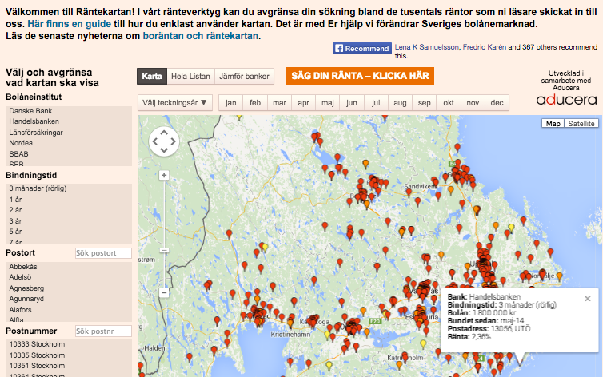
Appendix A.

Picture 1. Svenska Dagbladet’s Rantekartan. Each pin marks an interest rate submission. When one clicks on a pin, a more detailed view of the interest rate information pops up.

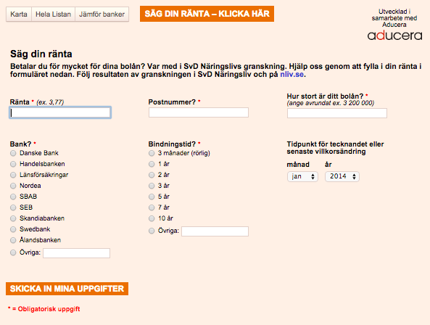
Picture 2. The submission form for the interest rate map. Users are asked to submit the interest rate, the duration of the loan, the bank, the zip code, the amount of the loan and the last date for changes to the loan.

