NUTRITION - NORMATIVE MESSAGE

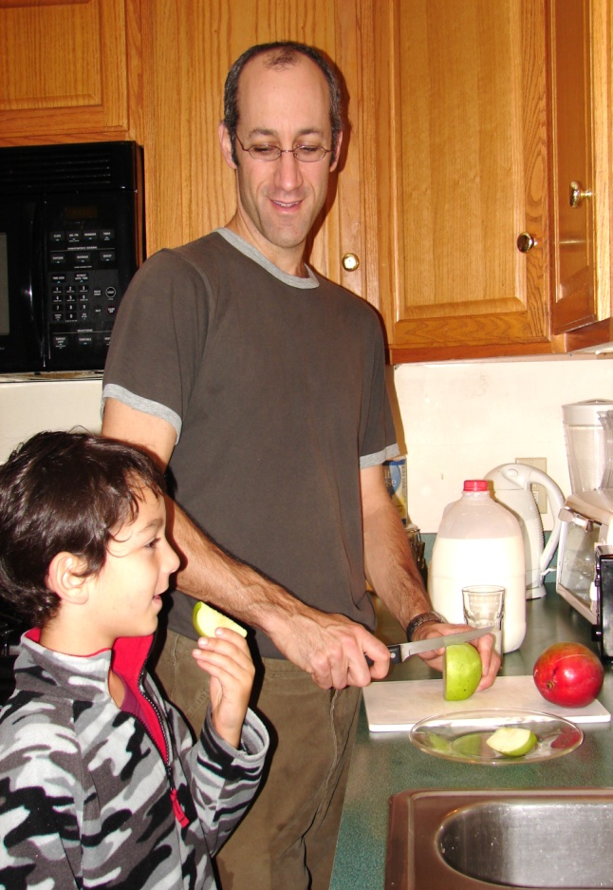
Set a great example –
Show your family and friends how important feeding your child healthy food
is to you.

Children and nutrition:

Some important facts

Proper nutrition will help your child's normal growth and development. Your child’s nutrition has a long-term impact on their health and risk of developing obesity and other related health problems later in life.

It is never too early to teach children the value of avoiding high fat and high sugar foods and the importance of fiber, calcium, iron and other minerals in the diet. Understanding the value of and adapting a well-balanced diet at an early age has life-long benefits.

Why is it important to provide healthy food choices for your child?

Like other parents of young children, you want what’s best for your child. You want your child to grow up in a healthy environment and learn healthy habits for life.

Just as you would protect your child from any danger or harm, it is also your responsibility to help reduce the amount of unhealthy foods your child eats, and to provide them with healthy and nutritious food choices.

Show your family and friends how much you care about your child’s nutrition

How can you help your child eat healthy foods?
- Increase your child’s intake of whole-grain and fruits and vegetables. Include vegetables in cooked foods for meals, or add fruits as a topping to food or as a snack. Substitute whole grain breads, cereals and pasta for refined grains, such as white bread, and high-sugar breakfast cereals.
- Reduce the amount of high-fat and high-sugar foods your child eats (for example, sweets, sugary snacks, and sodas). Check the nutritional labels to help decide whether foods are healthy.
- Encourage healthy choices without nagging. Do not restrict food, but make sure to praise healthy choices your child makes.
- Keep a variety of healthy foods in your home. Kids tend to eat what is available. It is important to set an example yourself and eat healthy foods for your own snacks.
- Sit down to family dinners at night as much as possible. Try to reduce the amount of times you order take-out for your family or eat at fast food restaurants.

Sometimes it can be difficult to get your young child to eat a healthy diet, but it’s worth making an effort.

Over time it will become easier.

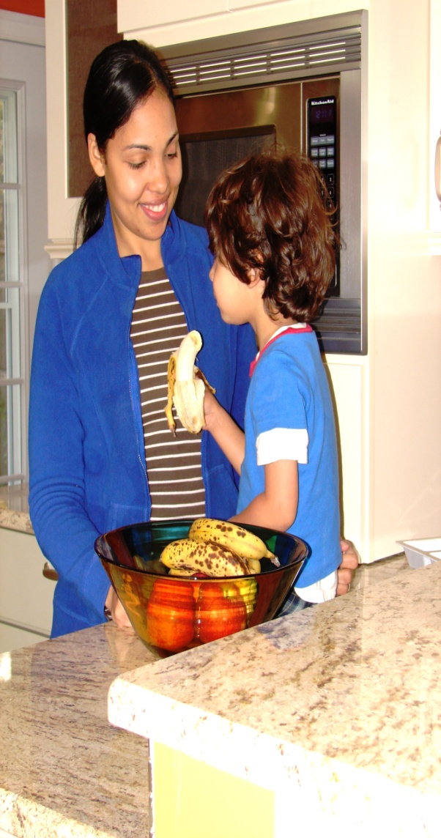

NUTRITION - ATTITUDINAL MESSAGE
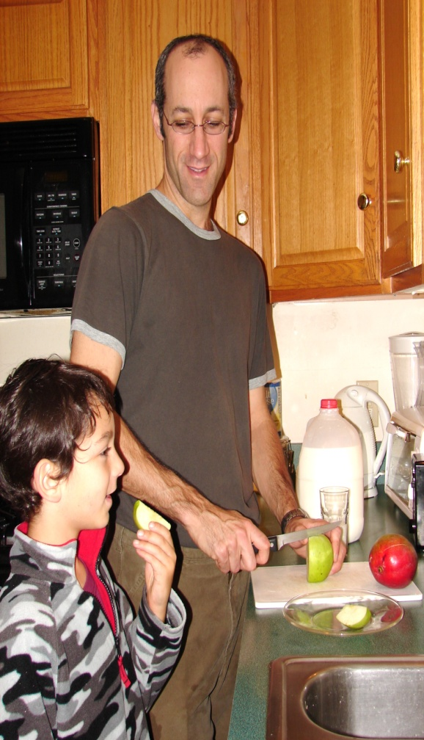
Feeding your child healthy foods will benefit their health now and in the future

Children and nutrition:

Some important facts

Proper nutrition will help your child's normal growth and development. Your child’s nutrition has a long-term impact on their health and risk of developing obesity and other related health problems later in life.

It is never too early to teach children the value of avoiding high fat and high sugar foods and the importance of fiber, calcium, iron and other minerals in the diet. Understanding the value of and adapting a well-balanced diet at an early age has life-long benefits.

Why is it important to provide healthy food choices for your child?

As a parent, you want what’s best for your child. You want your child to grow up in a healthy environment and learn healthy habits for life.

Just as you would protect your child from any danger or harm, it is also your responsibility to help reduce the amount of unhealthy foods your child eats, and to provide them with healthy and nutritious food choices.

Children and nutrition:

Some important facts

Proper nutrition will help your child's normal growth and development. Your child’s nutrition has a long-term impact on their health and risk of developing obesity and other related health problems later in life.

It is never too early to teach children the value of avoiding high fat and high sugar foods and the importance of fiber, calcium, iron and other minerals in the diet. Understanding the value of and adapting a well-balanced diet at an early age has life-long benefits.

Why is it important to provide healthy food choices for your child?

As a parent, you want what’s best for your child. You want your child to grow up in a healthy environment and learn healthy habits for life.

Just as you would protect your child from any danger or harm, it is also your responsibility to help reduce the amount of unhealthy foods your child eats, and to provide them with healthy and nutritious food choices.

Feeding your child nutritious foods will help them grow up healthy

How can you help your child eat healthy foods?
- Increase your child’s intake of whole-grain and fruits and vegetables. Include vegetables in cooked foods for meals, or add fruits as a topping to food or as a snack. Substitute whole grain breads, cereals and pasta for refined grains, such as white bread, and high-sugar breakfast cereals.
- Reduce the amount of high-fat and high-sugar foods your child eats (for example, sweets, sugary snacks, and sodas). Check the nutritional labels to help decide whether foods are healthy.
- Encourage healthy choices without nagging. Do not restrict food, but make sure to praise healthy choices your child makes.
- Keep a variety of healthy foods in your home. Kids tend to eat what is available. It is important to set an example yourself and eat healthy foods for your own snacks.
- Sit down to family dinners at night as much as possible. Try to reduce the amount of times you order take-out for your family or eat at fast food restaurants.

Sometimes it can be difficult to get your young child to eat a healthy diet, but it’s worth making an effort.

Over time it will become easier.

