Rousing the Facebook crowd: social media, emotion work and digital enthusiasm in the 2011 protest wave
Paolo Gerbaudo – King's College London

ABSTRACT

The management of political Facebook pages in the 2011 protests in Egypt, Spain and the US has been characterised by the use of an intensely emotional communication, with status messages adopting an impassioned language often eliciting an avalanche of likes, supportive comments, and solidarity shares. In this article I discuss this communicative “emotion work” (Hochschild, 1979), performed by activists through Facebook status messages and its role as catalyst of moments of “digital enthusiasm”, to be understood as phases marked by contagious positive mood in online conversations that is reinforced through rapid social media interactions. I argue that the online public space hereby manifested is profoundly different from Habermas’ rationalistic public sphere and is instead reminiscent of typical crowd dynamics.

Introduction

“The 15M was an emotional mood” is an assertion often heard from veterans of the Spanish indignados - or as alternatively named “15M”, because of its start date on the 15th of May 2011 - movement, what constituted one of the most remarkable events in the 2011 wave of protest, spanning from the Middle East and North Africa to the US. This expression is a commentary on the intensely emotional nature of the experience earned by thousands of participants in physical public space, in the face-to-face interactions within protest camps and popular assemblies. But it also captures the heavily emotionally laden character of online public space, of the social media communication that sustained the emergence of the indignados movement. Months before Spanish protestors would make their first appearance in the Spanish streets, digital activists were already intensely using social media as campaigning channels, by circulating impassioned denunciations of the hardship befalling on many Spanish people in the aftermath of the financial crisis of 2008, as well as calls to action against the hated bankers and politicians, held as the main responsible for the crisis. With messages abounding in exclamations, smilies and capital letters, digital activists endeavoured to convey the urgency of popular action, and embolden participants. Internet users responded enthusiastically, as seen in the waves of likes, supportive comments and “solidarity” shares these messages attracted.
The deeply emotionally laden messages channelled by the Democracia Real Ya Facebook page are a manifestation of the way in which activists across recent social movements, have utilised Facebook pages, as platforms to conduct what Arlie Hochschild called “emotion work”, as the “act of trying to change in degree or quality an emotion or feeling” (1979). More precisely this Facebook communication has been geared at provoking what we could call “moments of digital enthusiasm”: periods characterised by a contagious positive mood that is progressively reinforced through the feedback loop of social media interactions, until reaching spectacular points of climax on the eve and the start of major protest events promoted by these Facebook pages. This situation of collective enthusiasm has been manifested in the performance of many Facebook pages that have experienced remarkable spikes in the growth of the user base and in the level of user engagement, projecting in few weeks and months newly born pages to the leaderboards of political pages in their respective countries. Crucially, these moments of enthusiasm have been instrumental to offline protest action, with these movements drawing many participants from the online crowds gathered around political Facebook pages (Gerbaudo, 2012). What kind of emotional communication and emotion work facilitate this explosion of moments of digital enthusiasm? How did Facebook activists utilise the affordances of social media as an enthusing tool? And what do these deeply emotionally laden processes tell us about the nature of online public space?
To address these questions in this article I focus on the activity of three key Facebook pages in the 2011 wave of protest the Kullena Khaled Said (We are all Khaled Said) Facebook page, the most important communication channel in the Egyptian revolution of 2011, the Democracia Real Ya Facebook page in Spain, and the main Facebook page of Occupy Wall Street in the US, that have constituted the most important activist Facebook pages in their respective countries. Empirically, I draw on a mixed methods approach comprising a) quantitative analysis of the performance of these Facebook pages, b) discursive analysis of the status messages and comments posted on these pages, and on c) interpretive insights emerging from 50 interviews conducted with activists and protest participants across these three countries. My main goal in analysing this diverse empirical material is to establish the ways in which the emotion work performed through Facebook status messages, makes use of the specific features of social media, their mass communicative scale and their capacity for viral communication as means to facilitate the contagious spread of an enthusiastic mood among participants.
My argumentation centers on the prophetic and dialogic character of the emotion work performed by Facebook activists. Key in igniting moments of digital enthusiasm was the ability of Facebook activists to write, in a personal and moving style, capable of capturing the sentiments prevalent among their user base, and of transforming them in a way amenable to a process of mass protest mobilisation. In this context, Facebook messages often took a prophetic tone, foreshadowing the rise of a mass movement that might overcome the present social ills, trying to strengthen people’s interpersonal trust and attempting to defuse negative sentiments in online discussions. This framing proved very effective in attracting people’s attention and firing their hope, as reflected in the phenomenal growth of user engagement these pages experienced. Interestingly, Facebook activists often resorted to pointing to the metrics of Facebook interactions – likes, comments, and shares as an early proof of their prophetic messaging, with the aim of emboldening people’s self-confidence, and preparing them for offline protests, demonstrating the suitability of these social media feartures to the igniting of moments of digital enthusiasm.
The nature of these forms of expressive communication is clearly at odds with prevailing theory of internet communication and social media interactions, that have operated within the theoretical framework of the “bourgeois public sphere” as described by liberal theorist Jurgen Habermas (1994), and then applied by many scholars to describe the contemporary web (Papacharissi, 2002, Dahlberg, 2001, Sparks, 2001). Instead of the rationalistic understanding of the public sphere as a space for unbiased discussion and reasoned deliberation, these events reflect a more typical crowd logic, involving processe of bodily and emotional aggregation, and forms of solidarity. Through the intense emotion work conducted through political Facebook pages activists have been able to rapidly gather mass groupings around shared issues of concern, thus creating ad-hoc public spaces on social network sites. Yet, these public spaces have been also notably marked by a profound volatility, with “online crowds” often progressively dispersing soon after they have reached the climax of their collective enthusiasm, raising difficult theoretical and political questions that will be considered at the end of this article.

Protest politics, emotions and the digital plebeian sphere

Understanding moments of digital enthusiasm - those events in which the emotions of thousands of internet users become fused into a collective belief about the possibility to change society for the better - requires some rethinking of the theories by mean of which we understand politics and communication in a digital age, and the way we talk about social media as a sort of new public space. Making sense of these processes is impossible unless we question at the root the rationalistic aand individualistic ssumptions that dominate much debate about social media and public space which frames social network sites as “channels” for the circulation of quanta of information among individuals conceived as bounded rational subjects, along the lines of what James W. Carey criticised the “transmission model of communication” (Carey, 2008). Counter to this dominant approach, it is necessary to recuperate a sense of the centrality of emotional processes in social media, paying attention to the emotional character of the relationships that are established between the actors of online communications, and in this context between the admins of political Facebook pages and their user.
Debates about social media, politics and public space continue to be deeply influenced by Jürgen Habermas’s rationalistic theory of the public sphere the ugly English translation for the German Öffentlichkeit or “publicity” (1968/1994). This normative theory prescribes that communication in public space should involve forms of rational argumentation in an “ideal speech situation” involving unbiased individuals. The notion has been widelty adopted by media researchers to analyse the effects of the internet on politics. Thus Zizi Papacharissi has proposed to look at the internet as a “virtual public sphere” (Papacharissi, 2002), while other scholars have explored how the interactive affordances of the internet, with the possibility for users to intervene in online forums and chats, could provide similar characteristics to those of the tea-rooms and theatre foyers discussed by Habermas in his discussion of 17th and 18th centuries publics (Dahlberg, 2001, Sparks, 2001).
The problem with this line of theorising is not simply its profound abstraction, but also its elitism. By making discussions among bourgeois subjects in a tea-room the norm of good communication, this theory sees all other contexts of communications as necessarily inferior, and irrational. As Stanley Aronowitz has argued the theory of the public sphere is deeply imbued with a liberal ideology that is profoundly suspicion of collective action and which is animated by a profound “fear of crowds” and of street protest (Aronowitz, 2000). Notably, Habermas’s theory was already criticised in the early days by Oskar Negt and Alexander Kluge (1993), who instead of the bourgeois public sphere, tried to propose the notion of the “proletarian public sphere”. In a similar vein, analysing moments of digital enthusiasm, as they arise in political Facebook pages, can be seen as a contribution towards the analysis of what we could the “digital plebeian sphere”, that is an understanding of the internet as a space that is not reducible to bourgeois and phlegmatic types of interaction as those privileged by media theorists working in the vein of Habermas, but which instead encompasses forms of expressive and emotional communication such as those seen in crowd dynamics.
In the development of a theory of digital enthusiasm within an emerging digital plebeian sphere, important insights can be drawn from the current revival in the analysis of emotions.
Emotions, once nearly a taboo subject in the social and political sciences, also due to their association with outdated theories of irrational crowd behaviour, have been the object of increasing scholarly attention in recent years. This interest is testified by the discussion of this concept in the context of social movement studies (see for example, Jasper, Goodwin, Polletta, 2001). James Jasper has called for a recuperation of the role of emotions, arguing that “emotions pervade all social life, social movements included” (1998: 398) and has argued that emotions are subject to an intense process of cultural construction. Similar trends have been seen in political philosophy with scholars as Antonio Negri and Michael Hardt on the one hand (2000, 2004), and Ernesto Laclau (2005) on the other hand talking of “affect” as a fundamental dimension of all political endeavours, and even liberal philosophers as Martha Nussbaum (2010, 2013), arguing for a recuperation of emotions based on the assertion that “all political principles, the good as well as the bad, need emotional support” (2013: 2). Finally, also new media studies are experiencing a revival of discussion about emotions as testified by the discussion of emotions of indignation and hope in Manuel Castells book about the 2011 protest movements (2012), and in Zizi Papacharissi’s recent book on what she calls “affective publics” (2014), as a way to integrate emotional processes to her prior analysis of the public sphere.
The importance of emotional processes is highly visible in the context of social media, not least because of their personal focus (Turkle, 2012), and the way in which they are used to express personal feelings, opinions and preoccupations. Authors as Jodi Dean have thus for example described how blogging is animated by an obsessive psychological drive, the compulsion to start something all over again. Deeply intertwined with the logic of contemporary “communicative capitalism” (2010: 29-31) the drive loop does not provide according to Dean a resource for radical politics: “conceived in terms of drive, networked communications circulate less as potentials for freedom than as the affective intensities produced through and amplifying our capture”. Taking a more optimistic view point, Zizi Papacharissi has recently tried to reconcile public sphere theory and the study of emotions, seeing networked communications as leading to the emergence of “affective publics” (2014). She has argued that “digital, among other media, invite and transmit affect but also sustain affective feedback loop that generate and reproduce affective patterns of relating to others that are further reproduced as affect – that is intensity that has not yet been cognitively processed as feeling, emotion, or thought” (2014: 23). In highlighting the evident emotional dimension of social media, these contributions highlight the centrality of an interactive emotional loop, underscoring our communications, whose value can be both positive and negative, both enthusising or depressing.
Among the manifold emotions that are manifested in social movements, enthusiasm has a particularly important status, as the emotion most commonly associated with phases of revolutionary mobilisation already discussed by a number of authors such as Charles Tilly (1989, 1993) and Georges Rude’ (1959). Enthusiasm can be understood as a higher order emotion, or more specifically a positive “emotional mood” that is distinct from more elementary “reflex emotions” as fear and joy, as well as from “moral emotions” as compassion and indignation. Moods “are modular and transportable emotions. We typically carry a mood from one situation to the next” (421).
Enthusiasm can be seen as fundamental in motivating people’s participation given that, as Bert Klandermans has argued, one of the most important factors in people’s decision to participate in protest is ‘the impression that also other people will participate’ (Klandermans, 1984: 586). It is not surprising thus, that lot of the “emotion work” (Hochschild, 1979), that goes on within social movements revolves precisely around the attempt of instigating enthusiasm, while at the same time defusing negative sentiments. How does this emotion work develop in the use of social media platforms?
It is apparent that social media platforms provide a number of features and affordances that lend themselves to what we could call “enthusiasm work”, that is the deliberate attempt by protest organisers to ignite a moment of collective enthusiasm. This can be appreciated by referring to the various features of the “logic of social media” as it has been described by Thomas Poell and José van Dijck by comparing and contrasting it with the mass media logic (Altheide and Snow, 1979). Poell and van Dijck refer to four key features of this logic - programmability, popularity, connectivity, and datafication – two of which – popularity and connectivity are particularly interesting to understand the nature of activist enthuasiasm work. First social media’s facilitation of connectivity among like-minded individuals, provides basis for the development of interactions among “networked individuals”, who are at the same time isolated, yet united by common interests. This aggregative function of social media, can provide the basis for the formation of online crowds around shared causes. Second, social media’s notion of popularity as manifested in the importance metrics as likes, comments, and shares can contribute to the construction of collective enthusiasm, by providing with a running display of the growth of support for a certain cause, which in turn can end up eliciting further support. How did Facebook admins make use of these features as a means to construct moments of digital enthusiasm? What type of enthusiastic interactions between leadership and base did social media facilitate? And what is the nature of the public space emerging in this context?

Methodology

This article is based on qualitative research conducted about social media activism in Egypt, Spain and the US. The research lasted for 4 years between 2011 and 2014, and it involved a mixed methods approach, comprising in-depth semi-structured interviews, and analysis of select social media datasets. For each of the movements analysed I focused on the top Facebook page in terms of likes: the Kullena Khaled Said page in the case of the Egyptian revolution and the Democracia Real Ya page in the case of the indignados movement. Using the digital methods software Netvizz I archived all the status messages, interactions and comments in the period between June 2010 and February 2011 in the case of the Kullena Khaled Said Facebook page, February 2011 and June 2011 in the case of the Democracia Real Ya Facebook page and September 2011 to December 2011 in the case of the main Occupy Wall Street Facebook page. The data has undergone a textual analysis, utilising “bottom up” open coding methodologies, with the identification of basic categories and their progressive incorporation into larger categories. For this purpose I have utilised the qualitative data analysis software Nvivo. Besides analysing the content of these Facebook pages I have also drawn on insights originating from the 50 interviews I conducted with activists and participants.

“Let’s make it happen…”

“The most important objective was to inspire hope in the hearts of all page members and everyone who participated” (Ghonim, 2012: 81). The sentence written by Wael Ghonim, in his memoir of his activity as an admin of the Facebook page Kullena Khaled Said perfectly highlights the centrality of emotional processes in the management of what constituted the most important means of communication in preparation of the Egyptian revolution of 2011. Crucial in the communication of this and other Facebook pages was the attempt to emotionally “rouse” the online crowd of web users, imbuing them with a sense of mutual trust and hope in their possibility to prevail over all the enemies. The status messages posted in Facebook pages constantly tried to infuse hope and self-confidence in their users, appealing to their sense of national and generational pride. This emotion work largely bore its fruits, attracting attention from page users, and facilitating their engagement, as testified by the momentous growth of likes, comments and shares, in a white heat of digital enthusiasm that was a very important factor in the ultimate success of protest mobilisation. But what were exactly the forms of communication that elicited this explosion of user engagement? How did Facebook admin manage to construct an effective interaction with their user base?
Before we are able to address this question it is necessary to look at the performance of these Facebook pages, at the quantitative evolution of their users and their level of user engagement, as measured through typical web 2.0 metrics as likes, comments and shares. Examining the development of these campaigns online, it is apparent the way in which they attracted a sustained and in specific occasions, exponential growth in terms of both a) “status message likes” - likes expressed in response to specific status messages - as well as b) page likes, likes directed at a certain page, in fact an act of subscription to the feeds produced by the same page. This dynamic can be appreciated by looking at the charts representing audience history and post history across these movements.
- In Figure 1. it is represented the evolution of likes earned by status messages on the Kullena Khaled Said Facebook page. This highlights how the page experienced a rapid growth in the number of likes approaching the day of protest of the 25th of January 2011. The page performance continued growing in the following days, and in February after Mubarak’s ouster, before starting to gradually tail off in the Spring of 2011.
- A similar rapid growth was experienced by the page of Democracia Real Ya in Spain, as illustrated by Figure 2.. After growing steadily in March and April, the page experienced a period of exponential growth in the days immediately before the protests of the 15th of May 2011. It then peaked in the days after the 15th of May as Puerta del Sol and other occupations were set up. The page engagement began tailing off towards the end of 2011.
- Figure 3. shows a similar dynamic in the case of the main Facebook page of Occupy Wall Street, referring in this case to the growth of total likes for the page. After a relatively slow growth in September right before and during the beginning of the protests starting on September 17th 2011, until reaching a tipping point at the beginning of October, coinciding with the mass arrests on Brooklyn bridge on October 1st 2011, and sustained growth for all the month, with over 10,000 likes added in average per day, during that period.
Despite variations in terms of the time span considered and the trajectory of evolution, what is clear across these pages, is that they were all characterised by rapid rates of growth, reaching exponential progressions on the eve and during the initial phase of the protests, to then progressively tail off in the aftermath of these events, with varying degrees of rapidity. The role of activist communication in facilitating this pattern of enthusiastic support can be better analysed looking at each case separately before trying to identify some common patterns in the ensuing discussion sections.

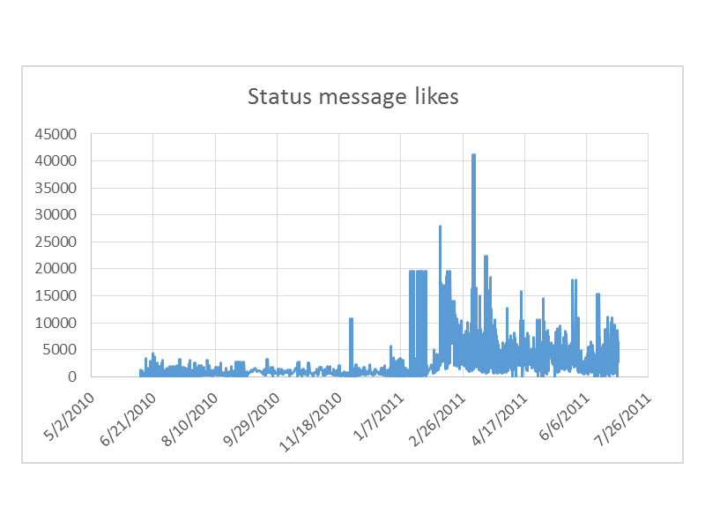
Table 1. Kullena Khaled Said Facebook page – Status message likes / Jun 2010 – July 2011
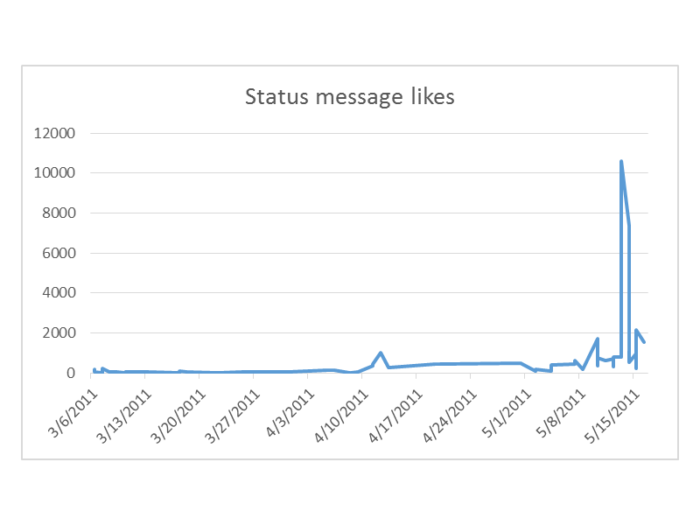
Democracia Real Ya Facebook page – status message lik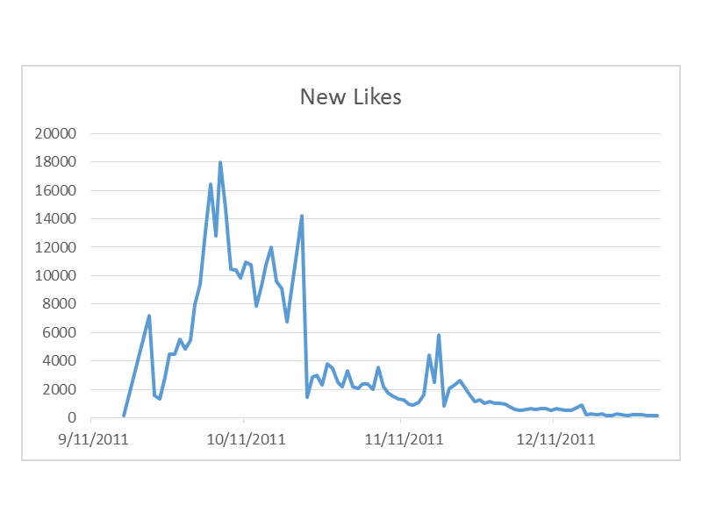Occupy Wall Street Facebook page – new page likes per day

The Egyptian Kullena Khaled Said (We are all Khaled Said) Facebook page is possibly the best example of the construction of moments of digital enthusiasm as a crucial resource for contemporary forms of mobilisation. This is not just because of the rapid growth experienced by the page, founded in June 2010, but more so because of the phenomenal peaks it touched on the eve of the protests of January 2011, and then again in February 2011, when Mubarak was eventually forced to resign, with the 5-day internet blackout starting on 28th of January and engineered as measure of last resort by the government, responsible for a break in-between these two peaks.
The page began with a bang, with 30,000 people who joined the page on its very first day of existence, then experiencing sustained growth in 2010 and an exponential rise in correspondence with the protests of January and February 2011, with 1 million people who RSVPed the Facebook event set up for the first day of protest on January 2015. How did the communications channelled through the page elicit this emotional response and this impressive builup of user engagement?
A good share of the merit for the emergence of this moment of digital enthusiasm has to be go to the intelligent communications orchestrated by Wael Ghonim, the main admin to the page who would later be joined by Cairene activist Abdelrahman Mansour. Ghonim, who at the time worked as Google Marketing director for the Middle East and was based in Dubai, made use of his impressive array of skills, including technical skills, a strong familiarity with marketing techniques, as well as a remarkable writing flair, cultivated since his early youth. These skills were combined with a keen ability to understand and direct the emotionality of the hundreds of thousands of internet users, who as expressed by Mustafa Shaimaa, a young veteran of the 2011 revolution found there their unlikely “political initiation”. The admins, signing themselves as “el shaheed” (the martyr in reference to Said’s heroic death) called for fellow Egyptians to realise the dire condition they faced amidst Mubarak Egypt, and issues of economic disarray, police corruption, and environmental pollution. Message after message they constructed a redemptive narrative of Egyptian people, as citizens who had for too long being under the thumb of an unfair regime, but who had grown tired of being tyrannised and had eventually come to the conclusion that they had to risk their safety if they wanted to live a life worth living.
The emotionally laden content channelled through the Facebook page is perfectly summed up by one of the chants contained in a file uploaded to Google Docs in anticipation of the 25th of January protest proclaiming “ Let’s make it happen Egyptians, wake up your spirits.. the gates of liberty are open”. This communication was necessarily imbued with a profound sense of affliction, as the utterances of a person who deeply cares about the destiny of his own country and is saddened to see it in such a bad shape, after decades under the jackboot of military dictatorship. But besides the grief about the state of the country, the messages always contained a glimpse of hope, inflected as they were by a profound and to a great extent idealistic trust in the fundamental good of his fellow Egyptian citizens, and a belief in their readiness to take on the government that oppressed them, to establish a democratic regime. This attitude is encapsulated in the status message, Wael Ghonim posted on the morning of the 25th of January Ghonim. ‘today we are going to prove that we are not guys of “Comment and like” as they claim. We are REALITY on Earth we are demanding our rights and we are all participating.’ The message turned upside down the stygmatisation of young people, as apathetic guys of “comment and like”, which had been for years one of the regime media favourite taunts against young urban protestors. This as many other messages posted in previous weeks contained a prophetic tone, articulating a collective sense of hope, shared by many Internet users despite their physical dispersion.
In Spain, the doings of Egyptian digital activists served as a powerful inspiration for activists organising to protest against the consequences of the economic crisis and austerity politics, particularly affecting the generation of Millenials and “digital natives”. Among the earliest adopters of these new digital tactics were the activists of Democracia Real Ya (Real Democracy Now), a campaigning group protesting against bankers and politicians that played a pivotal role in the launch of the indignados movement, which made its first public appearance on the 15th of May 2011. One of the first acts since the creation of the group was the setting up of a dedicated Facebook page on March 6th 2011, which, alongside a number of visible Twitter accounts, constituted the key mobilising platform for the movement. While not experiencing such a spectacular beginning as the Kullena Khaled Said page, the Democracia Real Ya fanpage grew quite rapidly, attracting a constituency of first thousands and then tens of thousands of people in the months before the protest, until experiencing a veritable explosion few days before the protests, as seen in the peaking of status message likes, eventually plateauing and tailing off in the end of 2011. The page thus strongly contributed to the launch and sustainment of a protest movement that would maintain protest encampments for several weeks in squares all over Spain, and gain the support of the large majority of the country’s population. But how did the communication conveyed through the page contributed to this impressive ballooning of the page users and their engagement?
Similarly to what happened in Egypt, key in eliciting a positive emotional response from users, and facilitating the rise of a moment of digital enthusiasm, was the the deeply emotionally laden messaging conveyed by the activists managing the page. This content aimed at capturing the
widespread sense of anger experienced by many Spanish people amidst the economic crisis and the politics of austerity pursued by the government and to turn it into a positive motivation for protest participation. As it was the case in Egypt, admins of Democracia Real Ya constantly emphasised the “positive”, the redemptive potential that was available also in a grim present, being careful that the negative element did not prevail in the conversation.
Indicative of the process of emotional articulation developed by Democracia Real Ya are the Facebook status messages posted during the long months of preparation of the first day of protest on May 15th 2011. What is remarkable in these status messages is the frequency of hopeful, and sometimes boastful messages, proclaiming with certainty the strength of the movement and its ultimate success, and often abounding in exclamation marks and ‘smilies’. For example on April 26th the admin announced “Ya somos 30.000 indignados confirmando nuestra asistencia en el evento estatal!! Invita a tus contactos y sigamos creciendo!!!” (We are already 30,000 indignants, confirming their participation in the state event!! Invite your contact and let's continue growing!!!”. While on April 28th 2011, the admin wrote “Ha llegado el momento de la revolución 15 de Mayo todxs a la calle!” (The moment of revolution has come. 15th of May is our day). This messaging found fertile terain among page users not only in terms of the quantity of likes, comments and shares, but also in terms of the quality of the comments. This was exemplified by users uttering supportive comments as “I am coming”, “let's go”, “let's all stand together”, “it was time”, “I will go”, “courage!” expressing a widespread feeling of excitement and desire not only to participate I online discussions but also to partake in offline protest action.
Also in the case of Occupy Wall Street, the main Facebook page was marked by the emergence of a moment of collective enthusiasm, but to a lesser degree than it was the case in Spain and in Egypt. The page managed to achieve high levels of user engagement only once protestors had already hit the streets beginning of September 17th 2011, and therefore it did not contribute to the construction of a process of anticipation and momentum-building towards the protest event. This was partly due to the delay in creating the main Facebook page of Occupy that was founded at short distance from the protests, just a month before, as compared to the 6 months and a half available to Ghonim and Abdelrahman Mansour, and to the two months used by Democracia Real Ya before the protests. However, this lesser effectiveness of the page in eliciting a moment of digital enthusiasm was also due to the nature of the content that it conveyed. While as we have seen in the foregoing discussion, the Facebook page of both Democracia Real Ya and Kullena Khaled Said, were characterised by a fervied and impassionate tone, the Facebook page of Occupy Wall Street initally adopted a dry and informative tone, that was not well equipped to elicit a strong emotional response from page users. Furthermore, it lacked a powerful narrative about why and how internet users gathered in an online crowd should have made their leap onto the streets, as it was instead the case with its counterparts in Egypt and Spain, some of the messages evidently lacking in emotional attractiveness (2012: 113-118). The relative failure of the Occupy Wall Street Facebook page, seems to confirm by negation the importance of emotional communication and of the construction of moments of digital enthusiasm in online campaigns.
Irrespective of this difference in the evolution of these online campaigns and their degree of success in instigating enthusiasm among useres a strong common pattern across all these cases, is the way in which after a rapid growth levels of user engagement started to progressively tail off for all these pages, never to return to their previous peaks. This tendency towards volatility of online collective action is an aspect that I already discussed in my previous work (2012) and that has since been recognised by a number of scholars looking at the nexus between social media and protest (2014). In the case of the Kullena Khaled Said’s page this process started already in the Spring of 2011, also because of the division and disappoinment created by the March constitutional referendum campaign. Engagement rose again in July 2011, coinciding with the start of a new wave of protest, until falling again in the rest of the year. Similarly Democracia Real Ya, after having experienced exponential growth in May 2011, the first month of the protests and continuing to grow until October 2011, experienced a slowdown in the following months. Then internal rife, and a battle for the ownership of the Facebook page, meant an abrupt stop for the page. Finally, the Occupy Facebook page, after experiencing rapid growth in October and in November 2011, began tailing off in December and more so in the first months of 2012. This tendency towards evanescence illuminates how the opportunities offered by social media campaigning are accompanied by important limits, and it raises important questions about the effectiveness of social media campaigning and of the construction of moments of digital enthusiasm.

The power and volatility of online crowds

The construction of moments of digital enthusiasm in the context of social media activism testifies to the great emotional power intrinsic in the use of social media as a means of communication and political organisation. The way in which activist Facebook pages have rapidly managed to attract a large user base, and the way in which the messaging of Facebook admins has managed to rouse a whirlwind of collective enthusiasm, is a remarkable phenomenon, and one which has had important consequences for the affected movements. Building an enthused online crowd, these Facebook activists have managed to carve out public spaces for people concerned about various issues such as economic crisis, police brutality and lack of democracy. In so doing these Facebook activists have gathered groupings from which they have ultimately drawn many of the protestors who have taken to the streets during the heydays of 2011. What can we learn from this phenomenon? What does it tell us about the nature of the public space emerging around social media platforms? And what are the potentials and limits of moments of digital enthusiasm?
The most significant finding of this paper is the prophetic character of the “emotion work” (Hochsschild, 1979) performed by activists through Facebook status messages, and the way in which it acts as a catalyst for the explosion of moments of collective enthusiasm. As we have seen looking at the content conveyed through Kullena Khaled Said page and the Democracia Real Ya fanpage, Facebook activists constantly strived to adopt an engaging and personal tone, that might capture the attention of internet users, and fire their sense of hope. They carefully aimed at defusing negative messages that might have hampered the cohesion of the online crowd, and its possibility of expansion, by constantly emphasising the positive, the possibility for redemption that was implicit even in a very bleak present. This communication took the form a bet on the future, a self-fulfilling prophecy to be confirmed first by the supportive reactions of internet users, and eventually by people’s mass participation in protest events. This prescient nature of these Facebook communications highlights the way in which people’s involvement in online politics often involves an online involvement and a leap of faith, of the type that is impossible to understand for rationalist political scientists, following the tenets of public choice theory.
The emotion work performed by Facebook activists made use of the affordances of social media popularity (Poell, van Dijck, 2013), and their facilitating of processes of aggregation, and emotional mobilisation. Alike forms of acclaim performed within traditional offline crowds, such as clapping, or screams of approval, these forms of interaction came to provide with a measurement of the “temperature” of the crowd, of its level of attention for the content channelled by the page, of its approval of the content thereby communicated, and of its readiness for action. Interestingly, these metrics - as likes, comments and shares - and their impressive growth in times of digital enthusiasm were often used by Facebook activists in their status messages to demonstrate that their prophecies about the rise of a mass movement were not far-fetched, and reinforce the sense of collective self-confidence. These interactions highlight the profoundly dialogic character of communication online, and the way in which metrics provide continues cues to managers of Facebook pages, allowing them to more effectively gear their communication.
Besides making use of the language of metrics as a persuasive rhetoric, Facebook activists also evidently profited from the forms of connectivity available on Facebook, as a means to facilitate the rapid expansion of the online crowd. If on the one hand the spike in user engagement provided existing participants with an emboldening cue, confirming the prophetic messages uttered by Facebook admins, on the other hand they also contributed to “converting” new users to the cause.
Internet users interaction with the page in the forms of shares, comments and likes assisted the Facebook pages effort of expanding their user base, by making it more likely that their network contacts would see relevant status message in their timelines, and that they would consequently subscribe to a given political Facebook page. This possibility of viral diffusion of status messages was particularly powerful at the time of emergence of these Facebook pages in 2010 and 2011, given the fact that the Facebook timeline algorhythm was far less restrictive than it was in recent years, as well as because there was not the saturation of Facebook pages experienced in later years.
It is apparent that the type of public space manifested in these moments of digital enthusiasm has very little to do with the idealised public space described by liberal theorists as Jurgen Habermas, as a space in which unbiased individuals come together to participate in rational discussions. Rather than taking the forms of a “public”, of a group of people engaged in conversations and deliberations, the gatherings we see in these conversations resemble more the dynamics of crowds, with their striving for internal cohesion and solidarity, and their tendency towards rapid expansion (Canetti, 1960). This is an occasion where the metaphor of “online crowd”, often used quite unreflectively by pundits and internet evangelists possesses a real cogency, which stands to indicate how these gatherings center around a sense of shared belonging and of solidarity and around the presence of specific events, and in particular in this case planned protest which provide internet users with a nodal point to gather around.
While the construction of moments of digital enthusiasm can no doubt constitute a powerful resource for contemporary social movements, this article has also illuminated some problems inherent in the activity of these online crowds. The rapidity with whom these crowds can gather contain its own dark side: the volatility that has marked the evolution of these pages, with the rapid growth in user engagement, being accompanied by a seemingly inevitable tendency for a progressive decrease of attention in the following months. This tendency towards volatility needs to be read as a consequence of the inherent volatility of the communicative architecture of social media, and their obsession with “nowness”, as seen in the focus on trending topics. Social media affordances allow for the rapid gathering of people’s attention around urgent issues. Yet, by the same token this process also favours a tendency towards rapid obsolescence of the gatherings thereby created. Given that enthusiasm is the energy that brings these groups together and allow for the continued expansion, as soon as enthusiasm begins fizzling out, mostly because of the evolution of the protest movements, these online crowds begin to slowly implode. While the emotional communication channelled through these platforms can elicit the build-up of moments of emotional enthusiasm, in the short term, this ballooning of collective positive sentiments can rapidly burst, due to the inherent fickleness of emotional moods, thus leading to the disappearance of those temporary public spaces that had arisen on social network sites.

Conclusion

Crucial in instigating these moments of digital enthusiasm, phases of contagious positive mood within online discussion, that have been a hallmark of many recent protest movements, has been a creative emotion work conducted by digital activists through Facebook status messages. This content has constantly tried to construct a positive collective mood, emphasising hope and determination in the face of obstacles and risks. This effort has been in most cases spectacularly successful, managing to gather the attention of tens and hundreds of thousands of participants, many of whom were then mobilised towards protest action. Developing this communication,
activists have made use of social media affordances and in particular of their capacity of mass aggregation and mass mobilisation, and utilised a prophetic tone, that has proven very effective in persuading people about making the move from the Net to the streets.
The public space created by these moments of digital enthusiasm bears little resemblance to the one described by Habermas and his acolytes. Rather than debating publics these groups can be better understood as online crowds, temporary gatherings of participants that come together around common issues and a common determination to act against perceived ills, and for which digital enthusiasm acts as both as a glue allowing them to hold together and as fuel for their continued expansion. While this tapping into emotional energy has allowed these pages to rapidly expand their user base, it has also contributed to their rapid dissipation, due to the proverbial fickleness of emotions, and of enthusiasm as particular. As soon as enthusiasm has begun fizzling out, the crowds gathered on Facebook pages have started to progressively dispersed, and the public space they created through their gathering to disappear. The challenge for activists and researchers does revolve around experimenting ways in which this dynamic can be stabilised, and to establish if and how digital enthusiasm, or some components of it can be routinised and transformed into a more durable resource for social movements.

References

Ahmed, S. (2013). The cultural politics of emotion. Routledge.

Altheide, D. L., & Snow, R. P. (1979). Media logic. Beverly Hills, CA: Sage Publications.

Aronowitz, S. (2000). 'Unions as counter-public Spheres' in Hill, M., & Montag, W. (Eds.). Masses, classes and the public sphere. Verso.

Ben-Ze'ev, A. (2004). Love online: Emotions on the Internet. Cambridge University Press.

Carey, J. W. (2008). Communication as culture, revised edition: Essays on media and society. Routledge.

Castells, M. (2013). Networks of outrage and hope: Social movements in the Internet age. John Wiley & Sons.

Dahlberg, L. (2001). The Internet and democratic discourse: Exploring the prospects of online deliberative forums extending the public sphere. Information, Communication & Society, 4(4), 615-633.

Downey, J., & Fenton, N. (2003). New media, counter publicity and the public sphere. New Media & Society, 5(2), 185-202.

Gerbaudo, P. (2012). Tweets and the streets: Social media and contemporary activism. Pluto Press.

Gerbaudo, P. (2014). Populism 2.0 3. Social Media, Politics and the State: Protests, Revolutions, Riots, Crime and Policing in the Age of Facebook, Twitter and YouTube, 16, 67.

Ghonim, W. (2012). Revolution 2.0: The power of the people is greater than the people in power: A memoir. houghton Mifflin harcourt.

Gitlin, T. (1998). 10 Public sphere or public sphericules?. Media, ritual, and identity, 168.

Habermas, J. (1991). The structural transformation of the public sphere: An inquiry into a category of bourgeois society. MIT press.

Hardt, M., & Negri, A. (2000). Empire. Harvard University Press.

Hardt, M., & Negri, A. (2005). Multitude: War and democracy in the age of empire. Penguin.

Hochschild, A. R. (1979). Emotion work, feeling rules, and social structure. American journal of sociology, 551-575.

Laclau, E. (2005). On populist reason. Verso.

Negt, O., & Kluge, A. (1993). Public sphere and experience: toward an analysis of the bourgeois and proletarian public sphere (Vol. 73). Minneapolis: University of Minnesota Press.

Nussbaum, M. C. (2006). Radical Evil in the Lockean State: The Neglect of the Political Emotions. Journal of Moral Philosophy, 3(2), 159-178.

Nussbaum, M. C. (2003). Upheavals of thought: The intelligence of emotions. Cambridge University Press.

Papacharissi, Z. (2014). Affective Publics: Sentiment, Technology, and Politics. Oxford University Press.

Papacharissi, Z. (2013). ON NETWORKED PUBLICS AND PRIVATE SPHERES IN SOCIAL MEDIA. Routledge Handbook of Social Media, 144.

Papacharissi, Z. (2002). The virtual sphere The internet as a public sphere. New media & society, 4(1), 9-27.

Poster, M. (1997). Cyberdemocracy: Internet and the public sphere. Internet culture, 201-18.

Rudé, G. F. E. (1959). The crowd in the French Revolution. Oxford: Clarendon Press.

Sparks, C. (2001). The Internet and the global public sphere. Mediated politics: Communication in the future of democracy, 75-95.

Tilly, C. (1993). European revolutions, 1492-1992. Oxford, UK: Blackwell.

Tufekci, Z. (2014). The Medium and the Movement: Digital Tools, Social Movement Politics, and the End of the Free Rider Problem. Policy & Internet, 6(2), 202-208.

Turkle, S. (2012). Alone together: Why we expect more from technology and less from each other. Basic books.

Van Dijck, J. (2013). The culture of connectivity: A critical history of social media. Oxford University Press.

Van Dijck, J., & Poell, T. (2013). Understanding social media logic. Media and Communication, 1(1), 2-14.

Van Dijk, T. A. (2001). Critical discourse analysis. The handbook of discourse analysis, 352-371.

