EXPERIMENTAL STIMULI

Study 1
Highly Attractive Model x Attractiveness Related Product
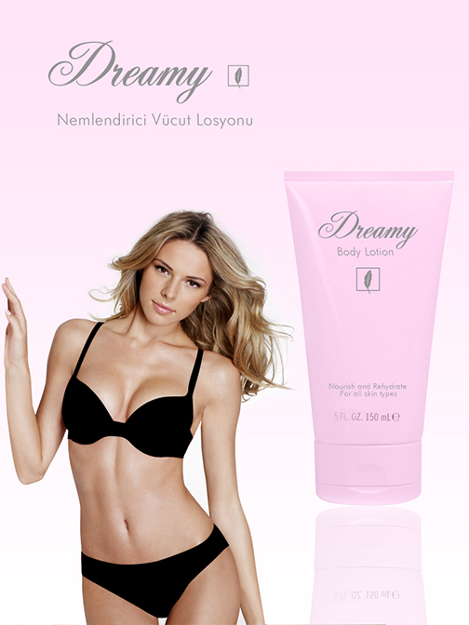

Moderately Attractive Model x Attractiveness Related Product
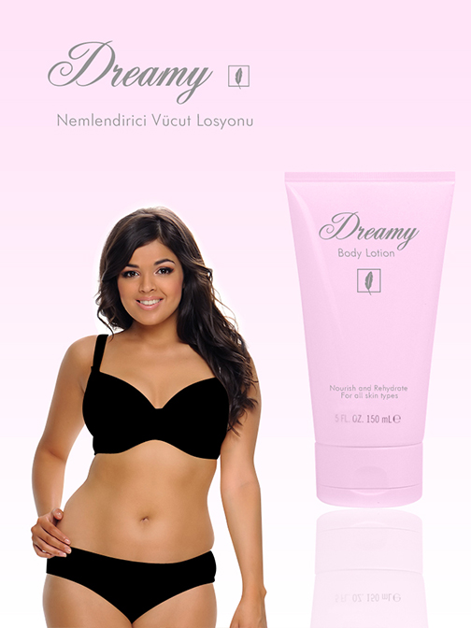

Highly Attractive Model x Non-Attractiveness Related Product


Moderately Attractive Model x Non-Attractiveness Related Product
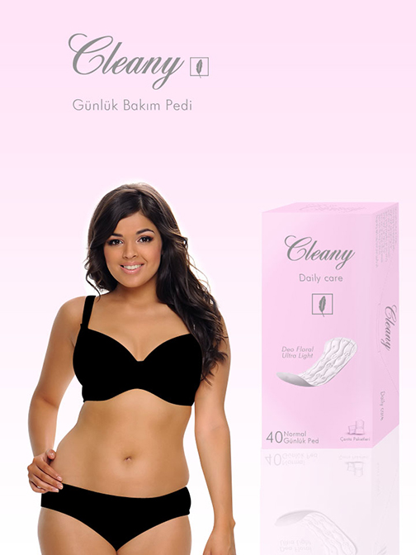

Study 2
Highly Attractive Model x Attractiveness Related Product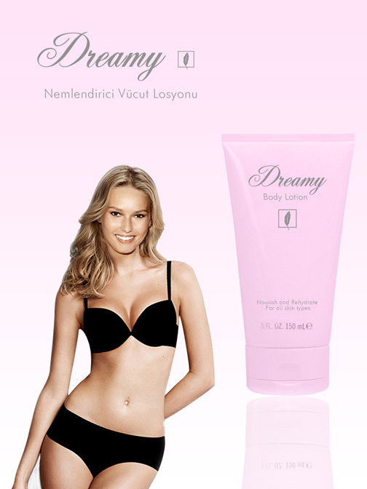

Moderately Attractive Model x Attractiveness Related Product
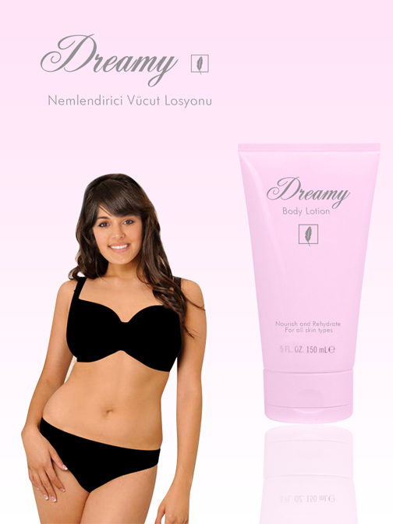
Highly Attractive Model x Non-Attractiveness Related Product
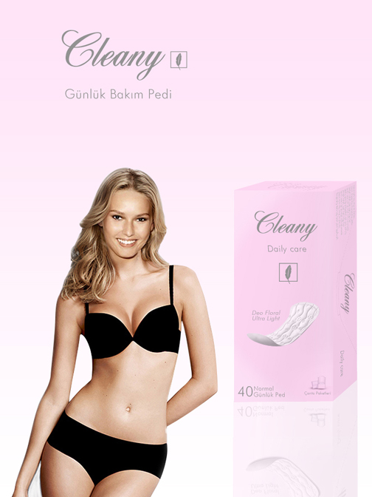

Moderately Attractive Model x Non-Attractiveness Related Product
