Abstract

This paper considers recent media texts from four Western countries that counter the taboo of looking at death. When the dying resist the default of social invisibility by participating in documentary media, they challenge hegemonic attitudes about dying and physical fallibility, even as they introduce yet another aspect of life into the logics of media visibility and self-disclosure. I focus on their invitation to witness and the faith in the possibilities of media visibility they express by agreeing to die on camera, bearing in mind the power relations among dying people, media professionals, and audiences within which this invitation occurs. The participants in these projects articulate a desire to deprivatize the death bed in order to help other dying people and their caregivers. Their motivation speaks to the idea that seeing death may puncture the neoliberal fiction of the autonomous, invulnerable self.
Keywords: image ethics, documentary, witnessing, death and dying, visibility

Invitation to Witness:
The Role of Subjects in Documentary Representations of the End of Life
In a scene from the 2003 documentary Dying at Grace (King) two people stand by the hospital bed of their friend Rick, who is very close to death. “He looks like a Renaissance painting,” one of them remarks. Rick’s friend looks to the art and visual representations of a much more distant past to make sense of what she sees. Her comment points to the dearth of contemporary visual representations of non-violent forms of death and dying. Its invisibility is so normal that many of us may not even notice this representational gap until faced with a health or care-giving situation that makes it suddenly loom. When I watched this film in 2003, a few weeks after my mother died of cancer at home, I recognized and related to Rick’s friends’ sense of awe as they grappled with a fact of life that had, into adulthood, eluded their direct experience, or even their gaze.
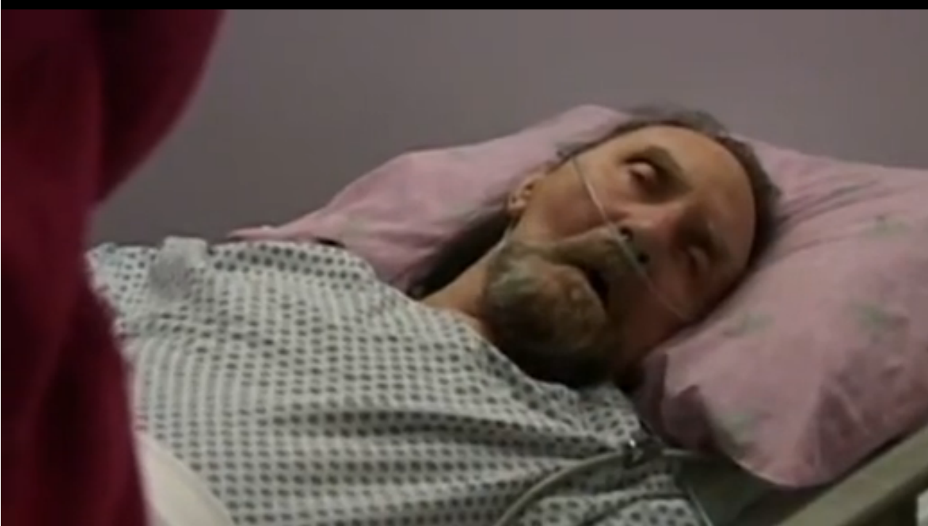
Figure 1 – Screen capture from Dying at Grace (2003). This scene described as “The Agony of Rick” by his friend by his bedside.
Whereas death for most of human history has been experienced and facilitated by the family and extended community, today many people in industrialized nations have little or no direct experience with the end of life (Gawande, 2014; IOM, 2014). Fear and denial tend to fill the void. The extension of this taboo to media representations, at least for the non-violent forms of dying that people of relative privilege are most likely to encounter, is well documented (Aaron, 2014; Ruby, 1995). As Phillipe Ariès (1985) has written, “Relegated to the secret, private space of the home or the anonymity of the hospital, death no longer makes any sign” (emphasis in original, p.266). There is some debate as to whether death denial really is as strong today as it was in the mid- to late twentieth century, when scholars were bringing it to scholarly and public attention. James Green (2008), for example, argues that a sense of taboo is on the wane, citing greater media preoccupation with death (e.g. Tuesdays with Morrie, coverage in mainstream media such as the New York Times about end-of-life issues). The 2014 Dying in America report produced by the Institute of Medicine documents a marked increase in news and entertainment coverage of death. This representational shift appears to be part of the pendulum swing away from a complete medicalization of end of life care, with people in the US starting to die at home in greater numbers rather than in institutions, for example (IOM, 2014). I agree with Norfleet (1993) however, who has argued that the taboo against looking at the end of life largely continues. She writes, “We want to see what death looks like, yet we don’t want to. These are hidden photographs [the photographs that family members take of deceased loved ones]. Taboo subjects tend to encourage voyeurism” (p.30).
The charges of sensationalism often levied against end-of-life texts suggest that images of death will be somehow titillating or a spectacle, that we will view them in a way that objectifies the subject and distances us from them. Sontag (1979) has expressed the concern that the ill are too easily seen as Other by the well, as a foil that confirms their own wellness. The risk looms large that in being exposed to the Other via visual mediation, viewers will use their spectatorial habits of objectification and distancing, thereby reducing the Other to an object incorporated into or mastered by the self. Such a possibility is captured by Tanner (2006), who writes about the scene of her father attending a family wedding in the last weeks of his life:
The unease in that crowded room circled around a body rendered so abject by the process of dying that it transformed the familiar subject into an unfamiliar object. My father’s body registered his impending death; in turning away from it, they would turn away not from him but from the anticipation of his loss and their own implied mortality. (p.1)
In public, death’s taboo inspires avoidance and denial; in private, the fear is that people will respond to the image of death in morbid or voyeuristic ways.
Allan King, director of the aforementioned Canadian documentary film Dying at Grace which follows the end-of-life experiences of five people in a hospice ward, was accused of sensationalism. One interviewer reported that he had watched the film with a friend who had pronounced it to be, in essence, “pornography.” Didn’t King feel like a voyeur in making this film, he asked? (Brown, 2003). A discomfort with “dying out loud” (Keller, 2014) was also apparent in the responses to the social media prominence of Lisa Bonchek Adams, a young woman with terminal breast cancer, by columnists from the Guardian and New York Times (the writers are a married couple). Emma Keller (2014) wrote in The Guardian, “Should there be boundaries in this kind of experience?...Is there such a thing as TMI [too much information]? Are her tweets a grim equivalent of deathbed selfies?” The articles inspired considerable backlash and the Guardian even retracted Keller’s column (Elliott, 2014), suggesting that norms of publicity and privacy in death and dying are very much in flux in this moment shaped by generational change, greater policy attention to end-of-life issues, and an increasing media presence for end-of-life representation.
In this paper I examine media texts that make an ethical claim for showing death, by moving it from the private sphere to media visibility. In 1984 Vivian Sobchak observed that “Our documentary films…avoid the representation of death. Indexical in code and function, they observe the social taboos surrounding ‘real’ death and generally avoid reference to it” (p.286). Thirty-plus years later, I examine how media producers are making this often unseen fact of life visible in the 21st century, through documentary film, television, and photography, and their subjects’ role in making these representations possible. In doing so, I offer a distinctive chapter in ongoing struggles over image ethics (Gross, Katz, & Ruby, 2003).
Media producers and ‘ordinary’ people who make or participate in these texts out death and dying from the private realm. The language of sexuality that I and others use to comment on these kinds of texts reflects the taboos that have surrounded death in Western cultures. Ariès (1974) famously wrote, “in the twentieth century [death] has replaced sex as the principal forbidden subject” (p.92). As Tait (2008) and Dean (2003) have observed, pornography has become a ubiquitous metaphor for images of death that inspire moral outrage, shutting down rather than facilitating discourse and debate. Dean (2003) explains that after World War II and the Holocaust, the photography of death that circulated inspired the use of the term “pornographic” to argue that these images “reduced men’s sacred bodies to objects of excitement, pleasure, or domination” (p.91). However, as Tait argues, the metaphor relies on narrow assumptions about the moral status of pornography, and ignores important ways that looking at sex differs from looking at death. She writes, “the term [pornography] does not automatically invoke notions of degradation but may signify pleasure, performance, or transgression” (Tait, 2008, p.96).
Unlike the so-called “death porn” that Tait analyzes, and despite complicated questions of consent in even professionally-produced pornography, those portrayed in porn and end-of-life texts voluntarily share their physical experiences with the public through media. In a less pessimistic reading of the value of pornography, the potential of both kinds of texts to publicize corporeal experiences in ways that are instructive or illuminating allows us to consider what happens when we turn this metaphor on its head. Queer and feminist pornography, for example, have been hailed as political, in making multiple forms of desire available in the public sphere and providing models for sexual expression (Taormino, Parreñas Shimizu, Penley, & Miller-Young, 2013). Norms of privacy are inextricably linked to social hierarchies shaped by heteronormativity and patriarchy. As Berlant and Warner (1998) argue, “there is nothing more public than privacy” (p. 587). Similar to arguments about the political possibilities of pornography, we can understand visualizing the end of life as a political move: producers and participants hope to inspire changes in public discourse, social learning, and connections between participants and audiences. Some AIDS activists, in particular, used photography and film of young, dying men to call for greater public attention and government dollars for disease treatment and research, particularly in the 1980s when there was little public empathy or responsiveness to the crisis, although this strategy was not without controversy (Crimp, 2002; Tanner, 2006). If the end of life is a sphere of intimacy that social norms dictate be kept private or restricted to “immediate family,” then “dying out loud,” inviting the public gaze to the deathbed, queers the end of life.
In contrast with ideas about the political value of publicizing intimate experience, recent media theory - informed by developments such as reality television, the culture of self-disclosure through social media, and the rise of celebrity culture – has emphasized the erosion of privacy in contemporary media culture, and counseled against the potential for exploitation through media publicity. These critiques argue that the private self is mined for value that serves capital (Andrejevic, 2005; Calvert, 2000). People bare all, literally or metaphorically, lured by the promise of fame or celebrity or, even more insidiously, by the sense that sharing the self to millions of strangers is a route to being their most authentic self. Our media culture of relentless publicity raises the concern that ordinary people will be exploited, even if they agree to participate voluntarily (Andrejevic, 2004; Brenton & Cohen, 2003), an argument of course that has also been made about women who “agree” to appear in porn (MacKinnon, 1985). The promise of media fame, combined with a misleading but culturally resonant discourse about appearing in media as a form of empowerment and free choice, stack the deck in favor of producers and against the interests of subjects (Pitcher, 2006). In this framework, visual representations of vulnerable people at the end of life is a topic ripe for exploitation and sensationalism.
This suggests a contradiction, however: what does it signify that looking at actual (not staged) death is taboo in a media context where supposedly “anything goes”? Perhaps that the end of life is sacred, and like any sacred thing, it should not be easily touched or gazed upon (Douglas, 1984). But, like sex, it can also signify that dying is shameful. To die is to “give up,” to “lose the battle” with illness or old age. Dying is undeniably a time of physical weakness and dependence, qualities not easily embraced in cultures shaped by neoliberal policies that assume, and therefore require, independent self-sufficiency. As Sobchak (1984) has observed, the natural death, “insupportably subversive of our culture’s myth of process as progress, has led to the spatial displacement of lived-bodies undergoing the process of decay” (p.289). Similarly Aaron (2014) reads “an investment in human invulnerability and disconnectedness” in the clichéd ways that mainstream media typically depict death (p.102). Our health is increasingly perceived as a matter of personal responsibility (Berlant, 2010; Crawford, 1980). Maintaining good health becomes a moral issue because it presumably leads to the independent, self-sufficient body that does not burden others, or the state. When applied to the end of life, this arguably neoliberal view of health contributes to the tendency to see death as failure.
These disciplinary regimes of visibility and “healthism” (Crawford, 1980) potentially come into contradiction with each other, complicating how we theorize the decision of subjects to appear in end-of-life media texts. Healthism - the normalization of good health as an expression of the good subject - implies the undesirability of gazing at the sick, the dying, and the disabled, thereby excluding sick and dying people from the culture of visibility. When people who are dying resist the default of invisibility by appearing in documentary media, they challenge hegemonic attitudes about death, dying, and physical fallibility, even as they introduce yet another aspect of life into the logic of media visibility and self-disclosure.
Therefore, we should consider the significance of the invitation to witness, bearing in mind the power relations among dying people, media professionals, and audiences within which such an invitation occurs. (Considering the conditions of the invitation does not necessarily require a firm pronouncement about the outcome.) In contrast to warnings about the pitfalls of sharing private experience through media, I consider the faith in the possibilities of media visibility expressed so powerfully by people who agree to die on camera, inviting us to witness their deaths. The decision to ‘go public’ at a time of great vulnerability suggests a deep faith in the media’s capacity to do justice to the experience - an unfashionable stance. Other scholars have considered similar questions. Lange (2007), for one, has argued that the “shared intimacies” of video bloggers are political to the extent that they stimulate discourse about topics and experiences that remain largely unaddressed in the public sphere. For her part, Grindstaff (2009) rejects the notion that ordinary people participating in documentary or reality genres are motivated only by the desire for celebrity and stardom. Rather, she acknowledges an array of motivations, including having “a life-changing experience to share, wanting to impart information or have one’s feelings/experiences publicly validated” (p.82). Sharing one’s experience of dying through media could, of course, be a misguided bid for immortality. But rooted in a desire to shape the available stories and images that circulate publicly about the end of life, this final gesture might also be considered an act of generosity, reflecting an understanding of the role that certain kinds of visibility play in shaping political and social life.
Showing the End of Life
The four texts discussed here share goals and representational strategies for showing the end of life on screen. They come from different documentary forms (television, photography, and film) as well as different national contexts in the West (UK, Canada, Germany, and USA). Although these countries have somewhat distinct (and evolving) policies and national conversations about the end of life, they operate within the same general medicalized, institutionalized paradigm for death and dying. These texts are from the 21st century, therefore produced in a media context of greatly expanded access to information via digital communication technologies. They focus on visually documenting the end of life, including actually showing death (either the moment itself, or the body after death), but do not engage with the issue of physician assisted suicide. (Numerous documentary texts focus on this policy issue, and some show the moment of death, but these representations have a different, more specific, set of political goals.) I draw on the texts themselves (in the case of the photo exhibit, the parts of it available online), press coverage, and DVD and online extras when available.
Two of the texts are television programs. In 2011 the BBC broadcast an episode of a documentary series called Inside the Human Body (Mosely & Gillings, 2011) which showed the decline and death of an 84 year-old man from cancer, a first on British television (Mosely & Gillings, 2011).
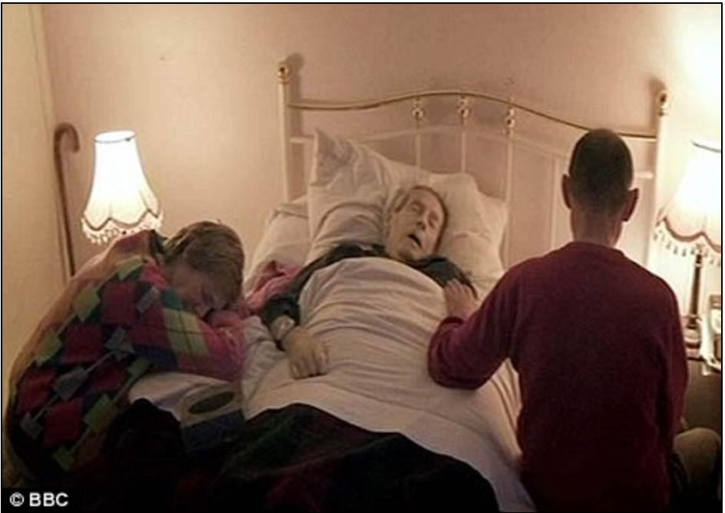
Figure 2 – Gerald from Inside the Human Body with family members. (Daily Mail Reporter, 2011)
The program led to some outcry, with the Daily Mail reporting that, “Critics said last night…the BBC had gone too far in choosing to broadcast Gerald's death and that it was a cynical attempt to boost ratings.” They quoted the campaign director of Care Not Killing, a British organization that promotes palliative care and opposes assisted suicide, who said: “Some aspects of life are so personal and private that even if individuals give their consent to be broadcast, we are wiser to keep them private” (Daily Mail Reporter, 2011).
While a person’s death from natural causes appeared on broadcast television in the UK in 2011, in 2013 US television followed suit with Time of Death on Showtime, a premium cable channel (Cutforth & Lipsitz, 2013). Created by Magical Elves, the producers of such popular reality shows as Top Chef, Braxton Family Values, and The Real L Word, this six-episode series features eight people dying of a variety of illnesses. Among the eight profiles, two people die on camera, and we see the bodies of three others after death. Responses to Time of Death in the United States were more positive than initial critiques of Inside the Human Body, with just some critics and viewers’ comments online raising the charge of voyeurism. For example, the Hollywood Reporter praised Time of Death but also suggested that its intimacy was “arguably to the point of invasiveness”: “the camera lingering on a lifeless body never feels quite right” (Keene, 2013). However, it is noteworthy that Time of Death aroused very little interest on a shock site like Findadeath.com (2013), where self-proclaimed “death hags” who are fascinated with the details and images of celebrity deaths, pronounced the series too depressing to watch.
The third text is the 2003 film Dying at Grace (discussed earlier) directed by Allan King - a prolific Canadian documentary filmmaker. Dying at Grace (2003) is an observational documentary of the palliative care unit at the Salvation Army’s Toronto Grace Health Center. Filmed in the tradition of his many other “actuality dramas” (as King calls his films), the camera follows five subjects through their final journeys, ranging from months to just a few days. The film announces its frank approach to death in its opening scene, in which nurses wrap up a recently deceased person and take him to the morgue. The level of access King negotiated is remarkable. We observe the patients’ very visible declines. We listen in on their conversations with the Chaplain. The camera does not look away when its subjects cry or exhibit paranoia, when their eyes roll back in their heads, or when their breathing becomes wet and labored in their final days and hours. It lingers in close-up on the patients’ faces, both before and after death. The film captures the last breath on camera for two out of the five people profiled.
The fourth text is the 2008 photography exhibit titled Life Before Death, which traveled internationally from Germany, with sections of the exhibit also appearing online (The Guardian, 2008). Photographer Walter Schels took portraits of 26 hospice patients in Germany, ranging in age from infancy to an 83-year old, both before and then very shortly after their deaths, while his partner Beate Lakotta interviewed the project’s participants about their experiences at the end of life to inform text that accompanied each portrait (Death Watch, 2008).
Why did these media producers undertake these projects? Allan King reported that his motivation to make his film was his own fear of what might be involved in the process of dying, as he began to seriously grapple with his impending mortality in his 70s (he died in 2009 at the age of 79). He explained:
People used to be accustomed to death, so death was a familiar figure and a familiar experience, so I think it was less terrifying because it was less strange. To be able to look death straight in the face is a big advantage. I think it’s the reward of the film… (quoted in Cowan, 2003, p.B4).
This is the same motivation Walter Schels reported. He explained:
I experienced the World War, and at the end of the war I was nine years old, and the house we lived in was bombed, and I saw a lot of dead people. So I had the rest of my life, very much in fear, about death. So I also wanted to get rid of it [his fear]. (Life Before Death, 2008)
Just as King aimed to intervene in a culture that denies death, Schels and Lakotta argued for the value of facing, literally, what we fear. The introductory text to their exhibition read: “Death and dying are arguably our last taboos ...opportunities to learn more about them are rare indeed” (quoted in Sinclair, 2008). Both King and Schels, despite reaching their 70s, had remained quite insulated from what natural forms of death looked like, and were fearful of it. The experience of making these projects was educational to them personally, which they hoped would also be the case for viewers. Similarly Michael Mosley, presenter of Inside the Human Body on the BBC, argued that “The death of a loved one is a hugely significant moment in all our lives, but not something to be feared.” Despite the controversy, “there is a case to be made for filming a peaceful, natural death – a view shared by many who work closely with the dying” (quoted in Topping, 2011).
All four texts privilege the faces of dying people as an entry point into this experience, particularly so in Dying at Grace and Life Before Death. Dying at Grace, although it includes a wide variety of activities in the palliative care unit, spends considerable time in close-up on the patients at different points throughout their process, including while they sleep or are unconscious. The closer they are to death, the tighter the close-ups. Indeed, the film ends on an extended close-up of one patient, Eda, as she dies on camera. Schels’ photographs are large, close portraits, devoid of much in the way of background. The two television texts, Time of Death and Inside the Human Body, invite viewers to connect with the faces of their subjects mostly through frequent close-up interviews.
In considering how these texts emphasize looking at people, and particularly their faces, as a technique for connection and understanding, Levinas’s perspective on the function of the face in communication is illuminating. Levinas writes that gazing upon the Other’s face is a powerful form of address in its confrontation of self and Other. But it’s a “powerless” form of power: “The frailty of the face is paradoxically the source of its command: its address is what exposes my primordial responsibility toward the Other” (Pinchevski, p.76). In order for communication to be ethical, we don’t merely gaze at the Other’s face, we respond to it – all before language or before informational ‘content’ is exchanged. The choice in these texts to focus on dying or dead faces on the one hand reflects the implicit argument that we should gaze at death and dying, in contravention to prevailing social norms. While privileging the face as a site of visual knowledge can certainly deepen habits of objectification or a false sense of knowing another’s experience, Levinas’s analysis of the encounter with the Other’s face feels descriptive of the experience of encountering these arguably “fragile” documentary faces up close.
Apart from the expected talking heads interviews with each participant and their family members, the Showtime series Time of Death varies in the proximity it offers the viewer to its dying subjects, arrangements apparently shaped by the subjects themselves. In fact, discussion on camera about why these individuals chose to participate in the project and their decisions regarding what would and would not be filmed is a distinct feature of this text compared to Dying at Grace and Inside the Human Body, and may help explain the relative lack of outcry in response to Time of Death. At moments we see subjects asking the crew to turn off the cameras, or family caregivers explaining why some moments were not filmed and why. Some participants consented to more fully share their death experience on camera than others, including Cheyenne, whose death from ALS (commonly known as Lou Gehrig’s Disease) happens on screen and, perhaps most devastatingly, 19 year-old Nicolle (the youngest subject of the series), whose death from skin cancer we see occur in her home surrounded by her family. With the question of consent handled explicitly, viewers and critics may have been less likely to wonder about exploitative relations behind the camera than with, for example, Dying at Grace. As Pitcher (2006) suggested about Girls Gone Wild (a very different text, but one that similarly involves people who volunteer to share something physically intimate on camera), this strategy can be understood as an effort to frame subjects’ participation as simply a matter of individual choice, a “staging of agency.” Pitcher argues that emphasizing the consent of the subject on camera has the function of taking our attention away from the unequal power relations between producers and subjects, in part because of how cultural ideologies of visibility are routinely presented as empowering. This critique takes us to the heart of the ethical challenge posed by these texts, which claim that their visual representation of dying is an ethical intervention into a culture that denies death: what is, and what should be, our relationship to the subject who dies on screen?
Our Relationship to the Dying Subject
Why people participated in these documentaries and whether the images are inherently exploitative, despite formal consent procedures, is a crucial question, not least because none of the dying participants can respond to the final programs made with their images. King defended the ethics of Dying at Grace by arguing that the film could not have been made without the agreement and investment of participants. According to King, the five people, who had been vetted through a lengthy consent process, had viewed their participation as a final gift that might help others. He argued, “The task must be as rewarding to the subjects as to the filmmaker. In this case it permitted dying people to pass on an invaluable legacy to the living and helped make their own experience more meaningful” (quoted in Brown, n.d.). This refrain is heard across the texts. Gerald, featured in the BBC documentary Inside the Human Body, also explained his decision to take part in terms of his hope that the program would help others (Deacon, 2011). Schels and Lakotta mentioned the surprisingly high rate of interest in participating in their project among the hospice patients they approached (Moorhead, 2008). Lakotta said that several patients appreciated the chance to discuss their death experience in a frank way; many friends and relatives would unwittingly prevent such talk through their own death-denial talk.
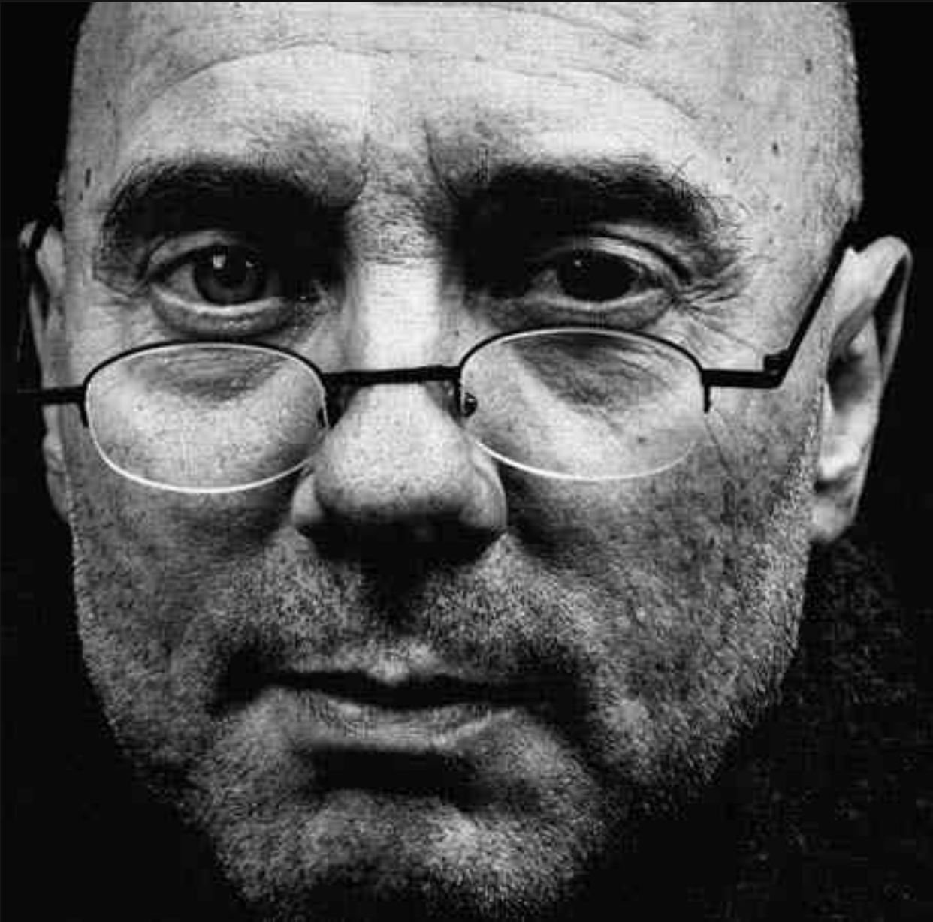 | 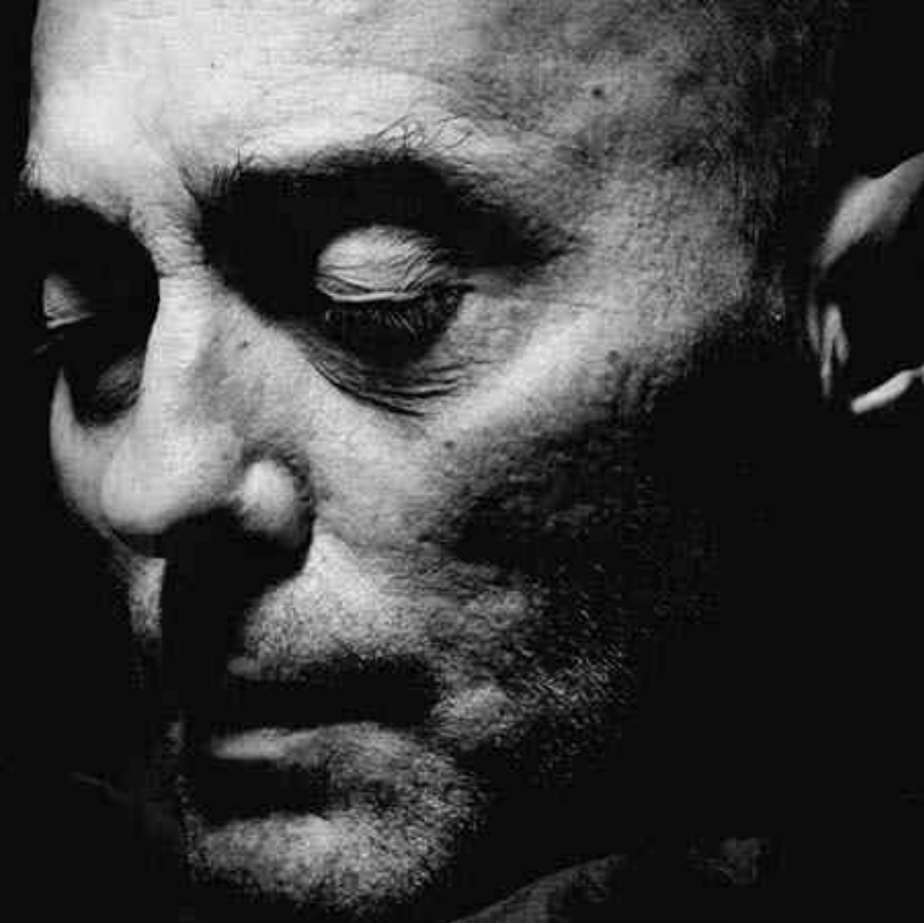
Figure 3: Portraits from Life Before Death. Heiner Schmitz, 52. First portrait: November 19 2003. Second portrait: December 14, 2003. Caption for the left-hand portrait: “Heiner was a fast talker, highly articulate, quick-witted, but not without depth. He worked in advertising. When he saw the affected area on the MRI scan of his brain he had grasped the situation very quickly: he had realised he didn’t have much time left.” Photographs: Walter Schels/Wellcome Collection (The Guardian, 2008)
The caption accompanying the photo of Heiner after death reads:
Heiner’s friends clearly didn’t want him to be sad and were trying to take his mind off things. They watched football with him just like they used to do: they brought in beers, cigarettes, had a bit of a party in the room. “Some of them even say ‘get well soon’ as they’re leaving; ‘hope you’re soon back on track, mate!’” says Heiner, wryly. “But no one asks me how I feel. Don't they get it? I'm going to die!” (Life Before Death, 2008)
Schels and Lakotta found the isolation and loneliness of some of their subjects more shocking than seeing these people after death. Lakotta reported, “Some of the dying said, ‘It’s so good you’re doing this – it’s really important to show what it’s like. No one else is listening to me, no one wants to hear or know what it’s really like’” (Moorhead, 2008, p.6).
The participants in Time of Death also cited the culture of death denial and the harm that it inflicts on dying people and their caregivers as key to their motivation to take part. Maria Lencioni, 48, the ‘main character’ of the series whose struggle with Stage IV Breast Cancer is featured in all six episodes, explains her participation on camera, saying, “I hope in some way it might help somebody else facing the same horrible, awful, life-altering -- life-ending -- dilemma” (Cutforth & Lipsitz, 2013).
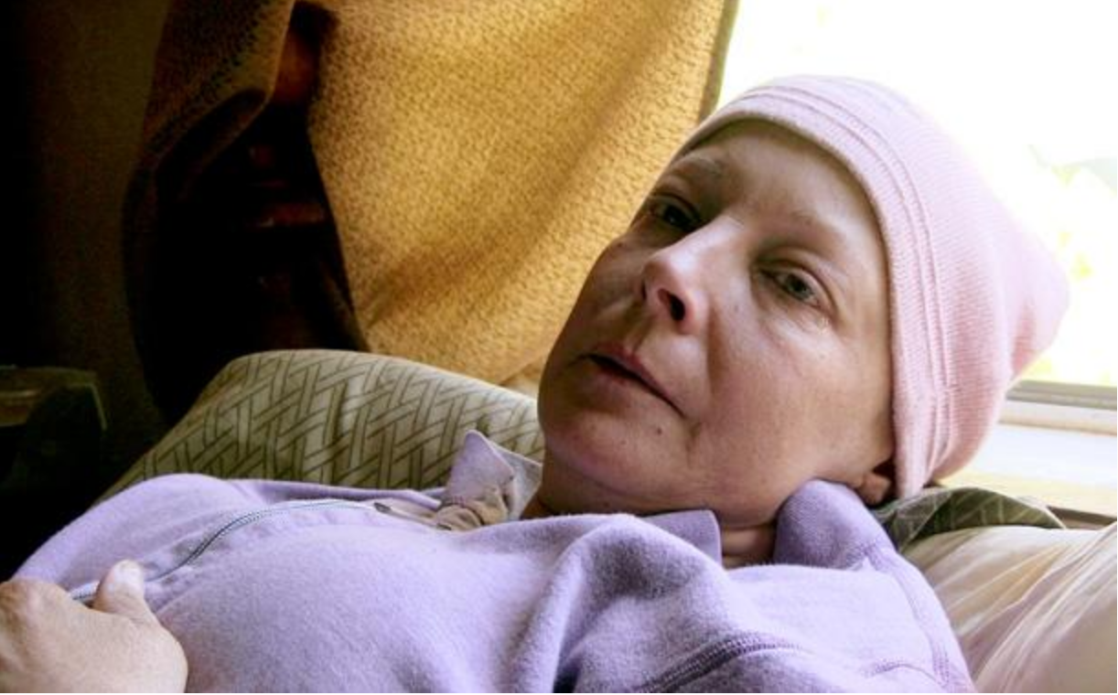
Figure 4 – Maria Lencioni, featured in Time of Death. Source: D&amp;J Productions/Showtime. (Jensen, 2013)
Her daughter Nicole (known as “Little”), whose amateur video footage is featured throughout the series, shares a similar view:
Time of Death is a demonstration of living through the departure of loved ones, an example that I wish I had seen before walking through it myself. In part because there was no example, I felt driven to help create one. The show captures it all -- the good, the bad and the ugly. It is my hope that my efforts may comfort those who feel alone. (Lencioni 2013b)
Lenore Leffer, a 74 year-old woman dying from pancreatic cancer, draws on her own experience as a psychotherapist working with cancer patients, saying “We live in a death-denying culture and I don't want it to be that way. I want my life to have made some difference” (Cutforth & Lipsitz, 2013).
The emphasis within the films and in extra-textual information about not just the consent but the active interest of the films’ subjects to participate recalls Sobchack’s (1984) observations about the 1976 film Dying:
The possibility of planned exploitation of human beings, of ghoulishness, of a cold voyeurism, is belied by the dying subject’s openness to the probity of the gaze, by a collaboration with its interest, by a frequent address to the stare which inscribes the off-screen presence and intimate acceptance of the filmmaker …the bedchamber again becomes a space for public ceremony, a space organized, in part, by the dying subject. Under the dying person’s self-direction, the filmmaker’s stare becomes ethically simplified. (p.296)
Participants in these projects are not behind the camera (which has occasionally occurred in documentary films, as in Black Is, Black Ain’t (Riggs, 1994) or Silverlake Life: The View from Here (Friedman & Joslin, 1993)), nor are they privy to the techniques of media production and ultimate editorial decision-making. In that sense it would be an overstatement to say that they are “self-directing.” However, Sobchack acknowledges the agency of dying people in inviting others to witness their experience, as well as the idea that to witness such a thing can be an ethical relation, an act that brings “public ceremony” to an event that is not necessarily made more sacred through greater privacy.
Laura E. Tanner’s (2006) analysis of Sharon Olds’s books of poems The Father, about Olds’s experience accompanying her father through his terminal illness, illuminates how complicated the viewing relation between well and dying people can be. In the poem The Lifting, Olds’s father, who is on a medical bed in his home, lifts up his nightgown and invites her to look at his naked, wasting-away body. Tanner considers how both Freudian and Foucauldian theories of the gaze fail to satisfactorily capture the dynamics of this moment. Olds rejects the experience as one defined by the erotics of a daughter gazing at her father’s nakedness, and Tanner rejects the idea that Olds sees her father through the medical gaze, in which the subjectivity of the patient is abstracted because of the focus on the diseased body. Instead, she writes, “In directing his daughter’s look, Olds’s father appropriates her vision to reclaim his status as subject of the gaze as well as its object” (Tanner, 2006, p.32). Olds’s father asks his daughter to see his dying body as an object, which he is also doing as he tracks its rapid transformation, in order to relate to his experience of embodiment, “to locate him in his unfamiliar body without reducing him to it” (p.32). Tanner (2006, p.35) calls the poem’s communication of a sense of “subjective intermingling” - one that promotes connection and identification while never denying the difference between self and Other - radical.
The powerful but unverbalized moment when a dying person invites another to witness their experience also occurs in the 2011 documentary film How to Die in Oregon. Although not one of the primary texts I consider, due to its focus on physician assisted suicide, the film offers a moment key to this analysis when Cody Curtis, a woman in her 50s who is dying of liver cancer, communicates silently but in a very intimate way with the filmmaker, and by extension viewers. In the final weeks of her life Cody goes to the hair salon, and during a few minutes when the stylist leaves her alone in the chair, director Peter Richardson captures an extended shot of Cody looking at herself in the mirror. It is difficult to convey the intensity of this moment. In the rest of the film we see Cody generally smiling (and sometimes crying), talking, and being very attentive to the people around her. This is one of the few moments in the film when we see her being still, with herself; the grave expression on her face suggests that she may be confronting her mortality, as she regards her drawn, yellowing face. Richardson has described this moment as Cody’s “gift” (quoted in Schnack, 2011). The way she allows the camera and the audience to accompany her in this painful solitude dramatizes her openness to strangers in the intimacy of her end-of-life experience. Like Sharon Olds’s father, the dying person inviting others to join their self-gaze is the viewing relation that allows us to identify with their embodied experience, and perhaps to ease their pain of solitude.
Jeff Jensen (2013), a television critic for Entertainment Weekly, reviewed Time of Death informed by his own experience as a caregiver for his wife, diagnosed with brain cancer. He emphasized the series’ ability to inform and invite empathy, rather than objectify the dying:
…Time of Death succeeds because its subjects and their families are willing to open their doors, let down their defenses, and surrender all vanity as they waste away. By sharing themselves this way, our capacity and empathy is [sic] stretched, and we gain insight and ideas for when death comes for us. (Jensen, 2013)
Jensen’s response to the series recalls Levinas’s argument about the preconditions of ethical communication writ large, which is apt for thinking about how these subjects at the end of life seek to communicate via media representation:
The plot of proximity and communication is not a modality of cognition….It is not due to the contents that are inscribed in the said and transmitted to the interpretation and decoding done by the other. It is in the risky uncovering of oneself, in sincerity, the breaking up of inwardness and the abandon of all shelter, exposure to traumas, vulnerability. (Levinas, 1998, p.48)
The producers but especially the participants in these projects undertook this “risky uncovering,” and in so doing took a considerable leap of faith – that viewers would watch with empathy and a sincere desire to learn and prepare for the future, rather than watch in judgment or morbid fascination. While this reading is not guaranteed, the generosity of the gesture and the faith that it communicates about the viewing public and our capacity to be open to others’ experiences through media, is a meta-message that begs for our attention.
Perhaps the most unresolved ethical question is whether it is possible to get truly voluntary consent from family members in these situations, particularly children. When the dying wish to take part in these projects, the pressure for family members to participate may be great. Particularly in Dying at Grace and Time of Death, the cooperation of family members was necessary, and caregivers were prominently featured in the series. However, it is the children featured in the series Time of Death who are arguably most ill-equipped to anticipate the experience of losing a loved one and to appreciate what they are consenting to. Indeed, Time of Death shows some of the children – including both primary school-aged children and teenagers - behaving in ways that it seems likely they will regret having on camera later: showing anger towards their dying family member, expressing selfish thoughts, or struggling to handle the intensity of the experience.
The documentaries may be of some comfort to the family members of people who had relatively ‘good’ or peaceful deaths. For example, Nicolle Kissee’s mother Vicki said of watching the program:
I found it joyful at times because I could see her face again and hear her voice…I cried of course. I really think they honored my family. Even though Nicolle wasn't coherent or really able to speak a lot while they were here, they really captured her personality. (quoted in Perkes, 2013)
But these programs may serve as painful reminders to those families whose loved one died in more difficult circumstances. Maria died alone after experiencing a great deal of anguish, her children having been placed in foster care once she was no longer able to care for them. The partner of another Time of Death subject, Dr. Toni Yancey, decided to ask the crew to leave towards the end when pain medication started to prove ineffective, fearing that the cameras would capture Toni losing control. She second-guesses herself after the fact, wondering if this is the decision that Toni herself would have made, and regretting that it also meant that the rituals that she and friends performed around Toni’s body after death had not been shared through the program. Although the decision to take part in the program may have been the dying subject’s, family members sometimes had to make the final, agonizing decisions, an additional burden in an already terrible situation.
Drawing attention to informed consent, whether in the text itself as in Time of Death, or in extra-textual materials and press interviews, can be viewed as a “staging of agency” that absolves media producers of responsibility and contributes to a simplistic narrative about the rights of subjects, boiled down to it being “their choice” (Pitcher, 2006). The variety of approaches that these participants took to invite the public to witness their end-of-life experiences, and the decision-making processes that were sometimes required as events unfolded, arguably illustrate a new realm of choice at the end of life that applies even beyond the context of media representation. In contexts where the practices of privacy and visibility are more scripted and homogeneous, such as the Art of Dying practices widely subscribed to in Victorian Britain (Ariès, 1974), dying people and their families may be subject to strong social norms, but they are also released from certain kinds of decisions: whether to tell others about their illness and prognosis, whether to retreat behind closed doors as the dying process advances, or to invite family and friends to attend the bedside. As much as the decisions of these dying subjects might seem remarkable, their negotiations with the filmmakers are analogous to the way so many dying people today negotiate the relative publicness or privacy with which they live their final days. While there are different ways of being ‘visible’ at the end of life, for example through Twitter, blogging, email updates, or newspaper columns (as Oliver Sacks did in the New York Times), these media texts dramatize the evolving question of how to manage our visibility to others as we die.
The Politics of Deprivatizing the Death Bed
How are terminally ill people and their caregivers affected by the near absence of realistic, public representations of ‘natural’ death? Experts have expressed the concern that a lack of familiarity with the end of life creates a void too easily filled with the institutional imperatives of hospitals and nursing homes, which often privilege ‘doing something’ over quality of life or, indeed, quality of death (Gawande, 2014; IOM, 2014). Deference to these routines, combined with a lack of frank communication before terminal illness arises, fuels unnecessary suffering and even shortens the lives of people dying of disease or old age. Indeed, medical staff explained that their decisions to take part in both Dying at Grace and Time of Death was informed by their belief that caregivers and loved ones would be better prepared if they had seen a film like this (Brown, 2003; Perkes, 2013).
Policymakers have continually expressed the need for more public discussion about end-of-life issues, in the hopes that a better educated and prepared public will be better able to advocate for their wishes as they die, and suffer less from fear of the unknown (Gawande, 2014; IOM, 2014). These projects challenge death denial and therefore the behaviors and policies that it fosters: under-funding hospice and palliative care; neglecting the ill and elderly; expecting at-all-costs interventions from doctors; and failing to provide empathic support for those who know that they are dying. The producers and participants of these programs proceed under the assumption that seeing death may puncture the fiction of the autonomous, invulnerable self, a fiction which fuels unrealistic attitudes towards death and inattention to planning and policy questions surrounding the end of life.
There remains the risk that images of dying will not be received in the spirit in which they were offered, suggested by those commentators who saw these texts inviting a profane or disrespectful gaze. However, rather than simply eroding the value of privacy or the sacredness of the death bed, the willingness of these subjects to die on screen points to the depth of their commitment to changing the culture. The risk they are taking is real, and easily perceived. Their gesture thus appears all the more profound and their call to the living or the well all the more urgent. A willingness to share personal intimacies through media is a particularly potent expression of faith in the power of media to connect and inform, one that has often been unfounded, as observers of talk shows, reality TV, and social media have noted. While we should remain vigilant about the ways that media erode privacy, as well as the inevitable selectivity of any media representation, can we also retain language and concepts-at-the-ready for recognizing the power of media visibility and publicity to effect change, to be a valuable resource for living and dying?
The parallels between using the media to shed light on the end of life and the way people have used media and other public forms to confront taboos about sex and sexuality are striking. It seems more than coincidental that Little, Maria Lencioni’s daughter in Time of Death, was inspired to participate in the series in part by her media activism around GLBTQ issues. As she wrote about her experience making the program:
We all live together, but dying is a party of one. It’s too sad and too uncomfortable to discuss because nobody wants it. So, good luck figuring it out on your own. And, if you do figure out, please don’t tell me; I don’t want to think about it. I’m pretty sure that we treated other taboo subjects like this in the past too, like the clap, queers and professional women’s basketball… all of which are here to stay despite how little people want to acknowledge them. Death has been systematically oppressed and as a result there are so little resources available to help the dying and to help the ones who live through a death close to them. (Lencioni, 2013a)
Little’s comments remind us that there is a fine line between privacy and loneliness, dignity and isolation. Our critical scholarship must defend the values of privacy and dignity while remaining open to the value of voluntary disclosure. Whether claiming recognition in public space for queer lives and practices, or asserting that dying is part of life and should be treated as such, people approach media representation as a potentially transformative cultural practice. Dying people enter these arrangements deeply disadvantaged in terms of representational power: they are intensely vulnerable, they have no say over the final edit (though, like wills and related directives, they can entrust their wishes to other people), and they are working with professional media producers who have careers to promote, audiences to please, and ratings to get. But this is not the only relevant power relationship at play. Perhaps more salient to dying people are the power relationships between themselves and the medical profession, who have so many resources to “broker” the death experience and shape it according to institutional imperatives (Timmermans, 2005). And in society at large, dying people frequently find they no longer have a place, or ways to be recognized or “seen,” even while they still live.
Though media logics of visibility and social logics of privacy for dying people emerge from the same economic and social structures, they are not the same processes and do not affect people in the same ways. To make the end of life visible contradicts those social practices that deny and privatize death and dying. As Tanner (2006) suggests, “Even as the patient is objectified by the medical gaze, he or she is simultaneously held accountable for a vulnerability to death which the culture would disavow” (p.3). While we recognize the myriad ways in which the deck is stacked against the rights of subjects, as well as the ethical complexities implicated in our gaze, we must somehow simultaneously hold in view the promise for recognition and connection that media representation offers in light of other social and institutional constraints. Dying people’s experiences are constructed within regimes of media visibility, medical expertise, healthism, and individualism. These regimes overdetermine each other but they do not produce a singular outcome. People find openings, or identify the hope for openings, in the contradictory logics among disciplinary conditions. When life itself is closing in and few ‘openings’ remain, an invitation to others, even strangers, to witness the end of life is a gesture towards connection and community, inescapably shaped by both the affordances and limitations of the media forms within which it takes place. In contexts where individualism and independence are hegemonic values, such a move can rightly be hailed as radical.

References

Aaron, M. (2014). Death and the moving image: Ideology, iconography, and I. Edinburgh, UK:
Edinburgh University Press.
Andrejevic, M. (2004). Reality TV: The work of being watched. Lanham, MD: Rowman &
Littlefield.
Ariès, P. (1974). Western attitudes toward death: From the Middle Ages to the present. (P.M.
Ranum, Trans.) Baltimore, MD: The John Hopkins University Press.
Ariès, P. (1985). Images of man and death. (J. Lloyd, Trans.). Cambridge, MA: Harvard
University Press.
Berlant, L. (2010). Risky bigness: On obesity, eating, and the ambiguity of “health.” In J.M.
Metzl & A. Kirkland (Eds.) Against health: How health became the new morality
(pp.26-39). New York, NY: New York University Press.
Berlant, L. and Warner, M. (1998). Sex in public. Critical Inquiry, 24, 547-566. Retrieved from
http://www.jstor.org/stable/1344178
Brenton, S. and Cohen, R. (2003). Shooting people: Adventures in reality TV. New York, NY:
Verso.
Brown, I. (Producer and Host). (2003, October). The view from here presents Dying at
Grace. [Television broadcast]. In I. Brown, The view from here. Toronto, ON:
TVOntario.
Brown, I. (n.d.). Interview with Allan King. Retrieved from http://www.tvo.org/dyingAtGrace/
Calvert, C. (2000). Voyeur nation: Media, privacy, and peering in modern culture. Boulder, CO:
Westview Press.
Cowan, J. (2003, September 12). Allan King’s unflinching eye. National Post, p.B4.
Crawford, R. (1980). Healthism and the Medicalization of Everyday Life. International Journal
of Health Services, 10, 365-388. doi: 10.2190/3H2H-3XJN-3KAY-G9NY

Crimp, D. (2002). Portraits of people with AIDS. In Melancholia and moralism: Essays on AIDS
and queer politics, pp.83-108. Cambridge, MA: MIT Press.
Cutforth, D. & Lipsitz, J. (Executive Producers). (2013). Time of Death [Television series].
Magical Elves Productions. New York, NY: Showtime.
Daily Mail Reporter. (2011, May 12). Coming to a TV screen in your home tonight...the
harrowing moment a man takes his dying breath.. Retrieved from
http://www.dailymail.co.uk/news/article-1386140/Inside-Human-Body-moment-Gerald-dies-BBC1-tonight.html
Deacon, M. (2011, May 12). Why the BBC was right to air footage of a dying man. The
Telegraph. Retrieved from http://www.telegraph.co.uk/culture/tvandradio/8510546/Why-the-BBC-was-right-to-air-footage-of-a-dying-man.html
Dean, C.J. (2003). Empathy, pornography, and suffering. Differences: A Journal of Feminist
Cultural Studies, 14, 88-124. http://dx.doi.org/10.1215/10407391-14-1-88
Death watch: Pictures of hospice patients taken before and after death by German lensman
Walter Schels are on show in Haifa, Israel. (2008, August 1). The Straits Times
(Singapore), Life News. Retrieved from www.lexisnexis.com
Douglas, M. (1984). Purity and danger: An analysis of concepts of pollution and taboo.
London, UK: Ark Books.
Elliott, C. (2014, January 16). Why an article on Lisa Bonchek Adams was removed from the
Guardian site. The Guardian. Retrieved from http://www.theguardian.com/commentisfree/2014/jan/16/why-article-lisa-bonchek-adams-removed
FindaDeath.com. (2013). Thread: 'Time of Death': Showtime series. Retrieved from
http://www.findadeath.com/forum/showthread.php?36996-Time-of-Death-Showtime-series
Friedman, P. & Joslin, T. (Producers and Directors). (1993). Silverlake life: The view from here
[Motion picture]. USA: Channel 4 Television and New York State Council on the Arts.
Gawande, A. (2014). Being mortal: Medicine and what matters in the end. New York, NY:
Metropolitan Books.
Green, J.W. (2008). Beyond the good death: The anthropology of modern dying. Philadelphia,
PA: University of Pennsylvania Press.
Grindstaff, L. (2009). Self-serve celebrity: The production of ordinariness and the ordinariness of
production in reality television. In V. Mayer, M. J. Banks, and J. T. Caldwell (Eds.) Production studies: Cultural studies of media industries (pp. 71-86). New York, NY: Routledge.
Gross, L., Katz, J.S. & Ruby, J. (2003). Image ethics in the digital age. Minneapolis, MN:
University of Minnesota Press.
The Guardian. (2008, April 1). Life before death [online exhibit]. Retrieved from
https://www.theguardian.com/society/gallery/2008/mar/31/lifebeforedeath
IOM (Institute of Medicine). (2014). Dying in America: Improving quality and honoring
individual preferences near the end of life. Washington, DC: The National Academies
Press.
Jensen, J. (2013, November 1). Review: The unbearable poignancy of Showtime's 'Time of
Death'. Entertainment Weekly. Retrieved from http://www.ew.com/article/2013/11/01/review-time-of-death-showtime
Keene, A. (2013, October 30). TV review: Time of Death. The Hollywood Reporter. Retrieved

From http://www.hollywoodreporter.com/review/time-death-tv-review-651919

Keller, E. (2014, January 8). Forget funeral selfies. What are the ethics of tweeting a terminal
illness? The Guardian (since removed from site). Retrieved from
https://web.archive.org/web/20140109033020/http://www.theguardian.com/commentisfree/2014/jan/08/lisa-adams-tweeting-cancer-ethics
King, A. (Producer and Director). (2003). Dying at Grace [Motion picture]. Canada: Allan King
Associates.
Lange, P.G. (2007). The vulnerable video blogger: Promoting social change through intimacy.
The Scholar & Feminist Online, 5.2, 1-5. Retrieved from http://sfonline.barnard.edu/blogs/lange_01.htm
Lencioni, N. (2013a, November 1). Time of Death’s Nicole ‘Little’ Lencioni: Dying is a party of
one. The Daily Beast. Retrieved from http://www.thedailybeast.com/articles/2013/11/01/time-of-death-s-nicole-little-lencioni-dying-is-a-party-of-one.html
Lencioni, N. (2013b, November 8). The philosophy of illumination. The Huffington Post.
Retrieved from http://www.huffingtonpost.com/nicole-little-lencioni/the-philosophy-of-illumination_b_4215724.html
Levinas, E. (1998/1974). Otherwise than being, or beyond essence. (A. Lingis., Trans.)

Pittsburgh, PA: Duquesne University Press.

Life Before Death [Video]. (2008). Wellcome Collection. Retrieved from
http://wellcomecollection.org/life-death
MacKinnon, C. (1985). Pornography, civil rights, and speech. Harvard Civil Rights-Civil
Liberties Law Review, 20(1), 1-70. Retrieved from www.heinonline.org
Mosely, M. (Presenter) & Gillings, A. (Producer, Director). (2011, May 12). Inside the human
body: From first to last [Television series episode]. In A. Harper (Producer), Inside the human body. London, UK: British Broadcasting Corporation.
Moorhead, J. (2008, April 1). G2: This is the end. The Guardian, Guardian Features, p.6.
Norfleet, B.P. (1993). Looking at death. Boston, MA: D.R. Godine.
Perkes, C. (2013, November 24). TV show, with CHOC patient, tackles death. The Orange
County Register. Retrieved from http://www.ocregister.com/articles/nicolle-537999-kissee-family.html
Pinchevski, A. (2005). By way of interruption: Levinas and the ethics of communication.
Pittsburgh, PA: Duquesne University Press.
Pitcher, K.C. (2006). The staging of agency in Girls Gone Wild. Critical Studies in Media
Communication, 23, 200-218. doi: 10.1080/07393180600800759
Riggs, M. (Director). (1994). Black Is, Black Ain’t [Motion Picture]. USA: Independent
Television Service.
Ruby, J. (1995). Secure the shadow: Death and photography in America. Cambridge, MA: The
MIT Press.
Schnack, AJ. (2011, May 25). Peter Richardson on filming his powerfully quiet prize-
winner, How to Die in Oregon. All these wonderful things. Retrieved from http://edendale.typepad.com/weblog/2011/05/before-i-saw-peter-richardsons-how-to-die-in-oregon-id-heard-over-and-over-that-it-was-a-incredibly-difficult-film-to-get-th.html
Sinclair, I. (2008, April 30). Culture – death and dying: The last taboo; Exhibition: Life Before
Death, Wellcome Collection. Morning Star. Retrieved from www.lexisnexis.com
Sobchak, V. (1984). Inscribing ethical space: Ten propositions on death, representation, and
documentary. Quarterly Review of Film Studies, 9, 283-300. http://dx.doi.org/10.1080/10509208409361220
Sontag, S. (1979). Illness as metaphor. New York, NY: Vintage Books.
Tait, S. (2008). Pornographies of violence? Internet spectatorship on body horror. Critical
Studies in Media Communication, 25, 91-111. http://dx.doi.org/10.1080/15295030701851148
Tanner, L.E. (2006). Lost bodies: Inhabiting the borders of life and death. Ithaca, NY: Cornell
University Press.
Taormino, T., Parreñas Shimizu, C., Penley, C., and Miller-Young, M. (Eds). (2013). The
feminist porn book: The politics of producing pleasure. New York, NY: The Feminist Press of the City University of New York.
Timmermans, S. (2005). Death brokering: Constructing culturally appropriate deaths. Sociology
of Health and Illness, 27(7), 993-1013. doi: 10.1111/j.1467-9566.2005.00467.x
Topping, A. (2011, April 25). BBC defends filming cancer patient’s death. The Guardian.
Retrieved from http://www.theguardian.com/media/2011/apr/26/bbc-films-cancer-patient-death

