Karen Beckman, ed., Animating Film Theory, Durham, USA: Duke University Press, 2014, 359 pp., $99.95 (hardcover), $27.95 (paperback).

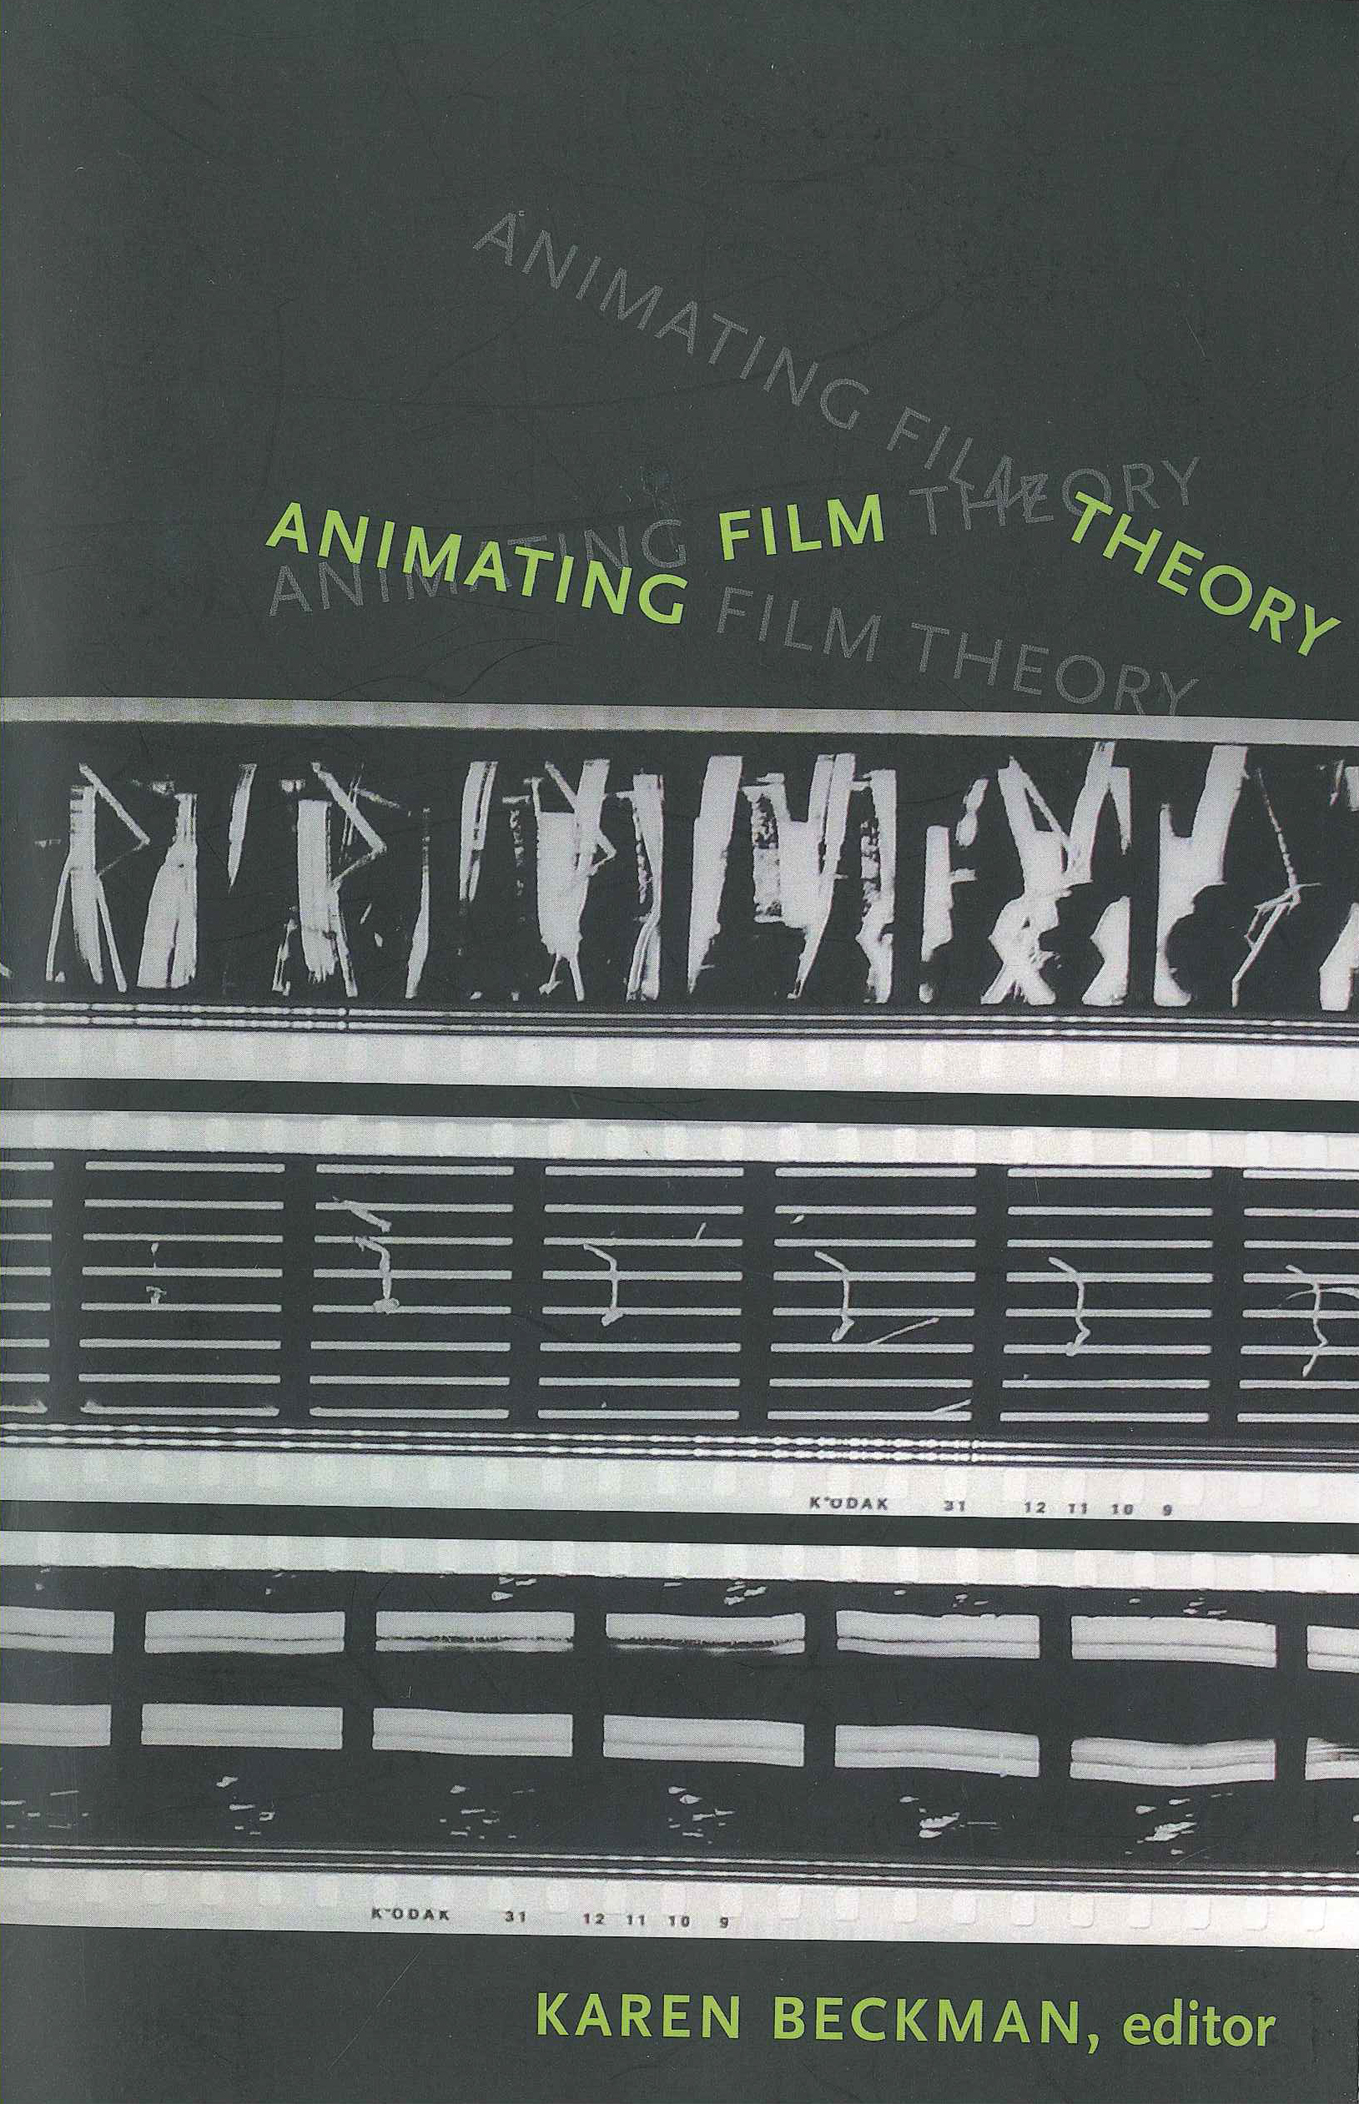

Reviewed by
XXX
XXX, USA

How has film theory discourse engaged animation up until now? And how would engagement with animation enrich contemporary film theory? These are the two focuses that Animating Film Theory explores through contributions from various authors, totaling seventeen separate chapters. The book’s overarching goal as defined by editor Karen Beckman is to explore the un(der)developed theoretical questions in regards to animation in the film studies field.

In structure, Animating Film Theory, opens with an introduction that is among the most important of any edited book I have read. Beckman barely uses the introduction to summarize and foreshadow the upcoming chapters, but rather aims to provide an essential background of animation history that is needed to follow the train of thoughts of the various contributors and to understand their arguments more fully in their respective chapters. Additionally, she provides readers with guidance of expectations and key points that can be looked for in each chapter. Using Vachel Lindsay’s work, The Art of the Moving Picture (1915), in particular, Beckman lays out the following four sub-topics that the author of each essay implicitly and/or explicitly discusses in their respective contributions. For one, that the cinema has the capacity to reframe the relationship between humans and objects; for two, it will be argued that animation can evoke attachments and emotional responses to non-human things; for three, a call to readers to reconsider the definition of the term ‘movement’ and discussion as to where said movement is located in relation to film; and four, the combined chapters illustrate that the cinema has the ability to alter one’s perception of space and time (p. 5).

Overarching, the book’s focus is defined as uncovering how film theory discourse up until now has engaged animation and how deeper engagement with animation can enrich contemporary film theory (p. 5). Marc Steinberg’s essay, Realism in the Animation Media Environment: Animation Theory from Japan, Chapter 16, is just one example that fits the volume’s goals like a glove. His key conclusion is that…

[b]oth animation studies and film studies can benefit from this transmedia approach to realism. Indeed, this group of writers and the problematics they develop in their debates shows the value of expanding the canons of film and animation theory to include writers from as yet underexplored critical milieus. (pp. 297-298)

The overarching guiding posts make the book’s overall structure a success. Regardless of which essay is being read, the background information standards outlined in the introduction assist in guiding the reader through each individual chapter. The essays are an average of 10-15pages, permitting exploration in as much depth as developing an argument warrants, while providing succinct respective sub-focuses that the reader can ‘take away’ from each chapter.

In addition to the introduction, the book is segmented into four parts. While chapters are housed within these four parts, the introduction’s guidance is more apparent and useful than the other divisions used to order the essays in this volume, with the exception of Part 1. Part 1—“Time and Space”—is the Part marked most distinctly, as the essays in this section focus as an introduction to the book’s premise from various perspectives and arguably include the loudest call-to-action of animation being an enrichment to film studies. Chapter 1, Esther Leslie’s contribution “Animation and History,” calls for animation being its own category worthy of study and becoming removed from a purely historical perspective. Her arguments favor animation becoming ahistorical, which will make other applications possibility. In her viewpoint, “[Animation] models the possibility of possibility” (p. 35). Part 1 also references many widely known historical moments—such as Muybridge photography in Chapter 2—permitting readers with a background in film studies to identify with and situate certain aspects of animation with widely known historical events or concepts. Resulting, the essays in Part 1 function successfully to bridge the potential knowledge gap that may exist between traditional film theorists and animation scholars. Thereafter, the parts’ structure is less important due to the respective essays’ niche focuses. Readers can target specific chapters based on their individual interests and needs. (Part 2’s heading is “Cinema and Animation,” such a general heading that it is devoid of much guidance and also means chapters in other parts would fit equally well into Part 2.)

In particular Parts 3 and 4 seem to divide essays into sections that may limit the reading position to a particular perspective (either “The Experiment” or “Animation and the World”). Many of the essays could fit equally well under both of them. Chapter 13, for instance, focuses on Japanese animation. Thomas Lamarre’s contribution on Imamura Taihei’s work in Japan, is located as the opening chapter for Part 4 (pp. 221-251). While this makes sense in regards to Part 4’s focus on international animation, reading the chapter and comparing it with other essays in Part 3, it becomes apparent that this piece could equally well be positioned in Part 3, given the details of Imamura’s work and theory under discussion. In fact, Part 3 includes discussions of international filmmakers, such as “Frame Shot: Vertov’s Ideologies of Animation”, co-authored by Mihaela Mihailova and John MacKay (pp. 145-166). Why was this latter essay positioned in Part 3 as opposed to 4? Besides the respective headings of each part, no summary or other guidance is provided as to these sub-divisions. This is a minor critique of the book that could be solved by adding specific context to the four parts’ respective purposes.

By including essays focused on animation analysis in different parts of the world, the book definitely meets its goal of “explor[ing] the un(der)explored theoretical questions in the film field” on two levels (p. 17). For one, by bringing unknown information to the reader. Likely, not many readers have heard about Imamura Taihei before. Neither will many readers be familiar with the Japanese word for photography, “shashin,” and the impact this word’s orientation has (had) on animation discourse (pp. 221-251). For two, by providing worldwide coverage, the editor demonstrates how underexplored animation studies remains on a global scale. While the majority of authors for this volume work at U.S. institutions of higher learning (at least at the time of the book’s publication), the book represents work from scholars employed in six different countries, representing North America, Europe and Australia. The respective author biographies, however, illuminate further diversity of the authors’ upbringings in different parts of the world. For readers interested in niche happenings and developments internationally, this book has a lot to offer.

Thus, the book definitely provides an eye-opening experience in regards to the multiple viewpoints and subtleties in and from which animation can be analyzed. Even seasoned film scholars will likely encounter a new argument or perspective that they had not considered previously. This makes the reading very rewarding. While film scholars will come across familiar information, such as Russia’s contributions to film development, specifically Sergei Eisenstein and Dziga Vertov, (Chapters 12 and 13 are just two of them where their names surface), the content is applied in new directions, illustrating the book’s aim to argue for animation to become a more prominent part of film theory and scholarship. As implied throughout this review thus far, particularly successful is the blend of known innovators and filmmakers that have become part of the history of film and unknown figures and their respective contributions across the globe. Reading essays from authors positioned in different parts and thus cultures of the world also implicitly demonstrates how one’s perspective on the subject matter is framed by one’s environment. Non-surprisingly the works cited of the essays represents the respective author’s cultural and academic background. The book suggests that sharing of international perspectives will move film theory forward in a potentially much more significant manner than inner-cultural collaborations.

While the effectives of the essay’s order can be debated, the book ends on a particularly uplifting essay, which if a reader does study the book in chronological order (as this reviewer did) results in satisfactory closure to this dive into animation history and theory. “Some Observations Pertaining to Cartoon Physics; or, The Cat in the Machine” by Scott Bukatman (pp. 301-316), discusses beloved cartoon characters Tom and Jerry, among others. Readers may find themselves on a trip down memory lane of their own personal experiences with these characters. Resulting, this last chapter certainly makes readers smile. Implicitly, the essay argues—just as many other essays have done throughout this volume—how well known animations are, how many animations readers have consumed, and thus that animation deserves (more than) a spotlight in film theory. Both discourse and engagement questions are thoroughly answered throughout this book—both explicitly and implicitly— and its goal has certainly been met.

