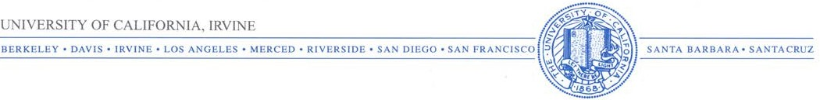

Department of Political Science

3151 Social Science Plaza
Irvine, CA 92697-5100

(949) 824-5361

Dear Dr. Gross, August 21, 2017

We wish to submit an original research article entitled “The Pull of Humanitarian Interventionism: Examining the Effects of Media Frames and Political Values on People’s Choice of Resolution” for consideration by the International Journal of Communication.

We confirm that this work is original and has not been published elsewhere, nor is it currently under consideration for publication elsewhere.
In this paper, we examined the effects of media frames, both single and multiple, as well as political values on people’s choice of resolution to conflict. The results showed that neither exposure to frames nor participants’ values were associated with the outcome. Participants overwhelmingly chose the ‘conduct a humanitarian intervention (through military force) to protect human rights’ option regardless of frame exposure and even in contrast to their own political values, demonstrating the influence of the mainstream media’s dominant, humanitarian interventionist frame on public opinion.

We believe that this manuscript is appropriate for publication by IJoC because it adds a significant perspective on a key facet of media policy in promoting unbiased, non-manipulative political communication.
We have no conflicts of interest to disclose.

Portions of these data have been published previously: Beattie, Peter, and Jovan Milojevich. 2017. “A Test of the “News Diversity” Standard: Single Frames, Multiple Frames, and Values Regarding the Ukraine Conflict.” The Journal of International Press/Politics 22 (1): 3–22.

Please address all correspondence concerning this manuscript to me at jovan.milojevich@duke.edu.

Thank you for your consideration of this manuscript.

Sincerely,

Jovan Milojevich
Sincerely,
Jovan Milojevich
112 Cabernet Dr.
Chapel Hill, NC 27516
(925) 286-4556
jovan.milojevich@duke.edu

