Appendix A
Foreign Policy Values Orientations

To devise the following foreign policy value orientations, we reviewed the political science literature and selected a hybrid division influenced most by Holsti & Rosenau’s (1990) approach. We then we looked for media outlets that could comfortably fit within these divisions. By selecting only four groups with straightforward lines of division, it was relatively easy to find media outlets comfortably fitting each. Upon reviewing articles dealing with the Ukraine crisis in each of the outlets, we were able to identify recurring themes that we then reproduced in our treatments.
Left Right

Leftwing Rightwing
Isolationist Isolationist
(LISO) (RISO)

Leftwing Rightwing
Interventionist Interventionist
(LINT) (RINT)

Isolationism

Interventionism

The ‘Left Isolationist’ (LISO) orientation is defined by a preference for non-military solutions to foreign policy problems (‘Isolationism’), and a preference for helping out-group as well as in-group members (‘Left’). Left Isolationists would tend to believe in a more open, inclusive framework for international relations, to be more idealistic, and to want to help the world become a better place through diplomacy and economic aid. The term ‘isolationist’ refers only to military intervention, however, since those with LISO values generally believe that the U.S. should provide economic and diplomatic assistance to help poor and persecuted people around the world. LISO values are exemplified by political figures like Dennis Kucinich and Bernie Sanders, and media outlets like Democracy Now! and The Nation provide LISO perspectives on the Ukraine conflict. The LISO frames we examined often explained the history of the conflict as the result of U.S. and E.U. meddling in the internal affairs of Ukraine and the expansion of NATO, provoking a Russian response. The motivations involved were corporate interests for the U.S. and national defense for Russia. The primary concern suggested by these media sources was to prevent war and stop the suffering of Ukraine’s people, and the solution advocated was to stop provoking Russia and meddling in Ukraine, and instead offer economic aid in cooperation with neighboring countries.
The ‘Left Interventionist’ (LINT) orientation is defined by a tolerance or even preference for military solutions to foreign policy problems (‘Interventionism’), and a preference for helping out-group as well as in-group members (‘Left’). Left Interventionists believe in a more open, inclusive framework for international relations and are generally more idealistic, wanting to help the world become a better place – including through the use of military force. The LINT orientation honors other countries’ rights to sovereignty and self-determination, but not when their governments are committing or permitting human rights abuses. LINT values are exemplified by political figures like Hillary Clinton and Samantha Power, and media outlets like the New York Times and The Washington Post provide LINT perspectives on the Ukraine conflict. LINT media frames often explained the history of the conflict as originating in Russia’s desire to stamp out democracy in neighboring Ukraine. The motivations involved were Russia’s desire to protect its own autocracy from the threat of a democratic example, and the U.S. desire to spread democracy in the region. The primary concern suggested by these media sources was to stop human rights abuses perpetrated by Russia, and the solution advocated was to provide a credible threat of military force against Russia and to supply military aid to Ukraine.
The ‘Right Interventionist’ (RINT) quadrant is defined by a tolerance or even preference for military solutions to foreign policy problems (‘Interventionism’), and a preference for helping in-group rather than out-group members (‘Right’). Right Interventionists tend to believe that the U.S. needs to be directly involved in world affairs and should use its economic, diplomatic, and military power to maintain world order and protect its national interests around the world. Neoconservatives, in general, would fall into this group. However, as Stephen Walt (2015) and others (Parenti, 2000; Szamuely, 2013) have noted, the alliance between Democrat liberal interventionists and Republican neoconservatives has made the ‘borders’ between these two quadrants (LINT and RINT) somewhat nebulous – many who espouse RINT support for military intervention to protect national interests also espouse LINT support for military intervention to protect human rights. RINT values are exemplified by political figures like Dick Cheney and John McCain, and media outlets like The Weekly Standard and The Washington Times provide RINT perspectives on the Ukraine conflict. RINT media frames often explained the history of the conflict as originating in Russia’s desire to reconstitute the Soviet empire, starting with Ukraine. The motivations involved were Russia’s desire for greater geopolitical power and the U.S. desire to uphold the world order and ensure stability. The primary concern suggested by these media sources was stopping Russian aggression, and the solution advocated was to send troops and military equipment to Ukraine.
The ‘Right Isolationist’ (RISO) quadrant is defined by a preference for non-military solutions to foreign policy problems, and a preference for helping in-group rather than out-group members (‘Right’). Right Isolationists tend to believe that the U.S. should maintain its dominant position as the world's most powerful nation, but by protecting the homeland, avoiding foreign entanglements, and focusing on strengthening its economy, and not through foreign military interventions. RISO values are exemplified by political figures like Ron and Rand Paul, and media outlets like The American Conservative and RT provide RISO perspectives on the Ukraine conflict. The RISO frames often explained the history of the conflict as originating in U.S. expansion of NATO to Russia’s doorstep, betraying promises to the contrary made to former Soviet leaders. The motivations involved focused primarily on Russia’s understandable desire for security, just as the U.S. would feel an acute need for security if Mexico or Canada joined a hostile military alliance. The primary concern suggested by these media sources was avoiding a major, possibly nuclear war, and the solution advocated was to roll back NATO expansion and end meddling in regional affairs.

CONTROL
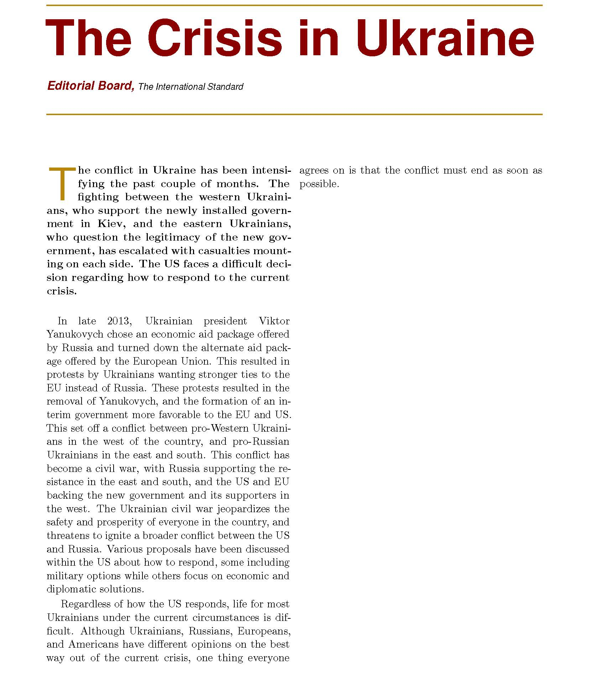
LISO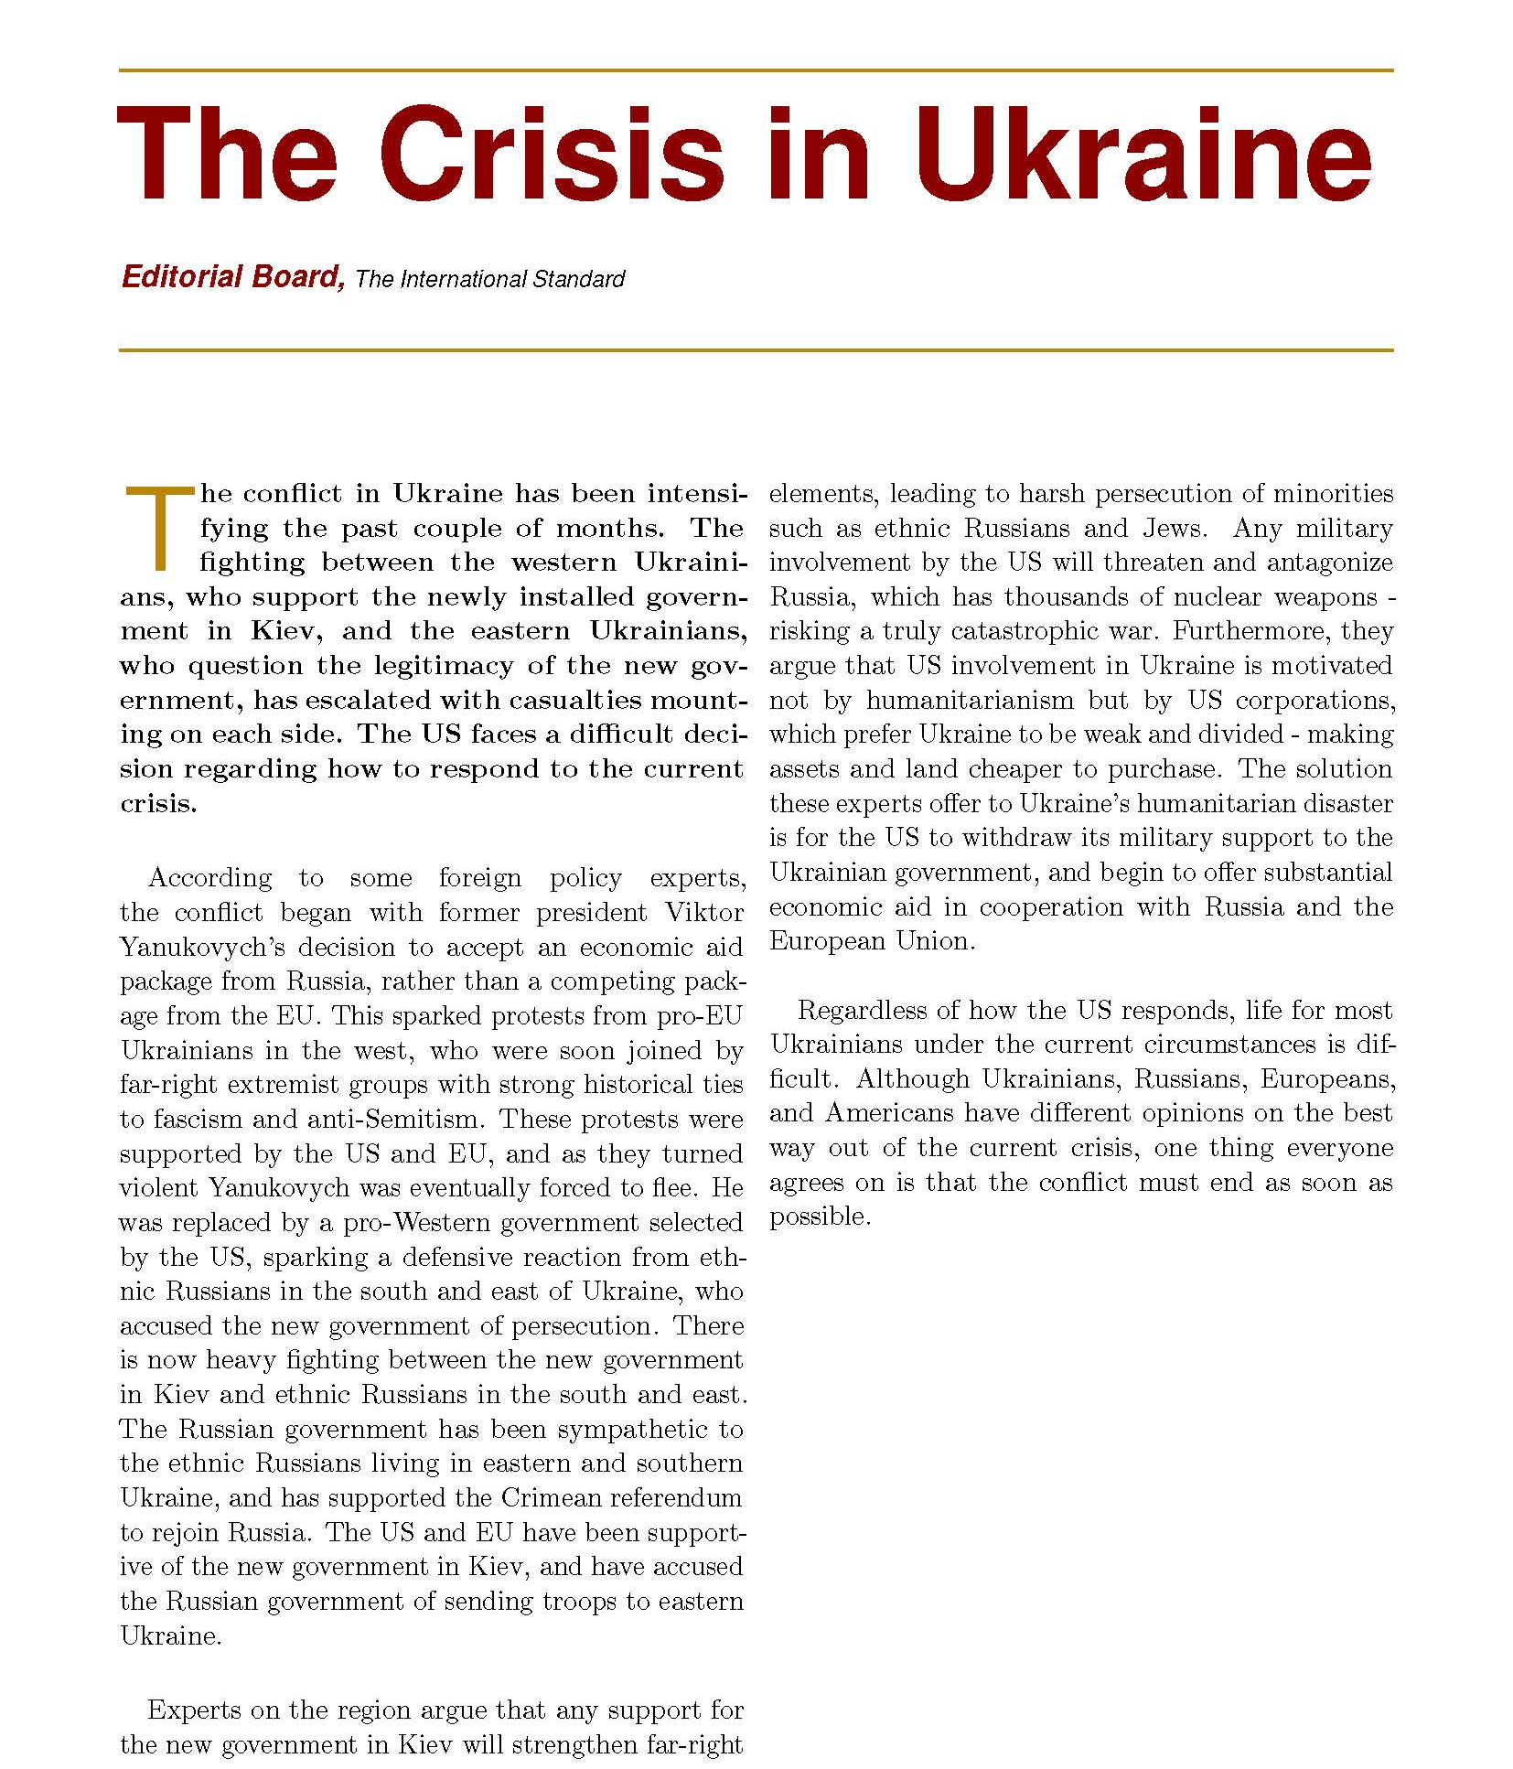
LINT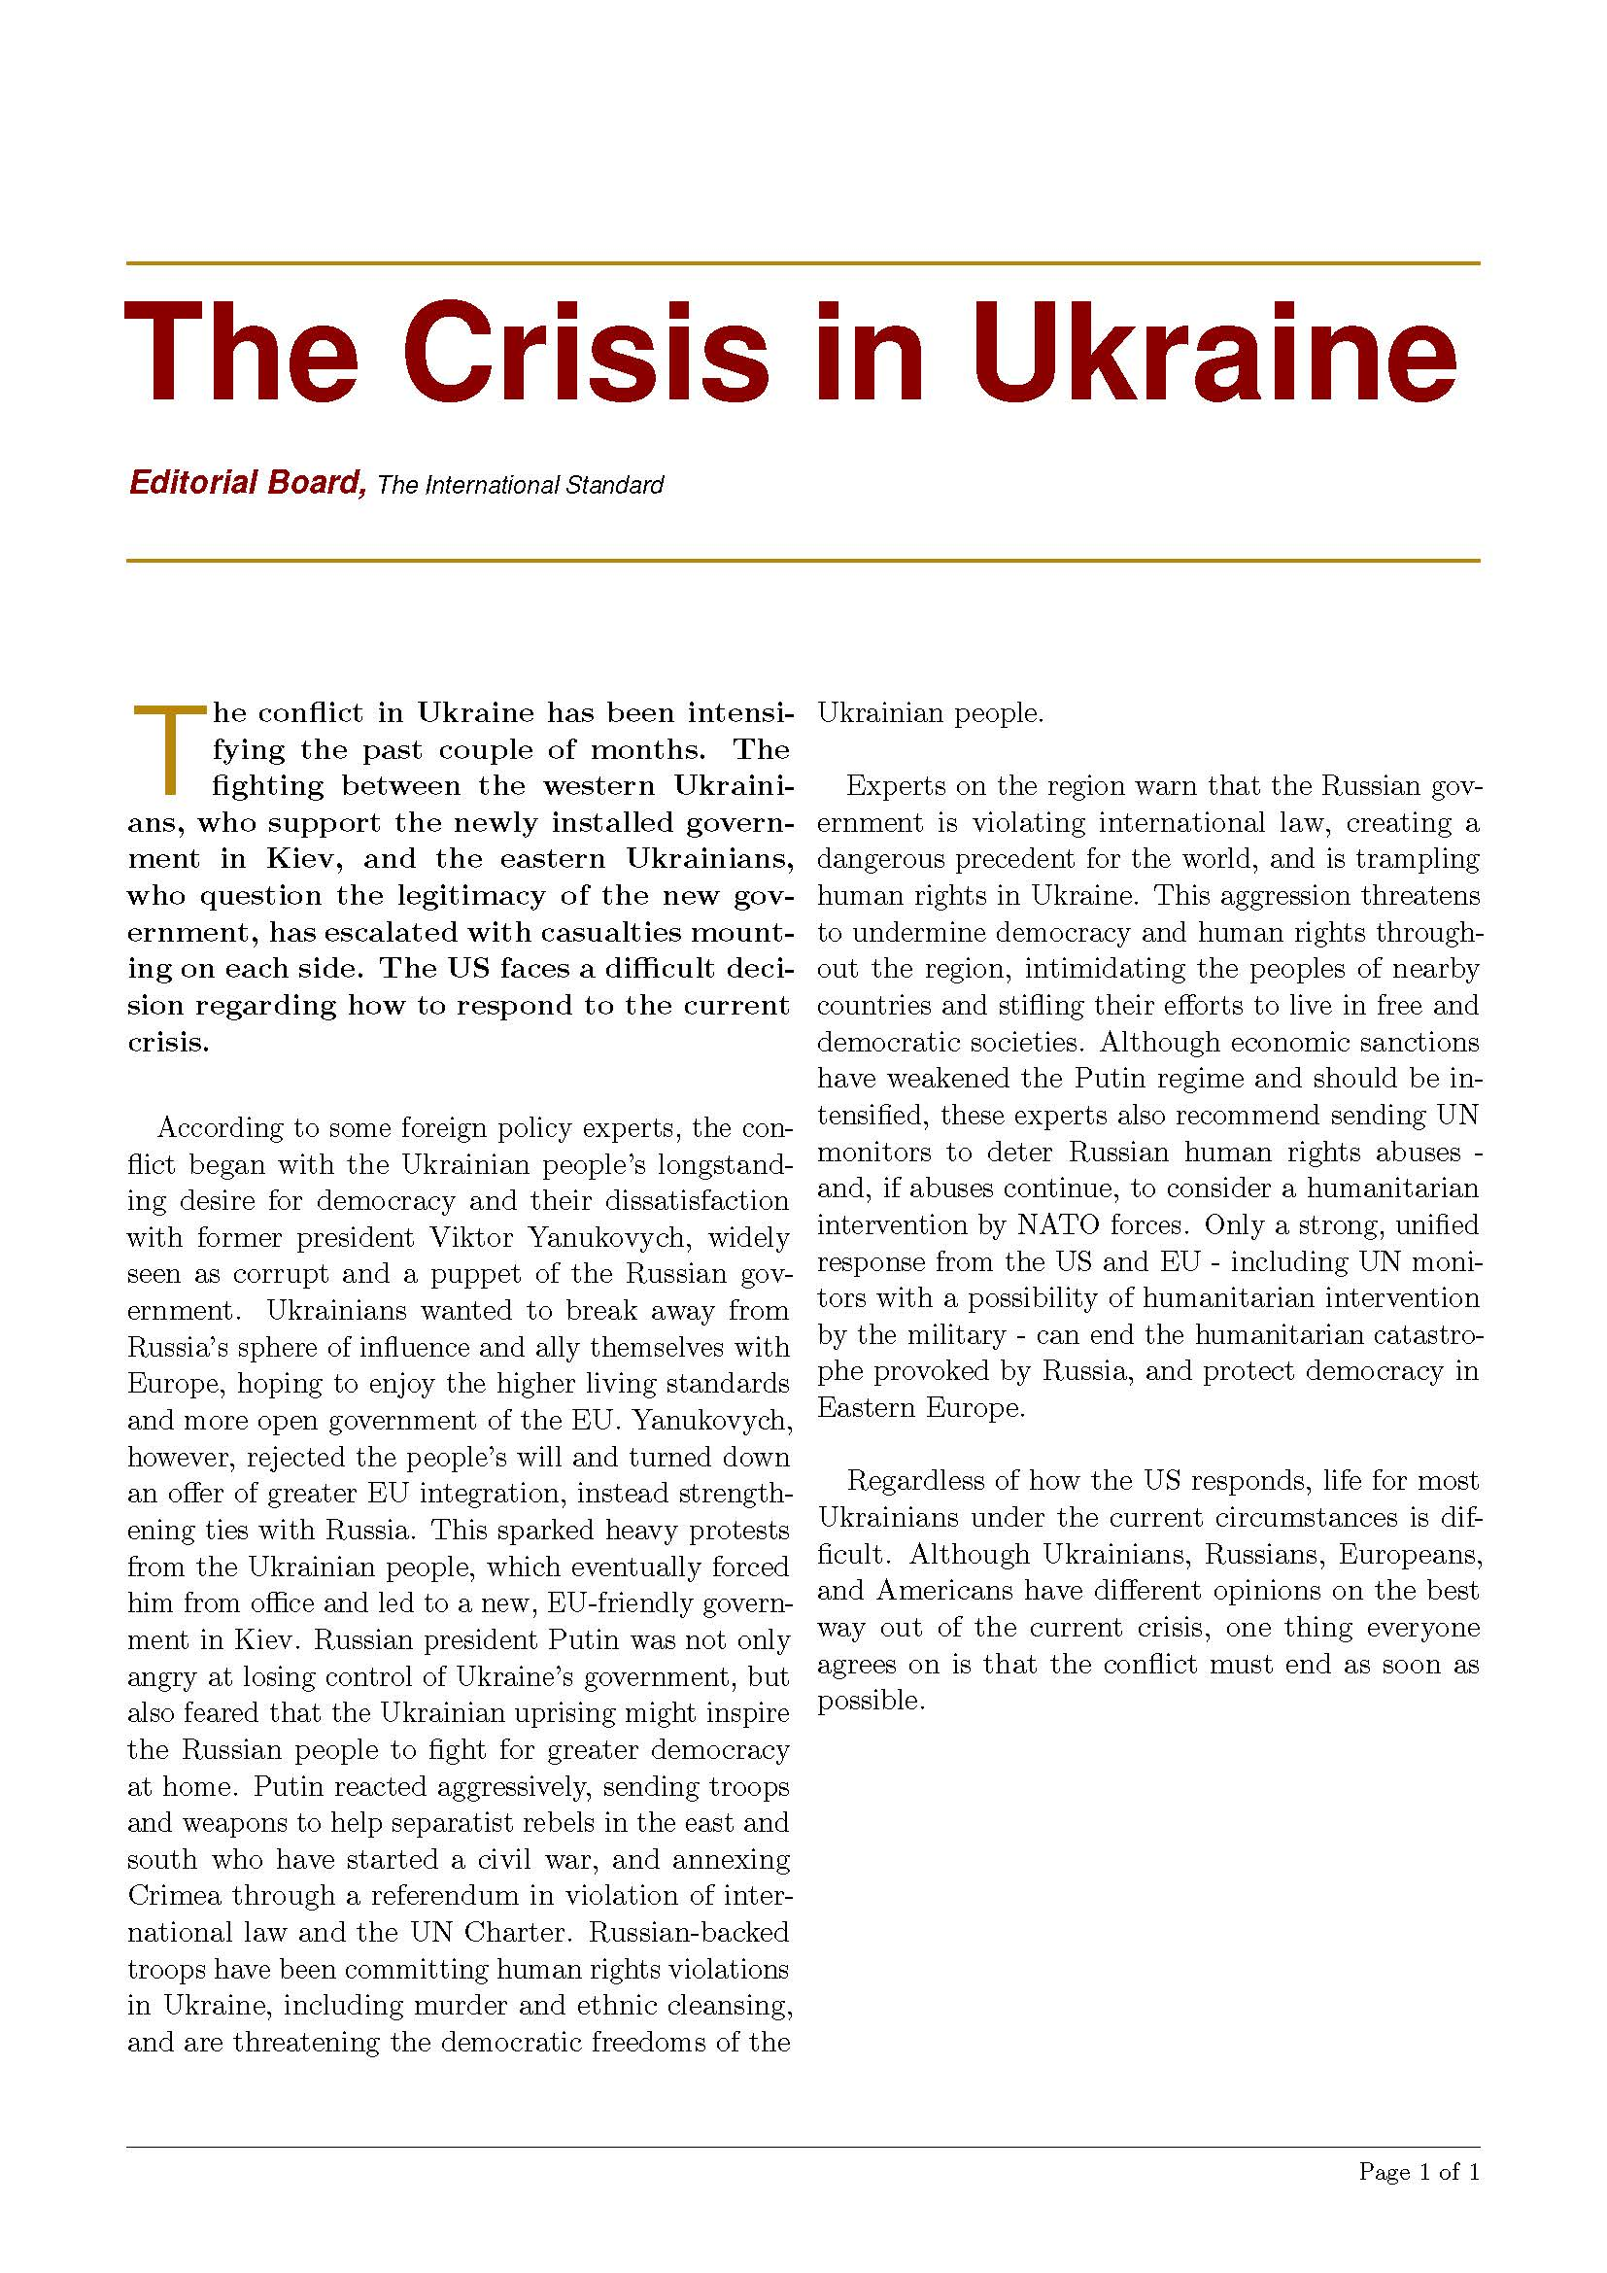

RINT
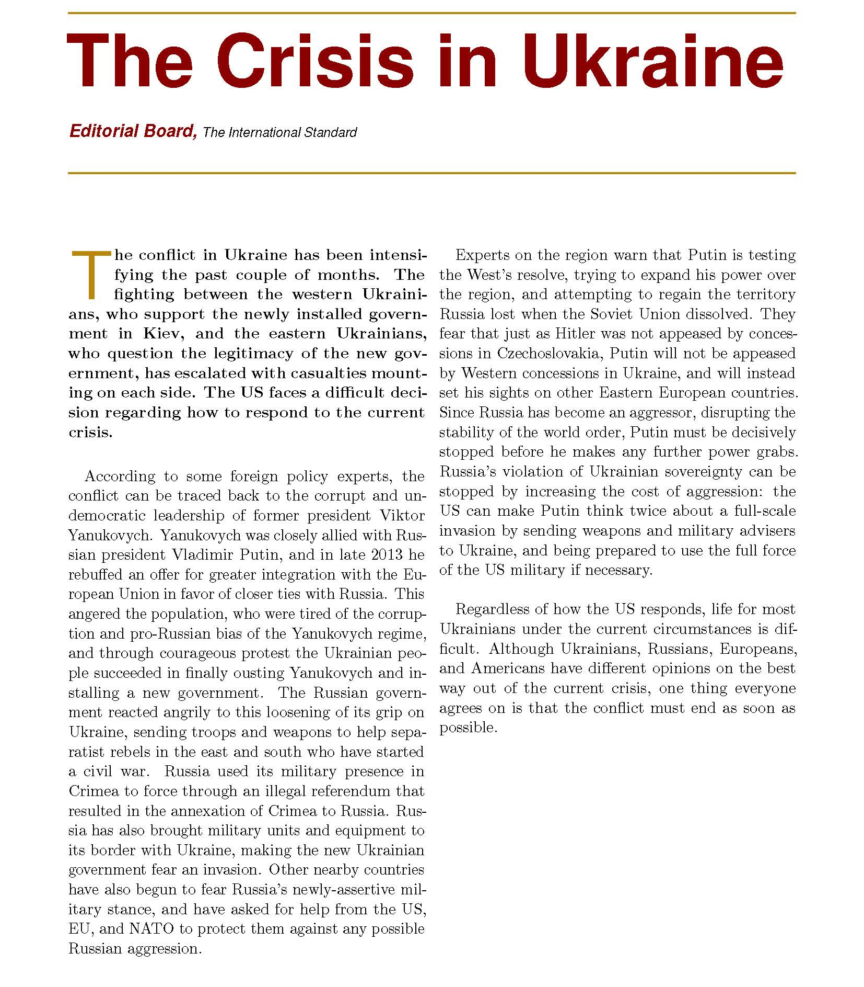

RISO
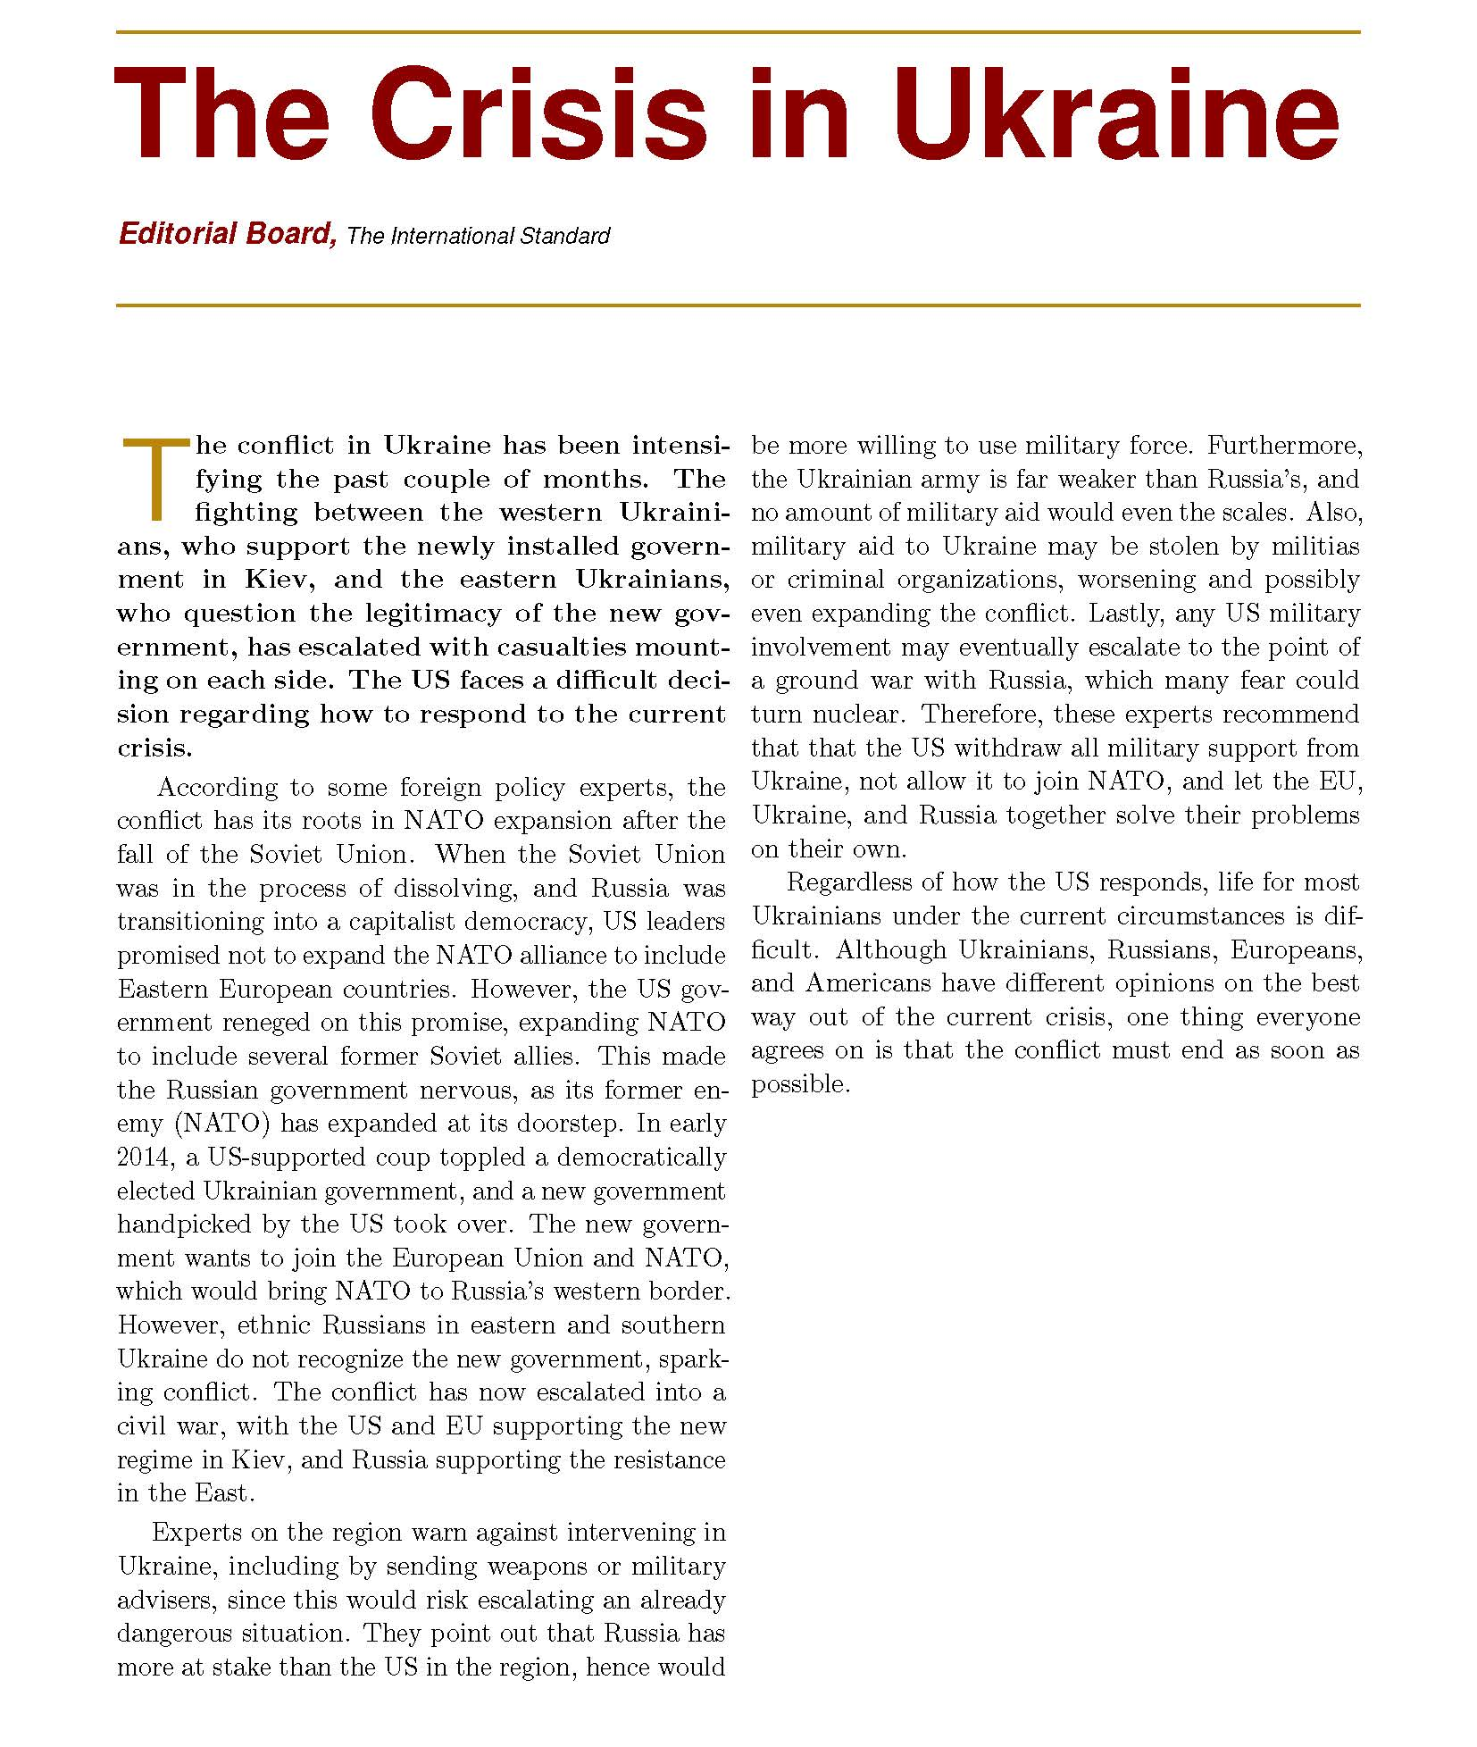

Multiple Frames, Intervention First
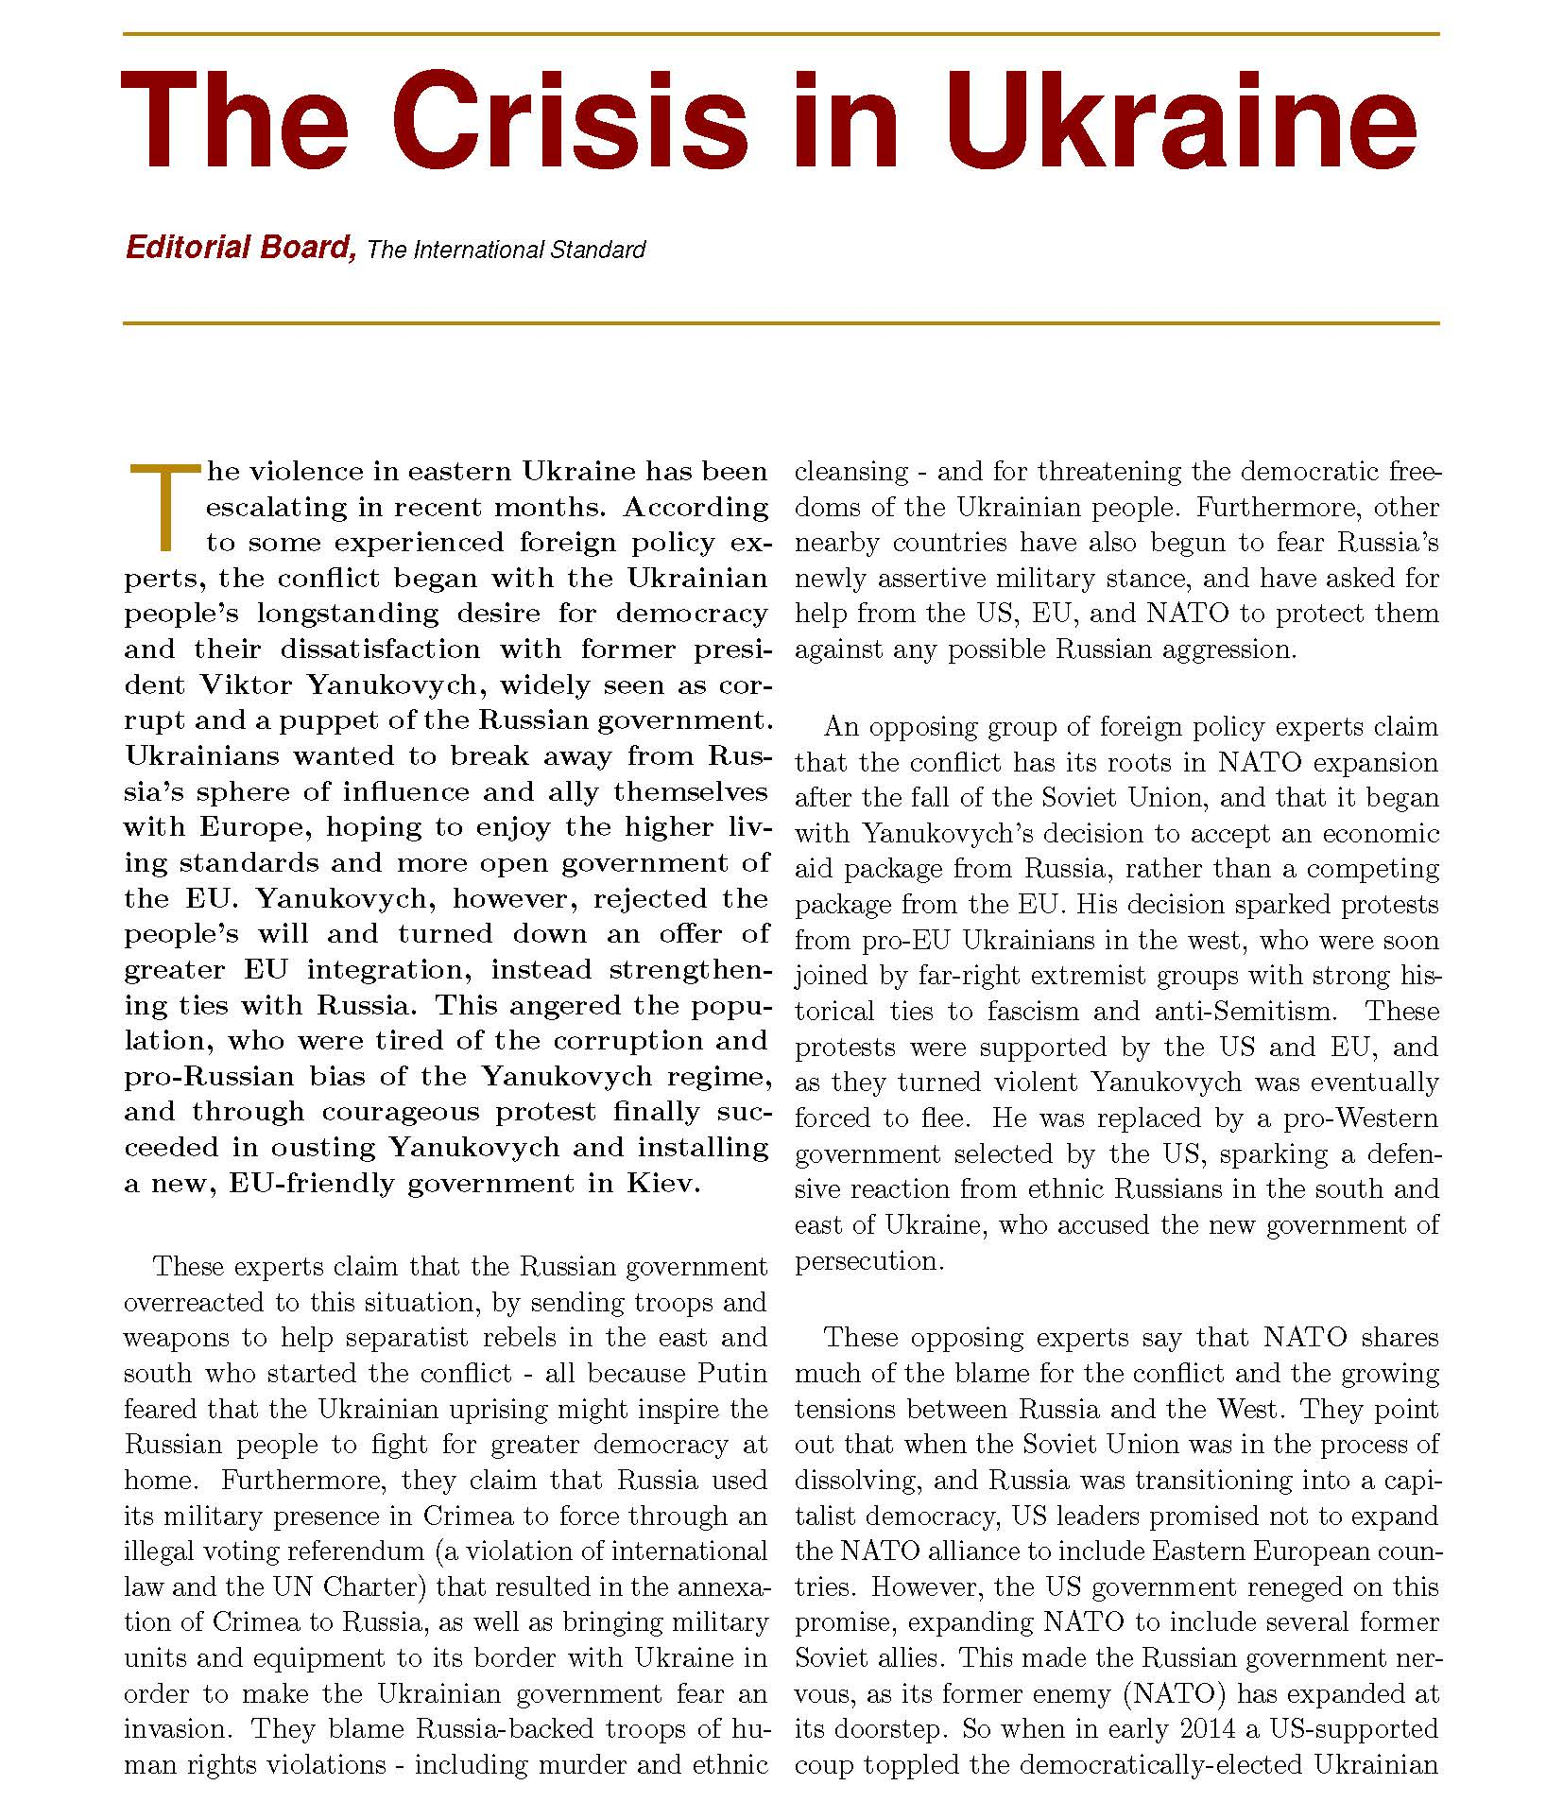
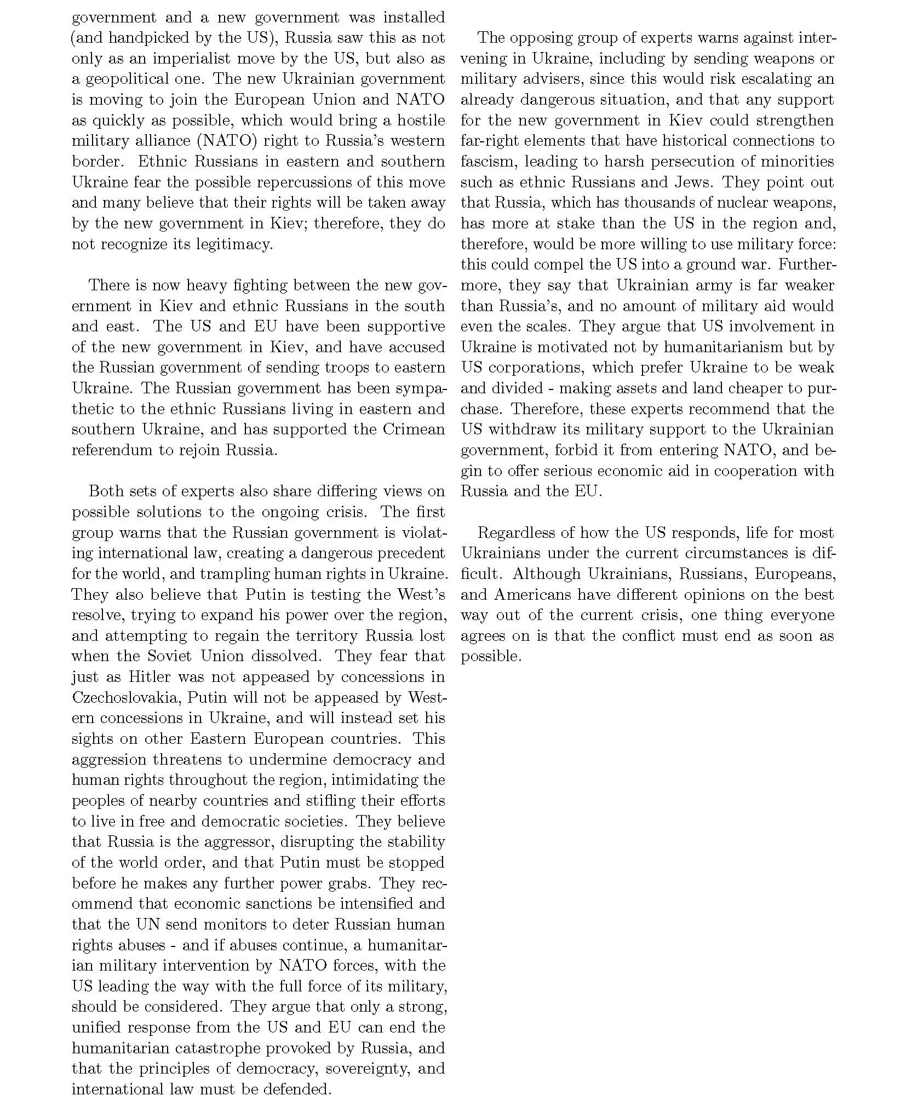

Multiple Frames, Isolation First
