Christina Dunbar-Hester
Low Power to the People: Pirates, Protest and Politics in FM Radio Activism
MIT Press (Cambridge, MA: 2014)
Hardcover $38, Paperback $30

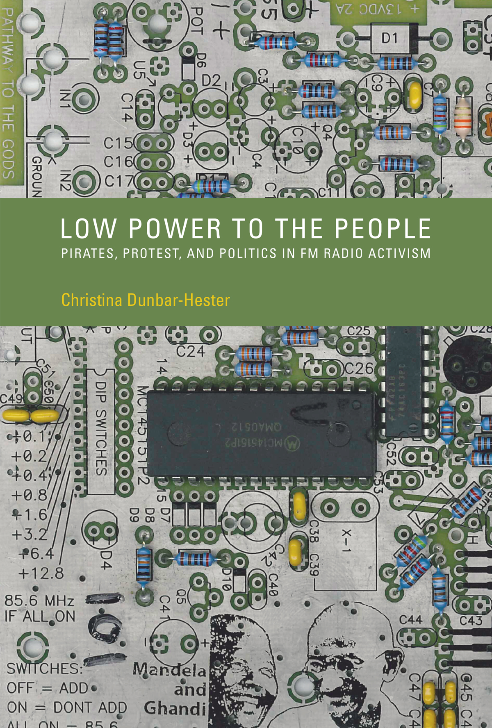

Reviewed by:
Michael Palm
Associate Professor
Media and Technology Studies
Department of Communication
Affiliated Faculty, American Studies
University of North Carolina at Chapel Hill

During the three years since the publication of Christina Dunbar-Hester’s Low Power to the People, streaming has taken over as the dominant mode of music consumption in the United States. Unlike mp3s, CDs, records, and cassettes, subscription streaming services resemble broadcast radio (and television) as “flow” rather than “publication” media, in Raymond Williams’ (2003) formative distinction between formats accessed by consumers rather than acquired. The ascent of streaming suggests that scholars of digital media have much to gain from an amplified interest in radio’s history, relative to those other, more celebrated pre-internet media such as film, television, and even telephony. (In previous publications and public presentations Dunbar-Hester had “thinly psuedonymized” (p. xxv) her case study, the Prometheus Radio Project, as Pandora. The choice is indicative of the droll, dry wit that seasons Low Power to the People.) Contemporary radio politics also merit more scrutiny than they have in decades, and Dunbar-Hester has provided a valuable resource for anyone invested in the future as well as the past and present of independent media. The fact that Low Power to the People continues to receive acclaim and appreciative reviews (e.g., Halper, 2016; Söderberg, 2017) is evidence of its continued relevancy to a shifting digital media landscape.

Low Power to the People (LPttP) is admirable in its clarity, focus and scope. The expansiveness of Dunbar-Hester’s analysis is born from the specificity of her research, and the breadth of her claims never outpaces the book’s extensive, deliberate documentation and careful reasoning. Informed by years of participant-observation with Prometheus, LPttP provides an embedded perspective on media activism and technological politics. Dunbar-Hester conveys the passions as well as politics of the group’s internal debates and decision making. Locating individual members of Prometheus as well as their collective actions at “the intersection of technical practice and political engagement,” she analyzes the pitfalls as well as potential of “promoting technology as a platform for emancipatory politics.” (p. x; xv) One of LPttP’s greatest strengths is the deftness with which Dunbar-Hester balances respectful appreciation of her subjects’ endeavors (and their personalities) with direct and pointed criticism. The narrative is never reduced to heroic activists doing battle against Big Media, and some of the most contentious politics and struggles described in the book are internal to Prometheus. Dunbar-Hester does not merely describe the struggles over meaning or direction among her subjects; she also painstakingly catalogs and thoroughly explains how their various perspectives are animated by cultural assumptions, political ideologies, and activist agendas, as well as by distinct subject positions and the relative privilege(s) therein.

In a book “focus[ed] on how differing communities and identities interact with technical practice,” it is not surprisingly that questions and controversies involving access and expertise come to the fore. (p. xviii) After a first chapter that places low-power FM radio (LPFM) within a history of media activism including pirate radio and Indymedia, Dunbar-Hester devotes chapters 2 and 3 (and much of 5 and 7) to “identity work,” demonstrating how Prometheus members’ identifications as tech geeks, activists, and iconoclasts were varied and uneven, often inconsistent, and occasionally contradictory. Chapters 4 zeroes in on the politics of technological expertise, and chapter 5 build on that analysis with an “examination of the role that technical affinity played as the group underwent organizational maturation.” (p. xv) Chapter 6 addresses “the discursive practices by which LPFM advocates attempted to redefine radio’s use and meaning,” before chapter 7 puts LPFM activism in dialogue with internet practices. (p. xv) Throughout all of the chapters, Dunbar-Hester methodically highlights the gender politics surrounding a group like Prometheus, which was self-assertively geeky and aggressively activist, not to mention demographically male-dominated. Whether describing the group’s “barnraisings” (collaborations with community members to erect LPFM transmitters), their “Geek Group” weekly tinkering sessions, or their projects of outreach and advocacy, Dunbar-Hester is unwavering in her attentiveness to the gender dynamics and politics of technical practice (“as well as race and class, though gender receives greater attention,” (p. xxi) as the author acknowledges up front.) The author also notes that “[her] own positionality as a middle-class white woman pursuing an advanced degree [LPttP is the fruit of Dunbar-Hester’s dissertation research] is certainly worth consideration.” (p. xxi) More than mere lip service, this self-reflexivity informs her analysis. Chapter 3, “The Tools of Gender Production,” opens with an anecdote about being approached by a Prometheus activist who “began to apologize for making me cry,” before realizing he had mistaken the author for “another young, white woman with short dark hair.” (p. 53) Anything but self-indulgent or egocentric, Dunbar-Hester succinctly uses this moment to introduce the chapter’s primary questions: “Why did mismatches between the stated goal of egalitarian participation and actual, unequal experience keep occurring? In what ways was gender implicated?” (p. 54) LPttP’s focus on gender is not circumscribed to the two chapters explicitly focused on “identity work;” instead, Dunbar-Hester’s discussions not only of access and expertise, but also of activism and the contemporary role(s) of radio and digital media, attend to how gender ideologies and gendered identities impact individual participation and group dynamics. For this reason, LPttP in its entirely will make a welcome addition to syllabi in women’s and gender studies curriculums, as well as in graduate and upper-level undergraduate courses focused specifically on media and technology, on activism, or on organizational culture.

The introduction to LPttP opens in Washington, D.C. at a raucous rally of LPFM activists outside the Federal Communication Commission’s headquarters, and policy is the missing “P” in the book’s subtitle, though not in the book itself. In a highly effective section of the intro, cheekily titled “What This Book Does Not Do,” Dunbar-Hester insists this is “not a book primarily about policy” (xvii), yet LPttP captures how federal communication policy comprises the stakes and context of local media activism and technological practice more generally. LPttP belongs in the new canon of media policy studies as well as media activism studies, alongside recent classics by the likes of Victor Pickard (2014) as well as Sasha Costanza-Chock (2014). Dunbar-Hester avoids the limitations inherent to policy studies based on discourse analysis and archival research, by “examine[ing] media activism at the level of practice” rather than advocacy. Which isn’t to say that advocacy isn’t a part of Prometheus’ agenda, but they and Dunbar-Hester approach advocacy as part of “the granular practices of activism,” (xviii) alongside more “on-the-ground” (or in-the-basement) activities such as the barnraisings and tinkering. (She reports (p. xvi) that one source, after reading a draft of the manuscript, congratulated her on having written “an anthropology of the basement.”)

Low Power to the People will continue to interest, challenge, and invigorate media activists and technology scholars for years to come. Dunbar-Hester allies herself with STS doyen Langdon Winner by claiming that the most fundamental question driving her research is, “how do certain artifacts come to have particular political meanings?” (p. xvi) LPttP announces Dunbar-Hester as a worthy successor to Winner as a theorist of technological politics. And when it comes to his famous question about artifacts and their politics, no doubt Winner would appreciate how much insight Dunbar-Hester has out of a case study of local activists and practitioners committed to an unassuming, seemingly outmoded medium like low-power radio.
References

Costanza-Chock, Sasha. (2014). Out of the shadows, intro the streets! Transmedia organizing and the immigrant rights movement. Cambridge, MA: MIT Press

Halper, Diane E. “FM Power to the People,” IEEE technology and society magazine, March, 2016, 15-16.

Pickard, Victor. (2014). America’s battle for media democracy: The triumph of corporate libertarianism and the future of media reform. Cambridge, UK: Cambridge UP.

Söderberg, Johan. (2017). “Inquiring hacking as politics? A new departure in hacking studies.” Science, technology, and human values, 42(5), 969-980.

Williams, Raymond. (2003). Television: Technology and Cultural Form. New York, NY: Routledge Classics.

Winner, Langdon. (1986). “Do artifacts have politics?” In The whale and the reactor. Chicago: U Chicago Press. 19-39.

