Department of Communication and
Media Research (DCM)
Prof. Dr. Diana Ingenhoff
Boulevard de Pérolles 90
CH-1700 Fribourg
 |  | International Journal of Communication
  T +41 26 300 83 98
  F +41 26 300 97 62
  diana.ingenhoff@unifr.ch
  www.unifr.ch/mukw

FACULTÉ DES SCIENCES ÉCONOMIQUES ET SOCIALES
Département des sciences de la communication et des médias
DOMAINE systèmes et
structures des médias

WIRTSCHAFTS- UND SOZIALWISSENSCHAFTLICHE FAKULTÄT
Departement FÜR MEDIEN- UND KOMMUNIKATIONSWISSENSCHAFT
bEREICH MEDIENSYSTEME UND MEDIENSTRUKTUREN
Fribourg, 2018/01/31
Manuscript submission
Dear Dr Gross, dear Dr Castels, dear editorial team,
Please find attached our manuscript submission entitled “Spillover effects of political leaders’ image onto their home countries: The influence of competence and charisma”.

In this paper, we test how the political leader’s image influences their home country’s image by employing an experimental design. Results confirm the hypothesized spillover effect of a political leader’s image on that of their home country, with the integrity of a political leader showing the greatest impact on the country image, followed by the competence and charisma dimensions. As such, the paper provides a valuable resource for public diplomacy theory and practice.

The article has not been previously published in any form and is not under submission to any other journal or publisher.

Sincerely,

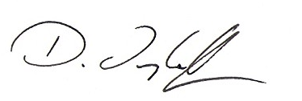

Prof. Dr. Diana Ingenhoff
diana.ingenhoff@unifr.ch
T +41 26 300 83 98

