FIGURES

Figure 1: Frame usage by time and outlet
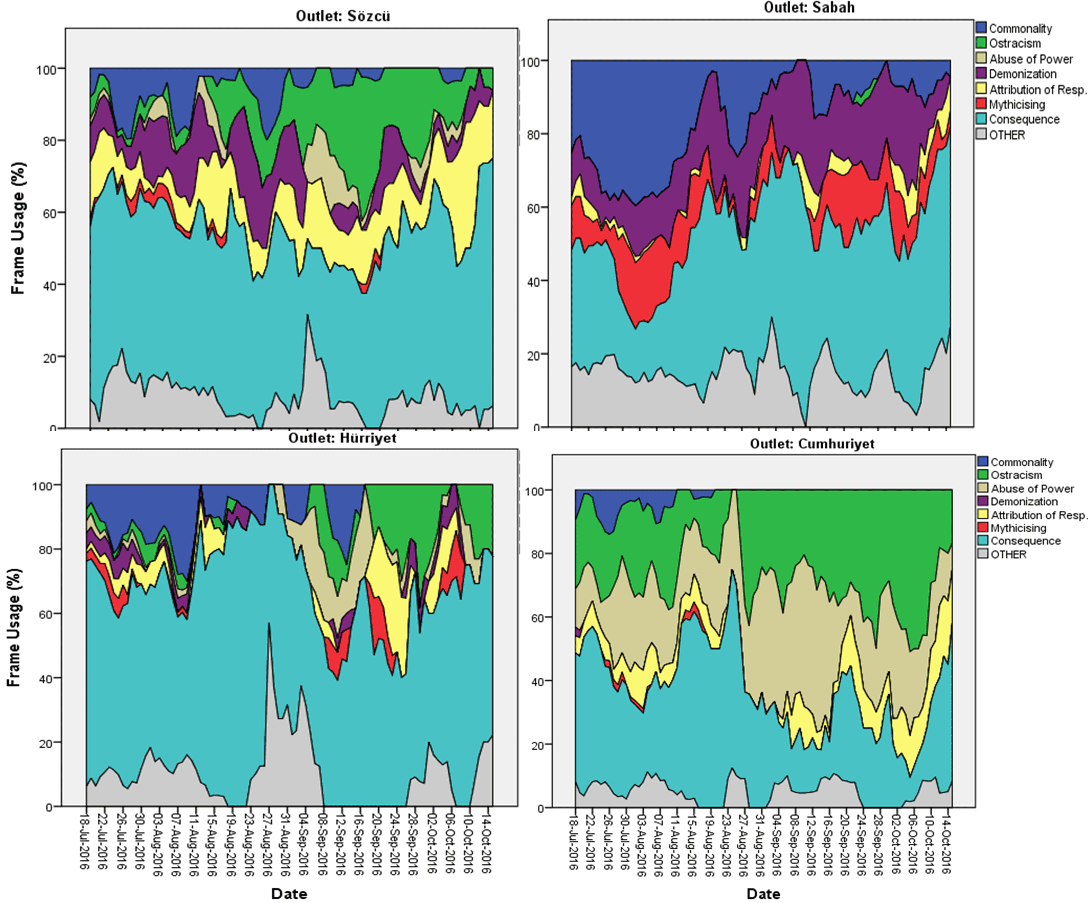

Figure 2: Overall Frame Usage by Outlet

Figure 3. News outlets use of commonality frame, July 16 – October 15, 2016

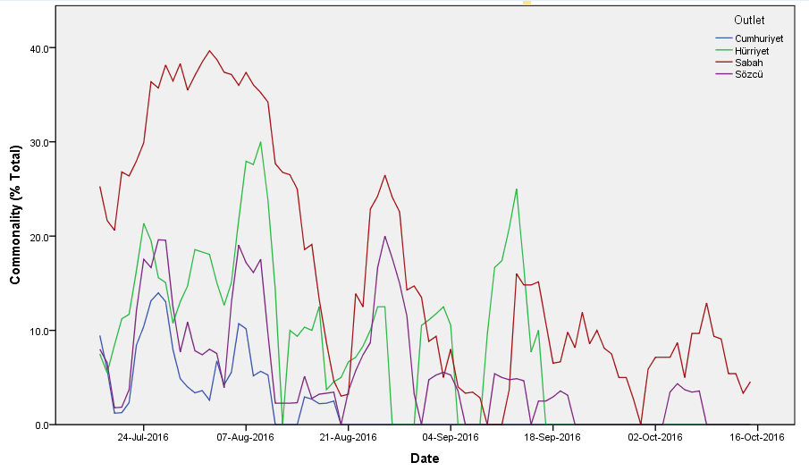

Figure 4. News outlets use of ostracism frame, July 16 – October 15, 2016
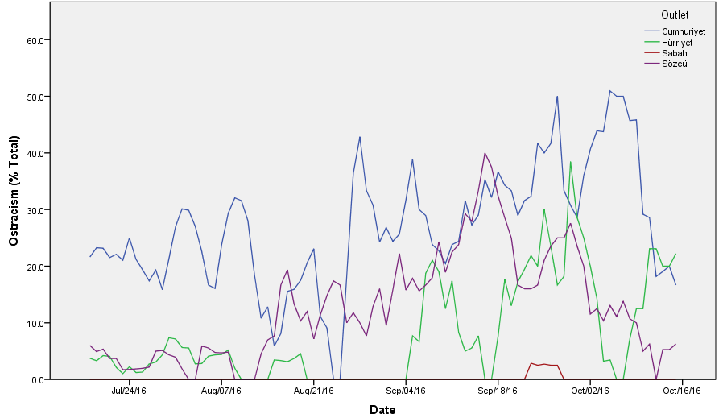

Figure 5. News outlets use of abuse of power frame, July 16 – October 15 2016
